Background paper

Joint report on the evaluability assessment of the common chapter to the strategic plans of UNDP, UNFPA, UNICEF and UN-Women

Summary
In decisions 2018/1 and 2018/2 of the Executive Board of UNDP, UNFPA and UNOPS, decision 2018/2 of the Executive Board of UNICEF, and decision 2018/2 of the Executive Board of UN-Women, the Boards requested that the evaluation offices of the four organizations seek opportunities for joint evaluations of joint programming and the common chapter of the strategic plans. The present document includes a synthesis of the common chapter’s evaluability assessment, which aimed to provide clarity on the operationalization of the common chapter in the first years of implementation and assess the existence of basic parameters that would make an evaluation of the common chapter possible. In light of the report’s findings on implementation of United Nations development system reform, and recognizing the potential major implications of the COVID-19 pandemic, the evaluation offices of UNDP, UNFPA, UNICEF and UN-Women seek the guidance of the Executive Boards on the continued relevance of the implementation of the second phase of the evaluation, as requested in previous decisions of the Boards.

Contents
 |  | Chapter |  |  | Page
 | I. |  |  | Introduction | 3
 | II. |  |  | Scope and methodology | 4
 | III. |  |  | Findings | 5
 | IV. |  |  | Conclusions and way ahead | 16
Annex |  |  | Theory of change in the common chapter |  | 18

- Introduction
- Achieving greater coherence and coordination in the work of United Nations development system organizations has been a long-standing goal and the subject of several initiatives and reforms across the system with varying degree of success. The 2030 Agenda for Sustainable Development, adopted in 2015 with its interrelated goals and targets, called for transformative, collaborative system-wide action and gave renewed impetus to enhancing coherence and integration within the United Nations system.
- In line with the requests of the General Assembly in its resolution 71/243 on the 2016 quadrennial comprehensive policy review of operational activities for development of the United Nations system, and resolution 72/279 on the repositioning of the United Nations development system, UNDP, UNFPA, UNICEF and UN-Women have committed to working better together, with a view to achieving greater coherence in support of results. This commitment is embodied in a common chapter of the organizations’ strategic plans, 2018-2021.
- Through the common chapter, UNDP, UNFPA, UNICEF and UN-Women have defined expectations for programme areas that require multisectoral approaches and where the organizations’ collaborative advantages complement each other in the pursue of issues of common interest, and for operationalization modalities to achieve greater synergy and higher efficiency. The four organizations also committed to continue harmonizing their approaches to results reporting, capturing their contributions to collective outcomes and the Sustainable Development Goals.
Figure I. Common chapter areas of collaborative advantage and collaborative approaches to strengthening how the organizations work together
- Eradicating poverty;
- Addressing climate change;
- Improving adolescent and maternal health;
- Achieving gender equality and empowerment of women and girls;
- Ensuring greater availability and use of disaggregated data and sustainable development;
- Contributing to peacebuilding and sustaining peace in conflict and post conflict situations.

- Planning together;
- Implement programmes together differently;
- Enhance multi-stakeholder partnerships;
- Enhance efficiency together.

- In response to a request by the Executive Boards of UNDP, UNFPA, UNICEF and UN-Women, the evaluation offices of the four entities initiated a joint evaluation of the common chapter to provide an independent assessment of progress and results achieved through the implementation of the common chapter. The evaluation report will be presented to the respective Executive Boards at their annual sessions 2021.
- This report presents the findings of the evaluability assessment of the common chapter and the suggested course of action in light of the changed environment in which the organizations operate.
- Scope and methodology
- The evaluability assessment of the common chapter was conducted from September to December 2019 by two independent evaluation consultants. It was designed to analyse basic parameters – such as the quality of design and data availability – to establish the feasibility of a full evaluation that would assess both the results of the common chapter’s implementation and the processes that have led to these achievements. The evaluability assessment also intended to collect information on the status of cooperation among the four organizations, create a baseline, and shed further clarity on the operationalization of the common chapter by looking at the extent to which it has influenced how the four organizations work together in programme and operations to leverage results at country level, with a focus on the six areas of collaborative advantage. The evaluability assessment was not intended as a review of the repositioning of the United Nations development system to deliver on the 2030 Agenda, for which no mandate had been given.
- Based on information available, the consultants constructed a draft theory of change for the common chapter (see annex) and identified process indicators that would make it possible to track progress at the level of immediate outcomes. Of the original common chapter indicators, the consultants retained those most appropriate to measure collaboration and for which data were readily available. A baseline was built, to the extent possible, with data from the previous strategic plan cycle, 2014-2017, distinguishing among country, regional and headquarter levels, between different approaches to working together under the common chapter and, to the extent possible, between the common chapter’s six areas of collaborative advantage.
- The evaluability assessment followed a mixed-method approach. Primary and secondary data sources included:
- Strategic and programmatic documents, information provided by the common chapter’s technical team, and websites;
- Interviews and focus group discussions with more than 50 concerned staff at headquarters and regional levels, representatives of United Nations entities that have system-wide coordination mandates, and managers of accelerator initiatives;
- A workshop with Executive Board representatives;
- The Information Management System (IMS) of the United Nations Development Coordination Office;
- Mainstreaming, acceleration and policy support (MAPS) mission reports; and
- An online perception survey to the heads of all country offices and multi-country offices of the four organizations, which reported a response rate of 48 per cent.
- The evaluability assessment faced some limitations related to data availability, access and labelling. In the absence of a central repository of information related to the common chapter, the IMS database was used to establish a baseline. IMS provided extensive information about the extent of collaboration among the four organizations in programme countries through quantitative indicators, but it did not allow for a qualitative assessment of pre-common chapter collaboration among the four organizations. In addition, IMS data could be disaggregated by organization and Goal, but could not be conclusively used to reflect the operationalization of the common chapter.
- Drafts of the evaluability assessment and this report have both been shared with the organizations’ common chapter technical team for review; their comments have been taken into due account.
- Findings
- The design of the common chapter was not accompanied by a conceptual framework that clarified joint results and ways to work better together around issues of common interest in the six areas of collaborative advantage.
- The common chapter was conceived as a tool to support implementation of the 2016 quadrennial review and contribute to addressing the challenges set out in the 2030 Agenda. Its development runs alongside the process that led in May 2018 to the adoption of General Assembly resolution 72/279 on the repositioning of the United Nations development system.
- To facilitate operationalization of the common chapter, UNDP, UNFPA, UNICEF and UN-Women defined issues of common interests and respective collaborative advantages based on each organization’s results statements. The four heads of organization then invited country offices to work together through a two-pronged approach: either building on existing mechanisms and initiatives (action A) or in support of accelerator initiatives for transformational change (action B).
- As confirmed by interviews with staff and survey respondents, however, the design of the common chapter presents weaknesses and ambiguities that have come to affect its operationalization. These include:
  - Common results are located at the distant level of Sustainable Development Goal indicators, and no theory of change has been designed to define and track combined contributions to the Goals. Certain common process indicators reflect the extent to which common chapter organizations are implementing the same quadrennial review priorities, rather than acting proxies for working together in the operationalization of the common chapter.
  - The annex to the common chapter does not conclusively reflect commonalities among the four organizations, listing only strategic plan objectives (except for UNDP) without a clear underlying logic. The selection of the thematic areas of collaboration does not seem to be based on a shared understanding of how the comparative and collaborative advantages of agencies could be leveraged to promote synergies and integrated results.
  - The common chapter and its annex are inconsistent; the former mentioning “peacebuilding and sustaining peace” among the areas of collaborative advantage and the latter focusing on “coherence, complementarity and coordination within and between development and humanitarian activities”. The only associated indicator is “the number of deaths, missing persons and directly affected persons attributed to disasters per 100,000 population” (the same used for climate change), without any mention of Goal 16.
  - The expectation to see better collaboration at the regional and global levels is not defined aside from the commitment to support country offices, which leaves room for interpretation. Furthermore, the rationale applied for selected global-level partnerships, system-wide approaches, coordination mechanisms and joint global programmes remains unclear. Few listed partnerships and coordination mechanisms go beyond the United Nations system; some involved only one common chapter organization; others no longer exist, or no information about them could be found. Key partnerships in the areas of collaborative advantage where common chapter organizations were participating, such as the Committee of the Chief Statisticians of the United Nations System or the Inclusive and Equitable Local Development Programme, are missing.
- The operationalization of the common chapter has been left to regional and country offices, with limited guidance from headquarters. Surveyed country offices reported a high level of awareness by senior management, but less so among staff. Planning for operationalizing the common chapter appears not to have been institutionalized.
- The joint report to the Executive Boards in 2019 points out that effective common chapter implementation and management arrangements had been established at global, regional and country levels. Based on the evidence collected by the consultants’ team, this information is insufficiently differentiated.
- At headquarters, the Common Chapter Management Group was created at the level of Assistant-Secretary-General and met four times in 2018-2019. A technical team (composed of two-three planning officers from each organization and with a rotating secretariat) met more regularly, although its guidance and oversight role could not be fully determined. Only few thematic experts who participated in headquarters-level focus group discussions identified as common chapter focal points for programmatic support; their level of familiarity with, and ownership of, the common chapter varied considerably. Overall, at the global level, organizations’ headquarters continued working together irrespective of the common chapter, based on “what made sense” and “as new opportunities arose” (such as, for example, in preparing for the Climate Action Summit).
- The operationalization of the common chapter was mostly left to regional and country offices, with limited guidance by organizations’ headquarters. The technical team indicated that it had interpreted the common chapter as a statement of intent, to be implemented through joint programmes and existing collaboration, for which no additional guidance was necessary.
- To the understanding of the evaluation team, the emails by the heads of organizations (dated April and July 2018) have remained the only joint formal communication. In the period September-December 2019, the executive directors of UNDP and UNICEF issued two calls for action to their country offices incentivizing collaboration in the areas of innovation and climate change, in the spirit of the common chapter, but without mentioning it and not involving UNFPA and UN-Women.
- According to the survey responses, country office representatives are mostly (59 per cent) familiar with the common chapter. However, only between 35 and 40 per cent of them recalled having received guidance either from headquarters or regional offices; most of them (53 per cent) did not find it very useful. Heads of organizations noted that country offices’ staff had overall little familiarity with the common chapter. Interviews conducted by the evaluation team reiterated the request made by regional directors during the 2019 management group meeting for a strategic vision, more formal communication, and clearer and flexible guidance from headquarters on how to implement the common chapter and the accelerator initiatives.
- At regional level, lead regional offices designated common chapter focal points which coordinated efforts around reporting and opportunities for joint regional programming (see also finding G on accelerators), although funding constraints, limited co-location, coverage of different programme countries, and different roles played by regional offices posed challenges. The UNDP and UNFPA regional programmes planned collaboration among common chapter organizations in all areas of collaborative advantage (although less so around data, peacebuilding and climate change), albeit without once pointing to the common chapter as a frame of reference.
- At country level, as the responsibility for coordination has not been prescribed, it has been managed differently. According to the survey respondents, formal arrangements for common chapter implementation have been made in a third of the countries (36 out of 107), with no significant difference among regions. Research into country programme documents/strategic notes, for the four common chapter organizations approved in 2018 and 2019, revealed references to the common chapter, but in an inconsistent manner. Overall, while 34 made a reference to the common chapter, 70 did not.
- As the direction for the reform of the repositioning of the United Nations development system was being clarified, its relationship with, and implications for, the common chapter have not been articulated.
When the General Assembly approved the reform of the Secretary-General in 2018, the link between the common chapter and the repositioning of the United Nations development system was not made explicit. On one hand, the common chapter was mentioned in passing in two reports of the Secretary-General, but not included in the June 2019 draft United Nations system-wide strategic document submitted to the Economic and Social Council, nor in the United Nations Sustainable Development Cooperation Framework (UNSDCF) Guidance. On the other, the implications of the reform for the operationalization of the common chapter have not been elaborated, and the role of the United Nations resident coordinator in the operationalization of the common chapter remains unclear.
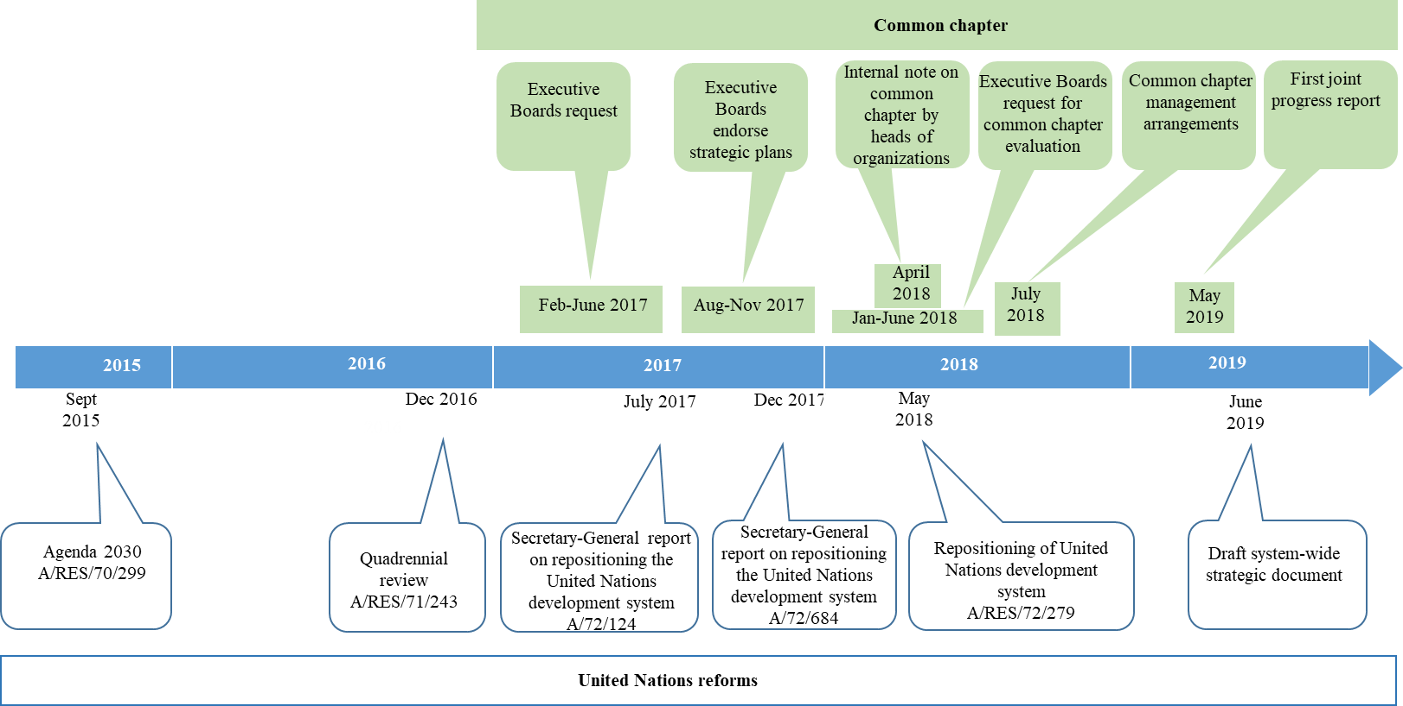
Figure II. Common chapter and United Nations development system reform timeline
- The large majority of survey respondents indicated that both the common chapter and the United Nations development system’s repositioning reform have had a positive influence on collaboration among the organizations, albeit to a somewhat more limited extent in the case of the common chapter, as confirmed in interviews. Respondents commented that the common chapter “influences thinking” and provides a “useful framework”, a “reminder”, a “common agenda”, or an “incentive” to work together in certain areas of common interest. Critical survey respondents, however, questioned the common chapter’s added value since “United Nations country teams are already delivering as one and considering the reform process”. Two extreme schools of thought emerged: on the one hand, the call for ending the common chapter; on the other, support for systematic incorporation of the common chapter in the methodologies of both the organizations and country teams’ instruments and processes – more consistent operationalization within existing mechanisms as a contribution to United Nations reforms.
- IMS data, as well as survey perceptions, indicate that country offices are overall collaborating more through planning and programme implementation. Available information does not however make it possible to qualify the cooperation, nor to define whether cooperation has derived from the common chapter. Very little information is available about multi-stakeholder partnerships.
- In the absence of an established baseline for the common chapter, most of the indicators that the team of consultants used to create one and track progress in the operationalization of the common chapter relate to “action A” modalities of cooperation (i.e., working through existing mechanisms) and refer to system-wide approaches and mechanisms that occur independently of the common chapter.
- The analysis of IMS data for 2018-2019 shows somewhat positive trends in cooperation (both planning and implementation) among the four organizations compared to 2014-2017. The four process indicators selected by the consultants to assess joint planning, based on available information, reveal that organizations have been planning together more by participating in common country assessments, MAPS missions, United Nations Development Assistance Framework (UNDAF)/UNSDCF processes, and joint planning exercises. The majority of survey respondents (66 per cent) also indicated a positive change in the way organizations “plan together”.
- As indicated in finding A, the information collected represents the best proxy indicators available, but it does not make it possible to provide a qualitative assessment of the cooperation, nor to ascribe any change in the “quantity” of cooperation to the operationalization of the common chapter.
Table 1. Common chapter organizations planning together at country level: a comparison
Process indicator | Baseline 2014-2017 | 2018-2019
Number of countries with MAPS missions, including two or more common chapter organizations | In 2016, six MAPS missions with the sole participation of UNDP.  In 2017, of 17 countries that benefited from MAPS missions, 11 missions involved two or more common chapter organizations (three missions with three common chapter organizations and one mission with four organizations) | In 2018, of 19 countries that benefited from MAPS missions, 15 involved two or more common chapter organizations – six of which with two common chapter organizations and two with all organizations.
Number of countries with a CCA with the participation of all common chapter organizations. | 81 countries out of 100 countries (2017) | 86 countries out of 104 countries (2018)
Number of countries with an UNDAF where all common chapter organizations are signatories. | 95 out of 126 (2017) | 99 out of 126 countries (2018)
Number of countries with a joint workplan where two or more common chapter organizations collaborate in at least one common chapter area. | Not available | 51 countries (2018)
- In terms of programme implementation, the participation of the four organizations in results groups in common chapter areas did not change significantly. The number of joint programmes that saw the participation of at least two common chapter organizations in the six areas of collaborative advantage instead increased to 180 from 155 in 2017, 36 of which included all organizations in 29 countries (up from 30 in 23 countries). Goal 5 (gender equality) and Goal 3 (good health and well-being for people) were consistently the most common theme. UNDP (121) and UNICEF (120) were most frequently parties to joint programmes, followed by UNFPA (110) and UN-Women (75). Data about other modalities of cooperation – including joint publications, communication and advocacy – were not available.
Table 2. Common chapter organizations implementing together at country level: a comparison
Process indicator | Baseline 2014-2017 | 2018-2019
Number of countries where two or more common chapter organizations participate in the same results group in at least one common chapter area. | 98 countries (2017) | 97 countries (2018)
Number of joint programmes in common chapter areas in number of countries in which two or more common chapter organizations engage. | 155 joint programmes with two or more common chapter organizations in common chapter areas in 79 countries, 30 of which included all common chapter organizations in 23 countries. The most common theme was gender (Goal 5) closely followed by health (Goal 3) (2017). | 180 joint programmes with two or more common chapter organizations in common chapter areas in 84 countries, 36 of which included all common chapter organizations in 29 countries. Gender (Goal 5) and health (Goal 3) were the most common themes (2018).
Number of countries that completed UNCT scorecards for the System-wide Action Plan (SWAP) on Gender Equality and the Empowerment of Women minimum standards with the participation of two or more common chapter organizations. | 38 out of 130 countries (2014-2017) | An additional eight country teams completed UNCT SWAP scorecards with the participation of two or more common chapter organizations (2018).
- Most survey respondents (64 per cent) indicated an improvement in “the way agencies implement together”. Organizations’ country directors/representatives indicated a positive trend in cooperation among the four organizations since the beginning of 2018, except in the areas of eradicating poverty and addressing climate change, where most respondents felt no change has happened. “Gender equality and women’s empowerment” and “ensuring greater availability and use of disaggregated data for sustainable development” are areas where the four entities are perceived as having made most headway in terms of working together. The highest levels of collaboration were reported in: the follow through on the zero-tolerance policy regarding sexual exploitation and abuse (163 respondents), violence against women and girls (154 respondents), and supporting monitoring and reporting on the Goals (135 respondents). In terms of which organizations collaborate most: in gender equality and women’s empowerment, UN-Women and UNFPA; in ensuring greater availability and use of disaggregated data for sustainable development, UNDP and UNFPA; and in improving adolescent and maternal health, UNICEF and UNFPA.
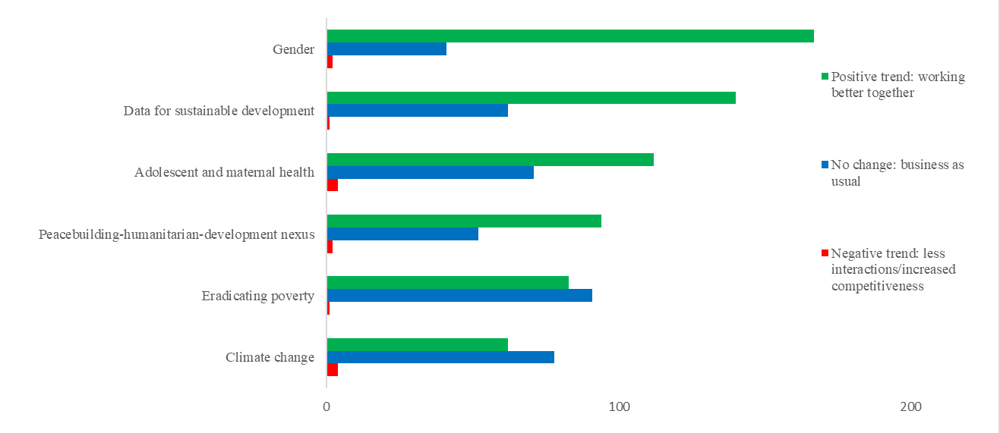
Figure III. Trends in cooperation in key areas of collaborative advantage
- The lack of a central repository for multi-stakeholder partnerships at the country level, combined with the lack of a definition for what this entails in the context of the common chapter (see finding A) made it hard to establish a baseline and define trends in this area. The evaluation team could not find any systematic evidence on coordination or joint involvement of the common chapter organizations with other stakeholders outside the system.
- In the absence of qualitative indicators, the evaluation consultants -- through a review of a sample of joint evaluations and analysis of survey responses -- identified a number of elements/factors affecting performance, which could be used to assess the extent to which the common chapter has helped promote good practices and remove barriers to cooperation:
  - Commitment, vision and leadership of senior management;
  - Clarity around priorities;
  - Competition for funding and visibility;
  - Host governments’ and donors’ openness/expectations for United Nations organizations to work together;
  - Clarity around comparative advantages, division of labour and reporting lines;
  - Strong joint monitoring frameworks and systems, including clear results statements, selected performance indicators, identified assumptions and baselines, and dedicated personnel. Joint field monitoring was encouraged, including based on common checklists, and the elaboration of joint progress reports rather than single agency reports;
  - Joint communication strategies and public outreach for greater visibility;
  - Strong partnerships when designing and implementing joint programmes, as well as coordination and information exchange, including with line ministries, civil society organizations and other international actors;
  - Presence and availability of human resource capacities to engage;
  - Enhanced resource mobilization from donors and the private sector, through resource mobilization strategies, a more efficient use of trust funds, and engagement with non-traditional partners;
  - Harmonized financial systems and procedures.
- Common chapter organizations participate in system-wide mechanisms, both at headquarters and at country level, to promote efficiency gains. Based on available information, the specific contribution of the common chapter to progress in this area will be difficult to ascertain.
- All four common chapter organizations participate in the High-level Committee on Management and the Business Operations Working Group of the United Nations Sustainable Development Group (UNSDG), which are key actors in advancing business operations system-wide to create efficiency. Through these fora, several policies and guidance noted were agreed on and rolled out, including business operations strategies, the harmonized approach to cash transfers, common premises and procurement. Since 2018, common chapter organizations became members of the UNSDG Business Innovation Group. At country level, common chapter organizations participated to a different extent in operations management teams, with no variation since 2014. More country teams have adopted full/partial business operations strategies, with the participation of common chapter organizations in 78 countries (with a slight decrease in percentage from 2014-2017 from 89 to 80 per cent).
- While common chapter organizations are involved in seeking efficiencies through shared business operations and premises, progress in this area can neither be attributed to the common chapter nor to efforts among the four organizations within wider United Nations processes. As was confirmed by interviewees, the common chapter has not been used to accelerate progress or innovations within the wider United Nations system.
- All but one of the accelerator initiatives were based on existing areas of collaboration and included two initiatives that pre-dated the common chapter. The implementation of new accelerators has reportedly been hampered by a lack of dedicated resources.
- Eight regional accelerators were identified in 2018, including two pre-existing initiatives -- Spotlight and the United Nations Integrated Strategy for the Sahel – that encompassed the spirit of the common chapter (labelled as first-generation accelerators). Other regional accelerators have most commonly been identified based on existing areas of collaboration, to which the accelerators could add value through additional resources and enhanced effectiveness derived from having a common theory of change, joint activities, joint communication, and joint monitoring and reporting. This was the case, for example, in the Latin America and Caribbean region where the accelerator was to focus on women and youth, building on ongoing work in the Northern Triangle (El Salvador, Guatemala and Honduras). Funding was sought through the Sustainable Development Goals Fund, which however could not support multi-country accelerators. In Europe and the Commonwealth of Independent States and Central Asia, no accelerator was created, but issues-based coalitions were developed by a larger group of United Nations organizations to prepare advocacy papers on gender equality, youth and data in support of CCAs and UNDAFs.
Table 3. Common chapter accelerators
 | Region | Based on existing collaboration | Participation of others
Spotlight Initiative | Global | Yes | Yes
United Nations Integrated Strategy for the Sahel | West Africa | Yes | Yes
Data for policymaking and tracking the Goals | Asia and the Pacific | No | Yes
Children and young people on the move in the Horn of Africa | East and Southern Africa | Yes | No
Adolescents’, young people and women’s access to formal and informal education, sexual and reproductive health services in the Great Lakes |  | Yes | No
Adolescent and youth development and empowerment through evidence-based advocacy (Botswana, Eswatini, Lesotho and Namibia) |  | Yes | Yes
Reducing violence in El Salvador, Guatemala and Honduras | Latin America and Caribbean | Yes | No
Disaster management, preparedness, and resilience-building in the Caribbean |  | Yes | No
- As of December 2019, the first-generation accelerators, which had their respective funding sources, have progressed, though without any strong relationship with the common chapter. In the case of Spotlight, collaboration among common chapter organizations under the leadership of the resident coordinator was defined as “very different”, with one secretariat to which the organizations provide staff resources, a global theory of change, and an unprecedented level of investment. In some countries, stakeholders have opted to entrust an organization with guaranteeing technical coherence. A complex management structure at the global, regional and country levels has also been set up to oversee the implementation of the United Nations Integrated Strategy for the Sahel, under the leadership of the Office of the Deputy Secretary-General. Initial information on these experiences are very positive, although it was reportedly often difficult to work “differently”.
- Overall, very little progress was found in implementing the other accelerators, mostly since no additional resource has been committed or made available. No additional funding has resulted out of the common chapter for these areas of work, nor have the regional offices received any instruction or encouragement to channel existing resources in these areas as a matter of priority. Only in Eastern and Southern Africa where the three areas of work identified as accelerators are reportedly moving forward, based on existing programmes, although the limited level of information available did not allow the team to establish to what extent the work done differed from “traditional joint programming”.
- Given the status of implementation of the accelerators, and the loose connection with the common chapter, any evaluation in this area would not add much value. Further, Spotlight -- which is the most advanced accelerator – has its own monitoring and evaluation system with planned outputs over a four-year period.
- The common chapter does not have an adequate monitoring system, and information collected in the first joint report to the Executive Boards appears neither complete nor analytical. No decentralized evaluation of common chapter’s implementation, other than that of Spotlight, has been planned.
- The common chapter does not have a monitoring system that tracks implementation of key actions and progress of achievement against target results. Current process indicators are inadequate (see finding A) and incomplete. The definition of common results at the level of Goals does not allow reporting against more immediate outcomes, to which the four organizations are contributing. To facilitate the integration of the common chapter in monitoring and reporting, UNDP and UN-Women have included the common chapter as part of joint programming in their respective systems – though it remains optional and does not involve headquarters units.
- The joint report to the Executive Boards remains the primary source of information on common chapter operationalization, based on joint inputs gathered through the regions. In the absence of a clear results framework, the first report submitted to the Executive Boards in May 2019 did not reflect how the operationalization of the common chapter at regional and country levels had created synergies and promoted development effectiveness gains, nor did it highlight changes in collaboration compared to the previous cycle. The report includes little information about tangible common results achieved; the evidence provided reflects cooperation among the organizations, but not necessarily as originated from the common chapter. In commenting on the presentation of the joint report, one Member State expressed an expectation for reporting on the common chapter to feature more prominently in future annual reports.
- Evaluations and audits -- including UNSDCF/UNDAF evaluations, country programme evaluations, joint evaluations and country office audits -- are another source of information from which data about country-level collaboration among the common chapter organizations could be gathered. Except for this effort and the planned midterm and final evaluation of Spotlight, the organizations have not planned to undertake any decentralized evaluation of the common chapter’s operationalization at regional or country level.
- Conclusions and way ahead
- UNDP, UNFPA, UNICEF and UN-Women are midway into implementing their respective strategic plans, 2018-2021, and the common chapter “Working together to support implementation of the 2030 Agenda”. However, as the concurrent process for the approval the United Nations development system repositioning reform unfolded, the four organizations appear to have opted to interpret the common chapter more as a statement of intent that did not lend itself to operationalization. The scope of the common chapter, as well as roles and responsibilities for its implementation, therefore remain unclear to many, or have been interpreted differently. Perceptions about the value added of the common chapter vary. Staff at all organizational levels, including in senior management positions, felt the repositioning of the United Nations development system has made the common chapter redundant. Others saw inter-linkages but were unsure of corporate thinking and expectations.
- The evaluability assessment makes clear that dedicated efforts originated from the common chapter, such as the accelerators, have not progressed sufficiently to be evaluated. For other efforts built on existing modalities, there is no evidence that can be directly attributed to the common chapter, with a high degree of certainty.
- The roll-out of United Nations development system reform, laid out in the 2016 quadrennial review, and to which the common chapter sought to contribute, has further changed the institutional setting in which UNDP, UNFPA, UNICEF and UN-Women operate. In keeping with the Secretary-General’s push for the Decade of Action to achieve the 2030 Agenda, the commitment for whole-of-system United Nations approaches embodied in the Funding Compact, and in response to the request of the Executive Boards, the four organizations will continue to seek opportunities to conduct joint evaluations of their contribution to the Goals, including through system-wide mechanisms.
- In light of the report’s findings on implementation of the United Nations development system reform, and in recognizing the potential major implications of the COVID-19 pandemic, the evaluation offices of UNDP, UNFPA, UNICEF and UN-Women seek the guidance of the Executive Boards on the continued relevance of the implementation of the second phase of the evaluation as requested in previous decisions of the Boards.

Annex
Theory of change in the common chapter
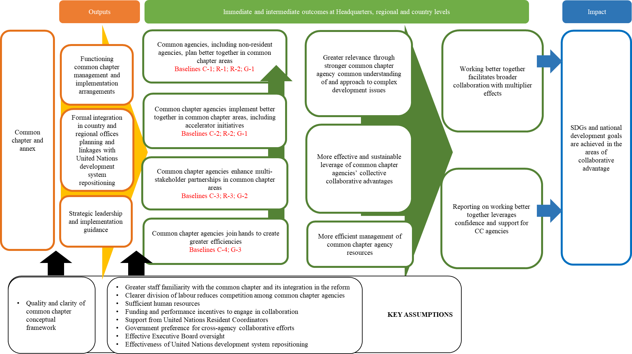

In 2017, in separate decisions of the different Boards, Member States formally requested the organizations “to work collaboratively [with UNDP, UNFPA, UNICEF and UN-Women] on the development of a specific chapter in its strategic plan, outlining a common approach in supporting Member States towards the implementation of the 2030 Agenda, in accordance with each entity’s mandate”: decision 2017/6 (UNDP), decision 2017/7 (UNFPA), decision 2017/18 (UNICEF) and 2017/1 (UN-Women).
In separate similar decisions of the different Boards, Member States requested the organizations and their evaluation offices to seek opportunities with other United Nations agencies for joint evaluations of joint programming, as well as the common chapter of the strategic plans: decision 2018/1 (UNDP), decision 2018/2 (UNFPA), decision 2018/2 (UNICEF) and decision 2018/2 (UN-Women).
Evaluability assessment of the common chapter, terms of reference.
In consultation with the secretariats of the Executive Boards of the four organizations, in December 2019 the UNDP Evaluation Management Group invited all Member States to participate in an informal workshop. The discussion was meant both to inform Member States about the status of the evaluability assessment and collect their views on the common chapter, including in the context of United Nations development system repositioning.
217 heads (UNDP 55, UNFPA 69, UNICEF 65 and UN-Women 28) responded to the survey from 107 countries (out of 130 targeted). A complete analysis of the survey results is included in annex 4 of the evaluability assessment.
The common chapter was approved a few months after the first report of the Secretary-General on repositioning of the United Nations development system (A/72/124-E/2018/3).
For example, “thematic funding as a percentage of other resources” and “percentage of country offices that track and report on allocations and expenditures using gender markers”.
The annex includes all the operational work of UN-Women and most of that of UNFPA (outputs 1 to 9, 11, 13, 14) but not output 12 on “strengthened response to eliminate harmful practices, including child, early and forced marriage, female genital mutilation and son preference” under gender equality and women’s empowerment. Neither is UNICEF strategic plan output 4.b.: “countries have implemented programmes to increase equitable access to sanitation and hygiene and end open defecation, paying special attention to the needs of women and girls and those in vulnerable situations”.
The United Nations System-wide Action Plan on Youth partnership no longer exists. The H6 partnership was subsequently found by the common chapter management group not to adequately fit the areas of collaborative advantage. In other cases - i.e., the Alliance for Child Protection in Humanitarian Action; the Global Action to Prevent and Address Trafficking in Persons and the Smuggling of Migrants; the Global Migration Group; the United Nations Trust Fund in Support of Actions to Eliminate Violence against Women; and the Global Campaign to End Fistula and Every New-born Initiative – only one common chapter organization’s headquarters was involved.
September and December 2018, March 2019 (briefing with regional directors), and December 2019. The planned frequency of meetings was, however, higher: in September 2018, two meetings were suggested for the fourth quarter; in December 2018, a meeting was planned for January/February 2019; in March 2019, a meeting was planned for April 2019.
No meeting minutes were made available to the consultants.
In 2018, UNFPA and UN-Women signed a tripartite agreement with the Korea International Cooperation Agency to improve the lives of women and girls and accelerate the achievement of gender equality. UN-Women also signed a bilateral memorandum of understanding to collaborate on various areas related to gender equality.
The September 2018 decision to send additional communications of what was expected from the field was not followed up.
UNFPA reportedly organized webinars on the common chapter in October 2018.
The April 2018 joint email by the four heads of organizations introduced the terminology “country team of the four agencies”, “four agencies’ country teams” and “common chapter country teams”, which have not however become mainstream terminology.
While in the Arab States and the Latin America and Caribbean regions, the regional lead organization has also been tasked to coordinate the common chapter country offices, other regions have left this decision open.
The team of consultants did not, however, have the opportunity to understand what the establishment of formal arrangements entailed.
A/73/63-E/2018/8 and A/74/73-E/2019/14
In March 2019, the Common Chapter Management Group agreed that the “new resident coordinator generation should be informed about the common chapter to enhance understanding and support for this initiative”. To the knowledge of the evaluation team, this has not happened.
Twenty percent of respondents indicated
In its comments to the draft report, the technical team of the common chapter pointed to discrepancies between the joint programming data held by the organizations and the United Nations Development Coordination Office Information Management System.
In 2014-2017, 27 joint evaluations were conducted with the participation of two or more common chapter organizations at country level. They covered all areas of collaborative advantage, apart from data for sustainable development, with gender equality and women’s empowerment and poverty eradication having been covered the most.
Overall, joint evaluations provided very limited insight into the administrative side of joint programmes.
The publication “Headquarters policies to enable cooperation, coordination and consolidation of Business Operations at the country level” (March 2017) provides an overview of 44 policies for country-level business operations.
Thirty-eight Operations Management Teams (out of 118) included all four common chapter agencies
In the case of UNDP, only six of the 53 country offices (11 per cent) referenced the common chapter, without providing further information.
In 2018-2019, UNFPA and UNICEF managed two joint evaluations of the Global Programme to Accelerate Action to End Child Marriage and the Joint Programme on the Abandonment of Female Genital Mutilation. In line with the quadrennial review and the Funding Compact, the evaluation offices of the common chapter organizations are also collaborating in the design of a new independent system-wide evaluation policy, as members of the United Nations Evaluation Group.
A/74/73/Add.1–E/2019/14/Add.1

