United Nations Office for Project Services (UNOPS)

UNOPS Management Response to
the Activity Report for 2015 of IAIG and the Activities of the Ethics Officer in 2015

- Introduction 1
- The UNOPS Audit Advisory Committee 1
- Role and functions of the Internal Audit and Investigations Group 1
Role and functions 1
Mandate 2
Coordination and collaboration 2
- IAIG Audits 2
Overview 2
IAIG Internal audits 3
IAIG Project audits 6
Audits of significant programmes 7
- IAIG Investigations 8
- Strategic response to audit recommendations 8
UNOPS internal control framework and management of risks 8
Certification of processes and people a means of assurance 9
Improvements in corporate strategic management and leadership 10
- UNOPS Ethics 11
Administering the UNOPS financial disclosure programme 11
Protecting staff against retaliation for reporting misconduct 12
Developing standards, training and education, and reaching out on ethics issues 12
Providing confidential advice and guidance to staff on ethical issues 12
Supporting ethics standard-setting and policy coherence within the UN system 12
Annexes 13
Annex I – Extract from UNOPS Financial Regulations and Rules, effective 1 Jan. 2012 13
Annex II – UNOPS new and revised policies, issued in 2015 14

Introduction

- UNOPS offers the following response with respect to the Activity Report for 2015 of the Internal
Audit and Investigations Group of the United Nations Office for Project Services (DP/OPS/2016/3) and the Activities of the Ethics Office in 2015 (DP/OPS/2016/4).

- This report is organized in sections A-H. Section B and C provides an overview of the independent
oversight and advisory bodies providing the UNOPS management with advice on areas of attention and strengthening in terms of risk and accountability. Section D provides an overview of reports and recommendations issues by IAIG during 2015, followed by a specific overview of the IAIG internal and project audits (DP/OPS/2016/3). In section E, the investigations function of IAIG is highlighted and in section F an overview of the UNOPS strategic response to audit issues is provided. Section G offers the management response to the Annual Report of the UNOPS Ethics Officers (DP/OPS/2016/4).

The UNOPS Audit Advisory Committee

- The United Nations Office for Project Services (UNOPS) is committed to United Nations’
harmonization and simplification of business processes, including those supporting the Executive Board, and subsidiary committees advising the Executive Director.

- Pursuant to Executive Board decisions 2015/4 and 2015/12, the Audit Advisory Committee of the
United Nations Office for Project Services was established on 2 March 2015, replacing the Strategy and Audit Advisory Committee (SAAC) for the purpose of further aligning the UNOPS governance and accountability arrangements with those of sister agencies governed by the Executive Board. As such, the roles and responsibilities of the AAC, as outlined in its Terms of Reference (DP/OPS/2015/CRP.1), are consistent with those of UN agencies that are under the purview of the Executive Board.

- The Audit Advisory Committee provides external, independent, senior level advice regarding the
Organization’s internal controls, and audit and investigations objectives, including any significant risk management issues. The Committee has an advisory role and assists the Executive Director in fulfilling her oversight responsibilities in accordance with best practices and industry standards.

- Management is pleased to note the significant contributions provided by the AAC in 2015 and its
concurrence with the observations reflected in the Audit Advisory Committee 2015 Annual Report (DP/OPS/2016/3 − Annex 3). Management notes that the AAC, in its advisory capacity, continue its substantive engagement with the organization, demonstrating the value-add of executive advice on strategic risk management. Finally, management would like to extend its appreciation to the current and past members of the Committee.

Role and functions of the Internal Audit and Investigations Group

Role and functions

- Management recognizes the important role Internal Audit and Investigation Group (IAIG) plays in
providing assurance, offering advice, recommending improvements, and helping to enhance the organization’s risk management, control and governance systems.

- Management also recognizes IAIG’s role in promoting and supporting accountability by
conducting investigations of potential violations of applicable regulations, rules and administrative or policy directives. Furthermore, IAIG’s endeavours to support management in the application of UNOPS general policies and objectives as described in the UNOPS Strategic Plan, 2014-2017 (DP/2013/3) are highly appreciated. As such, IAIG is a central component of UNOPS accountability framework, adding valuable contributions to management of strategic and operational risks.

Mandate

- The mandate of the UNOPS internal audit and investigation function is prescribed by Regulations
6.01, 6.02 and 6.03 and Rules 106.01, 106.02 and 106.03 in Article 6 of UNOPS Financial Regulations and Rules (FRRs), which took effect on 1 January 2012 in preparation for implementing the International Public Sector Accounting Standards (IPSAS).

Coordination and collaboration

- Management encourages IAIG’s continuous coordination with the United Nations Board of
Auditors (UNBOA), the Office of Internal Oversight Services (OIOS), the Representatives of the Internal Audit Services of the United Nations Organizations (UN-RIAS) and the Joint Inspection Unit (JIU).

- Management also supports IAIG’s strong collaboration and coordination with various UNOPS
business units, including the Legal Group, the People and Change Group, the Ethics Officer and several regional/country offices, promoting inter-departmental cooperation, support and continuous follow up on specific matters.

IAIG Audits

Overview

- The IAIG internal audits comprise three types: a) IAIG internal audits, b) project audits and c)
audits of significant programmes, as summarized in Table 1. Management notes that the overall number of reports in 2015 is higher compared to 2014, due to the increase of eight reports for IAIG project audits. Management also notes that no audits were requested of significant programmes. Management commends IAIG on its efforts to complete current and prior year workplans, which resulted in only one audit assignments carried over to 2016.

- In total, IAIG issued 158 recommendations in 2015 compared to 110 recommendations in 2014.
Management notes that the overall average number of recommendations per IAIG internal audit report increased from 12 to 16.6 for the same years. The average number of recommendations for project audit reports increased from 2 in 2014 to 2.6 in 2015, which is a slight increase but still below the 3.7 average from 2013. Management notes the advice of the Audit Advisory Committee that IAIG focuses on significant risks and systemic issues when issuing recommendations.

Table 1: Number of internal audit reports issued*
Year issued | 2014 | 2015 | Change
# IAIG internal audits | 8 | 7 | -1
# Project audits | 14 | 22 | 8
# Audits of significant programmes | 0 | 0 | 0
Total # of internal audits | 22 | 29 | 7
*Developed based on IAIG annual reports for 2014 (DP/OPS/2015/3) and 2015 (DP/OPS/2016/3).

- During the year, the UNOPS management has maintained a high rate of implementation of internal
audit recommendations, 96% in 2015 from 97% in 2014. The total number of open recommendations was reduced from 261 at the end of 2012 to 164 at the end of 2015. Continuing the process which was initiated in 2011, management made coordinated efforts to address outstanding aged audit recommendations in 2015. As a result, the number of open recommendations aged more than 18 months since date of issuance reached a new low, at only four.

Table 2: Number of internal audit recommendations issued*
Year issued | 2014 |  | 2015
 | total | average | total | average
# IAIG internal audits | 82 | 10 | 101 | 14
# Project audits | 28 | 2 | 57 | 2.6
# Audits of significant programmes | 0 | 0 | 0
Total # of internal audits | 110 | 12 | 158 | 16.6
*Developed based on IAIG annual reports for 2014 (DP/OPS/2015/3) and 2015 (DP/OPS/2016/3).

IAIG Internal audits

- In 2015, IAIG audited four of the UNOPS country and multi-country business units. For two
business units, the audits provided assurance that the internal controls, governance and risk management processes were adequately established and functioning well. In two other audits, the business units’ internal controls and risk management processes were found to be partially satisfactory or unsatisfactory. Management notes the value of the ratings and is taking action to ensure that adequate internal controls, governance and risk management processes are established.

Table 3: Overall rating of IAIG internal audits*
Year issued | 2014 | 2015
Satisfactory | 4 | 2
Partially Satisfactory | 3 | 1
Unsatisfactory | 0 | 1
Not rated | 1 | 3
Total # of IAIG internal audits | 8 | 7
*Developed based on IAIG annual reports for 2014 (DP/OPS/2015/3) and 2015 (DP/OPS/2016/3).

- Management notes a relative decrease in the number of recommendations of high importance
compared to recommendations of medium importance in 2015, compared to 2014. Management appreciates that low-priority recommendations are typically addressed during the field work stage of the audit. Management believes that the system of categorization by level of importance has potential for further integration into the risk management system of UNOPS and facilitation of prioritization of efforts to systematically address recommendations.

Table 4: Categorization of IAIG internal audit recommendations, by level of importance*
Level of importance | Number of recommendations |  |  | Percentage of total
 | 2013 | 2014 | 2015 | 2013 | 2014 | 2015
High | 52 | 37 | 44 | 60 | 45 | 44
Medium | 35 | 45 | 57 | 40 | 55 | 56
Total | 87 | 82 | 101 | 100 | 100 | 100
*Developed based on IAIG annual reports for 2014 (DP/OPS/2015/3) and 2015 (DP/OPS/2016/3).

- With regard to the functional distribution of internal audit recommendations, management notes
peaks in recommendations for ICT, Human Resources, and Project Management. These findings correlate to the internal audit reports issued by IAIG during 2015 which included a cyber security maturity assessment, review of the infrastructure process which is now part of the UNOPS project management group, and a review of leave entitlements in the area of human resources. Management appreciates the attention given by IAIG to these areas and continues to follow up and coordinate with relevant business units in the implementation of recommendations.

Graph 1: End-year status of internal audit recommendations which have been open during 2015, sorted by functional area.

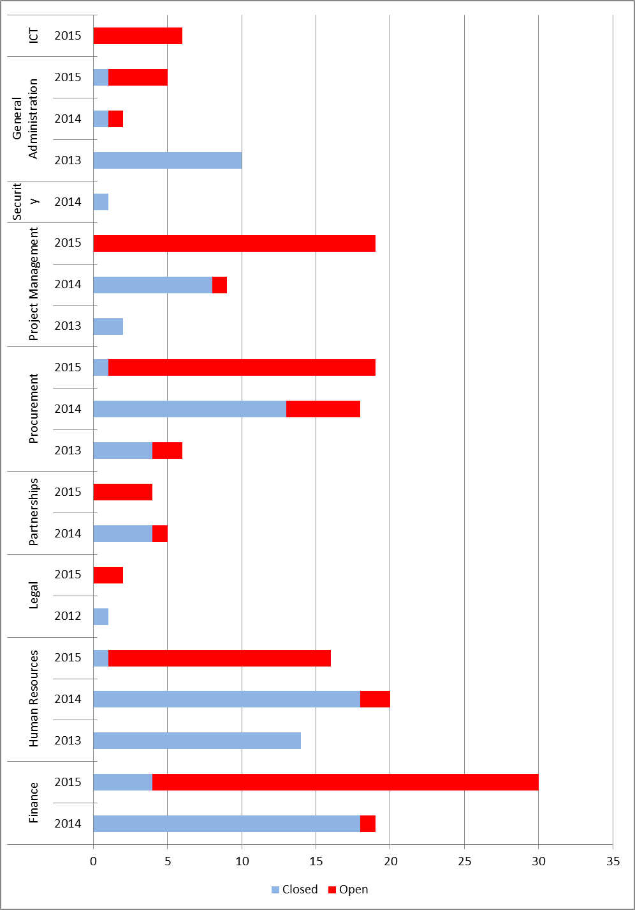

IAIG Project audits

- Management notes with satisfaction that the financial statement of project audits in 2015 received
unqualified opinions throughout. Management also notes that there were no unsatisfactory ratings of the overall level of internal controls in 2015 and the decrease of 20 percentage points of partially satisfactory ratings, indicating enhanced solidity of systems and operational practices on the ground.

Table 5. Summary of project audit opinions and ratings of internal controls for
project audits, 2013-2015*
Type of opinion or rating | Number of audit reports |  |  | Percentage of total
 | 2013 | 2014 | 2015 | 2013 | 2014 | 2015
Audit opinion on financial statement of project
Unqualified opinion | 12 | 14 | 22 | 92 | 100 | 100
Qualified opinion | 1 | 0 | 0 | 8 | 0 | 0
Total | 13 | 14 | 22 | 100 | 100 | 100
Rating of overall level of internal control
Satisfactory | 8 | 6 | 15 | 67 | 55 | 75
Partially satisfactory | 4 | 5 | 5 | 33 | 45 | 25
Unsatisfactory | 0 | 0 | 0 | 0 | 0 | 0
Total | 12 | 11 | 20 | 100 | 100 | 100
*Developed based on IAIG annual reports for 2014 (DP/OPS/2015/3) and 2015 (DP/OPS/2016/3).

- In terms of categorization of project audit recommendations by level of importance, management
notes with satisfaction a decrease in the number of high priority and low priority recommendations from 3 in 2014 to zero in 2015 and from 4 in 2014 to zero in 2015, respectively. Management will continue to focus on addressing identified medium priority issues.

Table 6. IAIG categorization of project audit recommendations, by level of importance,
2013-2015*
Level of importance | Number of recommendations |  |  | Percentage of total
 | 2013 | 2014 | 2015 | 2013 | 2014 | 2015
High | 9 | 3 | 0 | 19 | 11 | 0
Medium | 38 | 21 | 57 | 79 | 75 | 100
Low | 1 | 4 | 0 | 2 | 14 | 0
Total | 48 | 28 | 57 | 100 | 100 | 100
*Developed based on IAIG annual reports for 2014 (DP/OPS/2015/3) and 2015 (DP/OPS/2016/3).

- With regard to the functional distribution of project audit recommendations, management notes
peaks in recommendations for General Administration, Project Management, and Finance. This correlates to the increase in project audit reports and recommendations issued by IAIG in 2015, as observed in tables 1 and 2.

Graph 2: End-year status of project audit recommendations which have been open during 2015, sorted by functional area.

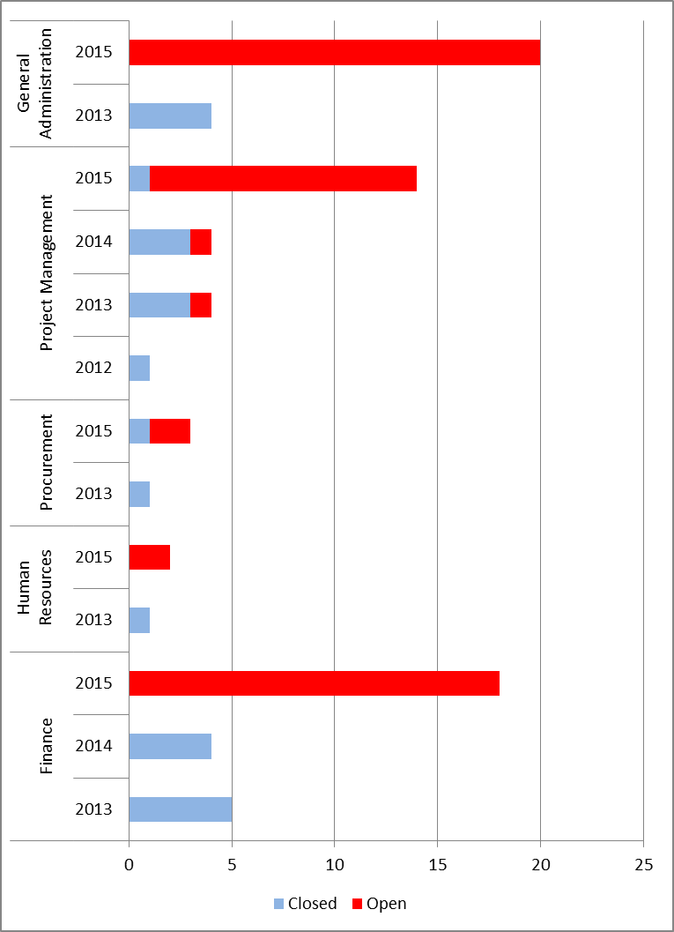

Audits of significant programmes

- It is noted that IAIG audits cover two significant programmes, parts of which are executed by
UNOPS on behalf of its partners, the Small Grants Programme and the Mine Action Programme. In 2015, no audits were requested by the client for the Small Grants Programme and the Mine Action Programme. Hence, there were no audit recommendations issued for significant programmes in 2015.

IAIG Investigations

- Management notes IAIG investigation function’s attention to ensuring close coordination with
relevant internal and external entities, inter alia, through internal collaboration with UNOPS Legal Practice Group, the People and Change Practice Group, and the Ethics Office; as well as external collaboration in the context of the United Nations Heads of Investigations Groups, with the OIOS, the investigation services of the other UN funds and programmes, and investigations offices of other international and national agencies.

- It is noted that the number of complaints received and processed by IAIG increased from 93 in
2014 to 120 in 2015. It is also noted that out of these 120 complaints, 56 became investigation cases, similar to the number of investigation cases in 2014. Management notes the 35 cases of alleged fraud or financial irregularities and appreciates the IAIG efforts to work with legal officers, senior managers and the UNOPS Vendor Review Committee to deter issues of this nature and reduce recurrence.

- Management appreciates IAIG’s various efforts to strengthen its Investigations function during the
year including, inter alia, the initiated recruitment process of an Investigations lawyer and the invitation for an independent peer review of the UNOPS investigations function. Management notes with appreciation that the concluded peer review indicated that the UNOPS investigations function concurs with its legal framework and generally accepted standards for investigations in international organizations. Management further notes that IAIG will review and begin implementing the material recommendations suggested in the peer review in 2016.

- With regard to matters of integrity and conflict resolution, management notes IAIG’s increased
efforts to provide training, preventive activities and an informal grievance procedure, following the appointment of a dedicated Conflict Resolution and Integrity Training Specialist. Management also notes the efforts of IAIG and the Ethics Officer to raise personnel awareness in order to deter fraud and misconduct.

Strategic response to audit recommendations

- Management takes note of the functional distribution of audit recommendations and recognize the
value of systematically sorting the recommendations for concerted functional action. This may have partially contributed to the overall high implementation rate across the organization. Management further notes with satisfaction the unprecedented low level of audit recommendations open for more than 18 months at the end of 2015, and will continue its coordinated drive for the implementation of audit recommendations.

UNOPS internal control framework and management of risks

- During 2015, UNOPS completed the implementation of a new enterprise resource planning
system – OneUNOPS – a flexible platform for integration of operational processes and systems. The ambition to better support the global UNOPS business process through use of information and communications technology was set out in the UNOPS strategic plan to, inter alia, improve the UNOPS internal control framework and management of risks.

- It is expected that the new ERP system will provide significantly improved reporting, based
on the re-designed organizational business intelligence platform integrating all UNOPS business applications in a single system. This includes several of the observations made pertaining to key areas of improvements as outlined by IAIG, including planning, budgeting and monitoring of projects; registration of suppliers; guidance on procurement and contract management; and processing of payments. The related corporate strategic initiative, overseen by a high-level steering committee, will also continue to further strengthen UNOPS capability to respond rapidly and effectively to the needs of Member States and local governments.

- Management notes that the ERP system will enable further enhancement of the existing
portfolio monitoring mechanisms and available management information, thus addressing additional key areas for improvements noted by IAIG related to Finance, Project Management, and Procurement. Previously, an external study had concluded significant room for integration of 67 key business processes in one system. At the time 21 processes were facilitated through the Atlas Partnerships ERP system, 17 through bespoke solutions, and 29 were manually operated. When OneUNOPS went live it comprised 17 integrated business processes including, inter alia, project management, human resources, finance, procurement and other support functions.

- Further, the new system will allow continuous optimization of operational speed and quality
ensuring value-adding services to the UNOPS partners. In addition to enhancing the efficiency of the UNOPS global operations, OneUNOPS will enable the organization to further leverage the benefits of IPSAS. The possibility of integrated real-time information will facilitate knowledge sharing and collaboration, targeted management of risks, as well as monitoring of compliance and performance across the global operations. As such, it is expected that the implementation of the enterprise resource planning system will help rectify and prevent issues pertinent to internal and project audits.

- To further strengthen the UNOPS response and approach to risk management, a Risk and
Quality Group was created in 2015, mandated with corporate responsibility for risk and quality management, in line with oversight and corporate controls established at institutional levels. The new group will, inter alia, further strengthen the UNOPS approach to risk assessment prior to acceptance of new projects, with particular focus on the identification of technical, legal, financial and mandate/political risks, thus strengthening the organization’s management of partners, products and services.

- Additionally, management launched an initiative to introduce the concept of Principled
Performance. This initiative will compliment other models such as the excellence and three lines of defence model, in the continual process of enhancing the organization’s risk management systems. In its Annual Report (DP/OPS/2016/3, annex 3) the UNOPS Audit Advisory Committee, noted that UNOPS is particularly exposed to risks when new projects are accepted, and the Committee supported the continued focus on strengthening its risk management systems in this area.

Certification of processes and people a means of assurance

- Management offers its personnel access to individual certification programmes based on externally
recognized international standards to address guidance and other causes of audit recommendations which are attributable to inadequate knowledge. The programmes include Prince2 Foundation and Prince2 Practitioner, Managing Successful Projects, and Management of Risk/Management of Value for project management; Chartered Institute of Purchasing and Supply (CIPS) for procurement, Association of Chartered Certified Accountants (ACCA) for finance, Emerging leaders programme, and Change Management.

- The Infrastructure and Project Management Group (former Sustainable Project Management
Practice Group and Sustainable Infrastructure Practice Group) undertook a number of dedicated efforts to further understand and strengthen the organizational project management capacity in UNOPS operations around the world, leveraging the internationally recognized Portfolio, Programme and Project Management Maturity Model (P3M3).

- External certification of compliance with internationally recognized standards is a central
component of UNOPS phased implementation of its risk management systems. Furthermore, the organization is committed to benchmarking its effectiveness and results against a range of industries and organizational types.

- Tools supporting corporate processes are a critical contributor to organizational efficiency,
effectiveness and compliance. In view of the implementation of the ERP system, the governance and decision-making process on corporate tools was revised to enhance full alignment and integration.

- In 2015, the organization maintained its certifications against ISO 9001 for Quality Management,
as well as the four major international standards for project management, namely Prince2, the standards of Project Management Institute (PMI), registered consultant with PMI and accredited consulting organization by the Association of Project Managers Group (APMG).

- Under leadership from the Infrastructure and Project Management Group the global roll out of
ISO14001 continued during 2015. Likewise, the organization successfully continued to implement a health and safety management system for infrastructure operations, which was certified against OHSAS18001. Furthermore, to improve the speed, quality and sustainability of infrastructure projects and support project operations, UNOPS continues its partnerships with ARUP and DLA piper.

- Already at a significant level of maturity, management primarily focused on further refining the
existing policy framework for practical application in 2015. UNOPS ended 2015 with its policy framework comprising 36 Organizational Directives and 70 Administrative Instructions. Management will continue to review and revise UNOPS overall framework of management policies to ensure its appropriateness for the organization’s ever-changing business environment and increasing maturity level.

- Management coordination and cross-functional integration are important means of mitigating risks.
In 2015, UNOPS sustained efforts to strengthen the organization's management fora and throughout the year the Senior Management Group convened eighteen formal meetings allowing collective deliberation and executive advice on the strategic positioning of UNOPS; institutional reforms; and early identification of crisis, challenges and opportunities. Similarly, the Corporate Operations Group convened thirteen formal meetings, covering a wide range of recurring and ad hoc areas including, inter alia, corporate investments; key functions’ strategies; the corporate programme on business improvement and innovation; human resources; and cyber security.

Improvements in corporate strategic management and leadership

- Management notes the observations relating to the development of Terms of References for, and
definition of oversight mechanisms and work plans for support functions, in multi-country operational hubs. Management also takes note of the observations pertaining to the strengthening of capacities of operational hubs in relevant functional areas.

- In the management budget and target setting process, the UNOPS managers are responsible for
articulating and prioritizing internal resource needs. In 2015, this process continued to deepen its utility as an informed and formally structured management assessment of the viability and sustainability to create new, or relocate existing, organizational entities. Entities formulated their business plans guided by the UNOPS Excellence Model, collaborating with UNOPS partnerships and finance functions during the process. The process was furthermore strengthened through the consistent use of indicators from the corporate systems and the dedicated analysis and strategic focus of regional portfolios.

- During 2015, UNOPS management convened a number of internal working groups with
representatives from its global management team representing headquarters and field operations. The topics of the working groups included services, strategic investments, costing and pricing, engagement acceptance, decision making, organizational structure and collaboration. The working groups presented 28 recommendations to the Executive Director all of which are now under implementation. By the end of 2015, management estimated the implementation of the recommendations to be 55 per cent complete.

- In 2015, the organization has proceeded to fully implement the global re-alignment of core
functions and geographical presence by, inter alia, integrating the Infrastructure and Project Management Groups into one coherent business unit, establish regional offices in Asia, Europe, and the Middle East, and launch a Global Shared Service Center. The revision of UNOPS internal and global structure was implemented and operationalized with the goal of increasing focus and value-add, optimizing presence, controlling costs and strengthening business development throughout the organization.

UNOPS Ethics

- Established pursuant to General Assembly resolution 60/1, the UNOPS Ethics Office operates in
accordance with the terms of reference laid out in the Secretary-General’s bulletin (ST/SGB/2007/11, as amended). Its mandate is to promote the highest standards of integrity and to foster a culture of ethics, transparency and accountability within UNOPS.

- Management notes with appreciation the report on the Activities of the UNOPS Ethics Office in
2015 (DP/OPS/2016/4), which covers the seventh full year of its operation as a separate and
independent function in UNOPS. During the year, the Ethics Office has assisted the Executive Director in ensuring that all staff conduct themselves with integrity and professionalism and uphold the Charter of the United Nations.

Administering the UNOPS financial disclosure programme

- Management notes that, also in 2015, 100% compliance with requirements for financial disclosure
was achieved. It is further noted that around 10% of the disclosures gave cause for further scrutiny. No case of actual conflict of interest was found.

Protecting staff against retaliation for reporting misconduct

- Management notes the importance of the ethics function’s impartial preliminary review of
complaints of retaliation, its close collaboration with IAIG, and its advice on measure to protect from retaliation. Furthermore, management concurs with the Ethics Office that raising further awareness of the policy on protection against retaliation is an important means of preventing retaliation and promoting an environment that encourages personnel to speak out against behaviour that places the reputation and standing of UNOPS at risk.Management takes note of the advice provided by the Ethics Office in relation to protection from retaliation in three cases.

Developing standards, training and education, and reaching out on ethics issues

- Management appreciates the Office’s active contributions, and collaboration with audit,
investigations and human resources, to further develop training materials on ethics issues, inter alia the Standards of Conduct training course developed in consultation with the Ethics Office delivered by IAIG.

- Management notes the Ethics Officer’s engagement with the UNOPS Audit Advisory Committee.
It further notes that the Officer, as ex officio member of senior management groups, has been kept abreast of agendas and minutes of UNOPS senior management meetings, and participated as observer in relevant meetings.

- Management notes the efforts undertaken by the Ethics Officer to support the further improvement
of the annual survey on integrity, ethics and anti-fraud, and appreciates the opportunity it provides to launch targeted awareness campaigns.

- In addition, management appreciates the Ethics Officer’s close collaboration with other corporate
functions, including procurement, human resources, legal, internal audit and investigation providing advice and guidance on clarification or interpretation of UNOPS regulations, rules and standards concerning prohibited or restricted activities and ethical dilemmas; and supported specific initiatives targeting anti-corruption and identification of risk in procurement.

Providing confidential advice and guidance to staff on ethical issues

- Management notes that during 2015 the Office received 498 requests for services, a number which
has been relatively stable over the years, but is the highest since 2010. It is further noted that in 2015 around half of these requests pertained to individual ethics advice. This number is comparable to 2012, and may indicate general awareness and confidence among personnel to engage with the ethics function for advice. Furthermore, management notes that from 2010 to 2014 the number of service requests pertaining to financial disclosure has declined, and has remained on a low level since then. This indicates that this process is well understood and embraced by the organization.

Supporting ethics standard-setting and policy coherence within the UN system

- Also in 2015, the Office has exercised its mandate in close coordination and collaboration with the
Ethics Panel of the United Nations and played an active role in the Ethics Network for Multilateral Organizations.

- Finally, management notes the continued services provided by the Ethics Office to the World
Tourism Organization and the International Maritime Organization. In addition, the Ethics Officer assisted UNICEF by acting as interim Principal Ethics Office Adviser from 1 December 2015 until year end.

Annexes

Annex I – Extract from UNOPS Financial Regulations and Rules, effective 1 Jan. 2012

Regulation 6.01
The Internal Audit and Investigations Group shall be responsible for the internal audit of UNOPS. It shall conduct independent, objective assurance and advisory activities in conformity with the International Standards for the Professional Practice of Internal Auditing. It shall evaluate and contribute to the improvement of governance, risk management and control processes, and report thereon. It shall exercise operational independence in the performance of its duties.

Regulation 6.02
The Internal Audit and Investigations Group shall be responsible for assessing and investigating allegations of fraud and corruption committed by UNOPS personnel or committed by others to the detriment of UNOPS.

Regulation 6.03
The internal audit function’s purpose, authority and responsibility shall be further defined in the Charter of the Internal Audit and Investigations Group.

Rule 106.01
The Internal Audit function shall evaluate the adequacy and effectiveness of governance, risk management and control processes regarding the:
(a) reliability and integrity of financial and other information;
(b) effectiveness and efficiency of operations;
(c) safeguarding of assets; and
(d) compliance with legislative mandates, regulations, rules, policies and procedures.

Rule 106.02
The Internal Audit and Investigations Group shall have free access to the organization’s records, personnel and premises, as necessary, in its opinion, for the performance of its duties.

Rule 106.03
The Internal Audit and Investigations Group shall submit its results to the Executive Director and other senior managers as appropriate. At least annually, the Director of the Internal Audit and Investigations Group shall submit a report to the Executive Board on the internal audit and investigation activities and on significant findings, providing insight into the efficient and effective utilization of resources.

Annex II – UNOPS new and revised policies, issued in 2015

UNOPS new and revised Organizational Directives (ODs)

- OD 41 – Framework for Determining Vendor Ineligibility/Sanctions (rev. 1, 8 December 2015); The policy has been updated to further align UNOPS’ vendor sanctions framework to those of other UN agencies, in line with the Model Policy Framework (MPF) that was adopted by the High Level Committee on Management Procurement Network. As such, the main changes have been the removal in OD41 of Part II, Addressing Other Than Proscribed Practices by Vendors and the reference in the AI to the MPF Sanction Guidelines. These changes will further enable UNOPS to cooperate with Agencies to avoid inconsistent treatment of Vendors within the UN System.

- OD 38 - UNOPS Personnel Performance Management Policy (rev. 3, 4 December 2015); The policy has been updated to reflect the new 5-point performance evaluation rating scale that will be introduced with effect from 1 December. The purpose of this new scale is to strengthen our ability as an organisation to differentiate performance results. This will enable us to improve the development and support we provide to individuals based on their specific and diverse needs.

- OD 15 – UNOPS Global Structure (rev. 1, add. 4, 8 September 2015); The purpose of this addendum is to establish the UNOPS Global Structure, 2015. The two annexes attached to the OD provide further details on changes to the Global Structure communicated on 21 August 2015.

- OD 39 – Talent Management Framework (rev. 1, 1 September 2015); The purpose of this policy is to strengthen our recruitment and talent management processes, and to better support talent development, succession planning and talent acquisition.

- OD 5 – Audit Advisory Committee and Strategic Advisory Group of Experts Terms of Reference (rev 5, 1 September 2015); The purpose of this revision is to reflect decision 2015/12 of the Executive Board. Through its decision the Board encouraged the Executive Director to proceed with the Audit Advisory Committee (AAC). Consequently, paragraphs 10-12 of the AAC TOR on the AAC membership have been fully aligned with DP/OPS/2015/CRP.1.

- OD 43 – Partnership with Non-UN and Non-State Entities (new, 30 June 2015); This Organizational Directive is designed to institutionalize a consistent and strategic approach towards UNOPS partnering with non-UN agencies and non-States entities in order to achieve the UN goals that have been outlined by the various General Assembly resolutions (See GA resolutions A/RES/56/76; A/RES/58/129; A/RES/60/215 and A/RES/62/211) and to materialize the encouragement provided by the “Guidelines on Cooperation between the United Nations and the Business Sector” adopted in 2009 to develop organization specific policies frameworks in line with each one of our mandates.

- OD 12 – UNOPS Record Retention Policy (rev. 2, 17 March 2015); The purpose of the revision of this OD is to modify certain record retention periods listed in Annex A.

- OD 34 – Framework for Delegations of Authority (rev. 2, 17 March 2015); The purpose of the revision of this OD is to modify the sequential number of delegation of authority resulting from the introduction of the new DOA tool (Article 3.4.4).

- OD 2 – UNOPS Accountability Framework and Oversight Policies (rev. 2, 2 March 2015); The purpose of this revision is to reflect decision 2015/4 of the Executive Board.

- OD 25 – Charter of the Internal Audit and Investigations Group (rev. 3, 2 March 2015); Revised to reflect decision 2015/4 of the Executive Board.

UNOPS new and revised Administrative Instructions (AIs)

- AI/PCG/2015/06 – Medical Insurance Plan (MIP) for locally-recruited UNOPS staff under UN Staff Regulations and Rules at designated duty stations (new, 29 December 2015); The purpose of this policy is to issue the UNOPS Medical Insurance Plan (MIP) Rules, which govern the enrolment procedure and participation in the plan, including issues such as contribution rates, schedule of benefits, claims procedure, and other relevant aspects of the plan. The UNOPS MIP Rules as well as the List of Reimbursable and Non-Reimbursable Items are attached to the policy as annexes. The UNOPS MIP Rules replace the UNDP MIP Rules for UNOPS locally-recruited active staff members (both in the General Service and National Officer categories), former staff members (in those categories), and their eligible family members, as of 1 January 2016. This notwithstanding, the UNOPS MIP Rules and the List of Reimbursable and Non-Reimbursable Items do not intend to introduce changes on the contribution rates, schedule of benefits or claims procedure.

- AI/PCG/2015/05 – Entitlement Travel (new, 17 December 2015); The purpose of this policy is to provide for entitlement travel of eligible UNOPS staff members and their dependents, including travel on initial appointment, change of duty station (on reassignment, transfer or similar), separation, home leave, family visit, in relation to education grant, travel and medical evacuation (including chartered medical evacuation).

- AI/PG/2015/01- UNOPS Vendor Review Procedures (new, 8 December 2015); The policy has been updated to further align UNOPS’ vendor sanctions framework to those of other UN agencies, in line with the Model Policy Framework (MPF) that was adopted by the High Level Committee on Management Procurement Network. As such, the main changes have been the removal in OD41 of Part II, Addressing Other Than Proscribed Practices by Vendors and the reference in the AI to the MPF Sanction Guidelines. These changes will further enable UNOPS to cooperate with Agencies to avoid inconsistent treatment of Vendors within the UN System.

- AI/PCG/2015/04 - Temporary Appointment (TA) - Instructions and Procedures (new, 4 December 2015); The policy has been updated to reflect the new 5-point performance evaluation rating scale that will be introduced with effect from 1 December. The purpose of this new scale is to strengthen our ability as an organisation to differentiate performance results. This will enable us to improve the development and support we provide to individuals based on their specific and diverse needs.

- AI/PCG/2015/03 - Performance Management and Appraisal for staff members – Instructions and Procedures (new, 4 December 2015); The policy has been updated to reflect the new 5-point performance evaluation rating scale that will be introduced with effect from 1 December. The purpose of this new scale is to strengthen our ability as an organisation to differentiate performance results. This will enable us to improve the development and support we provide to individuals based on their specific and diverse needs.

- AI/PCG/2015/02 – Renewal of Fixed-Term Appointments (new, 4 December 2015); The policy has been updated to reflect the new 5-point performance evaluation rating scale that will be introduced with effect from 1 December. The purpose of this new scale is to strengthen our ability as an organisation to differentiate performance results. This will enable us to improve the development and support we provide to individuals based on their specific and diverse needs.

- AI/PCG/2014/05 – Individual Contractor Agreement, Instructions (rev 4, 21 October 2015); The purpose of this policy is to align the ICA instructions to the Talent Management Framework (OD 39 and AI/PCG/2015/01); introduce a new functional review body; introduce the new 5-point performance evaluation rating scale to be implemented from 1 December 2015

- AI/PCG/2015/05 – Talent Management Framework (new, 1 September 2015); The purpose of this policy is to strengthen our recruitment and talent management processes, and to better support talent development, succession planning and talent acquisition.

- AI/PPG/2015/01 – Partnership with Non-UN and Non-State Entities (new, 1 July 2015); Following the promulgation the Organizational Directive on Partnership with Non-UN and Non-State Entities, this AI is designed to operationalize the implementation of the new policy.

- AI/PCPG/2014/01 – UNOPS Internship Policy (rev. 2, 4 June 2015); This AI increases the leave entitlements of interns from two days to two and a half days per month and introduces the pro-rating of the stipend, where applicable. The purpose of the AI is also to clarify Interns’ rights and obligations with respect to confidentiality, conflict of interest and duty station posting as well as the currency of payment of the stipend, and the applicable reduced DSA rate for calculation of the stipend.

- AI/PCPG/2014/03 – Learning and Development (rev. 4, 4 June 2015); The purpose of this revision is to clarify the conditions and the application process for accessing the UNOPS Educational Assistance Programme (EAP) as well as the reimbursement claims process; and to adjust the number of special leave days for study and examinations attendance.

- AI/PCPG/2015/02 – Partner Managed Personnel (new, 1 March 2015); This AI clarifies the concept of Partner Managed Personnel (i.e. not UNOPS Managed Personnel) where we provide contract administration services as per the existing guidance on the KS System. The KS system article will be updated once the attached AI is in effect. The attached AI incorporates feedback received and is an improvement over the existing rules in the KS System today.

- AI/PCPG/2015/01 – Requests from staff members to become Individual Contractors (new, 24 February 2015); This Administrative Instruction sets out the procedures for considering requests from UNOPS staff members (i.e. those personnel holding Letters of Appointment issued under the UN Staff Regulations and Rules) to become UNOPS Individual Contractors. This Administrative Instruction does not apply to cases where a staff member submits an application in response to a vacancy announcement for an ICA position, and resigns to take up that position.

- AI/CSPG/2014/01 – UNOPS Official Duty Travel: (A) UNOPS Staff and (B) non-UNOPS personnel (rev 3, 4 February 2015); The AIs for travel management are being revised to accommodate for the introduction of the Corporate Online Travel Tool which means that approval processes related to travel can be done online as well as in paper form. The roll out of the online tool was commenced in Copenhagen on 2 January and will be roll out to all of UNOPS. The tool is introduced to support and align with the UNOPS priority to have process excellence for all processes of the UNOPs business.

- AI/CSPG/2014/02 – UNOPS Official Duty Travel: Individual Contractors (rev 3, 4 February 2015); The AIs for travel management are being revised to accommodate for the introduction of the Corporate Online Travel Tool which means that approval processes related to travel can be done online as well as in paper form. The roll out of the online tool was commenced in Copenhagen on January 2nd and will be roll out to all of UNOPS. The tool is introduced to support and align with the UNOPS priority to have process excellence for all processes of the UNOPs business.

An extract of Regulations 6.01, 6.02 and 6.03, and Rules 106.01, 106.02 and 106.03 can be found in Annex I.
A complete list of new and revised Organizational Directives and Administrative Instructions, including a short summary of their purpose, can be found in Annex II.

