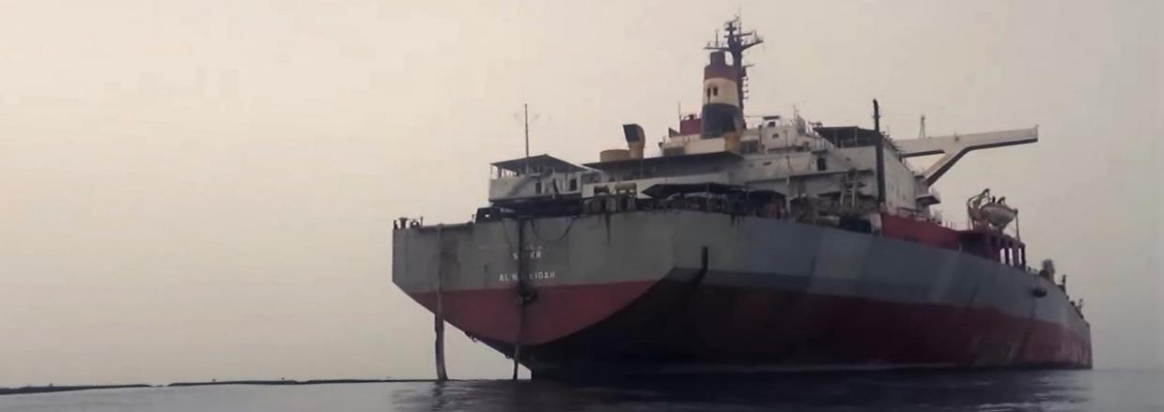

FSO Safer in 2021. Credit: UNRCO Yemen

Announcement Form

Submission and Inquiries
For submission and further inquiries please contact: ndeye.maty.cisse@undp.org, leanne.rios@undp.org , and barber@un.org

Financial commitments for the UN-coordinated plan should be made by filling out and submitting all parts of this form.
The United Nations will only record commitments communicated in writing through this form. The financial information provided will be included in an official press release issued when sufficient commitments have been received to commence the operation and subsequent milestones. Pledges may also be flagged on UN social media, media interviews or in other public forums unless the donor expresses otherwise.
If Others, please specify here:
Follow-up contact
Name: | Title:
Email: | Telephone:

Visibility information
Wishes for the pledge to be acknowledged publicly Yes No
Preferred social media handles

Please kindly alert RCO Yemen and UNDP of any planned press releases or social media related to your pledge for possible amplification: sabrin.al-aghbari@un.org, leanne.rios@undp.org, geekie@un.org

Announcement overview
Important notes
Please ensure your pledge announcement includes amount, currency, and timeframe for disbursement.

Select currency: If Other, please specify here:
Total Amount for 2022:

- Announcements for 2022
Amount  Please use same currency as above | Currency | Recipient organization / UNDP PSF | Planned disbursement  date | Details

B. Additional information

