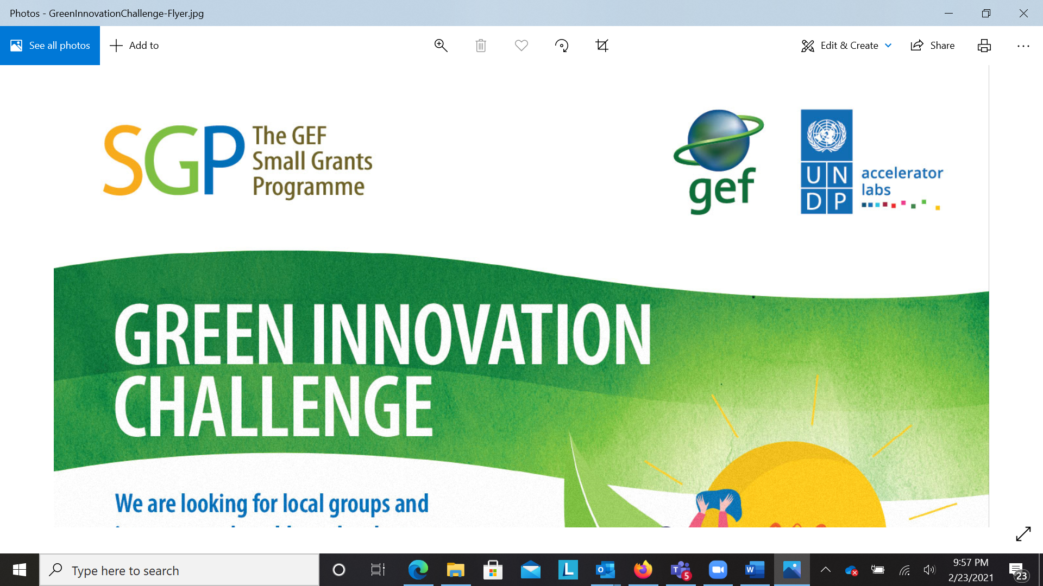

Green Innovation Challenge: Call for Concepts

The Global Environment Facility Small Grants Program (GEF SGP) and the United Nations Development Programme (UNDP) Accelerator Lab are looking for (a) environmental projects related to biodiversity, climate change, land degradation, chemical management and international waters, (b) new eco-friendly products and services and (c) innovative tools, techniques and platforms (digital and non-digital) that strengthen the market for locally produced, eco-friendly products. If you think this describes you and your work, you are invited to submit a concept by completing this form.

Short-listed concepts will be contacted and coached to prepare full proposals which will then be subjected to a competitive process for receiving funding, ranging from USD 5,000 to USD 50,000. Small enterprises and individuals are eligible for a maximum of USD 10,000.

|  |  |  |  |
| --- | --- | --- | --- |
|  | **SECTION 1: CONTACT INFORMATION OF APPLICANT** | | |
| 1.1 | Name of organization OR person applying for grant | | ………………..………………………………………………………………………………  BLOCK LETTERS |
| 1.2 | Mailing address | | |
|  |  | | |
|  |  | | |
|  |  | | |
|  |  | | |
| 1.3 | E-mail address(s) |  | |
| 1.4 | Telephone number(s) |  | |
| 1.5 | Facsimile number(s) |  | |

|  |  |  |  |  |  |  |  |
| --- | --- | --- | --- | --- | --- | --- | --- |
|  | **SECTION 2: NGO, NPO, COMMUNITY-BASED ORGNISATIONS, CIVIL SOCIETY ORGANISATIONS AND FAITH-BASED ORGANISATIONS** | | | | | | |
| **Instructions**: Complete this section if you are a registered NGO, non-profit organisation, community-based organisation, civil society organisation or faith-based organization in existence for more than 2 years. **If you are applying as an individual or your organization is less than 2 years old, please move to SECTION 3.** | | | | | | | |
| 2.0.1 | Are you a registered NGO, non-profit organisation, community-based organisation, civil society organisation or faith-based organisation? * | | | | | Yes | No |
|  | **If you selected “No” to question above, skip forward to **SECTION 3\*\*** | | | | | | |
| 2.0.2 | Are you an NGO, non-profit organisation, community-based organisation, civil society organisation or faith-based organization that has been in operation for **more than 2 years**? | | | | | Yes | No |
|  | **If you selected “NO” to question above, skip forward to **SECTION 3\*\*** | | | | | | |
| 2.0.3 | In 250 words or less, briefly describe your organisational structure (e.g. type of governance, how many members you have, if you are membership based, number of employees etc.). | | | | | | |
|  |  | | | | | | |
| 2.0.4 | List the positions of persons on the executive/board of directors below, indicating position, full name and gender, telephone number, email address e.g. (1) Executive Director, Jane Doe, female, (868)123-4567, janedoe@gmail.com. (2) Company Secretary, John Smith, male (868) 891-0112, johnsmith1@gmail.com (3) etc. | | | | | | |
|  | **POSITION** | **NAME & GENDER** | **TELEPHONE** | | **EMAIL** | | |
|  |  |  | |  | | |
|  |  |  | |  | | |
|  |  |  | |  | | |
|  |  |  | |  | | |
|  |  |  | |  | | |
|  |  |  | |  | | |
| 2.0.5 | Total number of employees (if applicable) | | | # Male | | # Female | |
|  |  | | |  | |  | |

|  |  |  |
| --- | --- | --- |
|  | **SECTION 2.1: PERSONS WITH DISABILITIES** | |
| **Instructions**: This section applies to people with disabilities (PWDs) who work in your organisation. PWDs refers to individuals with any disability including those who have long-term physical, mental, intellectual or sensory impairment, which in interaction with various attitudinal and environmental barriers, hinder their full and effective participation in society on an equal basis with others. | | |
| 2.1.1 | How many people with disabilities are there in your organisation? |  |
| 2.1.2 | Number of people with disabilities are there in leadership positions? |  |

|  |  |  |  |
| --- | --- | --- | --- |
|  | **SECTION 2.2: Experience in Environment Related Field** | | |
|  | This section is applicable to your organisation’s experience or involvement in environmental work in the areas of biodiversity, climate change, land degradation, chemicals and international waters. | | |
| 2.2.1 | What is the purpose of your organisation/ business/ operation? | | |
|  |  | | |
| 2.2.2 | State your registration status. | Registered as a company under Companies Act (1995) | |
|  | Registered with a government ministry | |
|  | In the process of registering | |
|  | I am not yet registered | |
|  |  | |
|  | If you are registered with a government agency, you can send a scan or copy of the registration document to our email address: [sgpmonitoring@gmail.com](mailto:sgpmonitoring@gmail.com).) | | |
| 2.2.3 | Which of the following best describes you or your organisation? | | Non-governmental organisation (NGO) |
| Faith-based organisation |
| Association |
| Co-operative society |
| Community-based organisation (CBO) |
| 2.2.4 | Provide details of any previous experience that your organisation has in implementing projects related to climate change, biodiversity, chemicals, international water and land degradation, if any. | | |
|  |  | | |
| 2.2.5 | Provide details of any previous experience that your organization has in implementing projects which promote community participation in promoting environmental management and building sustainable livelihoods, if any. | | |
|  |  | | |
| 2.2.6 | Provide details of any previous experience that your organization has in working with particular techniques or technologies being proposed for this project, if any. | | |
|  |  | | |
| 2.2.7 | Provide details of any previous experience that your organization has in working with the specific communities which will be affected by the proposed project, if any. | | |
|  |  | | |

**If you completed SECTION 2, skip forward to SECTION 4.**

|  |  |  |  |  |  |  |  |  |  |
| --- | --- | --- | --- | --- | --- | --- | --- | --- | --- |
|  | **SECTION 3: Micro and Small Enterprises, Individuals and NGOs under 2 years old** | | | | | | | | |
| **Instructions**:  **ONLY COMPLETE THIS SECTION IF YOU ARE A SMALL BUSINESS, INDIVIDUAL OR NGO LESS THAN 2 YEARS OLD.**  For the purpose of this grant, micro-small businesses (MSEs) are enterprises that have fewer than 25 employees including the owner-manager and generate less than TT$1M per year in sales. | | | | | | | | | |
| 3.0.1 | Is your concept related to indigenous eco-friendly goods and services OR an initiative that develops the market for eco-friendly goods and services OR an initiative that strengthens other businesses related to environmental sustainability? * | | | | | | Yes | | No |
| 3.0.2 | Which best describes you? | | I am an individual | | | | | | |
| I am a registered sole trader or other small business | | | | | | |
| I am an unregistered sole trader or other small business | | | | | | |
| I am an NGO/CBO, association or religious organization less than 2 years old | | | | | | |
| Other ………………………………………………………………. | | | | | | |
| 3.0.3 | Briefly describe your organisational structure (e.g. type of governance, how many members you have if you a membership based, number of employees etc.) Max. 200 words. If you are an individual or sole proprietor, please type "sole proprietor". | | | | | | | | |
|  |  | | | | | | | | |
| 3.0.4 | List the positions of persons on the executive/board of directors below, indicating position, full name and gender, telephone number, email address e.g. (1) Executive Director, Jane Doe, female, (868)123-4567, janedoe@gmail.com. (2) Company Secretary, John Smith, male (868) 891-0112, johnsmith1@gmail.com (3) etc. If you are a small enterprise or sole proprietor, please enter only your information. | | | | | | | | |
|  | **POSITION** | **NAME & GENDER** | | **TELEPHONE** | | **EMAIL** | | | |
|  |  | |  | |  | | | |
|  |  | |  | |  | | | |
|  |  | |  | |  | | | |
|  |  | |  | |  | | | |
|  |  | |  | |  | | | |
|  |  | |  | |  | | | |
| 3.0.5 | Total number of employees (if applicable) | | | | # Male | | | # Female | |
|  |  | | | |  | | |  | |

|  |  |
| --- | --- |
|  | **SECTION 3.1: PERSONS WITH DISABILITIES** |
| **Instructions**: Persons with disabilities: People with disabilities (PWDs) refers to individuals with any disability including those who have long-term physical, mental, intellectual or sensory impairment, which in interaction with various attitudinal and environmental barriers, hinder their full and effective participation in society on an equal basis with others. | |
| 3.1.1 | How many people with disabilities are there in your organisation? |
|  |  |
| 3.1.2 | Number of people with disabilities in leadership positions? |
|  |  |

|  |  |  |  |  |  |  |
| --- | --- | --- | --- | --- | --- | --- |
|  | **SECTION 3.2: Experience: Micro and Small Enterprises, Individuals and NGOs under 2 years old** | | | | | |
|  | You are directed to answer questions in this section only if you are an individual or sole trader. | | | | | |
| 3.2.1 | Is the owner, manager or senior officer in the company the lead on the project for which funding is sought? | | | | Yes | No |
| 3.2.2 | Provide name of project lead. |  | | | | |
| 3.2.3 | Gender of project lead | | Male | Female | Prefer not to say | |
| 3.2.5 | Please provide details on previous experience executing a similar product or service OR developing a similar platform to promote eco-friendly products and services. Make sure to include the duration of the experience. | | | | | |
|  |  | | | | | |
| 3.2.6 | Please provide some details of your previous experience creating and selling local eco-friendly products and services OR creating and managing platforms, spaces, tools and products that improve opportunities for eco-friendly products and services. | | | | | |
|  |  | | | | | |

**Continue to SECTION 4 (To be completed by ALL applicants)**

|  |  |  |  |  |
| --- | --- | --- | --- | --- |
|  | **SECTION 4: Description of Your Project/Product** | | | |
| **Instructions**: To be completed by all applicants. | | | | |
| 4.1 | Project title * |  | | |
| 4.2 | Proposed start date (Example: January 7, 2019) | | |  |
| 4.3 | Number of months for the project  *NB: Projects for Enterprise Grant applicants (those who completed Section 3) should be no longer than 6 months* | | |  |
| 4.4 | Focal area for which funding is being sought. Pick the ONE that best applies to you. * | | Biodiversity | |
| Climate change | |
| Land degradation | |
| Chemicals | |
| International waters | |
| Local eco-friendly products | |
| Eco-friendly services | |
| Digital application | |
| In 250 words or less give us an overview of your idea, proposed intervention, solution, product or service. * | | | |
|  |  | | | |
| 4.5 | In 250 words or less describe the overall objective of the proposed project/activity for which you are requesting funding. * | | | |
|  |  | | | |
| 4.6 | What makes your intervention, product, process, platform or solution unique, special and better than what currently exists? (To help us understand our solution, you can provide links and websites to examples of similar solutions that exist in other parts of the world.) * | | | |
|  |  | | | |
| 4.7 | Please provide information about the environmental problem your activity will address, and how your activity addresses it. Provide as much detail as necessary. You can provide photographs, videos and other supporting material to illustrate the problem. (You can send those to [sgpmonitoring@gmail.com](mailto:sgpmonitoring@gmail.com). Include your project title in the email title) * | | | |
|  |  | | | |
| 4.8 | In 250 words or less describe the project location or production site if you are creating a product AND any involvement of the local community. | | | |
|  |  | | | |
| 4.9 | Briefly describe the planned activities, time frame, expected results and associated indicators of the project. | | | |
|  |  | | | |
| 4.10 | What are the social and economic impacts of the proposed project? (If you are producing a good, service or digital application, you can feel free to tell us something about your competitors and customers.) | | | |
|  |  | | | |
| 4.11 | What are your main raw materials and who are the suppliers of those raw materials? | | | |
|  |  | | | |
| 4.12 | Project funding from the GEF SGP and Accelerator Lab is expected to come to an end. How will you sustain your work for at least 3 years after our funding has expired? * | | | |
|  |  | | | |

**Continue to SECTION 5.**

|  |  |  |
| --- | --- | --- |
|  | **SECTION 5: BUDGET** | |
| **Instructions:** All applicants to complete. Budgetary items are (1) equipment/material, (2) manpower/labour, (3) training/seminars /workshops, (4) transport, (5) technical assistance/contracts and (6) other. In the first question, state the amount of money you are requesting. In each of the questions thereafter, select the budget item and put in the **estimated** amount it will cost in Trinidad and Tobago dollars. | | |
| 5.1 | Total amount of money requested from GEF SGP Accelerator Lab Challenge in TT$. * | |
|  | Estimated budget according to planned activities: | Trinidad and Tobago dollars |
|  | Equipment/materials | $ |
|  | Manpower/labour | $ |
|  | Training/seminars/Workshops | $ |
|  | Transport | $ |
|  | Technical assistance/contracts | $ |
|  | Other | $ |
|  | **Total** | **$** |

**Continue to SECTION 6.**

|  |  |  |  |
| --- | --- | --- | --- |
|  | **SECTION 6: PREVIOUS GRANT FUND** | | |
| **Instructions: All applicants to complete.** | | | |
| 6.1 | Have you ever received funding from a government, private sector company, GEF SGP or any other organization to develop this good or service? * | Yes | No |
|  | If "Yes" to the question above, provide the name of the funder, stating when the funding was provided, the amount(s) provided, when the funding was provided and what was the outcome of the project. | | |
|  |  | | |

**Continue to SECTION 7.**

|  |  |  |  |
| --- | --- | --- | --- |
| **SECTION 7: BEFORE YOU SUBMIT** | | | |
| Before you submit make sure you are satisfied with your answers. Upon submission of your application you will receive an email with further instructions. Remember you can send photos, videos and supporting documents to [sgpmonitoring@gmail.com](mailto:sgpmonitoring@gmail.com). | | | |
| I certify that all the responses I have written here are true to the best of my knowledge. | | Yes | No |
| Name of person submitting form (BLOCK LETTERS): | …………………………………………………………………. | | |
| Signature | …………………………………………………………………. | | |
| Date |  | | |