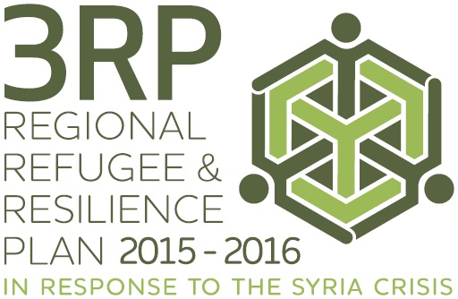
MEDIA BACKGROUNDER - 3RP PROGRESS REPORT

3RP PROGRESS REPORT - A CALL TO ACTION

The 3RP is only 23 per cent funded, and this severe shortage of funds is hampering efforts to meet the needs of more than 3.9 million refugees who have fled the conflict in Syria and the communities hosting them, according to the 3RP Progress Report released today.

To ensure adequate protection for refugees and humanitarian assistance for those in need, along with support for the resilience of host communities and governments, 3RP partners are calling for:
  - Increased solidarity and international responsibility-sharing with refugee-hosting countries;
  - Enhanced refugee protection in the region and beyond;
  - More funds and more quickly to address needs and consolidate efficiency gains;
  - Support to a new aid architecture to better address the complexities and long-term impacts of the Syria crisis;
  - More support to strengthen the resilience of local service delivery for a more sustained response; and
  - Increased access to livelihoods to alleviate suffering, restore dignity and reduce social tensions.

WHAT ARE THE CONSEQUENCES OF INACTION

Should the 3RP partners’ call for action remain unheard, the consequences would be severe, leaving a generation of Syrians behind and neighbouring countries striving to provide a global public good they should not and cannot bear alone. Levels of vulnerability and poverty will continue to rise and tensions between host communities and refugees will mount, contributing to further regional destabilization, rolling back developmental gains.

Consequences of underfunding of the 3RP across the region would include:
- 1.6 million people across the region will have further cuts to their food assistance.
- Up to 1.7 million people may face winter this year without fuel, shelter, insulation, blankets or warm clothes.
- 752,000 Syrian refugee children will continue to not participate in education.
- 130,000 extremely or severely needy families will not be supported with cash assistance for basic needs.
- Increases in morbidity and mortality, especially among children under five, women, and refugees with acute and chronic health conditions.
- 70,000 pregnant refugee women could face life-threatening complications, if timely emergency health care is not provided.

Some of the impacts in countries would include:
• Programmes for 100,000 out-of-school children or adolescents in Turkey will not start.
• Daily, 250 women and children in Lebanon will not benefit from medical, emotional or legal support to protect them from early marriage, sexual harassment and negative coping strategies.
• 312,000 people in Jordan will not have access to primary health care, while more than 120,000 women and girls of reproductive age living in host communities in Jordan are at risk of mortality and morbidity if protection and reproductive health services are not provided.
• 30,000 refugees in Iraq will be living in substandard shelter.
• Almost 2,000 refugees detained in Egypt on charges of attempted illegal departure will remain in detention for prolonged periods with limited or no humanitarian and legal assistance.

3RP FUNDING STATUS
As at 31 May 2015, only USD 1.06 billion - less than a quarter - of the USD 4.5 billion of agency requirements has been received since the appeal was launched last December. This leaves a gap of USD 3.47 billion, which is affecting the ability of agencies to response in all countries and sectors, and in both the refugee and resilience components of the response.

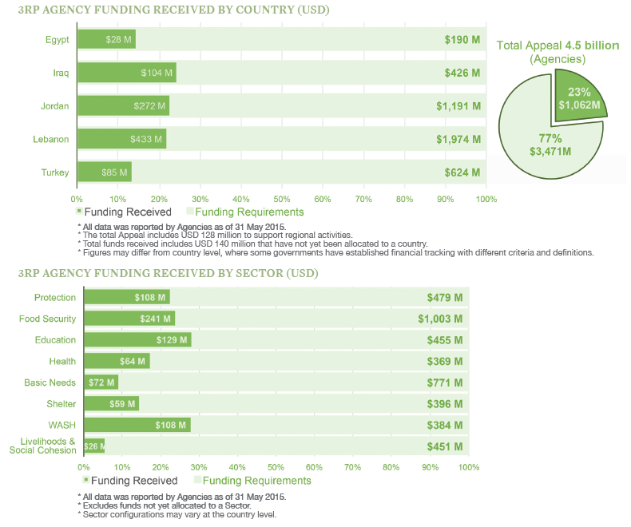
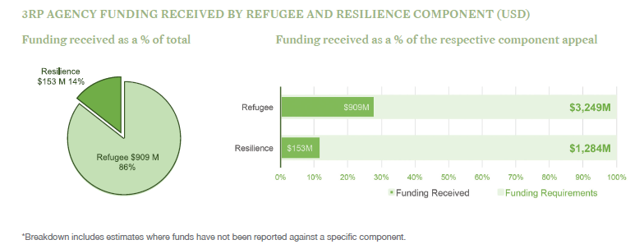
3RP ACHIEVEMENTS
3RP partners are rolling-out innovative approaches to increase the impact of the response and ensure that the limited funding available has been channelled to those most in need. Some of these include:
- Biometrics for refugee registration to improve protection and reduce fraud.
- Local delivery systems, including municipal services, intensively used for a more sustainable response and fewer parallel systems.
- Cash-based interventions for food and other basic needs to reduce overheads and transaction costs.
- Better data collection systems and assessments to identify and assist the most vulnerable.
- Development of real time communicable disease surveillance and response strategies.

Key achievements across the response to date in in 2015 include:
- 1.8 million people reached with food assistance.
- 1.6 million Syrian refugees registered to ensure protection and assistance.
- 1.5 million primary health care consultations provided.
- 675,000 people benefiting from improved access to safe water.
- 546,000 children assisted with school supplies or grants to help them access education.
- 243,000 households received help to get through the last winter.
- 58,000 households provided with shelter assistance.
- 16,000 households benefiting from training or employment services.

3RP BACKGROUND
The Regional Refugee and Resilience Plan (3RP) in response to the Syria Crisis is an international appeal aimed at addressing refugee protection needs, the humanitarian needs of the most vulnerable, and the longer-term socio-economic impacts of the Syria crisis on neighbouring countries of Turkey, Lebanon, Jordan, Iraq and Egypt.

The 3RP is a USD 5.5 billion funding appeal, comprising USD 1 billion of host government requirements and USD 4.5 billion in agency requirements for United Nations (UN) agencies and Non-governmental organisations (NGOs). The appeal is planned on a scenario of 4.27 million Syrian refugees in the region by the end of 2015, and aims to assist more than 20 million other members of impacted local communities this year.

