Report
Webinar Series “Digital Inclusion for Sustainable Development”
April to May 2021

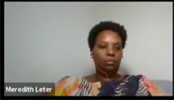
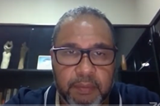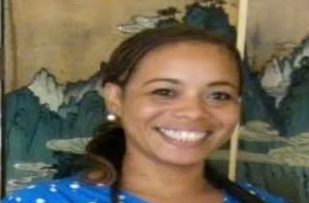

The United Nations Development Programme (UNDP) and the ICT Association Suriname (ICT-AS) had taken the initiative to partner on a series of four webinars with the topic “Digital Inclusion for Sustainable Development” during the month of April 2021. The webinars were meant to engage policy makers, business communities and other stakeholders within the ICT and related sectors in a dialogue on the role and importance of ICT in the context of national development in Suriname.

The objective of the webinars was to initiate a discussion on the important issue of digital inclusion and to contribute to the formulation of a national strategy and plan regarding “Digital Inclusion for Sustainable Development “.

The following topics were addressed during the webinars:
• Enabling digital innovation in the telecommunications sector to support the development of Surinamese society (digital transformation).
• Bridging the digital divide and providing broadband “Access for All” in Surinamese (“digital inclusion”).
• The importance of the developing of digital literacy and skills in this modern and fast-moving digital era.
• Contribution of ICT in achieving the 17 Sustainable Development Goals (SDGs) (the keystones social- and economic development).
• Relation between the SDGs and the 7 targets of the Broadband Commission, initiated in 2010 by the UNESCO and the International Telecommunication Union (ITU).

During the webinars various stakeholders had given a presentation regarding selected topics. After the presentation there was an opportunity for discussion with the presenters serving as panelists and the public had also the opportunity to raise questions by logging into the online platform. The webinars were held in Dutch and translation was provided for the session with presentation of non-Dutch speakers.

A preparatory working group was established to prepare and organize the webinar series, comprising of Mr. Gerard Den Dekker and Mr. Rajiv Hieralal of the ICT Association and Mr. Ruben Martoredjo, Ms. Julissa Marte, and Mr. Bissessar from the UNDP CO Suriname.

Each session was held from 7.30 PM to 09:30 PM where each speaker had been given a maximum of 10 minutes to make a statement or present her/his view on the subject. Once all statements had been made, a round of discussions and interactions with the audience and among the speakers took place.
A moderator was assigned to chair the sessions.

Session 1 - 8 April 2021 ICT General and Policy
The focus of this session was on ICT in General and Policy, during which the speakers elaborated on the national ICT vision and policy, regulations, strategy and e-Readiness, the contribution of ICT to national development and innovation and Digital inclusion. Also, representatives of the Indigenous and Tribal Peoples (ITPs) had presented their experiences on challenges related digital disparity and exclusion and their view on how they would benefit on digital inclusion.

Welcome and Opening Remarks | Welcome and introduction to the webinar by Mrs. Odette Miranda  List of Agenda points outlines  Welcome to H.E. Minister Albert Jubitana. Minister of Transport Communication and Tourism  Webinar series outlines  Welcome to Mrs. Margaret Jones Williams, representative of UNDP Suriname
Opening remarks by Dr. Margaret Jones Williams | Ms. Jones Williams underlined that the relevance of digital inclusion and adequate connectivity has been confirmed during the COVID-19 global pandemic. Digital access is a matter of survival for many. In general, COVID-19 has exacerbated weak basic services including the digital divide. The divide between those that have and those that do not have access to digital services. Access to vital and timely information is paramount especially for communities living in deep rural areas and the hinterland. Digital inclusion is necessary for information sharing and access to distance education.  She referenced on UNDP’s COVID-19 Rapid Digital Socioeconomic Impact Assessment among Indigenous Households (RD SEIA) launched in 2020 where e-questionnaires were applied to try to obtain information on communities, and the challenges of reaching remote rural areas. The exercise highlighted the need for access but also the many challenges on access to internet, access to electricity, availability of software, affordability of hardware and digital literacy. The 2030 Agenda and the Sustainable Development Goals – with the key motto of “Leave No One Behind” is the key aspect to underpin this Webinar Series. She underlined that the 2030 Agenda and the Sustainable Development Goals, with the key motto of “Leave No One Behind”, is the key aspect to underpin this Webinar Series. She thanked the partner, ICT Association, and all the presenters and look forward in hearing thoughts and views which will contribute towards the develop a comprehensive national strategy for the benefit of the people of Suriname.
Opening remarks by Ms. Anuska Sonai, Chair of ICT Association in Suriname | Mrs. Sonai, Welcomed Mrs. Jones and the other speakers, thanked the UNDP for the partnership in the webinar series that contributes towards the development of the country. She spoke about the historic background of the ICT associate. Resalting the ICT sector as the basis for all modern innovative economic systems contributing to growth and work opportunities using the SDGs as the mechanism to minimalize the risks of digital transformation making access to the technology to everyone possible to everyone even to the most marginalized groups of the society.
Remarks by H.E. Minister Albert Jubitana. Minister of Transport Communication and Tourism ICT Vision Government | - During the COVID-19 pandemic we used the ICT for recreation, education and to avoid stress caused by isolation  - The government has also used the technology to introduce policies and to distribute information during this difficult time  - The technology has been used also by the commerce to for example deliver products, food to the consumers and reduce the risk of infection.  - The Ministry of Transport Communication and Tourism also unites with the UNDP and the ICT association in the partnership for Digital Inclusion.  - The Ministry shall facilitate new policies and the Introduction of a new ICT law, expansion of the phone and internet infrastructure.  - Partnership between private and public sector.
Presentation by Mrs. Meredith Leter, Telecommunicatie Autoriteit Suriname | - TAS aims to respond to the fast developments in the field of ICT, to enable service providers to provide affordable, high-quality ICT to offer services to Surinamese society.  - ICT strategy and E-Readiness: As part of the ICT strategy and E-Readiness the TAS has introduced the following projects:  - Introduction of the 5G  - Girls in ICT project to stimulate the participation of women in ICT  - Long Range Wide Area Network LoRaWAN (IoT)  - Grant of License-exempt bands 2.4-5 GHZ  - Concept for the Electronic Communications law, this concept is a draft created in 2011 and they expect to finalize it between 6-8 to submit it to the parliament. In this law data network traffic will be regulated, infrastructure Sharing between companies, Universal Service and Universal Access (USO, UA), a spectrum of new facilities for innovation will be implemented and a flexible network and schedule to guarantee the easy changing and adaptation of the different network advances in the country.  - The challenges that TAS have identified are the following: Connectivity, The Finance part, Loss of employment (tech is more efficient), Abuse of the internet and social media: social conflicts: reduced person-to-person interaction, gossip, fake news etc., cybercrime, ICT waste. There are not norms to regulate the correct disposal of ICT equipment’s, COVID-19 pandemic, Privacy issues, ICT illiteracy – Educational gaps
Presentation by Prewien Ramadin E-Gov. : ICT strategy & e-Readiness | - A modern information society calls for a digital government. e-Government stands for:  - Increase self-reliance of citizens, the business community and the government itself.  - Access to government information and public services through self-service internet applications (e-services).  - Increasing attractiveness for foreign companies and investments  - Optimization and transparency of processes within the government  - e-Government pillars:  - Institutional Framework  - National e-government /digital readiness strategy  - Legal Framework  - Offering e-government services  - Enabler of new technology  - National and international cooperation  - Services from e provided by e-Government:  - Government to Citizen (G2C)  - Government to business (G2B)  - Government to government (G2G)  - Current advantages & risk factors  - Advantages  - Suriname has more than 380,000 internet users  - 90% of internet traffic goes through the 750,000 smartphones  - Network Coverage covers 95% residential areas  - Internet rates are among the 4 lowest in the region  - Good infrastructure  - Risk factors  - The digital potential is not fully exploited; the government is not optimally automated and e-Governance systems are insufficiently developed.  - Low score on the NCSI  - Low Ranking DBI as of 2020– 162  - IDI as of 2017 – 88 – possibly lower in 2021  - Elements of e-Gov vision  - Government portal  - Secure digital identity and digital signature  - Digital databases and secure data exchange  - Centralized robust and secure infrastructure for government applications  - Access to connectivity and ICT  - Conditions  - International frameworks  - Legal framework of e-Gov  - Coordinating institutions  - Political will and change management  - Access to services and raise awareness  - Digital databases of e-Gov  - Electronic databases are the backbone of e-Governance. The Surinamese government has started to convert the data from paper to digital format, this process is still ongoing.  - Important databases (main registers) include the population register (CBB), the real estate register (Kadaster) and the business register (KKF), the vehicle registration register (Juspol).  - Improving the integrity, effectiveness and completeness of such registers is cardinal, this is not just a technology issue.  - What is needed to achieve this?  - Attitude: “the citizen comes first, not the technology”.  - Transparent collaboration with and between all stakeholders.  - The government as facilitator, enabler and regulator.  - Integral approach: In addition to technology, also include organizational, legal and regulatory issues.  - The government must ensure “inclusion”. Everyone should have access to digital services
Presentation by Anuska Sonai, ICT Association in Suriname:  Contribution ICT to development & innovation | - The ICT sector offers Work opportunities, new professions, increment in the production sector, export possibilities, diversification of the economy  - ICT can be applied in all sectors of the industry: services companies, Financial institutions, healthcare, tourism, Agriculture sector, commerce, education production etc.  - The use of ICT contributes to efficiency, transparency, development of markets and increment of knowledge in the society  - ICT used as the foundation of Suriname’s digital economy has the following results:  - Provides access to affordable high-speed broadband  - Create a supportive macroeconomic & business climate  - Improve digital policy regulations  - Remove E-commerce logistic barriers  - Strengthen digital skills  - Provide incentives for digital startups  - Provide access to affordable hardware for education purposes  - The ICT infrastructure have a very important role in the developing and localizing of the 17 SDG’s goals in our country.
Presentation by Ms. Cylene France, Vereniging van Inheemse Dorphoofden Suriname -VIDS-: Digital Inclusion for Sustainable development | - VIDS is the association of Indigenous village chiefs created in 1992 after the civil war of 1991 and is conformed by villages of the following regions:  - Oost Marowijne  - West Suriname  - Para and Wanica  - Wayambo  - Zuid Wayana  - Zuid Trio  - The association defends the rights of the indigenous people and aims to the sustainable development of the indigenous villages in Suriname  - These goals are difficult to achieve because of the difficulties the indigenous people must endure.  - sustainable development and inclusiveness require leadership, coordination and ongoing mobilization and awareness among the indigenous, led by the traditional authorities who uphold the indigenous vision of the future, values, norms and culture  - Last year UNDP invited us to participate in the setup of an important research: Rapid Social Economic Impact Assessment of Covid-19 on Households in Indigenous villages and we could identify the issues that difficult the access to the internet and technology to the communities and possible solutions for this problem  - The research was successfully completed thanks to the following reasons  - The villager’s own devices that allow them to be connected  - Young people have basic knowledge of the modern technology and know how to use it, for example how to click a link and scroll documents  - One of the challenges that were identified by the research is the limited access to the electricity, not all regions have electricity. The mobile devices must be charged during a limited time frame.
Presentation by Ms. Renatha Simson,Representative  of KAMPOS: Digital Inclusion of tribal peoples | - KAMPOS is the collaboration of the six tribal peoples in Suriname. Namely the Kwinti, Aluku, Matawai, Pamaka, Okanisi and Samaka.  - The idea behind the establishment of KAMPOS is, among other things, to allow the development of tribal peoples as a community and their own individual development.  - The digital inclusion is not only the development and upgrade of networks to facilitate the access to social media platforms, but the way to catch up with the rest of the society and to eliminate disadvantages  - The SDG 3 speaks about healthcare, the reality is that distance and difficult access to tribal areas are more often cited as reasons why Surinamese doctors want to settle in these areas.  The digital technology can be a solution to guarantee the connection between the patient and the doctor through digital medical appointments, the digital infrastructure must be set up to make this possible.  - The SDG 4 speaks about the access to education to everyone, most of the parents chose to no send their kids to school because this implies that after the 6th grade the child must move to the city. Digital inclusion can aid to guarantee the continuity of the education through remote teaching.  - Digital Inclusion must be considered as the way avoid disadvantages and marginalization of the tribal people when preparing a national ICT vision and strategic and e-readiness policy. Don’t do it for the Indigenous or tribal people do it with the Indigenous and Tribal people
Closing of the webinar | - Closing words by the MC Mrs. Odette Miranda

Session 2 – date 15 April 2021- Subject ICT & SDGs
This session focused on the importance and contribution of ICT towards the achievement of the Sustainable Development Goals (SDGs)
Welcome and Opening Remarks | Welcome and introduction to the webinar by Mrs. Odette Miranda  List of Agenda points outlines
Presentation by Ms. Margaret Jones Williams, UNDP Deputy Resident Representative | - Mrs. Jones recognized the participation of the other panelists: Amb. Miriam Macintosch Permanent Secretary of The Ministry of Foreign Affairs International Business and International Cooperation.Mrs. Anuska Sonai, Chair of ICT Association in Suriname.Mr. Danny Lachman Director of Planning Office Suriname.  - Definition of digital exclusion, digital inclusión & digital literacy.  - Presentation of the Human Development Report 2020. “The Next Frontier, Human development and the Anthropocene.  - Anthropocene: Current geological age, viewed as the period during which human activity has been the dominant influence on climate and the environment.  - The Sustainable Development Goal 11: Sustainable Cities and Communities focuses on making cities and human settlements inclusive, safe, resilient and sustainable.  - More than 50% of the world’s population lives in cities.  - In 1990 there were 10 mega-cities with over 10 million people  - In 2014 this number increased to 28 mega-cities.  - The Sustainable Development Goal 13 on Climate Action recognizes that global warming in getting worse, more storms, more droughts and more extreme weather events.  - Efforts on climate mitigation and climate adaptation must continue.  - The Human Development Index (HDI) introduced in 1990 was intended to be a general index for global assessment and critique based on a minimal listing of capabilities focused on enjoying a basic quality of life.  - Human Development Report 2020 is measuring human development and the Anthropocene and confronting the Anthropocene calls for a new generation of human development metrics.  - The 2020 Human Development Report (HDR) focusses on the belief that people’s empowerment can bring about the action we need if we are to live in balance with the planet in a fairer world.
Presentation by Amb. Miriam Macintosch Permanent Secretary of The Ministry of Foreign Affairs International Business and International Cooperation | - Mrs. Mac Intosch presented apologies on behalf of H.E. Minister Ramdin  - 5 Principes (5Ps) 2030 Agenda for Sustainable Development Planet People, Prosperity, Peace and Partnerships.  The focus of the government of Suriname is People, Prosperity and Planet.  - Suriname adopted the SDGs in its NOP of 2017-2021 and they will be incorporated in the new NOP of 2021-2026  - Preparations to the first Tier Review Report of the Country regarding the implementation and localization of the SDGs in the Suriname at the high-level political forum of the United Nations.  - In the report Suriname will present the progress on the localization of SDG 1, 2,8,13 and 17.  - Part of the activities that have been implemented by the country are:  - Project localizing the SDG’s that was launched in 2016  - Knowledge Sharing regarding SDG’s localization with other countries as Grenada.  - Localization of SDGs in Suriname included the translations of the SDGs to Dutch  - Informational sessions as symposiums, discussion panels, regional seminars etc. in collaboration with the United Nations  - The ICT is the ideal tool to increment the development of the country, the private sector is the motor.  - Public and private partnership are essential part of the development plan
Presentation by Dr. Danny Lachman Director of Planning Office Suriname. | - The role of the SDGs in the National Development Plan 2022-2026 of Suriname.  - The National Development Plan is a strategic plan that outlines the current situation of the country and the vision or projected status in the coming 5 years. It describes the actions that must be taken to achieve the goal.
Questions and Answers Session | - Question 1 addressed to Mrs. Macintosh: Will Suriname present the Tier Review report to the United Nations every year?  Response: Not, a yearly reporting methodology is a very ambitious plan, because of the implications such activity as mobilization of target institutions, people etc.  The country can choose the period in which they will present the report.  - Question 2: Addressed to Ms. Margaret Jones Williams: Looking at the human development index for Suriname in the past 10 years are we making significant progress?  Response: The human development index shows the progress for various countries, is not a comparative index, Suriname has shown progress in some indexes and there are always opportunities for improving.  The progress achieved is influenced by the focus areas from the 2030 Agenda for Sustainable Development chosen as priority by the countries.  - Question 3, Addressed to Mr. Margaret Jones Williams: Where can the National Programme for the SDGs for Suriname be read? Please can have insight on the Reports.  Response: The question was deferred to Ambassador Macintosch.  There is not national reporting on SDGs done.  - Question 4: Does Suriname have a National to achieve the SDGs? Which goals are part of the plan?  Response: The planning office of Suriname wrote a National development plan for Suriname, the focus of this plan is not the SDG’s but how the country can adopt the goals, localizing them in the local context.  - Question 5, addressed to Mrs. Jones Williams: What does decade of Action means:  The decade of action refers to the 10 years period traced by the SG’ to accelerate the achieving of the 17 development goals.  - Question 6, addressed to Mr. Lachman: What is the role of the General Bureau of Statistics (ABS) and its reports in the gathering and processing of data regarding the SDG’s?  Response: Mr. Lachman affirm that ABS gather SDG’s data, but He is not fully informed of the role of the ABS regarding the SDG’s data gathering  Question 7, addressed to Mrs.Macintosch and Mr. Lachman: What is the role of ICT on the development of the country from the point of view of the public sector?  Response: ICT is an important actor and a partnership between the private, public, and civil society is essential for the development of the country.
Closing of the webinar | - Closing words by the MC Mrs. Odette Miranda

Session 3 - 22 April 2021 Education and ICT
This session focused on the importance and contribution of ICT in education and the inclusion of ICT in the education sector

Welcome and Opening Remarks | - Welcome and introduction to the webinar by Mrs. Odette Miranda  - List of Agenda points outlines  - Highlighting the importance of the trajectory of digital inclusion in the process of achieving the SDGs  - Announcing the speakers, namely Minister Marie Levens, Mr. Robby Holband, Ms. Shanti Venetiaan and Mr. Vincentius Kenswil  - Also announcing that statement will be made by Ms. Anuskha Sonai on the celebration of Girls in ICT Day
Remarks in celebration of 10th Anniversary of Girls in ICT Day | - Congratulates everyone with the tenth anniversary of the girl in ICT day  - Inspires more young women to start a career in the IT industry  - Also dwell on a big loss with the passing of Vivian Mertodikromo, a prominent woman in ICT community, who has contributed on getting an equal position of girls and women within this sector  - With this celebration Anuska wants to inspire girls and women to enter the ICT branch, which is more than the techno-nerd related activities such as programming etc., as one can also be a consultant or trainers.  - In addition, ICT is indispensable in departments, companies in all sectors  - And could provides opportunities for a career that one can maintain her/himself for the rest of ones life  - To the policy makers she notes that yes there are a lot of people who has a smartphone so that is the use of ICT but access must also be guaranteed to generate success in co-creation and deliver a sustainable future for young people.
Presentation by H.E. Minister Marie Levens, Minister of Education -  Renewal of the educational process through ICT | - It is always pleasant to be able to give a presentation, where the subject has already been thought of for you: Innovation in the educational process through ICT.  - You can go in several directions with the title. Is the innovation due to ICT or is ICT a means of implementing educational innovations?  - As in many other countries, education in Suriname is a quest for the best and most appropriate education for pupils and students growing up at a time when the world is changing rapidly - not least because of technology.  - What do today's students need to function in the society of the future? Think, for example, of the so-called 21st century skills such as collaboration, critical thinking, problem solving, communication and creativity, but also digital literacy. Do students not have much more in skills than in knowledge, now that information is at our feet due to digitization? However, information is not yet knowledge.  - There have been quite a few initiatives to innovate the educational process through the use of ICT i.e. there was already a large multi-day international conference in 2012.  - A national strategic policy plan was drawn up on the basis of the BEIP project in 2014.  - Computer labs have been added in recent years, teacher training courses have been held; The IOL has provided an ICT & Education course, many private individuals and foundations have done “something” with ICT in education and there have been numerous initiatives from the business community.  - As it goes, some initiatives were more successful than others and one question to ask, have all these efforts achieved their goals?  - At the use of ICT in the educational process, we see that it can be used in the primary process as well as in the secondary process.  - When using learning, research says it can lead to increased motivation, better learning performance and a more efficient learning process.  - With COVID everywhere in the world, digital solutions were immediately looked at. But now a year later, it is actually clear all over the world that effective distance learning is a lot more complicated than just giving the instruction lessons via an online video link.  - Suriname has a challenge that distance education via ICT cannot reach every student.  - Educational innovations using ICT cannot be more successful than the ICT expertise of the teachers and lecturers.  - Addressing the content and applications is also part of the DEALS project. Minowc has already put a large part of GLO's textbooks online.  - Good distance learning requires an online learning platform: it is desirable that schools and teachers have a way to offer their education online in a structured manner.  - And only now do we get to the infrastructure; with Telesur, we are working on internet connections for all schools.  - ICT can further strengthen our education. In the primary process with Learning with ICT: the possibilities are in principle endless and new possibilities are added every day.  - To return to my introduction: Is the innovation due to ICT or is ICT a means of implementing educational innovations?
Presentation by Mr. Robby Holband, Director PTC - Education, ICT and Digital Skills | - Thanking the organisers for the opportunity to participate  - Places the theme of Digital Inclusion of SDGs in the context of Suriname and raises the question on how the situation is in the country and if the country can achieve digital inclusion.  - PTC started as the first tertiary education institution with ICT in 2007, around its 10th anniversary, with the objective to support the ICT sector wit competent workers.  - The ICT program was developed with support from international and national partners.  - The national partner Telesur invested in the ICT infrastructure representing a classroom with 30 computers. In return PTC trained for 5 years 10 employees from Telesur in ICT  - The ICT programme specializes on programming and networking and currently preparations are made to introduce AI and robotics.  - PTC provides competence oriented and project and problem-solving education  - In 2014 the PTC started with distance education program with the aim to increase access to education by offering citizens the opportunity to receive education in their own environment and time  - Various of tools are used to present instructional materials such as audio/video materials, internet and e-learning  - Support was received from IDB in 2018 for developing the e-learning environment  - There are 2 important aspects of distant education namely the pedagogical and technical aspects.  - Initially, PTC adopted a blended approach in the utilization of ICT in its education process whereby ICT was used to support traditional classroom activities, aiming at the average student, and didactical activities were centerd around the lecturer. ICT tools were used by lecturers who had affinity with ICT.  - Looking a present day developments, we notice the availability of smartboards with possibility execute different activities simultaneously, integration with internet and live streaming, and access to several educational platform.  - Physical location is no longer a deciding factor; creating flexibility in time and format for each student.  - However, challenges persisted whereby lecturers have no pedagogical tools to provide online classes, or don’t know to utilize the ICT technology, and problems with connectivity. As a solution PTC developed training modules ICT in Education I and II.  - Also, students faced challenges comprising of not having the right attitude for online learning, don’t have the tools for online learning, and internet of available everywhere and not affordable for every student.  - In addressing these challenges PTC granted access to small groups to study in the classrooms, students with ICT equipment received education materials in memory sticks or CDs, while other students received materials in hard copy.  - Under ICT in Education module II the main focus is on building the capacity of the lecturers to be able to develop online modules.  - With the emergence of COVID, examinations are administered online using the Exam.Net and Zoom platform, lectures are conducted online using Moodle and Zoom, and an E-library is being developed.
Presentation by Ms. Shanti Venetiaan, Chair of the board of the Anton De Kom University of Suriname  Topic: ICT in practice: curricula & adaption global developments | - Covid is important point and for the rest of the life will be influenced  - UVS, approx. 4000 student, 400 tappers, 190 fulltime lecturures, and 22 courses  - Within the 10 years deal with Telesur, which is will end this year, Adekus has free internet access for students and staff.  - Bandwidth management is necessary as 150MB is not sufficient, especially with currently circumstances under COVID-19 pandemic  - During the pre-COVID period, internet was used for email communication, information and literature search, utilization of Moodle learning platform, and guest lectures (Zoom and Skype) for some departments  - Same as at PTC, lecturers with affinity with ICT are utilizing the internet facilities.  - Moodle platform gives more responsibilities to the students and is used to post course materials, registration of examinations etc. and the Medical Faculty has already used to post recorded classes and testing during pre-COVID to address classroom shortages.  - Adekus has been thrown into the deep with COVID but has managed to survive; everyone did their best to adapt. A myriad of tools are used including Zoom, BBB of Moodle, WhatsApp, Teams etc.  - Majority of lectures are conducted online, using various formats used such as live online classes, recorded classes, YouTube videos, and posted course materials.  - Texting online is not structured yet; attempts are made with Exam.net in combination with Zoom etc. but this method seems to be expensive. Moodle can be used but without possibility of visual control. Largest bottleneck is the fraud sensitivity and integrity of the examination results.  - As shown on the graphic the use of Moodle has increased 10 times: 2018-19 to 2020-21, from 45000 to 500000/month.  - Study conducted by the quality control department shows that in a scale of 1 to 4, the students value distance learning at 2.79, communication of changes 2.48 and the platforms used 3.14.  - For the near future, efforts should be made to select a single platform and develop standard protocol for online examination. Also more pre-recorded lectures and more alternative forms of examination will be used.  - There are bottlenecks to be addressed such as: slow internet, not all students have a laptop and internet connection at home, and students not yet independent and have the discipline for distance learning.  - The possible solutions for these bottlenecks are: more bandwidth from Telesur, discounts arrangements for laptops, establishment of PC rooms, and improved guidance and mentoring with establishment of mentoring system.
Presentation by Mr. Vincentius Kenswil, Lead Education Committee ICT Association Suriname.  Topic: Education, ICT and Digital Skills | - Extend condolences to the family and ICT community with the passing of well- known ICT colleague  - Congratulates Girls in ICT with the commemoration of the 10th Girls in ICT day  - Presentation will focus on the development of ICT skills and literacy  - Question is posted on how big the gap is between education and work in Suriname; the education system produces workers for the private sector, but also for the public sector and civil society.  - Children currently at the elementary schools will be functioning in a different world around 2030; a post-Covid world which have gone through a process of changes  - What is the definition of digital inclusion: Is the ability of individuals and groups to access and use of information and communication technologies  - The inclusion of different groups in society is important such as, women and children, interior and rural districts, elderly and people with disabilities.  - As education committee it is important to inform the youth of the fact that there are groups in society that are lagging behind in the use of modern/ICT technologies such as the elderly.  - We also know the definition of sustainable development which is development that meets of the present needs without comprising the ability of future generations to meet their own needs.  - Today is earth day and Suriname is on the eve of becoming an oil nation; but it is also important to give attention to other sustainable sectors.  - The ICT sector can become a substantive and viable sector for the economy.  - Referring to the 3 pillars of the SDGs namely economic viability, environmental protection and social equity, is economic viability of importance as current societal development/improvement is mostly measured by its economic strength. In Suriname our progress has been measured by the exchange rate, which is translated to our purchasing power.  - The other pillars are also important namely environmental protection, and social equity which has an impact on inclusion. And we need education for that; education is an important pillar for sustainable development as it produces human power for the society.  - Education is the transmission of social and cultural norms and values.  - And the 21st century skills are needed to function in today’s modern society  - There is a gap between education and business; what is delivered by the education system is not meeting the expectation of the private sector. But since no study is done, evidence/data cannot be presented to support this. The Education Cie. of the ICT Ass. is collaborating with partners incl. government and education institutes to present the required data.  - There is also a generation gap; we are currently in a transition. Those born before 1980 are regarded as digital immigrants and those born after 1980 are the digital natives.  - The education system has to address the gaps and anticipate on the knowledge on demand.  - The education platform established by the ICT Ass, has to be re-activated and strengthened with more active input from the private sector.  - There are enough reports but the actions/recommendations/plans should be implemented
Question 1 addressed to the Minister of Education:. Can the private schools be taken into account when decisions are taken regarding ICT policy with the education sector (online and blended lessons)
Response: Yes, is possible. In general, instructions/communications are extended to all schools in the country. The inspection department also visits all schools included the private ones which can only be established with approval from the ministry.

Question 1 addressed to the Minister of Education:. Can the private schools be taken into account when decisions are taken regarding ICT policy with the education sector (online and blended lessons)
Response: Yes, is possible. In general, instructions/communications are extended to all schools in the country. The inspection department also visits all schools included the private ones which can only be established with approval from the ministry.

Question 2; Why chose WhatsApp group for parents when completing distance education.
Not an instruction from the ministry. There is, however, instruction to reach the students and parents. The ministry realizes that not all children and parents have an internet connection and also a large group of students and parents do not have the devices and data (allowed but not required). It is difficult to work at the elementary school level with devices and internet.

Question 3: Which changes in education due to Covid can be implemented structurally, especially with regard to ICT
All educational institutions (seen also on the presentation) have taken a more serious approach to ICT technology. What has to change structurally is that all schools have access to the internet, something that we are seriously preparing with Telesur. We started with this Covid 19 situation and we have seen that parents do not have a smart phone. Say people have a smart phone, but not everyone has a smartphone with data and often not enough in households.
Most important all 12000 teachers training in how to use devices and how to teach with ICT. Materials are made to be used in the classroom. So the material also has to be adapted.
Some changes are coming and we are not going back for Covid: no back to big classes (no more than 25); for the time being also not going to 5 days of school for the larger schools, and possibly Saturday school for older children.

Question 4. To what extent has account been taken of what is prescribed under SDG 4 when making policy within Education?
agreed within
Some we do well, such as gender equality; with the boys we have a big problem, unlike in other countries. More women in higher education, VWO too, only GLO is 50 and 50.
SDG 4.5 have no problem; 4.1 Free education for everyone, primary and secondary, tuition fees are minimal (no tuition fees at BSC, but registration fees are)
SDG 4.2 Early child education has problems, but no room for 4; flow important because the for 4 cannot accommodate

Mr. Robby Holband :
How does PTC guarantee that their ITC training is and remains up to date?
PTC has a system (Structural) every year evaluation of the cirroculum with the sector; and sector free with proposals for adjustments/innovations; but also input/feedback can be provided by the sector for the Education and performance of the students and the curriculum is adjusted if necessary to meet the needs of the market.
The sector is also involved in the development of new specialization courses and they also participate in the curricula development committees.

Ms. Shanti Venetiaan and Mr. Robby Holband :

Can the examples of PTC and UVS be included by the Ministry and implemented at the Educational Institutions?

Invested in PTC to experiment and also collaborate intensively. Education has invested a lot in ICT, but at a lower level it is difficult to implement if the teachers are not ready to use ICT for teaching. These teachers must be trained and equipped with devices; but is a very large group and are spread over the country including the interior
Higher education is different At the Adekus and PTC this is not a problem because most lecturers are ready.

Ms. Shanti Venetiaan:
Scientific research is done on adek, among other things to the ICT sector and specifically to the facilitating role of ICT on the economic development of Suriname.
Not sure and going to check.

Isn't it an idea that PTC and Adekus work together in providing platforms, methodologies and training for teachers.
Venetian: Definitely look at it and PTC will be in a lot close to ADekus. They are already working together and are going to work together more.

Network where the sea cables are not needed; certainly interested, Inventing and elaborating experts, don't stick to slogans.
Minister Levens informed.

Mr. Robby Holband :
PTC focuses on collaboration; Strongly invested in it. have already done business together with Adekus and proposals are being made to do structural institutional business together. Collaboration is already underway at the executive level.

Is there a need for help from the diaspora; if so, which help in the field of Education and ICT.

Ms. Shanti Venetiaan: Of course help can use the diaspora.
Already have contacts with UWI, they are ready with a degree in computer science at the university. We want a lot but always comes after money. Adekus completely dependent on government subsidy The salaries are not interesting; difficult to find experts to draw it. Willing to work with the salaries of the Adekus. Shouldn't be the same as that of the PTC - what exactly is needed.
Diaspora is welcome, and written out very well

Minister Marie Levens: Diaspora people immediately look at the Netherlands; we have good contact with the Dutch-speaking college (Ned, Belgium), bilateral cooperation and ICT is on the agenda.
Also on the agenda of Latin America and CARICOM; chat group where a lot of information is shared. But within the group almost everyone struggles especially for the large numbers at lower level and the teachers.
There is cooperation, especially with companies in the ICT sector in the Netherlands; but there is a lot of offer but we can pay. There is voluntariness, but it must be usable.

How does the ministry view working parents in relation to 3 days of school per week for the child?
That question is often asked; I don't have a solution for it yet. There used to be after-school care. But most parents cannot pay, poverty is enormous and the teachers themselves can pay with a wage of 3200.
Struggle with taking care of the little ones. Solve as quickly as possible by shifting, creating space to accommodate the smaller ones.
Parents are right if there are ¾ children to succeed them; don't go back to big classes because the teachers get sick.
Is a social problem but must be solved and the government must make money available for it
Infrastructure is hugely important, putting money into infrastructure is important, but investing in the people is extremely important

Questions raised but not assigned by the moderator to the panel to be addressed:
-Digital divide between Interior and coastal area
-Import duties from devices
- Infrastructure for the entire country, must lead to Development of the country that benefits everyone and everyone is a stakeholder in the introduction of ICT systems

Closing of the webinar | Inviting public to participate at the next webinar, last one of the series of four

Session 4 - 29 April 2021 Contribution Private Sector to SDGs
This session addressed the importance and contribution of ICT in the private sector and contribution of the private sector in the achievement of the Sustainable Development Goals (SDGs)

Welcome and Opening Remarks | Welcome and introduction to the webinar by Mrs. Odette Miranda  List of Agenda points outlines
Opening remarks, Mr. Bryan Renten, Chairperson Suriname Trade and Industry Association (VSB) | - Digital inclusion and SDGs are important topics but insufficiently brought to the attention to respective audiences that's why this webinar series is important  - SDGs are the compass to a more sustainable world  - Internationally, especially in developed countries, companies have been able to integrate SDGs into their business operations, which have proven to create opportunities and pose no threat  - In Suriname only a handful companies has adopted/integrated the SDGs; it is mainly companies that have a foreign parent company, or whose owners are specially moved to do so.  - The Surinamese companies are generally not aware and therefore do too little. - It is understandable because Surinamese entrepreneurs are going through difficult times and are doing business in an unfriendly climate that has worsened by Covid. The private companies cannot afford to absorb more overhead.  - However, there is good news- more companies realize that incorporating/internalizing the SDGs in their business processes creates opportunities, such as focusing on sustainable consumer patterns can lead to more efficient production processes, energy efficiency and less waste.  - It's a process that will take time and is costly; Surinamese private sector just comprises of handful large and middle large companies – mostly SMEs, and they do not have the resources; there is also lack of information and knowledge on SDGs among SMEs.  - As a personal advice Surinamese companies have to set priorities, and focus on climate change, decent work and gender equality  - How further in getting the SDGs in the agenda of the private sector? This could be achieved through:1. more awareness and information sharing (webinar as good example); 2. VSB commits to play a role, in collaboration with other partners; 3. Collaboration/partnering of larger companies with or support smaller companies;4. Financial sector should also play a role; 5. The role of the government and all semi-public entities is essential; for instance the role of Telesur is eminent in digital inclusion; and the government could also give tax incentives.  - VSB commits that its business awards will be based on the principles of the SDGs starting 2022.
Contribution ICT to SDGs, Mr. Gerard den Dekker, ICT-AS | - Regard the 17 SDGs as the building blocks for a Sustainable Economic, Social and Ecological Development  - Leaving no one behind, stipulates an inclusive coexistence.  - Inclusiveness is the key word and tonight is about digital inclusiveness - connectivity and internet  - Achieving the SDGs is not the sole responsibility of the government, a broad involvement of society as a whole, including the private sector, is required  - Explanation in 3 parts to make the link between the SDGs and how to integrate them into the company goals.  - Framework: the SDGs, the global goals, are not goals of the world or of the UN, but of all of us.  - Global goals are translated into country/national goals and sector goals: therefore, the importance of a sector or sector organization.  - For the translation into company goals, we need human capital; there is interaction of the goals from top to bottom and bottom to top.  - Find out how your company can contribute to the SDGs.  - Step-by-step plan: Awareness, Alignment, Action and Analyzing the goals.  - Awareness: explaining the SDGs within the organization;  - and then look at how the business goals can be aligned with the SDGs and try to integrate the SDGs into your business plan  - Alignment: linking SDGs with your vision and mission – or linking core business with SDGs. You can also involve your suppliers and customers in your value chain.  - Companies can start by making a link with their CSR policy.  - Major companies in the ICT sector have taken initiatives related to SDGs, such as Microsoft – through focusing and linking all business goals to the SDGs.  - In Suriname, UCC has linked its business goals to SDGs.  - Not only from a commercial perspective you can look at the SDGs; but also from an ideal and stewardship perspective.  - SDGs can also be approached from the perspective of your livelihood security.  - Broadband commission for sustainable development, established by ITU and UNESCO, is an important entity in recognizing the role of ICT in achieving the SDGs.  - In regard to goal 1, No Poverty, ICT is important in achieving this goal; having a bank account – financial inclusion/having a bank account.  - For SDG 3 and SDG 4, ICT is essential, especially in current situation with the COVID pandemic.  - In order to achieve digital inclusiveness, we should start with energy inclusiveness, especially for the interior.  - Elaborates on the SDGs highlighting relevance and importance of the SDGs in relation with to ICT and business sector.  - ICT Development Index from ITU give an indication where you stand as a country.  - Digital inclusiveness is a precondition for sustainable development and connectivity is the basis for further development.  - The importance of ICT is underline and proposal is made to transform/upgrade E-Gov commission to a Directorate.
ICT in practice- Transformation to Digital Partner: facts & figures & facilitating the SDGs, Mr. Mike Antonius, CEO Telesur | - Currently we are in Version 4.0 of the industrial revolution: characterized by technological advancement and development of computer science – currently at the stage of smart technology  - Suriname has not always been active with its participation in the process of industrial revolution  - Globalization has not been understood and digitalization has made the process of globalization possible.  - Suriname has a backlog in digitalization – part of the global digital divide- and remains in the analog stage of the preparation process.  - COVID-19 is putting pressure on the digitalization process, especially with the increasing demand for online financial services.  - There is growth in broadband facilities in the last 10 years – exemplified through price and bandwidth relation comparison in time.  - Telesur National Broadband project is placed under an E-Suriname framework; what is the added value for the community? The E-Suriname vision; what should be done to safeguard our digital future in Suriname.  - Telesur is the E-enabler by providing the highspeed broad band facilities and services which creates spinoff effects of eservices such as e-payment solutions.  - For each services area an E-service could be created. Telesur has chosen to participate and be part of the E-service creation process such as the participation at the Safe Safety project, E-commerce etc.  - E-services is meant to enrich our life which is aligned to the SDGs.  - Internet of things is becoming important and to facilitate that the infrastructure is important – standard set for the future through 4G LTE.  - Strategic plan: to give more priority to the E-Suriname vision  - Telesur will transform from just a service provider to digital partner; to be closer to the partners to whom Telesur provide services and ultimately to become the Trusted Digital Partner  - How will the company translate the vision to action: main improvement to be made in the service delivery and service recovery – these are the areas which the company has challenges with and strategies were developed to address them before the emergence of Covid. With COVID these challenges are exacerbated as the demand of e-services is increasing.  - In facilitating the achievement of the SDGs in Suriname, the national broadband project is essential, together with the mobile access and digital tv for the interior, supporting education, enabling e-payment and e-services.  - The digital divide is widening and forms a challenge; due to economic conditions in the country access to devices becomes problematic with serious impact on distance learning initiatives.  - Telesur contributes in alleviating the situation by providing free data platform, focus on the website content of education institutes and accessibility of the Moodle platform;  - Through its 2017-2019 Broadband project high financial and HR investments were made - glass fiber lines installed and large old yellow building replaved by the gray boxes  - Currently in execution the “Last Mile Optimization” activities which includes replacing copper connections with glass fiber for higher speeds – limitation is formed by the ADSL modems, which should be replaced ($5Million dollar investment) for the next step in the broadband connectivity.  - COVID-19 Pandemic doesn't contribute in achieving the SDGs, modem are getting expensive due to high demand and scarcity of chips, while prices are constantly increasing.  - Summing up the progress made in the area of Mobile tv for the Interior meant to improve connectivity and access; 80 sites provided with mobile access in the interior; social package and free data (for access to digital for youth) for the education section; Uni5 pay + mobile top up for E-commerce; and E-health service provision.  - Telesur celebrating its 40th Anniversary in during a Covid pandemic and economic/financial difficulties in the Country situation – the focus is on securing the digital future.
Responsibility private sector to SDGs, Ms. Malty Dwarkasing, Director Suriname Trade and Industry Association (VSB) | - The 17 goals of the SDGs are interlinked and have interfaces with entrepreneurship and combating poverty: Less poverty more purchasing power, more sales.  - The VSB, is the largest employer’s organization, with member companies of various sizes.  - Initially, VSB focuses on Corporate Social Responsibility when linking with SDGs, such through issuance to CSR awards  - The CSR, which is based on ISO 22000 – promotes good governance within the companies and community involvement, and takes into account respect for norms and values ​​including human rights, equality, non-discrimination and gender equality, environmental protection and sustainability, and lastly also how to accommodate People with Disabilities.  - Decent work and economic growth is also stimulated by VSB; is also member of the National Decent Work Monitoring Committee  - Inclusiveness is inherent to principle of Leave No Behind, is supported by VSB.  - Through the Alliance for Decent Work for People with Disabilities (Alliance) , the VSB in collaboration with its partners (Government, CSOs, and UNDP) promotes inclusion of PWDs in the world of Work. The Alliance is implementing the BNTF funded sub-project to stimulate entrepreneurship among and provide skills training to PWDs.  - Cashless transaction become increasingly desirable in time of COVID pandemic; Everyone must be included in the financial system by having a bank account – also SOZAVO beneficiaries are being included through financial inclusion initiatives of the government and the banking sector.  - Digital inclusiveness is important: no innovation in production process and services can be achieved without digitalization – digitalizing is important and promoted by VSB  - More knowledge and information on the SDGs and how you should integrate in the private sector business processes is needed.  - Critical adaptation of the SDGs taking into account the national reality and collaboration is needed to be develop a vision, strategy and action plan.  - Initial conversations with Rotary and UNDP are taking place to promote integration of SDGs in the private sector and to learn from each other especially from the front runner companies  - Private sector should also collaborate with the government on the SDGs
Questions and Answers Session #1 | Question for Mr. Antonius and Ms. Dwarkasing raised and responded via chat.
Innovation, ICT and SDG’s, Mr. Hank Stokbroekx, Vice President, Huawei Enterprise Services | - Visited Suriname under a cooperation project with Telesur in 2017  - Congratulates Telesur with its 40th Anniversary  - Works with Huawei since 2011 and stationed in China since 2012  - Short introduction of Huawei; established 32 year ago, now represented in 157 countries, has 197000 employees worldwide, of which more than 50% in R&D., Innovation is one of the spearheads of the company and invests heavily in R&D  - Inclusiveness is already embedded in the mission of the Huawei.  - ITU is an important partner of Huawei has the contribution to SDGs clearly formulated  - ITU is using digital technologies for achievement SDGs  - Inclusiveness could be achieved through access to information and services, connectivity between people and organisations, productivity and resource efficiency (economic growth) – ICT can play an important role  - Four pillars of Huawei are: Digital inclusion; Environmental protection; Security and trustworthiness; and Healthy and harmonious ecosystem.  - Huawei produces the Global Connectivity Index report annually; reports the index of each country, and countries are supported to improve their connectivity.  - Main concern of ICT is security and trustworthiness related to data security and privacy.  - Through its Tech for All programme in coorperation with universities and schools, Huawei helps to train students in ICT to address the gap in talent and to improve the supply of students in ICT. This is done through train the trainers and curriculum development.  - To comply with sustainability and contribute towards achievement of SDGs, Huawei works closely with suppliers on energy efficiency to reduce energy consumption, trustworthiness and harmonious ecosystems, and on harmonious ecosystems with their employees.  - Through its ICT trucks, Huawei contributes towards ICT inclusiveness: travelling in different countries, students can use the technology in expanding the knowledge and access to information.  - For Safeguarding the Rainforest, Huawei collaborates with others to develop a plat form for monitoring and preventing illegal logging and protecting endangered animals  - With its AI Track – Huawei helps children with eye impairments, while its 5G Smart mining, contributes to safer mining activities.  - Huawei has established its Cyber Security Transparency Center in Brussels, to show the world that Huawei is a trustworthy company  - Digital inclusion cannot be without security and trustworthiness  - Environmental protection – less use of energy (also the data centres) – promote use of renewable energy; objective reduce carbon emition  - Seeds for the Future Programme: objective to involve more students to ICT (earlier invited student to China for visit and education in ICT- objective: more insights on ICT and to create enthusiasm for ICT);  - With its Annual Sustainability report Huawei share what it is doing on sustainability and inclusiveness.
Questions and Answers Session #2 | - Question for VSB: How SMEs can contribute to SDGs; what is the benefit for these companies?  Response: Referred to the presentation of VSB  - Question for VSB:  How will VSB address the informal sector especially those in the hinterland?  - Question for Stokbroekx/Huawei: How does Huawei support; concretely or directly?  Support is provided via local partner Telesur.  Concrete information on digital inclusion and sustainability will be obtained from local colleagues and shared.  - Contribution to Education:  Support also provided to the education sector; specific details will be obtained from local team and shared.  Mr. Antonius concurs that contributions are provided to Education sectors: data service - little local content – ​​hosting sites, important to work on local content – ​​with free data service for Education – Moodle with blue options – is hosted at Datasur, which reduces costs, more local hosting. Suriname needs to develop and host more local content.  - Nancy del Prado: Legislation needed to promote implementation of the SDGs:  Den Dekker: Don't think that specific legislation is necessary – it's about things we already do, don't name as such  View the pragmatic approach to make connections and contribute don't make it complicated  1Goals, targets - indicators  Questions received through the Q&A box and addressed to Mr. Stokbroekx:  - Ghenel Shrubs: Could Huawei also contribute to education in Suriname  - Nancy del Prado: Question for Hank: The platform "to monitor and prevent illegal logging" in 11 countries. Is Suriname one of the 11 countries? will be  - Ariana de Bie: Would Huawei also want/could participate in wildlife protection in Suriname?  Response: Yes, but what are the plans of Suriname; Will be responded in detail by email.
Closing Remarks, Ms. Anuskha Sonai, Chairperson ICT-AS | - Thanking all speakers, contributors and preparation team  - National discussions to incorporate SDGs in the business sector has started, but this should also take place within the public Sector  - The webinar series has had wide reach and but also reaching the right audience  - The inputs received will be incorporated in the ICT vision 2030
Closing Remarks, Ms. Margaret Jones Williams, UNDP Deputy Resident Representative | - Acknowledgement given to all the partners, contributors (presenters/panelists), and audience for their contributions and participation.  - Special recognition for the contribution of the representative of the Indigenous and Tribal Peoples (ITPs) (VIDS and Kampos), the Minister of Transport, Communication and Tourism, H.E. Minister Albert Jubithana, Minister of Education, H.E. Minister Marie Levens and Permanent Secretary of Ministry of Foreign Affairs, International Business and International Cooperation, Amb. Meriam Mac Intosch.  - Special vote of thanks extended to the ICT Ass. for the partnership.  - Congratulates the government of Suriname and their partners Telesur and Social Being on the launch of the fee data service for the education sector.  - COVID-19 has created many challenges but also so many opportunities and push to move into the age of digitization, e-banking, distance learning, teleworking is an opportunity that certainly has presented itself.  - The conversation should be sustained; and all insights, ideas and intentions should be translated into programmes, projects, interventions. in short follow-up actions should be taken to implement the ideas and perspectives that we have shared and learned.

Conclusions/Recommendations:

- Main objective of bringing all key actors around the table in a dialogue on the different key aspects of Digital Inclusion for SDGs was achieved; Government Ministers, Permanent Secretary and Department Heads (policy makers), Service providers, Vulnerable/excluded groups (ITPs), Private Sector incl. ICT sector, and even international Innovator had the opportunity to share their views.
- Good turn-out in regard to participation (more than 90 participation on session 3), which underlined the importance and interest on the subject matter.
- What was started with this collaborative effort in providing a platform and sharing views through dialogue should not stop; the conversation should be sustained; and all insights, ideas and intensions should be translated into programmes, projects, interventions -in short follow-up actions should be taken to implement the ideas and perspectives.
- ICT is not only a facilitator, but more in its role of innovator and accelerator should be a key factor in the achievement of SDGs and in providing digital access and creating equal development opportunities for all Surinamese.

Annex 1.

Webinar Series “Digital Inclusion for Sustainable Development”

- Objective
Inform and exchange with the audience regarding the key topic: “Digital inclusion for Sustainable Development“
- Enabling digital innovation in the telecommunications sector to support the (digital transformation) development of Surinamese society
- Bridging the digital divide and providing broadband access to all Surinamese (“digital inclusion”).
- Contribution of ICT sector to the 17 Sustainable Development Goals (the keystones social- and economic development)

- Target Audience
ICT stakeholders in Suriname, for example (not limited to):
- Government: Ministry TCT, Education, Foreign Affairs
- e-Government commission
- Telecom Authority Suriname
- UNDP & affiliate UN organizations
- Telecom Operators
- Members ICT Association
- Management & Staff ICT departments public and private sector
- Media

- Location, time, costs
- Location: Virtual/webinar (Zoom - live stream You tube)
- Date: 4 sessions, dates to be discussed (Q2 2021) (April) – Thursday 8, 15, 22, 29 – 19:30)
- Time: to be decided
- Costs: free registration

- Structure webinars

Sessions:
- 4 sessions:
- 90 Minutes3 speakers/ 1 topic/ 3 stakeholders per session
- 15 minutes statement per session
- 30-45 minutes panel discussion
- Moderator per session
- Sessions 1, 3 and 4 in Dutch
- Session 2 in English
- Recording
- Subtitles (English?)

Session 1. ICT General & Policy (8 April)
- ICT Vision Government Ministry TCT
- Policy, regulations, strategy ICT & e-Readiness T.A.S./ e-Gov
- Contribution ICT to development & innovation ICT-AS
- ITPs…….. VIDS/Kampos
Session 2. ICT- SDGs (15 April)
- Current position and prioritizing the SDGs in Suriname Ministry BIBIS
- United Nations in the Urban Anthropocene & SDGs UNDP
- Appearance of SDGs in Development Plan 2021-2026 Planning Office Government

Session 3. Education & ICT (22 April)
- Renewal education process through ICT Ministry OCW
- Education, ICT & digital skills ICT-AS Education Cie
- ICT in practice: curricula & adaption global developments PTC
- Research and Development ADEKUS

Session 4. Contribution Private Sector to SDGs (29 April)
- Contribution ICT to SDGs ICT-AS
- ICT in practice: facts & figures & facilitating the SDGs Telesur & Digicel
- Responsibility private sector to SDGs VSB

Output: Report & Recommendations
Annex 2. Flyers and Banners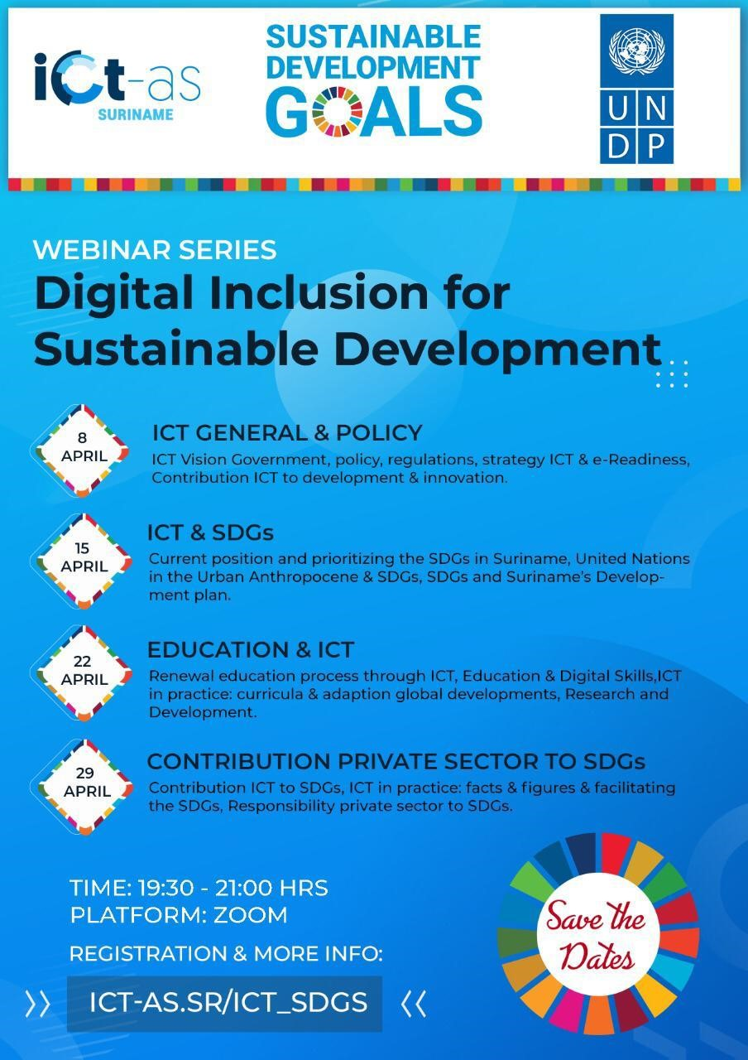

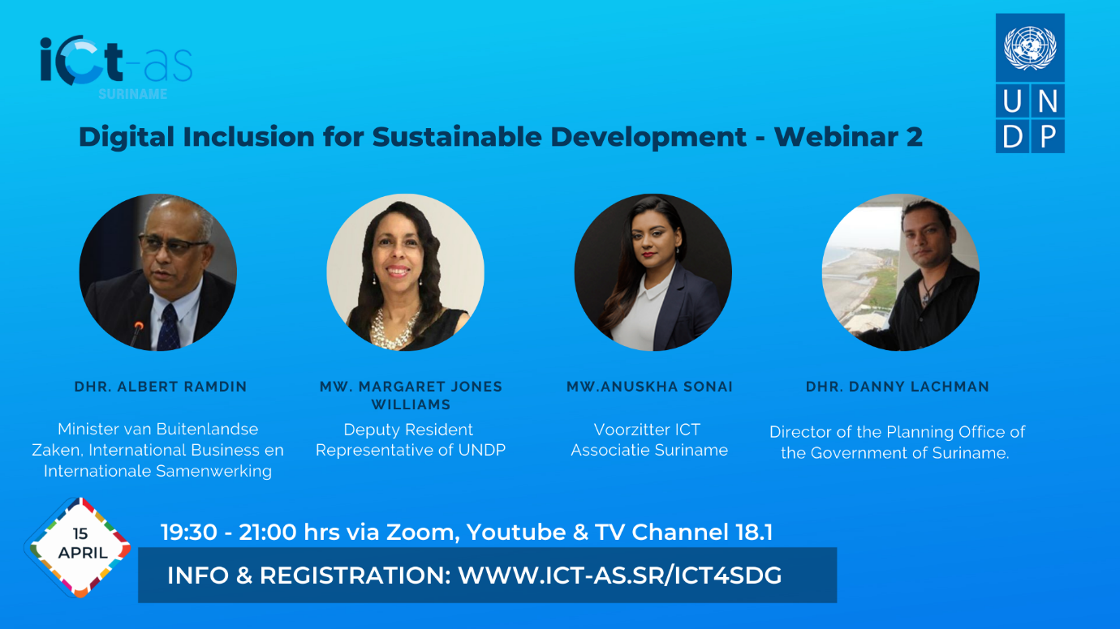
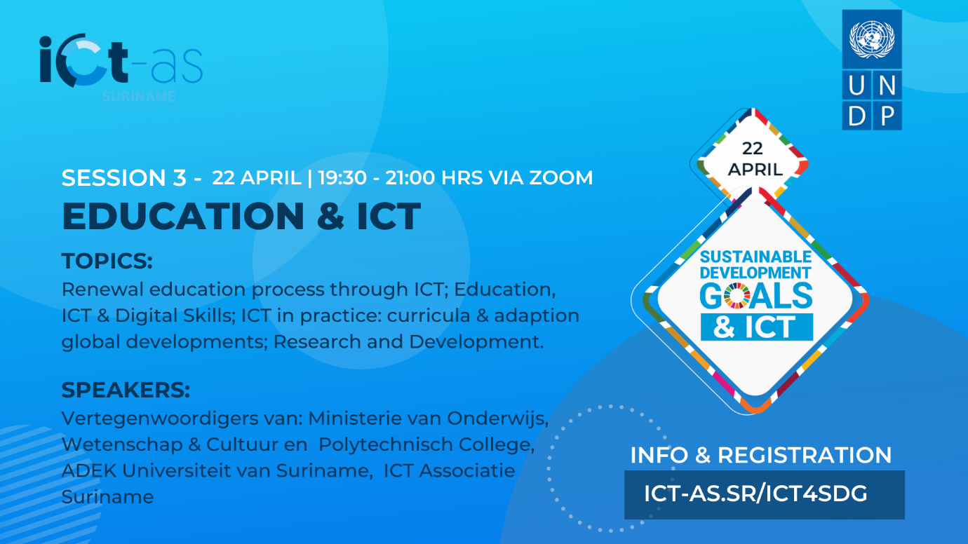
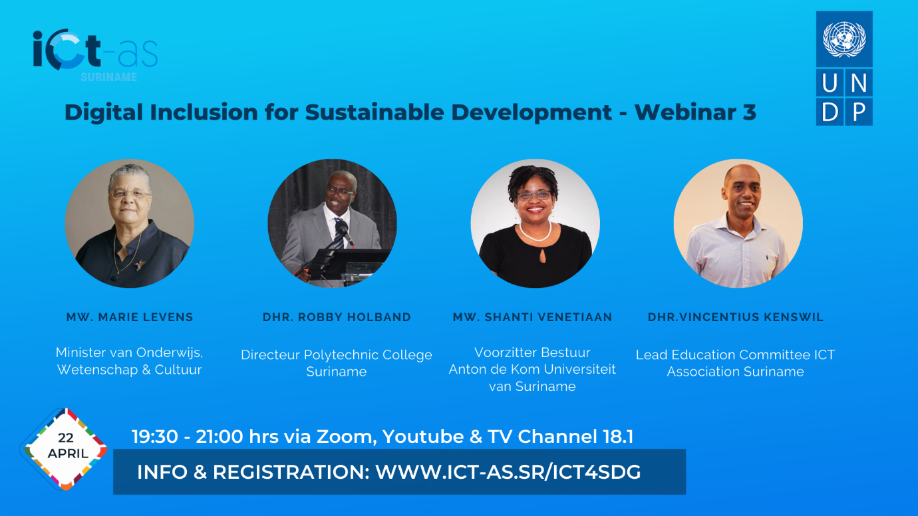
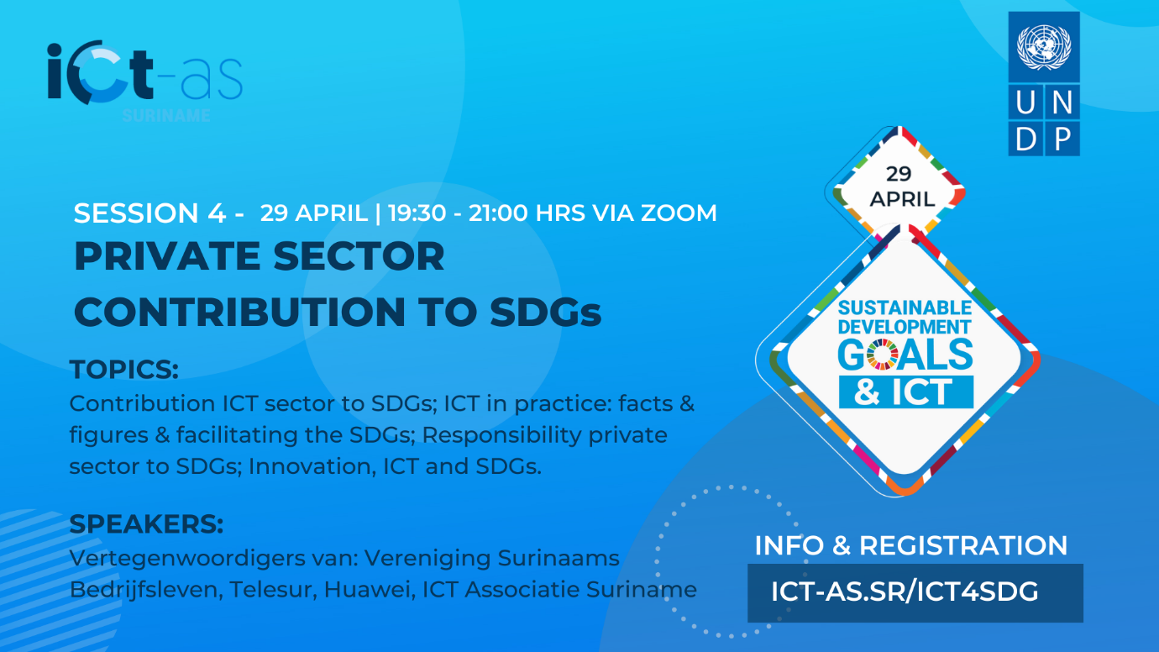

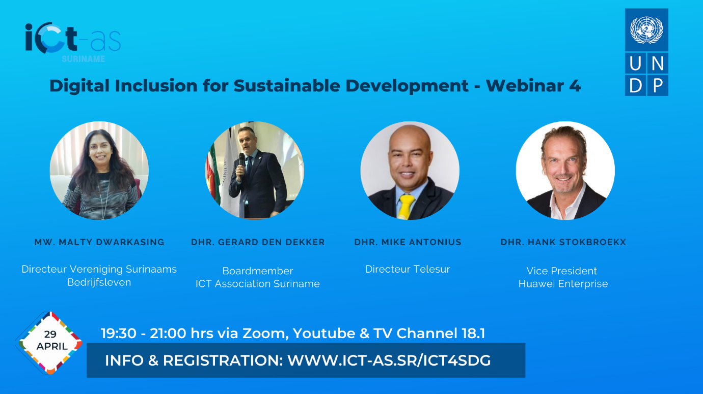
Annex 3. Programme

Programme Session 1:
Webinar Series: Digital Inclusion for Sustainable Development
Session 1: ICT General & Policy
8 April, 2021
Time 19:30 – 21:00
Time | Description | Speaker | Title/Function
19:30 | Welcome | Odette de Miranda | Moderator
19:35 | Opening Statement | Dr. Margaret Jones Williams | DRR UNDP
19:40 | Opening Statement | Ms. Anuskha Sonai | Chair of the Board, ICT Association
19:45 | ICT Vision Government | Minister Jubitana | Minister TCT
19:55 | Policy and regulations, | Ms. Meredith Leter | T.A.S.
20:05 | ICT strategy & e-Readiness | Mr. Prewien Ramadhin | E-Gov.
 | Contribution ICT to development & innovation | Ms. Anuskha Sonai | Chair of the Board, ICT Association
20:15 | Digital Inclusion | Ms. Cylene France | Director VIDS Bureau
20:25 | Digital Inclusion | Ms. Renatha Simson | Representative KAMPOS
20:35 | Discussion/Interaction | All Speakers & Public
21:00 | Closing | Odette de Miranda | Moderator

Programme: Session 2
Webinar Series: Digital Inclusion for Sustainable Development
Session 2: ICT and SDGs
15 April, 2021
Time 19:30 – 21:00
Time | Description | Speaker | Title/Function
19:30 | Welcome | Odette de Miranda | Moderator
19:35 | Current position and prioritizing the SDGs in Suriname | Hon. Minister Albert R. Ramdin, represented by Amb. Miriam Mac Intosh | Minister of Foreign Affairs, International Business and International Cooperation; PS Bisis
19:45 | Urban Anthropocene & SDGs | Dr. Margaret Jones Williams | Deputy Resident Representative, UNDP
19:55 | SDGs and Development Plan 2021-2026 | Dr. Daniël Lachman | Director National Planning Office.
20:05 | Discussion/Interaction | All Speakers & Public
21:00 | Closing | Odette de Miranda | Moderator

Programme: Session 3
Webinar Series: Digital Inclusion for Sustainable Development
Session 3: Education and ICT
22 April, 2021
Time 19:30 – 21:00
Time | Description | Speaker | Title/Function
19:30 | Welcome | Odette de Miranda | Moderator
19:35 | Renewal education process through ICT | Hon. Minister Marie Levens | Minister of Education
19:45 | ICT in practice: curricula & adaption global developments | Mr. Robby Holband | Director PTC
19:55 | Education and ICT at the Adekus | Dr. Shanti Venetiaan | Chairperson of the Board, Adekus
20:05 | Education, ICT & digital skills | Mr. Vincentius Kenswil | Chairperson ICT-AS Education Cie
20:15 | Discussion/Interaction | All Speakers & Public
21:00 | Closing | Odette de Miranda | Moderator

Programme: Session 4
Webinar Series: Digital Inclusion for Sustainable Development
Session 4: Contribution Private Sector to SDGs
29 April, 2021
Time 19:30 – 21:00
Time | Description | Speaker | Title/Function
19:30 | Welcome | Odette de Miranda | Moderator
19:35 | Opening remarks | Mr. Bryan Renten | Chairperson of VSB
19:40 | Contribution ICT to SDGs | Mr. G.G. den Dekker | Member of Board ICT Ass.
19:55 | ICT in practice: facts & figures & facilitating the SDGs | Mr. M. Antonius | CEO TELESUR
20:05 | Responsibility private sector to SDGs | Miss M. Dwarkasing | Director VSB
20:15 | Discussion/Interaction Round 1 | Speakers & Public
20:30 | Innovation, ICT and SDG's | Mr. H. Stokbroekx | Vice President, Huawei Enterprise Services
20:40 | Discussion/Interaction Round 2 | Speakers & Public
21:00 | Closing Statement | Dr. Margaret Jones Williams | UNDP Deputy Resident Representative
21:05 | Closing Statement | Ms. Anuskha Sonai | Chairperson ICT Ass.

Annex 4.

Opening Remarks
by
Margaret Jones Williams
UNDP Deputy Resident Representative

at

Digital Inclusion for Sustainable Development Webinar Series
Thursday, April 08, 2021
Via Zoom Virtual Platform

Salutations
- Minister Albert Jubitana, Minister of Transport Communication and Tourism (TCT)
- Miss Jap-A-Joe, Telecommunications Authority Suriname (T.A.S).
- Mr. Ramadhin, E-Government Commission
- Miss Anushka Sonai, ICT Association
- Ms Ceylene France of VIDS
- Ms. Renatha Simson of KAMPOS
- Mr. Gerard den Dekker of Rotary Club
- Representatives from various Government Ministries and Agencies
- Representatives of the Private Sector
- Representatives of Civil Society Organizations
- Ladies and Gentlemen

- It is indeed a pleasure to join you al this evening and I am very heartened to see the great turn out and the number of persons already online. This event has been many months under discussion and it is good to see that it has finally materialized.

- The relevance of digital inclusion and adequate connectivity has been confirmed during the global pandemic. While the internet and various hardware and software applications have been in use for many years, over the last year, the need for this beyond entertainment, communication and work has been shown. Digital access is a matter of survival for many.

- In 2020 as part of UNDP’s support in the pandemic, we conducted a COVID-19 Rapid Digital Socioeconomic Impact Assessment among Indigenous Households (RD SEIA). With e-questionnaires applied to try to obtain information on communities. Reaching communities that are in remote rural areas is ever more relevant for information sharing and for data gathering. The exercise highlighted the need for access but also the many challenges on access to internet, access to electricity, availability of software, affordability of hardware and digital literacy.

- In general, COVID-19 has exacerbated weak basic services including the digital divide. The divide between those that have and those that do not have access to digital services. Access to vital and timely information is paramount especially for communities living in deep rural areas and the hinterland. Digital inclusion is necessary for information sharing and access to distance education.

- The 2030 Agenda and the Sustainable Development Goals – with the key motto of “Leave No One Behind” is the key aspect to underpin this Webinar Series. How can we ensure that We Leave No One Behind in this age of Digital Activity?

- The webinars are meant to engage policy makers, business communities and other stakeholders within the ICT and related sectors in a dialogue on the role and importance of ICT in the current context of national development in Suriname. The aim is to initiate a discussion around the important issue of digital inclusion and to contribute to the formulation of a national strategy and plan.

- “Leave No One Behind” can only be achieved if inclusiveness is embedded in development policy (national, regional and local); importance of participation and involvement of all actors (public, private, and civil society).

- Focus on vulnerable groups in society including low income households, Persons with Disabilities (PWDs), Women, Girls, Youth and Indigenous and Tribal Peoples (ITPs).

- For years ICT has been a facilitator of development and a catalyst of innovation.

- We look forward to sharing and hearing thoughts and views to develop a comprehensive national strategy for the benefit of the people of Suriname.

********
Annex 5. Presentation Slides - Text

Session 1:

Session 2

Session 3:

Session 4:

Annex 6: Closing Statement UNDP Deputy Resident Representative

Closing Remarks
by
Margaret Jones Williams
UNDP Deputy Resident Representative

at

Digital Inclusion for Sustainable Development Webinar Series
Thursday, April 29, 2021
Via Zoom Virtual Platform

Salutations
- Ms. Anushka Sonai, Chairperson of the Suriname ICT Association
- Representatives from various Government Ministries and Agencies
- Representatives from the Private Sector
- Representatives from Civil Society Organizations
- Distinguished Presenters of this evening’s programme
- Ladies and Gentlemen

- It has been such a privilege for UNDP to be a partner in this series, four session on Digital Inclusion for Sustainable Development. Again, I am very heartened to see the great turn out and the number of persons online.

- I will speak in English but rest assured that I have gotten the information presented this evening through the slides and my colleague Ruben has been diligently sending me translations.

- The existence of digital divide and the need for digital inclusion, the relevance of digital literacy and the need to get beyond digital exclusion has been confirmed during this global pandemic. While the internet and various hardware and software applications have been in use for many years, over the last year, the need for this beyond entertainment, communication and work has been shown. Digital access is a matter of survival.

- The 2030 Agenda and the Sustainable Development Goals – with the key motto of “Leave No One Behind” is the key aspect to underpin this Webinar Series. How can we ensure that We Leave No One Behind in this age of Digital Activity?

- The webinars were designed to engage policy makers, business communities and other stakeholders within the ICT and related sectors in a dialogue on the role and importance of ICT in the current context of national development in Suriname. Over the last four weeks, with various presenters, participants on line and strong participation in the Question and Answer sessions, I think we have been able to raise the level of awareness on this important issue. We had over 100 persons for Session 1, a session that went way beyond 10:00 p.m. For Session 3 we had over 90 persons, and tonight we have approximately 50 persons still engaged. Over the four weeks we have heard from Ministers of Government, Service Providers, Vulnerable Groups, Private Sector and Businesses, the ICT sector and an International Innovator.

- We have made a good start and this conversation should be sustained; and all insights, ideas and intentions should be translated into programmes, projects, interventions. in short follow-up actions should be taken to implement the ideas and perspectives that we have shared and learned.

- In Session 2, I gave a presentation on UNDPs 2020 Human Development Report and how the traditional Human Development Index has over the years been adjusted beyond the measurement of GDP to reflect various aspects such as gender, and now to have a planetary adjustment to reflect the Anthropocene pressures. It would be very interesting now to consider a digital adjustment. Our standard of living based on digital access and experience.

- On the ICT sector congratulations must go to the government of Suriname and their partners Telesur and Social Being on the launch of the fee data service for the education sector. Contribution to SDG 4 on Education and a working example of SDG 17 on Partnerships. Students and teachers can now access the Internet with or without credit on their phone to visit educational sites. This is a positive step towards digital inclusion, especially for pupils and students from low income households).

- COVID-19 has created so many challenges but also so many opportunities and push to move into the age of digitization, e-banking, distance learning, teleworking is an opportunity that certainly has presented itself.

- We must acknowledge the partnership with the ICT Association of Suriname, for the initial discussions on this initiative and for strong engagement throughout. We must thank all the speakers who gave of their time and expertise which made this such a rich experience. In particular representatives of the ITPs (VIDS and Kampos). Senior Government officials included the Minister of Transport, Communication and Tourism (mINISTERAlbert Jubithana), Minister of Education (Marie Levens) and PS of Ministry of MOFA (Amb. Meriam MacIntosch.

- Tonight we had Mr. Bryan Renten and Ms Malty Dwarkasing from the Suriname Business Association (VSB), Mr. Gerard Den Dekker Member of the ICT Association, Mr. Mike Antonius, CEO of Telesur, Mr. Hank Stokbroekx, Vice President of Huawei and connecting with from China. To my co-host in the staging of this event Ms. Anushka Sonai, Chairperson of the Suriname ICT Association, a special thank you for the partnership, the collaboration and the opportunity to raise awareness on the importance of ICT in the 2030 Agenda and to ensure We Leave No One Behind.

- Thank you.

********

Annex 7: Letter of invitation and vote of thanks to the Minister of Transport, Communication and Tourism

Annex 8: Links to online video recordings:

Session 1 https://www.youtube.com/watch?v=ZRHzZx34sk0
Session 2 Session 2 - ICT & SDGs - Digital Inclusion for Sustainable Development - YouTube
Session 3 Session 3 - Education & ICT - Digital Inclusion for Sustainable Development - YouTube
Session 4 Session 4 - Private Sector Contribution to SDGs - Digital Inclusion for Sustainable Development - YouTube

