Role of law enforcement agency during COVID-19 discussed with Korean National Police Agency
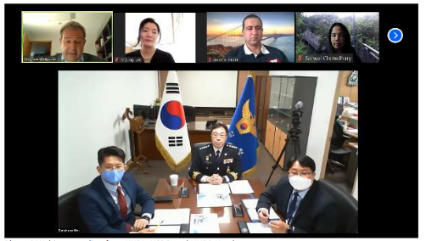
On 27 April 2020, UNDP Seoul Policy Centre (USPC) and the Korean National Police Agency (KNPA) kickstarted USPC’s governance-themed webinar series titled “Innovative Responses to COVID-19: Concrete Examples from Korea.” The webinar session shared the policing experiences of the country’s leading law enforcement agency and its lessons learned. The meeting served as a unique opportunity to highlight the role of police service agencies during a pandemic and provided reference points for country partners seeking to develop their police planning during COVID-19.

Law and order is inevitably threatened during a crisis like COVID-19. KNPA promptly adopted an organized approach to protect social stability with specific policy examples, which include: providing police enforcement for the Government’s disease prevention and control activities; actively investigating and cracking down on illegal activities generated from social disorder; supporting epidemiological investigation; and protecting essential public facilities.

Mr. Yong-Jong Kim, Director of the Crisis Management Centre at KNPA, noted “The current positive trend [in containing COVID-19] was possible owing to amalgamation of the Government’s preemptive actions and a strong drive for social distancing and active cooperation of the public.” KNPA’s policing experience pointed to the importance of inter-ministerial coordination and development of a preemptive legal framework and protocol.

Dr. Stephan Klingebiel, Director of USPC, remarked that “this webinar shared how KNPA has quickly taken a systematic approach to COVID-19 in close coordination with relevant government bodies, and thereby serves as a concrete example of how national police forces can respond to COVID-19.”

In order for police forces to effectively respond to COVID-19, Mr. Sofiene Bacha, Policy Specialist from the Rule of Law, Security, and Human Rights team at UNDP, emphasized that UNDP and other UN practitioners must gain a thorough understanding of the crisis before tailoring operation to different contexts.

This webinar was joined by a large audience of 120 participants from 37 countries. Following the webinar, KNPA shared its English publication ‘Policing Under and Against COVID-19’, and addressed any unanswered questions remaining after the webinar with USPC. Those resources are accessible on the USPC website.

Critical role of local governance in fighting COVID-19: discussion using the example of Seoul Government

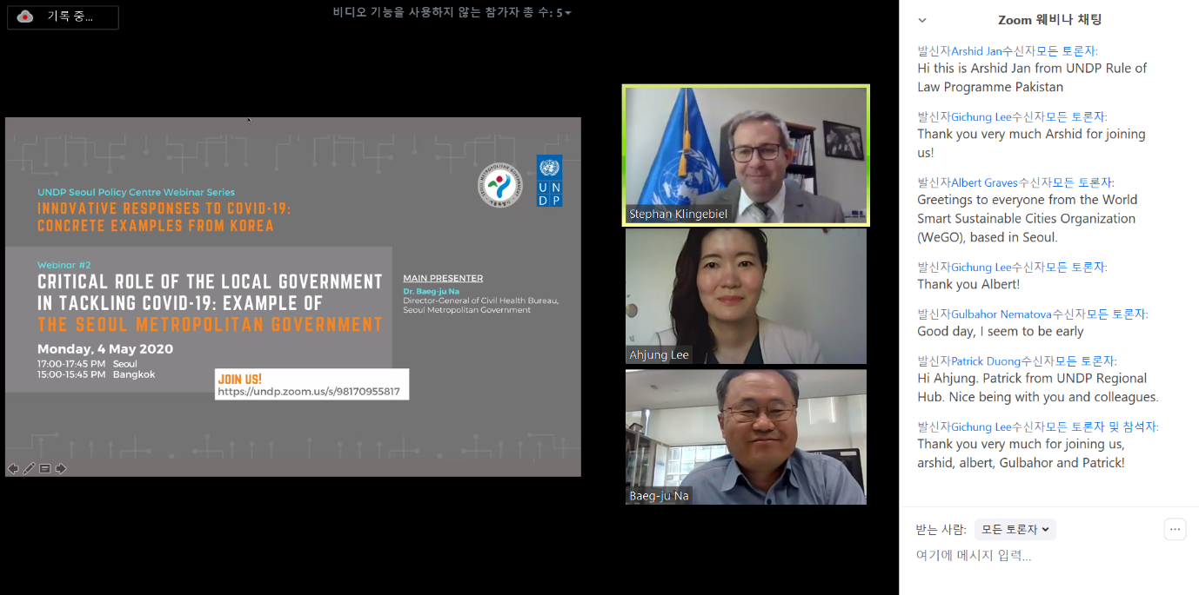

As part of the “Innovative Responses to COVID-19: Concrete Examples from Korea” webinar series, the UNDP Seoul Policy Centre (USPC), together with the Seoul Metropolitan Government (SMG), jointly organized a webinar on the “Critical Role of Local Government in Tackling COVID-19” on 4 May 2020 with the aim to introduce SMG’s inspiring experiences in fighting COVID-19.

This governance-themed online seminar highlighted the importance of the local government especially during a crisis like COVID-19. USPC Director, Stephan Klingebiel, noted, “The role of local government is important, perhaps more than ever, in terms of delivering the necessary information and services to citizens, as well as piloting innovative policies for national-level scale up.”

Dr. Baeg-ju Na, Director-General of the Civil Health Bureau at SMG, outlined Seoul City’s key principles of promptness, transparency, democratic participation, innovation, and cooperation that underpin the immediate actions of the Seoul Government, including public information website, testing facilities, living and treatment center, and social distancing campaign.

As Ms. Ahjung Lee, Policy Specialist at USPC, noted, “Seoul’s success in crisis preparedness and response is neither free nor by chance”, but based on years of practice and investments to institutionalize lessons learned from Korea’s past experience in response to the Middle East Respiratory Syndrome (MERS).

This webinar offered a learning ground for UNDP practitioners and country partners to facilitate the “prepare, respond and recover” approach in dealing with a pandemic crisis by introducing Korea’s swift actions to fight COVID-19 as well as the lessons learned.

In addition to SMG’s webinar presentation, the briefing document on Seoul’s fight against COVID-19 was shared with the 151 participants from 47 countries. The document presents a detailed timeline of the COVID-19 outbreak in Seoul and illustrates policy responses other than those covered during the presentation. The resources are accessible on the USPC website.

Creative response of anti-corruption and public complaint handling institutions during COVID-19: example from Korea
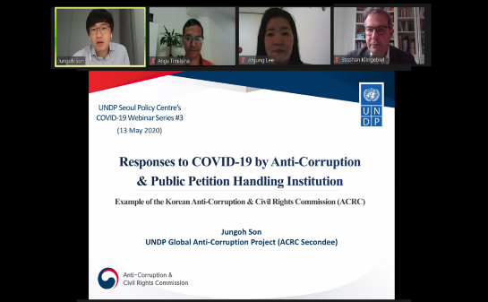

On 13 May 2020, UNDP Seoul Policy Centre (USPC) and the Korean Anti-Corruption & Civil Rights Commission (ACRC) co-organized the webinar “Creative Response of the Anti-Corruption & Public Complaint Handling Institution: Example of the Korean Anti-Corruption & Civil Rights Commission”, thereby successfully concluding the Centre’s governance-themed webinar series on tackling COVID-19. The webinar highlighted that ACRC’s anti-corruption efforts are of crucial importance due to the prevalence of corruption risks during the crisis.

Mr. Jungoh Son, Anti-Corruption Policy Advisor and ACRC secondee to UNDP, introduced ACRC’s online platform called ‘e-people’ which collects COVID-19 related petitions from citizens, as well as analyzes and channels these public petitions to relevant administrative agencies. As to which practical actions can be taken by anti-corruption agencies in times of crisis, Mr. Son provided a guidance checklist based on ACRC’s experience and lessons learned on corruption prevention.

Ms. Ahjung Lee, Policy Specialist at USPC, noted, “This [webinar] demonstrates the need to make serious and strategic policy investments for creating effective institutional mechanisms for corruption prevention, so that even in crisis situations like COVID-19, the anti-corruption work can be done.”

Mr. Anga Timilsina, Global Programme Advisor on Anti-corruption, provided a brief overview of UNDP’s anti-corruption offers and shared his thoughts on the most important aspects of fighting corruption in an emergency situation: effective oversight, access to information, and transparency and accountability in response mechanisms and processes, in particular to make service delivery and procurement processes more transparent.

This online meeting facilitated knowledge sharing and cooperation between the Republic of Korea and the global network of UNDP by demonstrating how to effectively implement corruption-prevention measures in the context of crisis. As USPC Director, Stephan Klingebiel, noted, “[Our Centre] thought this sharing of experience on COVID-19 would be meaningful at this challenging time for many UNDP Country Offices and partners.”

As immediate follow-up to the webinar, resources on ACRC’s innovative policy tools such as Anti-Corruption Initiative Assessment, Corruption Risk Assessment and Improper Solicitation and Graft Act were shared with the webinar’s 99 participants from 52 different countries. The resources are accessible on the USPC website.

