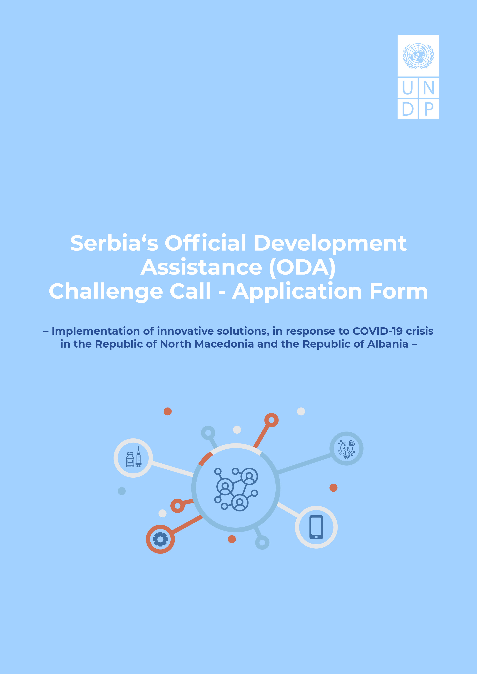

Serbia's Official Development Assistance (ODA) Challenge Call - Application Form
– Implementation of innovative solutions, in response to COVID-19 crisis in the Republic of North Macedonia and the Republic of Albania –

How should I submit the Application?
You can send the application with the required attachments by e-mail to: oda.challenge.rs@undp.org Attachments may not exceed a total of 25 MB per e-mail.
What is the Deadline for Concept Note Submission?
The deadline for receipt of your application is no later than 28th June 2021, 23.59 Belgrade time (GMT+1)
Any application received after this date and time will not be accepted.
Please review the Call for Proposals prior to completing this Application form.
An Application will be accepted only if it:
- is submitted in the correct form, fully completed and dated;
- is signed by the person authorized to enter into legally binding commitments on behalf of the applicant;
- presents a budget in conformity with the Call for Proposals;
- meets the submission arrangements set out in the Call for Proposals;
- is submitted by the deadline.

PROJECT
Project Title:
Date of Implementation: _____ /2021 –____ december/2021 [No More Than FIVe Months, not later than 15th December 2021]

Please Select Country of Implementation:
☒ REPUBLIC OF NORTH MACEDONIA
☒ REPUBLIC OF ALBANIA
☒ BOTH COUNTRIES

applicant INFORMATION
Applicant Information
LEGAL Name:
Legal Registration Number, Country and Year of Registration:
Type of Entity:
NUMBER OF STAFF:
Postal Address:
E-MAIL ADDRESS:
Telephone:
Websites:

Main Contact Person Responsible for this Submission
Name:
Telephone:
E-mail address:

The Applicant is kindly asked to inform UNDP about any contact details change during the implementation of the Project via e-mail to: oda.challenge.rs@undp.org
___________________________________________________________________________________

Please Select:
☒ INDEPENDENT application
☒ CONSORTIA application

in case of consortia application, PLEASE PROVIDE PARTNER INFORMATION*
LEGAL Name:
Legal Registration Number, Country and Year of Registration:
Type of Entity:
NUMBER OF STAFF:
Postal Address:
Name of contact person:
E-MAIL ADDRESS:
Telephone:
Websites:

*In case of Consortia application consisting of more than one partner, please provide the above required information for all partners.

EXECUTIVE SUMMARY OF THE PROJECT (up to 500 words)
Please summarize the Project proposal and the expected results in country(ies) of implementation. (up to 500 words)

Context, Problem analysis and beneficiaries (up to 300 words)
- Please briefly elaborate on the current situation caused by the COVID-19 pandemic in the country(ies) of implementation, and local demands for the proposed solution.
- Who is the main partner entity(ies) and other stakeholders and what is their role? Describe the background and experience of the partner entities and other.
- Who are the target beneficiaries and how will they benefit from the project? Describe the background of the beneficiaries.
- Please select from the SDGs below the ones that your project proposal contributes to (for more information visit the link: https://sdgs.un.org/goals )
☒ 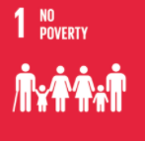 ☒ 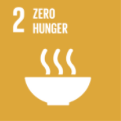 ☒ 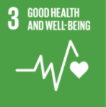 ☒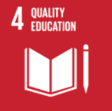 ☒ 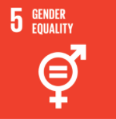 ☒ 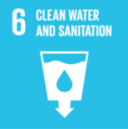

☒ 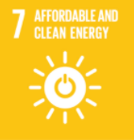 ☒ 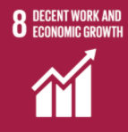 ☒ 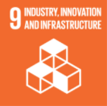 ☒ 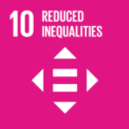 ☒ 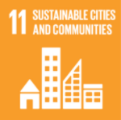 ☐ 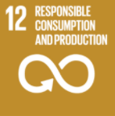

☒ 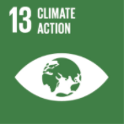 ☒ 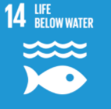 ☒ 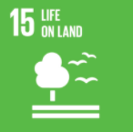 ☒ 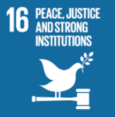 ☒ 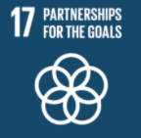

Project Description (up to 1500 words)
- Please describe the planned activities, the basic assumptions on which your project idea is based, and the project goal.
- Within the project description, it is necessary to explain how the proposed project addresses the challenges defined in this Call for Proposals. (Your solution towards partner countries' responses to COVID-19 may address more than one challenge/problem at once.)
- Describe your approach and how it will address the challenge (one of the three issue areas announced) and specific problem, note the impact to the local conditions and compare your solution to how it is dealt with today.
- What is innovative about your Project? (Consider some of these questions: What are the innovative elements of the proposed idea? Does the project represent the implementation of an existing idea in a new operating environment, etc.? Why will your innovation be more successful in solving a certain problem compared to some other, more standardize approach?)

PROJECT outcomes, IMPACT and Results (up to 800 words)
Please provide a brief summary of the following:
- What are the outputs of activities and outcomes of the Project? Clearly describe methodology and project logic, how your activities lead to outcomes and state measurable indicators for outcomes.
- If implemented, how would you determine and measure that it is successful?
- Approximately how many beneficiaries do you expect your innovation to reach if it is successful. Describe the expected size/scope of positive impact.

WORKPLAN AND Activities
- Please indicate the milestones of the Project and means for their verification.
- Provide a schedule for the implementation of activities.
[LIST DELIVERABLES/MILESTONES] | MEANS OF VERIFICATION | [INDICATE DELIVERY DATES]

SUSTAINABILITY (up to 300 words)
- Briefly explain in which way the project is sustainable. (aspects of sustainability (i) Financial Sustainability (How will the activities be financed after the end of the Project?); (ii) Environmental Sustainability (Will the proposed solution contribute to the quality of environment on a long-term basis?); (iii) Social Sustainability (How the proposed solution promotes well-being of people and understanding of their needs?).

SCALING (up to 300 words)
- Explain how your innovation could be scaled up (e.g. through private sector, government, international donors/non-profit entities, or a combination) over the coming years.

Project management (up to 800 words)
- Please describe how the project will be managed, including the role of local partners
- Describe the whole management structure with the division of responsibilities, structure of communication
- Provide a list of personnel participating on the project implementation. Note their position and also their main area of expertise, demonstrate relevant educational and professional experience (provide practical examples of work/references), and suitable knowledge of English and local languages. Provide CVs of experts in the attachment.

PREVIOUS EXPERIENCE OF SIMILAR PROJECTS
If applicable, please attach the links to previous experience in relevant sectors (i.e., the list of implemented projects).

RISK MANAGEMENT (up to 500 words)
- Please list and briefly describe risks associated with the successful implementation of the project and propose all the possible and applied mitigation measures. Identifying risks and providing mitigation measures will not have a negative impact on UNDP’s consideration of your application, so please be thorough.

budget (up to 300 words)
- Applications must include a detailed estimated Budget Breakdown in balance using the EXCEL SHEET, in which the estimated costs are identified. These costs shall be given in USD. See guidelines for examples of eligible and ineligible costs.
- The Applicants should provide co-funding of at least 20% of the total cost of the Project. Co-funding can be in-kind. Co-funding above the minimum threshold is preferred and will be taken into account during the evaluation.

Requested funding from UNDP:
Co-funding from Applicant´s Side:
Total Project cost:

- Please describe value for money and cost effectiveness (the extent to which the proposed solution is expected to achieve its results at lower cost compared with alternatives).

The need for The Challenge Call Funding (UP to 300 words)
The Challenge Call aims to enable new approaches to be tested that would not normally be financed through commercial financing routes. This section should answer the following questions:
- Would the project idea take place at all without the Challenge Call financing?
- Why have you not been able to raise the required financing from other sources?
- Would the project take place on a different scale or address a different target group without the Challenge Call financing?

Attachments to the application:
- Attachment I - CVs of Experts and Background of the Entity – in English language
- Attachment II - Budget Breakdown in the Budget Form (Excel Sheet) – in English language
- Attachment III - Extract from Public Registry, i.e. Commercial Register [APR] or another registry according to the type of the Applicant – is acceptable in Serbian language
- Attachment IV - The declaration of the partnership with local partner (from the Republic of North Macedonia and/or the Republic of Albania, as appropriate) in the form of a Letter of Support or Contract
- Any other relevant documents supporting the Application like patent registration or additional contracts with partners from the Republic of Serbia etc. – is acceptable in Serbian language
- If the Applicant is a group of legal entities that will form or have formed a Consortia, they shall confirm that they have designated one party to act as a Lead applicant, duly vested with authority to legally bind the members of the Consortia jointly and severally, which shall be evidenced by a duly notarized Agreement among the legal entities, and submitted as the attachment to the Application – is acceptable in Serbian language

Acceptance of terms and conditions
By signing this form, the Applicant accepts the following terms and conditions:
- The Applicant declares that he/she is bounded by the process and rules of the competition that have been highlighted in the Guidelines and shall accept the outcome of the process without any deviation or reservation.
- The Applicant shall bear all costs related to the preparation and submission of the proposal regardless of whether his/her proposal is selected or not. He/she accepts that UNDP will in no case be held responsible or liable for those costs regardless of the outcome of the process.
- The Applicant accepts that UNDP determines the level of responsiveness to a challenge fund window exclusively on the contents of the written Application forms.
- The Applicant accepts that information relating to the examination, evaluation, and comparison of Applications, and recommendation of contract award shall not be disclosed to you or any other person not officially concerned with such processes.

Signature: …………………………………………………

Name: …………………………………………………

Date: …………………………………………………

Please indicate the milestones of the Project.

