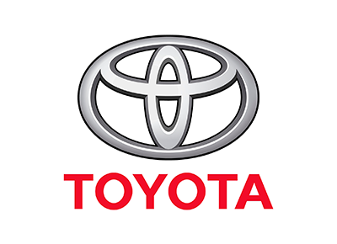
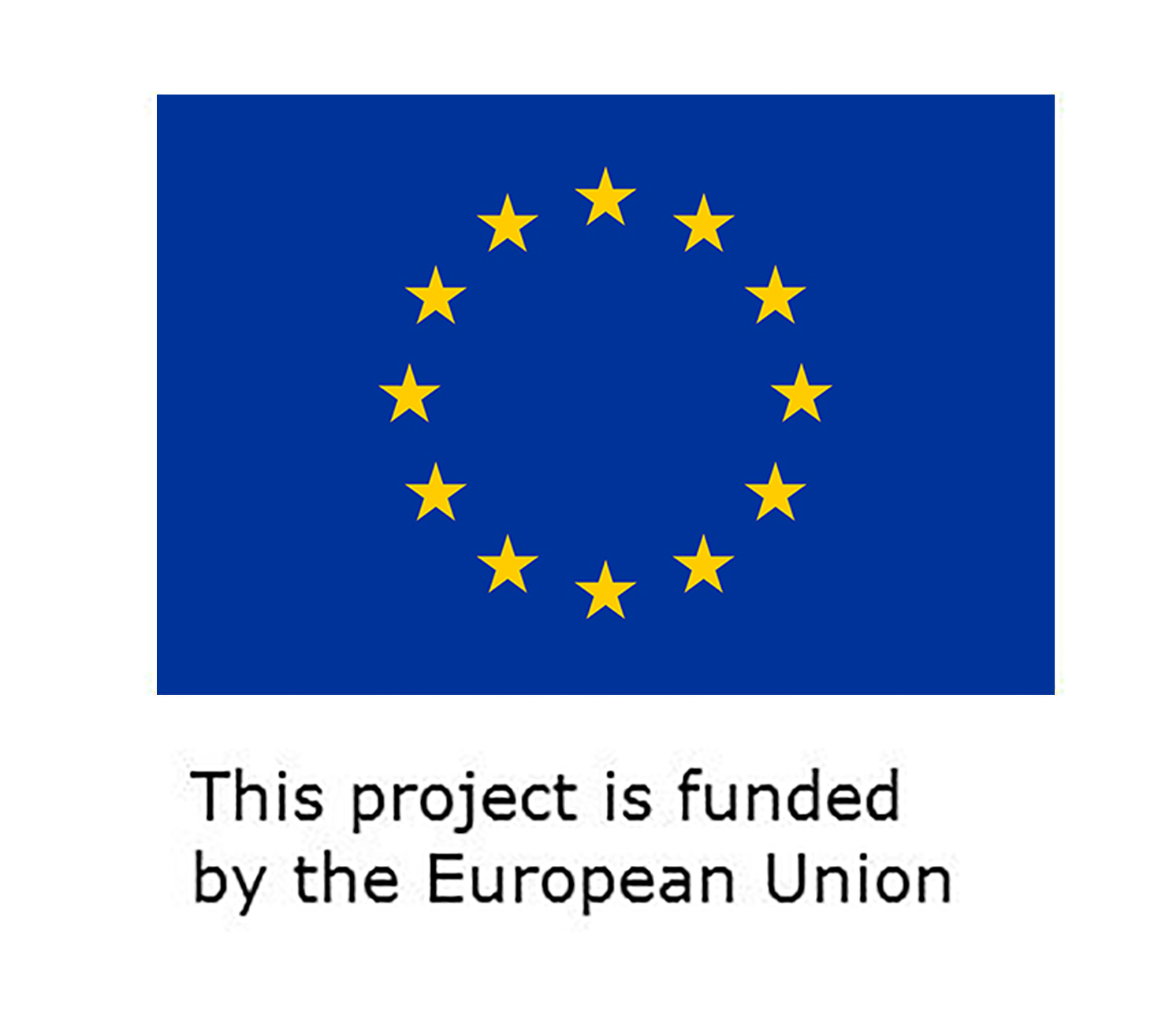

Official Submission Entry Form
Expansion of the Discover Your Talent Programme
1. Details of the participant
(Please provide your details in the below table. Add additional rows if necessary)
Name

Age

Sex

Fluency in Arabic | Yes /No
Education (including year of graduation)

Mailing Address, phone, emails and other contact details

Confirmation of availability to travel to Misrata and spend at Toyota Center three months- January- March 2020

Recommendation letter from the Institute attached | Yes  No
Certificates | Good health certificate attached: yes / no  No criminal record certificate attached: yes/no
If you are an internally displaced person, please elaborate:

The following target localities will be prioritized:

Tripoli, Sabratha, Sebha, Murzuq, Benghazi, Kufra

Please elaborate if associated with them.

2. Motivation letter
Please describe your interest and motivation to attend the training programme in not more than 400 words
You may consider the following elements:
Why would you like to attend the training programme?
How is the programme related to your previous background?
How is it linked to your long term /career goals?

Please submit your entries in writing to: dyt@toyotalibya.ly
Deadline for submission is 30 November 2019

