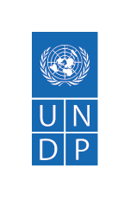
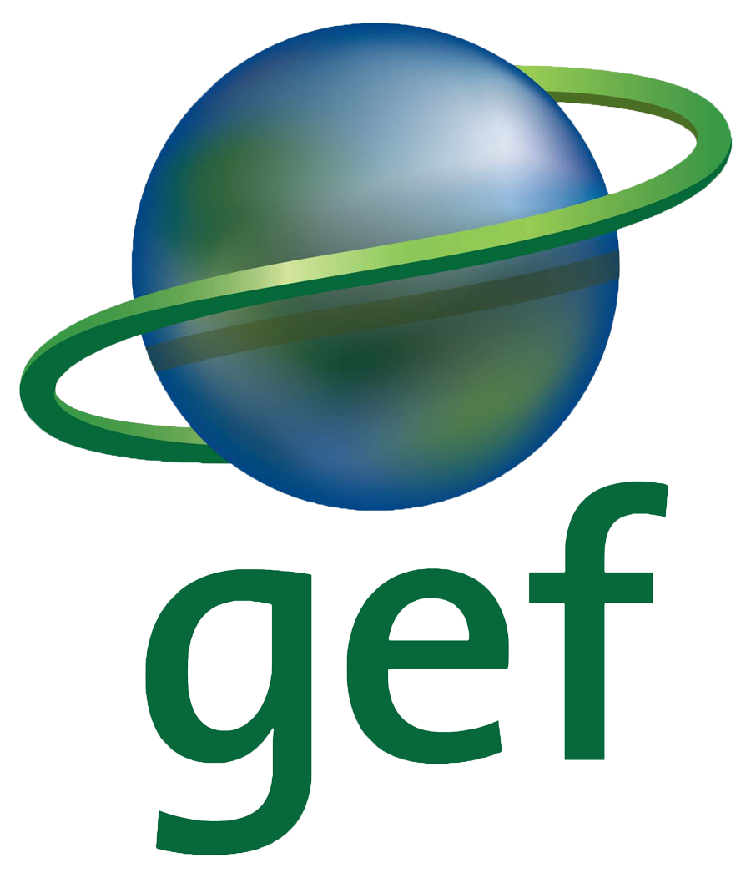
RULES
of the republican video competition
"Time to change"

I GENERAL PROVISIONS

  - Name: Republican competition "Time to Change"

  - Territorial coverage: territory of the Republic of Kazakhstan

II AIMS AND OBJECTIVES

2.1. Aim of the competition. Raising public awareness about the problems and consequences of global climate change through the prism of video works of a wide segment of the population.

2.2. Objectives of the competition:
- drawing public attention to the topic of climate change;
- stimulating representatives of different generations to show interest to the problems of climate change;
- support of media interest in this topic;
- initiating a trend to search for information and understanding what climate change is for Kazakhstan.

III ORGANIZERS AND WORKING BODIES OF THE COMPETITION

3.1. Initiators. The competition was initiated in 2021 by the United Nations Development Programme (UNDP) project on the development of the National Communication of the Republic of Kazakhstan under the UN Framework Convention on Climate Change.
3.2. Working bodies. To conduct the competition, two collegial bodies are formed: the organizing committee and the jury.
3.3. Organizing committee. The organizing committee is responsible for announcing the competition, collecting and registering works submitted for the competition. As part of this body, there is an Expert selection commission, the functions of which include checking the submitted works for compliance with the terms of the competition. The organizing committee is also responsible for the transfer of the registered works to the jury, for summing up the results of the competition, for the timely notification of the finalists of the competition about the victory.
3.4. Jury of the competition. Upon completion of the stage of collecting works for competition, all video works are submitted to the jury. The jury includes experts in the field of geography, ecology, UNDP experts, media specialists.

IV. SUBJECT OF THE COMPETITION

4.1. Video works (no more than 1 minute) are accepted for the competition on how you can change the lifestyle of Kazakhstanis in order to avoid or reduce the consequences of climate change with a creative presentation.

V. PARTICIPANTS OF THE COMPETITION

5.1. Any citizen of Kazakhstan over 16 years old can participate in the competition.

VI. COMPETITION NOMINATIONS

6.1. There are no nominations in the competition.

VII. REQUIREMENTS FOR THE WORKS

7.1.
- Subscribe to the @undp.kazakhstan page on Instagram;
- Tag your friends and acquaintances, who would also be interested in participating in the competition under the contest announcement post on Instagram.
- Create a video (no more than 1 minute) about how we could change the life style of Kazakhstani people to avoid or reduce the impact of climate change in a creative and original format (the main character of the video will be considered as a participant);
- Post the video on your personal Instagram page using #undpkazклимат and #climatepromise hashtags.
- The participant's Instagram page must remain publicly accessible until the winners of the video-contest are announced.

- Please note that video works that previously took part in other competitions are not allowed and will not be considered in this competition in order to avoid violation of copyright and other rights.

- Video works are accepted from October 18 to November 25 inclusive. Videos sent later than November 25, 2021 00:00 Nur-Sultan time cannot participate in the competition.

- Participants who send videos give their consent to the transfer of copyright for the distribution and use of the videos by the organizers and partners of the project, with the obligatory indication of the name and surname of the author of the video.

7.2 Video works submitted for the competition can be in different thematic areas, including:

- Health and climate change;
- Agriculture and Climate Change;
- Climate threat to biological diversity;
- New Energy;
- Water resources and climate change;
- The role of family in informing about the climate.

7.3 Video works that previously took part in other competitions are not allowed and will not be considered in this competition in order to avoid copyright and other rights.

VIII. TIMELINE

8.1. The organizers announce the start of the competition on October 18, 2021. The collection of works continues until November 25, 2021.
8.2. Works received after the specified period do not take part in the competition.
8.3. From November 26 to December 2, the works are evaluated by the members of the jury.
8.4. In the period from December 2 to December 6, 2021, the winners of the competition are determined through a congratulatory post in social media and on the UNDP Kazakhstan website. The winner will be notified by email or phone call.

IX. WINNER'S REWARD CEREMONY

9.1 Participants who won prizes receive valuable prizes from the organizers of the competition.
9.2 The winners will be awarded before December 10, 2021. Prizes will be sent by mail or can be received by the winners at a meeting organized on the occasion of summing up the results of the competition.
9.3 The winners will be sent a message to their Instagram account, within 5 days the winner must provide their contact details for further transfer of the prize. If the organizer does not receive an answer. The prize is awarded to the next nominee.
9.4 All points regarding the receipt of prizes are explained additionally by phone call.
9.5 According to the results of the competition, two winners are determined for each prize place.
9.5 Prizes for the winners of the competition:
9.5.1. 1st Place Prize - bicycle (two items)
2nd Place Prize - backpack (two items)
3rd Place Prize - sleeping bag and yoga set

In addition to the main prizes, the winners are entitled to branded products from UNDP.

9.6 Prizes shown in competition promotions may have a different color and brand.

X. TRANSFER OF COPYRIGHT
10.1. The participant who has sent his videos to the competition gives his consent to the transfer of copyright for the distribution and use of the videos sent by the organizers and partners of the project, with the obligatory indication of the name and surname of the author of the video.

