**Ugatuzi Brief – Volume 4, 2017**

UNDP, in collaboration with national and county governments, UN Women, and UN Volunteers is implementing the Integrated Programme to Support Devolution (2014-2018) project. The project is anchored on the National Capacity Building Framework (NCBF) and organized around five pillars with the following outputs:

1) Policies, laws and institutional reforms at national and county levels;

2) Strengthened institutional and human capacities at national and county levels;

3) Improved service delivery mechanisms and response to opportunities and threats of insecurity and disaster;

4) Strengthened citizen participation mechanisms for effective and equitable service delivery and transparent and accountable use of resources;

5) An integrated service delivery framework pilot implemented.

**Climate Change: From Global Goals to County Realities**

Global negotiations and international environmental governance agreements such as last year’s Paris Agreement are crucial to tackling climate change; however, local action is an immediate imperative that cannot wait. UNDP, together with national and county governments, is taking action to make a difference on the ground.

Climate change is a direct threat in itself and a multiplier of many other threats - from poverty to displacement to conflict. The effects of climate change are already being felt around the world. They are dangerous and they are accelerating.

Antonio Guterres, U.N. Secretary General, May, 2017

At the national level, the integration of climate change into national planning processes is a pre-requisite for sustainability and uniform application of standards across counties. UNDP’s devolution project efforts are bolstered by its strong portfolio of climate change projects and is working with the Climate Change Directorate in the Ministry of Environment and Natural Resources and the Ministry of Devolution and Planning to champion climate change mainstreaming at all government levels.

UNDP has been at the forefront of supporting the evolution of Kenya’s dynamic policy and regulatory terrain around climate change. From the National Climate Change Response Strategy in 2010, to the National Climate Change Action Plan covering (2013-2017), culminating in the Climate Change Act 2016, the country has made tremendous gains this area. Under this Project, UNDP supported Kenya’s ratification of the Paris Agreement in December 2016. UNDP experts also worked closely with the Climate Change Directorate and Kenya School of Government to develop and deliver a training course for national and county personnel on mainstreaming of climate change adaptation and mitigation in planning, budgeting and implementation. A comprehensive certification training course on the use of Geographic Information Systems (GIS) for County Spatial Planning for senior National and County Government officials in collaboration with the United Nations Institute for Training and Research (UNITAR) is also at an advanced stage of being rolled out.

**Climate Change as a Developmental Issue**

There is emerging consensus that climate change is one of the key developmental issue for the globe today. However, in the review of Kenya’s MTP II, it was noted that climate change issues were implemented as a separate project, instead of being mainstreamed. This was partly attributed to a lack of clear indicators in the MTP II indicator handbook for reporting and tracking the implementation of the climate change plan. To enhance tracking and reporting climate change interventions, UNDP is working with the Monitoring and Evaluation Directorate (MED) to support the government to prepare effective MTP III and CIDP II climate change indicator handbook. These were used in the development of the MTP III and will avail clear and achievable set of climate resilient indictors for the country. UNDP will be working with counties to ensure that these indicators are customized and utilized at the CIDP level.

If plans such as the MTP III and new CIDPs are to be effectively implemented with climate change objectives they require solid data and evidence, an appropriate budget, and ongoing monitoring and evaluation. The devolution project supported training at national and county levels to ensure that climate change financing obligations in line with National Policy on Climate Finance as well as the global climate change framework for Kenya are accounted for. This included training on M&E for climate change and disaster risk reduction and management over the next five years.

**Linking Climate Change Adaptation to Better Planning**

Adapting to climate change requires careful planning backed up by accurate data. In recognition of this, the County Government Act of 2012 stipulated that county governments must prepare a ten-year spatial plan using a Geographic Information System (GIS) data base. In turn, this will be a component of the County Integrated Development Plan (CIDP).

**What is GIS?**

Geographic Information Systems (GIS) is a planning tool that has gained popularity globally over the last 50 years. A GIS is generally defined as a collection of digital information technologies capable of capturing, storing, manipulating, analyzing, managing, and presenting data related to positions on the earth’s surface. GIS was developed in the 1960s but its adoption in the early years was limited by high costs associated with their hardware, and the limited capabilities of software. The systems have however experienced dramatic advances over the last two decades, which has greatly enhanced their adoption and usability at all levels of governance.

In Kenya, while the science is still at an early stage of use, it has received a lot of attention in the last decade. In the last few years, GIS has received growing attention on all aspects of development, particularly those related to planning and development related activities. This, coupled with high value systems and reduced costs of the systems, have boosted usability of the systems in the country.

UNDP, in partnership with national and county governments, the Council of Governors (CoG), and CSOs, parastatals, learning institutions, and private companies conducted a county and national level GIS needs assessment. This assessment took place within the framework of county spatial planning needs and recommended that:

* Investment in GIS structures in counties must focus on getting a proper balance between hardware, software, human resource and data requirements;
* Counties must budget for hiring continuous training of GIS professionals;
* A system to promote national institution collaboration with counties for data standardization and sharing as well as knowledge transfer is needed;
* Capacity building will the key to successful adoption of GIS in the counties;
* GIS Guidelines and a GIS centre at CoG are needed;
* Provision of a generic GIS lab structure guideline is urgent.

The next steps are acting on these recommendations and training county officials and other stakeholders to utilize GIS information to produce climate change smart CIDPs.

**Strengthening Kenya’s Resilience to Disaster Through Devolution**

**“An ounce of prevention is worth a pound of cure”**

**Benjamin Franklin, 1736**

This famous quote stands the test of time as disasters in Kenya and around the world continue to cause untold misery. Recurring disasters, particularly droughts and floods, have significantly impacted livelihoods and economic development in Kenya.

Floods and droughts are becoming more frequent, with drought cycles in Kenya now occurring every 2-3 years instead of every 5-7 years. A severe and prolonged drought from 2008-2011 affected 3.7 million people, caused $12.1 billion in damages and losses, and over $1.7 billion in recovery and reconstruction needs. In February of this year the Government of Kenya declared drought a national disaster.

From droughts to floods and fire to disease, disaster resilience is an increasingly critical imperative for Kenya’s governments to consider when planning and budgeting. UNDP is working with all levels of government and the public to develop planning and budgeting platforms to mitigate the human and financial costs of disasters.

The absence of approved policies and legal frameworks at county level are limiting factors for effective and coordinated disaster management. Having a Disaster Risk Management (DRM) policy and a related Bill will help ensure effective governance for DRM.

**For every dollar spent on disaster risk reduction, a country is likely to save four to seven dollars in humanitarian response.**

To support the counties in the formulation of DRM Policies and Bills and legislative drafting, UNDP through the National Disaster Management Agency (NDMA) has engaged the National Disaster Operations Centre (NDOC) and the Kenya Law Reform Commission (KLRC) to support several counties to develop, review and validate their DRM policies.

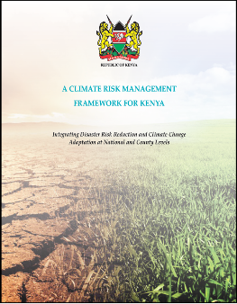UNDP’s Disaster Risk Reduction (DRR) team has also successfully integrated DRR and DRM in seven key policy documents. This includes the development of county level DRM policies, integration of DRR and DRM into new generation CIDPs, as well as mainstreaming of DRR into the MTP III at the national level. In addition, to allow more public access and utilization of county risk information, county hazard maps have been developed and made available on a public website.

Cumulatively, since the project started, UNDP has trained over 800 officers at county and national level to strengthen risk informed policy development and resource allocation. As a result, 38 policies, bills, strategies and other frameworks have been developed or reviewed to ensure legislation of disaster risk reduction in 8 counties and at the national level.

The development of DRM policy and sector policies at county level provides an improved legal and policy environment for counties to undertake a structured allocation of resources for disaster preparedness, response and recovery at the local level.

Hazard and risk assessments are critical elements of good DRM at the county level. They form the foundation for planning and a basis for formulating county DRM policies. UNDP has worked with six counties to produce hazard atlases. This includes training county staff on the utilization of the information in hazard atlases for planning and the county DRM policy.

In Baringo County, with the help of the World Food Programme, the DRM and DRR support has been utilized in the County’s Agriculture Policy with the aim of improving long-term food security.

**Legal Remedies for Environmental Ills**

UNDP and the Green Africa Foundation worked together to help Narok County prepare a Bill that is helping tackle environmental problems by reducing pollution, conserving forests and managing waste properly.

Narok County is one of the largest producers of charcoal which has contributed to deforestation in the Mau Complex, affected the water table, and threatens the rich but fragile Maasai Mara ecosystem. Efforts to ban charcoal burning were hampered by the lack of a legal document to back the move. The Bill now provides this.

The Environment Bill provides stiffer penalties for offenders found engaging in the charcoal business without a valid permit or licence. The Bill states, if a person is found in possession of charcoal without a licence, he or she is liable to conviction and a fine of not less than Ksh 50,000 or to imprisonment for a term of not less than one year. The county will now develop a charcoal policy to regulate the sector.

With the regulation of the sector, a sustainable solution can be found where both the environment and local income generation are protected. The Bill also provides for elimination of plastics from Narok County, in addition to other transformative environmental management measures.







Below is sample idea to show off project PRODUCTS. would need formatting



**Sustainable Development Goals**

**Taking the SDGs from Paper to Planning to Practice**

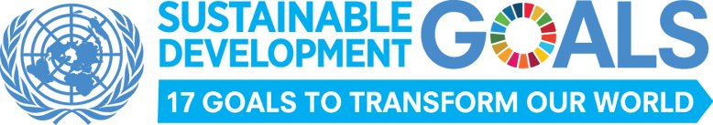Kenya has been a top advocate of Agenda 2030 and was a member of the High Level Panel of Eminent Persons who advised the United Nations Secretary General on the global development framework beyond 2015. Kenya’s Permanent Representative to the UN, Ambassador Macharia Kamau, co-chaired the UN General Assembly Open Working Group on Sustainable Development Goals (SDGs) mandated to develop a set of sustainable development goals. Kenya is part of the 2017 voluntary national review of the high level political forum on sustianable development.

The SDGs are well anchored in Kenya’s development blueprints. From the long-term plans of Kenya Vision 2030, the third Medium Term Plan (2018-2022), and county planning documents, the SDGs are providing a basis for better and more human-centred development planning.

UNDP, in partnership with other UN Agencies and with the strong support of the government at national and county levels, has led the training of county level stakeholders in how to incorporate SDGs into primary planning processes and documents. In addition to training national level officials on the SDGs, UNDP has worked with the Senate to demonstrate how utilizing SDGs can help improve lives and attain Vision 2030’s goals. The Senate’s 2017 Legislative Summit concluded that: *“That there should be continuous consultation between the Parliament, County Governments, National Government and Development Partners to mainstream the planning, legislation and implementation of Sustainable Development Goals (SDGs) through the development framework at the national and county level.*

The Senate’s legislative Summit Implementation Plan dictates that the need for:

**a. Legislation to facilitate the implementation of the Sustainable Development Goals.**

**b. Mainstreaming the SDGs through capacity building.**

At the county level the County Integrated Development Plan (CIDP) is a five-year planning document that sets plans and priorities for a county from which annual plans, budgets, and activities are to be derived. The CIDP offers the perfect entry point to identify the SDGs that match county needs and priorities. UNDP’s training on SDGs targets both county officials, local elected officials, and CSOs on how to interpret and use the relevant SDGs, including their targets, so that these are incorporated in a meaningful way that will ultimately translate into budgeted county government development activities with measurable targets and indicators.

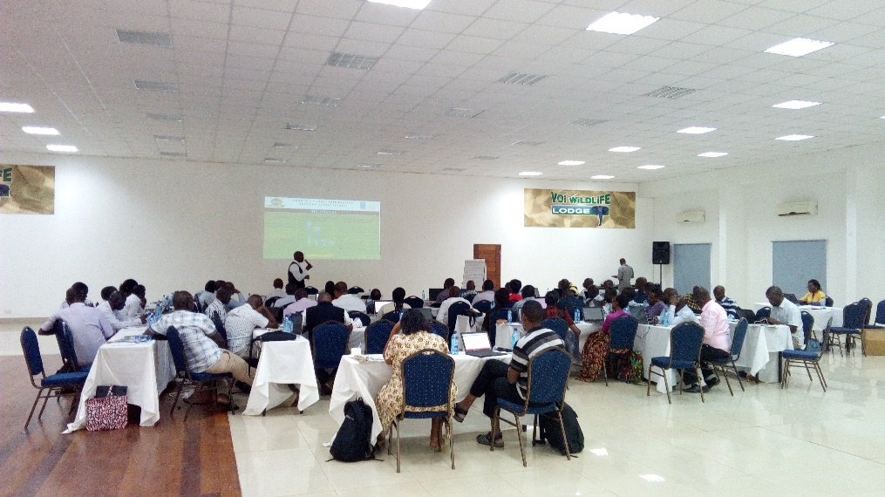

**Taking SDGs to the County**

UNDP is working with Taita Taveta County on an approach that will ensure that the county localizes, mainstreams and sensitizes the public on SDGs that fit county needs.

Training on mainstreaming SDGs in the County Integrated Development Plan (2018-2022) resulted in the creation of a county SDG secretariat comprised of the public & private sectors, development partners, civil society, academia and religious organizations.

“We are quite excited to be the first county to embark on this exercise. When we talk about SDGs, we are talking about transforming the lives of our people. It is critical that we find a mechanism of ensuring that the information generated here is cascaded to the sub counties, the wards and even the villages,” remarked the County Governor (former), H.E Hon. John Mruttu.

Apart from creating awareness among the county officials and Members of County Assembly on the SDGs, UNDP’s training targeted: stakeholder engagement strategies; planning and budgeting for SDGs; results based management for monitoring and reporting and accountability mechanisms for SDGs.

SDG Training in Taita Taveta County

**Gender Equality and Women’s Empowerment in Kenya in Counties\***

The legal framework for gender equality and women's empowerment (GEWE) in Kenya stems from the Constitution of Kenya 2010, national legislation and general rules of international law and treaties ratified by Kenya at the regional and International level in accordance with Article 2 of the Constitution.

These include the Sustainable Development Goals (SDGs) in particular goals 5, 4 and 8; Kenya's Vision 2030, the Medium Term Plans, the Constitution of Kenya 2010, the National Gender and Equality Commission Act (2011), public procurement laws that reserves 30% of all public procurement to special interest groups including women and laws with respect to elections, social protection laws, citizenship among others.

*“I am convinced to reach Africa’s shining destiny of prosperity and security for all, we must simply have women as equal partners in leading and governing ourselves,”*

H.E. President Kenyatta

The Council of Governors (COG), under its project on 'Effective implementation of the Gender Functions at the County Level', in partnership with UN Women, commissioned a rapid gender assessment in ten counties. The assessment examined county progress in gender equality and women's empowerment in the last three years in Kilifi, Meru, Mombasa, Kisumu, Turkana, Kakamega, Vihiga, Trans Nzoia, Wajir and Makueni. The assessment recommended seven key policy options for counties to meet their obligations related to gender equality and the empowerment of women:

1) Gender sensitive CIDPs & annual county and sectoral plans: It is recommended that each county undertakes a gender analysis to understand how gender equality is a key driver of development. Following from this, counties can develop specific gender mainstreaming policies and strategies to guide design, resourcing and implementation of programmes and projects.

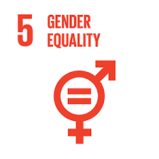2) Institutional strengthening of county gender directorates: All counties need to outline clear institutional roles and organisational frameworks for the promotion of Gender Equality and Women Empowerment (GEWE). The process should assess the human resource needs, financial resources and other institutional requirements such as those related to coordination. Counties, through gender offices, may consider forming strategic partnership with the national gender machinery; the State Department of Gender Affairs, the National Gender and Equality Commission (NGEC) and development partners. Deliberate training on gender mainstreaming ought to be budgeted for and undertaken. Training should target departments of human resources, county planning, county treasury, health, agriculture and education. It is also crucial that the County Public Service Boards (CPSBs) and the County Assembly Service Boards (CASB) are included.

SDG 5: Achieve gender equality

and empower all women and girls

3) Enhanced accountability mechanisms: There is need for counties to develop management and accountability instruments to facilitate gender mainstreaming. These include gender mainstreaming policies and strategies; gender mainstreaming guides and checklists; sex disaggregated data collection and analysis; monitoring and evaluation frameworks that include gender sensitive indicators; the inclusion of gender indicators in performance contracting, drawing on best practice from the national level.

4) Change of organizational culture: There is need to sensitize all organs within the county government structure on the meaning and application of the 2/3 gender principle. This would also call for changing the current narrative that this principle applies only to women and can be done by engaging key actors in the counties and community leaders including religious and cultural leaders.

5) Create an enabling legal framework: There is need to fast track the enactment of public participation, gender balance and diversity bills and policies to provide an enabling environment and implementation of inclusivity principles.

6) Improve the working environment: There is need to have in place elaborate non-discrimination and sexual harassment policies across the county governments. This should also include work to improve the promotion of and their representation at senior levels to ensure a more representative face of county governments.

7) Phasing out retrogressive cultural practices: This can be done through education, legal and policy measures and behaviour change campaigns. The focus should be on enforcing compulsory elementary education for all, particularly in pastoralist communities, putting in place policies to make education accessible and affordable. The national and county governments ought to work on a framework to review the curriculum of adult education to make it more relevant and accessible. This will improve the well-being of women and girls in these counties and their participation in development.

**What is Gender Responsive Budgeting?**

Gender responsive budgeting (GRB) is a means of integrating a gender perspective into all steps of the budget process — planning, budget allocation, implementing and monitoring/evaluating and reporting — so as to ensure that budget policies take into consideration the gender issues in society (UNESCO, 2010) GRB does not involve creating separate budgets for women and girls, or simply increasing specific budget allocations directed to these groups. Males and females have different needs and priorities, warranting differential allocations of expenditure based on these needs and priorities. The basic idea therefore is to ensure that spending serves the needs and priorities of women and men, with an aim of reducing gender inequalities.

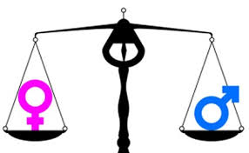

* Condensed excerpt from the Council of Governors’ Gender Policy Brief produced with UN Women through the UNDP Devolution project

**Empowering Women in Vihiga County**

A revolution began in Vihiga County in 2017 when the county assembly’s female leadership went on a mission to ensure that gender mainstreaming is felt by all. UNDP responded to a request from these MCAs and trained twelve female MCAs to develop their capacity in leadership, governance, and social empowerment. After the training, the women leaders committed to promote solidarity among women in general and among women parliamentarians in particular. Their aim was to: influence policy and legislation from a gender perspective; raise awareness of gender equality issues in parliament; enhance the capacity of women parliamentarians as effective legislators and representatives; ensure that gender policy and legislation is effectively implemented. The women leaders presented a motion in the assembly to formalize the registration of a women’s caucus as an organ of the county assembly and on March 14th the Vihiga County Women Caucus was launched.

“Our main aim of forming the women caucus was to bring together the women of Vihiga County and to know the problems the women were facing. For example, we mobilized women between the ages of 35 - 70 from across the county and trained them on economic empowerment skills, “said Hon. MCA Maureen Ambasa. Already 100 women from the county’s five sub counties have been trained on Financial Management and Entrepreneurship.

*“The people who drafted the constitution of Kenya had big dreams for women, hence women need to be vigilant in ensuring that they are represented at all levels of leadership. Women should aim to achieving more than the largely mandated 1/3 representation”.*

Vihiga Deputy Governor (former), Hon. Caleb Amaswache.

After the training on Financial Management, the women groups were taken for an exchange program, where they learnt from a group of women in the informal settlements of Soweto, Nairobi. “The Soweto exposure made us discover that with better financial skills, it was possible to do more than just saving,” says another trainee, Ms. Nancy Salano.

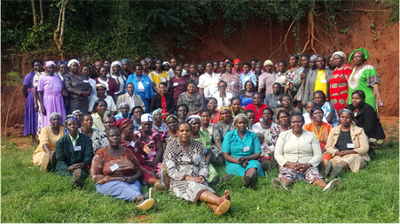At the end of the year, Ms. Salano’s 36-member group had saved over KES 700,000(USD 7000). “Usually, at the end of every year, we would share our savings amongst ourselves and start saving again the following year but after seeing how the women of Soweto had used their savings to better their livelihoods, we decided to try it their way and so at the end of 2016 instead of distributing all the money among ourselves, we opened a new savings account where we deposited KES 360,000 - half of the total savings, and then shared the remaining half within the group. The training and exchange program has been an eye opener; a starting point in our lives. It has made us know that we can better our livelihoods from just where we are; we have the resources we need to improve our lives. Something we did not know. “

“Our political representation should be more substantive than descriptive. Our presence should add value and not merely recognize gender equality. We are proud when we hear the stories of these women who have been trained through the caucus initiative,” remarked the Caucus chairperson, and one of the elected MCAs, Hon. Elizabeth Okila.

Please insert text on what this group photo is e.g. Vihiga women caucus pose for photo during a women’s empowerment training

Back Cover: update and/or change to new

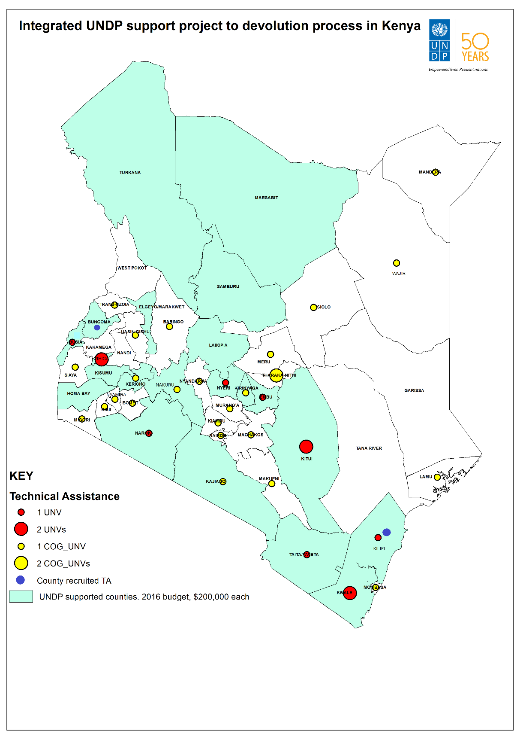

For More Information Contact:

United Nations Development Programme

United Nations Office in Nairobi, Block M, Level 3

P.O. Box 30218, 00100 Nairobi, Kenya

Phone: +254 20 7624394, email: [registry.ke@undp.org](mailto:registry.ke@undp.org)

[www.ke.undp.org](http://www.ke.undp.org)

Like our Facebook page: insert Facebook logo: UNDP Kenya

Follow us on: Twitter logo @undpkenya

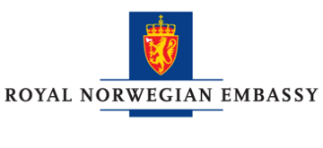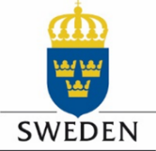The project is generously supported by the U.K.’s DfID programme, USAID, Sweden, and Norway.

