SECURE Himalaya Project
National Competition – Logo & Tagline; Illustrations

The SECURE Himalaya National competition on Logo-tagline and illustration was launched on 15 September 2018. The two categories for the competition were i) Illustration ii) Logo and Tagline. The theme for the competition was Protecting Wildlife, Preserving Landscapes & Empowering Local Communities.
Each category had two prizes. The prize for a winning entry was INR 50,000/- and the runner up prize was a trip to Hemis National Park, Ladakh, Jammu and Kashmir. The competition was announced on 15 September 2018 with a deadline of 31 October 2018, which was extended to 5 November 2018. It was open to all age groups. The announcement was spread across all states through social media (web and mobile), web portals, national newspapers and posters. We received more than 1000 entries.
Total Logo & Tagline Entries | Total Illustration Entries | Total Entries  (Logo & Tagline and Illustration)
755 | 320 | 1075

The entries were evaluated by a panel that comprised of experts in the field of communication design, biodiversity and natural resource management.
Illustration Winners and their design:
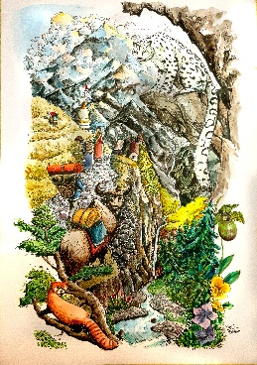
David Yambem’s artwork won the first prize in the illustration category. Yambem is from Kakching, Manipur but stays in Delhi. He is currently studying design and is an illustrator by profession.

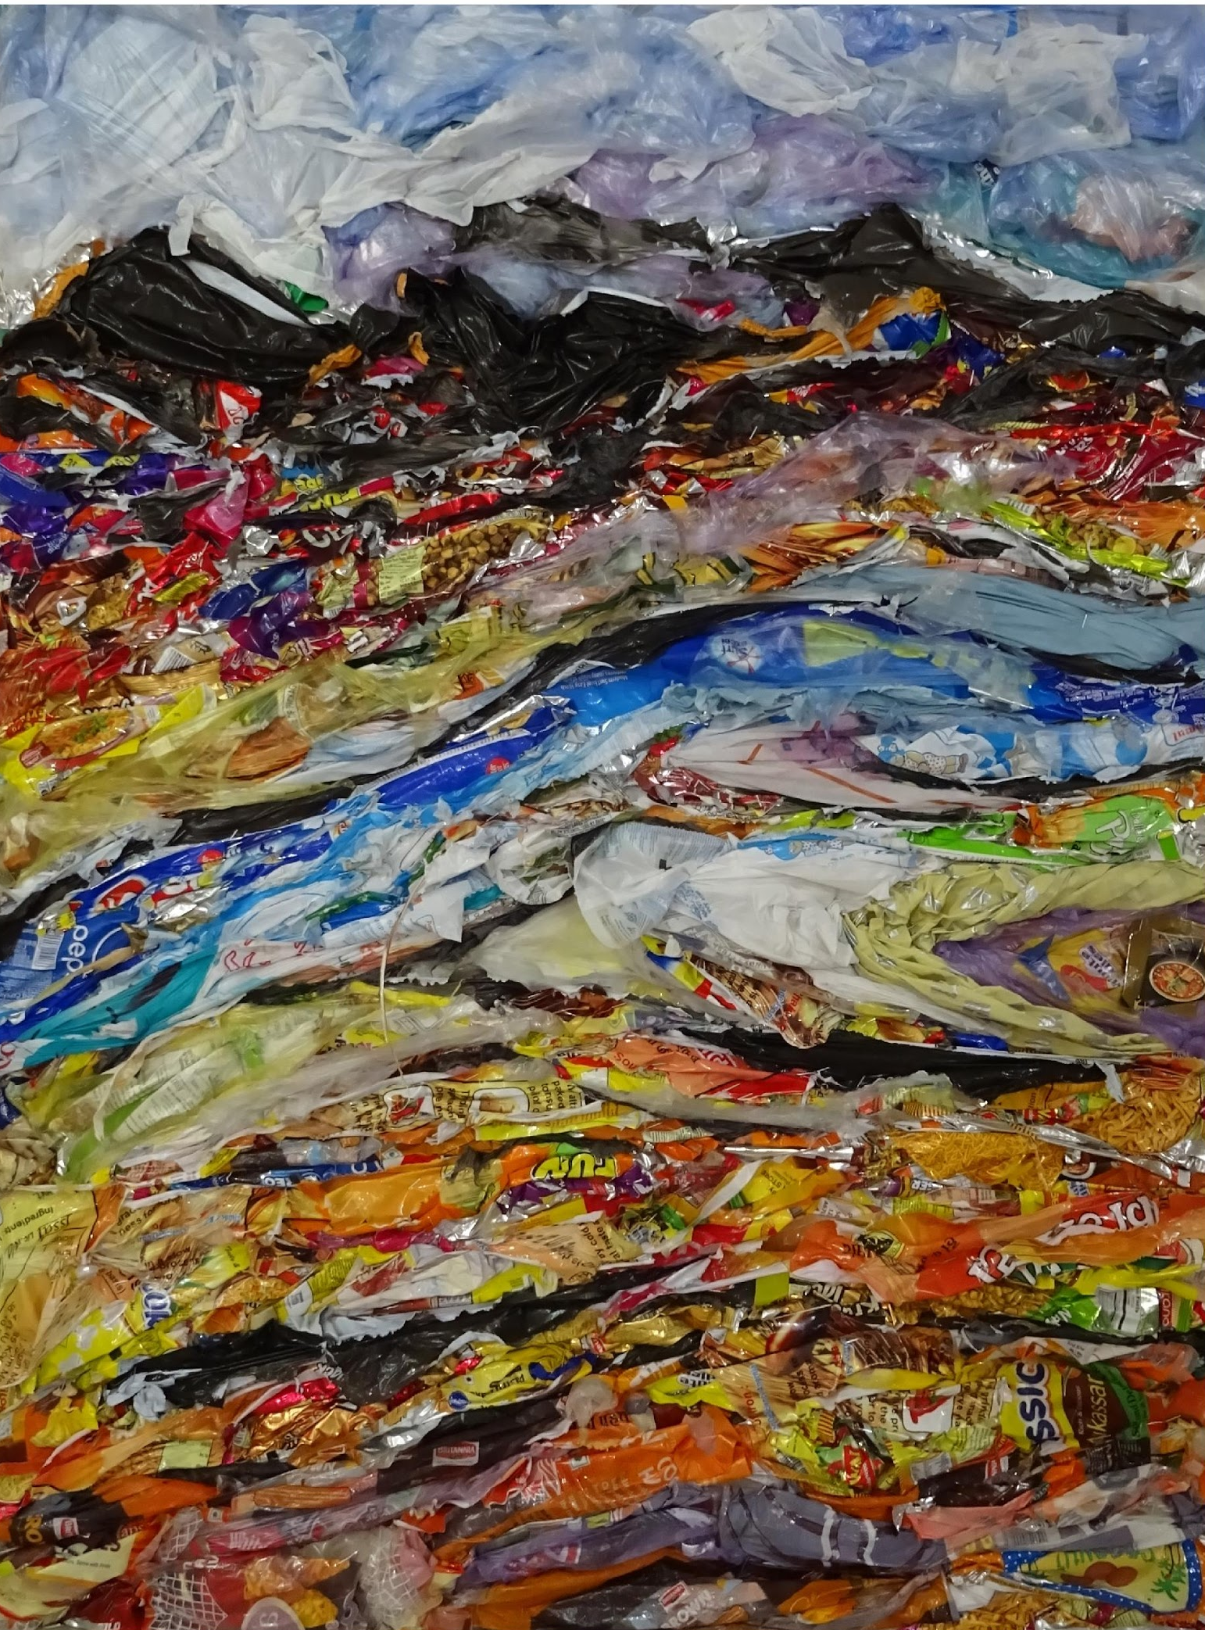
Manveer Singh’s unique artwork won the second prize in the illustration category. Manveer is from Delhi and has completed his B.F.A & M.F.A from College of Art, where he now teaches. He has participated in many art festivals and events. Currently, he is working on a project which is transforming trash into art, also showcased in his entry.

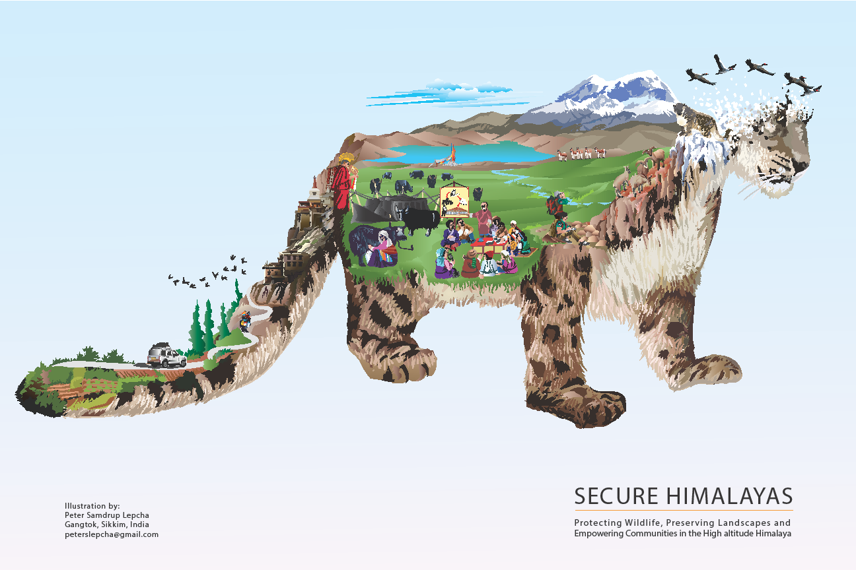
Peter Samdrup Lepcha’s artwork also won the second prize in the illustration category. Peter is from Gangtok, Sikkim and is an illustrator, artist and graphic designer by profession. He works as a freelancer for organizations like: GIZ, The Mountain Institute and WWF India.

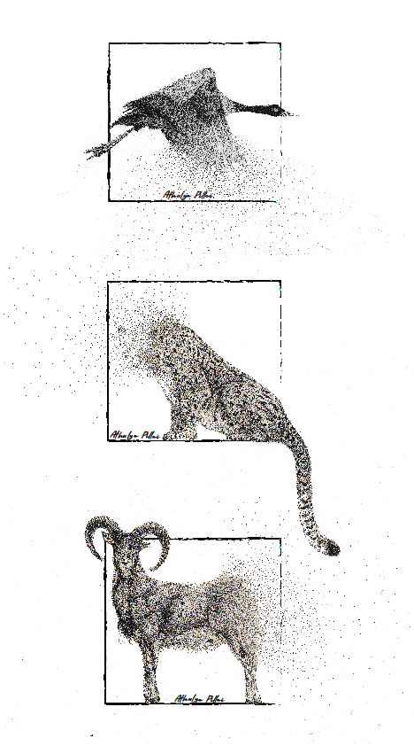
Athulya Pillai’s artwork won a special mention in the illustration category. Pillai is from Kochi, Kerala, is an illustrator and currently works in Ladakh. She illustrates everyday life in her spare time.

Logo & Tagline Winners and their design:

Apurva Chandrakant Raikar won the first prize in the logo and tagline category. She is a product designer at Lemon Yellow LLP- A design company based out of Thane, Maharashtra. Her Tagline is “TIME TO ACT”

Jaimini Patel won the second prize in the logo and tagline category. She is from Ambalia, Rajkot and is studying visual communication at Karanavati University, Gandhinagar. Her tagline is “Their survival is in your hands”.

Sakshi Gaggar also won the second prize in the logo and tagline category. She is from Mumbai and works at a design consultancy in Mumbai. She recently graduated from Srishti Institute of Art, Design and Technology, Bangalore in Visual Communication and Strategic Branding. Her tagline is “Protect Nature's Sublime Mark"

