About UNDP

F
or the last 50 years, UNDP has been working to reduce poverty and inequality and foster human development. We are on the ground in 177 countries and territories, and offer global perspectives and local insights to help people improve their lives.

UNDP has been supporting Indonesia’s development since establishing an office in the country in 1970. Since the 1990s, UNDP has been particularly supporting Indonesia in its transition to democracy and economic reforms. It has helped alleviate poverty and reduce vulnerabilities. UNDP has also promoted the adoption and implementation of policies for environmental protection. When disasters strike, as in December 2004, UNDP works with partners to provide relief and early recovery, as well as building resilience and better risk management.

UNDP works in close partnership with central and local governments, civil society, the private sector, and communities throughout the country. As part of the UN system, it also works closely with other UN agencies. UNDP assistance benefits from the financial support of bilateral donors that allow for stronger positive impacts on Indonesia’s development and people’s lives.

Development in Indonesia
I

ndonesia has made significant steady progress since gaining independence. The country is now at middle-income status, and has a GNI per capita of USD9778. The economy is now 16th biggest in the world. Human development in Indonesia has also significantly improved. The Human Development Index (HDI) raised from 0.474 in 1980 to 0.684 in 2014, making the country one of the top ten worldwide in human development progress over the period and placing it in the medium human development category. Indonesia has also been successful in working toward the Millennium Development Goals, making considerable gains in poverty reduction, health, and education. Between 2000 and 2015, the proportion of Indonesians living below the national poverty line fell from 19 per cent to below 11 per cent.

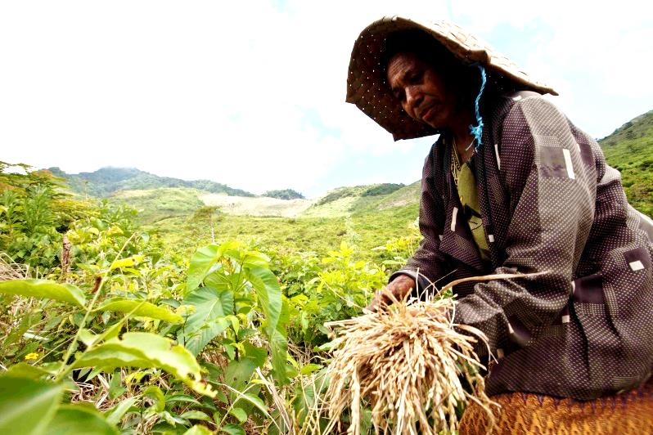

But progress has been uneven and remains marked with significant regional, urban/rural, and gender disparities. In 2016, there are still 28 million people living below the national poverty line. In the Papua region, poverty rates are twice the national average. Large sections of the population lack access to basic services, with only 68 per cent, mainly those in urban centers, with access to safe drinking water and 61 per cent to sanitation. Women continue to have less access to education, employment, and services. Between 2002 and 2013, income inequality increased by 24 per cent and the Gini coefficient has worsened to 0.413 from 0.329 in 2002.

Long-term development in Indonesia is jeopardized by environmental degradation and climate change. The country’s economic growth has been largely driven by the extraction of natural resources at the expense of the environment. Indonesia is also one of the world’s top emitters of greenhouse gases, and the deforestation rate is one of the highest in the world.

For Indonesia the challenge now is to generate the growth it needs to reduce poverty and inequalities and at the same time protect natural resources and long-term development prospects.

UNDP-Indonesia Partnership For the SDGs

Examples of Joint Development Results
UNDP’s support has yielded concrete results in policy changes and improved lives. Some examples are:

- Indonesia Democracy Index – measures progress of democratic governance in all 34 provinces in the country through such means as public participation and the state of political parties, and provides a policy planning tool for government institutions
- A national law on Social Conflict Management, which extends greater power to subnational governments to tackle communal conflicts
- Indonesia Forest Governance Index – At the national and provincial levels, the index analyses the current state of forest governance in Indonesia’s most forested provinces and analyses the drivers of deforestation
- At the grassroots level, more than 20,000 Indonesians benefited from a legal aid bill that UNDP supported. The bill permits legal aid to be channeled through non-governmental organizations, which allows for easier access to services

In September 2015, the Executive Board of UNDP approved a new Country Programme for Indonesia covering the period 2016 to 2020. Under this new Country Programme and in line with the Government priorities, UNDP supports Indonesia in addressing the remaining and emerging challenges to progress on its development path and achieve the SDGs. UNDP and its wide range of partners are working together to maximize the synergies between the SDGs and national development strategies, in particular the Nawacita and the Medium-Term Development Plan (RPJM).

- Reducing poverty and inequalities

Reducing poverty and inequalities will remain a key area of UNDP’s work. At the policy level, UNDP conducts research and analysis to identify key issues and formulate recommendations, taking into consideration the national and local context as well as up-to-date international experience. UNDP policy work is informed by grassroots-level projects that focus on poor and near-poor women – particularly those based in rural areas – and poor forest-dependent people who live on less than USD2 per day. Approximately 17 million smallholder farmers are being prioritized. UNDP targets provinces lagging furthest behind in human development, in particular East Nusa Tenggara and Papua. In Papua and West Papua with support from New Zealand, UNDP contribute to local economic development through skills development programme that help initiate and revive local businesses and created jobs for the indigenous population, in majority poor women.

- Mitigating and adapting to climate change

Recognizing that Indonesia needs to adopt a sustainable development path, UNDP supports the country in its transition to a green economy model that takes into consideration long-term development prospects as well as the impact of climate change. UNDP supports natural resource management to protect Indonesia’s vast expanses of tropical forests, rich seas and unique biodiversity. A major programme is Reducing Emissions from Deforestation and forest Degradation (REDD+) financed by Norway. UNDP also support the Indonesian biodiversity strategy and action plan (2015-2020). In the energy sector, UNDP provides policy advice and implements pilot projects for enhanced access to energy, improved energy efficiency and the development of renewable energy to help Indonesia achieve its objective of 23 per cent of renewable contribution in primary energy in 2025. UNDP supports the formulation of national energy efficiency standards and labeling regulations for home appliances and the adoption of regulations to accelerate investments in renewable energy sources. UNDP also aims to support the nationwide application of the Indonesia Green Economy Model (I- GEM), a model that aims to inform policy planning for the long-term transition from a brown to a low carbon footprint.

- Consolidating democracy and access to justice

Governance is core to UNDP’s mandate and remains a crucial area for Indonesia’s development. To accompany the strengthening of democracy, UNDP and Australia supports the Indonesia Democracy Index that analyses progress and identifies areas where more gains can be made in civil liberties, political rights and the institutions of democracy.

UNDP works with the Government to strengthen the rule of law and access to justice and protect rights, in particular those of vulnerable groups. Through 2019 in a partnership between UNDP, the European Union, and the Supreme Court, support is being provided to build the capacity of judges, increase transparency in court functioning, and improve the quality of justice services for all Indonesians. UNDP is also supporting the improvement of the customary court system in Indonesia’s provinces of Aceh, Central Sulawesi and Central Kalimantan to make it more compatible with international human rights standards and national laws. The customary court system is often the only platform available for marginalized communities, particularly those in remote areas, to settle disputes and achieve justice.

- Supporting Indonesia’s engagement in global issues and South-South Cooperation (SSC)

As an emerging country and a provider of development cooperation, Indonesia plays an important role in global development. UNDP works with the Government to support Indonesia’s international engagement, in particular for the 2030 agenda, the Global Partnership for Effective Development Cooperation and the G20. Together with Norway, UNDP supports the Government of Indonesia in enhancing the effectiveness of its South-South Cooperation through the provision of policy recommendations and the sharing of experience from developed and developing countries as well as its own. UNDP supports the formulation of the strategic directions for SSC, the strengthening of the regulatory framework and institutional building. With Indonesia and partner countries, UNDP is engaged in triangular cooperation where it can combine its experience and knowledge with that of Indonesia.

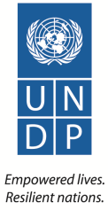
United Nations Development Programme Indonesia

Menara Thamrin Building 8-9th Floor
Jl. MH Thamrin Kav. 03
Jakarta 10250, INDONESIA
Email: suryo.tomi@undp.org
Website: id.undp.org

