EXPANDING THE YOUTH INNOVATION SPACE
Highlights of E-Workshop

© June 2020

Introduction

Youth impact series
These are highlights of the 3rd session of the ‘Youth Impact Series’ on Expanding the Youth Innovation Space in Ghana. This is part of UNDP’s Support for youth as drivers of policy change within the framework of economic and strategic policy. While the youth innovation space exists in Ghana, the conversation suggested that this must be doubly expanded. The key policy change suggested through this conversation is one of learning curricular because the biggest challenge is lack of mentorship, coaching and networking. Everyone, the conversation suggested has a role to play in expanding this Youth Innovation Space. The key next action is to map out the Youth Innovation Space to enable an ecosystem action.

The ‘Youth Impact Series” is an initiative of the United Nations in Ghana coordinated by the United Nation Population Fund (UNFPA) to increase young people’s awareness on prevention, protection, response to COVID-19. The series often attract participation from Ghana, across the continent and worldwide. The maiden edition saw over 300 participants from 13 countries. The second edition was hosted by UNESCO and on the impact of the pandemic on Education.

Methodology
The session was held online via Zoom for 1 hour on the 11th June 2020 from 2pm to 3pm. The session was attended by 345 youth from 17 countries, with 82.9% from Ghana, 11.0% rest of Africa and 6.1% from the rest of the World.
It was a panel of 4 resource persons moderated by Mr. Emmanuel Kwasi Afriyie, an astute journalist with an interest in business development. Mr. Oliver Boachie was from the Ministry of Environment, Science, Technology and Innovation (MESTI) which is a public institution with innovation policy oversight responsibilities. Dr. Gordon Kwesi Adomdza of the Ashesi University Design Lab an academic innovation lab that is proactively incubating entrepreneurs. Mr. Joshua Opoku Agyeman is the President of Internet of Things Network Hub. Zulaiha Dobia Abdullah is a co-founder for Divaloper; Chineyenwa Okoro Onu is a Social Entrepreneur, Environmentalist and An Enabler.
The following questions guided the discussion:
- How would they characterize the youth innovation space? Is it wide open or are there critical bottlenecks that must be addressed? What are those bottlenecks?
- What policy shifts do they see need to happen to expand the youth innovation space?
- Any suggestions on how young people can best be supported to fully tap into their creativity and innovative capabilities?
Interactions from participants in the form of questions were admitted in the chat box and were channeled into the discussion by the moderator. Four online polls were conducted to avail participants the opportunity to contribute to the discussions.

Emerging Areas of Action

Expand the Youth Innovation Space
The question to participants was for them to describe the current space for youth innovation along a continuum – doesn’t exist; not wide and open; relatively wide and open; and very wide and open. One hundred twelve (112) participants responded to this question. About 47.4 percent were favourable, that it is at least relatively wide and open; the others (52.7 percent) thought otherwise.
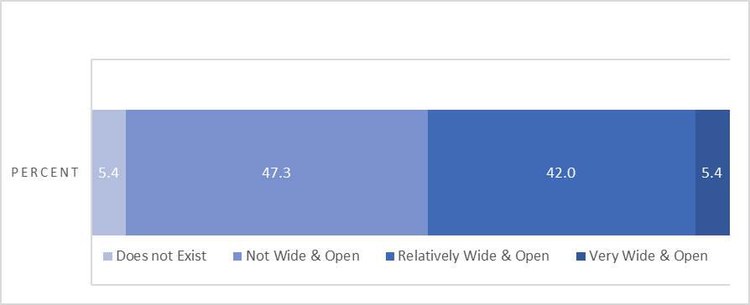

Partners must Collaborate
There was consensus both from the discussion and from the survey that partners must collaborate in the same space. When asked who they see as the key players in the area of innovation, none dominated, even though academia came on top. The call was for academia, industry, government and donors to support the expansion of the Youth Innovation Space.

Tackle critical Challenges

The top three critical challenges identified through the survey were: mentorship, coaching and networking; funding opportunities, and mindset shifts. The discussion focused on specific aspects that were thought to amplify these challenges, notably: predominant stereotypes especially for girls; soft skills for young people; the policy awareness and communication gap; and an enabling environment.
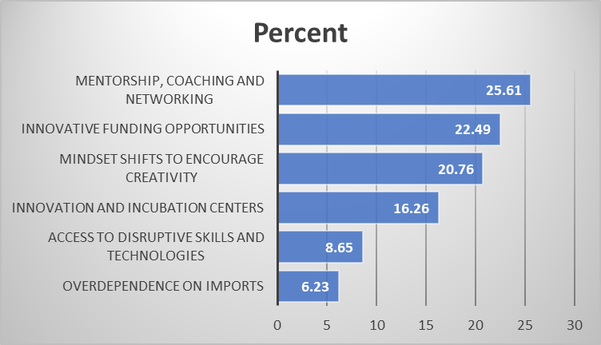

- Breaking predominant stereotypes and empowering girls, especially in rural areas where the majority of Ghanaians live: The predominant stereotype thinking particularly for girls in and of rural communities is perceived to be a major bottleneck. Nurturing youth mentors, role models for both girls and boys, intensifying grassroot public sensitization are critical. The broad consensus was that young people should be enabled to reimagine themselves, improve their knowledge about current trends, enhance their skills, become passionate and courageously venture into new territories in innovation and entrepreneurship for employability and economic self-reliance.
- Building the soft skills of young people to innovate: Participants pointed to the need to begin teaching and exposing young people from early ages to think and act innovatively. They need to be made to appreciate the practical importance of generating ideas which solve everyday challenges around them, so that they can from their early years in life work on actualizing these ideas into prototypes which can be scaled as marketable innovation solutions. Young innovators are also encouraged to build good communication, digital, negotiation, networking skills which utilize existing technologies to actively engage potential partners and supporters.
- Creating an enabling environment for innovation: Participants concurred on the need for an enabling environment. An environment that has the right incentives, laws and policies that enable and protect innovations. Providing education and statutory support on issues of patenting innovations came up prominently. The issue of incentivizing, particularly, technical vocational training, came out of the conversation. This would prepare young folks for their innovation journeys.

Make specific policy shifts
The participants made suggestions on policy changes that must happen to Expand the Youth Innovation Space. The top 3 policy shifts include: policies related to education curricular across board to institute innovation; policies on participation of young people in decision making; and attractiveness of vocational education.
