UNDP GHANA GOVERNANCE UPDATES
UNDAF OUTCOME 10 (Political Governance)

Issue Date: 31st August 2013

Dear Readers,

Welcome to the first edition of UNDP Governance Programme Update, the periodic journal under UNDAF Outcome 10 (Political Governance) to help inform staff and colleagues about governance programme implementation and governance events in the country. Issues featured in this edition include:
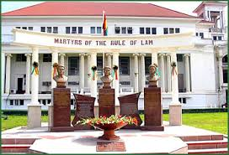

- 2013 UNCAC Review of Ghana
- Customs Baseline
- NACAP Review by Parliament
- Governance Assessments & Social Accountability
- Access to Justice and Prison Decongestion in Nsawam
- National Peace Architecture
- Ghana Conflict Mapping
- Constitutional Review Implementation
- Youth in Governance
- Decentralization

We wish you happy reading. Should you have any comments or questions, please contact Jane Owiredu Yeboah, Head of UNDP Governance Cluster at jane.o.yeboah@undp.org.

Consolidating Transparency & Accountability: Anti-Corruption Efforts

UNCAC Review: Ghana is scheduled to be peer reviewed by Swaziland and Rwanda under the United Nations Convention Against Corruption (UNCAC) in October 2013. Although UNCAC came into force on December 14th 2005, Ghana ratified the convention in 2007 and it was only in 2011 that the UN established mechanisms for implementation of the Convention. This first cycle of the review involves 10 countries and focuses on criminalization, law enforcement and international cooperation. UNDP is supporting the Commission on Human Rights and Administrative Justice (CHRAJ), which has been designated as the focal point for the review. With UNDP & UNODC support, and to meet the first requirement, a steering committee comprising 15 governmental experts on corruption were appointed and trained on the review processes and their roles. The steering committee and governmental experts, jointly collected data for the completion of a self-assessment checklist which will guide the reviewing countries. The completed checklist has been submitted to the reviewing countries through UNODC, the official UN organization coordinating the review, on the 15th of July, 2013. The checklist revealed a few issues, including:
- The lack of a proper database and information on anti-corruption in the country. This impacts tracking of anti-corruption cases for effective management and control.
- Anti-corruption issues are not institutionalized but most information is found with individuals; there is also a general lack of coordination and information exchange among anti-corruption institutions.
- The current anti-corruption laws are not backed by regulation, leaving much interpretation and subjectivity.
- Most anti-corruption laws are outmoded and do not meet current global practices.
NACAP Implementation: CHRAJ, the state institution mandated to combat corruption in Ghana, in collaboration with stakeholders, developed a comprehensive 10-year National Anti-Corruption Action Plan (NACAP) in December 2011. The plan, which contains various initiatives and programs to address corruption in Ghana, has not yet been adopted by parliament. UNDP support to CHRAJ therefore facilitated the engagement of the Parliamentary Select Committee on Corruption in a three day immersion meeting on the NACAP in June 2013 at Koforidua. This meeting sought the Committee’s support to facilitate NACAP’s adoption by Parliament and built the capacity of CHRAJ staff to investigate corruption cases. 21 CHRAJ staff have received capacity building to conduct systemic investigations into corruption in public institutions. Members of Parliament proposed some minor edits to the plan which have been incorporated and resubmitted to Parliament pending approval.
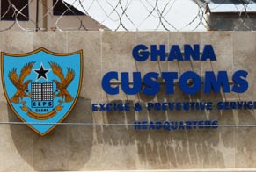

Customs: The Customs Division of the Ghana Revenue Authority is the second most corrupt institution in Ghana according to a 2011 Ghana Integrity Initiative perception survey. As an agency who has shown interest in redeeming its image, Customs is being supported to conduct a baseline survey on corruption and internal processes within the Division. The draft instruments for data collection for the baseline have just been completed and are undergoing a thorough technical review by UNDP, Customs and experts from UNDP’s Regional Service Center in Addis Ababa. Once the instruments are finalized, consultants will visit the 15 entry/exit points of customs to engage both officers and clients and collect the necessary information. The baseline findings are expected to underline a major reform within the customs division to address corruption and improve processes for greater efficiency and transparency.
UNDP also conducted a TOT on integrity and ethics for 30 custom directors in July. In support of efforts to redeem their image, UNDP supported the development of a communication strategy which has been approved by the Commissioner of Customs for implementation to sensitize clients and the general public on customs rules and procedures.

Governance Assessment and Social Accountability

Governance Assessment: Since 2004, the Ghana National African Peer Review Mechanism (APRM) is mandated to coordinate and manage a non-partisan and informed assessment of the APRM in Ghana, to promote good governance, and effective and efficient service delivery. UNDP, since 2012, has supported APRM to pilot the use of mobile technology to collect data for governance assessments as a complement to the community score card methodology. This led to a 49% increase in the number of individuals covered from 11,078 in 2011 to 16,512 with women participation at 43.8% and the youth constituting 47%.
Respondents noted that public services, especially electricity supply, health services and sanitation had worsened with 22% noting a decline in the quality of education. When asked to note which public services improved during the past 12 months, very few respondents (12%) reported improvements in any services, leading to the often repeated observation and overall perception that public services are going downhill.
Social Accountability Project: To assure inclusive and participatory governance, citizens’ voice have to be included in decisions at the national, regional and district levels. UNDP is this year supporting three social accountability initiatives. Two of the projects implemented by the Ghana Anti-Corruption Coalition (GACC) and the Centre for Democratic Development (CDD) focus on building CSO capacity to lead the demand for accountability and transparency at the local Assembly level.
GACC have organized an engagement with officials of Metropolitan, Municipal and District Assemblies (MMDAs) in three regions for them to appreciate the need for the involvement of CSOs in their planning and budgeting processes. CDD is forming local accountability networks, whose capacities will be built to demand accountability from their local government officials, based on a capacity assessment that was conducted by UNDP in 2012.
The third Social Accountability project is a collaboration with the Regional Service Centre and Star Ghana to promote transparency and accountability in the Health Sector of Ghana, specifically to assess the effectiveness of the National Health Insurance Scheme (NHIS). Implemented by the Ghana Integrity Initiative (GII), the local chapter of Transparency International, the
NHIS Community Scoring at Kedjebi in the Volta region, Ghana Aug, 2013
project targets 24 communities in six regions, (Central, Eastern, Volta, Upper East, Western, and Brong Ahafo) with UNDP funding implementation in four regions. The ‘Community Score Card’ methodology is used to engage citizens in an extremely inclusive and participatory manner, with special focus on the elderly, youth, women and persons with disability. Women constituted approximately 60% of participating community members. Two regions, Central and Volta regions have so far been covered.
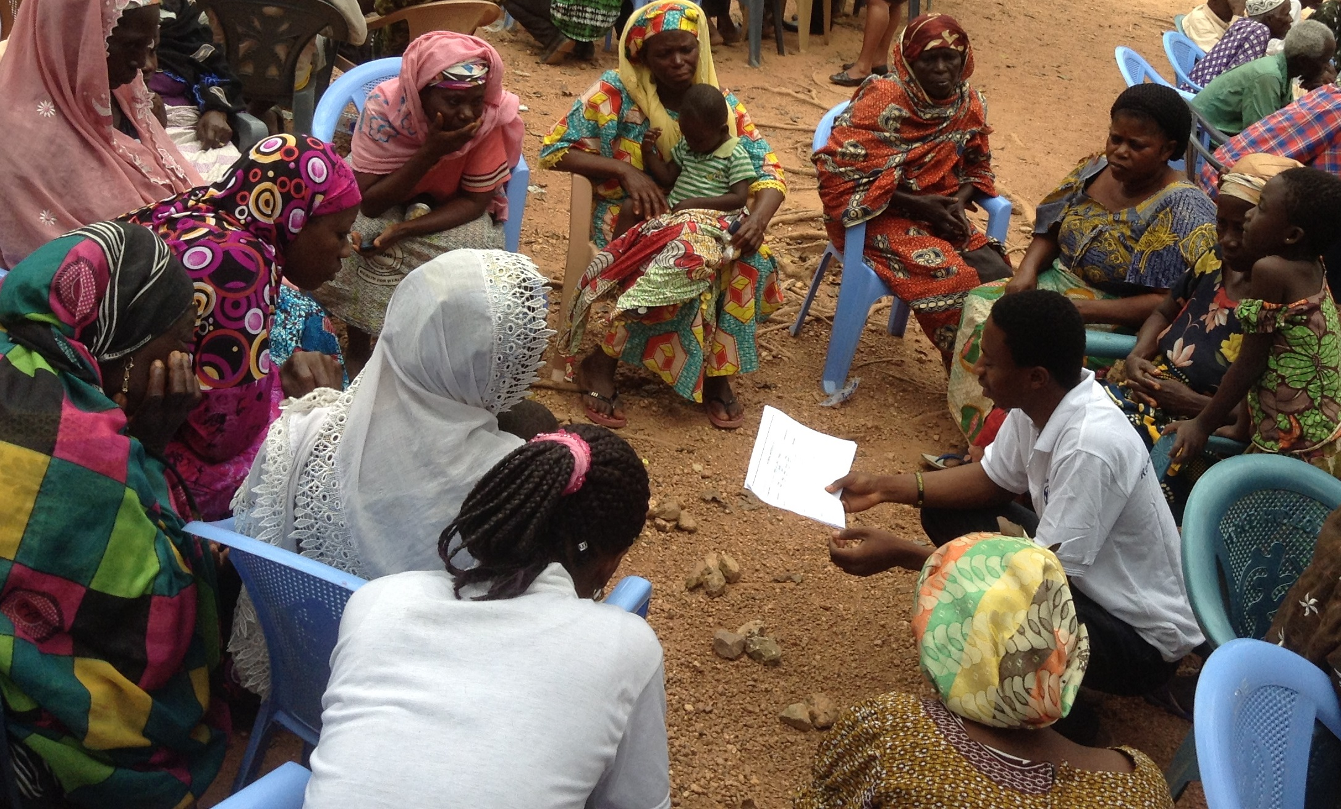
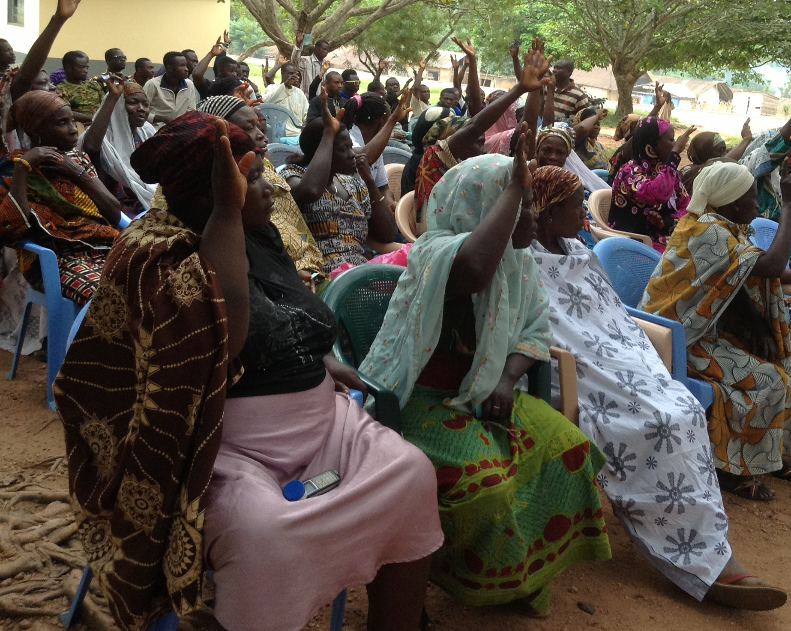

NHIS Community Scoring at Kedjebi in the Volta region, Ghana Aug, 2013

During a recent mission to the Volta region, both community members and health personnel stated that this is the only platform available to them to address and assess public services. Issues raised by community members and health personnel’s include:
- Limited knowledge of NHIS by both patients and institutions, which serves a basis for corruption and extortion of money;
- Poor quality of health services and health care delivery; absence of health personnel at the health post on weekends;
- Discrimination and delays in the medical treatment for NHIS patients compared to those paying cash;
- No uniform charge for the renewal of the National Health Insurance card;
- Inadequate space, personnel and lack of facilities, which usually leads to overcrowding and patient frustration.
- Payment for drugs by NHIS lower than the prevailing cost of the drugs in the market, making it difficult for the hospital to purchase quality drugs.

Promoting Access to Justice and a Justice Reform in Ghana Consolidating Peace in Ghana

Ministry of Justice and Attorney General’s Department (MOJAGD): As part of promoting access to justice and in the first step of a major justice sector reform, MOJAGD is being supported to organize special court sittings in the Nsawam to decongest the prisons; specifically 30 court sittings, reviews cases of remand prisoners who are without warrant or trial. The process features 10 simultaneous court sittings for three full days in September 2013.
Legal Aid Scheme (LAS): According to the 2012 UNDP/MOJAGD baseline Survey, 79% of Ghanaians have practically no knowledge of the existence and operation of Legal Aid Scheme; where the scheme exist to provide legal services for the poor and vulnerable. Unfortunately, the scheme has a total of under 50 staff to serve the entire population. UNDP is supporting LAS to enhance access to justice by the poor and vulnerable who cannot afford legal services and also increase public knowledge of the scheme:
- A five year strategic plan (2014-2018) to facilitate strategic direction and build the institutional capacity of the scheme is being developed, as currently the demand for LAS exceeds the supply.
- The Development of an Operational and Training Manual for the scheme to facilitate the training of their lawyers and paralegals, to harmonize processes and service delivery. A consultant will prepare the two manuals by the end of the year.
- UNDP also supported the drafting of a new bill for LAS which has been presented to MOJAGD for endorsement and presentation to parliament. This bill complements the ongoing constitutional review implementation committee efforts to make LAS an independent institution.
As part of UNDP’s support to Ghana through the National Peace Council (NPC) aimed at consolidating peace in Ghana, significant progress has been made in the implementation of the NPC’s five-year strategic plan of action (2013-2017). The following key milestones have been reached within the first eight months of implementation of the plan:
Capacity strengthening, of the Peace Architecture: The skills and capacity of National Peace Council Board members (10 out of 13) and staff (10) have been strengthened in practical conflict mediation, dialogue and negotiations to prepare the NPC to better address ongoing and potential conflicts. With financial and technical support from UNDP, roadmaps have since been developed for engagements with key actors in preparation towards the peaceful outcome of the just ended presidential election petition at the Supreme Court of Ghana. Interventions in conflicts include: a follow up engagement processes in Alavanyo and Nkonya after the signing of a peace accord in Accra in June 2013; efforts at reactivating the peace process in Dagbon through the Committee of Eminent Chiefs (Otumfuor Committeee); and dialogue with members of the Bawku Inter Ethnic Peace Committee (BIEPC), particularly facilitating the return of the Mamprusi ethnic group to the committee to carry through with the peace process that was stalled as a result of the non-functioning of the BIEPC.
Coordinating Conflict mediation in Ghana: With UNDP support through the NPC, stakeholders comprising Civil Society Organisations, Chiefs, Queen Mothers, Women and youth groups have been identified and engaged to map out their specific roles in the peace architecture in order to coordinate, harmonize and create mechanisms for joint actions in conflict mediation efforts. These stakeholder engagements are expected to promote effective communication and synergies between actors at all levels of the peace architecture and clarify points of intervention in emerging and existing conflicts.
Ghana Conflict Mapping: The NPC, with UNDP support, has commissioned a conflict mapping research project for Ghana that is conducted by the University of Cape Coast. Phase one of the conflict mapping involving the Northern, Upper East and Western regions of Ghana have just been completed, following the completion of a stakeholder validation/review process in June 2013. The conflict mapping identified 25 conflict hot spots in the northern sector of Ghana by use of a spatial map, providing very useful insights, a context analysis and recommendations for policy formulations and action by state and non-state actors on conflict. Being the
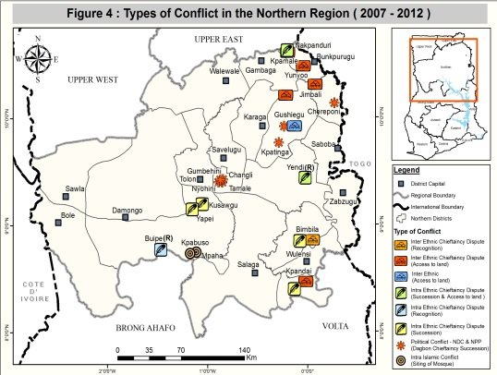
first comprehensive mapping of conflict hotspots to be undertaken for the northern sector of the country, the map provides text and maps, the spatial and temporal dynamics of violent conflicts as a tool for policy makers, security agencies and students of peace studies to anticipate and pre-empt violence. The second and third phases of this research covering the Middle (Brong Ahafo, Ashanti, Eastern regions) and the Southern (Volta, Greater Accra, Central and Western regions) sectors commenced this month.

INCLUSIVENESS and DEMOCRACY

Constitutional Review Implementation: UNDP is assisting the Constitution Review Implementation Committee (CRIC) to foster public reaction to the Constitutional Review Commission (CRC) report and the Government’s White Paper as well as prepare the country for a referendum to pass needed constitutional changes. CRIC has been supported to prepare an implementation plan and raise public awareness on the constitutional review, the CRC report and the variances between the CRC report and the government white paper issued in 2012. Bills are being drafted for the non-entrenched clauses of the constitution which will be presented to Parliament when they resume sitting October. Although the current mandate of CRIC expires in December 2013, it is expected the amount of work to be conducted to achieve the set objectives of this activity set will warrant an extension of their mandate by the Presidency.

Gender Equality: the Ministry of Gender, Children and Social Protection (MoGCSP) with support from UNDP validated the draft proposals of the Affirmative Action Bill with key stakeholders from Civil Society, the government, Parliament and Development Partners. The AA Bill if passed into law is to promote the political participation and representation of women and other vulnerable groups in Ghana. Currently, the AA bill is being drafted by a legal consultant after which it will be sent to the Attorney General’s Department for review and finalization.

Youth in Governance: The Youth Bridge Foundation (YBF) is being assisted to conduct two activities; Promoting the Decentralisation Policy Framework and Action Plan Among Ghanaian Youth and Building Capacities of Youth Groups for Effective Participation in the Local Level Policy Planning Processes. For the period under review: 120 youth leaders in the 6 project districts have acquired knowledge in district planning and budgeting processes and in specific resource allocations directly affecting their development. The youth groups are expected to use the knowledge acquired to support mass educational campaign on district planning and budgeting processes.
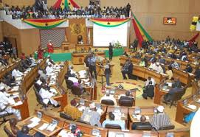
Ghana Parliament in Session

YES Ghana: UNDP, via the Youth Empowerment Synergy (YES) is supporting the Youth Manifesto Coalition as a national platform for engaging government, political parties and other stakeholders towards sustaining youth participation in development. Specifics of the engagement include mapping of youth organisations and conducting of Youth Media Campaigns to engage in governance. So far 320 youth organisations have been registered under the mapping exercise and an e-directory has just been completed. In addition, Youth Media Campaign and Community Youth Hearings have been organised in six Communities using community radio networks.
Decentralization
Ghana is accelerating its decentralisation process, which seeks to devolve political, administrative and financial authority from the centre to the local assemblies through the district assemblies, through the implementation of the new National Decentralisation Framework (NDPF) and the new National Decentralisation Action Plan (NDAP). For 2013, UNDP has committed to support at least five government and civil society partners to achieve the developmental objectives of the Government of Ghana in this sector.
Research Studies and Assessments
The Inter-Ministerial Coordinating Committee on Decentralization (IMCC) is being supported to conduct research studies on capacity constraints of district assemblies to implement the new decentralization policy in three sub-thematic areas: (i) investigate the extent to which Composite Budgeting has been effective in enhancing fiscal decentralization in Ghana since its implementation in 2011 (ii) capacity constraints of district assemblies to implement the NDPF and NDAP through effective monitoring and reporting (iii) Capacity constraints of district assemblies to implement the complaints and public relations committees and support their activation through capacity building.
These studies, which cover 80 out of the 216 administrative districts in the country, are expected to help verify the existence of and provide greater insight into the operations of the Complaints and Public Relations Committees of the Metropolitan, Municipal and District Assemblies (MMDAs) with a view to increase the transparency of local governance and make appropriate recommendations for further policy reforms in the composite budgeting system and fiscal operations of MMDAs. The reports of these studies are expected to be validated and disseminated by the end of September 2013.
UNDP is supporting the Institute of Local Government Studies (ILGS) to assess the level of implementation of the new decentralization policy, a sequel to the `Development of a Tracking Tool for the Assessment of Progress in Ghana’s Decentralisation Programme’ activity supported by UNDP in 2012. The major expected outputs of this activity will be the validation of an official index for tracking progress of decentralisation. Partners to ILGS in the execution of this exercise include the Ministry of Local Government and Rural Development (MLGRD) and the Decentralisation Sector Working Group (DSWG); the Local Government Service Secretariat (LGSS); IMCC Secretariat; the National Association of Local Authorities of Ghana (NALAG) and the Local Governance Network (LOGNet) as well as other civil society organisations.
Advocacy, Sensitization and Capacity-building
IMCC has organised two Advocacy Workshops on decentralization in Sunyani (for Ashanti and Brong Ahafo Regions) and Takoradi (for Central and Western Regions). These are part of the zonal series which commenced in Tamale in 2012 for the three regions of the north. These workshops specifically seek to: (i) Strengthen the demand side of accountability with focus on CSOs and Assembly members; (ii) Bring stakeholders up to date on the status of implementation of the New Decentralization Policy Framework and Action Plan; (iii) Educate stakeholders on the role of IMCC in the implementation process and role of other stakeholders especially CSOs and Assembly members; (iv) Identify other key issues necessary for the successful implementation of the new Decentralization Policy and Action Plan. The 200 participants drawn from MMDAs, Youth, Women and Disabled CSOs are expected to be capacitated to appreciate their roles in the implementation process, and as well as avenues and resources available to them for deepening decentralisation in the country.

The Local Governance Network (LOGNet), the umbrella body for active CSOs in the area of local governance, was supported to build the capacity of local level stakeholders, women and the socially-excluded in planning and budgeting via three separate events in Kumasi, Koforidua and Cape Coast in May, June and August respectively. 150 women associations, queen mothers, faith-based women groups, economic groups, gender activists, unit committee and the physically-challenged in seven regions benefited from the project. Participants are expected to use their knowledge to demand inclusion and participation in the planning and budgeting processes at the local level through lobbying assembly members and actively participating in inclusive processes at the local level.

Human Security Project
The United Nations Joint Programme on Human Security for the three regions in the North of Ghana has finally ended on August 31, 2013. The project which lasted four years from 1st June 2009, comprised of six UN agencies UNICEF, WFP, FAO, UNIDO, UNU with UNDP playing the lead role for the $3 million project. At the last steering committee meeting in August 21, 2013 at Novotel hotel, the ministry of finance noted that HSP provided a platform for the UN System to Deliver-as-One and was most successful in achieving its objectives in the areas of local governance, conflict prevention and advocating the Human Security concept of ordinary citizens living in dignity, free from fear and having a secured livelihood across board. A final evaluation of the programme conducted by a team of independent consultants, noted the most significant achievement as a reduction in violent conflicts in the programme sites during the period of implementation (2009-2012); it also noted that HSP did not directly target to solve the the major conflicts (chieftaincy, land and political) in the areas. All agencies have completed implementation with the exception of UNIDO and FAO who are left with a few outstanding activities.

GENERAL UPDATES
Supreme Court Verdict: The Supreme Court of Ghana on Thursday, the 29th of August 2013, affirmed the declaration of John Dramani Mahama as the legitimate winner of the country’s closely contested 2012 presidential election. Although some of the petitioners’ claims were upheld by individual justices, the combined effect of their collective opinions resulted in a dismissal of the petition by the New Patriotic Party (NPP). The verdict of the judges on three of the issues - duplicate serial numbers, polling station codes and unknown polling stations was unanimous; the claim had no basis they said. On the claims of over-voting, absence of presiding officer's signatures and voting without biometric verification, five out of the nine justices in each case dismissed the claim, while four upheld it. Nana Akuffo Addo, flag bearer of NPP, who is also one of the Petitioners, has publicly accepted the verdict and congratulated the President. In a statement issued by Kofi Annan, former UN General Secretary, he stated that, “That we were able to resolve this contested electoral result peacefully through our justice system is an encouraging illustration of the progress we have made as a society over the past two decades....This success must not blind us to the flaws in our electoral system that the judicial review has brought to light."
Justice Sector Reform: Ghana’s cabinet has in the last week of July, 2013 approved for implementation major reforms in the justice sector, to enhance the effective dispensation of justice in the country. In a presentation by the Minister of Justice to cabinet, Mrs Marietta Brew, indicated that the reform was based on the UNDP/Ministry of Justice baseline survey of the Justice sector revealing gaps and weaknesses in the sector. The reform includes automated processes to enable the tracking of cases, improve court attendance by lawyers and attitude to work schedules, digital record keeping ensuring the maintenance of accurate records of government cases and contracts. Unfortunately the reform does not address the lack of coordination among the key justice sector institutions and the long delays of court cases which is the first deterrent to people when resolving disputes as noted by the UNDP/MOJAGD 2012 baseline survey.
Please stay tuned for more Governance updates in the next issue which will provide details of activities implemented in September 2013 including the KAIPTC Regional Programme on Small Arms funded by the Government of Japan. Other highlights will include:

- Update on the review of non-entrenched provisions of the 1992 Constitution of Ghana
- CHRAJ operationalizing the ombudsman function which is the third mandate aside human rights and administrative justice
- UNDP work in support of composite budgeting and district level planning
- Regional meeting on Infrastructures for peace regrouping ECOWAS, AU, UNDP, BCPR experts

