INSERT BUSINESS NAME HERE
INSERT BUSINESS IMAGE OR LOGO BELOW
(LOGO OR PHOTO)
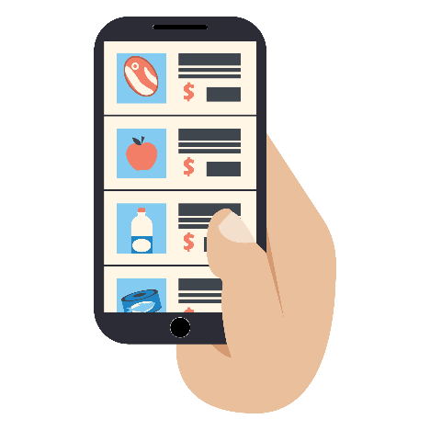
INSERT BUSINESS WHATSAPP/PHONE NUMBER HERE
THANK YOU FOR SUPPORTING XYZ, A LOCAL BUSINESS!
BY COMMUNICATING WITH THE NUMBER ABOVE, WE OFFER: (List your business offerings)

PAYMENT METHODS (Select the ones that apply to your business):
1) Cash
2) Transfers: Bank Name / Account Number / Account Type
3) Credit cards: VISA / Mastercard
4) Mobile Wallet
- Orders by WhatsApp / telephone
- Home delivery
- Curbside pick-up
- Product catalogs and daily promotions

