Case Study
“De-risking and Scaling-up Investment in Energy Efficient Building Retrofits” UNDP-GCF Project through gender equality lenses
The “De-risking and Scaling-up Investment in Energy Efficient Building Retrofits” UNDP-GCF Project (hereinafter Project) implemented by UNDP Armenia country office intends to create wider opportunities for addressing gender inequalities, capacity building, financing and employment. The project objective is to create at least 1,700 jobs and to promote “gender-balanced employment”. To achieve this objective the project team has developed the gender action plan which specifies a set of actions such as informing women on the availability of jobs, consulting them on types of jobs they would like to access and building their skills, as well as encouraging the partner-companies to employ more women in the jobs created thought UNDP Project.
The main objective of this study is to propose a simple non-sophisticated method for collecting, compiling, comparing, analyzing and evaluating the gender indicators. Furthermore the disaggregated data and related analysis of data, as well as the conclusions resulted from the evaluation of gender indicators can guide the Project team (program manager, gender specialists, assistants on data collection and processing, etc.) in the both setting feasible targets in the Project’s Gender Action Plan and adjusting the planned actions towards the set targets.
The subject of this case study are gender indicators of employed through jobs created for the Project in the period of 2017-2019. Gender-disaggregated indicators are further used for calculation of gender equality coefficients that are more specific for gender analysis. The gender equality coefficient (W/M) is calculated as number of the employed women related to number of the employed men as well as the number of women/girls beneficiaries to the number of men/boys beneficiaries.
To promote the availability of gender-disaggregated data UNDP is encouraging the companies who apply for provision certain services under UNDP contracts to ensure gender-balanced employment. For this reason, the companies are requested to provide data on the composition of key personnel by gender and main professional groups (specialties). The requested data concerned exceptionally the personnel to be hired/worked for the Project.
Thus, having already regulated the women-employment promotion and gender-disaggregated data provision processes, the contractor-companies will communicate data on employed persons. Based on received data, the companies were reviewed against the set of gender indicators grouped by contractor-companies, by companies focusing on retrofitting of public buildings, and by main groups of beneficiaries as presented in the tables below.
The analysis of gender indicators compiled in Table 1, revealed a significant variation of gender equality coefficient depending on the company profile. The main patterns are the following:
- there is no woman involved in the technical supervision companies,
- the gender equality coefficient in the construction companies is very low being equal to 0.03 (3/110),
- the highest gender equality coefficient is in the research/consulting companies - 0.54 (14/26).

Table 1. Gender indicators of employed through jobs created for the Project, 2017-2019 (August)

Contractor-company profile | Number of companies contracted | Total number of jobs created | Number of women employed | Number of men employed | Share of women in total, % | W/M – Gender equality coefficient of employed
Construction | 2 | 113 | 3 | 110 | 2.6 | 0.03
Design | 12 | 88 | 30 | 58 | 34.1 | 0.51
Suppliers /Vendors | 5 | 46 | 12 | 34 | 26.1 | 0.35
Technical supervision | 2 | 8 | 0 | 8 | - | 0.0
Research/Consulting | 7 | 40 | 14 | 26 | 35.0 | 0.54
Project staff/Experts | - | 32 | 9 | 23 | 28.1 | 0.39
Total | 27 | 327 | 68 | 259 | 20.8 | 0.26

In Armenia, traditionally, the women employment rate in construction sector, which includes also its technical supervision, is less than 2% of the total number of employed in the sector. In 2017, from 35-36 thousand employed in construction only 700 were women. At the same time, the jobs created in designing, research, consulting companies are more favorable for women, because they do not require heavy labor, are intellectual and, for some professional groups, are higher paid. The preferences of the Armenian women for intellectual labor (office works) come from their much higher (in comparison with men) educational level. Thus, 58.4% of economically active women has tertiary, post-graduate (32%) and secondary specialized, vocational educational attainment (26.4%), whereas for economically active men these indicators are 47.1%, 27.6 and 19.5 respectively.
Nevertheless, the analysis of the Project data reveals that, the “bad” gender equality situation with employment in construction, due to higher weigh of employed (35% of total) influences “good” gender indicators of employment in designing companies and consulting, due to lower weigh of later (27%) and (12%) respectively (Diagram).

Diagram. Gender equality coefficient by main groups of employed in frames of the Project.

Conclusion 1. While setting up target indicators for the objective on “ensuring gender-balanced employment” the use of mean statistical indicators, sometimes, cannot express the real achievements in gender equality, so, there is a need to disaggregate the set targets by sectors or jobs profiles, in some cases even by occupations and specialties.
Table 2. Gender indicators of employed involved in retrofit of two public buildings, as of 31.12.2018
 | Contractor Companies | Gender disaggregated data |  | Gender equality indicators
 |  | Number of women employed | Number of men employed | Share of women in total number of employed, % | Gender equality coefficient of employment, W/M
N 160 kindergarten, Yerevan | Construction company | 0 | 48 | - | -
 | Design | 0 | 2 | - | -
 | Suppliers/Vendors | 4 | 11 | 26.7 | 0.36
 | Technical supervision | 0 | 4 | - | -
 | Total | 4 | 65 | 5.8 | 0.06
N 3 Erebuni Child &  Youth Center, Yerevan | Construction company | 3 | 62 | 4.6 | 0.05
 | Design | 2 | 8 | 20.0 | 0.25
 | Suppliers/Vendors | 8 | 23 | 25.8 | 0.35
 | Technical supervision | 0 | 4 | - | -
 | Total | 13 | 97 | 11.8 | 0.13
TOTAL |  | 17 | 162 | 9.5 | 0.10

Another methodological approach to evaluate to which extend the project activities advance gender equality is to compare the gender equality indicators by sub-projects. In Table 2, the gender disaggregated data and gender equality indicators are presented by two sub-projects: retrofit of N160 kindergarten and N3 Child & Youth Center in Yerevan. Comparative analysis of indicators shows that there is more than 2 times difference between the gender equality coefficients of employed persons: as much “design and supply” related works are required for the sub-project implementation, the better is the gender equality coefficient of employed within the framework of sub-project.
Even more, the modern design of retrofit with the use of new construction materials requires less heavy-labor workers in construction. So, for the retrofit of kindergarten, the men employed in construction companies compose 70% (48 vs.69) of total number of all employed (both men and women), while for the retrofit of the Child & Youth Center women represent only 56% of total employment (62 vs. 110).
Conclusion 2. While formulating the scope of work for retrofit it is worth to include requirements for modern design, including the use of new-creative construction materials, which will decrease the share of construction heavy labor, and consequently will improve the gender equality situation in total employment within the framework of the Project.
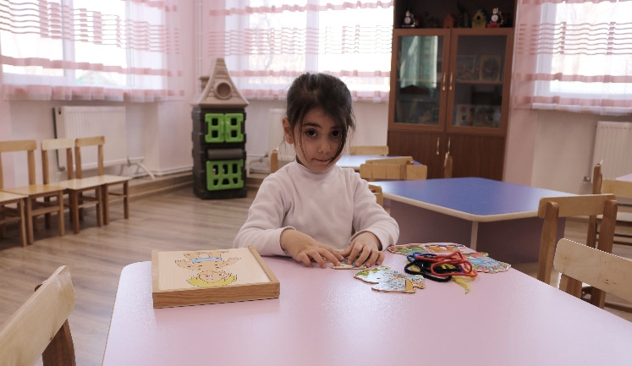
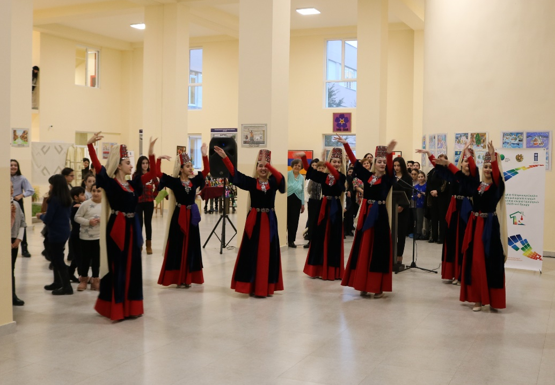
Finally, evaluation of gender equality is highly required from the viewpoint of gender profile of the Project beneficiaries. The Table 3 presents the gender-disaggregated data on beneficiaries concerning the same two sub-projects.
Table 3. Gender profile and gender equality indicators of beneficiaries by two retrofitted public buildings, as of 31.01.2018
 |  | Total number of beneficiaries | Number of women/  girls | Number of men/  boys | Gender equality indicators
 |  |  |  |  | Share of women/girls in total number of beneficiaries, % | Gender coefficient of beneficiaries, W/M
N 160 kindergarten, Yerevan | Staff | 33 | 28 | 5 | 84.8 | 5.6
 | Children | 197 | 90 | 107 | 45.7 | 0.84
N 3 Erebuni Child &  Youth Center, Yerevan | Staff | 57 | 38 | 19 | 66.7 | 2.0
 | Children | 800 | 600 | 200 | 75.0 | 3.0
TOTAL |  | 1087 | 756 | 331 | 69.5 | 2.28

In general, the gender equality indicators related to the beneficiaries of the retrofitted public buildings point to the fact that women are key beneficiaries of UNDP/ project activities. Nevertheless, in comparison with the kindergarten, where gender equality coefficient is the highest mostly due to the prevalence of women-staff, in opposite, in the child & youth center the gender equality coefficient is high due to the largely involvement of girls-beneficiaries.
Conclusion 3. While selecting public buildings for energy efficiency retrofit to give preference to the buildings with location of institutions providing services to the higher number of children beneficiaries would ensure for the Project not only better-balanced gender impact, but also valuable social impact.

Prepared by:
Diana Harutyunyan, Climate Change Programme Coordinator, PhD in Biology
Astghik Mirzakhanyan, National Expert on Social Vulnerability and Gender Issues, PhD in Economics

The “De-risking and Scaling-up Investment in Energy Efficient Building Retrofits” UNDP-GCF Project document, p.27 http://www.nature-ic.am/Content/Projects/18/GCF%20PROJECT%20BRIEF%20ENG.pdf
In this study the employment cases are limited by the contractor-companies involved in the public building retrofits activities, since in these companies the total number of employed in the jobs only created by the Project is much more than in other areas (e.g. training, etc.). The data on personnel directly contracted by the Project (staff, experts, etc.) also included in the quantitative analysis.
“Labour market in the Republic of Armenia in 2013-2017” statistical handbook, p. 70
“Labour market in the Republic of Armenia in 2013-2017” statistical handbook, p. 32 https://www.armstat.am/am/?nid=82&id=2106

