Draft Report
National Study on Rural Labor Market

Ref: UNDP/Addressing Social Inclusion through Vocational Education and Training

Contents

Executive Summary
Acknowledgements
Acronyms

I. Project background
I. 1 Introduction Background on labor market and rural labor market in Albania
I.2 Identification of issue
I.3 Purpose of study
II. Rural market study methodology & limitations

III. Labor Market indicators
III.1 Overview of Labor market Indicators Assessment
III.2 Labor Market Indicator by districts
III.3 Labor Market indicators for youth

IV. Local Economic Units

V. Employers’ perspectives and skills requirements
V.1 Skills Requirement

VI. Evaluation of the role of institutions and public policy in rural labor market

VII. Main findings, Conclusions & Recommendations

- Annexes
Annex I: Terms of Reference of the study
Annex II: Methodology
Annex III: Inception Report and Work plan
Annex IV: Data collection instruments, databases and results
Annex V: List of the persons interviewed
Annex VI: Bibliography

Executive Summary
Acknowledgements
Acronyms

I. Project Background

I.1 Introduction Background of rural labor market in Albania

Issues of employment in general and rural employment in particular are vital to the economic wellbeing of any economy, especially for a developing economy such as that of Albania. In this respect, employment should be at the forefront of economic policy since it is directly linked to sustainable development. In the case of Albania, where much progress has been made in terms of economic growth and poverty reduction, the issue of rural areas still remains, where employment is the main factor. In fact, rural areas still remain as the poorest areas of the country and in addition there is a very large portion of self-employed individuals in agriculture, which are considered employed.
The matter of fact remains that much less in known in terms of economic activity, employment, and rural non-farm activity in the rural areas of Albania. Therefore, it is imperative to consider the issues of employment in the rural areas, as well as identify potential rural non-farm activities that might contribute to increases in employment as well as overall development of these areas in the country. In this respect, cross-cutting themes such as youth employment, SME, green jobs, gender sensitivity, and the like should also be considered in the larger scheme of rural labor market and rural development.
Consideration of youth employment insures inclusion of a vital part of the labor force who will become the most productive force of tomorrow. Inclusion of youth into the labor force and the labor market increases the utilization of the available labor force as well as increase economic productivity. In the context of Albania, youth makes up 25% of the population, and Albania is recognized as having a young population. In addition, almost half of youth reside in rural areas thus their livelihoods and prospective in the labor force is linked to these areas.
SME-s and the potential of green jobs should also be given some consideration whenever possible. In regards to the existence and development of SME-s in rural areas special consideration should be given to the employment that they may foster as well as to economic sustainability. Further development of SME-s may also be linked to increased entrepreneurial efforts in the rural areas as well as skill development for the rural labor force. The possibility of green jobs may be viewed under EU-s initiatives to foster these types of jobs especially in the rural areas.
Lastly, all considerations should be done under a gender lens. The issue is twofold: first, if gender is not taken under consideration, there is the risk of exclusion of half of the population and of the labor force. This in return would impact productivity and economic growth. Second, if considerations are gender insensitive, they risk leaving in place the existing gender bias and impeding development once again.

I.2 Identification of the Issues

In the broader framework of the joint United Nations’ initiative on social inclusion in Albania, social exclusion is defined as the process whereby certain individuals and groups are pushed to the edge of society and prevented from participating fully by virtue of their poverty, lack of access to basic services and opportunities, lack of capabilities, and/or as a result of discrimination. This distances them from job, income and education opportunities as well as from social and community networks and activities.
Education, training, and employment represent central dimensions of social exclusion. These are interlinked, as limited access to educational and training services affects employability. Unemployment does not relate only to poor living conditions and inability to afford material goods, services and housing, but in itself it inhibits people’s ability to fully participate in society, build social networks and realize their potential.
In a regime of limited state resources, where legislative reforms primarily target systemic changes, the implementation of education and training programmes that aim labor market integration sometimes fails to reach out to the least advantaged. Improving access to Vocational Education Training (VET) for marginalized groups is key to enhancing their functioning, thus facilitating their inclusion in the labor market.
Within the frame of education and employment as two central dimensions of social exclusion, the long-term unemployed, people receiving social insurance or unemployment benefits, the disabled, the Roma and Egyptian minorities and women are some of the more marginalized groups at risk of social exclusion. In addition, children and women belonging to any of these marginalized groups face an added risk of exclusion from both education system and subsequently the labor market.
The project Addressing Social Inclusion through Vocational Education and Training facilitates access to vocational education and training by promoting participation in VET and by building the institutional capacity to support the inclusion of marginalized and socially excluded groups in the VET system. This is in line with the national Vocational Education and Training (VET) strategy and the UN initiative on social inclusion.
Its ultimate aim is to promote coordination on employment and social services across national institutions and between central and local levels. The initiative will build upon the vast experience of the UN in addressing social inclusion and the needs of the vulnerable groups, while collaborating closely with MoLSAEO, MoES, and all other development partners working in the VET sector.
The aim will be accomplished by focusing on four strategic directions:
- Generation of better and more reliable information on vulnerable and marginalised groups at riskof labour market exclusion
- Institutional capacity support to relevant institutions
- Advocacy, policy dialogue, and awareness raising
- Design of employment programmes in target municipalities
The expected results by the end of the project will include improved knowledge and understanding among policy makers on labor market measures that can be undertaken to tackle the disadvantage of socially excluded and marginalized groups, and a more prominent focus on the employment of these groups through a comprehensive VET strategy and interventions at the local, regional and national level.

I.3 Purpose of the Assignment

Until now, rural labor markets have remained peripheral to policy discussions on growth, employment and poverty reduction in Albania. Experience in developing countries and emerging economies demonstrate that when given proper support, farm and non-farm rural activities can thrive and be engines of growth, innovation, and attractive jobs. Research shows that in Albania, as in many other countries, the incidence of poverty is highest in rural areas, where an estimated 49% of Albania's population resides and most of them depend on agriculture for their livelihood. In Albania poverty is 50 % higher in rural areas than in urban centers. A strong link exists between poverty and unemployment; unemployment being one of the main determinants of poverty. The very low level of arable land allocation per capita in the rural areas is considered one of the main causes of poverty. Having no other means of livelihood besides the agricultural land, most of the families rely mainly on the incomes and products of their farms. Many small-scale farmers lack access to market outlets for their products, particularly in mountain areas. Without outlets, farmers cannot increase their income and standards of living.
As a result of the privatization process of agricultural land , and due to the lack of alternative employment opportunities in rural areas, Albania‘s agricultural sector, which accounts for over half of employment rate but only about one-fifth of GDP, is limited primarily to small family operations and subsistence farming . The problem of hidden employment is quite marked in transitional economies, which may suggest that the official estimates of the unemployment rate are misrepresenting the real situation.
In particular, unemployment in rural areas does not officially exist in Albania, as the farmers and their families are considered “self-employed in agriculture”. This share significantly overstates and misleads the real employment figures in agriculture, as all members of rural households possessing agricultural land, are counted and considered employed for as long as they do not have any alternative employment and/or if they do not register as being unemployed. Hidden unemployment is characteristic of the rural areas, and is an outcome of the low rate of arable land per capita and the low level of economic, non-farm activities in the rural areas.
Documented rural labor statistics (compiled, produced and analyzed regularly) are a requisite tool to support national development plans to ensure that the economy progresses in a sound, more geographically balanced manner . An examination of rural labor markets has strong links and overlaps with other issues, notably: Social exclusion – issues of unemployment, and low pay; Rural economies – various issues, especially commuting which is fundamental to an understanding of the operation of labor markets; The role of SMEs – especially the implications for skills development and training of the preponderance of small firms in rural areas. These links and overlaps highlight the salience of economic and social aspects of labor market issues in rural areas.
The purpose of the call study is to conduct an assessment of rural labor market, including identification of economic opportunities in the regions and the rural labor market demand. Its main concern is the providing of a synthesis of existing knowledge on rural labor markets which will also serve to initiate the discussion on the creation of appropriate labor statistical tools for rural areas. The assignment will use the European Guidelines for Employment and will build on prior and on-going UN studies and initiatives to develop rural labor information for rural development work, complemented by quantitative data collection and qualitative interviews at regional level. Successful European models in promotion of rural employment will have to be reviewed and taken into consideration.
Firstly, the assignment will review the structure of the rural labor market, demographic and economic trends in rural areas, focusing on problem issues. It will help to describe and understand the types of work performed in both farm and non-farm jobs and their rural labor-related characteristics. It will look at factors influencing the demand for workers, and the potential for new sources of employment outside traditional sector activities , and ways to connect the offer with the demand. This will be done through quantitative data collection, interviews and focus group discussions at each region.
Secondly, it will highlight the current policies of relevance to rural employment, alongside with the relationship between rural employment and rural development and the existing employment policy, instruments, as well as vocational training provision that can be applied to rural areas in the country.
The conclusions from this study will provide a baseline analysis of rural labor market and skills development challenges, and will identify areas where rural development programmes can be targeted to increase their contribution to employment creation. This will also suggest formulation of policy recommendations on stimulating new sources of employment, and the conditions for success in stimulating employment in rural areas.
II. Rural market study methodology & limitations

The issue of employment encompasses three main forces, namely: 1. Supply side, made up of the labor force, 2. Demand side, made up of employers and potential employers, and 3. Institutions, be those governmental, non-governmental, etc., which act as intermediaries. Successful cooperation between these factors would bring about improvements in the labor market and open up new venues of employment. Consequently this study looks at all three factors as to shed light on the gaps and existing opportunities. More specifically the proposed methodology is as follows:
Desktop Research: It reviews existing documents from various sources such as UN, World Bank, IFAD, NSDI, ILO, academic literature, etc. to identify existing programs in rural employment, strategies, policies, and existing gaps to better understand and identify the issues in this matter. It will also serve to identify skills needed for the rural labor force, outlined in a recently conducted national study of sector skill needs in Albania.
Supply Side: It includes quantitative analysis on labor force participation, employment, unemployment, contributing family workers and farm/non-farm workers in rural areas. The analysis will be divided by sex, age, and education, etc. in order to bring disseminated information. Furthermore the analysis will be conducted for each district as to find regional differences or similarities. This part of the analysis will aim to clarify the situation in the labor market in rural areas and highlight urban-rural differences whenever possible as well as gender differences and youth employment. The main source for this part of the analysis is Labor Force Survey 2007-2012.
Demand Side: It includes quantitative and qualitative analysis based on questionnaires and focus groups. This is completed through field work. Actors of the demand side are identified, and qualitative information regarding employment opportunities, required skills and qualifications of the workforce, job information dissemination, difficulties in finding skilled workforce, etc. will be collected. This information is used to see the prospect of employment on the employers’ side and complements quantitative analysis based on the census of enterprises 2010, which provides information on economic local units by activity in rural areas, size of local units, labor force, etc. Some of the identified supply side actors are not limited to, but include:
- 110 Businesses in rural areas
- Representatives of Farmers Cooperatives
- Specialists of agriculture
- Albanian Agro-business Association
- Dairy Entrepreneurs National Association
- Farmer Interest Groups
- Albanian Agribusiness Council
- Other potential employers in agriculture and rural non-farm
Institutional Intermediaries: It consists of qualitative analysis based on semi-structured interviews with actors that may coordinate the efforts of supply and demand side. This analysis will serve to identify at a macro level the opportunities and gaps that exist through the role of the intermediaries be those in employment, or financing schemes. Since active labor market measures are inexistent in rural areas, interviews with National Employment Services, regional employment services, vocational training centers as well as MoLSAE and Ministry of Agriculture and food will shed some light on the constraints of active labor markets reaching the rural areas as well as ways of improvement. The list includes government institutions, local NGOs and international organizations active in this area. Some of the foreseeable interviews include but are not limited to:
- National Labor Office
- Local Labor Offices
- MoLSAE
- Ministry of Agriculture and Food
- District Departments of Agriculture
- Mountain Areas Development Agency
- Regional Agricultural Advisory Centers
- Vocational Training Centers / VET School
- GIZ, SDC projects UN women etc.
- A number of Local and International NGOs with focus on rural economy VET and Employment
- Intermediary business for recruitment and employment services
III. Labor market indicators

III. 1 Overview of labor market indicators

The labor market in rural areas is a somewhat unknown territory facing significant challenges compared to urban areas. The rural areas have mainly been characterized by a lower-skilled workforce, limited opportunities, heavily reliance on subsistence agriculture, higher poverty levels, and the like. Lately, there have been various improvements in rural areas regarding poverty reduction, economic activity, revival of agriculture, etc. In 2012, poverty appears to have had a shift towards the urban areas, whereas in 2008, rural areas experienced quite a reduction of poverty. Nonetheless, labor market issues still need to be unraveled in these areas, and a close analysis of labor market indicators along with gender and district differences is necessary. In return, this provides a picture of the labor market situation in the rural areas, which may serve policy-makers to tackle the most important issues. A major challenge in rural areas is unraveling labor market statistics and what they are in fact capturing. Given the accepted definition of employment, rural areas appear to have higher employment level than urban areas, when in fact those statistics may be capturing underemployment, or a high level of women’s unpaid labor. A very large percentage of women are in unpaid family labor and that is heavily reliant in rural areas. Land holding in Albania are quite small, averaging to about 1.1 hectares, and furthermore there is a large level of land fragmentation. Therefore, even engaging on an hour labor on the land for subsistence farming shows up as employment. In reality, this is an issue, which needs to be dealt with substantially as to channel the rural workforce into paid employment, or self-employment in a real sense.

Although at prima vista rural employment (63.7% in 2012) appears quite larger compared to urban employment (38.9% in 2012) (Figure 1), those numbers should be viewed with caution for the reasons underlined above. Consequently, comparisons between the two areas are not appropriate for any of the labor market indicators. In rural areas, employment trends between 2007-2012 show that after the fall of employment rate between 2007 and 2008, employment stayed at about that rate in the next three year up to 2010. Employment rate picks up after 2010. Similar trends are also apparent for men and women in rural areas, however, women have much lower employment rates than men. In 2012, women’s employment rate in rural areas is 60% compared to 67.4% for men. The difference in employment has started to close after 2011, whereas it has been much larger between 2008 and 2010, ranging between 49.9%-48.3% for women and 61.4%-62.6% for men respectively.

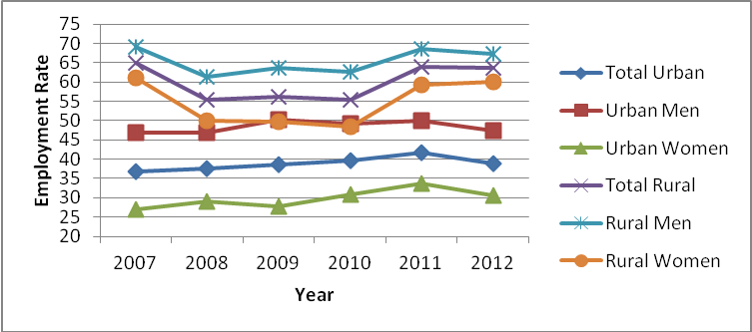
Source: INSTAT; 2007-2012 LFS
Figure 1: Employment Rate Urban-Rural Areas

Labor force participation rate also shows large differences between men and women in rural areas (Figure 2). As with employment, labor force participation in rural areas has decreased between 2007 and 2008 from 66.9% to 58.0%. In 2009 and 2010 labor force participation stays close to 2008 level around 60.0%. After 2010, labor force participation increases to 68.7% in 2011, and is 67.8% in 2012. These trends are also apparent for men and women in rural areas, however as with employment, women have much lower levels of labor force participation. In 2012, labor force participation for women is 62.2% compared to 73.4% for men. Similar to employment, the largest differences occurred between 2008 and 2011.

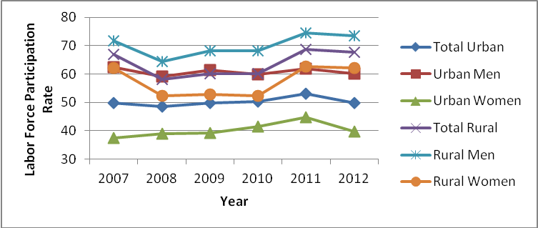
Source: INSTAT; 2007-2012 LFS
Figure 2: Labor Force Participation Rate Urban-Rural Areas

Unemployment rate is a problematic statistic even within rural areas. Given the higher level of employment and labor force participation in rural areas, unemployment statistics are expected to be much lower in rural areas compared to urban areas, therefore comparisons are inadequate. In addition, within rural areas gender comparisons in terms of unemployment rate are also problematic given women’s high inactivity rates in these areas. Unemployment rates for women in rural areas appear lower than men, especially after 2010. However, instead of really capturing unemployment, these statistics are capturing high levels of inactivity for women in these areas. In 2012, unemployment rate of rural women is 3.6% compared to 8.1% for men (Figure 3). In fact these statistics may caution for a dire position of women in rural areas characterized by high inactivity rates due to household responsibilities, or unpaid family worker.

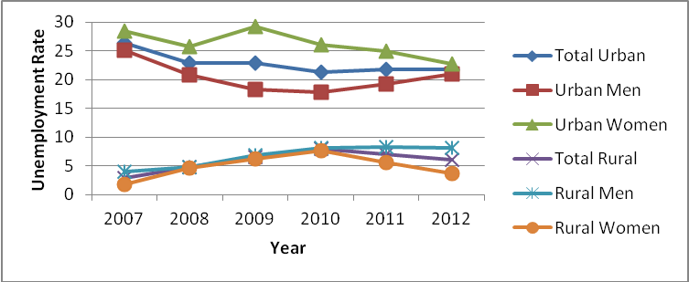
Source: INSTAT; 2007-2012 LFS
Figure 3: Unemployment Rate Urban-Rural Areas

Indeed, statistics on contributing family workers in rural areas show that the overwhelming majority is comprised of women (Figure 4). These statistics show the disadvantageous position of women in rural areas. Large participation of women as contributing family workers and unpaid labor increases the likelihood for economic dependence and economic disempowerment. The differences are alarmingly large ranging between 62.9% in 2007 and 73.9% in 2012 for women versus 22.6% in 2007 and 39.9% in 2012 for men. The very large percentage of women as contributing family labor, falsely increases labor force participation and lowers unemployment. Incidentally, in 2012, women have the largest percentage as contributing family workers in the five year period between 2007 and 2012, this year also marks a reduction of unemployment for women from 5.5% in 2011 to 3.6% in 2012.

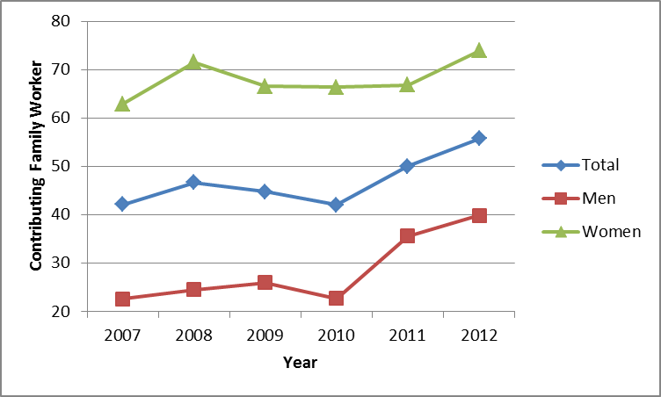
Source: INSTAT; 2007-2012 LFS
Figure 4: Contributing Family Worker Rural Areas

Furthermore, the labor force in rural areas heavily relies on farm work (Figure 5). The majority of workers in rural areas are farm worker. The number of non-farm workers is quite low in rural areas. This goes to show that economic activity lacks diversification in these areas and there is need for increased rural non-farm activities. Heavy reliance in farm work may also impede demand for education and human capital accumulation, which on the other hand may reinforce activities in farm work. As a result, the need for rural non-farm activity arises, both as a way of risk diversification and demand for different skills. In 2012, in the rural areas there are 491,737 farm workers and 143,889 non-farm workers.

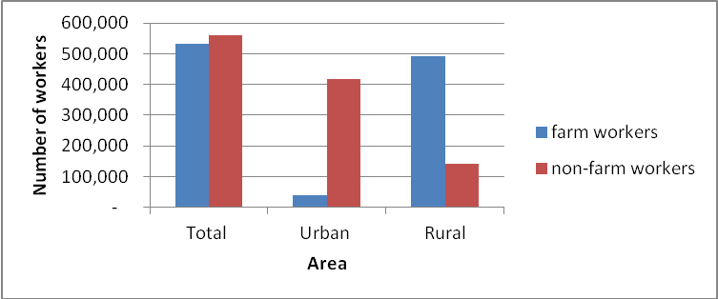
Source: INSTAT; 2012 LFS
Figure 5: Farm/Non-farm workers by area

Although male and female farm workers are quite comparable in number in the rural areas (224,639 male and 267,098 female), there is large difference between men and women in terms of non-farm labor in the rural areas (Figure 6). These differences are indicative of lack of economic opportunities for women therefore continuously trapping them into unpaid labor. Consequently they limit women’s opportunities for advancement and channeling into paid labor as well as the potential of the labor force for the rural areas. Therefore, through lack of economic opportunities of women, rural areas may also suffer in terms of social and economic development. The number of female non-farm workers is very limited. In 2012, there are 30,610 female non-farm workers versus 112,279 male non-farm workers.

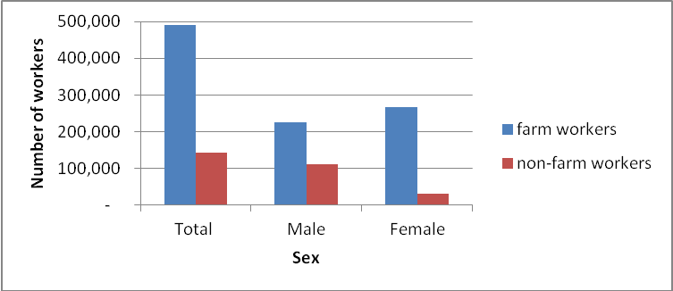
Source: INSTAT; 2012 LFS
Figure 6: Farm/Non-farm workers by sex rural areas

As expected, rural areas are overwhelmingly involved in agriculture (Table 1). There is a lack of spread into other economic activities, which is the opposite for urban areas. The number of labor in non-agricultural activities in rural areas is quite limited, which once again reinforces the idea of lack of economic diversification. The issue at hand is two-fold. On one hand, lack of diverse economic activity and economic opportunity limits the need for skill acquisition or skill diversification. On the other hand, lack of skill in the labor force limits economic activity, resulting in a classical coordination failure. Whereas rural areas are mainly directed towards agriculture, urban areas are mainly directed towards services and industry. The number of labor into agriculture in rural areas is 491,986 workers. Participation in industry is quite low, especially in manufacturing, 16,885 workers and extractive industries, 7,620 workers. Participation in construction within industry is somewhat higher with 34,429 workers. Services are also limited with 55,930 workers in market services and 34,668 workers in non-market services. They are quite different from urban areas which have 54,624 workers in manufacturing, 58,182 workers in construction, 12,942 workers in extractive industries, 176,002 workers in market services, and 135,554 workers in non-market services.
Economic activity also shows gender differences and very limited participation of women in other activities besides agriculture. Lack of participation in paid employment and in activities that have higher pays such as industry, where women’s participation is quite limited also has repercussions in terms of social security and old age pensions for women. In return, this puts them at higher risk of economic difficulties and dependency. Aside from agriculture, industry is the second largest economic activity for men (12,083 workers in manufacturing, 34,118 in construction, 6,583 in extractive industries), whereas it is very limited for women in rural areas (4,802 in manufacturing, 312 in construction, 1,037 in extractive industries). Rural men also have a much larger participation in services (42,703 in market services, and 22,324 in non-market services) compared to rural women (13,226 in market services and 12,344 in non-market services).

Table 1: Economic Activity by Sex in Rural Areas
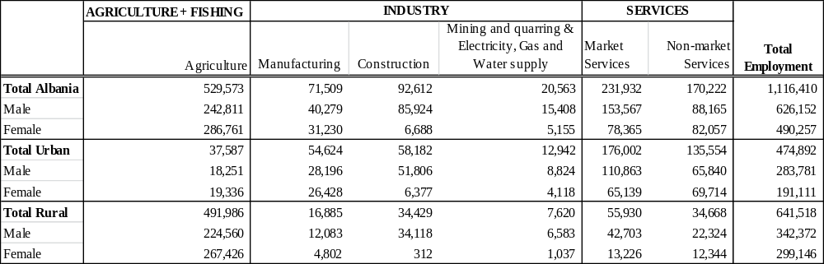
Source: INSTAT; 2012 LFS

III. 2 Labor market indicators by district

Given the statistical problems discussed in the beginning of this section, labor market
indicators do not necessarily reflect the real situation, rather they may be capturing heavy reliance on small scale agriculture, or subsistence farming, and women’s unpaid labor in agriculture. Although it is harder to precisely identify districts that are doing well versus those that are not, the district of Shkoder seems to be lacking behind, whereas the district of Vlore seems ahead. District division in rural areas shows that in 2012 the district of Vlore has the largest labor force participation rate of 83.9% (Figure 7). Lezhe is the second highest district in terms of labor force participation with 76%, followed by Fier with 72.8%, Gjirokaster 71.7%, Korce 71.4%, and Berat 71%. The district with the lowest rate of labor force participation is Shkoder with 57.8%. The rest of districts range between 61.4% and 67.4% of labor force participation rate. Other labor market indicators such as employment rate closely follow the ranking of districts by labor force participation. The district of Vlore also has the highest employment rate of 79.3%, followed by Berat 69.8%, Lezhe, 69.2%, Korce 68.3%, Fier, 67.9%, Elbasan 66.3%, Gjirokaster 65.3%, and Diber, 63%. Shkoder also has the lowest employment rate, 49.6%. The rest of districts range between 57.7% and 59%. Unemployment rate is the lowest in Elbasan, 1.5% and Berat, 1.7% and highest in Shkoder 14.1% and Kukes 13.7%. Other district such as Gjirokaster, 8.9%, Fier, 6.8%, and Tirane, 6.7% also have relatively high unemployment rates. The rest of districts vary in-between these rates.

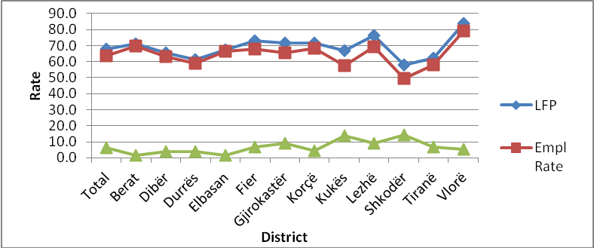
Source: INSTAT; 2012 LFS
Figure 7: Labor Market Indicators by District Rural Areas

Higher rates of employment and labor force participation in rural areas of districts are mainly associated with large numbers of workers in farm labor (Figure 8). Districts like Elbasan, Fier, Korce, Tirane, Berat and Diber are among the districts with the largest amount of farm workers in rural areas. Other districts such as Kukes, Lezhe and Shkoder that also have the highest unemployment rate have less farm workers. These latter districts have fewer workers in farm and non-farm labor; therefore their high unemployment rates may reflect lack of economic activity, which is also associated with high poverty in these districts.

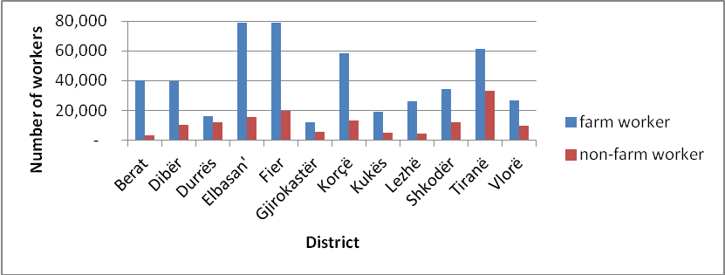
Source: INSTAT; 2012 LFS
Figure 8: Farm/Non-farm Workers by District Rural Areas

Gender differences within rural areas of districts show a clear gap in all labor market indicators between male and female. This gap would be even greater if we could account for female unpaid labor. Districts like Berat, Diber, Elbasan and Kukes show a smaller gap between male and female workers in terms of labor force participation (Figure 9). However it should be noted that these districts mainly have farm workers, which is why the gap appears smaller (Figure A3). Gender differences in labor force participation do not reflect higher equality in the rural areas of these districts rather they warn against low levels of economic activity and rural non-farm employment. They appear more equal perhaps due to economic hardship all around. Other districts such as Shkoder (68.1% male versus 47.4% female), Tirane (71.9% male versus 52.3% female), Gjirokaster (80.0% male versus 63.1% female), Lezhe (84.7% male versus 68.0% female), Durres (69.4% male versus 53.3% female), and Fier (79.5% male versus 66% female) have quite large gender differences in terms of labor force participation, where males have much higher levels of participation. Vlore has the highest rate of female labor force participation, 80%, whereas Shkoder has the lowest 47.4%.
Employment rates in rural areas of districts show a similar situation (Figure 10) reflective of labor force participation rate. Consequently, districts like Berat, Diber, Elbasan, Kukes have a minimal or no gap at all in terms of employment rate by gender. Other districts like Durres, Gjirokaster, Lezhe, Shkoder, Tirane have the largest gap. Vlore has the largest female employment rate, 76.8% and Shkoder has the lowest, 43.3%.

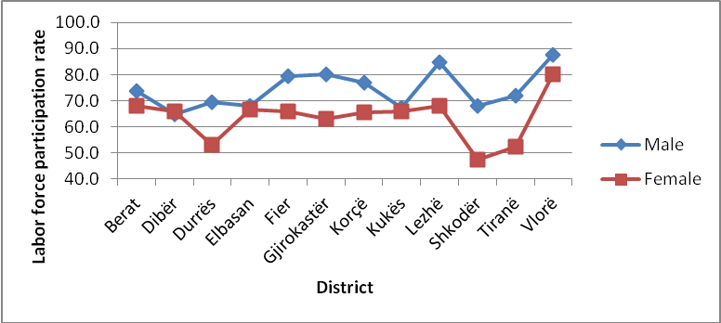
Source: INSTAT; 2012 LFS
Figure 9: Labor force participation by sex and district in rural areas

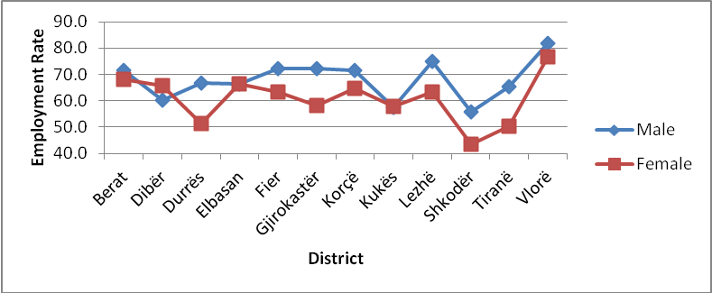
Source: INSTAT; 2012 LFS
Figure 10: Employment rate by sex and district in rural areas

As explained above, unemployment statistics are problematic due to the high levels of unpaid family levels, and also high inactivity rates of females. As a result, they appear lower for females in the rural areas of districts as they have appear so farm everywhere else (Figure 11). Nonetheless, there is a pattern for which rural areas of districts with high levels of farm workers and reliance on small scale agriculture and/or lack of diverse economic activity show lower levels of unemployment, or unemployment gap between male and female workers. In terms of unemployment, Kukes (12.6%), Shkoder (8.5%) and Gjirokaster (8.0%) have the highest female unemployment rate, whereas Berat (0.3%), Diber (0.6%), and Elbasan (0.8%) have the lowest.

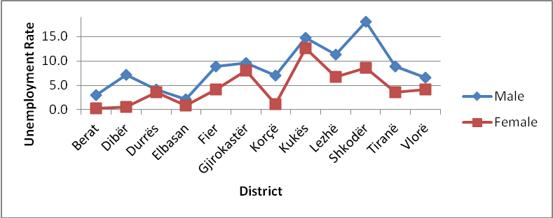
Source: INSTAT; 2012 LFS
Figure 11: Unemployment rate by sex and district in rural areas

Further statistics show that all rural areas by district, with the exception of Lezhe have more female farm workers than male farm workers (Figure 12). Rural areas in the districts of Elbasan and Fier have the largest number of female farm workers, 43,057 and 41,481 respectively. Rural areas in districts of Gjirokaster and Durres have the lowest number of female farm workers, 6,322 and 9,952 respectively. The largest difference in terms of male and female farm workers is in the districts of Tirane (8,191), Elbasan (7,152), and Diber (6,906).

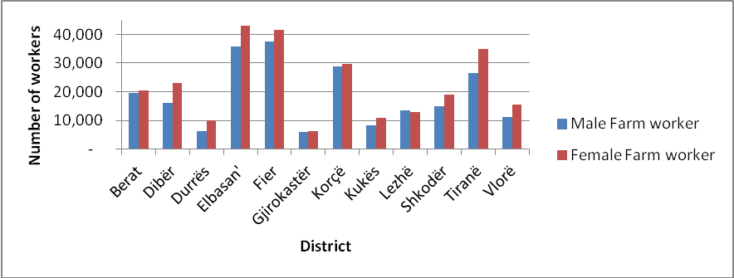
Source: INSTAT; 2012 LFS
Figure 12: Farm workers by district by sex in rural areas

A striking difference between farm and non-farm workers by sex and district in rural areas show that non-farm work is quite limited in rural areas however it is even more limited for female workers (Figures 13 and 14). Female workers have very limited numbers of non-farm workers in every district in rural areas and therefore there is a very large difference for females between farm and non-farm workers. In this respect, Elbasan (43,057), Fier (41,581), Tirane (34,839), and Korce (29,569) have the largest numbers of female farm workers. On the other hand, Gjirokaster (6,322) and Durres (9,952) have the lowest numbers of female farm workers. In terms of non-farm labor, Berat has the lowest number of female non-farm workers (592), whereas Tirana has the largest number (6,533).
The situation for men is quite different (Figure 14). They have larger numbers as non-farm workers as well as smaller differences between farm and non-farm workers per district. Tirana (26,438), Fier (37,428), Elbasan (35,905) and Shkoder (10,850) have the largest number of male non-farm workers, whereas Berat (2,862), Lezhe (3,213) and Kukes (3,627) have the smallest number. Districts like Durres and Tirana have the smallest difference between farm and non-farm workers for men. Rural areas of Durres have 3,529 more male non-farm workers than male farm workers, whereas rural areas of Tirana have 210 male farm workers more than non-farm workers. Districts like Elbasan (24,640), Fier (21,800), Korce (19,310), Berat (16,735), and Lezhe (10,268) have the largest difference between farm and non-farm workers for men.

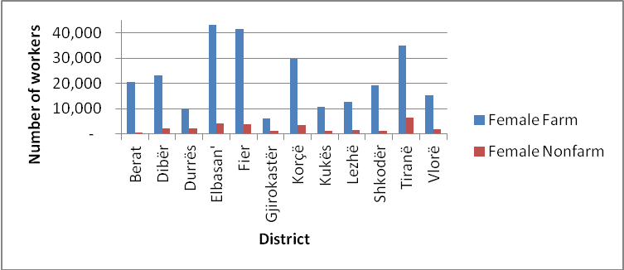
Source: INSTAT; 2012 LFS
Figure 13: Female Farm/Nonfarm workers by district rural areas

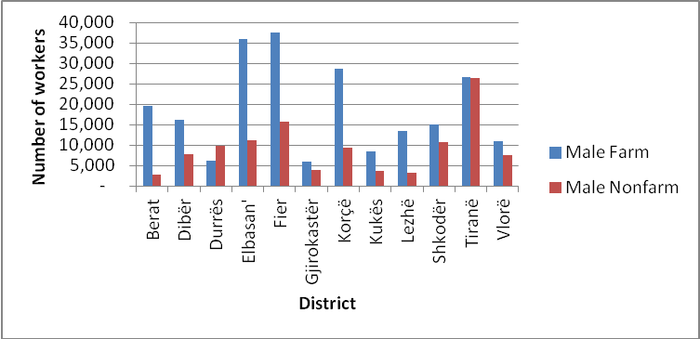
Source: INSTAT; 2012 LFS
Figure 14: Male farm/non-farm workers by district rural areas

Economic activity by district shows a wider spread of economic activity for urban areas between industry and services, and a large concentration of economic activity in agriculture for rural areas (Table 2). Aside from agriculture, which is the main economic activity for all districts in rural area, Tirane (3,870) and Durres (3,735) have the largest number or workers in manufacturing industry, whereas Berat (181) and Vlore (204) have the lowest. Tirane (11,168), Shkoder (3,836), Elbasan (3,812), Vlore (3,691) and Fier (3,200) have the largest number of involvement in construction, whereas Berat (280) and Lezhe (825) have the lowest. The difference is quite large between Tirana and other districts, which may be related to the larger construction activity coming from Tirana. Largest number of workers in extractive industries are in Fier (2,754), Diber (1,281), and Korce (1030), and lowest numbers are in Berat (134), Lezhe (152) and Gjirokaster (182). Services, market and non-market have the largest number in Tirane (13,814 in market services and 6,613 non-market services), Fier (8,114 in market services, 3,970 in non-market services), and Elbasan (6,558 in market services and 3,170 in non-market services). Districts such as Lezhe (1,161 market services and 2,399 non-market services), Gjirokaster (1,596 market services and 1,937 non-market services) and Berat (1,657 market services and 1,261 non-market services) appear quite limited in workers in services.
Table 2: Economic Activity by District; Urban-Rural Areas
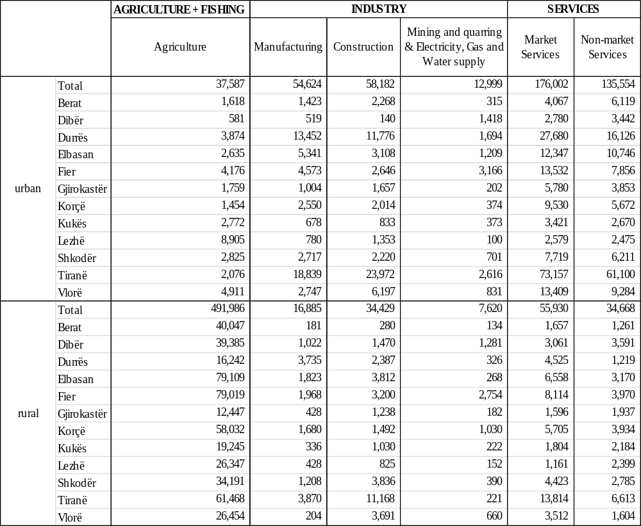
Source: INSTAT; 2012 LFS

Economic activity in rural areas by sex and district shows the limited economic activity of women in rural areas. Whereas economic activity for women in urban areas is more diversified, it is heavily concentrated on agriculture for rural areas. Economic activity in construction is almost inexistent whereas it is very limited in extractive industry. On the other hand, services are also limited compared to men, and within services there is higher participation in non-market services for various districts. In this respect, men have the largest number in manufacturing industry in the rural areas in the districts of Durres (2,845), Tirane (2,713), Fier (1,620), Korce (1,320), Shkoder (1,176) and the lowest in Berat (181), Kukes (183), and Vlore (204). Construction has the highest number of men in Tirane (11,168), Elbasan (3812), Shkoder (3,753), Vlore (3,691) and Fier (3,200). The district of Diber has the lowest number of male in construction (280). Extractive industry has the largest number of male in rural areas in the districts of Fier (2,675) and Diber (1,019), and the lowest numbers in Elbasan (51), Gjirokaster (120), Berat (134), and Lezhe (152). Lastly services have the highest numbers of male in Tirane (10,863 in market services and 3,976 in non-market services), Fier (5,836 in market services and 2,648 in non-market services), Elbasan (4,780 market services and 2,002 in non-market services), Korce (3955 in market services and 2,513 in non-market services), Durres 3905 in market services, and Shkoder (3, 779 in market services and 2,362). The lowest numbers in market services are in Lezhe (1,046), Gjirokaster (1,129), Kukes (1,269) and Diber (1,306) non-market services Durres (798), and Vlore (713).
Employment by district for women shows low numbers by district in other economic activity besides agriculture. Rural areas in the districts of Vlore and Diber have no women in manufacturing, construction or extractive industries. Manufacturing is quite limited and the highest numbers are found in the districts of Tirana (1,156) and Elbasan (1049). The lowest numbers are found in Shkoder (32), Lezhe (67) and Gjirokaster (86). As mentioned earlier, construction is almost inexistent and extractive industries are quite limited. Market services have the highest numbers in Tirane (2,950), Fier (2,278), Elbasan (1,778), and Korce (1,750). Lezhe districts has the lowest number of women in market services (115). Lastly, non-market services have the highest numbers in Tirana (2637), Korce (1,422), Lezhe (1,330), Fier (1,322), Elbasan (1,168), and Diber (1160). Lowest numbers are in Berat (300), Durres (421), and Shkoder (423).

Table 3: Economic Activity by District; Male-Female

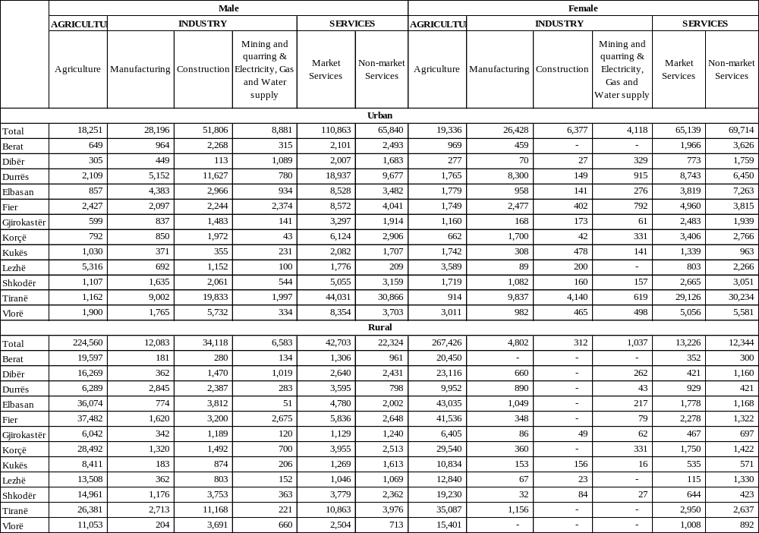
Source: INSTAT; 2012 LFS

III.3 Labor market indicators for youth

Youth has the most vulnerable position in the labor market not solely in Albania, but also elsewhere in the world. In the aftermath of the financial crisis, youth employment rate are quite low and unemployment rates are quite high in the European Union. Likewise, compared to other groups of the population, youth in Albania also have the highest unemployment rates, and lowest labor force participation and unemployment rates. For reasons explained throughout the report, we proceed immediately with youth labor market indicators in the rural areas.
Youth labor force participation in rural areas seems more volatile than the national average. In the five year period between 2007 and 2012, youth labor force participation has decreased between 2007 and 2008, increased between 2008 and 2009, decreased again between 2009 and 2010, increased between 2010 and 2011, and decreased between 2011 and 2012 to lower levels than 2007 (Figure 15). Youth labor force participation in 2012 is 58.0%. Female labor force participation for youth is consistently lower than male youth. Differences have increased especially between 2008 and 2011. In 2012, female labor force participation is 51.3% compared to 63.6% for their male counterparts.

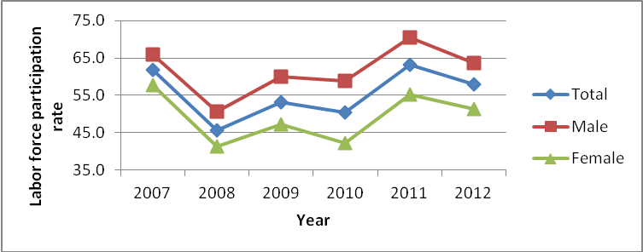
Source: INSTAT; 2007-2012 LFS
Figure 15: Labor force participation rate youth in rural areas

Youth employment rate has had a very large decrease between 2007 and 2008 from 57.7% to 39.5% respectively (Figure 16). After this sharp fall employment rate has mainly recuperated between 2010 and 2011 from 42.2% to 55.7% respectively. Employment rate has decreased to 50.1% in 2012. The largest differences by gender are from 2008 to 2011. In 2012 the differences are smaller with an employment rate of 46.9% for young females versus 52.9% for young male. This may in part be due to the fact that both have experienced a decline in employment between 2011 and 2012 as has the national average.
As indicated by the sharp decrease in employment rate between 2007 and 2008, unemployment rate has mainly increased between this period more than doubling from 6.6% in 2007 to 13.6% in 2008 (Figure 17). Another significant increase of unemployment rate has occurred between 2009 and 2010 from 12.2% to 16.4% respectively. In 2012, youth unemployment rate is 13.3% close to 2008 levels. Gender differences are difficult to isolate given the problems of unemployment statistics for females highlighted throughout the report. Nonetheless, the largest gap in unemployment rate has occurred between 2010 and 2012 favoring young females. In 2012, unemployment rate for young male is 16.8%, whereas for young females is 8.6%.

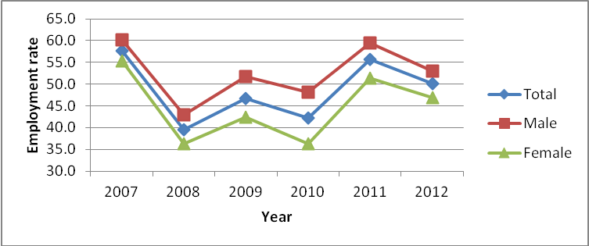
Source: INSTAT; 2007-2012 LFS
Figure 16: Employment rate youth in rural areas

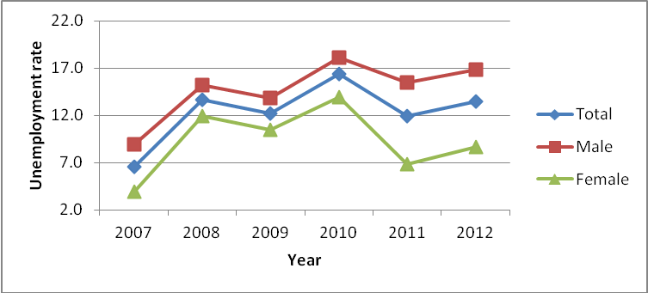
Source: INSTAT; 2007-2012 LFS
Figure 17: Unemployment rate youth in rural areas

As with the rest of the population, the vast majority of youth workers are farm workers (Figure 18). In 2012 there are 120,882 youth farm workers versus 36,207 non-farm workers. The number of male and female youth as farm workers is quite comparable, 61,198 young female and 59,684 young male farm workers. However, in terms of non-farm workers, the difference is quite large between young females and young males. There are 6,975 young female non-farm workers versus 29,232 young male non-farm workers. These differences are significant and they may start at youth and are carried over throughout life as has been shows from other statistics in this report. As a result, efforts need to be taken as to reduce these differences from younger age and channel youth and especially female youth in alternative economic activities besides farm work.

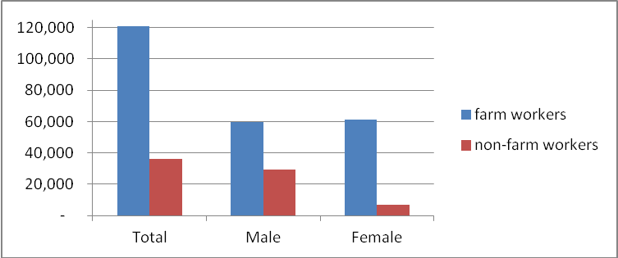
Source: INSTAT; 2012 LFS
Figure 18: Youth farm/non-farm worker by sex

Economic activity for youth in rural areas is also quite limited aside from agriculture, which involves the majority of workers (Table 4). Urban areas have a larger participation in manufacturing and services, whereas rural areas are predominantly agricultural and some activity in construction and extractive industry, where participation is larger than in urban areas. In rural areas, construction is the main activity within industry that has the largest number of young workers (11,715). Within industry, there are 4,807 workers in manufacturing and 1,307 workers in extractive industry. Market services have 13,521 young workers, whereas non-market services have 7,252 workers.
Gender differences show that the vast majority of workers in each economic activity are male. The number of young females outside of agricultural activity is very limited. Numbers are especially limited in industry. There are 1,397 young females in manufacturing versus 3,410 young male. There are 153 young females in construction versus 11,561 young males. There are 478 young females in extractive industries versus 829 young males. Lastly, within services young females are mainly in non-market services. There are 1,985 young females in market services and 3,564 young females in non-market services compared to 11,536 young males in market services and 3,689 young males in non-market services. Consequently, distribution of young males and females in economic activity show two thing: 1. economic activity is quite limited for young females, and 2. they are mainly concentrated in lower paying activities. These differences, which are then carried out throughout life increase the gender wage gap, which is the largest in the rural areas.

Table 4: Economic Activity of Youth 15-29 years
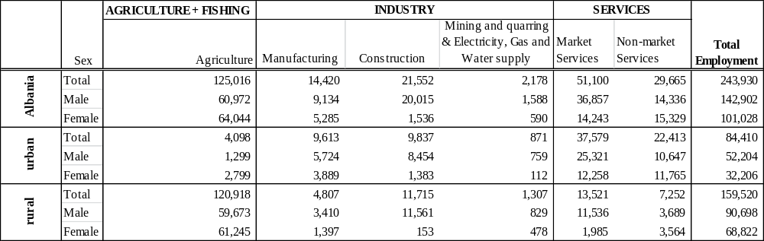
Source: INSTAT; 2012 LFS

Lastly, statistics by district in the rural areas show that youth labor force participation rate is the largest in Vlore (89.4%). Other districts with higher labor force participation are Lezhe (70.7%), Fier (65.4%), Korce (61.6%), and Gjirokaster (57.55). The lowest rate is in Durres (41.4%), followed by Kukes and Shkoder (51.3%), Diber (51.7%), and Elbasan (52.2%). Employment rates also follow these trends with Vlore having the largest employment rate (77.5%) and Durres (35.5%) and Kukes (37.1%) the smallest. Unemployment rates show smaller differences between districts. Kukes has the largest youth unemployment rate (27.7%) followed by Shkoder (24.3%), and Gjirokaster (21.5%). Berat (2.8%) and Elbasan (4.0%) have the lowest unemployment rate. It should be noted again that these statistics are mainly guided by availability of farm labor and are often related to young females’ unpaid family labor and inactivity rates.

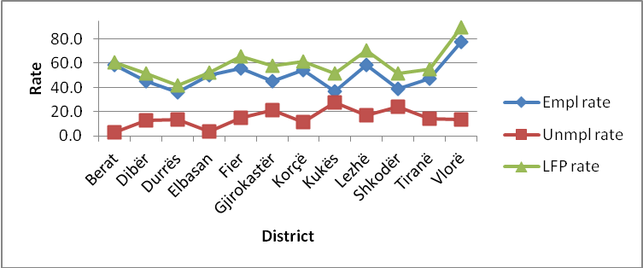
Source: INSTAT; 2012 LFS
Figure 19: Labor market indicators by district rural areas youth

IV. Local Economic Units

Economic activity by district in rural areas shows that there are there are more producers of services than producers of goods (Table 5). There are 16,750 local units in communes that are producers of services versus 4,490 that are producers of goods. The largest number of local units is in trade, 7,604 local units followed by 3,427 in hotels, cafés, and restaurants, transport and communication, 3,193, industry, 2,747, agriculture and fishing, 983, and lastly construction 760. Low numbers of local units in communes in agriculture and fishing support the idea that agriculture in rural areas is mainly small scale family farming or subsistence farming hosing unpaid employment. The latter however remains the predominant activity in rural areas.
According to local units by economic activity, rural areas in districts of Tirana, Fier, Elbasan, Korce appear to be among the ones with larger economic activity, whereas districts like Kukes, Diber and Lezhe appear to be much more restricted in terms of economic activity. However, lower economic activity may also indicate higher levels of informality. Within producers of goods district division shows that Fier (175) and Shkoder (167) and Vlore (120) have the top three largest numbers of local units in agriculture and fishing, whereas Kukes (13), and Diber (19) have the lowest numbers of local units. With regards to industry, Tirane (544) and Fier (410) are the two top districts for the number of local units. Kukes (23), Diber (113), and Lezhe (129) have the lowest numbers of local units in industry. Construction is mainly concentrated in Tirane with 269 local units. Other districts have much lower numbers of local units in construction with the lowest numbers in Kukes (18), Diber (22), and Gjirokaster (25). Within producers or services, trade is mainly concentrated in Tirane (1,861) and Fier (1,401), and least in Kukes (42) which has a very large difference with the rest of the districts. Other districts such as Diber (117), and Gjirokaster (220) also have limited numbers. Hotels, cafes and restaurants are mainly concentrated in Tirane (884), Fier (555), Shkoder (457) and least in Kukes (12), Diber (36), and Gjirokaster (109). Transport and communication is mainly concentrated in in Tirane (500), Fier (459), Korce (426) and Elbasan (409), and least in Kukes (54), and Lezhe (109).
Table 5: Local units by districts and economic activity, communes
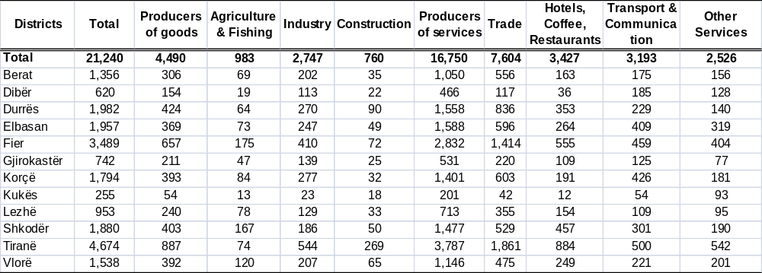
Source: INSTAT; 2010 Economic Census of Enterprises

The vast majority of local units have between 1 and 4 employees showing that they are relatively small and many of them may also be activities of self-employment (Table 6). Economic activity appears to be mainly concentrated in self-employment or small units and very limited for large scale units. This in return limits economic activity and labor demand in rural areas, which does not allow for skill accumulation and diversification of the labor force. There are 18,982 local units with 1-4 employees. Tirana (3905) has the largest number of local units with 1-4 employees, however this is expected since Tirana also has the largest number of local units. Fier is the second largest with 3,299 local units with 1-4 employees. The lowest is found in Kukes with 185 local units of 1-4 employees. There is a large difference between local units with 1-4 employees and those with 5-9 employees. There are 1,085 local units with 5-9 employees. Tirana (396) and Durres (113) have the largest number of local units with this level of employment. The rest of districts vary between 19 (Kukes) and 99 (Fier) local units with 5-9 units. The number of local units with 10-49 employees is close to those of 5-9 employees. There are 1,022 local units with 10-49 employees. The largest number is in Tirane (301) and Elbasan (107), whereas Berat has the lowest number (35) followed by Kukes (47), Lezhe and Gjirokaster (56). Lastly, the number of local units with more 50 or more employees is quite limited amounting to 151. Once more, Tirana (72) has the largest number followed by Elbasan (13) and Fier (12). Diber (1), Kukes and Gjirokaster (4) have the least.

Table 6: Local units by district, economic activity and number of employees; communes
Districts | Total | Number of employees
Districts | Total | 1-4 | 5-9 | 10-49 | 50+
Total | 21,240 | 18,982 | 1,085 | 1,022 | 151
Berat | 1,356 | 1,267 | 48 | 35 | 6
Dibër | 620 | 505 | 37 | 77 | 1
Durrës | 1,982 | 1,784 | 113 | 76 | 9
Elbasan | 1,957 | 1,755 | 82 | 107 | 13
Fier | 3,489 | 3,299 | 99 | 79 | 12
Gjirokastër | 742 | 642 | 40 | 56 | 4
Korçë | 1,794 | 1,632 | 84 | 71 | 7
Kukës | 255 | 185 | 19 | 47 | 4
Lezhë | 953 | 832 | 56 | 56 | 9
Shkodër | 1,880 | 1,746 | 57 | 70 | 7
Tiranë | 4,674 | 3,905 | 396 | 301 | 72
Vlorë | 1,538 | 1,430 | 54 | 47 | 7
Source: INSTAT; 2010 Economic Census of Enterprises

Given the larger number of local units in producer of services, this sector also provides for 67.5% of employees, whereas producers of goods host 32.5% of employees (Table 7). Economic activity division shows that industry provides for the largest percentage of employment 27.9% of those employed in local units. The second largest is trade 18.8% followed by hotels, cafes and restaurants 9%, transport and communication 3.3%, construction 3% and agriculture 1.6%. These rates show that agriculture is very limited in terms of formal employment, and other activities such as construction and transport and communication are also limited. Growing sectors such construction and transport and communication, which are also quite profitable, are very limited in rural areas whereas they are quite prominent in urban areas. Limitation and economic activity and employment in formal non agricultural activities also limit the potential for rural development and economic well-being.
In Berat, industry provides for most of employees in local units, 55.8%. Whereas construction has the lowest percentage of 1.1%. Other activities such as agriculture, transport and communication, and hotels, cafes and restaurants are also quite limited. Employment in local units in rural areas of Diber is mainly concentrated in other services 74.2% and is quite limited in all other economic activities. Employment in Durres is mainly concentrated in industry 50.2%, trade 14.2%, and hotels, cafes and restaurants 10.5%. Other activities such as construction, transport and communication and agriculture are quite limited. Elbasan mainly provides employment in industry 19.7%, trade 13.7%, and hotels, cafes and restaurants 9.3%. The rest of economic activities are quite limited. Fier mainly hosts employment in trade 23.1%, industry 16.2%, and hotels, cafes and restaurants 12.2%. The rest of economic activities provide insignificant employment. Gjirokaster is also mainly concentrated in trade 20.5%, industry 14.7%, and hotels, cafes and restaurants 8.6%. Employment in Korce is mainly hosted by industry, 15.8%, trade 14.6%, and hotels, cafes and restaurants 7.5%. Lezhe (47%) has the third largest concentration of employment in industry after Durres and Berat. Trade is the second largest activity in terms of employment 13.9% followed by hotels, cafes and restaurants 7.4%. Kukes has quite limited employment in any above mentioned economic activities. The majority of employment is concentrated in other services, which shows small scale employment in various services 70.5%. The rest of employment is in industry 10.6% and construction 10.9%. Employment in Shkoder is mainly concentrated in trade 18.9% and hotels, cafes and restaurants 10.55. Tirane and Vlore also mainly provide employment in industry 27.7% and 15.9%, trade 25.8% and 14.5% and hotels, cafes and restaurants 9.7% and 11.7%, respectively.

Table 7: Employed in local units by district and activity; communes, in percentage
Districts | Producers of goods | Agriculture & Fishing | Industry | Construction | Producers of services | Trade | Hotels, Coffee, Restaurants | Transport & Communication | Other Services
Total | 32.5 | 1.6 | 27.9 | 3.0 | 67.5 | 18.8 | 9.0 | 3.3 | 36.4
Berat | 58.5 | 1.6 | 55.8 | 1.1 | 41.5 | 10.4 | 4.0 | 1.6 | 25.5
Dibër | 12.6 | 0.3 | 8.5 | 3.9 | 87.4 | 6.0 | 2.1 | 5.1 | 74.2
Durrës | 54.2 | 2.4 | 50.2 | 1.7 | 45.8 | 14.2 | 10.5 | 2.3 | 18.8
Elbasan | 24.9 | 0.7 | 19.7 | 4.4 | 75.1 | 13.7 | 9.3 | 2.4 | 49.7
Fier | 23.8 | 4.9 | 16.2 | 2.6 | 76.2 | 23.1 | 12.2 | 3.0 | 37.9
Gjirokastër | 19.9 | 1.8 | 14.7 | 3.4 | 80.1 | 20.5 | 8.6 | 3.0 | 47.9
Korçë | 19.7 | 3.6 | 15.8 | 0.3 | 80.3 | 14.6 | 7.5 | 2.7 | 55.4
Kukës | 21.4 | 0.0 | 10.6 | 10.9 | 78.6 | 2.7 | 0.4 | 5.0 | 70.5
Lezhë | 49.1 | 0.7 | 47.0 | 1.3 | 50.9 | 13.9 | 7.4 | 2.4 | 27.2
Shkodër | 17.3 | 3.5 | 7.4 | 6.4 | 82.7 | 18.9 | 10.5 | 2.5 | 50.8
Tiranë | 31.5 | 0.4 | 27.7 | 3.3 | 68.5 | 25.8 | 9.7 | 4.5 | 28.4
Vlorë | 20.2 | 1.9 | 15.9 | 2.4 | 79.8 | 14.5 | 11.7 | 2.5 | 51.0
Source: INSTAT; 2010 Economic Census of Enterprises

Employment in local units by sex support the gender differences found so far in the labor market. In every district in communes there is a larger percentage of males employed reinforcing the large percentage of females in unpaid family labor. There are large differences between Tirana and other districts. Of all employed females in local units, Tirana employees 43.5% followed by Durres 10.4%, Fier 7.4%. (Table 8). Kukes and Diber have the lowest percentages of 1.8% and 2.3% respectively. Within each district of all those employed in local units in communes, Vlore (29% difference), Fier (27.5%) and Diber (27%) have the largest difference in employment favoring men. The lowest difference between females and males is found in Shkoder, Berat and Lezhe, 12.6%, 13.1% and 13.2% respectively.

Table 8: Employed in local units by sex and district; communes, in percentage
Counties | Female | Male | Of total employed
Counties | Female | Male | Female | Male
Total | 100 | 100 | 39.3 | 60.7
Berat | 4.3 | 3.6 | 43.4 | 56.6
Dibër | 2.3 | 2.6 | 36.5 | 63.5
Durrës | 10.4 | 11.1 | 37.9 | 62.1
Elbasan | 5.9 | 6.2 | 37.8 | 62.2
Fier | 7.4 | 8.5 | 36.2 | 63.8
Gjirokastër | 2.8 | 2.8 | 39.4 | 60.6
Korçë | 5.9 | 5.1 | 42.8 | 57.2
Kukës | 1.8 | 1.7 | 39.9 | 60.1
Lezhë | 3.4 | 2.8 | 43.4 | 56.6
Shkodër | 6.6 | 5.5 | 43.7 | 56.3
Tiranë | 43.5 | 43.3 | 39.3 | 60.7
Vlorë | 5.8 | 6.8 | 35.5 | 64.5
Source: INSTAT; 2010 Economic Census of Enterprises

V. Employer perspective and skill requirements

Interviews done with 109 rural businesses in all 12 districts shed light on employers
perspective regarding employment and labor force in rural areas. Although the analysis is strictly qualitative and it is not statistically representative, it provides information from employers that complement the statistical analysis provided in the previous sections. It is also a way to provide qualitative information and employer insight that is not available in quantitative measures. Tables A1-A3 provide information on the demographics of the businesses.
Interviews with rural businesses reveal that the majority as is the case with national averages are mainly owned by men. There are 94 male owners and 15 female owners. Same is the case in terms of labor force. The majority of the labor in companies is made up of men, and half of the companies have up to 2 female employees. Youth is also in minority, with over 50% of companies having up to 3 young employees. However, when asked about opportunities for employment of female and youth they responded positively. Companies report that there has been growth in terms of labor force in the last year however it appears slow. The majority of companies have grown by 1 or 2 workers. There are twenty-one companies reporting to have grown by 2 employees, twelve companies by 1 employee, ten companies by 5 employees, four companies by 3 employees and four companies by 4 employees. Businesses foresee future growth in their activity and workforce (88) businesses. As part of their foreseen growth, businesses identify workforce qualifications such as administrators, marketing, technologists and technicians as the main required fields. Businesses appear clear on where they are planning to be heading, therefore a better coordination with intermediaries is required to match skill needs of businesses with those of the labor force.
Business start-up is mainly done for self-employment (10 companies), a way to increase family income (16 companies) and initiative to have a business (32 companies). These reasons support statistical figures shown on the previous section where the majority of businesses have between 1 and 4 employees reinforcing the idea that they are mainly for self-employment or a way to secure income for the family. The rest for the reasons vary from experience from abroad, previous experience in the field, market demand and lack of activity in the area, passion for the land and business, available financing opportunities, availability of olives in the area allowing for olive oil business, inheritance of factory. These reasons hint towards individuals responding to market demand, business and finance opportunities. Therefore given the right incentives, opportunities and business climate, there should be increased business initiatives.
In terms of labor force education, the vast majority of businesses respond to have workers with secondary school education (88). A very limited number of companies have labor force with primary education (8 companies), high education (3 companies) and vocational training (8 companies). This reporting by the companies goes in line with the fact that as education level increases so does employment. National statistics also show that individuals with secondary education have higher employment rates than those with primary education. On the other hand, vocational training is quite limited in Albania and it appears quite low in terms of labor force for businesses. Consequently, the need for education in rural areas and higher employment opportunities as education increases is also apparent from the business interviews.
The overwhelming of interviewed companies (101) respond to find their work force themselves or though notifications. This is an indication of lack of job-search mechanisms. Businesses do see a role for employment services and vocational training even though they are not extended in rural areas. In regards to employment services the main recurring theme for businesses is provision of qualified workforce. In this regards, vocational training may provide services for skills and qualifications needed by employers. Furthermore, businesses mainly report to have a lack of qualified agricultural workers, technicians, and services and sales. The main problems in regards to the labor force are lack of work experience, lack of professional qualifications and lack of both. As a result, many companies (77 companies from 92 who responded this question), report to provide on the job training. Consequently, it may be assumed that there is need for vocational training especially in rural areas.
Lastly, there is a willingness of businesses to engage in green business activities (88 out of 91 companies who responded are involved in some sort of green activities in their business). Although it is still early for advanced green activities in Albania, employer’s perspective show their willingness as well as realization of the importance of these activities for businesses as a business opportunity as well as for social responsibility. A recurring response from companies is that green economy activities should be undertaken and be spread out by businesses because they help businesses and the environment. Often times they are linked to the environment and clean work environment, but also linked as good and necessary initiatives for the community and society. The vast majority of companies report to undertake green economy initiatives to protect the environment and natural resources. Even though green economy initiatives are quite new and underdeveloped in Albania and their focus appears to be mainly related to preserve the environment and a clean work environment there is potential for growth in these activities. Furthermore, companies appear to be responsive to these activities; however financing and training is needed as to spread the idea and understanding of the green economy especially in the rural areas of Albania.

V.1 Skill requirements

Skill requirements from employers and skill composition of the workforce should
complement each other and go hand in hand. If mechanisms which bring together demand for skills and acquisition of skills are lacking, the workforce may lack behind. Lacking behind of the workforce becomes an obstacle for businesses, which in return becomes an obstacle for skill acquisition. Given the high rates of unpaid labor and family farming in rural areas and lack of vocational training or appropriate curricula of vocational training, the labor force does not specialize or acquire a particular set of skills. As a result, employers have difficulties finding qualified workers for their business activities. The fact however remains that higher levels of education are associated with higher rates of employment and lower rates of contributing family workers (Table 9).
Education and skill acquisition are imperative into gaining employment and getting out of unpaid labor. Data on contributing family worker by education (Table 9) show that there is a large difference between lower and higher education levels. In 2012, 61.0% of individuals with primary education in rural areas are contributing family workers and 45.8% of those with secondary education are contributing family workers. The same trend is true for youth employment. However, it should be noted that in addition to education, skill acquisition is very important. Vocational education would be of a particular strategic importance providing the workforce with skills required by employers.

Table 9: Contributing family worker rate by education level
 | CFW rate by educational level
 | 2007 | 2008 | 2009 | 2010 | 2011 | 2012
Primary education
15-29 | 63.1 | 68.9 | 68.2 | 64.1 | 69.5 | 71.5
30-64 | 40.6 | 49.0 | 43.0 | 41.9 | 49.2 | 56.7
15-64 | 48.1 | 53.1 | 50.5 | 47.9 | 55.1 | 60.4
15+ | 47.9 | 52.9 | 50.4 | 48.2 | 55.3 | 61.0
Secondary education
15-29 | 50.0 | 58.6 | 60.9 | 56.6 | 58.8 | 65.2
30-64 | 18.6 | 25.3 | 23.2 | 21.2 | 34.0 | 38.1
15-64 | 27.1 | 31.2 | 33.3 | 30.7 | 41.8 | 45.6
15+ | 27.0 | 31.3 | 33.5 | 30.6 | 41.4 | 45.8
Tertiary education*
15-29 | 17.1 | 10.4 | 29.6 | 15.4 | 35.8 | 41.6
30-64 | 5.3 | 4.7 | 10.6 | 3.2 | 9.3 | 17.7
15-64 | 7.6 | 6.1 | 20.6 | 8.0 | 20.5 | 28.4
15+ | 7.5 | 6.0 | 20.6 | 8.1 | 21.7 | 29.2

As pointed out by interviews with the companies there is a lack of skill and work experience of their workforce. Another study conducted at national levels also shows that there are various skills identified by employers in various sectors of the economy that are needed, but missing. The identified missing skills and qualifications should serve as a guide for vocational education especially in the rural areas that have the largest level of contributing family workers. A summary of skills for each sector that also operates in the rural areas is given below.
Agriculture and Agro-processing: Businesses report that professional positions are hard to fill. There is a lack of technologists, cost accountants, and supervisors of production processes with management and organizational skills and knowledge on technological process and cost. More specifically, there is a lack of agronomy specialists, technicians of production processes and technicians for machine operations and repair services. These professions are mainly lacking in rural areas. There is a lack of work attitudes and technical skills. Engineers and maintenance staff are also difficult positions for which to find the appropriate workforce. There is a lack of knowledge and practical skills for young mechanic and electrical engineers. Employers are wary of the future when they will need to replace their retiring workforce that have a lot of skill and experience with the younger workforce. There are however existing online training and information on extension services provided by the Ministry of Agriculture.
Textile and Foot Wear: This sector also lacks specialized staff for mechanics of textile machines and sewing machines. Given the very restricted number of existing specialists in this field, the existing specialists move from business to business making it costly and time consuming for the businesses. Cost accountants are also lacking for this sector making it difficult to detail and calculate costs of the production process. University graduates are also not able to calculate all the costs involved in the production process. Footwear more specifically lack workers in shoe stamp production and modeling specialist are virtually inexistent.
Tourism: This sector needs hotel staff with hotelier and tourism knowledge and skills. However, the number of students following hotelier studies is very limited. Furthermore, even those graduated in vocational schools still lack the knowledge, skills and work attitude appropriate for this sector. The majority of them do not intend to be involved in hotelier services, but they continue university studies in other fields such as business administration.
Hospitability, culinary or landscape and rural heritage training are almost non existent. These skills are very important for valorizing area resources and rural tourism potential and therefore also for creation of new jobs and activities in rural territory. Rural youngsters met during the research were very interested in this skills however they were skeptical about the likelihood of such business venture in the near future.
Construction: There are various professions in this sector for which businesses have difficulties finding workforce. Some of the most difficult professions and skills to find in construction are maneuver of concrete pump, pumper, metal lifter, specialized brick layer for capote systems, hydro isolator, duralumin and plastic worker, mechanical for installation of elevators, electrician for installation of elevators. Other professions such as elevator panel installer, electrician for central TV antenna, electrician for maintaining the control facilities for parking and electronic specialist for maintaining the camera system of parking are even harder to find.
Transport and communication: Businesses report that this sector has the most difficult specialties to be found in the labor market. Specialties like generic, electro auto and motorist repair are extremely difficult to find. Furthermore, graduates of vocational school in these fields almost totally lack theoretical and practical skills as well as the work attitudes. The work force in these positions is over 58 years old whereas young employees do not have an interest to learn and work in these professions.
Individual commitment to vocational education
Limited access of rural youth in Vocational Education and training is closely linked to the limited VET schools or accessible and affordable VET courses. On the other hand uncertainty of jobs and future business or employments opportunities makes it difficult for young individuals to commit to a long term VET. Youngster met during the study, were more interested in short term ( 3-6 months) courses than a full term school unless they had some indication on business perspectives in the area or outside the area they live.

VI. Evaluation of the role of institutions and public policy in Rural Labor Market in Albania

Market institutions in Albania play an important role in the functioning, regulation and development of the rural areas, including their support to the rural labor market as an important mechanism for the allocation of labor, resources and income generation in both demand and supply forces across the various economic activities in the country. With the substantial economic reforms and the changes in the national economic structure, traditional economic activities in the rural areas have gradually lost share in the national output as agriculture, as the dominant activity in the rural areas of Albania today accounts for about 17.5% of the GDP (INSTAT, GDP and employment figures, 2012) In contrast with this trend however, the employment by the agricultural sector of more than 55% of the workforce in the country (INSTAT), is an indicator of both the still significant relevance of the rural labor market in the national labor market and the weaknesses in the productivity levels relative to the other economic activities in the country and also lack of diversification of economic activities within rural areas.
These factors are also reflected in the prosperity levels across the rural areas of Albania, inhabited by 46.5% of the population (INSTAT, Census 2011) largely living under sub-standards levels compared to the urban areas. Distribution of the Albanian population across the wealth quintiles shows that about eight in ten persons living in urban households are in the two highest wealth quintiles, while seven in ten persons living in rural households are in the two lowest wealth quintiles.
While it is a responsibility of the market institutions to support the integration of the rural areas in the national labor market and sustain higher income generation in the rural areas, markets, particularly in the rural areas are somehow distant from the perfect models, thus a review of the role and responsibilities of related institutions is important in order to understand the main issues and constraints present in these areas. Furthermore, the rural economic activity has been affected by a myriad of public policies, institutional reforms and political choices aiming to promote general economic growth and better governance, despite their often unintended consequences in specific areas of the country.
The Ministry of Social Welfare and Youth (former Ministry of Labor, Social Affairs and Equal Opportunities) has been the leading government agency in charge with labor related issues, but various other Ministries and government institutions share other significant responsibilities in the cross-sector rural labor market. Other public organizations, mostly under the institutional umbrella of the Ministry of Social Welfare and Youth complement the role of these Ministries in fulfilling government’s objectives and responsibilities in the rural labor market. As the structure of the new government is still consolidating, this report, unless otherwise stated, assumes the key responsibilities analyzed would remain assigned on the same institutions.
The cross-sector nature of the rural development policy, requiring government’s interventions in a broad array of public policy areas such as infrastructure development, decentralization, agricultural support, diversification of economic activity, education, training and healthcare, business environment, gender-related issues, unemployment etc. poses significant challenges to tackle and coordinate each of the policy options and streamline effective mechanisms in place. This challenge gets even more complicated from the perspective of the rural labor market, as policy choices aiming overall rural development are compounded with the underlying factors analyzed in the previous section of this report.
The institutional coordination mechanism on rural development issues in general, including the its impact on the labor market forces and processes in the rural areas, appears to be one of the main challenges for the government. Although the Ministry of Social Welfare and Youth maintains the leading role in labor policy area and the Ministry of Agriculture, Rural Development and Water Administration executes the main functions related to rural development, none of these Ministries, nor other government agencies including the role of the Department of Strategy and Donor Coordination (assisting the government in policy coordination and the dialogue with the main international donors and streamlining the NSDI/sector and crosscutting strategies and European Integration agenda to the medium-term budget plans adopted by the government), or ad-hoc bodies such as the Inter-Ministerial Committee for Agriculture and Rural Development, has established proper mechanisms to efficiently coordinate the cross-cutting issues identified in the previous section of this report.
With the new government in place since September 2013 an initial positive step has been taken by the incorporation within the MoSWY of the responsibility for the administration of the vocational education system, formerly under the responsibility of the Ministry of Education. This reform of the VET system would enable a better alignment of the public VET services with the needs and requirements of the labor market, closely monitored by the MoSWY. Yet it remains still to be decided how and when the public VET services could reach the rural areas (this topic is further elaborated later in this section).
Challenges related to the institutional coordination aspect mainly arise from the functional organization of the central government institutions, designed to optimize the internal performance in each specific strategic area of activity, but often lacking adequate ability to synchronize with other institutional mechanisms operating in different policy areas. This problem is further exacerbated as specific policy tasks are often subordinated to other government agencies under the responsibility of specific ministries, which have the tendency to operate in isolation from the duties they are designed to perform.
To illustrate - in addition to the closely related policy areas (i.e. social protection and youth), the MoSWY develops and implements policy and legislation in the areas of employment, VT, social protection, and labor market regulations. The National Employment Service (NES) is a government organization under the MSWY (established by the Council of Ministers Decision “On the approval of the status of the National Employment Service” No. 42, of 17.01.1998), responsible for the provision of the employment services across Albania. The NES mission states that NES works to ensure that all Albanian citizens who live in Albania have access to employment through employment services and participation in the labor market programs, as well as the overall development of the country’s labor force through investments to increase employment and self-employment skills, flexibility and competitive skills focusing on these main areas of activity:
- mediation service for jobseekers, employed persons, disable persons and employers; professional advice, career guidance and qualification for the jobseekers;
- unemployment benefits support;
- incentives for employers who create new jobs and employ persons with disabilities; and,
- preparation of labor market studies.

Despite the fact that NES is an important government agency and it employs in its headquarter, regional and local employment offices a significant staff of around 360 persons, its role and impact in the rural labor market is rather limited as the NES services are almost exclusively offered to the urban areas of Albania where its regional offices are located. This spatial vacuum in the provision of the abovementioned public services is not related only to cost-effectiveness factors. It mostly builds on the assumption that citizens in the rural areas of the country are self-employed in the agriculture sector, hence in no need of NES employment services, while other government agencies focus on the development of the agricultural sector.

In parallel, the Ministry of Agriculture, Rural Development and Water Administration (MoARDWA) leads the role on rural development but its focus of activity is more restricted on agricultural support to the rural areas, while other Ministries support non-agricultural activities in these areas. A main arm under the administration of MoARDWA, are the extension services staffed by 290 employees providing technical qualified services through the regional directorates of agriculture in all the regions to the farmers, aiming to support higher levels of income generation. The national extension service and the Agricultural Technology Transfer Centres (public institutions under MoARDWA) reach with information up to 20% of the farmers and agribusinesses about 70,000 farmers out of the about 353,000 farms and 2,000 agribusinesses/processing enterprises. More than 8,000 farmers are assisted by extension service staff to apply/benefit from the support schemes. Similarly, the Mountain Areas Development Agency (MADA), a public agency under the primary responsibility of the MoARDWA, provides development support to the mountain areas, while ARDA (Agriculture and Rural Development Agency) focuses on other rural areas, mostly for infrastructure development and small project financing. Unfortunately the degree of cooperation among these government agencies on the rural labor market is minimal as each institution is more concerned with its primary responsibilities.
If room can be identified for policy and institutional reform improvements concerning the coordination among the main government institutions working on the rural labor market issues, on a vertical assessment, the coordination between the central government institutions and the local authorities, appears even more weak. The local governments (municipalities and communes in all the areas of the country) share or exercise direct responsibilities for the administration of the rural areas. Under the decentralization reform they have rights to issue and enforce orders and local regulations, collect revenues and execute budgets under their own responsibility. The role of the local governments is especially important in the rural areas where the activity and impact of the central government is far more limited compared to the urban areas of the country. The agricultural sector is the main economic activity in many municipalities and communes, which calls for the necessity of preparing local economic development programs, operation of market infrastructure, business promotion, as well as the protection of the environment.
While certain public services, such as social care (kindergartens, elderly houses etc.) are exclusively a responsibility of the local governments, other services, closely related to the rural labor market, such as the social assistance support, are shared functions of both local and the central government. Especially the social assistance support program, managed by the local governments, has often been subject of criticism for its lack of effectiveness, transparency, and for being counterproductive to the development of the rural areas with its impeding effect in the supply side of the rural labor market.
An analogous situation is observable in the area of coordination between the government and the international organizations, donors or local organizations active in the rural labor market. Various non government institutions and organizations affect the rural labor market. Most notably, the international organizations and donors active in Albania have targeted the rural areas with their support and development projects in order to address the poverty, gender or youth related issues which are significantly more problematic in these areas. Although most of such interventions are narrowly focused on scope, area, or target group, their impact has contributed to continuous improvements. Within this group of institutions are also included a number of local associations and organizations focused on advocating policy in support of the marginalized groups, decent work agenda and social protection. Discussions with past or ongoing donor-financed projects focusing in the rural areas and the labor market have indicated weak coordination among the main stakeholders.
While there is no specific strategic document on the government’s policy on the rural labor market, streamlining the various policy documents remains another important challenge to address the existing concerns in the future. The new government program includes an ambitious section on rural development of Albania, focusing on the need to tackle the informality in the development of rural areas in order to support sustainable development; several specific measure aiming to improve the productivity of the agriculture sector; new job creation in the rural areas by supporting agro processing sector and new services such as agro-tourism, hunting and fishing etc. The government has indicated it aims to increase by 5 times the public funds for rural development; and, restructuring the Agency for Rural and Agricultural Development. The program comprises a set of specific measures to be taken by the government in various economic sectors supporting the development of the rural areas.
The National Strategy for Development and Integration 2007-2013 (NSDI) is the main strategic document which provides the cross-cutting framework for an integrated approach on the social-economic development of the country and its EU integration perspective. The government’s role in the labor market and the creation of employment opportunities are emphasized as important challenges of the NSDI in the area of employment. The following related strategic priorities are outlined in the strategy:
- Improving public employment services across the country and developing of partnerships with private sector;
- Increasing efficiency of the active and passive employment programs;
- Improving Vocational Education and Training (VET) system including preparation of Albanian Qualification Framework (AQF), curriculum modernization, institutional developments, development of competencies of teachers and instructors etc.
As the NSDI has been adopted prior of the VET transfer from the Ministry of Education to the MoSWY, distinct objectives in the education system which share common ground with the labor policy, are identified in the strategy. Guaranteeing a modern education system, which will stimulate economic growth, consolidating democracy and achieving success in the regional and international dialogue and competition are emphasized as important challenges of the NSDI in the area of education, including VET. The following related strategic priorities are specified in the strategy:
- Improving governance in education sector through reforming and strengthening management capacities;
- Improving quality of teaching and learning process;
- Increasing efficiency of education financing;
- Building and developing human capacities; and
- Developing of competition and improvement of the quality of services in the non public schools.
On a more specific sector-level, directly affecting the rural labor market, the Inter-sectorial Strategy for Agriculture and Rural Development in Albania, as part of the National Strategy for Development and Integration aims to improve the quality of life in the rural areas, support higher levels of income generation and prepare these areas for integration in the EU. This policy document outlines government support measures in the following policy areas:

- Enhancing farm viability and competitiveness of agriculture and primary food-processing, while progressively aligning with the Union standards
- Specific objectives for restoring, preserving and enhancing ecosystems dependent on agriculture and forestry
- Specific objectives for balanced territorial development of rural areas promoting social inclusion, poverty reduction and balanced economic development in rural areas
- Transfer of knowledge and innovation in agriculture, forestry and rural areas and assistance to implementation of rural development policies

The strategy includes the establishment of national financial support schemes channeled in four main directions as follows:

- Income support to farmers and other support schemes
- Rural Infrastructure
- Horizontal interventions: Equal opportunities
- Insurance System in Agriculture

Finally, two specific strategies also affect the labor market, including its span in the rural areas. The Strategy on Employment and Vocational Training 2007-2013, adopted by the Albanian Government in January 2007, reflects the priority actions on employment promotion and Vocational Training (VT) system development. In addition, a separate VET Strategy 2007-2015 was drafted during 2007 considering the inputs from National Agency for Vocational Education and Training (NAVET). The strategy foresees the improvement of employment and VT service through:
- Establishment of a modern and unique system of employment services in the whole country;
- Establishment and development of partnership relations with other actors in the labor market;
- Development of information technology in the employment services;
- Improvement of contacts with enterprises;
- Development of human resources capacities;
- Improvement of collaboration with private employment services;
- Establishment of a unique and qualitative VET system, capable to contribute in the ongoing development of occupational skills and active citizenship for youngsters and adults;
- Provision of vocational qualifications in line with demands of the economic and social country development in the frame of EU integration.
The other strategic document - the Social Inclusion Crosscutting Strategy 2007 – 2013 has been adopted by the Albanian Government as a component of the NSDI. This policy document was developed with the purpose to articulate government policies in this broad area in an integrated manner and provide the monitoring framework against which progress can be assessed. The monitoring framework of the strategy is modeled along EU practices and aims to report on the Laeken Indicators (LI). The SICS includes three main strategic priority objectives:
- To raise the income generation opportunities of individuals through facilitating labor market participation of particular groups, extending and formalizing the labor market and promoting lifelong learning;
- To facilitate access to services (social care, health, justice, housing, transport, telecommunications, water and sanitation);
- To assist vulnerable groups, including children, Roma, people with disabilities, women, young people at risk and elderly people.
In addition to the above strategic documents there are also many other strategies and sector policies adopted by the government, which are dynamically linked with the rural and labor markets, such as the decentralization strategy, business development strategy, strategy of energy etc. These policy documents, while serving as a guideline for the public policy direction, should also reflect in a coherent manner the objectives in the area of rural labor market.
The necessity to revise, update, prioritize and coordinate the strategic documents of public policy has been a topic of permanent public debate among the policymakers and other relevant stakeholders. Less elaborated is the other aspect of government’s strategic function – the monitoring and continuous assessment of the implementation processes in each area of strategy, which is even more important in cross-sector policy areas influenced by various strategies, such as the development of the rural labor market. Quite often policy documents do not incorporate comprehensive monitoring mechanisms which would enable the government to assess the process of implementation, this appears to be the case for example also with the drat strategy of rural and agricultural development, which under the Strategy Monitoring Indicators section, has no clear indicators for the rural market development or rural labor.
Impact assessment analysis practices should be used as integrated tools of the development strategies in order to inform in advance and provide policy guidance to decision makers and stakeholders about the impact of their decisions, improve the quality of policy proposals, assess whether the strategy is achieving the desired objectives, and take corrective measures as necessary to reflect the performance of the stated objectives.
The integration of impact assessment analysis helps both improved governance of the programmes and at the same time it ensures sustainability and affordability of the proposed instruments in each development strategy. A common feature of the strategies related to the rural labor market, mentioned in this section, is the weak link that exists between the strategic objectives and the related budgets in the medium term public expenditure framework. Very often the strategic objectives are not justified by the allocated expenditure in the respective programs and vice versa, fiscal space available in the MTEF cannot guarantee sufficient space for certain objectives. For illustration, the strategy for agricultural and rural development 2013-2020 (draft format) indicates that the public expenditure financed by the government for the rural development in the year 2013, allocated to the Ministry of Agriculture is only 10 million Euro, expected to increase gradually up to 13.9 million Euro by the year 2020, a budget which could hardly justify the strategic objectives outlined in this strategy.

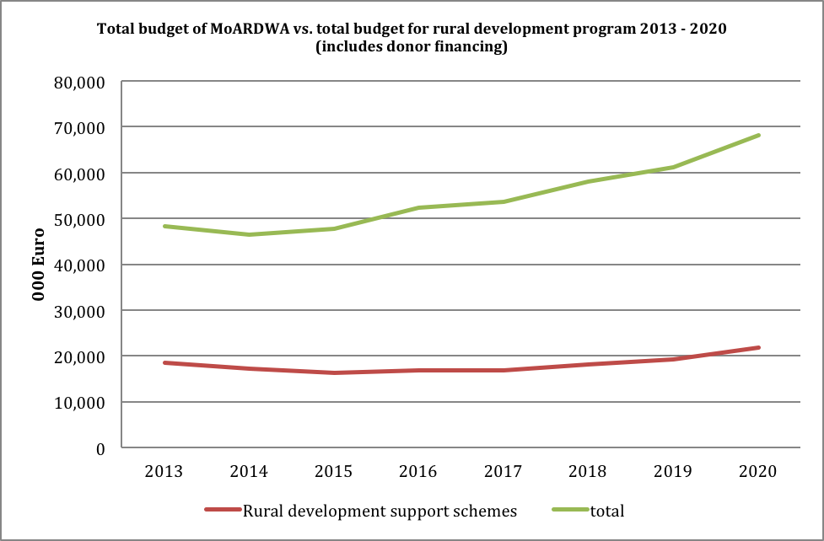
Figure 1: Agriculture budget vs. rural development program. Source: MoARDWA, Strategy 2013-2020

In addition to the modest financing from the government’s budget, the development of the rural areas in Albania would benefit also from the EU support, currently channeled through only two out of the five IPA components. But the expected approval of the EU accession candidate for Albania would enable the country to access IPARD funding which is the main EU assistance component on rural development. Estimations of IPARD financing for Albania range between 5.6-14.6 million Euro annually, which is a significant support compared to the support schemes financed by the government’s budget. In the path toward the European integration the rural areas of Albania face the largest challenges as their current status of development is significantly under the EU requirements. Such challenges are reflected in various dimensions as the productivity levels of the Albanian agricultural enterprises, size of the farms, etc.
In order to absorb IPARD financing, preliminary work has been made to establish the administrative capacities of the IPARD Operating structure and a draft IPARD Programme for the period 2011 – 2013, which was used as a framework for the preparation of current IPARD like grant scheme, has been established. ARDA is the responsible structure for implementing the agricultural and rural development policy measures as well as the implementation of the pre-accession assistance – IPARD. The agency has initiated the implementation of a pilot IPARD like grant scheme under the IPA 2011 project, “Support for Agriculture and Rural Development”, implemented by GIZ. This IPARD-like grant scheme started at the end of 2012 with the main objective of increasing awareness and capacity of actors involved in rural development and facilitating the development of agro-food sector and quality farming alignment with the EU standards. The scheme provides considerable funds for the farmers and food processors and will contribute to increasing the competitiveness of the agro-food sector.
On another important ingredient of the development strategies, no good public policy can be properly designed and implemented without reliable data and information. The rural labor market topic is not an exception to this rule as evidence has shown in the preceding part of this report. However, due to the high levels of informality and widespread family based activity in the rural areas, the collection and research on data and statistics for the rural labor market including both the supply and demand side analysis in Albania, is rather limited. Most research available is conducted on specific areas of the country or targeting particular groups, especially those that are considered as marginalized. The annual labor market surveys conducted by the National Employment Services do not contain information from the economic activity in the rural areas. Data sources collected by the Institute of Statistics for the Labor Force Survey, Living Standard Measurement Survey, Census Data, Enterprise Census Data, provide valuable information for conducting research and policy analysis on this topic.
The adoption of a comprehensive strategic framework would require also a revision of the main legal acts regulating the rural labor market. The Labor Code (law 7961 date 12.7.1995, amended) is the legal backbone of the labor-related issues in Albania while the Law on Employment Promotion provides the legal framework on employment. The VT and on the job training are considered as main ways for promoting employment of job seekers and young adults. According to the Law the VT system must not lead to social exclusion, it should be supportive for vulnerable groups and therefore the distribution mechanisms of subsidies must allow target group oriented financing under special conditions. Career guidance is another important aspect stipulated in the Law. The Law stipulates that VT is a service not only for the unemployed jobseekers, but also for the employers and it is implemented through courses or participation in working processes. The law envisages that the training can be provided through public and non public training centers and it regulates the modalities for participation fees to be paid by trainees in order to attain the training courses in public centers. The Law allows the stimulation of enterprises by employment offices through subsidizing or crediting their activities in order to provide VT for the unemployed. Also, the Law envisages that special groups in need pay differentiated training fees or be provided with free of charge training services.
The VET Law is designed to establish a unique system of VET and to encourage involvement of the social partners and local community. One of the intentions of the law is to guarantee the right for lifelong learning, the possibility of accomplishment the primary vocational education and also gaining the useful professional knowledge for employment, creating equal possibilities for all. The VET Law defines MoSWY as the main responsible institution for delivering trainings.
In March 2010 the Law on Albanian Qualification Framework was approved which together with the amendments of the VET Law introduced significant changes to VT system. The main changes consisted on: (i) Modernization of the VET system in Albania and quality assurance and enhancement in the vocational education and training institutions; (ii) introduction of the Albanian Qualifications Framework (AQF) with the aim of developing, recognizing and granting qualifications in the Republic of Albania, in line with the standards of knowledge, skills and competencies that should be achieved by students and trainees; (iii) the support that the state shall provide to companies and the involvement of the latter in the public VET system; (iv) a larger autonomy of schools and centers which allows them to have a more flexible use of their resources. Thus, schools and centers are eligible to be transformed into vocational training agencies and multifunctional centers able to offer a range of courses with different duration periods for different categories of students, participants and customers, in an effort to achieve use their capacity throughout the day.
Other Government Decrees, CoM Directives, MoES and MoLSAEO Instructions and Common Instructions of both Ministries are part of the existing regulatory framework regarding employment and VET sectors, which also in some cases facilitate the VT issues. The establishment and closure procedures of the VT public institutions, licensing procedures, accreditation of VET providers, activity of National Labor Council (NLC) and National VET Council (NVETC), content and issue’ procedures of Certificates are the main considered aspects in this regulatory framework.
On an operational perspective many government agencies have limited coverage or difficulties in accessing the rural areas of the country. This poses an important constraint in reaching the rural labor market in Albania. This limitation cannot be explained only with the capacity resources available within the public institutions or logistics issues, in the case of the labor market services it appears that the lack of reach in the rural areas is more based on the belief that the self-employed in the agricultural sector are considered as employed persons who do not seek access to the labor market services fully available to the persons living in the urban areas. To consider this problem from the perspective of the National Employment Service, this service follows the implementation of 5 main programs encouraging employment:
- of unemployed job seekers
- through on the job training
- through institutional vocational education
- for unemployed female job seekers, focused on marginalized Roma and Egyptian, victims of trafficking, and disabled women in the labor market
- of unemployed job seekers graduated from Albanian and international universities, or through professional practices in state or private institutions and enterprises.
However, it has been confirmed through the various meetings organized for this report, that NES virtually has no coverage at all in the rural areas of the country as its regional offices are located and serve only the urban areas of Albania. This has been confirmed also through the survey conducted for this report, which shows that only 21% of the interviewed enterprises would expect from the NES offices to supply qualified labor force. Consequently, citizens living in rural areas are deprived from this public service and find themselves disadvantaged in the labor market.
Precisely the same problem persists also with other labor market public services, including the provision of the VET services, although the VET service to a certain degree are complemented by the provision of private or donor-financed services which occasionally are present in selected rural areas. In fact, the survey on the rural labor market indicates clearer expectations for specific VET services from the enterprises participating in the survey, compared to the generic request for qualified workforce from the NES service.
In addition of the de facto physical absence in the rural areas, the public VET services often and unintentionally produce adverse effects in the labor market, primarily due to the skills gap measured as the distance between the quality of skills demanded in the labor market and the skills acquired through the VET services. This contrast, in the rural areas is much stronger due to the disadvantaged position citizens from the rural areas have in accessing this service and because the curricula of the VET services has been designed to assist the ultimate beneficiaries, i.e. not the persons coming from the rural areas. The MoSWY has the responsibilities to (i) develop policy and legislation in the areas of VT in conformity with the European directions of VT development; (ii) define the main criteria for VTC operation and decides on establishment, reorganization and closure of VTCs; (iii) define the criteria for employment, qualification, certification and periodical training of VT instructors; (iv) approve the curricula in the central level for VT; (v) supervise the activity of public VTC; and (vi) cooperate with the NLC for licensing of VT providers. The VT institutions are managed by the VTC Management Council composed by 4-6 representatives of employment offices, local government, Chamber of Commerce and employers proposed by respective institutions and approved by the Minister of MoSWY. The VTC Director is appointed by the Minister of Labor based on an open competition procedure. The accreditation of the vocational training programs is the responsibility of NAVETQ in compliance with the level of National Qualification Framework and quality assurance system. The standards, criteria and the accreditation procedures for the vocational training system are approved by the MoSWY.
However, as these responsibilities are not fully exercised in the rural market and other studies have identified that even in the urban areas the current curricula used by the vocational training centers does not match the required skills for a dynamic market (for example - VET services are often gender biased based on traditional professions for male and female, there is a high degree of stereotyping and the majority of courses into which females are channeled offer low wages and are prone to informality), the reform of the VET curricula should also include in consideration the needs from the rural market. The MoSWY as the government institution which administers the activity of the Vocational Training Centers, the non-mandatory licensing of private VET institutes and monitoring their activity and organizes trainings for VT instructors should lead the process of eliminating these distortions and assess how the VET services could bring more added value also in the rural market.
In addition to the role of government agencies and VET public services, there are also two important categories of private organizations which affect the rural labor market – the private VT institutions, and recruitment services, including online job search services. The private VT institutions offer specialized training courses with a maximum duration of 2 years. They are licensed through the National Licensing Center and their activity is periodically monitored by the NES and MoSWY in terms of compliance with the professional standards and conditions to develop their activity. The recruitment service companies including online job search services as intermediaries in the job market are primarily oriented on the high skill edge of the job market, targeting large and foreign companies operating in Albania. Consequently, although their activity is still booming in Albania, their impact on the rural labor market is still limited.
Discussions with the recruitment companies, held during the preparation of this report, have indicated modest interest on the rural market while these companies are open to build partnerships with the government to jointly extend their services in the rural areas, especially with the internet access now accessible in these areas. The same conclusion is valid for the services of the VET providers, which can adopt with more flexibility to the needs of the rural areas based on a partnership with the government. Almost all recruitment companies don’t discriminate the job search services based on location of residence and they keep records of rural market workers to match arising potential activities. The ultimate decision on the direction of possible reforms in this area belongs to the government, however, a detailed feasibility study assessing the various options for a possible extension of VET, including the recruitment services, is necessary to be conducted to support the decision making process on this important issue.
The education system as well as the VET mechanisms has its weaknesses in the rural areas of the country. Citizens living in rural areas face additional barriers to access the higher education system and they are prone to low skills formation, diminishing their chances for employment in non-traditional activities. The quality of the education system and its accessibility in the rural areas is a critical factor to enable better jobs and working conditions for this part of the society. The Ministry of Education and Sports has an important role in preparing and implementing the educational policies and for the education system management, including overall resource management of the public education system and the supervision of the non public education sector, which are all related to the overall quality of the factor conditions in the rural labor market. Furthermore, it is important to note that the education system infrastructure, present in most rural areas of Albania, represents together with the public health system facilities the only knowledge-creation public centers available especially to the youths in these areas.
The skills development topic is closely linked with the expectations on the rural economic development in Albania, the role of agriculture in rural activities and the future of a more diversified economy in these areas. Therefore, considerations on ways to promote participation of rural workers in the VET services, should also take into account the potential and need for the diversification of economic activity. While the business enterprises operating in the rural areas represent the core part of the demand side in the rural labor market, due to the informal economy largely present in these areas and concentration of agriculture activity in family-based units, the available statistics on enterprise activity in the rural areas should be analyzed with caution.
Although agricultural production has been shrinking as a share of the gross domestic product, its output has increased over time. As Albania has still large underutilized resources available, favorable terrain, could improve the productivity of agricultural production through investments and new technologies, has a domestic market which consumes more than half billion Euro of net food imports every year etc. the future of agriculture with no doubts would continue to contribute to national output, as indicated in the following chart showing the production of the main agricultural sub-sectors. Assuming similar productivity levels across the various subsectors of the agriculture, the chart provides also an approximation of the employment in the agriculture by each main sub-sector.
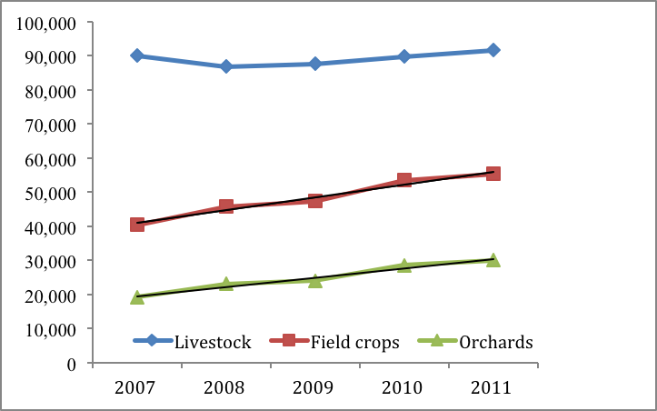
Figure 2: Production value of the main agriculture sectors (million ALL, 2006 prices) - Source - MAFCP statistics yearbook
But the main question for the rural labor market remains how the trends of growth in other economic sectors would affect the shifts of the labor force from agriculture to other economic activities. The strategy for agricultural and rural development identifies the following areas as potential for development in the rural areas, through diversification of economic activity:
- Primary production (unconventional products, e.g. aquaculture, mushroom production) and collection of wild products
- Production of traditional food and branding of products
- Production of renewable energies (e.g. oil seed rape, forestry and other natural resources, wind energy or solar energy, water power, services for sun collectors)
- Rural tourism (e.g. accommodation and catering, recreational activities e.g. fishing, hunting, diverting traditional or historical (farm) buildings into "authentic" accommodation), recreational activities like skiing, sports, adventure tourism (e.g. off road adventure, canoeing, biking), nature tourism, archaeological tourism, health tourism.
- Processing/marketing of food stuff (honey production, to some extent micro/ small food processors - non-farm households - with transport and cooling facilities for fresh primary products)
- Other activities (e.g. traditional crafts, handicrafts such as woolen articles, wood carving, arts work, craft workshops, souvenirs), social and health farming.
Table 5 of section 1.II outlines the activity of the business enterprises in the rural areas by the specific industry and employment. Interestingly, the survey conducted in August-September 2013 with 109 rural enterprises across Albania indicates that 97% of the enterprises are engaged in green activities and all of them consider that such activities could be successful in Albania.
The issue of economic diversification is very important as it brings in the institutional mechanism the contribution of other government agencies as well. Ministry of Economic Development, Trade and Entrepreneurship has a key role to promote non-agriculture business development (see more below), the Ministry of Urban Development and Tourism contributes to the rural development as the tourism sector is among the largest non-agriculture sector and potential for development in the rural areas of Albania (13% of the enterprises participating in the survey were focused in the tourism sector), the Ministry of Energy and Industry has an important role in administering some key non-agriculture activities which account for significant employment in the rural labor market, such as mining, renewable energies and other industries in Albania etc.
The impact of the global crisis has negatively affected the Albanian economy as an overall growth slowdown has been observed in most key sectors of the economy over the last few years, and both the budget deficit and public debt have widened to critical levels. Under the conditions of weak economic performance government’s only plausible route is to maintain a conservative approach in the public expenditure programs to face the economic hardship. In fact, budget cuts have become modus operandi for many government agencies and the overall public expenditure allocated for the National Employment Service has been declining over the recent years, mainly due to budget constraints. With the deterioration of economic performance ultimately fuelling up unemployment figures, increased number of returning migrants – with majority of them living in the rural areas of the country, declining remittances and reduction of public expenditure due to fiscal constraints, financing of the employment services, not limited to NES but on a broader view, all public services affecting the rural labor market, would likely be even more difficult in the future.
Last but not least, it is important to re-emphasise that the rural market in Albania is largely informal. Not just the labor relationships in the market, but the way the entire rural market mechanism is designed and operates is still informal and through a vicious circle the informality adds to more poverty and poverty builds up more informality in the market. The informality keeps in shadows the economic activity in the rural areas as official statistics cannot capture the full view of the market forces. Informality poses a critical problem in the agricultural sector as it de facto isolates the production of goods from the domestic distribution channels, which being more formalized, face real legal, taxation and infrastructure problems to purchase agricultural goods from the domestic production. Consequently most major food retailers in Albania do not trade domestic agricultural production and farmers frequently sell in the streets products they are not able to market in the trading system. The informality adds to the quality of the working conditions and it is also reflected in the unpaid family labor.
The Ministry of Economic Development, Trade and Entrepreneurship maintains the leading role of government for business development in Albania, including the enterprise support in the rural areas, promotion of foreign investments and improvements in the overall business environment quality while the Ministry of Finance through the General Tax Department administers the taxation mechanism in the country. The MoEDTE runs various support schemes and aiming to enhance the natural competitive advantages of Albania, the improvement of the productivity of available human and natural resources, the mobilization of underutilized potential of Albania regarding the available natural resources, agricultural land and tourism development, the geostrategic position for trade and transport and the development of energy as a precondition for the growth of industrial production. The MoEDTE has established direct financial support schemes for the SMEs and exports promotion and is engaged in activities to support the diversification of economic activity in the rural areas through non-agricultural activities such as handcrafts etc. Efforts to reshape the trading mechanisms with the aim to enable rural workers, primarily farmers, to access with full rights and obligations the real market, should be lead by the cooperation of these institutions.

VII. Main findings, Conclusions & Recommendations

Finding 1. According to official statistics, rural areas of Albania appear to have high levels of employment, which many uncover underemployment, and high levels of women in unpaid labor.
Statistical comparisons between urban and rural areas indicates discrepancies due to high rates of contributing family workers and family farming activity in rural areas counting towards statistical employment.
Conclusion 1. High levels of unpaid farm labor in rural areas artificially increase labor force participation and employment statistics while reducing unemployment statistics.
Recommendations 1. Given the high percentage of people in subsistence farming and women’s high involvement in unpaid labor or inactivity, statistical measures need to be revisited as to capture what they are supposed to capture. There is confusion on what basic labor market indicator are capturing, which also makes comparisons very difficult between urban and rural areas or districts. Consequently labor market statistics need to be revisited or alternative measures such as underemployment should be provided to capture the reality of the situation in rural areas.
Finding 2 Difficulty in interpreting women’s unemployment rates given high levels of unpaid labor and inactivity.
Lower employment and labor force participation of women in rural areas compared to rural men and higher rates of women as farm workers.
Conclusion 2. Women are in disadvantage position in the Rural Labor market which limits their economic independence and empowerment.
Recommendation 2 a) Given women’s high rates as farm workers mainly into unpaid labor, efforts are required to push women into paid labor and offer them opportunities for rural non-farm employment. The burden of women in unpaid labor and inactivity due to household responsibilities must be alleviated and increased efforts should be taken as to integrate rural women into the labor market. Increased economic and social action is required to push women into paid labor.
Recommendation 2 b) Gender differences existing for youth are then carried through in all age categories, which call for gender sensitive policies for all ages in the labor market. Increased efforts are required to channel young females in non-farm work starting from younger ages as to reduce gender differences later on. This calls for gender sensitive policies not only in terms of employment, but also education, or vocational training.
Finding 3. Low rates of labor force participation and employment for rural youth.
Conclusion 3. Youth is in a particularly vulnerable position in the labor market.
Recommendation 3. Steps should be taken as to channel rural youth into vocational training in growing sectors or rural non-farm, or non-farm activities. Early provision of training and skill acquisition may be a first step into moving youth away from unpaid farm work. A clear strategy or rural development and employment provision for rural areas is needed in order to direct youth towards growing activities that require or will require work force in the future.
Finding 4. Agriculture is the predominant activity in rural areas however there are few agricultural local units compared to the rest of economic activities. Even though it has gone through continuous growth, the agriculture sector is organized mostly as small scale mainly for family farming. Furthermore, there is limited economic diversity in rural areas as industry, tourism and other services are relatively underdeveloped. Nevertheless, local businesses appear endorsing green initiatives in their economic activities.
- There are districts such as Tirane, Durres and Fier, Elbasan that have diversified economic activities in rural areas beyond agriculture into industry, construction, trade, hospitality and restaurants activities and transport and communication. Tirane has the highest activities in all categories. This is also reflected in farm non farm work ratios. Other districts such as Kukes, Lezhe, Diber appear to be lagging behind.
- At the district level, overwhelmingly there are more female than male farm workers. A striking difference between farm and non-farm workers by sex and district in rural areas show that non-farm work is quite limited in rural areas however it is even more limited for female workers.
- There is a pattern for which rural areas of districts with high levels of farm workers and reliance on small scale agriculture and/or lack of diverse economic activity show lower levels of unemployment, or unemployment gap between male and female workers. Gender differences in both labor force participation and employment rates, do not reflect higher equality in the rural areas of districts rather they warn against low levels of economic activity and rural non-farm employment. They appear more equal perhaps due to economic hardship all around.

Conclusion 4 a): A uniform approach in addressing the issues related to the rural labor market would not be the appropriate solution to the problem. Heavy reliance of rural areas in family farming and predominantly agricultural activities is may not sustain economics growth or development in rural areas.
Conclusion 4 b) With abundant domestic demand and available factor resources agriculture is likely to continue its steady growth, despite the declining share in the economy and its still-low level of productivity. From this perspective agriculture provides moderate potential for new jobs with its underlying challenge to upgrade the existing activities. Albania needs to develop a rural employment agenda building on the momentum of successful sectors, such as tourism, clean energy, services etc. Promotion of green activities should be at the heart of government support programs.
Recommendation 4 a) Any improvement in the policy, institutional and operational mechanisms supporting the rural labor market in the country should take in consideration the specific requirements and the diversity of the context in the related areas.
Recommendations 4 b) Increased efforts are required to provide or support rural non-farm activities, which may foster rural employment and also serve strategic needs of countries development. In this respect, particular attention should be given to districts that are lacking behind such as Kukes, Lezhe, Diber and further stimulate districts that are ahead. Steps should be taken to consolidate farms and promote paid agricultural activities. Furthermore, additional efforts are required to increase the number of local units operating in the rural areas.
Recommendation 4 c): Albania should support the transformation of the agricultural production into a competitive and green sector of the economy, aiming to achieve by 2020 productivity levels similar with the other recent members of the European Union.
Finding 5: The National Employment Service, as the main governmental agency in charge with employment services in the country, currently does not provide such services in the rural areas of Albania. A comparable picture reflects the activity of vocational training services although various donor-supported projects complement the role of the government in this aspect. Businesses operating in the rural areas find it difficult to hire local workers capable of matching the skills required for their jobs while the labor market appears to not include adequate mechanisms for job information dissemination. Limited access of rural youth in Vocational Education and training is closely linked to the limited VET schools or accessible and affordable VET courses. Conversely, uncertainty of jobs and future business or employments opportunities makes it difficult for young individuals to commit to a long term VET.
Conclusion 5: Albania needs to address the pressure for more qualified workforce in the rural areas, which are practically deprived from VET services, currently provided almost exclusively in the urban areas of the country.
Recommendation 5 a): Initiatives should be taken to identify the most effective way to provide vocational training and education for rural people particularly for rural youth. Vocational training should follow needs of businesses in terms of skills. This will also serve to channel the rural labor force into specialized activities of growing economic sectors in those areas. VET programs should include entrepreneurial skills formation which should also complemented by other incentives and facilitation of a pro-business environment.
Recommendation 5 b) Employment service extension at present state would be ineffective and redundant without feasible models for Albania identified based on international experience and know-how of employment services, vocational education and training. A feasibility study will serve to identify services and structure of employment services for rural areas.
Finding 6: The unemployment in most of the rural areas of Albania is typically associated with the dominance in the local markets of the informal economy, which poses serious constraints to (i) adequate measurement of unemployment rates (consequently affecting related policy actions), (ii) economic growth and eradication of poverty in these areas, and (iii) better organization of business activities in market oriented models, differently from the current family-level units focused almost exclusively at subsistence production. The current regulations by the tax authorities requiring VAT invoice issued by the supplier for each commercial transaction and the practical inability of the farmers to issue such a document, discriminates the domestic producers as it forces the local wholesalers to prefer purchasing imported products (with proper tax documentation) and restricting access to the agricultural domestic production lacking this important market opportunity.
Conclusion 6: Tackling the informality of the economic activity in the rural areas of Albania would support greater engagement of the local workforce in more competitive formal activities, resolving many unemployment related issues, and secure higher standards of living for Albanian citizens in the rural areas.
Recommendation 6 a): The adoption of proper incentives (or abolishment of current disincentives) aiming to promote the citizens living in the rural areas to pull out from the self-employed status and join the market with equal rights and obligations, is an important step in this direction. Effective instruments may include the reforming of the pension or healthcare systems, calling for provision of partial/realistic contributions for the public services received, better enforcement of property tax collection etc.
Recommendation 6 b) Even more important than above, a substantial revision of the tax legislation is necessary in order to enable local wholesalers of agricultural products to freely purchase domestic goods from the rural suppliers in the market.
Recommendation 6 c) The establishment of efficient market mechanisms aiming to promote economic cooperation in the rural labor market eventually would contribute to a natural shift of economic activity from the family-based units toward more integrated and value added activities. Apart of necessary improvements and enforcement of legislation, specific instruments may include cost-sharing schemes in rural areas for capital investments above a certain threshold, technical assistance and trainings for business units employing a certain number of persons from rural areas etc.
Finding 7: A weak link exists between the (still-limited) support for rural and agricultural development in the country, and the outcome in the rates of employment in the rural areas.
Conclusion 7: Considering the relevance of the agricultural sector in the economy and its contribution in the employment rates at the national level, public expenditure on support for the poor provide negligible, or even negative effects on employment promotion in the rural areas.
Recommendation 7: Clearer separation of policy goals (and related mechanisms and financial allocations) between the responsibility to protect the poor across the country and to support rural development would benefit both policies. The former is a social policy issue, the later is and should remain primarily focused on establishing a competitive agricultural sector as a vibrant and key sector of the economy, supporting through higher productivity levels the creation of new jobs and improvement of the quality of life of all the citizens in the rural areas. Similarly the recommendation could be extended to other economic activities in the rural areas, however agriculture remains the largest sector.
Finding 8: A broad array of public institutions, organizations, policy documents including legislation framework and budgets impact the rural labor market forces in Albania.
Conclusion 8: The rural labor market is a cross-sector topic requiring not only optimal contribution by all the stakeholders affecting the public policy, but also an efficient coordination among them.
Recommendation 8: The government should lead the process of establishing an efficient coordinating structure on rural labor issues comprising decision makers from the key government agencies, local governments, main donors, local organizations and business services in the labor market, with main responsibilities to coordinate efforts by the stakeholders, support streamlining the legislative framework and optimize the allocation of the available resources. Proper impact assessment and monitoring mechanisms should be part of the legislation on rural labor market.

APPENDIX
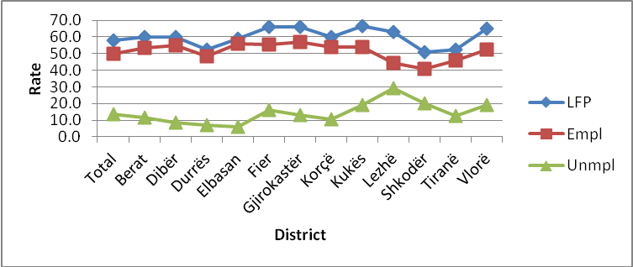
Source: INSTAT; 2012 LFS
Figure A1: Labor Market Indicators by district
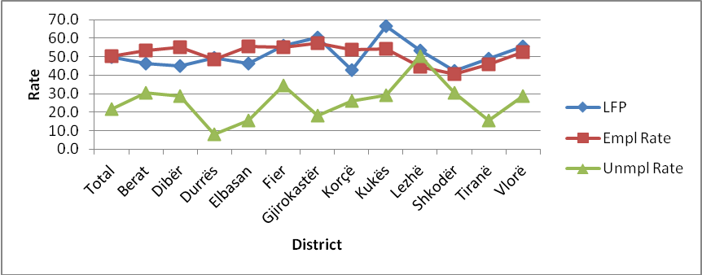
Source: INSTAT; 2012 LFS
Figure A2: Labor Market Indicators by District Urban Areas
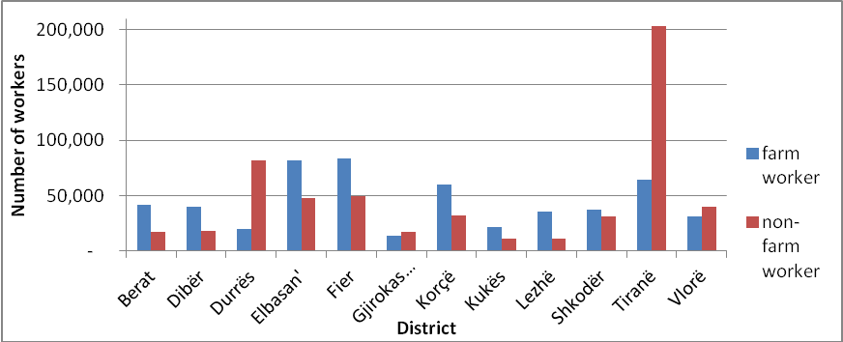
Source: INSTAT; 2012 LFS
Figure A3: Farm/Non-Farm Workers by District
Companies Interviewed during the study

Table A1: Number of companies by District
District | Number of companies
Berat | 9
Diber | 16
Durres | 6
Elbasan | 10
Fier | 10
Gjirokaster | 6
Korce | 8
Kukes | 6
Lezhe | 5
Shkoder | 18
Tirane | 7
Vlore | 8
Total | 109

Table A2: Economic Activity of Companies
Economic Activity | Number of Companies
Agriculture, Hunting, Silviculture | 9
Fishing | 1
Food Industry | 75
Textile and clothing industry | 2
Manufacturing of wood products | 1
Chemical Industry | 1
Fabrication of non-metallic mineral products | 2
Trade | 1
Hotels and Restaurants | 16
Total | 108

Table A3: Year of company start
Year of company start | Number of companies | Year of company start | Number of companies
1981 | 1 | 2002 | 4
1990 | 1 | 2003 | 4
1991 | 2 | 2004 | 8
1992 | 1 | 2005 | 6
1993 | 2 | 2006 | 7
1994 | 5 | 2007 | 6
1995 | 4 | 2008 | 6
1996 | 3 | 2009 | 8
1998 | 7 | 2010 | 7
1999 | 3 | 2011 | 4
2000 | 9 | 2012 | 3
2001 | 6 | 2013 | 1

List of persons/organizations interviewed
Name of | Representative
KASH | Enver Ferizaj; Director
Associacion of Albanian Communes | Agron Haxhimali, Director
NES regional office Shkoder | Xita Teli, Director
Yunus Albania | Shkelzen Marku, Director
Ministry of Labor, Social Affairs and Equal Opportunities | Klevis Bitro, Director of Cabinet
Ministry of Agriculture | Grigor Gjeci, Director of RD; Roland Kashi Director of Statistics; Tatjana Dishnica Extension services
ADAD | Hafuz Domi Director
AULEDA Regional developement Agency Vlore | Mirela Koci, Director
INSTAT | Names TBC
Agritra Vizion | Majlinda Hoxha; Executive Director
Permaculture Resource Center | Tom Ndoka; Director
LAG Drini | Fllanca Shehu; Coordinator
LAG Adrijon | Arjana Bubeqi Coordinator
Focused group with Youth representatives in Shkrel commune
DM consulting /Dua pune | Eliana Meta; Executive director
Risi Albania /SDC project | Edlira Muedini; Project Manager and Name and title to add
Swiss contact | Silvana Haxhiaj ;Project Coordinator /Kleidor Rustemi component coordinator
UN women | Estela Bulku
UN Gender project | Ermira Shkurti
GADC ( Gender alliance development center) | Mirela Arqimandriti Director
GIZ | Ismail Beka; Project Manager
Federata e fermereve Shkoder | Isak Bajrami
Kooperativa Vreshtaret e Zadrimes Lezhe | Zef Pashuku; Head of cooperative
Shoqata Domni ne Zhvillim Shkoder | Sylo Ujka
Shoqeria e bashkepunimit reciprok Shkoder
Prodhime Patate Vermoshi, Malesi e Madhe
Drejtoria Rajonale e Bujqesise, Lezhe
Inspektoriati shteteror i punes, Lezhe
Shoqata e turizmit "ATA" ; Vlore
Shoqata e prodhuesve te vajit te ullirit "Kalinjot" Vlore
Shkolla profesionale Vlore
Drejtoria rajonale e punesimit Gjirokaster
Shkolle e mesme industriale Gjirokaster
Drejtoria rajonale e bujqesise Gjirokaster

For reasons explained in the beginning of the section, urban-rural comparisons are inadequate. Nonetheless, labor market indicators overall and for urban areas are included in the appendix Tables A1 and A2.
Local unit is one enterprise or part of it (i.e. workshop, factory, warehouse, office, mine or depot) located in areas identified geographically. At this or from this location is exercised the economic activity for which – except for some cases – work at least one or more persons (though with reduced time) for a single enterprise.
Rama and Matja (2012) “Sector Skills Needs Analysis in Albania”
The strategy for the period 2014-2020 is still in draft format.
Inter-sectoral Strategy for Agriculture and Rural Development in Albania 2013-2020, policy document, draft, discussed with the Ministry of Agriculture, Rural Development and Water Administriation
Law no. 7995, date 20.09.1995 partially modified by Law No. 8862, date 7.03.2002 and by Law No. 9570, date 3.07.2006.
Article 4, point 4, paragraph b and c.
For instance registered unemployed, repatriated, handicapped, female vulnerable of trafficking, Roma long term unemployed etc.
Law no. 8872 dated 29 march 2002 and Law on “promotion of Employment”, article 13.
Article 11.
Law no. 8872, date 29.03.2002. The Law is amended on June 2011.
Law No 10247, dated 04.03.2010, for "National Qualification Framework".
Law No 10434, dated 23.06.2011, for “Amendment of VET Law”.

