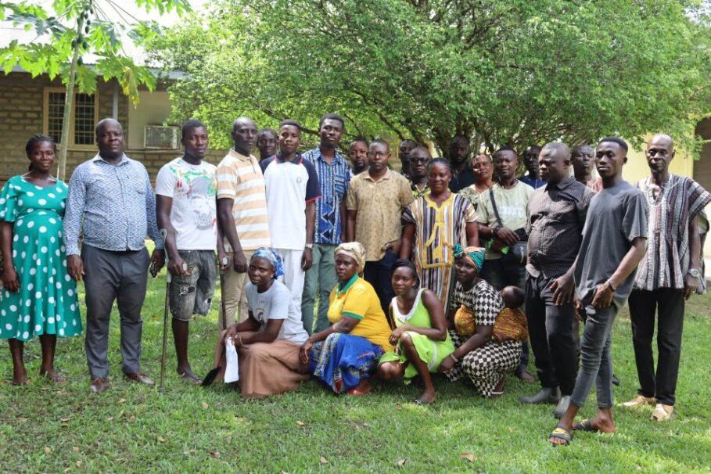
WORKSHOP ORGANIZED FOR COMMUNITY VOLUNTEERS.
Fostering Reforestation Environmental Sustainability and Tourism in the Okyenman Area.

Summary: A workshop was organized for the Community Nursery Volunteers from Thursday, March 14, to Friday, March 15. This training aims to empower volunteers with the essential technical and entrepreneurial skills required for initiating and managing community nursery enterprises.

Background/ Context
The FOREST Okyeman Project seeks to address deforestation in the Akyem Abuakwa area through considerable investments in reforestation hinged on sustainable environmental management and livelihood empowerment. The project is building on the existing local initiative of the Okyeman Environment Foundation (OEF) to facilitate the planting of 1 million trees to restore degraded landscapes and create awareness on best agroforestry practices in the project area.
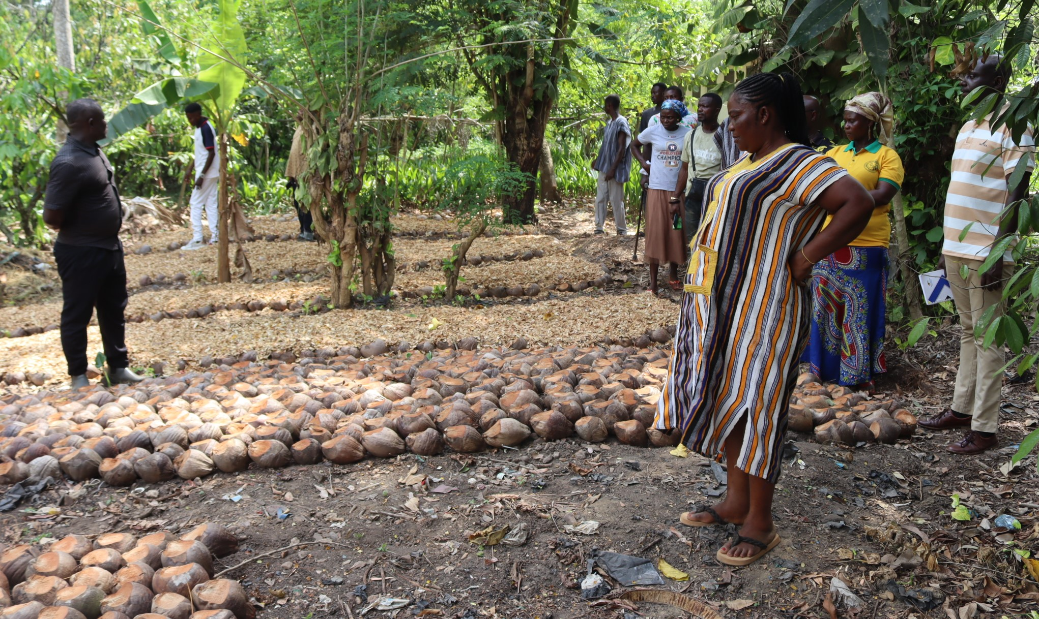
A picture of the volunteers undergoing the training.

Key Results
- Empowering volunteers with the essential technical and entrepreneurial skills required for initiating and managing community nursery enterprises.
- Planning meeting with the various stakeholder for the strengthening/forming Community and School Environmental Health Clubs through the Okyeman Environment Foundation.
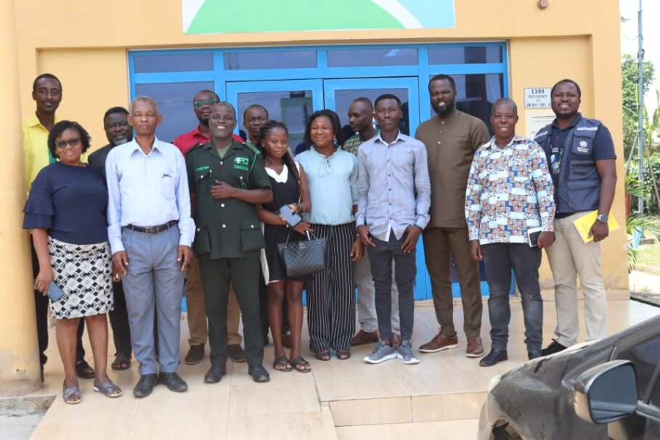
A group picture with the stakeholders
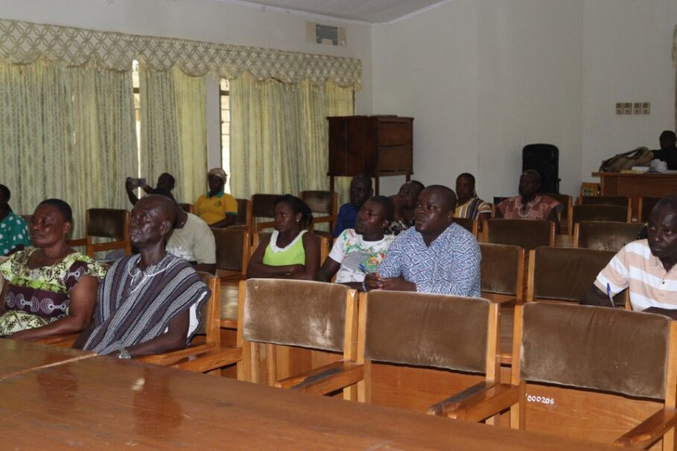
Cross section of volunteers at the workshop

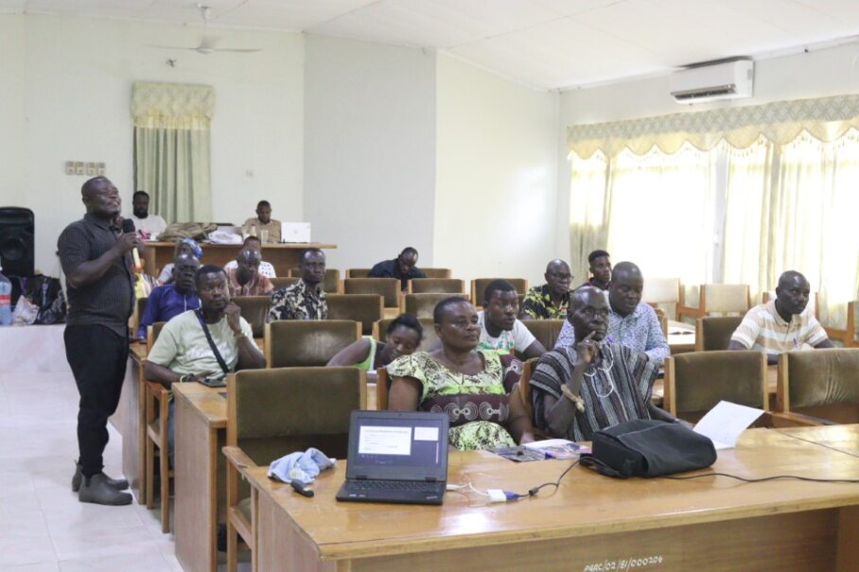
Volunteers at the workshop.

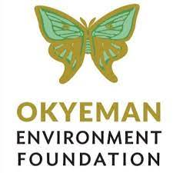
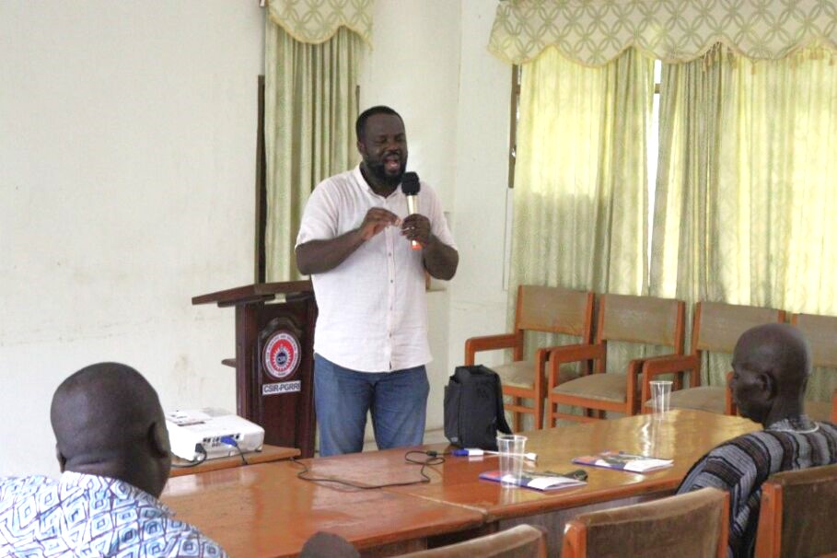
An Official from OEF addressing the volunteers

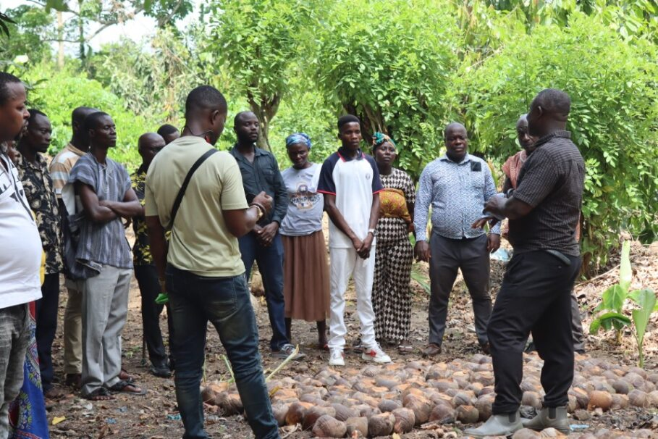
Volunteers with the Resource Person
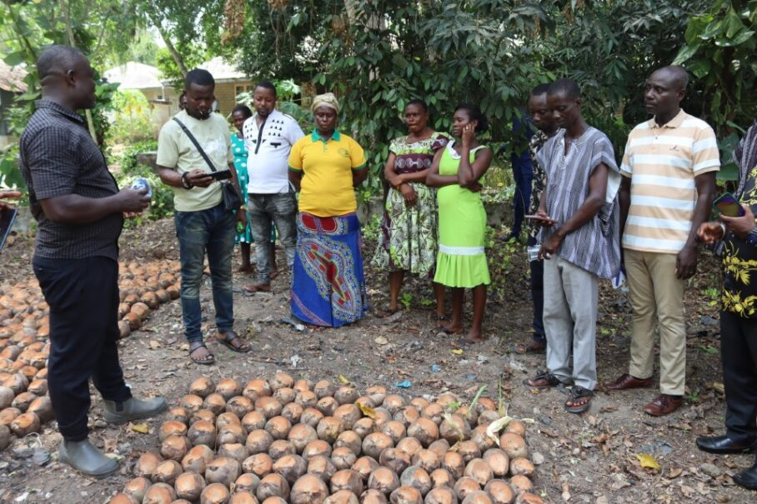
A Resource person engaging the volunteers.
Some Volunteers at the Workshop.

