WARM-UP GAME FOR DAY 1
I. Implementing process
1. Introduction to game rules
- Use online platform such as Ahaslide, Kahoot
- Introduce learners to the game's rules.
- Provide instructions on how to name players in a free, friendly, or funny way.
2. Play game
- The trainer shows each question on the screen
- At the end of each question, the trainer declares who is leading the game
- At the end of all questions, the trainer announces the winner
3. Wrap – up
- The organizers give prizes to the winners
- Wrap up and introduce the lesson

II. Question & Answer
No. | Question | Answer
1 | Facebook was subject to a $ $5billion fine for violations in which area?  1. Salary & working time  2. Violation of privacy  3. Environment  4. Violation of national security | 2.Violation of privacy
2 | What is the highest fine imposed on businesses due to human rights violation?  1. 5 billion dollars  2. 10 billion dollars  3. 25 billion dollars  4. 20 billion dollars | 4. 20 billion dollars
3 | In what sector was the record $20 billion fine for violations?  1. Labor right  2. Customer right  3. Environment  4. Discrimination | 3. Environment
4 | The below photo that triggered the media crisis is from which fashion brand?  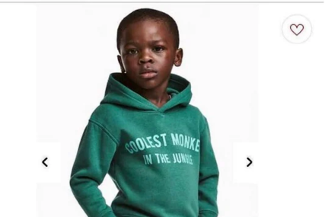  1. Inditex  2. H&M  3. ZARA  4. NIKE | 2. H&M

Question 1
In 2019, the US Federal Trade Commission - FTC issued a $5 billion fine to Facebook as a result of a long investigation into privacy violations following the Cambridge Anatalyca scandal. Facebook has agreed to pay fines and increase monitoring of activities related to users' private data
Question 2 & Question 3
On April 20, 2010, the Deepwater Horizon oil rig in the Macondo Prospect of Gulf of Mexico exploded and sank, killing 11 people and spilling the largest amount of crude oil in the history of oil drilling operations. On April 4, 2016, New Orleans federal judge Carl Barbier approved a fine of about $ 20 billion that British oil giant BP must pay to resolve compensation claims.
Question 4
H&M faced a global backlash in January 2018, when it advertised an image of Liam Mango, a 5-year-old black boy, modeling a decorated green hoodie. The words "Coolest monkey in the jungle" was in white capital letters, while monkey is considered a degrading stereotype by people of African descent. Liam is the son of Kenyan immigrants.

