**Annexes to DP/2024/13**

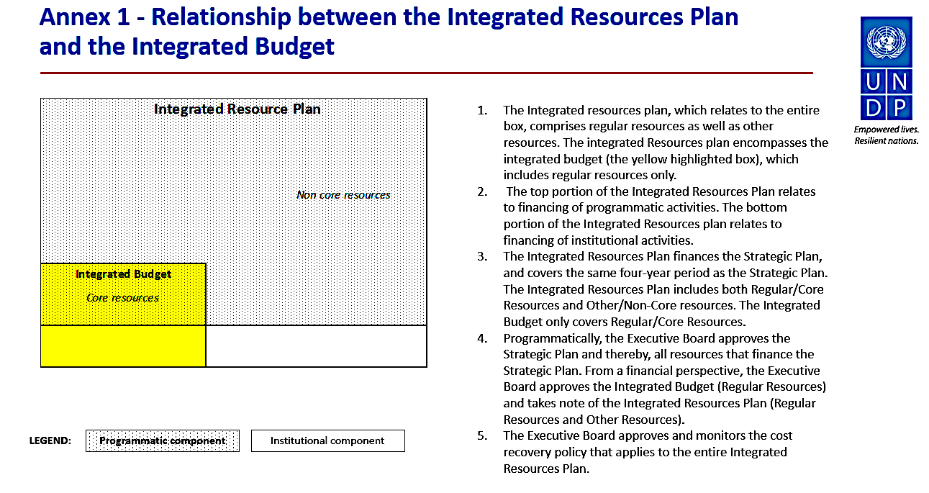

**Annex 2. Detailed tables and figures**

**Figure A. Initial planned use of total resources compared to updated estimates 2022-2025**

*in billions of US dollars*

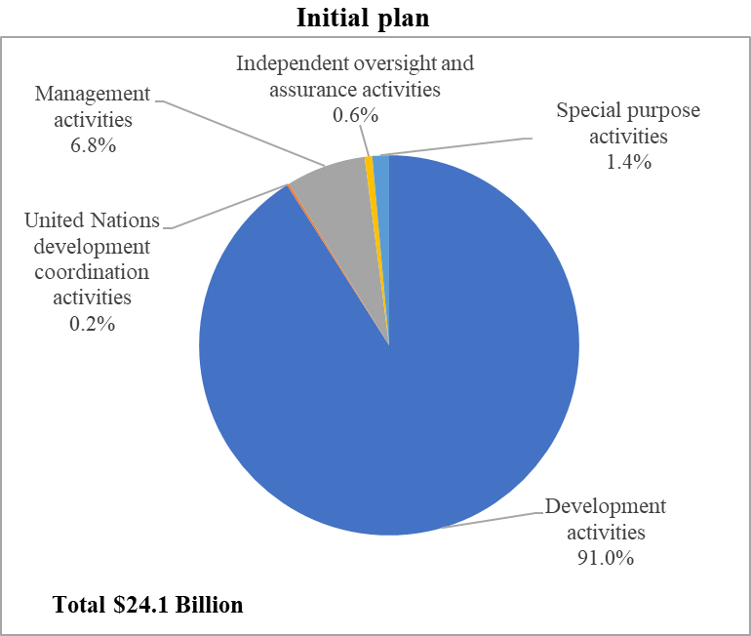 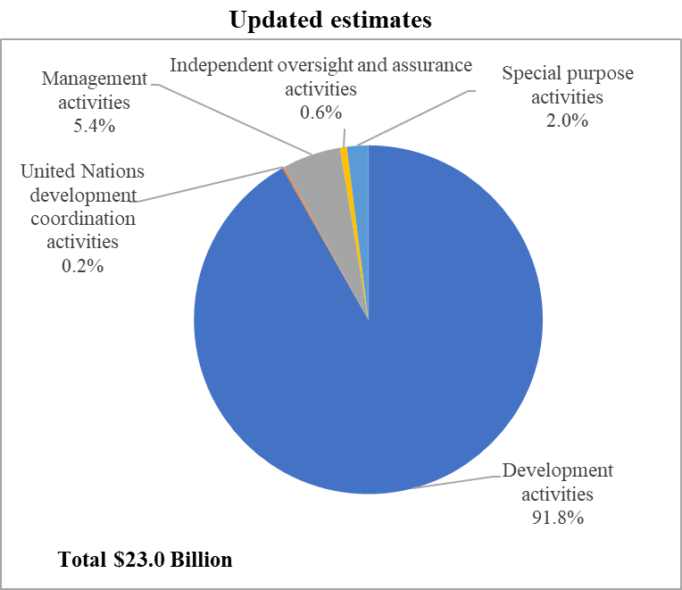

**Table 1.** **2022-2023 initial plan compared to 2022-2023 actuals[1]**

*in millions of US dollars*



**Table 2. Integrated resources plan, 2022-2025: original estimates compared to updated estimates[2]**

*in millions of US dollars*



**Table 3**. **Institutional component of the integrated budget by expenditures catego**r**y** **2022-2025 planning estimates compared to 2022-2023 actuals plus 2024-2025 updated estimates**

*in millions of US dollars*

|  |  |  |  |  |
| --- | --- | --- | --- | --- |
|  |  |  | **2022-2025 planning estimates vs 2022-2023 actuals plus 2024-2025 updated estimates** | |
| **Category of expenditures** | **2022-2025 planning estimates** | **2022-2023 actuals plus 2024-2025 updated estimates** | **$** | **%** |
| Posts | 928.6 | 815.7 | (112.9) | (12)% |
| Other staff costs | 1.4 | 0.7 | (0.7) | (50)% |
| Consultants | 25.5 | 31.9 | 6.4 | 25% |
| Travel | 18.2 | 28.5 | 10.3 | 57% |
| Operating expenses | 136.0 | 115.0 | (21.0) | (15)% |
| Furniture/equipment | 17.0 | 14.1 | (2.9) | (17)% |
| Reimbursements/contributions | 19.1 | 21.5 | 2.4 | 12% |
| Provision for strategic investments | 48.0 | 43.9 | (4.1) | (9)% |
|  |  |  |  |  |
| **Total expenditures** | **1,193.8** | **1,071.2** | **(122.6)** | **(10)%** |

**Table 4**. **Programmatic component of the integrated budget by line:**

**2022-2025 planning estimates compared to 2022-2023 actuals and 2024-2025 updated estimates**

*in millions of US dollars*

|  |  |  |  |  |
| --- | --- | --- | --- | --- |
|  |  |  | **2022-2025 planning estimates vs 2022-2023 actuals plus 2024-2025 updated estimates** | |
| **Core Programmatic Lines** | **2022-2025 planning estimates** | **2022-2023 actuals plus 2024-2025 updated estimates[3]** | **$** | **%** |
| TRAC-1 | 1,025.6 | 977.1 | (48.5) | (4.7)% |
| TRAC-2 | 551.2 | 401.8 | (149.3) | (27.1)% |
| TRAC-3 | 213.5 | 141.6 | (71.9) | (33.7)% |
| PAPP | 8.6 | 4.7 | (3.9) | (45.4)% |
| Regional Programmes | 155.0 | 86.3 | (68.7) | (44.3)% |
| HDRO | 30.7 | 20.4 | (10.3) | (33.5)% |
| South-South Cooperation | 21.0 | 14.1 | (6.9) | (32.9)% |
| Consolidated Development Effectiveness Line | 138.7 | 75.5 | (63.2) | (45.6)% |
| UNCDF | 5.3 | 2.9 | (2.4) | (44.9)% |
| UN Development Coordination - SRC | 48.0 | 42.3 | (5.7) | (11.9)% |
| **Total - Core Programme Budget** | **2,197.6** | **1,766.7** | **(430.9)** | **(19.6)%** |

**Figure B. Programmatic component of the integrated budget by line: 2022-2025 planning estimates compared to 2022-2023 actuals and 2024-2025 updated estimates**

*in millions of US dollars*

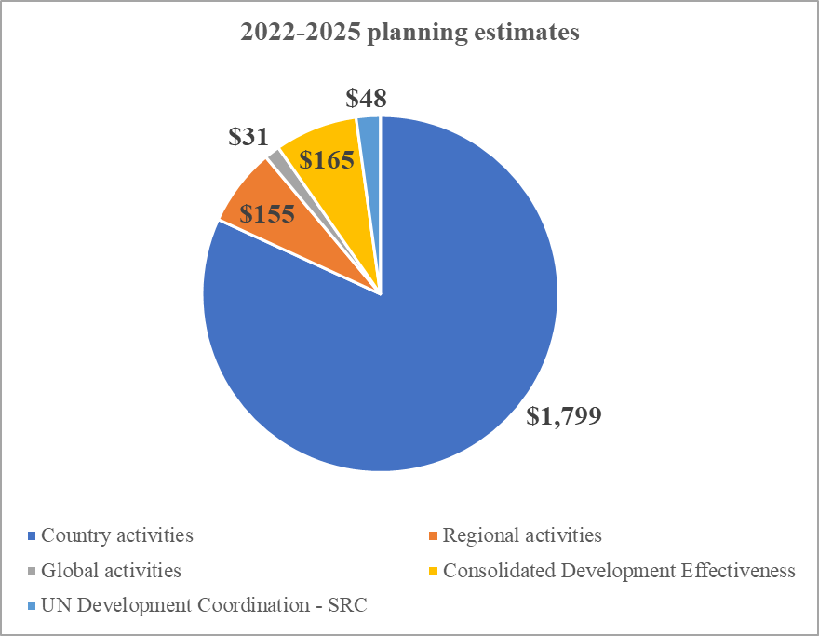 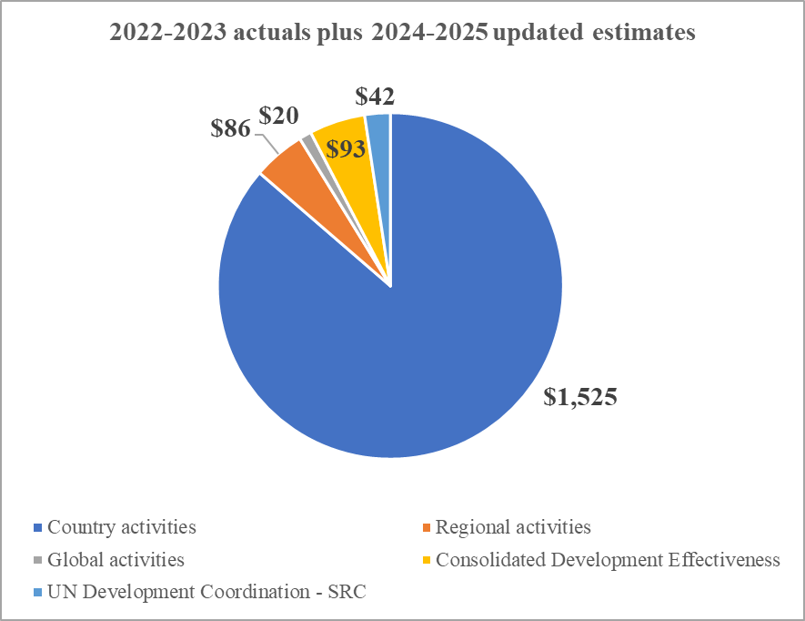

**Table 5. Integrated budget by component:**

**2022-2025 planning estimates compared to 2022-2023 actuals and 2024-2025 updated estimates**

*in millions of US dollars*



**Figure C. Institutional component of the integrated budget by cost classification category: 2022-2025 planning estimates compared to 2022-2023 actuals and 2024-2025 updated estimates**

*in millions of US dollars*

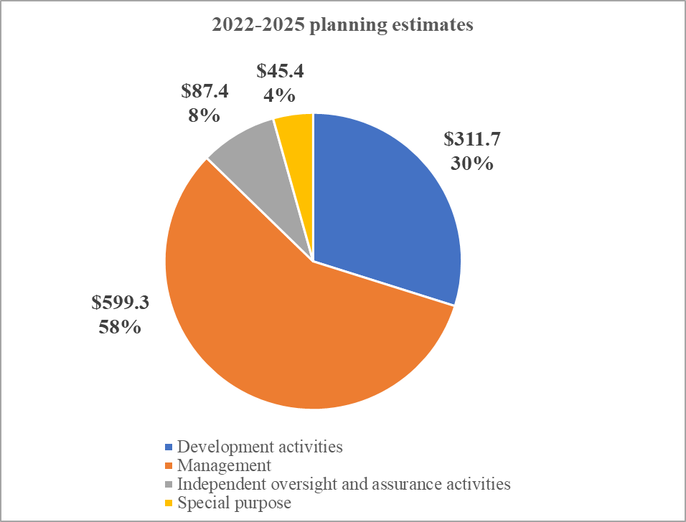 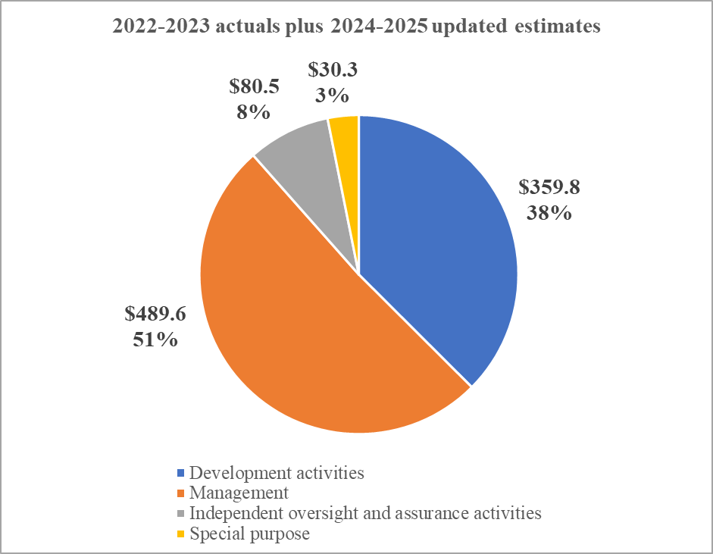

**Table 6. Regular resources senior posts, by location**



(*) Data as of February 2024

**Annex 3. Actual expenditure by country typology in 2022-2023**

**Distribution of 2022-2023 resources by region, country typology, and development status**

**Part 1 – highlights by country typology**

*in millions of US dollars*



**Part 2 – regular (core) resources**

*in millions of US dollars*

**2022-2023 distribution of regular (core) resources by region**

**Core: TRAC-1, 2 and 3**

|  |  |  |  |  |  |  |
| --- | --- | --- | --- | --- | --- | --- |
|  | **Programmatic resources** | | **Institutional resources** | | **Total resources** | |
|  | **$** | **%** | **$** | **%** | **$** | **%** |
| Africa | 465 | 68% | 109 | 42% | 574 | 61% |
| Asia and the Pacific | 97 | 14% | 47 | 18% | 144 | 15% |
| Arab States | 71 | 10% | 35 | 14% | 106 | 11% |
| Europe and the CIS | 25 | 4% | 31 | 12% | 56 | 6% |
| Latin Americas and the Caribbean | 28 | 4% | 37 | 14% | 64 | 7% |
| **Total** | **685** | **100%** | **259** | **100%** | **944** | **100%** |

**2022-2023 distribution of regular (core) resources by country typology**

**Core: TRAC-1, 2 and 3**

|  |  |  |  |  |  |  |
| --- | --- | --- | --- | --- | --- | --- |
|  | **Programmatic resources** | | **Institutional resources** | | **Total resources** | |
|  | **$** | **%** | **$** | **%** | **$** | **%** |
| LIC | 517 | 75% | 92 | 35% | 609 | 64% |
| MIC | 150 | 22% | 137 | 53% | 287 | 30% |
| MIC (GNI per capita > $6,692) | 18 | 3% | 24 | 9% | 42 | 4% |
| NCC | 0 | 0% | 7 | 3% | 7 | 1% |
| **Total** | **685** | **100%** | **259** | **100%** | **944** | **100%** |

**2022-2023 distribution of regular (core) resources by development status**

**Core: TRAC-1, 2 and 3**

|  |  |  |  |  |  |  |
| --- | --- | --- | --- | --- | --- | --- |
|  | **Programmatic resources** | | **Institutional resources** | | **Total resources** | |
|  | **$** | **%** | **$** | **%** | **$** | **%** |
| LDC | 562 | 82% | 112 | 43% | 674 | 71% |
| Non-LDC | 123 | 18% | 148 | 57% | 270 | 29% |
| **Total** | **685** | **100%** | **259** | **100%** | **944** | **100%** |

**Part 3 – other (non-core) resources**

*in millions of US dollars*

**2022-2023 distribution of other (non-core) resources by region**

|  |  |  |  |  |  |  |  |  |
| --- | --- | --- | --- | --- | --- | --- | --- | --- |
|  | **Share of programmatic resources** | | | | **Share of institutional resources** | | **Total resources** | |
|  | **Bilateral/multilateral** | | **Government cost sharing** | |
|  | **$** | **%** | **$** | **%** | **$** | **%** | **$** | **%** |
| Africa | 1,690 | 29% | 336 | 14% | 82 | 25% | 2,108 | 25% |
| Asia and the Pacific | 1,268 | 22% | 167 | 7% | 65 | 20% | 1,500 | 18% |
| Arab States | 1,367 | 24% | 266 | 11% | 68 | 21% | 1,701 | 20% |
| Europe and the CIS | 858 | 15% | 277 | 11% | 38 | 12% | 1,173 | 14% |
| Latin Americas and the Caribbean | 591 | 10% | 1,392 | 57% | 73 | 22% | 2,055 | 24% |
| **Total** | **5,773** | **100%** | **2,439** | **100%** | **325** | **100%** | **8,538** | **100%** |

**2022-2023 distribution of other (non-core) resources by income typology**

|  |  |  |  |  |  |  |  |  |
| --- | --- | --- | --- | --- | --- | --- | --- | --- |
|  | **Share of programmatic resources** | | | | **Share of institutional resources** | | **Total resources** | |
|  | **Bilateral/multilateral** | | **Government cost sharing** | |
|  | **$** | **%** | **$** | **%** | **$** | **%** | **$** | **%** |
| LIC | 1,922 | 33% | 299 | 12% | 82 | 25% | 2,302 | 27% |
| MIC | 3,174 | 55% | 827 | 34% | 159 | 49% | 4,160 | 49% |
| MIC (GNI per capita > $6,692) | 601 | 10% | 1,101 | 45% | 56 | 17% | 1,758 | 21% |
| NCC and Transitional NCC | 76 | 1% | 212 | 9% | 29 | 9% | 318 | 4% |
| **Total** | **5,773** | **100%** | **2,439** | **100%** | **325** | **100%** | **8,538** | **100%** |

**2022-2023 distribution of other (non-core) resources by development status**

|  |  |  |  |  |  |  |  |  |
| --- | --- | --- | --- | --- | --- | --- | --- | --- |
|  | **Share of programmatic resources** | | | | **Share of institutional resources** | | **Total resources** | |
|  | **Bilateral/multilateral** | | **Government cost sharing** | |
|  | **$** | **%** | **$** | **%** | **$** | **%** | **$** | **%** |
| LDC | 2,154 | 37% | 354 | 15% | 101 | 31% | 2,610 | 31% |
| Non-LDC | 3,619 | 63% | 2,085 | 85% | 224 | 69% | 5,928 | 69% |
| **Total** | **5,773** | **100%** | **2,439** | **100%** | **325** | **100%** | **8,538** | **100%** |

**Part 4 – total (core and non-core) resources**

*in millions of US dollars*

**2022-2023 distribution of total (core and non-core) resources by region**

**Core: TRAC-1, 2 and 3**

|  |  |  |  |  |  |  |  |  |
| --- | --- | --- | --- | --- | --- | --- | --- | --- |
|  | **Share of programmatic resources** | | | | **Share of institutional resources** | | **Total resources** | |
|  | **Bilateral/multilateral and core resources** | | **Government cost sharing** | |
|  | **$** | **%** | **$** | **%** | **$** | **%** | **$** | **%** |
| Africa | 2,155 | 33% | 336 | 14% | 191 | 33% | 2,682 | 28% |
| Asia and the Pacific | 1,365 | 21% | 167 | 7% | 112 | 19% | 1,644 | 17% |
| Arab States | 1,438 | 22% | 266 | 11% | 103 | 18% | 1,807 | 19% |
| Europe and the CIS | 883 | 14% | 277 | 11% | 69 | 12% | 1,230 | 13% |
| Latin Americas and the Caribbean | 618 | 10% | 1,392 | 57% | 109 | 19% | 2,120 | 22% |
| **Total** | **6,458** | **100%** | **2,439** | **100%** | **585** | **100%** | **9,482** | **100%** |

**2022-2023 distribution of total (core and non-core) resources by income typology**

**Core: TRAC-1, 2 and 3**

|  |  |  |  |  |  |  |  |  |
| --- | --- | --- | --- | --- | --- | --- | --- | --- |
|  | **Share of programmatic resources** | | | | **Share of institutional resources** | | **Total resources** | |
|  | **Bilateral/multilateral and core resources** | | **Government cost sharing** | |
|  | **$** | **%** | **$** | **%** | **$** | **%** | **$** | **%** |
| LIC | 2,439 | 38% | 299 | 12% | 174 | 30% | 2,911 | 31% |
| MIC | 3,325 | 51% | 827 | 34% | 296 | 51% | 4,447 | 47% |
| MIC (GNI per capita > $6,692) | 618 | 10% | 1,101 | 45% | 80 | 14% | 1,799 | 19% |
| NCC and Transitional NCC | 76 | 1% | 212 | 9% | 36 | 6% | 324 | 3% |
| **Total** | **6,458** | **100%** | **2,439** | **100%** | **585** | **100%** | **9,482** | **100%** |

**2022-2023 distribution of total (core and non-core) resources by development status**

**Core: TRAC-1, 2 and 3**

|  |  |  |  |  |  |  |  |  |
| --- | --- | --- | --- | --- | --- | --- | --- | --- |
|  | **Share of programmatic resources** | | | | **Share of institutional resources** | | **Total resources** | |
|  | **Bilateral/multilateral and core resources** | | **Government cost sharing** | |
|  | **$** | **%** | **$** | **%** | **$** | **%** | **$** | **%** |
| LDC | 2,717 | 42% | 354 | 15% | 213 | 36% | 3,284 | 35% |
| Non-LDC | 3,741 | 58% | 2,085 | 85% | 372 | 64% | 6,198 | 65% |
| **Total** | **6,458** | **100%** | **2,439** | **100%** | **585** | **100%** | **9,482** | **100%** |

1. Regular Resources-funded Programme expenditure includes $52.1 million relating to UNDP’s Covid-19 Rapid Response Facility.
2. Regular Resources-funded Programme expenditure in 2022-2023 includes $52.1 million relating to UNDP’s Covid-19 Rapid Response Facility.
3. This excludes $52.1 million regular resources-funded expenditure relating to UNDP’s Covid-19 Rapid Response Facility.