WORKING SHEET

Instruction: During the training course, students can utilize this working sheet to take notes and apply the knowledge they have gained in each section of the course into the actual circumstances of their businesses. This working sheet can be used as a review material after the course.

- GENERAL INFORMATION
List down key take-away knowledge:.
- Responsible business concept (refer to section 1a)
………………………………………………………………………………………………………
………………………………………………………………………………………………………………………………………………………………………………………………………………………………………………………………………………………………………………………………………………………………………………………………………………………………

How to describe the concept and principle of responsible business for your colleagues or family members? ………………………………………………………………………………………………………………………………………………………………………………………………………………………………………………………………………………………………………………………………………………………………………………………………………………………………
- Human Rights ( refer to section 2)
………………………………………………………………………………………………………………………………………………………………………………………………………………………………………………………………………………………………………………………………………………………………………………………………………………………………
………………………………………………………………………………………………………
What are important official documents / information about “Human Rights” definition? ………………………………………………………………………………………………………………………………………………………………………………………………………………………………………………………………………………………………………………………………………………………………………………………………………………………………
- UNGPs ( refer to section 2.2)
………………………………………………………………………………………………………
………………………………………………………………………………………………………………………………………………………………………………………………………………………………………………………………………………………………………………………………………………………………………………………………………………………………
What are the three pillars of UNGPs? ………………………………………………………………………………………………………………………………………………………………………………………………………………………………………………………………………………………………………………………………………………………………………………………………………………………………

- Responsibility of businesses to respect human rights ( refer to section 2.2.2)
………………………………………………………………………………………………………
………………………………………………………………………………………………………………………………………………………………………………………………………………………………………………………………………………………………………………………………………………………………………………………………………………………………What are 3 key words on human right? They are called as “a set of MINIMUM rights that are for us to live in Dignity and Equality
………………………………………………………………………………………………………………………………………………………………………………………………………………………………………………………………………………………………………………………………………………………………………………………………………………………………

- HUMAN RIGHTS POLICY COMMITMENT
Does your business have any commitments(mentioned in statements), policy documents (internal/public),operation manuals/handbooks on human rights issues?
Such policies may relate to one or a number of issues: hiring/recruitment, health and safety, occupational hygiene, wages, benefits, child labor, unpaid or forced labor, harassment, discrimination or environmental impacts on community (refer to section 2.3)
Upon completing below table, ask or share with your colleagues in charge of general affairs or compliance for further discussion.
General | Yes | No | Don’t know
- Short reference to human rights in the company’s mission, values statement, or other overarching document
- A statement outlining the company’s expectations and accountability structures with respect to human rights (code of conduct/ broader sustainability policy)
- General
- For employee
- For manager
- For business relationships
- For other stakeholder

Health and safety | Yes | No | Don’t know
- A clear, publicly-available health and safety policy statement is in place
- Risk assessment guideline of the whole site reflecting existing and emerging issues and good practice.
- Solutions/corrective actions guideline that put in place to resolve any situations causing an accident or injury, with actions assigned to specific people and followed up to check they are completed
Wages and benefits | Yes | No | Don’t know
- A clear, publicly-available wage and benefit policy statement is in place
- The regulation about keeping record of pay journal/payroll, timecards, production records, piece rate records for all workers (at least 12 months)
Child labour and underage workers | Yes | No | Don’t know
- A clear, publicly-available child labour and young labour policy statement is in place
- Have a system in place to check official documentation that proves a worker’s age, at the time of hiring, such as birth certificate/ ID card with date of birth, photo ID preferred where possible.
- A guideline about keeping a copy of this document and ensure the original is returned to the worker
- A guideline about the list of all ‘young workers – workers under 18’ and ensure that the tasks they are assigned to are not hazardous and that their working hours are in line with legal restrictions and are not at night.
Harassment | Yes | No | Don’t know
- A clear, publicly-available sexual harassment and other type of harrassment policy statement is in place
- Guideline / Code of Conduct on prevention and combat of harassment in the workplace
- A confidential and effective procedure for managing complaints regarding harassing behavior is in place
Security
- Guideline / Training document for all security staff so that they understand that their role and actions must never undermine workers’ or third parties’ human rights and they should always try to avoid the use of force and if force is used it should only be what is strictly necessary.
- A confidential and effective procedure for managing complaints regarding security staff behavior in workplace
Discrimination
- A clear, publicly-available discrimination policy statement is in place

- Regulation about reviewing the recruitment procedure and questions asked in interviews and application forms. Does it include any information about the worker that you think could be being used to discriminate against them in recruitment/hiring such as race, pregnancy?
- Regulation about reviewing, analyzing pay records. Ensure that women are paid the same as men for the same job. Ensure people of different races, religions, nationality etc are paid the same for the same job.
Regular employment | Yes | No | Don’t know
- A clear, publicly-available regular employment policy statement is in place

- All workers (regular, contract, piece rate and home-workers) have formal, written employment agreements (including duration of contract, job functions, wages, hours, benefits, pay cycle, resignation and termination conditions/process), signed by both the worker and manager, in a language they can understand. The content is clearly explained and workers should receive a copy.
Environment | Yes | No | Don’t know
- A clear, publicly-available environmental policy statement is in place
- Regulation related to updated list of hazardous and non-hazardous substances used on site.
- Regulation about handling, transporting and disposing all hazardous waste (including gas, liquids and solids) in accordance with relevant requirements.
- Regulation about measuring levels of potential toxic chemicals in both water waste and air emissions to ensure they are in line with legal requirements
- Regulation about handling, transporting and disposing all hazardous waste (including gas, liquids and solids) in accordance with relevant requirements.
- Regulation about measuring levels of potential toxic chemicals in both water waste and air emissions to ensure they are in line with legal requirements

- IDENTIFY AND ASSESS ACTUAL AND POTENTIAL HUMAN RIGHTS IMPACTS
This part is to practice the first step of the HRDD process - identifying your company’s own human rights risks. Once you have identified them, assess their order of priority.
- Please draw your company's supply chain, especially who and what kind of company is involved into your business operation? For example: raw materials supplier, service providers, seasonal labor sourcing, etc.
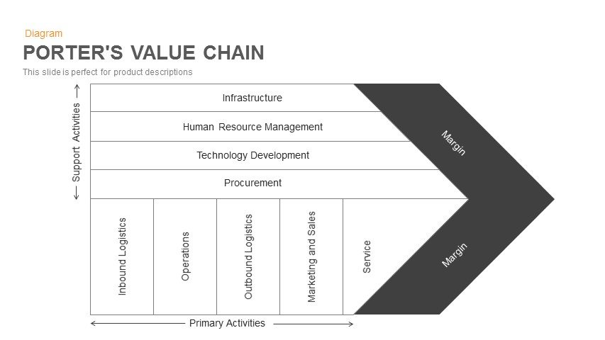

- After drawing the value chain of your business, what do you think are the (actual and potential) adverse human rights impacts of your company based on your own knowledge? Besides the impacts caused by the company operations, you should also consider the adverse impacts of each of its suppliers (refer to section 3.1)
………………………………………………………………………………………………………………………………………………………………………………………………………………………………………………………………………………………………………………………………………………………………………………………………………………………………………………………………………………………………………………………………………………………………………………………………………………………………………………
………………………………………………………………………………………………………
- Order of priority for adverse impacts at your company (fill in chart, refer to section 3.1, slides 14 – 22) This 3X3 chart is for illustration purposes. You can add more rows (levels of severity) and more columns (levels of impact) according to the level of detail. Some companies use 4X4 or 5X5 or more.

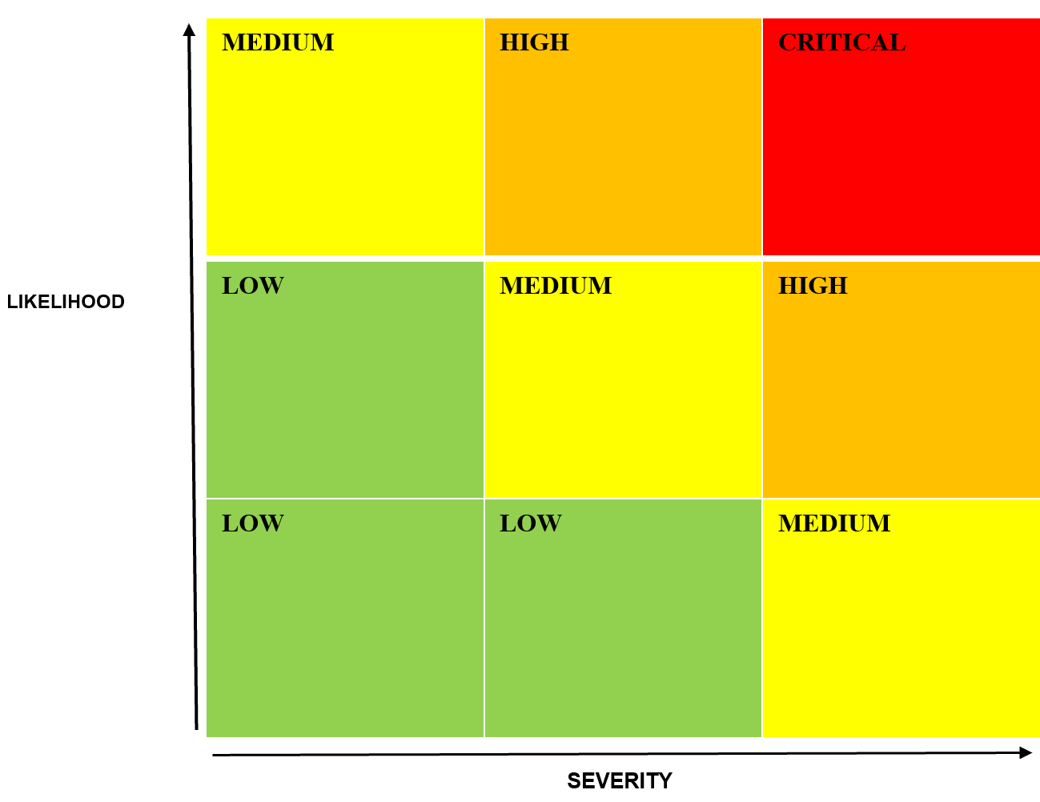

………………………………………………………………………………………………………………………………………………………………………………………………………………
………………………………………………………………………………………………………………………………………………………………………………………………………………………………………………………………………………………………………………………
………………………………………………………………………………………………………………………………………………………………………………………………………………………………………………………………………………………………………………………

- INTEGRATING AND ACTING ON FINDINGS
You should consider the actual situation of handling, minimizing and preventing adverse human rights impacts at your business, specifically as follows:
- What processes does your business have in place to integrate, minimize and prevent adverse human rights impacts? For example, because a child labor risk is identified, the company has established a recruitment process that integrates child labor risk prevention measures from application review, interviews, cross-examination, verification, post-employment verification) to prevent this risk. Procedures are established in the form of written or operational guidelines

………………………………………………………………………………………………………………………………………………………………………………………………………………………………………………………………………………………………………………………………………………………………………………………………………………………………………………………………………………………………………………………………………………………………………………………………………………………………………………
- Does your company use "leveraging" to address, minimize or prevent adverse human rights impact in suppliers? If so, what are those measures (contact between individuals in charge, training, audits, inspections, specified in the contract)? (refer to section 3.2)
………………………………………………………………………………………………………………………………………………………………………………………………………………………………………………………………………………………………………………………………………………………………………………………………………………………………………………………………………………………………………………………………………………………………………………………………………………………………………………………………………………………………………………………………………………………………………………………………………………………………………………………………………………………………………………………………………………………………………………………………………………………………………………………………………………………………………………………………………………………………………………………………………………………………………………………………………………………………
- TRACKING EFFECTIVENESS
This section assists you in making a realistic assessment of the success of taking action to address, minimize and prevent adverse human rights impact
- Does your business have mechanisms/departments/individuals assigned to monitor human rights-related processes? If so, you should fully list and evaluate the effectiveness of these mechanisms and check whether those mechanisms are provided with sufficient resources (time, money) to work effectively?
………………………………………………………………………………………………………………………………………………………………………………………………………………………………………………………………………………………………………………………………………………………………………………………………………………………………………………………………………………………………………………………………………………………………………………………………………………………………………………

- COMMUNICATING ACTIONS
This section helps you in self-evaluating the degree of communication and transparency around your company's treatment of adverse human rights impacts that it detects through its internal monitoring .
- Is the information about the actions to address, minimize and prevent adverse impacts on human rights collected, analyzed and communicated to relevant management and departments of your company? This information should be collected, analyzed and, at least, internally discussed amongst management and related departments in order for them to understand the situation of controlling and acting on adverse human rights impacts, and this therefore ensure the consistency in company’s policies and actions.
………………………………………………………………………………………………………………………………………………………………………………………………………………………………………………………………………………………………………………………………………………………………………………………………………………………………………………………………………………………………………………………………………………………………………………………………………………………………………………
- Is there any of the above information publicly disclosed? For example: posting on bulletin boards, public announcements (especially on environmental impacts), presented in various types of annual reports, and published on the website.
………………………………………………………………………………………………………………………………………………………………………………………………………………………………………………………………………………………………………………………………………………………………………………………………………………………………………………………………………………………………………………………………………………………………………………………………………………………………………………

