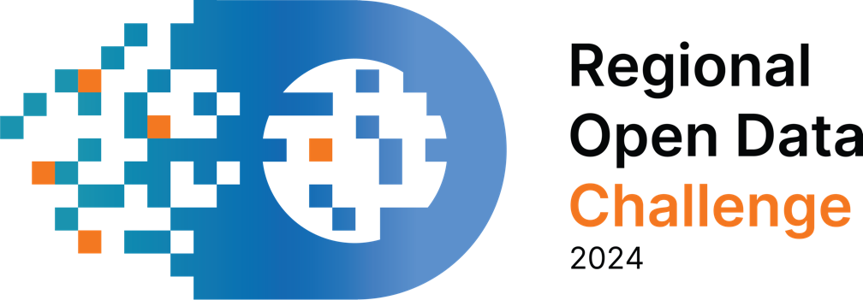

THE REGIONAL OPEN DATA CHALLENGE 2024

APPLICATION FORM

Applicant

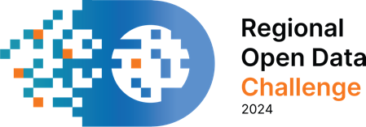

Dear participants of the Regional Open Data Challenge 2024,

This is the application form for the Regional Open Data Challenge 2024 (RODC 2024). The activity is implemented jountly by the Regional School for Public Administration (ReSPA) and United Nations Development Programme Serbia (UNDP Serbia). This initiative aims to promote the use of open data for addressing challenges recognised as the themes of common interest for ReSPA Members - Albania, Bosnia and Herzegovina, Montenegro, North Macedonia and Serbia.

The application form consists of six parts: introduction, desription of the idea, professional capacities of the applicant, timeline and budget, declaration of the applicant, declaration of the partner if applicable.

Please read carefully, fill in the form and apply by 3rd May 23:59 CET via email datachallenge.rs@undp.org

For more details on the RODC 2024, please read the public call.

Wishing you a good luck!

I INTRODUCTION

- BASIC DATA ABOUT THE PROPOSAL IDEA FOR SOLUTION DEVELOPMENT

Which challenge are you applying for? | ☐ Challenge 1: Mobility and Transportation Data  ☐ Challenge 2: Workforce mobility  ☐ Challenge 3: Tourism Atlas  ☐ Challenge 4: Demographic trends
Under which category do you apply? | ☐ Solution  ☐ Idea
Partners within application (if applicable)

- BASIC INFORMATION ABOUT THE APPLICANT

Mark the category that applies to you as an applicant | ☐ Business Entity  ☐ Civil society organization/Foundation  ☐ Scientific - research institution  ☐ Natural person/group of natural persons
Your country of residence (in case the applicant is the natural person) /country of residence of the legal entity which is the applicant | ☐ Albania  ☐ Bosnia & Herzegovina  ☐ Montenegro  ☐ North Macedonia  ☐ Serbia
National ID number (to be filled out unless the applicant is a natural person)
Applicant's Name (to be filled out unless the applicant is a natural person)
First and Last Name of the responsible person
Contact phone
Address (to be filled out unless the applicant is a natural person)

3. BASIC INFORMATION ABOUT THE PARTNER IN APPLICATION
(if there is a partnership, copy several times if necessary)

Mark the category that applies to you as an applicant | ☐ Business Entity  ☐ Civil society organization/Foundation  ☐ Scientific - research institution  ☐ Natural person/group of natural persons
Your country of residence (in case the applicant is the natural person) /country of residence of the legal entity which is the applicant | ☐ Albania  ☐ Bosnia & Herzegovina  ☐ Montenegro  ☐ North Macedonia  ☐ Serbia
National ID number (to be filled out unless the applicant is a natural person)
Applicant's Name (to be filled out unless the applicant is a natural person)
First and Last Name of the responsible person
Contact phone
Address (to be filled out unless the applicant is a natural person)

II DESCRIPTION OF THE IDEA

- Summary of the idea - briefly describe your idea. In the summary, please explain how your idea answers the goal of the challenge and how it achieves the expected effects.

- What problem does your proposed solution address? How is the solution relevant to a specific economic and social problem in the local/national context?

- Which open datasets should be used for the development of the solution?

Title of the open dataset | Is the dataset publicly accessible? If yes, provide the link. If not, describe how the specified data will be accessed.

- Besides data, what resources should be used to develop the solution (programming languages, platforms, etc.)?

- What makes the proposed solution innovative?

- Please describe long term sustainability of the project beyond the competition.

- Describe the end users and network of relevant stakeholders of the proposed solution and how it meets their needs.

III PROFESSIONAL CAPACITIES OF THE APPLICANT

From this point until the part “Declaration of the applicant”, only applicants in the cateogory of “solution” should fill the form.

- Describe the applicant's experience in the field of open data and the challenge topic.

- How do you envision your contribution to the open data initiative in the region in the next two years?

- Please list the relevant projects/initiatives/services provided in the last three years (please copy the table as much as necessary). You can list the projects which are implemented by the partner, if the partnership exists.

Name of the project/initiative/service: | Value of the contract in USD (if possible to disclose):
The place of implementation: | Period of implementation (since - until):
Client / Donor: | Number of persons included in the project implementation:
Partner in implementation (if applicable): / | Name and surname of responsible person:
Short description: | Contact in the name of the client/donor (name and surname, phone number, email):

- Describe the organizational structure of the applicant. List the resources at your disposal (to be filled in unless the applicant is an individual).

- Team which will develop the solution:

Name and Surname | Expertise Area | Role in Solution Development

It is necessary to provide CVs for all team members containing information about relevant experience required for the role in solution development (through jobs, training, etc.). CVs should be submitted in a free format.

IV TIMELINE

      - Describe the activities in the development of the solution and place them in the timeline for implementation (1st June – 17th July 2024).

Activity | 1st week | 2nd week | 3rd week | 4th week | 5th week | 6th week | 7th week

      - If it is envisaged that the solution will be developed in a partnership, please describe the division of roles.

V DECLARATION OF THE APPLICANT

I, the undersigned, confirm that:
(a) the information provided in this form is accurate,
(b) the applicant meets all the conditions stated in the open data challenge call,
(c) the applicant and the individuals designated for project implementation possess professional competencies for solution development.

First and Last Name:
Signature:
Date and Place:

VI DECLARATION OF THE PARTNER

Only applicants which apply in partnership fill out this form.

I, the undersigned, on behalf of the partner in application, confirm that:

(a) the partner meets all the conditions from the call to participate in the open data challenge,
(b) I agree with the content of this form,
(c) the partner and the individuals intended for the project implementation have the professional competencies for solution development.

Partner's Name (to be completed except in the case when the partner in application is an individual):

First and Last Name:
Signature:
Date and Place:

