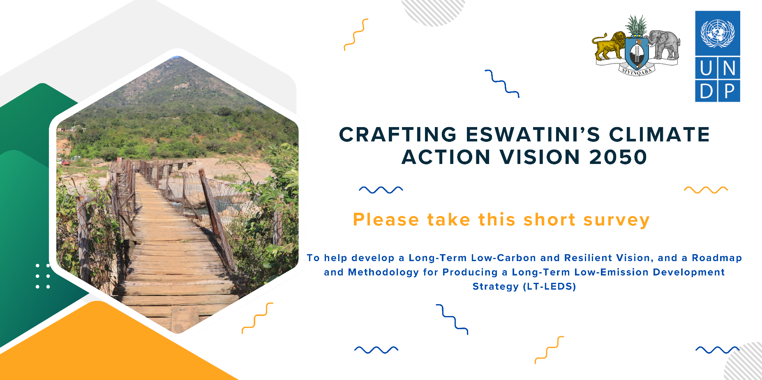

Background

On 21 September 2016, the Government of the Kingdom of Eswatini ratified the Paris Agreement that seeks to hold the increase in the global average temperature to well below 2°C above preindustrial levels and pursue efforts to limit the temperature increase to 1.5°C above preindustrial levels. In addition, Eswatini has submitted and launched its Nationally Determined Contributions (NDC) to the United Nations Framework Convention on Climate Change (UNFCCC). The NDC is a policy document that represents the planned efforts of the country to reduce national emissions, also called mitigation, and adapt to the impacts of climate change, also called adaptation, in the short term, until 2030. The NDC will be updated every five years.

Long-Term Low Emission Development Strategy (LT-LEDS)
Achieving carbon neutrality in the second half of the century by all countries is a crucial requirement set by the Paris Agreement to avoid irreversible global climate change. In 2024, the Government of the Kingdom of Eswatini will therefore develop its Long-Term Low Emission Development Strategy (LT-LEDS) within the framework of its commitments within the Paris Agreement. The LT-LEDS should ensure the coherence of short-term climate action with long-term climate goals. Eswatini sees that a long-term strategy for climate action can further strengthen her aspirations towards a cleaner and greener economy and to fulfil her obligations to improve the lives of the citizens, particularly, the most vulnerable groups.

The process to develop the LT-LEDS for Eswatini requires the engagement of stakeholders including the key ministries, sub-national government institutions, private sector actors, NGOs, civil society organizations and communities to build a shared vision for long-term sustainable development. The process will also require the creation and reconsideration of existing institutional arrangements for long-term planning, the development of an enhanced transparency framework, and the analysis of financial options and socioeconomic impacts of the priority actions selected. The LT-LEDS and its Low-carbon and Resilient Vision for 2050 component (the Vision 2050) will be the guiding instrument for the development and updating of the NDCs and other policy and management instruments related to climate change.

In the first phase of the development of the LT-LEDS – January to March 2024 – the Vision 2050, and the roadmap for the development of the LT-LEDS will be co-created with stakeholders representing the “Whole of Society”. In the subsequent phase, March to December 2024, the LT-LEDS document will be developed guided by Vision 2050 and the roadmap.

Scope and Objectives of the Survey
The Vision 2050 will articulate the country's long-term aspirations and values, setting the overall direction for sustainable development and just transition. Co-creating a Low-carbon and Resilient Vision for 2050 involves engaging a diverse range of stakeholders to ensure that the strategy reflects the needs, concerns, and expertise of different sectors of society. The survey is presented in this document and contains tailored questions for the stakeholders to collect their views and inputs that will support building a draft Climate Vision for the country. This will include perspectives about the country’s challenges, needs, gaps, and opportunities. The key identified issues will be used to develop the draft Vision 2050 document including the roadmap.

Envisioned Component of the Vision 2050 Document
The key elements of the Vision 2050 Document are imagined to include the following.

            - Vision statement: Articulates the country's long-term aspirations and values, setting the overall direction for sustainable development and just transition. This is typically a short statement of three to five sentences.
            - Introduction: the global climate crisis, international commitments, objectives of the Vision 2050 and LT-LEDS process.
            - Country context:
  - National circumstances, such as geography, climate, economy, sustainable development, and poverty eradication.
  - Overview of the climate policy landscape.
  - Key sectors, policies and measures for climate action and economic development.
  - NDCs sector emission reduction targets.

  - NDC adaptation measures and policies.
  - Overview of Eswatini´s emissions profile.
  - Overview of development priorities.
  - Overview of governance and planning
- Stakeholder perspectives: common and divergent stakeholder perspectives, results of the stakeholder dialogue process.
- From NDC to LT-LEDS: pathways and scenarios towards achieving a low-emissions and climate-resilient economy and society.
  - Mitigation measures to achieve a low-emissions and climate-resilient economy.
  - Adaptation measures to achieve a climate-resilient economy.
- Just transition: shared vision and pathways for a just transition to a low-emissions and climate-resilient economy.
- Social inclusion and gender: integrate social inclusion and gender equality considerations in the long-term vision.
- Roadmap for the development of the LT-LEDS: the roadmap will be a strategic plan that will guide the step-by-step process of developing the Eswatini LT-LEDS, and will outline the objectives, activities, stakeholders, and timeline for its development.
- Concluding remarks and next steps.

Please send your responses to the below questionnaire to:

zitsile.khumalo@undp.org

Survey questionnaire:

This questionnaire should take about 15 to 20 minutes to complete. Your responses will be treated confidentially and anonymously and will only be used to develop the LT-LEDS. There are 7 questions, each with sub-questions. Some questions may be more technical and require specific expertise. If you cannot answer a certain (sub)question you may omit it and move to the next question. You are however encouraged to provide answers within each category.

Please answer the questions concisely.

- Understanding Current Perspectives:
  - What are your current perceptions and concerns regarding climate change and its impacts on our country?

Response:

  - How do you envision a low-carbon and resilient future for our country?

Response:

  - In your opinion, what are the key challenges and opportunities associated with transitioning to a low-carbon economy?

Response:

- Vision and Aspirations:
  - What long-term aspirations and values do you have for the country in terms of sustainable development and climate action?

Response:

  - Which key components should the Vision 2050 include?

Response:
  - What specific goals and targets do you think are essential for achieving a low-carbon and resilient future?

Response:
  - To your knowledge, are there international best practices or models that we should consider for our vision?

Response:

- Identifying Priority Areas:
  - What sectors or industries do you believe should be prioritised for emissions reduction and resilience-building efforts?

Response:

  - Are there specific geographic regions or communities that should receive special attention in our vision for 2050?

Response:

- Mitigation Measures and Strategies:
  - What measures and strategies would be effective in reducing greenhouse gas emissions over the long term in your sector or community?

Response:

- Adaptation Strategies:
  - What are the key vulnerabilities of the country to the impacts of climate change, and how may these be addressed through adaptation strategies?

Response:

  - How can we enhance the resilience of our critical infrastructure and communities to climate change impacts?

Response:

- Technology and Innovation:
  - What role do you see for technology and innovation in achieving our low-carbon and resilient goals?

Response:

  - Are there specific technologies or innovations that should be prioritised or avoided?

Response:

  - What policies would encourage research and development in clean technologies?

Response:

- Just Transition, Inclusivity, and Gender Equality:
  - How can we ensure that the transition to a low-carbon future is equitable and inclusive for all members of society?

Response:

  - Are there vulnerable or marginalized groups that need special consideration in the vision?

Response:

  - How can the Vision 2050 and LT-LEDS ensure a just transition for workers and communities affected by the shift to a low-emission and resilient economy?

Response:

  - How should gender considerations be integrated into the Vision 2050 and LT-LEDS, recognizing the differentiated impacts of climate change on women and men?

Response:

Please send your responses to the questionnaire to:

zitsile.khumalo@undp.org

