Strengthening Marine Protected Areas in SE China to conserve globally significant coastal biodiversity
(China-Protected Areas System Reform (C-PAR) Program Child Project #4)

Safeguards Risk Management Assessment Report

Final Draft

July 2023

Table of Contents
Abbreviations 6
Executive Summary 8
1 Project Description 10
2 Legal and institutional framework 12
2.1 Land based and sea-based pollution sources and Pollution Prevention Plans 14
3 Project Area 18
4 Baseline Information 26
5 Project Stakeholders 27
6 Project Sustainability-Safeguards Tools 28
6.1 Project Risk Monitoring Matrix 28
6.2 Environmental and Social Management Framework ESMF 31
6.3 Social and Environmental Screening Template SESP 31
7 Sustainability Risk Analysis 33
7.1 Environmental Risks 33
7.2 Social Risks 33
7.3 Governance Risks 34
8 Mitigation Measures 37
8.1 Environmental Mitigation Measures 37
8.2 Social Mitigation Measures 40
8.3 Governance Mitigation Measures 41
9 Project Sustainability Monitoring and Reporting 42
10 Annexes 44

List of Tables
Table 01 Marine Reserves Related Laws 12
Table 02 Marine Reserves Related Regulations & Planning 12
Table 03 Project areas and relevant institutions 18
Table 04 UNDP Risk Category 30

List of Figures
Figure 01 Three locations of the Project’s areas 19
Figure 02 Xiamen Bay Coastal Waters Pilot Area 19
Figure 03 Xiamen Bay Coastal Water Pilot Area-Satellite Image 20
Figure 04 Xiamen Bay Coastal Water Area-Satellite Image 20
Figure 05 Qinzhou-Beihai Coastal Waters Pilot Area 21
Figure 06 Qinzhou-Beihai Coastal Waters Pilot Area, Satellite Image 22
Figure 07 Qinzhou-Beihai Coastal Waters Area, Satellite Image 22
Figure 08 Zhuhai-Jiangmen Coastal Water Pilot Area 23
Figure 10 Zhuhai-Jiangmen Coastal Water Pilot Area, Satellite Image 24
Figure 09 Zhuhai-Jiangmen Coastal Water Area, Satellite Image 24

List of Annexes
Annex 01 National Environmental Regulations in the Project Three Areas
Annex 02 Project Area Baseline Information
Annex 03 Stakeholders Roles and Responsibility
Annex 04 Risk Monitoring Matrix
Annex 05 National ESIA Procedures
Annex 06 Updated SESP
Annex 07 National Marine Protection Measures

Abbreviations
ADB Asian Development Bank
AFIP Academy of Forest Inventory and Planning, National Forestry and Grassland Administration
AGRS Appeal and Grievances Redress System
AMSCD APEC Marine Sustainable Development Center
APEC Asia-Pacific Economic Cooperation
BQCW Beihai-Qinzhou Coastal Waters
C-PAR China’s Protected Area System Reform
CAS Chinese Academy of Science
CBAP Coastal Biodiversity Action Plan
CBD Convention on Biological Diversity
CBO Community Based Organization
CBP Coastal Biodiversity Partnership
CBPF China Biodiversity Partnership and Framework for Action
CHM Clearing House Mechanism (under CBD)
CITES Convention on International Trade in Endangered Species
CNY Chinese yuan
CWD Chinese White Dolphin
DNPAM Department of Natural Protected Area Management, National Forestry and Grassland Administration
ERP Emergency Response Plan
ESA Ecologically Sensitive Area
ESG Environment, Social and Governance
GEF Global Environment Facility
GIS Geographic Information System
IA Implementing Agency
IUCN International Union for the Conservation of Nature
IWC International Whaling Commission
KBA Key Biodiversity Area
LAP Livelihood Action Plan
LPAC Local Project Appraisal Committee
M&E Monitoring and evaluation
MARA Ministry of Agriculture and Rural Affairs
MEE Ministry of Ecology and Environment
METT Management Effectiveness Tracking Tool
MFZ Marine Functional Zone
MNR Municipal Nature Reserve
MNR Ministry of Natural Resources
MoF Ministry of Finance
MPA Marine Protected Area
MTR Mid-term Review
NBSAP National Biodiversity Strategy and Action Plan
NFGA National Forestry and Grassland Administration
NGO Non-Governmental Organization
NIM National Implementation Modality
NNR National Nature Reserve
NR Nature Reserve
PA Protected Area
PIMS Project Information Management System
PIR Project Implementation Review
PNR Provincial Nature Reserve
PPG Project Preparation Grant (for GEF)
PRC Peoples Republic of China
PSC Project Steering Committee
QPR Quarterly Progress Report
RF Results Framework
RTA Regional Technical Advisor
SAR Special Administrative Region
SCCBD Biodiversity Management in the Coastal Area of China’s South Sea project
SDG Sustainable Development Goal
SESP Social and Environmental Screening Procedure (UNDP)
SOA State Oceanic Administration
TIO Third Institute of Oceanography
UNDAF United Nations Development Assistance Framework
UNDP United Nations Development Programme
UNEP United Nations Environment Program
USD United States Dollar
WWF World Wide Fund for Nature
XBCW Xiamen Bay Coastal Waters
ZJCW Zhuhai-Jiangmen Coastal Waters

Executive Summary
This institutional empowerment and management development project aims to conserve globally significant coastal biodiversity in southeast (SE) China through integrated seascape planning and threat management, MPA network expansion, and strengthened Marine Protected Areas (MPAs) operations. The project focuses on coastal ecosystems, using the Chinese White Dolphin (CWD) as an indicator and flagship species to engage multiple stakeholders in novel ecosystem-based approaches. The target area for the project is the three provinces in southeast China: Fujian, Guangdong, and Guangxi.
The project duration is from 2018 to the end of 2024, and the total cost is $25,015,145.58. This is financed through a GEF grant of $2,652,293.58, parallel grant co-financing of $150,000 from UNDP, and $22,212,852 in similar grant co-financing from government sources in China. UNDP, as the GEF Agency, is responsible for the execution of the GEF resources. This is a National Implementation Modality (NIM) project, and the Implementing Partner is the National Forestry and Grassland Administration (NFGA) under the Ministry of Natural Resources. The objective is to conserve globally significant coastal biodiversity in Southeast SE China through integrated seascape planning and threat management, MPA network expansion, and strengthened MPA operations. The project’s activities are carried over three components:
- Component 1: Strengthened MPA legal framework and mainstreaming and expanding MPA network.
- Component 2: Demonstrations of improved MPA and ESA (Ecologically Sensitive Area) management.
- Component 3: Monitoring, evaluating, and sharing knowledge and information on coastal habitats and species.
This study includes the update of the Social and Environmental Screening Template (SESP), presented in Annex 06. A total of eight risks have been identified. Risk 8: Climate change impacts are expected in China's coastal ecosystems, risking achieving project targets/objectives, identified as a moderate risk and is subject to change to low Risk by the end of the project when the project management develops relevance to the national and regional Risk Emergency Response of MPAs. Seven risks have been assessed as low-significance risks requiring monitoring and mitigation measures. The low risks are:
(1) Risk 1: access restrictions for fishermen/women);
(2) Risk 2: Existing community conflicts over access to marine resources could be exacerbated by project activities;
(3) Risk 3: There are gender disparities at project sites that could potentially be reproduced by the creation/enhanced management of MPAs;
(4) Risk 4: Project activities will occur within/adjacent to environmentally sensitive areas posing potential risk to sensitive habitats and species;
(5) Risk 5: There are small levels of ethnic minorities in project sites that could be impacted by project activities
(6) Risk 6: Creation of MPAs and ESAs will change the use of marine resources with potential adverse impacts on habitats;
(7) Risk 7: Project will address harvesting of fish and aquatic species, which could damage aquatic habitats if carried out at unsustainable levels
The overall project risk categorization is low. An ESMF has been prepared for the project (and three other CPAR projects) outlining the additional safeguard measures that apply to the project and will be completed during the project to minimize potential risks. This updated SESP template shall form the basis to complete and endorse the mitigation measures.
The proposed mitigation measures shall include the following:
- Update Stakeholder Engagement Plan
- Appeal and Grievance Redress System
- Livelihood Action Plan
- Disaster Response Plan
- Sustainability Reporting

In conclusion, ongoing mitigation measures exist, e.g., an eco-compensation scheme. Therefore, the project maintains the rating of low risk, with the management's commitment to developing and implementing the proposed mitigation measures.

Project Description
This institutional empowerment and management development project aims to conserve globally significant coastal biodiversity in south-east (SE) China through integrated seascape planning and threat management, MPA network expansion, and strengthened Marine Protected Areas (MPAs) operations. The project focuses on coastal ecosystems, using the Chinese white dolphin (CWD) as an indicator and flagship species to engage multiple stakeholders in novel ecosystem-based approaches. The target area for the project is the three provinces in southeast China: Fujian, Guangdong, and Guangxi.
As the only C-PAR child project focusing on coastal and marine ecosystems, this project offers opportunities for replication and learning across the marine environment, linking marine and terrestrial approaches and between Marine Protected Areas MPAs and Terrestrial Protected Areas TPAs.
The project duration is from 2018 to the end of 2024, and the total cost is $25,015,145.58. This is financed through a GEF grant of $2,652,293.58, parallel grant co-financing of $150,000 from UNDP, and $22,212,852 in similar grant co-financing from government sources in China. UNDP, as the GEF Agency, is responsible for the execution of the GEF resources and the cash co-financing transferred to the UNDP bank account too. This is a National Implementation Modality (NIM) project, and the Implementing Partner is the National Forestry and Grassland Administration (NFGA), under the Ministry of Natural Resources.
The project has one objective and three components, each comprising several outputs and activities. The objective is to conserve globally significant coastal biodiversity in South-East SE China through integrated seascape planning and threat management, MPA network expansion, and strengthened MPA operations. The components are:
Component 1: Strengthened MPA legal framework and mainstreaming and expanding MPA network. This will extend the area and improve the connectivity of MPAs protecting globally significant biodiversity, piloting innovative mechanisms to mainstream biodiversity conservation into marine spatial planning and improving MPA regulations and financing.
Component 2: Demonstrations of improved MPA and Ecologically Sensitive Area (ESA) management. This will strengthen the management effectiveness of MPAs in the project’s three pilot areas, build the capacity of MPA staff, enhance the participation of communities, and reduce locally specific threats in MPAs and across wider seascapes through participatory action and enforcement and improved awareness.
Component 3: Monitoring, evaluating, and sharing knowledge and information on coastal habitats and species. This will establish a functioning MPA Network linking MPAs across SE China, including a GIS-based information platform for knowledge and information sharing, enhance the coordination of research and monitoring for globally significant biodiversity, and ensure that the project is implemented effectively and knowledge and lessons learned are widely shared with project stakeholders, including the broader public in coastal SE China and nationally through the GEF-financed, C-PAR Program, of which this project is a part.

The experienced main barriers to the project realization are:
1) Inadequate MPAs and enabling framework for integrated coastal biodiversity conservation;
2) Lack of experience, capacity, and participation to apply ecosystem-based approaches;
3) Inadequate coordination, knowledge management, and information systems for effective threat management.
This safeguard assessment report shall address these challenges and their impact on the project's sustainability and propose mitigation measures to overcome such barriers.

Legal and institutional framework
In 2016, the State Oceanic Administration newly approved 16 national marine parks. The PRC has already established 271 marine nature/special reserve zones (marine parks) of different levels, with a total area of 124,000 km². According to the regulations of World Marine Law, the PRC possesses a marine territory of 2.997 million km², including inland waters, territorial waters, exclusive economic zones, and a continental shelf. Therefore, the area of maritime reserve zones accounts for 4.13% of the national marine area.

China has adopted several basic laws and regulations for marine biodiversity conservation and species protection, as exhibited in Tables 01 and 02.
Table 01 Marine Reserves Related Laws
Laws & Regulations | Promulgation Date
《Marine Environment Protection Law of the PRC》 | Promulgated on August 23rd, 1982
《Customs Law of the PRC》 | Promulgated on January 22nd, 1987
《Wildlife Protection Law of the PRC》 | Promulgated on November 8th, 1988
《Environmental Protection Law of the PRC》 | Promulgated on December 26th, 1989
《Law of the PRC on the Territorial Sea and the Contiguous Zone》 | Promulgated on February 25th, 1992
《Port Law of the PRC》 | Promulgated on June 28th, 2003
《Law of the PRC on Island Protection》 | Promulgated on December 26th, 2009
《Island Protection Law》 | Passed on December 26th, 2009
《Mineral Resources Law of the PRC》 | Promulgated in 2014
《Fisheries Law of the PRC》 | Promulgated in 2014
《Law of the PRC on the Exploration and Development of Resources in Deep Seabed Areas》 | Promulgated on February 26th, 2016

Table 02 Marine Reserves Related Regulations & Planning
Laws & Regulations | Promulgation Date
《Regulations of the PRC Concerning Environmental Protection in Offshore Oil Exploration and Exploitation》 | December 29th, 1983
《Regulations of the PRC on Control Over Ocean Dumping》 | March 6th, 1985
《Regulations of the PRC on Traffic Safety Management in Fishing Port Waters》 | July 3rd, 1989
《Regulations of the PRC on Implementing Aquatic Wildlife Protection》 | October 5th, 1993
《Regulations of the PRC on Nature Conservation Reserves》 | October 9th, 1994
《Administrative Regulations on Maritime Engineering Projects to Prevent and Rectify Maritime Pollution and Damage》 | August 30th, 2006
《Administrative Regulations on Maritime Construction Projects to Prevent and Rectify Maritime Pollution and Damage》 | August 30th, 2006
《Regulations on Nature Conservation Reserves》 | Promulgated on October 9th, 1994
《Administrative Guidelines on Marine Nature Reserves》 | Promulgated on May 29th, 1995
《Law of the PRC on Sea Area Use Administration》 | Passed on October 27th, 2001
《Guidelines on Special Marine Reserve Administration》 | Promulgated & implemented in 2010
《Construction Standard and Administration Instruction on National-Level Marine Reserves》 | Published in October 2014
《National Major Marine Function Zone Planning》 | Promulgated in August 2015

China has also established comprehensive mechanisms for marine spatial planning. Marine Major Function Oriented Zoning is essential to National Major Function Oriented Zoning. The National Plan of Marine Major Function-Oriented Zoning is the basis for advancing the layout of the significant function-oriented zones. Through the National Plan of Marine Major Function-Oriented Zoning, the marine space is divided into Optimized Development Areas, Key Development Areas, Restricted Development Areas, and Prohibited Development Areas. Restricted Development Areas include marine fisheries protection zones, special marine reserves, islands, and their surrounding waters, while Prohibited Development Areas include various types of marine nature reserves at all levels.
In addition to this national, macro-level marine spatial planning system, the Marine Environmental Protection Law also established the Marine Function Zoning (MFZ) system, which is more regional and operational. The National Marine Functional Zone system was approved by the State Council in 2012. The National Marine Function Zoning Scheme (2011-2020) published by SOA divides China's marine function zones into eight categories, specifying the classification of marine function areas and marine environmental protection requirements. Today there is no law directly stipulating the establishment of Ecological Sensitive Areas (ESAs) and no definition. However, similar terms are widely used in the related legislation to describe essential areas for biodiversity, migrations, etc. To safeguard the long-term conservation of globally significant coastal and marine biodiversity of SE China, the Government aspires to establish a systematic approach towards the application of Ecologically Sensitive Areas (ESAs) through the MFZ system as buffer zones and corridors connecting MPAs to ensure coverage of representative ecosystems and the critical ecological needs of globally significant endangered species with specific habitat requirements and reduce essential threats of these areas through regulations, enforcement, and participatory approaches.
Two legal frameworks are assessed as a high priority for project sustainability. These are the farmland use and financial compensation. The following is a brief review of the status of their legal framework. Financial compensation is the second legal framework that is ongoing as part of the project activities. The issue of ecological compensation is particularly complex in marine and coastal areas due to the natural attributes such as the fluidity of water bodies, spatial stereoscopic and integrality, the scarcity of supply of marine ecological resources, the difficulty of changing the direction of resource use and the social characteristics of resource use by stakeholders. At present, the practice of environmental compensation for coastal communities in China is mainly reflected in the reclamation of the sea. It provides a reference for preparing community ecological compensation in China's Marine protected areas.
The compensation laws have shortcomings that need to be recognized in this project but are not necessarily resolved:
- Regulations are not unified, and the compensation standards are vague. China has not yet established uniform principles and standards for ecological compensation in marine laws and regulations. Provisions are scattered in various laws, resulting in differences in compensation standards in all regions. Mechanisms are, therefore, weak, and prone to instability. The unparalleled and mutually exclusive compensation provisions affect the authority of the law.
- The compensation is not a unified, simple method of compensation, unreasonable compensation for losses caused by long-term interests.
- The compensation program is disordered, lacking fair and just compensation, due to a lack of process control and risks causing more severe abuse of power.
- The compensation is challenging to implement, and the remedies are not perfect. For example, in Jiang town of Dongtai, Jiangsu Province, the fishermen could not obtain permits to use sea areas, meaning their legitimate interests could not be effectively protected.

Land based and sea-based pollution sources and Pollution Prevention Plans

Marine pollution prevention laws and regulations at national level
The followings are reference to the main national regulation for pollution prevention in the MPAs. These regulations constitute the framework for operation in MPAs and for the Livelihood Action Plan and Capacity Building Measures in this study.
Marine Environmental Protection Law of the People's Republic of China (Third amendment on November 4, 2017)
Chapter IV: Prevention and Control of Pollution Damage to the Marine Environment from Land-based Pollutants
Chapter V: Prevention and control of pollution damage to the marine environment from coastal engineering construction projects
Chapter VI: Prevention and control of pollution damage to the marine environment from marine engineering construction projects
Chapter VII: Prevention and control of dumping of waste pollution damage to the marine environment
Chapter VIII: Prevention and control of ships and related operational activities on the marine environment pollution damage
Source: http://hyj.qinzhou.gov.cn/czfg/t13494475.shtml (official website of Qinzhou Marine Bureau)

Regulations on the Prevention and Control of Pollution and Damage to the Marine Environment by Marine Engineering Construction Projects (Second amendment on March 19, 2018)
Chapter III Marine Engineering Pollution Prevention
Article 20 Strict control of reclamation projects. Prohibit reclamation activities in the natural spawning grounds of economic organisms, breeding grounds, baiting grounds, and bird habitats. Filling materials used in reclamation projects should meet relevant environmental protection standards.
Article 21 The construction of marine engineering shall not cause erosion, siltation, and damage to the base of the territorial sea and its surrounding environment, so as not to endanger the stability of the bottom of the territorial sea. When constructing sea dikes, bridges across the ocean, aquatic recreation and sports, and landscape development project construction, adequate measures shall be taken to prevent erosion or siltation of the coast.
Article 22 The outfall setting of the offshore sewage discharge project shall be consistent with the zoning of marine functions and marine environmental protection planning. It shall not damage the operation of adjacent sea areas. Offshore discharge of sewage shall not exceed the national or local emission standards. In the area controlling the total amount of pollutants discharged, the number of pollutants released shall not exceed the standard.
Article 23 Those engaged in mariculture should take a scientific approach to farming and reduce marine environment pollution from farming bait. In the case of sea pollution or severe damage to the maritime landscape due to aquaculture, the farmers should restore the damage.
Article 24 In the construction and operation of the exploration and development of marine solid mineral resources project, the construction unit shall take adequate measures to prevent the spread of large-scale suspension of pollutants to damage the marine environment.
Article 25 In exploring and developing marine oil and gas mineral resources, operations should have oil-water separation facilities, oily sewage treatment equipment, oil discharge monitoring devices, oil residue and waste recovery facilities, and crushing garbage equipment.
Article 26 Units engaged in exploration and exploration of marine oil and gas mineral resources exploration and development should handle civil liability insurance for pollution damage.
Article 27 and Article 28 are provisions, respectively, for offshore blasting operations and offshore engineering demolition operations.
Source: http://hyj.qinzhou.gov.cn/czfg/t13494475.shtml (official website of Qinzhou Marine Bureau)

Regulations on Prevention and Control of Vessel Pollution of the Marine Environment (Sixth Amendment on March 19, 2018)
Chapter II: General provisions for the prevention and control of Pollution of the marine environment by ships and relevant operational activities
Chapter III: Discharge and reception of pollutants from ships
Chapter IV: Prevention and control of pollution from ships related operational activities
Source: https://www.mee.gov.cn/ywgz/fgbz/xzfg/201805/t20180516_440446.shtml (official website of Ministry of Ecology and Environment of the People's Republic of China)

Marine pollution prevention program and planning at municipal level in project area
Qinzhou City, Guangxi Province
A. The 14th Five-Year Plan for Marine Ecological Protection in Qinzhou City (2021-2025)
(1) Existing problems:
Local offshore sea pollution problem continues to be prominent; the layout of mariculture is not reasonable; the trend of alien species spread has not been effectively curbed; the environmental quality and service quality of sea-friendly space needs to be improved.
(2) Planning goals:
Looking ahead to 2035, the green production and lifestyle in coastal areas are widely formed, the marine ecological environment is fundamentally improved, and the goal of building a beautiful bay with clear water and clean beaches, fish and gulls, and harmony between people and the sea is basically accomplished; the quality and stability of marine ecosystems are significantly improved, and marine biodiversity is effectively protected; people's demand for a beautiful marine ecological environment is met; marine ecological environment governance system and governance capacity is modernized.
(3) Work tasks:
Deepen the management of land-based sources of pollution into the sea; strengthen the categorized treatment of seawater pollution; promote marine litter clean-up and remediation
Source: http://hyj.qinzhou.gov.cn/czfg/t13494475.shtml (official website of Qinzhou Marine Bureau)

- Ecological Protection Pollution Prevention and Control Operation -- Work Plan for Water Quality in Nearshore Waters in Qinzhou City (Qinzhou Marine Bureau, June 13, 2018)
- In the three industrial parks above the autonomous region level, strengthen the management of centralized sewage treatment facilities and the construction of supporting pipeline networks; monitor the water quality of industrial wastewater after pretreatment to meet the water quality requirements of the incoming water; by the end of June 2018, ensure treatment facilities stably operate and meet the discharge standards.
- In the Beibu Gulf (BBG) Forestry Industrial Park and Overseas Chinese Investment Zone, support or rely on centralized sewage treatment facilities and pipe network and install automatic online monitoring devices.
- Implement new standards for coastal vessels; gradually transform the existing vessels to meet the new standards by the end of 2020, and the ones that do not meet the transformation requirement within the specified time will be eliminated.
- Implement regulatory system for the receipt, transfer, and disposal of ship pollutants.
- Construct facilities for 26 cargo terminals and fishing port terminals in the reception, transfer and treatment of initial rainwater, sewage, and garbage, and effectively improve the emergency response capacity for pollution incidents.
- Implement the planning of emergency response capability building concerning the prevention and control of ships and their operations to pollute water environment; carry out joint emergency exercises no less than once a year, to effectively enhance the emergency response capabilities of personnel to deal with oil and hazardous chemical spills.
- Carry out the cleanup and rectification of outfalls into the sea, strengthen monitoring and supervision, and ensure the 32 outfalls to meet stable discharge standards.
- Crackdown on illegal sand mining in the sea.
Source: http://hyj.qinzhou.gov.cn/czfg/t13494475.shtml (official website of Qinzhou Marine Bureau)

Annex 01 describes in detail the National Environmental Protection Regulations in the three project’s areas.

Project Area
The Chinese Government has established 8 MPAs totaling 130,407 ha for CWD specifically. And 16,400.16 ha of new MPAs have been added in SE China, comprising 141.98 ha in Guangdong, 2,225.56 ha in Guangxi, and 14,032.62 ha in Fujian.
Additionally, in 1996, Sha Chau and Lung Kwu Chau Marine Park were designated as one of the most important habitats of CWD in Hong Kong. In 2003, Fujian Dongshan – Guangdong Nanao waters were listed as a Marine Biodiversity Demonstration Area to protect CWD. However, the current network of protected areas is insufficient to cover the life cycle needs of the CWD according to the known distribution areas, and several vital sites remain legally unprotected.
The project area is the coasts of Fujian, Guangdong, and Guangxi provinces, which encompass the remaining mainland range of the project’s flagship species, the Chinese White Dolphin. The project has three pilot seascapes: a) “Xiamen Bay Coastal Waters” in Fujian Province, b) “Zhuhai and Jiangmen Coastal Waters” in Guangdong Province,” and c) “Beihai and Qinzhou Coastal Waters” in Guangxi Province. The project has five target nature reserves and one proposed nature reserve: Shankou Mangrove National Nature Reserve (NNR), Dugong Chinese White Dolphin (CWD) NNR, and the proposed Sanniang Bay CWD Provincial Nature Reserve (PNR) in the pilot area of Beihai and Qinzhou Coastal Waters, Pearl River Estuary CWD NNR (PRE CWD NNR) and Jiangmen CWD PNR in the pilot area of Zhuhai and Jiangmen Coastal Waters, and Xiamen Rare Marine Species NNR (Xiamen RMS NNR) in the pilot area of Xiamen Bay. The project proposes two pilot villages: Sanniangwan Village, next to the proposed Sanniang Bay PNR, and Shanliao Village, next to the Dugong CWD NNR. Table 03 exhibits the project areas and their relevant responsible institutions. Figure 01 displays the three locations of the project’s areas. Figures 02 to 10 exhibit each of the project’s areas. The satellite images reflect the dense urban development and activities in the project’s three areas. Dense coastal areas are often subject to the impacts of natural flood and seasonal storms and the potential of vertical agriculture becomes more valid and popular options for local farmers. The Figures also reflect the locations and proximity of the pilot activities.

Table 03 Project areas and relevant institutions
Pilot Area | Beihai and Qinzhou Coastal Waters |  |  | Zhuhai and Jiangmen Coastal Waters |  | Xiamen Bay Coastal Waters
Project province |  | Guangxi |  | Guangdong |  | Fujian
Target Nature Reserve | Shankou Mangrove NNR | Dugong CWD NNR | Proposed Sanniang Bay PNR | PRE CWD NNR | Jiangmen CWD PNR | Xiamen RMS NNR
Project Municipality/city | Beihai |  | Qinzhou | Zhuhai | Jiangmen | Xiamen
Project County/district | Hepu |  | Qinnan | Qi’ao Island | Taishan | Xiamen

Figure 01 Three locations of the Project’s areas
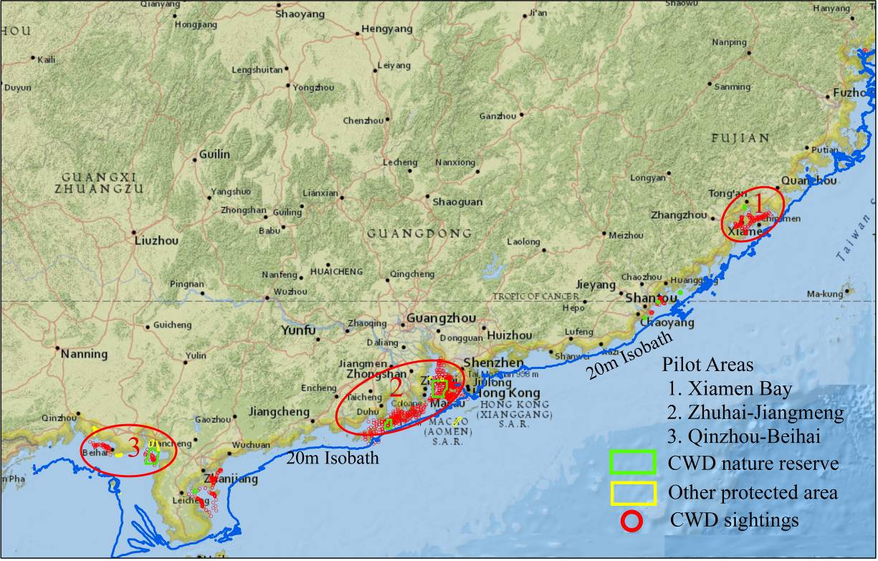

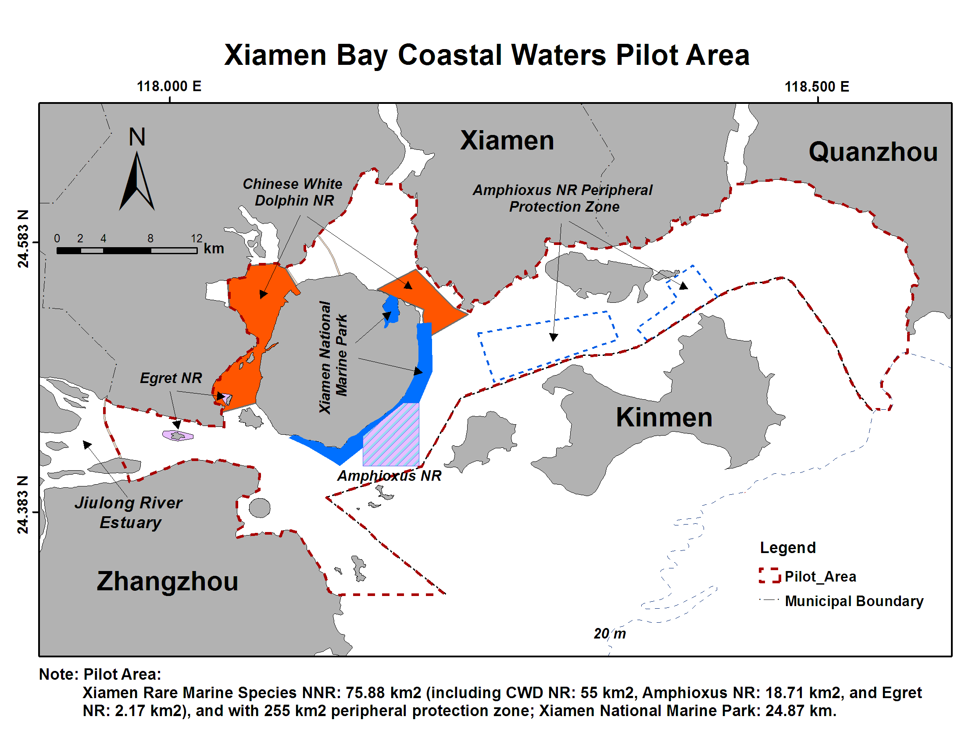
Figure 02 Xiamen Bay Coastal Waters Pilot Area
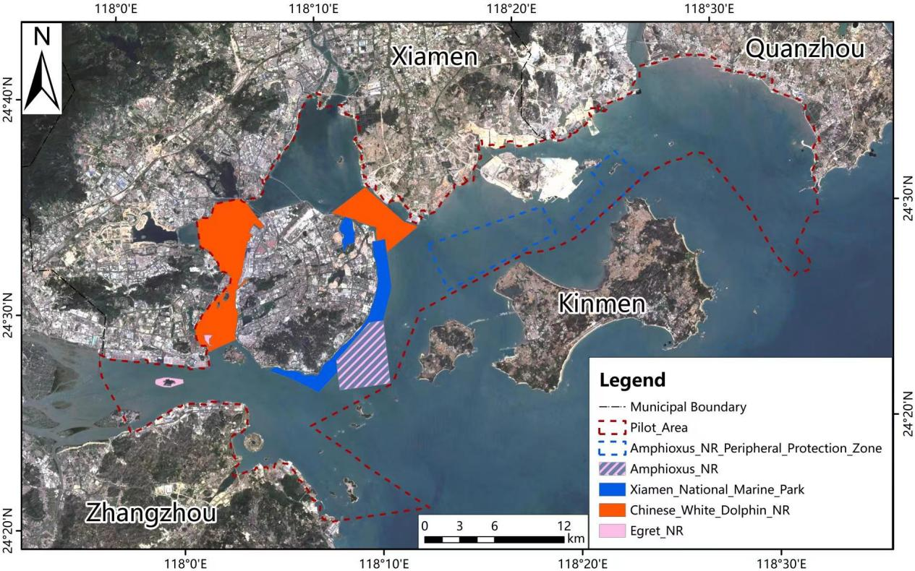
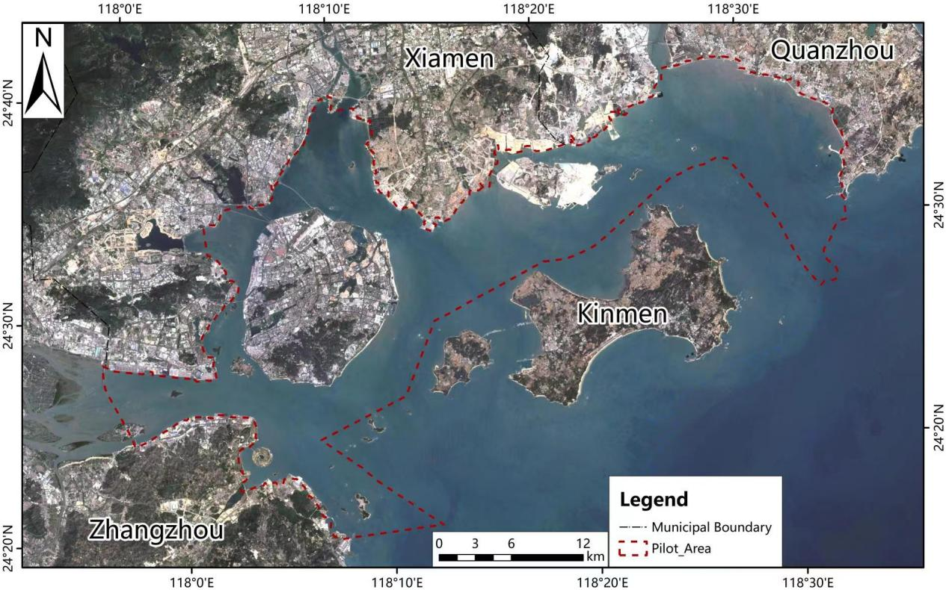
Figure 03 Xiamen Bay Coastal Water Pilot Area-Satellite Image
Figure 04 Xiamen Bay Coastal Water Area-Satellite Image

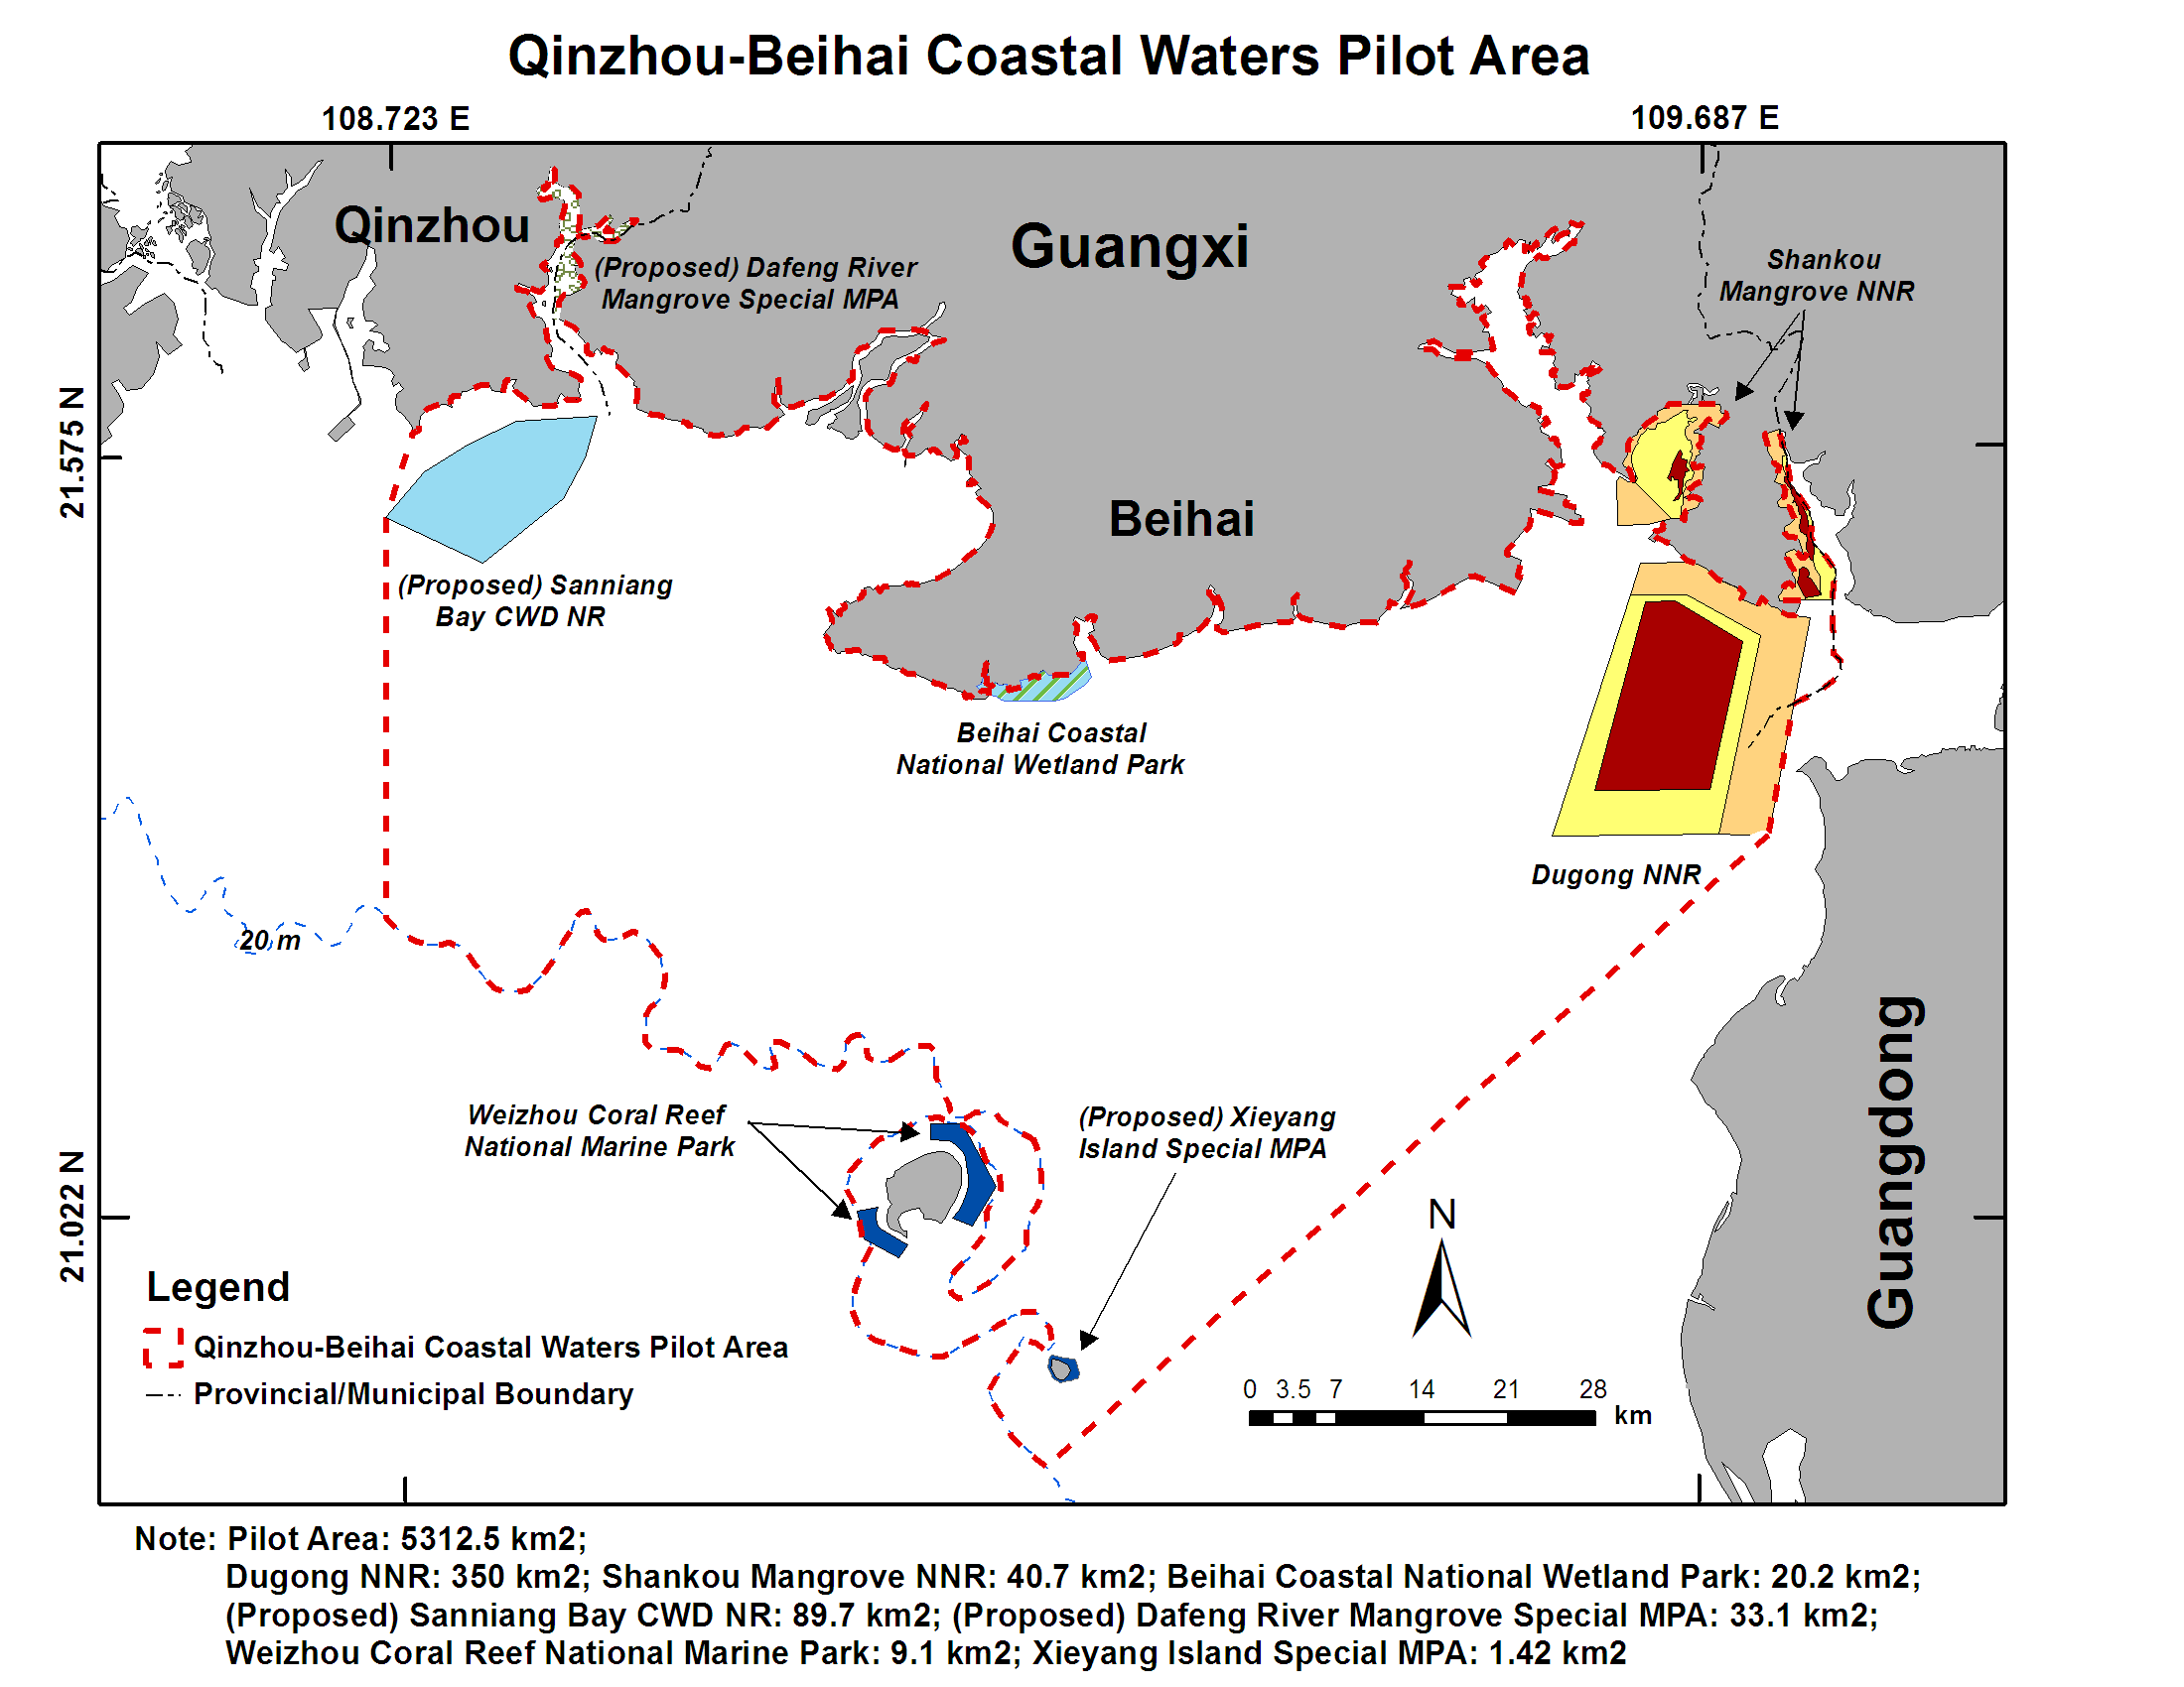
Figure 05 Qinzhou-Beihai Coastal Waters Pilot Area
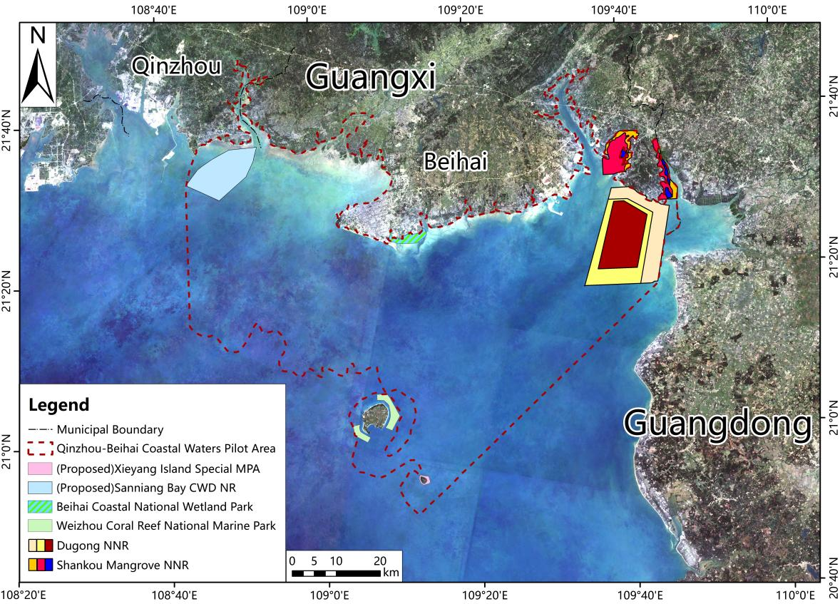
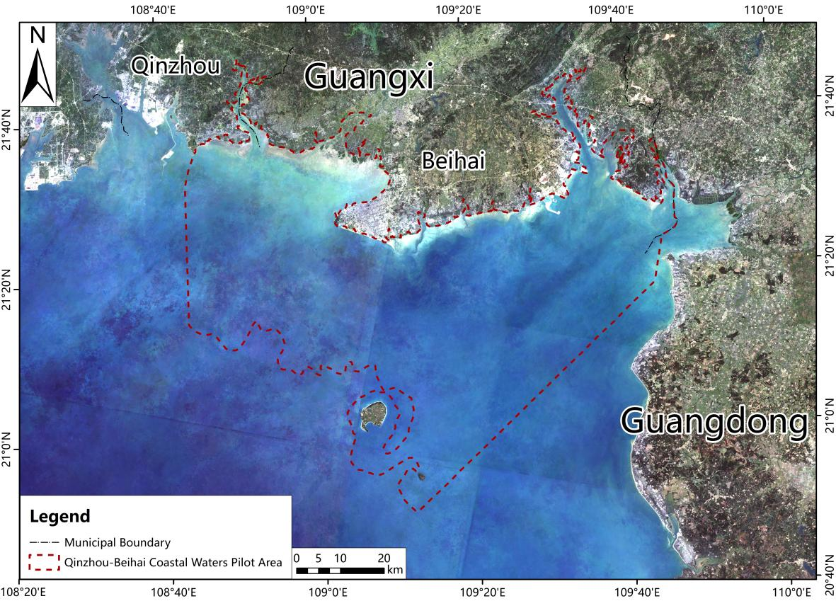
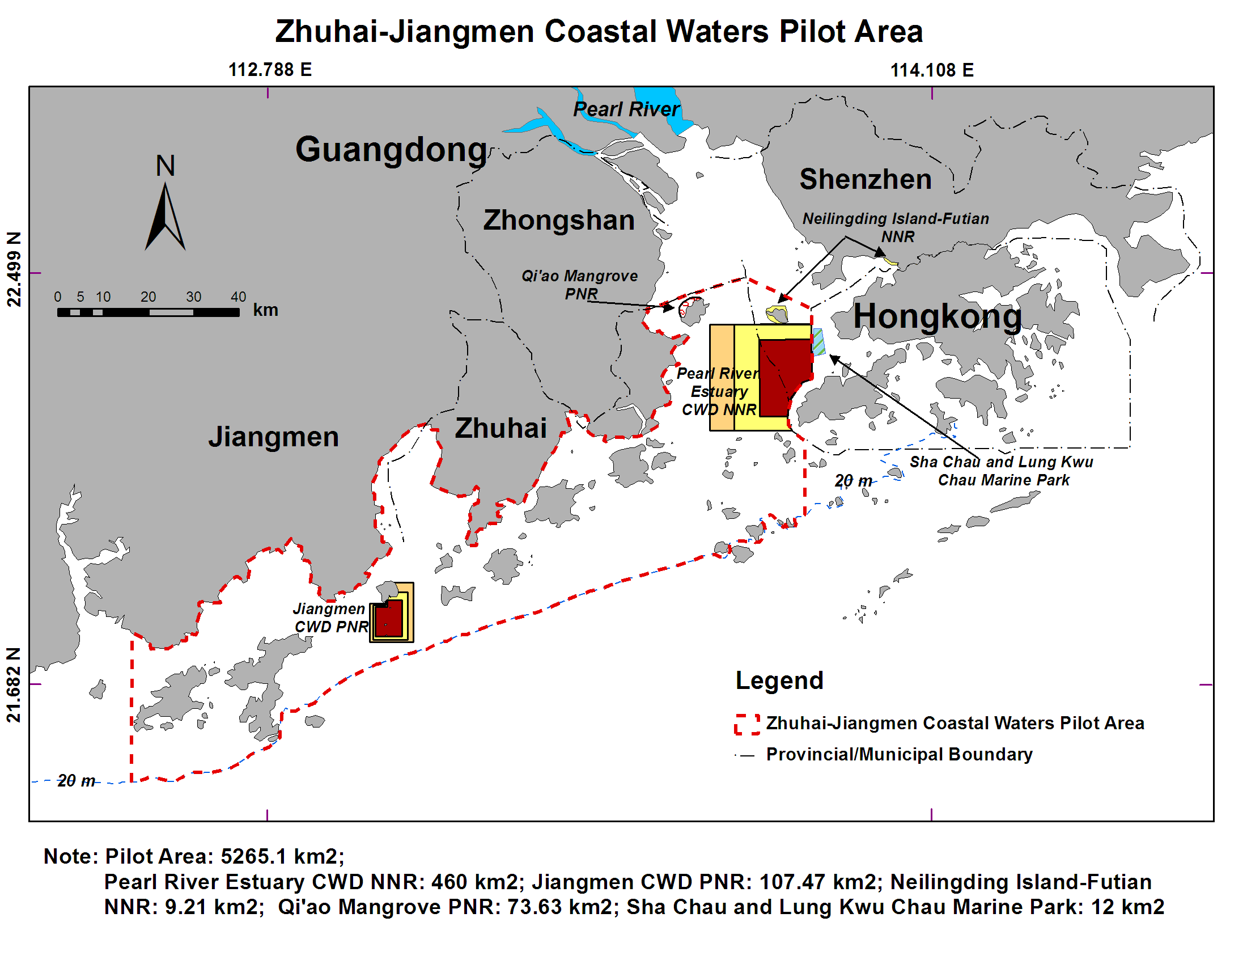
Figure 06 Qinzhou-Beihai Coastal Waters Pilot Area, Satellite Image
Figure 07 Qinzhou-Beihai Coastal Waters Area, Satellite Image
Figure 08 Zhuhai-Jiangmen Coastal Water Pilot Area
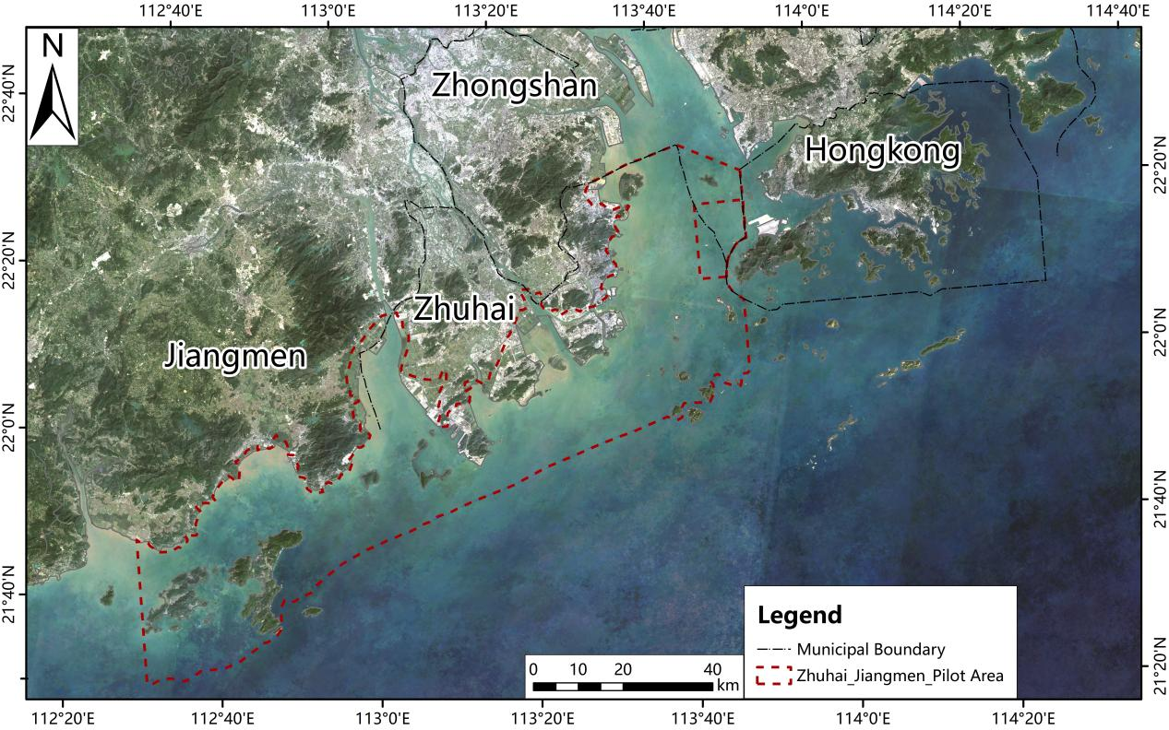
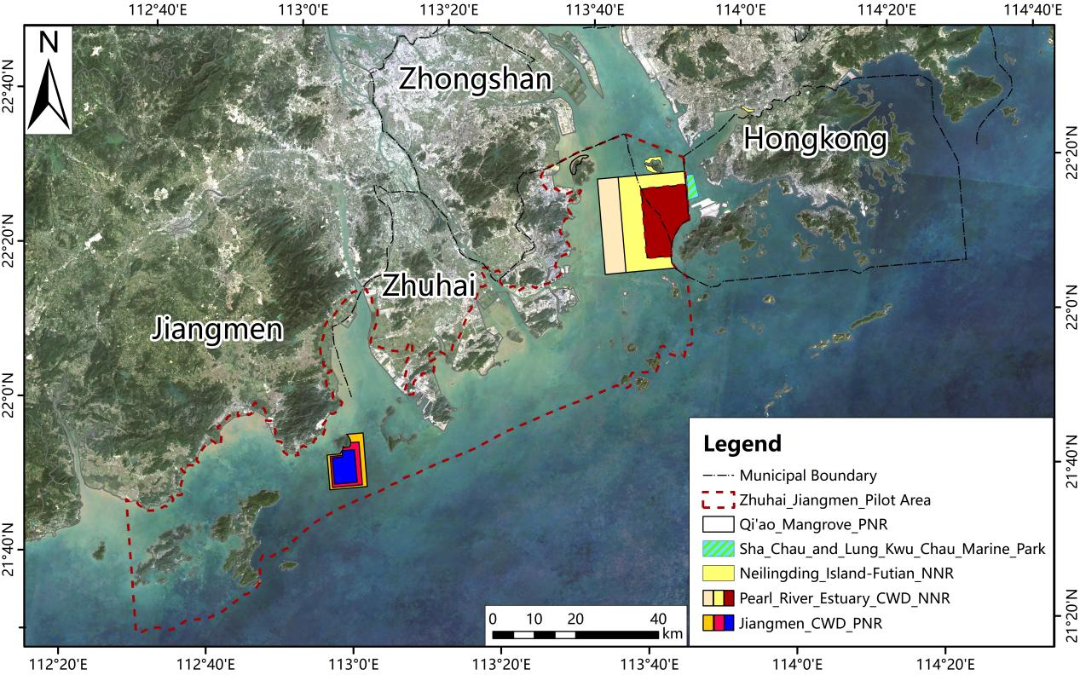
Figure 10 Zhuhai-Jiangmen Coastal Water Pilot Area, Satellite Image

Figure 09 Zhuhai-Jiangmen Coastal Water Area, Satellite Image

Livelihood in the Project’s Areas
The villagers' livelihood within or adjacent to the target nature reserves depends on the marine natural resources. The following is a brief review of the demographic and socio-economic features of the project’s area:

- No people live within the project nature reserves except Shankou Mangrove Nature Reserve in Guangxi Zhuang Autonomous Region (GZAR). Many communities were dependent on marine resources surrounding the Dugong NNR and proposed Sanniang Bay NRs in GZAR. A large adjacent urban population lives in the areas of the Pearl River Estuary CWD National Nature Reserve (PRE CWD NNR) and Jiangmen CWD nature reserve (Jiangmen CWD NR) in Guangdong Province, and the Xiamen Rare Marine Species National Nature Reserve (Xiamen RMS NNR) in Fujian Province, with about 630,000 people adjacent to the PRE CWD NNR, 950,000 people adjacent to the Jiangmen CDW NR, and 3,920,000 people adjacent to the Xiamen RMS NNR)
- Less than 2% of ethnic minority people in the villages located within or adjacent to the project nature reserves, although about 10% of ethnic minority people live in Qinzhou Prefecture in GZAR. And one-third of the total population in Guangxi was ethnic minority people, which was much higher than the national average
- Females account for about 50% of the total population in the project area. Labor division between women and men is different.
- Major environmental threats from community activities include overfishing, ecosystem-unfriendly fishing, and fisheries in the intertidal area.
- Many households in Sanniangwan Village in Beihai-Qinzhou Coastal Waters are engaged in CWD tourism-related livelihoods, such as restaurants, homestay, and selling small items to tourists. However, there are no village regulations or service standards on the services. Households provide services to tourists according to standards of their own.
- To some degree, there is conflict among villagers and between villagers and the Dugong Nature Reserve in Beihai-Qinzhou Coastal Waters about the use of the intertidal zone. The area legally belongs to the experimental zone of the nature reserve, but most of the site is now occupied by five households because of historical reasons.
- Estimated direct beneficiaries include 3,500 persons from 710 households in the two proposed pilot villages in Beihai and Qinzhou Coastal Waters Area.
- The villages have much fewer land resources per capita than their provinces' average (1.26 mu in Guangxi and 0.45 mu in Guangdong). The limited land resources are not enough to maintain the lives of the local communities.
- The involvement of the villagers in marine-related production activities was high, while participation in marine conservation was limited.
- The rich coastal and marine resources, in turn, support essential industries such as fishing, maritime shipping, and oil and gas exploration, which jointly contribute to over 10% of China's overall GDP and are growing at an annual rate of 15%.

Baseline Information
The three pilot areas have markedly different ecological, socio-economic, and baseline conditions. The pilot area demonstrations in Xiamen Bay and Zhuhai-Jiangmen coastal waters will build on a solid baseline of technical studies and municipal engagement, which needs to be taken to a new level by strengthening mainstreaming of biodiversity into marine spatial planning and sectoral participation to address threats to globally significant biodiversity. The pilot area in Qinzhou-Beihai coastal waters lacks this strong baseline. Still, it is a crucial priority for strengthening protection for a resident population of some 300 CWD and community co-management of coastal natural resources. Conservation efforts at this site should start with developing better trust, cooperation, and shared understanding between MPAs and local communities built around the flagship species of CWD and the opportunities that sustainable natural resource management provides for local livelihoods.
With 3 million km² of marine area and 6,500 islands under its jurisdiction, China hosts an exceptional marine biodiversity comprising about 20,300 recorded species, including 12,000 species of marine fauna, for which the South China Sea is essential. The rich coastal and marine resources support important industries such as fishing, maritime shipping, and oil and gas exploration, contributing over 10% of China’s overall GDP and multiplying. Therefore, the maritime economy has developed rapidly, with high growth of coastal populations, intensified ocean development and land reclamation, and severe pollution. These represent extreme threats to the country’s rich and diverse coastal ecosystems. Some coastal rural communities also remain highly dependent on direct access to coastal natural resources for subsistence and livelihoods.
Critical baseline information is also lacking, such as life cycle requirements, movements, distribution, abundance, and the impacts of different threats on CWD and its echolocation system. The situation for other globally significant biodiversity and critical habitats is even more inadequate, with massive gaps in the evidence base due to a lack of basic coordinated research and monitoring. Despite the severe and diverse threats described above, there is no comprehensive monitoring and evaluation system for assessing and reporting threats in critical habitats and no system for coordinated threat management and enforcement. All these constraints hinder a more effective unified approach towards the conservation of the globally significant coastal biodiversity of SE China, based on an accessible and agreed knowledge base, shared understanding of threats and priorities, and common goals and actions. Annex 02 further describes the baseline data and information in the project’s area.

Project Stakeholders
The project’s Stakeholders Engagement Plan SEP was part of the approved and disclosed project’s documents in 2018, and it was presented as Annex E. Based on the existing SEP, this study shall revisit the relations between the project’s stakeholders and their roles in terms of sustaining the project-outputs, presented in Annex 03, as per the following:
- Governance:
  - Policy Making, Regulating and Financing
- Environmental and Social
- Operation, Capacity Building, Communication and Monitoring & Reporting
The detailed review of the stakeholder mapping is part of the Capacity Building Measures Report in this study. The visualization and mapping of the relationships among the project’s stakeholders should provide a communication platform for strengthening relations and cooperation among stakeholders. The following stakeholders’ roles analysis is proposed:
- Key stakeholders are actors without whose support and participation the targeted results of a project usually cannot be achieved,
- Primary stakeholders are actors who are directly affected by the project, either as designated project beneficiaries, because they stand to gain – or lose – power and privilege or because they are impacted by the project in some other way, for instance, if they must be resettled,
- Secondary stakeholders are actors whose involvement in the project is only indirect or temporary
The following indicators are proposed for monitoring and reporting on the project’s Stakeholder Engagement Plan and Mapping:
- Enabling active local community engagement and participation in decision-making, particularly those at risk of being left behind;
- Ensuring transparency of programming interventions through the provision of timely, accessible, and functional information regarding supported activities, including potential environmental and social risks and impacts and management measures;
- Ensuring that stakeholders can communicate their concerns and have access to rights-compatible complaints redress processes and mechanisms; and
- Providing effective monitoring—and, where appropriate, participatory monitoring with stakeholders—and reporting on implementing social and environmental risk management measures.

Project Sustainability-Safeguards Tools

Project Risk Monitoring Matrix
The Project Risk Assessment Matrix and the Social and Environmental Screening Template (SESP) are complementary documents. The Risk Assessment Matrix addresses overall risks to the project. At the same time, the SESP focuses on environmental and social risks to the project with detailed screening, analysis, and mitigation measures. The updated Risk Assessment Matrix of this project includes the attributes of the project- risks. The Risk Assessment Matrix is a dynamic document that project management could update quarterly.

As part of the project document, the ESMF, Annex H, was approved and disclosed in 2018, the original risk matrix has five moderate and four low risks. This study shall maintain the original risks and further report on their status. In addition, the study introduces an advanced Risk Monitoring Matrix, exhibited in Annex 04. The matrix can be utilized for monitoring and reporting purposes in real-time and through the indicative online dashboard. The following are the attributes of risk indicators. The matrix is aligned with UNDP Risk Category exhibited in Table 04. And the matrix is developed in line with UNDP Managing Risks Across UNDP Programming and Operation, Guidance Note 2019. https://info.undp.org/sites/ERM/Shared%20Documents/UNDP%20ERM%20Guide_Sept2019.pdf. (This section shall be populated with data as part of the Capacity Building Measures Report. Annex 04 is an Excel book including Dashboard-charts).

Attributes of Risk Indicators
The composition of risk indicators often consists of identifying risks from the view of stakeholders, understanding their probability, predicting their impact and the impacted stakeholder, planning for mitigation, and its cost estimate. The following are the risk indicator attributes:

- Description: the title or brief description of the risk.
- Project Area: reference to all the project areas and each pilot area.
- Type of Risk Indicators: in terms of a stage of the life cycle of the project: input, process, output, impact/result.
- Categories and Sub-Categories of Risks: Social & Environmental, Financial, Operational, Organizational, Political, Regulatory, Security, Strategic, and Others. Exhibited in Table 04.
- Date of Risk Identification: the quarter and year when the risk was identified.
- Probability: an estimate of the likelihood of the risk occurring on a scale of 1 (not likely) to 5 (expected).
- Impact: impact on the project progress if the risks were to occur on a scale of 1 (low) to 5 (critical).
- Risk Owner: the institution/community responsible for managing and mitigating the risk.
- Description of Impact: this entails the negative result and changes to the project outputs if the risk is manifested with no mitigation measure
- Impacted Stakeholder: this involves definitions of organizations, communities, services, infrastructures, and eco-systems that will be affected if the risk is manifested and there is no mitigation measure.
- Risk Management Decision: this includes decisions by the responsible institution in the project regarding the action against identified risks: tolerate (the risk and its likely impact), mitigate (the risk to reduce the possible impact or exposure), transfer (the risk to another party) and terminate (the activity generating the risk).
- Description of Risk Mitigation: what action has been taken/will be taken to counter a risk.
- Status of Risk Mitigation: in terms of status such as complete, none, and ongoing.
- Date of Mitigation: the quarter of the Status of Risk Mitigation.
- Cost of Mitigation: this includes the estimated/actual mitigation cost incurred by the Risk Owner.
- Compliance Measure: this entails defining the institution responsible for the review and reporting on compliance and maturity of risk management.

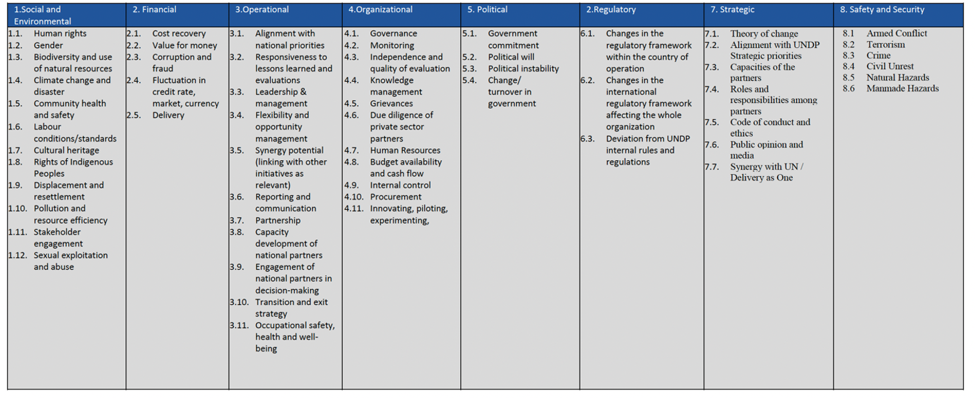
Table 04 UNDP Risk Category

Environmental and Social Management Framework ESMF
The project’s ESMF, Annex Eb, as part of the project document, was approved and disclosed in 2018. The ESMF was developed for this project (jointly with the three other UNDP-supported child projects in the C-PAR program). The ESMF is the framework document for ensuring comprehensive implementation and reporting on the environmental and social safeguards as part of project management. There are two options for maintaining the ESMF. One option is to update the ESMF as part of the maintenance process for the project documents. Or maintain the original ESMF and introduce updates in the project-relevant studies—for example, this Safeguards Risk Management Assessment Report. The second option is more relevant to this project, where projects that the ESMF governs have different ratings and different implementation plans.

The ESMF usually introduces the general environmental context of the country, including the gap analysis of governing national regulations and UNDP-Standards and international best practices. The reasoning for this available background and context is that the project’s Terms of Reference dictate the project activities. While the project’s ESMF bridges the project context and outcomes to the national and international level sustainability and global reporting. In addition, the ESMF should provide general guidelines for stakeholders mapping, grievance redress system, disaster response, livelihood recovery, and reporting. This study presents a commendable effort to include relevant national information describing the governing regulations and the natural environmental conditions in the project’s area.

Social and Environmental Screening Template SESP
At the national legislative level, to implement the Environmental Protection Law, Environmental Impact Assessment Law, and Regulations on the Administration of Environmental Protection of Construction Projects, China enacted the General Technical Guidelines for Environmental Impact Assessment in 1997 and revised it for the first time in 2011 (HJ 2.1-2011), adding social impact assessment to this revision, and stipulating that regional SIA should be conducted when land use and planning are carried out. Annex 05 presents the ESIA National Procedures that are relevant to the project.

The UNDP Social and Environmental Screening Procedure (SESP) was finalized during the project design, and the results were summarized in the project document 2018. The purpose of this study is to revisit and update the SESP as per the MTR, progress reports, and consultation with the project management team. The updated SESP followed the same eight risks that were approved at the time pf the project commencement. This study updated the context and ratings of those established eight risks. This is an institutional empowerment and management development project for biodiversity and marine ecosystem protection. The field activities for the project implementation have no impact on the environment. On the contrary, the project outputs will positively affect the natural environment in the project area and region. However, the outputs of project activities impact local communities in terms of economic displacement. These impacts can be mitigated as per the recommendation of this study. In addition, there are already ongoing mitigation measures through capacity-building activities and eco-compensation measures. Also, the required targeted assessment is addressed in this study as part of the Appeal and Grievance Redress System.
There are already ongoing mitigation measures, e.g., an eco-compensation scheme. Therefore, the project maintains the rating of low risk, with the management's commitment to developing and implementing the proposed mitigation measures.

A total of eight risks have been identified. Risk 8: Climate change impacts are expected in China's coastal ecosystems, risking achieving project targets/objectives, identified as a moderate risk and is subject to change to low Risk by the end of the project when the project management develops relevance to the national and regional Risk Emergency Response of MPAs. Seven risks have been assessed as low-significance risks requiring monitoring and mitigation measures. The low risks are:

(1) Risk 1: access restrictions for fishermen/women);
(2) Risk 2: Existing community conflicts over access to marine resources could be exacerbated by project activities;
(3) Risk 3: There are gender disparities at project sites that could potentially be reproduced by the creation/enhanced management of MPAs;
(4) Risk 4: Project activities will occur within/adjacent to environmentally sensitive areas posing potential risk to sensitive habitats and species
(5) Risk 5: There are small levels of ethnic minorities in project sites that could be impacted by project activities
(6) Risk 6: Creation of MPAs and ESAs will change the use of marine resources with potential adverse impacts on habitats
(7) Risk 7: Project will address harvesting of fish and aquatic species, which could damage aquatic habitats if carried out at unsustainable levels

The overall project risk categorization is low. An ESMF has been prepared for the project (and three other CPAR projects) outlining the additional safeguard measures that apply to the project and will be completed during the project to minimize potential risks. This updated SESP template shall form the basis to complete and endorse the mitigation measures.
The proposed mitigation measures shall include the following:
- Update Stakeholder Engagement Plan
- Appeal and Grievance Redress System
- Livelihood Action Plan
- Disaster Response Plan
- Sustainability Reporting

Sustainability Risk Analysis
Based on the project's documents and progress report review, the project risk monitoring matrix analysis, and Social and Environmental Screening, the followings are the main groups of risks for the project's sustainability. The risks are grouped into Environmental, Social, and Governance.

Environmental Risks
The environmental risks are attributed to the following:
- Significant degradation of marine ecosystems and invasion of alien species causing declines in the marine biodiversity and rare and endangered species.
- Rivers often carry contaminants and sudden overload discharge into the sea.
- Coastal economic zones have heavy environmental land losses. In the recent ten years, China has set off a new round of reclamation to meet the needs of urban construction, ports, and industrial construction.
- Communities in or surrounding the nature reserves in Beihai-Qinzhou Coastal Waters in GZAR are largely economically dependent on the nature reserves, and a few economic activities are not ecosystem-friendly.
- The project area has observed a continued and rapid decline in fisheries resources. The decline in fisheries resources will result in an imbalance in ecosystem food webs, including a reduction in food supply to the CWD. Major environmental threats arising from the local communities to the marine ecosystem, especially to the CWD, include:
overfishing which severely competes with the CWD for food;
deep-sea ecosystem-unfriendly fishing or illegal fishing, such as trawl fishing;
illegal sea-related activities, such as sea-sand excavating;
digging and collecting sea products such as Sipunculus nudus (Sha-Chong in local language) in the intertidal area; and
disturbance due to noises from the tourist yachts. Besides, garbage and wastewater from tourism-related activities might also be a threat, and
many households in Sanniangwan Village in Beihai-Qinzhou Coastal Waters are engaged in CWD tourism-related livelihoods, such as restaurants, home stay, selling small items to tourists. However, there are no village regulations or service standards on the services. Households provide services to tourists according to standards of their own. The on-going eco-tourism activities are not sustainable and require alignment with best practices of eco-tourism.

Social Risks
The social risks are attributed to the following:
- Community co-management of the intertidal area in Dugong Nature Reserve (Guangxi) seems difficult because of the complicated relationship and illegal occupation of the site for over ten years. With support from local CSOs, using participatory approaches, the project will develop awards schemes to motivate women's good performance in marine conservation.
- Less than 2% of ethnic minority people in the villages located within or adjacent to the project nature reserves, although about 10% of ethnic minority people live in Qinzhou Prefecture in GZAR. As part of the 12.4% ethnic minority in Qinnan District, 11.8% were Zhuang Ethnic Group people. In the project provinces: one-third of the population in Guangxi is ethnic minority people, much higher than the national average.
- There is a low-risk conflict among villagers and between villagers and the Dugong Nature Reserve in Beihai-Qinzhou Coastal Waters regarding access to the intertidal zone. The area legally belongs to the experimental zone of the nature reserve, but five households now occupy the area.
- Gender disparities still exist in education attainment, training opportunities, employment opportunities, participation, decision-making, and wage equality in the PRC, in the three project provinces, in the project prefectures and counties, and adjacent to the project MPAs. Women and men have different roles and responsibilities in the project area. Men are usually in charge of external affairs, attending meetings, and participating in training. At the same time, women are responsible for domestic affairs, including cooking, washing, cleaning houses, and taking care of children and older adults. Women are the primary users of the intertidal zone for collecting sea products, while men are more involved in fishing activities. Rural women's education attainments are lower than rural men's and much lower than urban women. Women have a low level of involvement, and are often absent from participating in, public affairs. Rural women have less access to employment opportunities and less opportunity to be involved in decision-making related to community affairs.

Governance Risks
The Government ownership of the project is excellent, and the project's alignment with national environmental priorities is very high. This is a solid platform to start communicating with government planners and decision-makers to address the following risks of MPAs-sustainable management:
- Although there has been rapid growth in the number and area of MPAs in China, the current network remains inadequate compared to international targets and the heavy development pressures facing coastal ecosystems. While the SDG14 target is for at least 10% of coastal and marine areas to be conserved by 2020, and China has a national target of 5%, the PPG preliminary gap analysis reveals that 5.3% of the coastal area of the project's three target provinces is protected by MPAs. There has been little systematic planning of MPAs nationally and no formal assessment of marine (KBAs) in China. Furthermore, they are overseen by five national departments, with their management systems, financial resources, separate administrations, and overall encounter challenged in their efficiency. However, institutions in China are being optimized in terms of functional division and cooperative relationships, which also have a direct or indirect positive impact on this project.
- Inadequate MPAs and enabling framework for integrated coastal biodiversity conservation.
- Lack of experience, capacity, and participation to apply ecosystem-based approaches.
- Inadequate coordination, knowledge management, and information systems for effective threat management.
- Legislation and management measures for marine nature reserves mimic terrestrial nature reserves. It is recommended to develop more marine environment-oriented management measures (e.g., 3-dimensional, fluid) or its users.
- The integration and optimization of PAs have also brought more uncertainty to the expansion and upgradation of PAs at the local level in the short term. The work on integrating and optimizing national protected natural areas is still in progress. Through the preliminary work, a better comprehensive understanding of the base number of national PAs optimized the spatial pattern of protected areas and grasped the specific situations of various conflicts in protected areas, laying a solid foundation for the realization of the goal of comprehensive integration and optimization of protected areas in 2025. The project paid close attention to the progress of this work and will carry out activities according to relevant policies of protected areas shortly.
- Institutional setup for the project management is a risk where C-PAR4 was initially designed to be implemented by the former State Oceanic Administration (SOA), back to NFGA after institutional reform in 2018. Many aspects need to enhance communication and running-in. The project needs to organize more activities, promote contact between the stakeholders of the project provinces, increase the exchange and communication between the project demonstration protected area and other protected areas, and promote the communication and exchange between the different involved departments.
- There has been no agreement on research and monitoring priorities, and there is an urgent need for protocols for data gathering and formal mechanisms for evaluating or sharing the results. Without such evidence, the conservation of coastal ecosystems in SE China is compromised, with little evidence to challenge threats, etc.
- The management of the MPAs is fragmented between agencies, and there is poor coordination with uses in surrounding areas and a lack of specific legislation. The project, therefore, applies novel ecosystem-based approaches to conserve globally significant coastal biodiversity, using the iconic and declining Chinese White Dolphin (CWD) as an indicator and flagship to engage multiple stakeholders at the ecosystem scale. The CWD attributes can be summarized as follow:
- MPA network in SE China is the Chinese White Dolphin (CWD) Sousa chinensis – also called the Indo-Pacific humpback dolphin. CWDs are generally found in estuarine and coastal waters no deeper than 20 m,
- Since the Xiamen Rare Species MPA was set up, the CWD population has stabilized, showing the value of MPAs, although this small population remains highly threatened.
- To improve the yield of shellfish, fishermen often use chemicals such as disinfectants, antibiotics, and pesticides to eliminate benthonic animals from the mudflats, posing a severe threat to coastal biodiversity.
- These habitats and the invertebrates and fish they support are at the base of the CWD's food chain.
- The noise levels could be sufficiently high to cause adverse effects on the dolphins, such as auditory masking, temporary threshold shifts, and behavioral and physiological responses.
- Even some long-established MPAs, such as the Pearl River Estuary CWD NNR lack Master Plans, and these plans often lack attention to issues such as community-based management, eco-tourism development, and public participation.

Mitigation Measures
The following mitigation measures form the basis for the development of sustainability plan that identifies how the project’s results can be continued beyond the project duration. These include identifying institutional roles and responsibilities for continuing the operation of key project deliverables after the project.

Environmental Mitigation Measures
The project demonstrated the government's commitment to protecting marine ecosystems. This agrees with the government policy where the 19th Communist Party Congress (October 2017) released the following policy "Implement key ecosystem protection and rehabilitation projects, optimize ecological security shelter system, build ecological corridors and biodiversity conservation network, improve the quality and stability of the ecosystem."
In addition, the project will build adaptation measures into relevant activities to address the long-term risk. Climate change adaptation will be mainstreamed into all guidelines and the Coastal Biodiversity Action Plans that will be prepared and implemented for each pilot area. A brief Emergency Response Plan should be introduced to link the project area to the regional and national emergency and disaster response plans as part of climate adaptation measures.
The Livelihood Action Plan shall introduce the proposal of the MPAs to be considered for carbon sequestration. China has a nearly 3 million km2 marine land area, and the potential for oceanic carbon sinks is enormous. In promoting the double carbon target (carbon summit and carbon neutral), mainly the carbon neutral target, the development of marine carbon sinks is facing remarkable opportunities and challenges. At present, the preliminary work has been fully rolled out, and achievements have been made in the following fields: institution building, basic theoretical research and R&D of sink enhancement technology, development of monitoring, survey, and assessment, and the standardization system, transaction, and accounting, etc. In addition, Annex 07 details the ongoing national marine ecological protection Measures.

Climate Change Mitigation and Carbon Sequestration
Opportunities of carbon sequestration are introduced in this study to support the financial sustainability of the MPAs by issuing green bonds for carbon sequestration in MPAs. Private corporates provide financing as part of their corporate social responsibility, and corporates can report on the acquired green bonds in their ESG report to the financial market. The following is a brief background to carbon sequestration.
Carbon sequestration is part of the natural carbon cycle by which carbon is exchanged among the biosphere, pedosphere, geosphere, hydrosphere, and atmosphere of Earth. Carbon dioxide is naturally captured from the atmosphere through biological, chemical, or physical processes. The IPCC Sixth Assessment Report defines it as "Storing carbon in a carbon pool."
Carbon sequestration (or carbon storage) is storing carbon (atmospheric carbon dioxide) in a carbon pool. Carbon sequestration is a naturally occurring process, but it can also be enhanced or achieved with technology, for example, within carbon capture and storage projects. There are two main types of carbon sequestration: geologic and biologic (also called biosequestration). Carbon dioxide (CO₂) is naturally captured from the atmosphere through biological, chemical, and physical processes. These changes can be accelerated through changes in practices. The following technologies are common worldwide to enhance carbon sequestration processes in oceans: Seaweed farming, ocean fertilization, artificial upwelling, basalt storage, mineralization, and deep-sea sediments, adding bases to neutralize acids. The project follow-up sustainability measures provide an opportunity for feasibility studies that are required for such technologies.

Climate Change Mitigation
Carbon sequestration - when acting as a carbon sink - helps to mitigate climate change and thus reduce the harmful effects of climate change. It helps slow the atmospheric and marine accumulation of greenhouse gases released by burning fossil fuels and industrial livestock production.

The annual amount of coal plant capacity being retired increased into the mid-2010s. However, the retirement rate has since stalled, and global coal phase-out is not yet compatible with the goals of the Paris Climate Agreement. In parallel with the retirement of some coal plant capacity, other coal plants are still being added, though the annual amount of added capacity has declined since the 2010s. A 2011 Lawrence Berkeley National Laboratory report predicted that Chinese CO₂ emissions will peak around 2030. This is because in many areas, such as infrastructure, housing, commercial building, appliances per household, fertilizers, and cement production, a maximum intensity will be reached, and replacement will replace new demand. The 2030 emissions peak also became China's pledge at the Paris COP21 summit. Carbon emission intensity may decrease as policies strengthen and are more effectively implemented, including more effective financial incentives, and as less carbon-intensive energy supplies are deployed. In a "baseline" computer model, CO₂ emissions were predicted to peak in 2033; in an "Accelerated Improvement Scenario," they were expected to peak in 2027. China also established ten binding environmental targets in its Thirteenth Five-Year Plan (2016-2020). These include an aim to reduce carbon intensity by 18% by 2020 and a binding target for renewable energy at 15% of total energy, raised from under 12% in the Twelfth Five-Year Plan. According to BloombergNEF, the levelized cost of electricity from new large-scale solar power has been below existing coal-fired power stations since 2021.
Source: ChinaFAQs: China's Energy and Carbon Emissions Outlook to 2050, ChinaFAQs on 12 May 2011, "ChinaFAQs: China's Energy and Carbon Emissions Outlook to 2050 | ChinaFAQs". Archived from the original on 5 May 2012. Retrieved 2012-05-17.
Runyon, Jennifer (2021-06-23). "Report: New solar is cheaper to build than to run existing coal plants in China, India and most of Europe". Renewable Energy World.

Targets
In the 14th Five Year Plan (2021-2025), the Chinese government revealed climate mitigation goals, including a higher share of non-fossil fuels in the energy mix, reduction of CO₂ emissions per unit of GDP, carbon cap for the energy sector, reduction of fine particle pollution in key cities, and more excellent forest coverage. These goals cover industrial production, transportation, forestry, and citizens' daily lives.
The targets in China's Intended Nationally Determined Contribution (INDC) in 2016 will likely be met but insufficiently combat global warming properly. China also established ten binding environmental targets in its Thirteenth Five-Year Plan (2016-2020). These include an aim to reduce carbon intensity by 18% by 2020 and a binding target for renewable energy at 15% of total power, raised from under 12% in the Twelfth Five-Year Plan. For the first time, the Thirteenth Five-Year Plan also set a cap on total energy use from all sources: no more than 5 billion tons of coal through 2020.
Source: "Climate and energy in China's 14th Five Year Plan – the signals so far". China Dialogue. 2020-11-26. Retrieved 2021-04-20.
"To prevent catastrophic global warming, China must hang tough". The Economist. 2019-09-19. ISSN 0013-0613. Archived from the original on 2019-10-04. Retrieved 2019-10-04.
"The 13th Five-Year Plan | U.S.-CHINA". www.uscc.gov. Archived from the original on 2018-11-14. Retrieved 2018-11-20.

Emergency Response Plan
As part of the climate change adaptation measures, the management of the MPAs shall adopt an Emergency Response Plan ERP that is part of the overall national and regional response plans. Emergency Response Plans are also perceived as part of the capacity building for better governance of the MPAs. The review and approach to the ERP shall be part of the Capacity-Building Measures Report in this study. The following is a brief background of the ERP.

The People’s Republic of China is the world’s second-largest economy and the largest country by population, with over 1.4 billion people. The government is highly diverse, both in geography and ethnography. The country’s geography can be generally divided into four regions. The Southern region consists of hilly terrain and the Yunnan-Guizhou Plateau. The Northern region consists of low-productivity plains and deserts. The Western Region consists of high-altitude plains and mountains in Tibet's Autonomous Region, and the Eastern region, which can be sub-divided into the Central Plain, North Plain, and Northeast Plain, consists of alluvial plains of the Yangtze and Yellow Rivers, and a densely populated coastline.

China’s vulnerability to climatic hazards is high. Annual losses due to natural hazards average $76 billion, and around one-third of China’s agricultural land is affected by natural hazards such as storms, droughts, floods, land subsidence, and landslides. China’s Nationally Determined Contribution (2016) sets out a solid commitment to transitioning to a sustainable and resilient low-carbon economy. In 2020, China acknowledged its aim to peak CO₂ emissions before 2030 and achieve carbon neutrality by 2060. China’s Third National Communication to the UNFCCC (NC3) (2018) identifies the impacts of climate change in areas such as agriculture, water resources, ecosystems, coastal areas, and human health as priority concerns.

Social Mitigation Measures

Appeal and Grievance Redress System
The project has a comprehensive list of the project’s stakeholders. The proposed stakeholder mapping in this study shall revisit the relationship between project stakeholders and their roles in sustaining the project outputs in financing, updating, monitoring, and reporting. In addition, the study shall identify new stakeholders when needed.

The Capacity-Building Measures Report introduces the Appeal and Grievance Redress System AGRS promotes dialogue and engagement, using an understandable and transparent process that is culturally appropriate, rights-compatible, and readily accessible to all stakeholders at no cost and without retribution. The system shall be utilized for implementing the targeted assessment of the risk of economic displacement at specific project sites. The following indicators are proposed for the assessment of the relevance and appropriateness of the system:

- Free of external manipulation, interference, coercion, and intimidation.
- Gender and age-inclusive and responsive.
- Culturally appropriate and tailored to the language and accessibility preferences and decision-making processes of each identified stakeholder group, including disadvantaged or marginalized groups. Where applicable, it includes differentiated measures to allow the effective participation of disadvantaged or vulnerable groups, including persons with disabilities.
- Based on prior and timely disclosure of accessible, understandable, relevant, and adequate information, including draft documents and plans.
- Addresses social and environmental risks, adverse impacts, and the proposed measures and actions to address them.
- Seeks to empower stakeholders, particularly marginalized groups, and enable the inclusion of all relevant views of affected people and other stakeholders into decision-making processes, such as project goals and design, mitigation measures, the sharing of development benefits and opportunities, and implementation issues.

Gender
As part of the social mitigation measures the key strategies to be followed include a) Building the capacity of the project management staff to promote gender equality; b) Ensuring women’s genuine and equal representation (e.g., in task forces, committees, training, sustainable livelihoods, etc., allocating women-targeted budgets if necessary to achieve this); c) Ensure women’s equal access to project information (e.g., by ensuring specific consultations with women’s groups).
The project was identified as GEN2 based on the relevant GEF and UNDP gender policies, which means the project has great potential to empower women and girls and to promote gender equality effectively.

Financial Sustainability and Livelihood
Today, direct beneficiaries are estimated to include 3,500 persons from 710 households in the two proposed pilot villages in Beihai and Qinzhou Coastal Waters Area. The financial sustainability and resourcing for MPAs: a) amount of financing from new eco-compensation mechanism (diverse sources including the governmental, private sector, etc.); and b) improved financial sustainability as measured by the Financial Sustainability Scorecard (FSS). See Annex B as part of the approved project’s documents. In addition, the PRC will further increase its future financings in marine reserve zones, primarily adding channels to protect maritime islands, construct special marine reserves, and restore and compensate for coastal wetlands. FSS Components consist of:
- Legal, regulatory, and institutional frameworks
- Business planning and tools for cost-effective management
- Tools for revenue generation (average of the three pilot areas)
Part of this study is to propose a Livelihood Action Plan LAP in addition to the ongoing eco-compensation activities. The proposed LAP, is discussed in the LAP Report, entails the introduction and development of the following diversified livelihoods:
- Introduction to best practices in Vertical Farming
- Introduction to best practices in Eco-Tourism
- Introduction of E-businesses for women groups
- Cooperation with Enterprises-Social Corporate Responsibility
- Easement rights to local businesses and communities and issuance of green usufruct bonds

Governance Mitigation Measures
The project supports the institutional empowerment and management development of MPAs. For example, an effect of this project is for the Provincial Administrations to establish a multi-stakeholder Coastal Biodiversity Partnership (CBP) utilizing cooperation agreements following the framework of the project in each pilot area is a reasonable attempt to mainstream biodiversity conservation into marine spatial planning, improve collaboration between sectors and municipalities and harness the efforts of civil society.

The study shall contribute to the strengthening of the MPAs Administration system through the development and introduction of:
- Updated Stakeholder Engagement Plan
- Appeal and Grievance Redress System
- Livelihood Action Plan
- Disaster Response Plan
- Sustainability Reporting

Project Sustainability Monitoring and Reporting
The project's objectives and proposed activities align with national priorities and plans for the conservation and sustainable management of China's biodiversity and coastal ecosystems. The National Biodiversity Conservation Strategy and Action Plan (NBSAP 2011-2030) formulated by the Ministry of Environmental Protection together with over 20 other departments and institutions, identifies 35 priority protection regions, including the Taiwan Strait and the South China Sea – which entirely coincides with the project area of the coastal zones of Fujian, Guangdong and Guangxi provinces. The establishment of marine reserves plays an essential role in protecting the ecological navigational system, endangered marine and coastal species, and seascapes.
The project will contribute substantively to the Ministry of Agriculture's recently published "CWD Conservation Action Plan (2017-2026)," which aims to strengthen coordination, regulations, research, guidelines, public awareness, and participation for this flagship species.
The project will support the Government of China in implementing its obligations under the Convention on Biological Diversity in several of the key Aichi Targets: under Strategic Goal A: Target 1: to make people more aware of biodiversity; under Strategic Goal C: Target 11: to increase the coverage of protected area systems, and Target 12: preventing the extinction of known threatened species.
With regards to the UN Ocean Conference Voluntary Commitments, the project will support the implementation of voluntary commitments made at the 2017 UN Oceans Conference, including the Chinese government's responsibility 'Strengthen the Protection of Marine Ecological Environment' (#OceanAction17134), which among other actions, is aiming to increase MPA coverage and enforce marine ecological red lining. In addition, this project is listed as a voluntary commitment by UNDP in partnership with implementing partners (#OceanAction18588).
The proposed Sustainability Reporting to be developed in this study provides an outlook of the project to sustainability reporting at national and international levels. The proposed three tiers of reporting encompass reporting on the SDG https://sdgs.un.org, the Ten Principles of the UN Global Compact https://unglobalcompact.org/what-is-gc/mission/principles and the international sustainability reporting indicators. In addition, the updated Stakeholder Engagement Plan SEP, the Appeal and Grievance Redress System AGRS, Livelihood Action Plan LAP shall also have their monitoring and reporting indicators. This section shall be discussed in the Capacity Building Measures Report of this study. The following reporting is the proposed SDG Goals:
- Goal 01: No Poverty
- Goal 03: Good Health
- Goal 05: Gender Equality
- Goal 11: Sustainable Communities
- Goal 13: Climate Action
- Goal:14 Life Below Water
- Goal: 16 Strong Institutions

And the three environmental principles as part of the UN Global Compact https://unglobalcompact.org:
- Principle 7: Businesses should support a precautionary approach to environmental challenges;
- Principle 8: undertake initiatives to promote greater environmental responsibility; and
- Principle 9: encourage the development and diffusion of environmentally friendly technologies.

Annexes
Annex 01 National Environmental Regulations in the Project Three Areas
Annex 02 Project Area Baseline Information
Annex 03 Stakeholders Roles and Responsibility
Annex 04 Risk Monitoring Matrix
Annex 05 National ESIA Procedures
Annex 06 Updated SESP
Annex 07 National Marine Protection Measures

https://oceanconference.un.org/commitments/?id=17134
https://oceanconference.un.org/commitments/?id=18588

