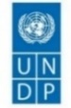 |  | 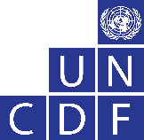

Management commentaries
on the
2022 Annual Report on Evaluation

Content |  |  | Pages
I. | UNDP management commentaries |  | 2-12
II. | UNCDF management commentaries |  | 13-14
III. | Annexes |  | 15-17

UNDP management commentaries on the
2022 Annual Report on Evaluation

- INTRODUCTION

- UNDP welcomes the 2022 Annual Report on Evaluation (ARE), submitted by the Independent Evaluation Office (IEO) to the Executive Board. Management commentaries reflect UNDP perspectives of critical elements related to evaluation issues and performance raised by ARE, actions taken by UNDP, and strategic priorities to strengthen the UNDP evaluation function in 2023.

- LESSONS LEARNED

- UNDP highly values findings reflected in the ARE 2022, synthesizing lessons from thematic and independent country program evaluations (ICPEs) and the Reflection Series produced by IEO. UNDP is pleased to note the evaluation’s positive findings in the areas of fostering entrepreneurship; enhanced energy access; supporting public infrastructure initiatives; rapid response to the pandemic; e-governance; integrating livelihoods and poverty eradication into environment portfolio interventions and promoting women’s and youth political and economic empowerment. This section illustrates how lessons from evaluations inform actions and shape policies and programs.

- Integrated Programming that Leaves No One Behind: Calls for stronger commitment to non-discrimination, equity, and equality and to pursue efforts that go beyond “projects” towards integrated portfolios. In this regard, UNDP is taking concrete steps through the rollout of the portfolio initiation framework in 40+ countries. In addition, operational linkages and synergies between the various service offers are ensured work by addressing inequality shifts those leaves no one behind and addressing intersectionality through project markers on leave no one behind, human rights, climate, and digitalization

- Improved metrics to address risk and vulnerabilities: UNDP is committed to working with national counterparts on improving data and analytics on inequality and overlapping vulnerabilities by assessing risks and vulnerabilities faced by populations, enabling the development of specific risk-informed solutions UNDP has significantly expanded its empirical and capacity development work on multidimensional poverty, vulnerability, and inequality metrics to develop MPIs at both national/subnational levels to identify and address the overlapping deprivations facing poor and vulnerable people, going beyond income poverty. However, UNDP notes that these lessons are not yet trickling through country program evaluations.

- Development financing for accelerating SDGs: Financing national sustainable development plans necessitates innovative mechanisms and partnerships. UNDP’s Integrated National Financing Framework facility” provides technical capacities for countries to prioritize policy priorities and options for financing instruments. With UNDP support, 86 countries are developing Integrated National Financing Frameworks. In addition, a strengthened offer on taxation offers the potential to ramp up domestic resource mobilization for the attainment of SDGs.
- Diversifying Partnership for Greater Development Impact: Stepped-up efforts to strengthen engagement with civil society actors will take a deliberate approach to empower them as advocates for change and promoters of accountability. Leveraging on its convening power, technical capacity, and partnership networks UNDP will promote meaningful participation of civil society actors by removing barriers for specific population groups, strengthening the capacity of civil society actors representing those furthest behind, and amplifying formal and informal partnerships with youth groups, volunteers, indigenous peoples, and NGOs for the achievement of the SDGs.

- Intersecting Crises calls for Recalibrating Development: Building on lessons learned from its early recovery resilience offering and based on renewed integrated development solutions, UNDP launched the “Crisis and fragility framework, to address policy and program coherence across its signature solutions to prevent and respond to protracted crises. This is accompanied by strengthened partnerships with UN entities and IFIs to design and finance portfolios that are conflict-sensitive, complement peacebuilding efforts, and focus on transformative results inclusive of youth, women, and marginalized populations.

- Strategic innovation accelerates transformation: Investing in new technologies and rethinking capabilities for business effectiveness and efficiency has brought greater agility, flexibility, and client satisfaction. Recognizing strategic innovation as an enabler, UNDP has invested in developing and mainstreaming innovation capabilities. UNDP’s network of “Accelerator labs”, reaching out to 115 countries is engaging grass-roots organizations and informal sector groups to collect new data and solutions and “do development” differently, build new skills, and bring new partners on board.

- Fostering Digital Inclusion: Expanding the use of digital technologies, to leverage digital innovations and services that benefit all while striving to bridge the digital divide. UNDP is advocating for countries to develop digital identity platforms, maintain registries, diversify digital payment systems, increase transparency, improve monitoring mechanisms, and employ digitalization and machine learning to develop predictive analytics. These efforts aim to enhance digital inclusion by enabling citizens to access and benefit from programs like access to justice, and social protection, as well as facilitate dialogue and collaboration between governments, civil society, and the private sector.

- Tackling Gender Disparities for Inclusive Development: Evaluations identified a growing demand for UNDP to help countries go further in shifting power relationships and cutting the deep roots of gender inequality. In response generation of new evidence and sophisticated analysis will aim to highlight intersections of gender concerns with other risks faced by the poorest, such as disability, racism, xenophobia, sexual orientation, etc. to inform development solutions that address multi-dimensional disparities e.g., women’s economic security and empowerment n the context of green transition and climate shocks.

- Lifting Result-based management for adaptive management and greater impact: Responding to the call of the Strategic Plan and thematic evaluations, UNDP is upgrading its RBM strategy to foster an integrated approach of strengthened metrics, agile, and adaptive ways of working, accountability, and learning to inform decision making for greater development impact.

- Evaluation learnings inform quality programming: To improve the quality, coverage, and use of evaluations, UNDP leadership will sustain and lift investments for dedicated and skilled evaluation oversight capacities and resources for strategic evaluations at all levels in the organization. The results of these investments are evident from the increase in the satisfactory quality ratings of Decentralized evaluations in 2022 which rose from 19 per cent in 2018 to 41 per cent in 2022 to feed into higher quality programs and projects.

- INDEPENDENT EVALUATIONS

THEMATIC EVALUATIONS

Implementation of thematic evaluations
- UNDP appreciates the IEO for presenting the three thematic evaluations to the executive board in 2022 namely (1) the evaluation of UNDP support to youth economic empowerment, (2) the evaluation of UNDP support to energy access and transition, and (3) the formative evaluation of the UNDP response to the pandemic and SDG financing. Through the executive board’s informal and formal sessions, UNDP presented its management responses to the first two evaluations at the first regular session in February 2022, and the final one in the Annual session in June 2022.

- UNDP was actively engaged in implementing and finalizing the three thematic evaluations conducted in 2022, to be presented in the executive board sessions in 2023. These include (1) the formative evaluation of the integration by UNDP of the principles of Leaving No One Behind; (2) the evaluation of UNDP’s Support for Social Protection; and (3) the Evaluation of UNDP’s Support to Access to Justice.

Implementation of management actions of thematic evaluations recommendations
- In November 2021, in line with the Executive Board decision, UNDP institutionalized quarterly monitoring of key performance indicators (KPIs) to strengthen oversight and offer timely support to planning and implementing decentralized evaluations.

- UNDP appreciates IEO’s leadership in the conduct of 12 thematic evaluations over a period of five years. Management Responses to the evaluation recommendations are tracked for a period of 5 years, after the completion of the evaluation. UNDP is pleased to inform the executive board that 97 per cent of management actions were implemented for thematic evaluations (71 per cent “completed”, 26 per cent “ongoing or initiated” with only per cent overdue). Figure 1 highlights that the implementation of management actions for the evaluations is on track with actions completed for evaluations conducted in 2018 and 2020. The use of thematic evaluations of management actions and the extent to which they informed management decisions are detailed in Annex I.

Figure 1: Implementation of management actions for thematic evaluations conducted in 2018-2022

INDEPENDENT COUNTRY PROGRAMME EVALUATIONS (ICPEs)

Coverage and Use of ICPE/ICPRs
- UNDP values credible evidence from independent country program evaluations (ICPEs) and independent country program reviews (ICPRs) to support the development of new country program documents (CPDs). This is evidenced by the uptake of ICPE recommendations in the design of new CPDs approved in 2022 enjoying satisfactory ratings against UNDP’s program quality index.

- The 2018 Executive Board decision (2018/1) noted the IEO decision “to achieve full evaluation coverage of all country programs prior to the Board’s consideration of new country program documents, as guided by decision 2015/8.”

- In response to the 2018 Executive Board decision, out of the 35 CPDs approved by the executive board in 2022, UNDP appreciates the 21 ICPEs and 4 ICPRs undertaken by IEO to support these CPDs. UNDP further acknowledges IEO’s technical and financial support to 4 country offices in the conduct of Decentralized Country Programme Evaluations (DCPEs) where the pandemic restricted the organizations’ ability to undertake ICPEs. Learning from this experience, UNDP recognizes that DCPEs in comparison to ICPEs are not able to offer an independent assessment of development results potentially impacting the quality of new CPDs developed as well as affecting the Country Programme performance rating undertaken by IEO. Therefore, UNDP requests IEO, in line with the executive board decision and IEO’s 2022 – 2025 multi-year work plan, to ensure the UNDP framework of support at the country level is anchored in an independent assessment of development results. Details on ICPE coverage are captured in Table 1.

Table 1: Coverage of ICPEs/ICPRs to new CPDs submitted to the Board 2018-2022
Year | CPDs approved by the Executive Board | CPDs with ICPE/ICPRs | Coverage (%) | CPDs approved without ICPE/ICPRs
2018 | 35 | 13 | 37%
2019 | 17 | 17 | 100%
2020 | 20 | 18 | 90% | South Africa, Congo (DRC)
2021 | 23 | 20 | 87% | Albania, Laos, Eritrea
2022 | 35 | 25 | 71% | Niger; Pakistan, Srilanka, Thailand; Libya, Jordan; Kyrgyzstan; Guyana, Suriname, Trinidad and Tobago
Note: In 2022, out of 10 CPDs without ICPE/ICPRs - IEO provided technical/ financial support to 4 country offices (Srilanka, Thailand, Kyrgyzstan, Suriname) for country program evaluations led by country offices.

Implementation of management actions of ICPE evaluation recommendations
- In 2018-2021, IEO conducted 81 ICPEs in five regions, for which UNDP committed to 1029 management actions. Compared to 2021 the implementation of ICPE management action increased from 92 per cent to 97 per cent (75 per cent completed, 23 per cent ongoing), and overdue management actions have fallen from 6 per cent to 2 per cent. Except for Africa, all the bureaux have implemented more than 95 percent of management actions with less than 1 percent overdue (Figure 2).

Figure 2: Implementation of management actions for ICPEs conducted in 2018-2021, disaggregated by region.

- DECENTRALIZED EVALUATIONS

- Investment in strengthening the evaluation function with particular attention to decentralized evaluation, has resulted in visible improvement across all evaluation Key Performance Indicators namely: evaluation planning, implementation, quality, capacities, follow-up, and uptake of recommendations to inform higher quality programming in UNDP. Figure 3 highlights the trend of key performance indicators.
Figure 3: The trend of Decentralized Evaluation Key Performance Indicators (2018-2022)
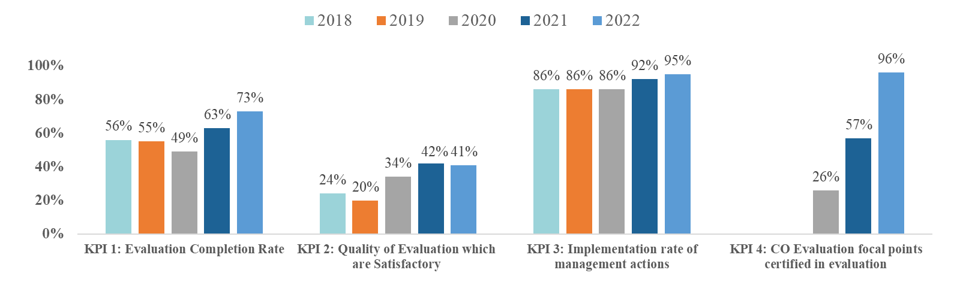

Implementation of decentralized evaluation plans
- As reflected in the 2022 ARE, UNDP completed 73 per cent of planned decentralized evaluations (396 against 545 planned) compared to 63 per cent in 2021. This improvement is attributable to the leadership commitment of Regional and Central Bureaus in undertaking systematic reviews, scoping exercises, and evaluability assessments to inform and adjust evaluation plans. As a result, compared to 2021, forty-four more evaluations were conducted across all regions in 2022. RBAS completed 98 percent of planned evaluations, RBEC, RBAP, and Global units completed around 75 per cent whereas the largest gaps were recorded in the RBA and RBLAC covering 65 per cent of evaluations planned.
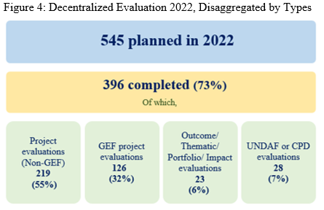
- UNDP remains committed to conducting a range of evaluations like impact, thematic, programme, outcomes, portfolio, and project evaluations in the new strategic plan cycle. This approach ensures comprehensive evaluation coverage at all levels of the program (outcome and outputs) to strengthen learning and inform higher-quality programming. Compared to 2021, outcomes, thematic, portfolio, and impact evaluations increased from 9 per cent to 13 per cent. These are the result of several corporate measures including timely guidance to regional bureaux on prioritizing a good mix of evaluations during programme formulation, as well as reinforcement of the robust performance indicators on their completion.

- As mentioned in the 2022 ARE, the uncertainties posed by the COVID-19 pandemic, volatile situations in protracted crisis countries, and shifting political dynamics within the region delayed the timely implementation of evaluations. These challenges were coupled with operational bottlenecks associated with procurement as well as the protracted process of partner consultations in the finalization of Terms of Reference relating to thematic and joint evaluations. Implementing end-of-project evaluations encountered delays in the start and completion. Additional challenges included the timely availability of quality evaluators, especially in crisis contexts.

Quality of decentralized evaluations

- UNDP appreciates IEO’s support in rating the quality of decentralized evaluations. Of the 307 evaluations assessed in 2022 for quality, 41 per cent were rated as satisfactory; 48 per cent as moderately satisfactory, and 11 per cent were moderately unsatisfactory or unsatisfactory. In terms of regional distribution RBAS had 60 percent of evaluation reports rated “satisfactory” meeting the corporate quality target of 50 percent. Comparing 2021, RBAP increased its satisfactory rating from 43 to 47 per cent however satisfactory rating declined for RBA, RBEC, RBLAC, and Global projects evaluations.

Actions were taken to improve decentralized evaluation quality.
- UNDP has worked closely with IEO to lift the quality of evaluations, reduce the number of evaluations rated as ‘unsatisfactory’, and increase more ‘fully satisfactory’ ratings. A five-year analysis of the quality ratings of decentralized evaluations shows a positive trend, with 41 per cent of evaluations rated as satisfactory in 2022 compared to 24 per cent in 2018 and whereas the decentralized evaluations rated as unsatisfactory decreased to one percent in 2022 from 5 percent in 2018. (Figure 5). In addition, in 2022, 96 per cent of evaluation focal points (191) secured advanced evaluation certification compared to 57 per cent (121) in 2021. These improvements are a result of targeted support at the central, regional, and country levels for improving the quality of evaluation including:
- Systematic review of issues affecting evaluation quality including measures to address cross-cutting themes such as gender, human rights, disabilities, and vulnerable groups. In 2022 UNDP leveraged quarterly reviews of quality assessment ratings, to address gaps for lifting evaluation quality.
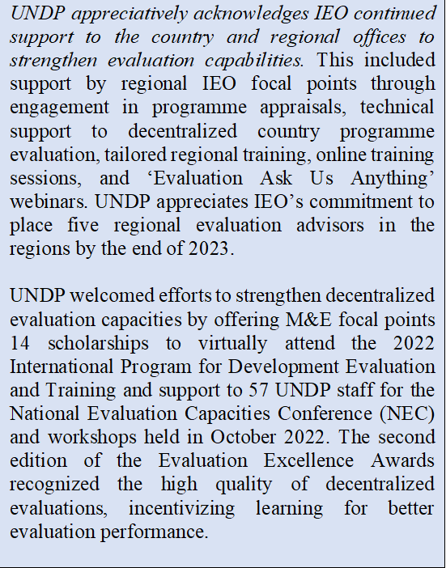
- Dedicated full-time capacity/staff the evaluation function at regional and country levels with particular attention to complex and large programs.
- Provision of guidance and roll out of capacity-building plans for evaluation focal points.
- Roll out of peer learning platforms and staff exchange initiatives to foster scaling of good practices.
- Corporate drive to ensure completion of evaluation certification and socialization of guidelines.
- Institutionalization of quality assurance mechanisms at the regional level, including the development of standard operating procedures, implementation trackers, or simplified checklists, to oversee and support at structured intervals evaluation quality.
- Effective evaluation planning and budgeting adequate time for quality assurance.
- Upgraded evaluation roster with quality-assured evaluators enabled access to relevant expertise.

Figure 5: Decentralized evaluation quality, 2018-2022

Note: Number of evaluations completed in year 2018= 283; 2019 =290; 2020 = 249, 2021 =352 and 2022 = 396

Implementation of Management Actions of Decentralized Evaluation Recommendations
- UNDP strengthened its system for the uptake of decentralized evaluation by institutionalizing mechanisms, for the timely implementation of management actions. In 2018-2022, UNDP completed 1752 decentralized evaluations in five regions. The implementation rate of management actions for decentralized evaluations conducted rose to 95 per cent compared to 91 per cent in 2021 (Figure 6). A disaggregated regional snapshot of management actions completed is captured in Figure 7. UNDP acknowledges IEO’s advice to further lift the quality of management responses.

Figure 7: Implementation of management actions for decentralized evaluations conducted in 2018-2022, disaggregated by region.

V. ACTIONS TAKEN IN 2022 TO STRENGTHEN DECENTRALIZED EVALUATIONS
- "Roadmap for strengthening decentralized evaluations in UNDP” was developed jointly by UNDP and IEO in response to the Executive Board decision (UNDP/2022/3). Key actions from BPPS on the implementation of the DE roadmap in 2022 are listed below.

Pillar 1. Evaluation Implementation, Independence, and Quality
- Strategies at the Central and Regional Bureau level for strengthening decentralized evaluations: The strategies contain commitments to strengthen management accountability and strategic actions to improve the coverage, quality, and use of decentralized evaluations in decision-making.

- Strengthening programming tools related to evaluation: In line with UNDP evaluation guidelines, BPPS in coordination with IEO reviewed and updated the Programme and Project Management (PPM) - Programme and Operations Policies and Procedures (POPP) guidance documents related to evaluation.

- Enhanced support for the development of country program evaluation plans: BPPS extended strategic advisory inputs to 37 country offices in the development of evaluation plans focusing on (a) inclusion of conducting a range of evaluations like impact, thematic, programme, outcomes, portfolio, and project evaluations; (b) balanced evaluation coverage across all country program outcomes; and (c) realistic timing, resourcing, and sequencing of evaluations.

- Expansion of the Express Roster for quality evaluators: BPPS partnered with IEO to quality assure evaluators in the roster to ensure high-quality expertise across all signature solutions, ensuring geographic coverage and language requirements. This effort has resulted in an increased uptake of evaluators sourced from the roster (1 in 3 decentralized evaluations conducted sourced expertise from the roster). In addition, the roster is powered by artificial intelligence functionality for ease of access.
Pillar 2. Management Accountability and use
- Evaluation scorecard and key performance indicators: The rollout of the Evaluation Scorecard complements the data available in IEO’s Evaluation Resource Center, offering management real-time data on evaluation performance to facilitate timely action to lift UNDP’s performance on evaluation KPIs. Detail of the performance metrics and progress against KPIs in 2022, is presented in Annex 2 and 3.

- Quarterly monitoring and senior management review of decentralized evaluation performance: UNDP has institutionalized regular monitoring by senior management of KPIs. In 2022, four quarterly reviews were conducted to monitor and analyze performance for timely action.

- New Tier 3 indicators on evaluation performance for the IRRF of the Strategic Plan: Five evaluation indicators were included in UNDP strategic plan 2022-2025 with associated methodological notes. BPPS monitored and tracked the progress to ensure the timely completion of milestones. The progress of each IRRF evaluation indicator is presented in Figure 8.

- Updated Annual Reporting on Evaluation Actions and Expenditure: In 2022 UNDP annual system for reporting on results was updated to align with the new Strategic Plan. This included the revision of the methodology to accurately capture organizational investments in the evaluation function in line with the UNDP evaluation guideline and approved an organizational roadmap for strengthening quality, coverage, and use of decentralized evaluations.

Figure 8: UNDP Evaluation Indicators for UNDP Strategic Plan, 2022-2025
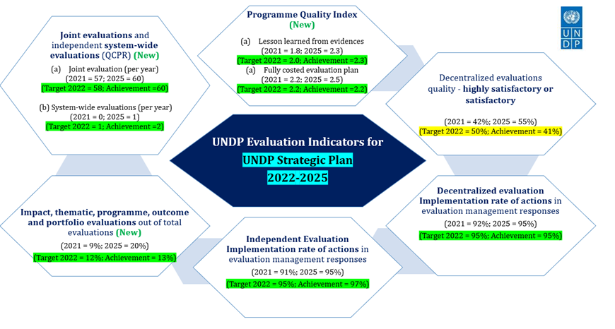
- INVESTMENT IN EVALUATION

- In 2022, UNDP’s expenditure on evaluation totaled $36.9 million – a 33 per cent increase compared to $27.8 million in 2021. The evaluation spending in 2022 will be approximately 0.8 per cent of UNDP’s total program expenditure, inching the organization closer to its evaluation policy target of 1 per cent. For details see Table 2 on UNDP evaluation expenditure.

Table 2: UNDP evaluation expenditure, 2018-2022
UNDP overall Evaluation expenditure |  |  | 2018-2022
 |  |  | 2018 | 2019 | 2020 | 2021 | 2022
UNDP expenditure | UNDP Country Office expenditure on evaluation | Evaluation implementation costs | $6.6 | $7.0 | $6.0 | $9.04 | $10.8
 |  | Staff costs | $3.9 | $4.8 | $5.4 | $5.2 | $8.8
 |  | Additional evaluation-related costs | $1.0 | $1.5 | $0.9 | $0.1 | $3.6
 |  | Country office expenditure | $11.5 | $13.2 | $12.3 | $14.3 | $23.2
 | Expenditure at Headquarters and by regional bureaux | Evaluation costs | $0.3 | $0.25 | $0.4 | $0.8 | $0.7
 |  | Staff costs | $1.4 | $1.3 | $1.8 | $1.3 | $1.2
 |  | Additional evaluation-related costs | $0.1 | $0.05 | $0 | $0.02 | $0.02
 |  | Regional expenditure | $1.8 | $1.6 | $2.2 | $2.1 | $1.9
 | TOTAL |  | $13.3 | $14.8 | $14.5 | $16.4 | $25.1
IEO expenditure | Evaluations and other institutional activities TOTAL |  | $ 8.7 | $10.9 | $11.2 | $11.4 | $11.8
GRAND TOTAL |  |  | $22.08 | $25.7 | $25.8 | $27.8 | $36.9
% Resources spent for evaluations |  |  | 0.48 | 0.58 | 0.57 | 0.58 | 0.77
UNDP program expenditure |  |  | $4,603 | $4,411 | $4,507 | $4,802 | $4810

- CO expenditure increased from $14.3 million to $23.2 million ($8.9 million) on two accounts – (1) more evaluations were conducted in 2022 (10 per cent increase); (2) the revision of the methodology to accurately capture organizational investments in the evaluation function (including staff time, additional evaluation costs) in line with the UNDP evaluation guideline and the approved organizational roadmap for strengthening quality, coverage, and use of decentralized evaluations.

- UNDP will continue to make improvements to the system in partnership with IEO, especially in strengthening ROAR guidance notes on what can and cannot be reported as evaluation spending accompanied by a robust quality assurance from the regional bureaus.

- STRATEGIC PRIORITIES FOR 2023

- UNDP looks forward to deepening its engagement with IEO in implementing planned actions articulated in the decentralized evaluation roadmap to reinforce management accountability and responsibilities for improved evaluation planning, implementation, quality, and decision-making. Strategic actions prioritized in 2023 are as follows:
- Conducting a range of evaluations like impact, thematic, programme, outcomes, portfolio, project, and joint evaluations.
- Operationalizing evaluation guidelines on portfolio evaluations.
- Updating UNDP RBM strategy on results and impact measurement.
- Effective planning and promoting systematic review of the quality of annual evaluation plans.
- Improving the evaluation quality through targeted actions to address bottlenecks at the country level.
- Strengthening evaluation capacity by rolling out regional bureaux capacity-building plans.
- Socializing evaluators with UNDP evaluation guidelines and standards.
- Reinforcing institutional mechanisms for the systematic review of performance at the central, regional, and country office levels by strengthening data analytics for timely management action.
- Prioritizing programmatic and management/operational actions leveraging findings from evaluation synthesis and IEO’s Artificial Intelligence for Development Analytics to inform management decision-making, communication, and advocacy.

UNCDF management commentaries on the
2022 Annual Report on Evaluation

UNCDF welcomes the 2022 Annual Report on Evaluation, submitted by the Independent Evaluation Office (IEO) to the Executive Board. The report provides a summary of key findings from independent evaluations for organizational lessons to help UNCDF improve program quality. UNCDF Management commentaries reflect UNCDF perspectives of critical elements related to evaluation tasks, independent evaluations, actions taken by UNCDF in 2022, and those that will be elaborated by the UNCDF evaluation function during the 2022-2025 Strategic Framework period.

In line with UNCDF’s commitments under the Strategic Framework 2022-2025, UNCDF Management reiterates its intention to continue to ensure an appropriately – resourced evaluation function (UNDP Evaluation Policy (point 27), UNCDF will aim to continue to allocate at least 1 per cent of its combined programmatic (core and non-core) resources to the evaluation function on an annual basis) that can support the independent evaluation of selected key programs and projects at the mid-term and final points of their implementation. UNCDF also commits to increasingly purpose thematic and portfolio evaluations to capture UNCDF’s performance at the organizational level overall and across key themes and priority areas of UNCDF’s work – including with its key partners.

- LESSONS
UNCDF highly values findings reflected in the report, synthesizing key lessons from Evaluations conducted by UNCDF. UNCDF is pleased to note the evaluation findings in the areas of promoting government transparency and accountability; including climate adaptation in local planning, budgeting, and investments; its contribution to strengthening institutional capacity to formulate and implement regulatory frameworks; its contribution to improving the ‘voice’ of women and overall positive impact on the lives of beneficiaries. Key lessons from various evaluations informing actions of the UNCDF programming approach are: strengthening gender and human rights mainstreaming, strengthening mainstreaming within government systems, and strengthening coordination with partners.

- IMPLEMENTATION OF EVALUATION PLAN
UNCDF Management acknowledges the delays in the implementation of the UNCDF Evaluations against the annual evaluation plan in 2022. The UNCDF Evaluation Plan included 3 Evaluations for 2022. Only one of the evaluations planned for 2022 could effectively be started in 2022. This was due to the accumulation of delays in the 2018 – 2021 Evaluation Plan because of the COVID pandemic, resulting specifically in the need to postpone evaluations planned for 2021 to 2022. In addition, these delays were compounded by a progressive downsizing of the Evaluation Unit from three professionals to one because of the requirements of the rotation policy for the Head of the Unit and the end of an externally funded contract for another Evaluation Officer.

To address the delays, UNCDF Management has taken corrective measures for 2023. These include the careful review and approval of a realistic but still ambitious evaluation plan, the allocation of administrative support staff to the Evaluation Unit, as well as a strategic refocus of the evaluation unit’s work plan towards prioritizing the implementation of the evaluation plan while maintaining the quality and utility of its evaluations. In addition, going forward in 2023, UNCDF Management will be considering increasing efficiencies by streamlining evaluation support through its Practices Monitoring Officers.

- IMPLEMENTATION OF MANAGEMENT ACTIONS
Over the last 5 years, UNCDF conducted 12 evaluations, tabling a total of 105 Recommendations with 250 Management Actions. 91 per cent of management actions were implemented (70 per cent completed, 21 per cent initiated, 8 per cent not initiated, and 0 per cent overdue)[1]. UNCDF Management Recognizes the importance of the Management Response for effective organizational learning and will continue to focus on maintaining its commitment to the timely implementation of management response key actions.

- STATUS OF EVALUATION QUALITY RATINGS
Of the 3 Evaluations’ quality assessed in 2022, all were rated satisfactory (scoring 5 out of 6). This remains consistent with the Quality Rating received over the last 5 years with a total of 14 Evaluations rated satisfactory or above. In addition, 3 IEO Excellence Awards were received by UNCDF acknowledging the quality of its report in 2021 and 2022.

UNCDF Management is appreciative of this recognition and is committed to maintaining the same quality for all evaluations going forward while recognizing the challenges the UNCDF Evaluation Unit currently faces and the tension that exists between the acceleration of the delivery of evaluations against the evaluation plan and maintaining the quality of each evaluation necessitating a high degree of involvement by the Evaluation Unit. Going forward, the UNCDF Evaluation Unit will continue to be highly involved in each evaluation and will continue to rely on the Evaluation Long Term Agreement (LTA) in which it has invested by building the capacity and expertise of its consultants.

- ERC FOCAL POINT WITH EVALUATION CERTIFICATIONS
UNCDF notes the request by the UNDP Management Response, to complete the certification of ERC focal points by 2023 (KPI4). UNCDF Management would like to clarify that UNCDF Evaluation Unit has currently one full-time Evaluation Staff who is duly certified. The Evaluation Unit has currently the part-time assistance of an Associate Staff that has been given access to the Evaluation Resource Center to support the administration of the platform. As per KPI 4, this is flagged as a UNCDF ERC Focal Point not having completed the certification. It is the objective of UNCDF Management in 2023 to build the evaluation capacity of the Associate position and have the staff duly certified by the end of 2023.

- GOING FORWARD
UNCDF Management will receive quarterly updates during Management Meetings on the progress made by the Evaluation Unit in achieving its KPIs. These will be in addition to the regular briefings by the Evaluation Unit to the Executive Secretary to whom it reports.
ANNEX– I

THEMATIC EVALUATIONS (2021-2022)
STATUS OF MANAGEMENT ACTIONS AND USE

Management commentary addendum focuses on nine evaluations conducted in the last two years that reflect on the lessons learned from the evaluation and implementation of management actions that positively affected UNDP programmatic and operational decision-making functions.

Evaluation of UNDP support for Climate change adaptation
Completed in 2021

The evaluation of UNDP support for Climate Change Adaptation (CCA) took stock of UNDP achievements and performance in helping partner countries adapt to new climate conditions created by global warming. The evaluation looked across the UNDP climate change adaptation offer but gives special attention to support for countries especially vulnerable to climate shocks. As of 31 January 2023, all 16 key management actions were completed (a total of 8 recommendations). A detail of the management response actions implementation is available in the attached link. Management actions - CCA evaluation

Evaluation of UNDP Support to Conflict-affected Countries
Completed in 2021

The evaluation of support to conflict-affected countries assessed the UNDP role and contributions in 34 conflict-affected countries in the key areas of crisis prevention, response, peacebuilding, and state-building for transitions to medium- to long-term development. As of 31 January 2023, 19 out of 25 key management actions were completed (10 recommendations). Management actions – Conflict evaluation

Evaluation of UNDP support to the Syrian refugee crisis response and promoting an integrated resilience approach
Completed in 2021

The evaluation of UNDP support for the Syrian crisis response, and promotion of an integrated resilience approach, assessed the extent to which the humanitarian-development nexus and resilience-based development approaches have underpinned the Syrian refugee response framework, as well as other UNDP refugee responses and corporate frameworks. The evaluation confirmed the 3RP model is the first of its kind in combining humanitarian support and resilience-based development to address the needs of refugees, host communities, and national governments. As of 31 January 2023, 16 out of 20 management actions are completed related to 6 recommendations. Management actions - Syria refugee crisis evaluation

Evaluation of the UNDP Strategic Plan, 2018-2021
Completed in 2021

The Evaluation of the UNDP Strategic Plan, 2018-2021, assessed whether the Strategic Plan ​offered a coherent vision, purpose, and sense of mission for the organization​. It was recognized across the organization as a guide for action to help countries meet their development needs and contributed to improved development results within the three broad development settings identified in the Strategic Plan​. Addressing 7 recommendations, a total of 18 management actions were planned out of which 10 actions were completed by end of 2022. Management actions - UNDP Strategic Plan evaluation

Evaluation of the GEF Small Grants Programme
Completed in 2021

The Small Grants Programme (SGP), a flagship corporate program of the Global Environment Facility (GEF) implemented by UNDP, was evaluated jointly by the GEF Independent Evaluation Office and UNDP Independent Evaluation Office. The purpose of the joint evaluation was to provide the UNDP Executive Board and GEF Council with evaluative evidence of SGP relevance, effectiveness, efficiency, and sustainability while examining whether any changes are required to improve efficacy. With 9 recommendations, 9 out of 14 management actions are completed by 2022. Management actions - GEF small grants evaluation.

Evaluation of UNDP Support for youth economic empowerment
Completed in 2022

In 2022, Independent Evaluation Office completed the evaluation of UNDP support for youth economic empowerment covering the period from 2015 to mid-2021. The primary focus of the evaluation is the UNDP’s contribution to decent work and livelihood creation for youth in program countries. The objective was to assess the results of past UNDP work against its goals as stated in strategic and programmatic documents, shape organizational learning, and inform the strategic direction of UNDP youth economic empowerment work in the Strategic Plan, 2022-2025. UNDP welcomes the evaluation’s findings and fully accepts all seven (7) recommendations and welcomes the evaluation as useful to further enhance its work and impact. As of 2022, out of 15 management actions committed, 2 are completed, 10 are ongoing and 3 aren’t initiated. Management actions - Youth evaluation

UNDP support to energy access and transition
Completed in 2022

The UNDP IEO conducted the first comprehensive analysis of the contribution of UNDP to access to energy and the transition to renewable forms of energy in 2021. The evaluation aims to provide UNDP management and program stakeholders with an independent assessment of the effectiveness of UNDP work on energy access and transition; the relevance of UNDP work in this area; and the opportunities to support the strategic positioning and performance of UNDP work on energy as one of the six signature solutions in the Strategic Plan. UNDP welcomes the evaluation’s findings and accepts all 7 recommendations with a commitment to implement 25 management actions. As of 2022, a total of 2 actions are completed with 23 actions ongoing. Management actions - Energy evaluation

Financing the Recovery: A Formative Evaluation of UNDP’S Response to the COVID-19 Pandemic and SDG Financing
Completed in 2022

The Independent Evaluation Office of UNDP conducted a formative evaluation of UNDP’s response to the pandemic and SDG financing encompassing the period from March 2020 to June 2021. The evaluation explored the level to which UNDP has been able to support and will continue to support governments to deliver the SDGs, given existing financial and fiscal constraints and needs. UNDP welcomes this first formative evaluation of UNDP’s work on SDG financing and excepts all 7 evaluation recommendations. Management actions - COVID financing evaluation

Formative Evaluation of the Integration by UNDP of the Principles of Leaving No One Behind
Completed in 2022

In 2022, the IEO shared the formative evaluation of the integration by UNDP of the principles of “leaving no one behind”, covering the period 2018 to mid-2022. The evaluation assessed the UNDP corporate approach to these principles and traced the effectiveness of the UNDP contributions to inclusive change, guided by principles of equality, non-discrimination, and equity. It also looked at UNDP’s institutional capacity and data systems. UNDP uploaded a management response in February 2023. Management response - LNOB evaluation
Annex II: Performance thresholds - Reference for the scoring KPIs
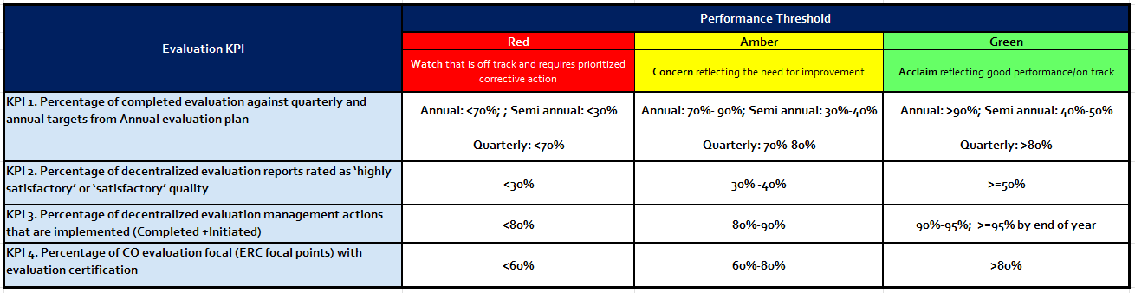
ANNEX III: Evaluation Key Performance Indicators 2022 (As of 31 January 2023)

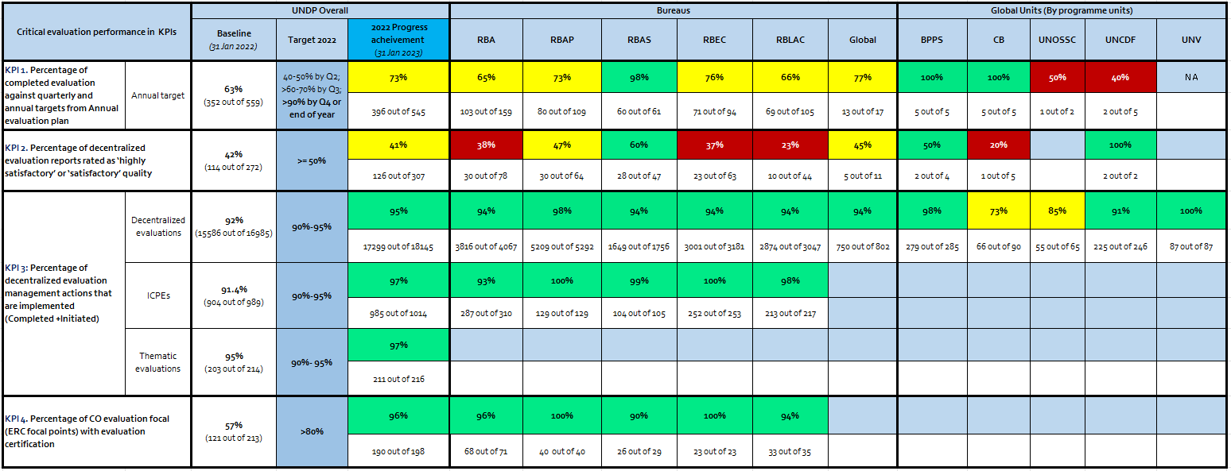

RBA: Regional Bureau for Africa; RBAP: Regional bureau for Asia and the Pacific; RBAS: Regional bureau for Arab States; RBEC: Regional bureau for Europe and the CIS; RBLAC: Regional Bureau for Latin America and the Caribbean
In 2022, 78 per cent of the completed evaluations are quality assured (307 out of 396) which is so far the highest number of quality assured in the last five years. On average 240 decentralized evaluation reports are quality assured by IEO in the last five years (2017-2021).
Updated PPM chapters (11) related to evaluation functions and procedures: Quality Standard for Programming; Formulate Programmes and Projects; Multi-country and South-South Cooperation Projects; Performance-Based Payments; Appraise and approve; Annual Planning; Deliver Results; Monitor; Manage Change; Report; Close and Transition
Updated methodology included staff time of all ERC focal points (previously it included only selected M&E focal points)
Additional evaluation-related costs are captured categorically from each country office and HQ/RBx. It includes stakeholder validation workshops, assessments/surveys, evaluation training/capacity building events, communication, and other contingency costs.
UNCDF initially planned for 6 evaluations at the beginning of the year 2022.
[1] 250 Actions; 172 Completed; 53 Initiated; 21 Not Initiated

