UNDP in Uzbekistan
Guidelines on Gender-Sensitive Communication

Introduction
Who is this document designed for?
• Colleagues working in communications and knowledge management;
• Gender Focal Points and members of Gender Focal Team;
• Colleagues speaking on behalf of UNDP.

This guide aims to:
• Help readers identity sexist language; and
• Provide guidance for inclusive language for written communications as well as visual and audio materials.
What is in this document?
1. The rationale of gender-sensitive communications
2. Seven Principles for written and oral communications
1. Ensure that women and men are represented
2. Challenge gender stereotypes
3. Avoid exclusionary forms
4. Use equal forms of address
5. Create a gender balance
6. Promote gender equity through titles
7. Avoid using 'female' and 'male'

3. Principles for audio & visual materials
4. Intersectional approach

1. The rationale of gender-sensitive communications
Language plays a critical role in how we interpret the world, including how we think and behave. In the UNDP context, the specific language in which official messages, press releases, social media content, publications, and statements from senior management use provide a crucial model for both, staff and our partners. Word choices often reflect unconscious assumptions about values, gender roles and the abilities of women and men. Gendered language is still commonplace in both the workplace and everyday life. For example, when speaking about a Resident Representative; many colleagues automatically use the male form ‘he’, not knowing if the person is a woman or a man.
It is important to remember that imprecise word choices can be interpreted as discriminatory, demeaning or biased, regardless of how they are intended. Such language hinders efforts to increase women’s empowerment and is not in accordance with UNDP’s goals.
The UNDP Gender Equality Strategy for 2018-2022 underlines UNDP’s commitment to advancing gender equality and women’s empowerment. “UNDP is committed to making gender equality, a basic human right and a necessity for a sustainable world, a reality. Women's empowerment and gender equality are vital to achieving the 2030 Agenda for Sustainable Development, which envisions a world “of universal respect for human rights and human dignity” in which “every woman and girl enjoys full gender equality and all legal, social and economic barriers to their empowerment have been removed.” Therefore, all UNDP communications must portray women and girls, men and boys equitably and fairly. By doing this, UNDP aims to transform attitudes and behaviors related to gender inequality and the exclusion of women. As UNDP personnel and development professionals, it is paramount to examine our messages to reduce or eliminate word choices that silence, stereotype, or constrain others.
While some language expressions are intended to cause offense, others do not convey the original meaning or are open to misinterpretation. This document is intended to be used as a guide and will not account for all situations where gender-sensitive communication is needed.
2. Seven principles of gender-sensitive communications
1. Ensure that women and men are represented
As UNDP’s partners are women and men, both should be seen, heard, and treated equally in corporate media products and messages. It is important to ensure that quotes from both men and women are included in press releases, stories and other communications.
Additionally, presenting female voices in traditionally male roles and vice versa contributes to deconstructing stereotypes and gender norms. Such messages, including visuals and written messages can have a positive impact on people’s attitudes over time. When preparing press releases, stories and other materials it is important to plan ahead and clarify how women’s and men’s voices can be captured.

2. Challenge gender stereotypes
Our use of language often reinforces gender stereotypes and assumptions about women and men are often formed through such gender stereotypes. It is important to avoid using these, as gender stereotypes limit and trivialize both women and men, presenting inaccurate images.
In UNDP’s context, it is important to not represent certain vocations or roles as only appropriate for, or held by, by women and men. For example, doctors are men and nurses are women.
It is also critical to not imply, for example, that women and girls are timid in comparison to men and boys, or that females are passive, and males are active. Similarly, one should avoid using phrases that stereotype women’s or men’s behavior or thought processes. For example, gender stereotypes are deployed when describing men as aggressive or violent, and when describing women as emotional, shrill, or passive.
Gender biased | Gender sensitive
The training focuses of building the capacity of businessmen in cross border trade. | The training focuses of building the capacity of entrepreneurs in cross border trade.
The men attending the Ministerial level Working Group meeting all agreed that trade is important. | The attendees of the Ministerial level Working Group meeting all agreed that trade is important.
The microfinance program makes a real difference in the lives of the clients and their wives and children. | The microfinance program makes a real difference in the lives of the clients and their families.

3. Avoid exclusionary forms
Exclusionary forms of language indicate the use of “he”/ “his” when referring to both a female and male, which excludes females. One can use “he” and “she” to be inclusive or use the plural ‘they’ to avoid using any gendered pronouns.
When using gendered pronouns, it is important not to confuse your audience by using she in one paragraph and he in the next. In these situations, it is good practice to stick to one pronoun, or use a plural, or eliminate the use of pronouns altogether by rewording the sentence. In addition, when used sparingly, using he or she in a sentence can be a good way to include both sexes.
Gender biased | Gender sensitive
Each state representative will have more confidence if he has a voice in the decision. | State representatives will have more confidence if they have a voice in the decision.
Migrant should aware of his rights. | Migrants should be aware of their rights.
Mothers should take of their children health. | Families

4. Create a gender balance
In written and oral communications, it is important to be mindful of the gender implications of generic terms. Generics are nouns and pronouns intended to be used for both women and men. For example, the terms ‘fatherland’ or ‘mankind’ describe concepts that encompass men and women but both terms are evidently male dominated. Male-specific generics tend to call up primarily male images for readers and listeners. It is best to avoid such generics, to create a more gender-inclusive language.
Similarly, word order can often give the assumption that one sex is superior to the other, or that the latter sex is an afterthought. For example, using the phrases men and women, or ladies and gentlemen, may give this impression. Instead, it is better to address groups of people with generic terms. For example, addressing a group as colleagues or members of the delegation avoids using any gender bias.

Gender biased | Gender sensitive
This project aims at building the entrepreneurial capacities of men and women in the district. Outputs will include business trainings for salesmen and owners of small enterprises. | This project aims at building the entrepreneurial capacities of women and men in the district. Outputs will include business trainings for salespeople and owners of small enterprises.
Man-made hazards | Human-made hazards
Forefather | Ancestor
Fireman | Firefighter
Repairman | Repairer
Tradesman | Skilled worker
Waiter, waitress | Server
Weatherman | Meteorologist, weather forecaster
Russian version examples
материнский язык | национальный язык

6. Promote gender equity through titles, labels, and names
Titles for people and occupations often reflect inequitable assumptions about males and females; gender-sensitive language promotes more inclusive and equitable representations for both females and males.
Referring to a woman as a ‘career woman’ instead of a ‘professional’, or to a server as a waitress can exacerbate inequality, as women are not perceived as equal to men.
Additionally, feminine suffixes such as –ess or –ette can also reinforce the notion that women are subordinate or doing a different job to men. For example, instead of using actress or stewardess, for women professionals, it is better to use the generic term (actor or flight attendant) to avoid promoting gender inequality.
Gender sensitive language should be used to ensure women’s visibility in professions.
Avoiding sex- and gender-based discrimination starts with language, as the systematic use of gender-biased terminology influences attitudes and expectations and could, in the mind of the reader or listener, relegate women to the background or help perpetuate a stereotyped view of women's and men's roles.
It is important to ensure that voices of women are heard, and they are positioned as experts or authorities and empowered. Thus, using gender-sensitive language underlining women’s voices and positions are important to demonstrate UNDP as leader in the global conversation on gender.
Gender biased | Gender-neutral | Gender-sensitive
Бизнесмены | Предприниматели | Предпринимательницы /предпринимательница
Швея, портной | Работники швейного дела | Швея, портниха
Сварщик, электрик | Мастера газосварочных работ | Сварщица
Руководитель | Руководители | Руководительница

7. Avoid using 'female' and 'male'

‘Male’ and ‘female’ define biological distinctions used in the fields of medicine and biology.

‘Woman’ and ‘man’ define human beings and are the correct way to indicate personhood.

Using ‘female’ and ‘male’ to describe men and women reduces them to their reproductive abilities and enforces the differences between men and women as grounded in biology, instead of socially constructed roles.

3. Principles for audio & visual materials
Pictures, graphics, video and audio materials are powerful communication tools to influence perceptions, attitudes and eventually social changes. The principles for gender-inclusive written and oral communications above also apply to audio and visual materials i.e. videos, photographs, and info-graphics.
As UNDP uses many of these communications products on a regular basis, it is important to apply principles of gender-sensitive communications for these products as well, and to avoid any stereotypical portrayal of men and women in terms of social beliefs, norms of expected behaviour, sexual division of labour, access and control to resources decision making and power differentials.
- Ensure women and men are represented equally
When preparing written, audio and visual materials including voice-overs, please remember to include women as interviewers, interviewees and speakers at events as well as combining female and male voices in voice-overs. This should be done regardless of the development topic and it should be ensured that the style of expression and the messages convey equal status and authority when altering between male and female voices.
While it may not be possible to have an equal number of women and men in every photograph, illustration, cartoon or video segment, it is important that in the total presentation in these media, the presence of women in the society be demonstrated as balanced, not as exceptional or sporadic. Generally, women should be portrayed as equal and active participants in all aspects of life: in the workplace, in manual labor positions and in white-collar professions; at home; at educational institutions; in politics and in civil society; in public life and in the community.
2. Challenge gender-stereotypes with images
In the same way as written materials, the depiction of women and men should attempt to break with notions of gender roles that perpetuate gender inequalities. Women and men should be portrayed as equals, rather than having roles and characteristics traditionally assigned on the basis of dominant gender norms. Women should be depicted as being able to leverage opportunities or as having equal opportunities; being in positions of power and in professions that are not usually linked to women such as professors, doctors or head of states.
In addition to choosing images that show women in non-traditional and non-stereotypical roles and professions and to ensure equal numbers of women and men in our image selection, it is important to be mindful of subliminal messages about gender norms. For example, it is recommended to choose images in which postures, expressions, gestures and clothing convey equal status and authority.
Stereotypical images of women and men
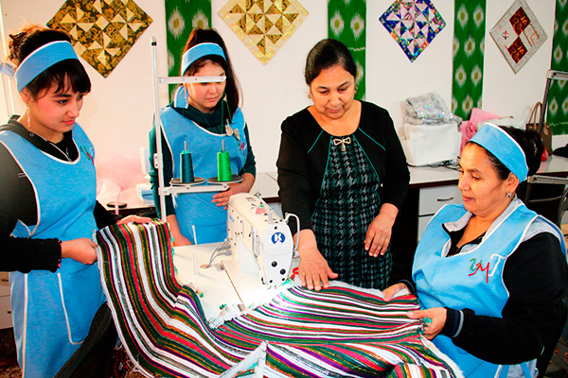

Men are at the construction, women are in traditional business

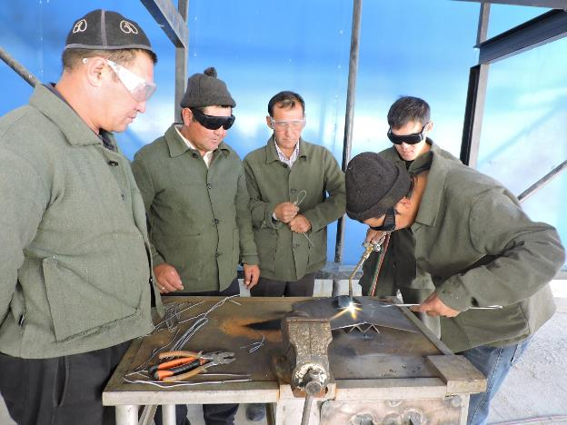
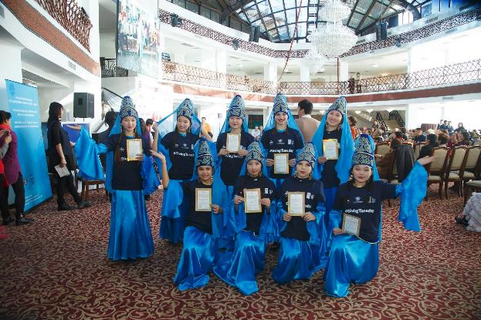
Women are performance givers Men are at traditional “masculine” exercise

Women are in the kitchen, a traditional gender positioning
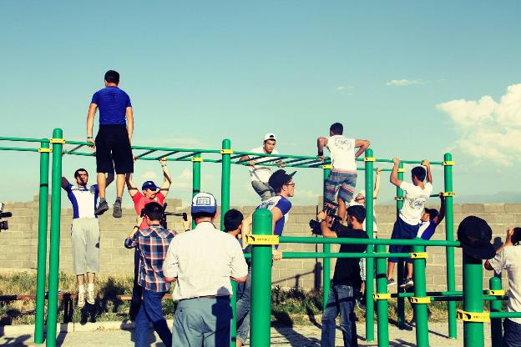
Men are at the sport yard, making the perception that the space belongs to men only
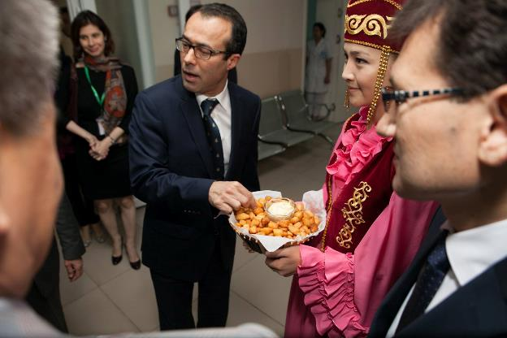
Men (at the decision making) are receiving treat from women (making space “beautiful”)

Non-stereotypical images of women and men
Women are seen as horse riders 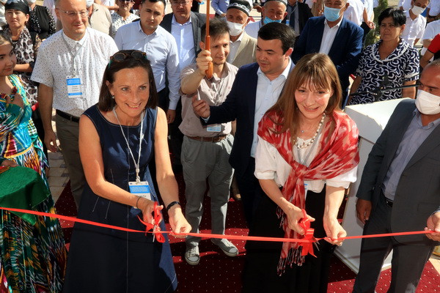
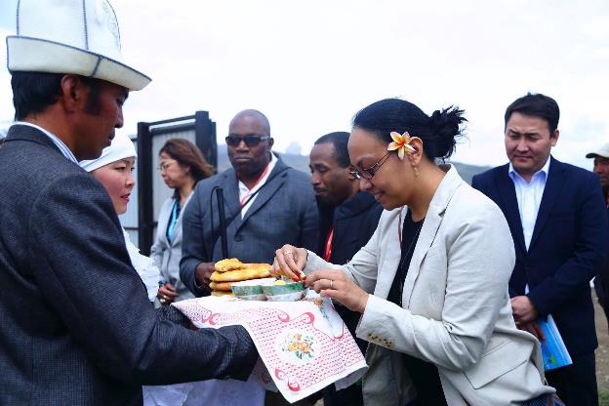
Women are a lead at the opening ceremony

Women are welcomed by men

4. Intersectional approach

Women and men are not homogeneous groups, they differ by their abilities, class, locality and many other factors.

Avoid the particular ways in which women, rural women and people with disabilities are usually portrayed:
as victims of sexual and domestic violence
as mothers who sacrifice for their children
as unable to escape poverty
as being vulnerable and powerless
as passive beneficiaries
Even if they are struggling, give them credit for the ways in which they have dealt with the issues they face and highlight how you are building on their efforts.

Common mistake: Don’t erase people's abilities and power to find solutions to improve their lives.
Good practice: Show women and men as active participants to development instead of passive beneficiaries

- Avoid unnecessary reference to the physical and or intellectual ability of a person or a group. Avoid using terms which equate a person or a group with a disability.

Bad example: A blind musician played the violin at the local concert.
Good example: A musician with a vision impairment would be preferred.

Use terms that recognize that a disability is only one characteristic of the person or group.
Bad example/ AVOID | More preferred
a disabled person | a person with a disability; people with special needs
deaf | people with hearing impairments
blind | people with visual impairments
handicapped | people with physical disabilities; people with psychiatric disorders

- Avoid imprecise terms and euphemisms for a person or a group with a disability.
Please avoid using psychiatric disorders to label people (down syndrome, idiot, etc). For example: Schizophrenia is a particular type of psychiatric disorder, not a general term.

This document is adjusted version of Principles of Gender-Sensitive Communication, UNDP Gender Equality Seal initiative.
UNDP Gender Equality Strategy 2018-2021 https://www.undp.org/publications/undp-gender-equality-strategy-2018-2021

