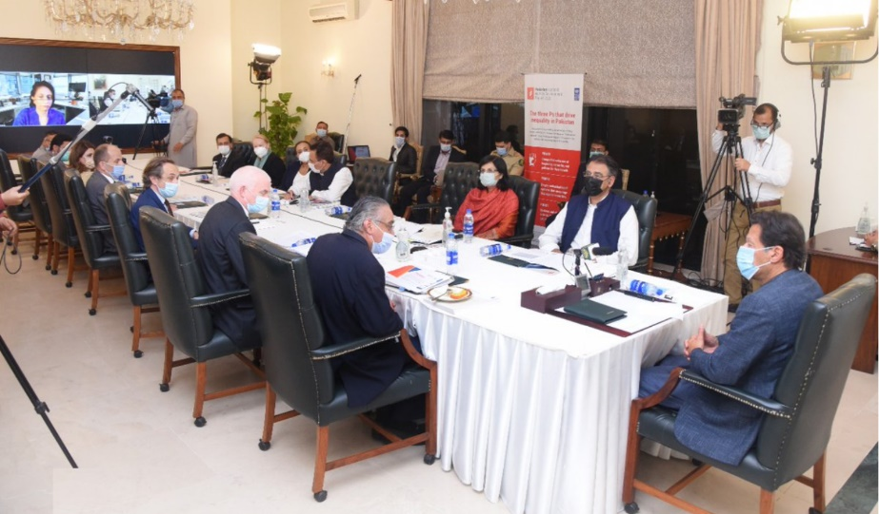

Policy Support Programme

Strategic Objectives
The Policy Support Programme is designed to provide upstream policy advisory support to the Government of Pakistan and our development partners through evidence-based research, technical assistance, dialogue, communications and advocacy initiatives.
Established in 2013, the programme’s objectives include:
- Strengthening UNDP’s upstream policy advisory and technical support to the Government and Development Partners on public policy issues.

Quick facts
Duration: 2013-2022 (extended period)
Location: Nationwide
Funding partners: UNDP HQ and Asia-Pacific; UN Agencies; Open Society Foundation (OSF)
Annual budget (2021): USD 422,012
Implementing partners: Federal and Provincial Governments of Pakistan, International Development Partners, UN Agencies, Civil Society, Private Sector, Academia.
Contact: Umer Akhlaq Malik, Policy Analyst, Development Policy Unit, UNDP Pakistan
umer.malik@undp.org

- Expanding national and sub-national capacities through evidence-based research, programme and policy analytics, and the development of strategic programme frameworks.
- Serving as a solutions-exchange hub for key partnerships and programmes by convening and catalyzing Government, development partners, UN agencies, UNDP Asia-Pacific Bureau, UNDP Headquarters New York, as well as international development thought and policy institutes, etc.

Since its inception, the programme has generated policy debate and influenced policy action on Pakistan’s most pressing development challenges. In partnership with the government and development partners, it has contributed to development policy planning in areas of poverty & inequality, the youth bulge, urbanization and crisis resilience, governance, environment, and climate change, strengthening capacities in generating inclusive and sustainable economic growth, and advancing the role of innovation in policymaking to generate development solutions.

The programme also produces UNDP’s flagship knowledge publications, such as the National Human Development Report, and official quarterly journal, Development Advocate Pakistan.

Current Portfolio Progress
The programme’s most recent portfolio activities, outcomes and results include:
National Human Development Reports:
- Work on developing the NHDR 2023 on Digital Transformation, entailing a mix of policy research, communication and advocacy, as well as piloting and prototyping demand-driven digital solutions around e-governance. This will be done alongside convening a digital transformation policy hub and focusing on Innovation for Development through digital transformation initiatives.
- Conducted the Prime Minister’s launch of the UNDP Pakistan NHDR 2020 on Inequality. The report highlights the gaps between Pakistan’s richest and poorest groups, and analyses the country’s severe inequalities from a multidimensional perspective. It provides policy recommendations for action at various levels of government, media, and civil society. The NHDR 2020 Post-Launch Advocacy Campaign was conducted at federal and provincial levels through the Pakistan Inequality Debates, with webinars and launches that aimed to create awareness and policy impact around the report’s findings.
Urban Development:
- In collaboration with the Institute of Business Administration (IBA) Karachi, initiated a pilot study on Urban Resilience that leverages the Social Innovation Platform to strengthen the inclusion and resilience of migrants, displaced people and host communities in the informal urban settlements of Azam Basti and Rehri Goth in Karachi. This included mapping and characterization of informal settlements, setting up private sector partnerships to facilitate initiatives such as water plants and book drives, creating awareness and social cohesion through various advocacy initiatives including trainings and workshops, and using storytelling as a major component of empowering the communities to advocate for their own growth.
- Development of Urban Platforms by engaging stakeholders such as the Metropolitan Corporation Islamabad, the Rawalpindi Development Authority, Karachi Metropolitan Corporation, private sector, and CSOs through high-level consortiums.
- Pilot interventions in Rawalpindi and Islamabad on water conservation and recycling in the hospitality sector, mosques/religious institutions, and urban forests.
COVID-19 Response:
- Established a COVID-19 Secretariat at the Planning Commission to provide data, analytics and technical services support to government. Following on from this, UNDP also facilitated BISP/Ehsaas by providing policy advisory and technical assistance with a focus on producing evidence-based policy papers, policy dialogues, and advocacy activities, especially in the context of making the Ehsaas strategy more inclusive and participatory.
- Conducted a country-level COVID-19 Social Economic Impact Assessment to be leveraged as a foremost knowledge and evidence resource for Government and development partners for crafting COVID-19 policy response, strategy and programmes.
What’s next?
In 2022, the programme will:
- Publish four quarterly issues of Development Advocate Pakistan on key thematic areas (Inclusive Growth in Times of Uncertainty, Media for Development, The Future of Work, Gender Mainstreaming).
- Work on developing the NHDR 2023 on Digital Transformation, entailing a mix of policy research, communication and advocacy, as well as piloting/prototyping demand-driven digital solutions around e-governance.
- Expand programming on economic stabilization, inclusion and resilience, both geographically (to border districts in Balochistan and Khyber Pakhtunkhwa) and programmatically (to include Regional Connectivity).
- Applying a Portfolio Initiation Framework aligned with the UNDP CPD outcome 4 on Gender Equality, by leveraging the Social Innovation Platform to focus on themes such as gender and climate change, particularly in light of the floods in Pakistan.
- Scale up urban development and resilience programming in collaboration with UNDP Asia-Pacific, governments, private sector, academia, and civil society. Continue implementing the global Social Innovation Platform approach in Karachi, Sindh to strengthen urban resilience and development with a focus on migrants, displaced people, and host communities in informal urban settlements.
- Deepen programmatic focus on innovation for development through digital transformation initiatives for e-governance, e-service delivery solutions, and green economic recovery solutions targeting vulnerable youth and women.
- Support cross-border connectivity and cooperation in the context of the Afghanistan-Pakistan-Iran border through a study focusing on strengthening governance, capacity building, trade facilitation, human mobility, and opportunity creation.
- Support COVID-19 resilience through green economic recovery and social protection enhancement for reducing inequalities in partnership with government’s Ehsaas Programme/Poverty Alleviation & Social Safety Net division.
- Provide policy advisory and technical assistance to the Government of Pakistan on Financing for Development (F4D). To introduce nature capital financing solutions, UNDP continues to develop the nature-restoration performance bond instrument in target countries, including Pakistan, and is facilitating advisory and technical assistance through national stakeholder consultations for introducing industry-led insurance and risk financing for disaster risk management.

