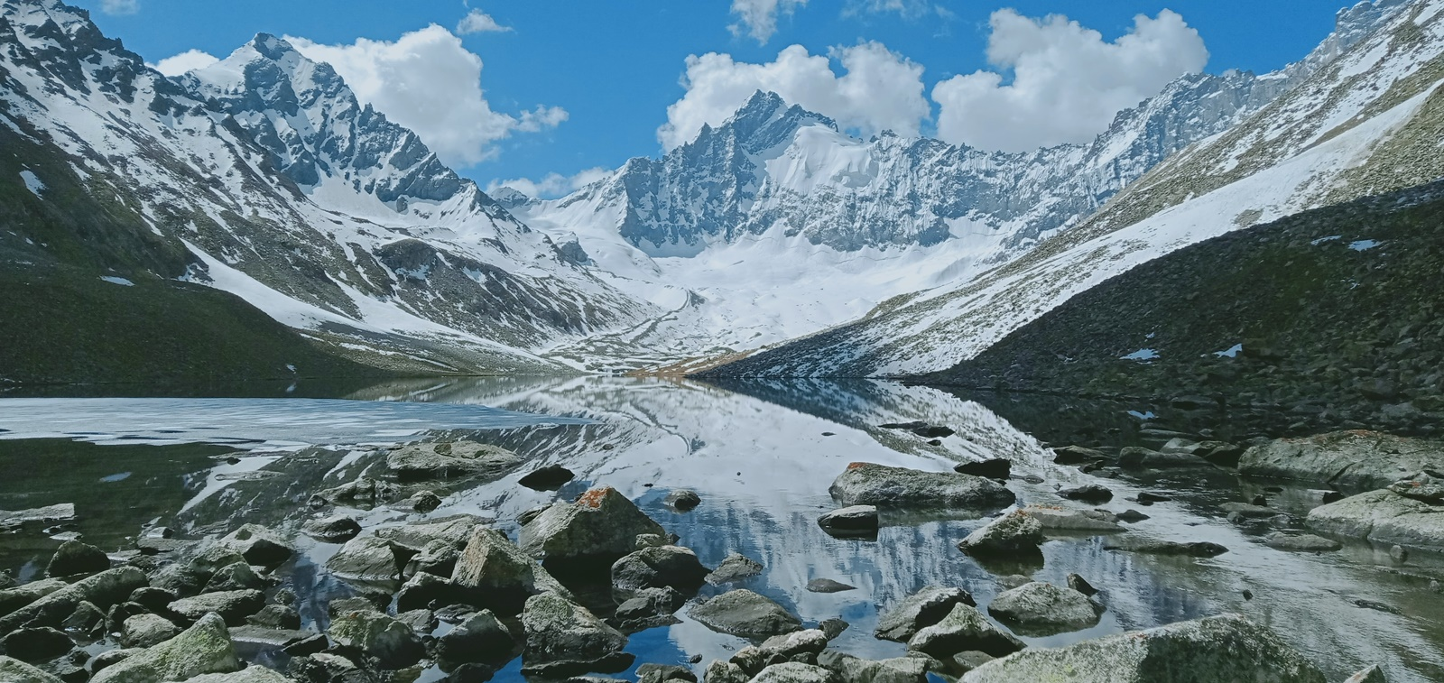 © GLOF II Pakistan
Scaling-up of Glacial Lake Outburst Flood (GLOF) Risk Reduction in Northern Pakistan (GLOF II PROJECT PAKISTAN)

Quick facts
Duration: 2017 – 2024
Implementing partners: Ministry of Climate Change
Funding partner: Green Climate Fund, UNDP, Government of Gilgit-Baltistan (GB)
Implementation areas: Khyber Pakhtunkhwa (KP), Gilgit-Baltistan (GB)
Total budget: USD 36,900,000 (GCF); USD 500,000 (GoGB)
AWP 2022 budget: USD 12.46 million.

Contact: Misbah Zafar- NPM
Email: Misbah.zafar@undp.org

Project context
Due to rising temperatures, glaciers in Pakistan’s northern mountain ranges (Hindu Kush Himalayas and Karakorum) are melting rapidly. Over 3,000 glacial lakes have developed in Gilgit-Baltistan and Khyber Pakhtunkhwa regions, of which 33 glacial lakes have been assessed as prone to glacial lake outburst flooding (GLOF) – which are sudden outburst events releasing millions of cubic metres of water from glacial lakes, leading to destruction downstream, loss of lives, property and livelihoods. An estimated 7.1 million people in GB and KP are vulnerable. The Scaling-up of GLOF risk reduction in Northern Pakistan (GLOF-II) project is a continuation of the four-year ‘Reducing Risks and Vulnerabilities from GLOF in Northern Pakistan’ (GLOF-I) project, which helped vulnerable communities in two districts to prepare for and mitigate GLOF risks through early warning systems, enhanced infrastructure and community-based disaster risk management.

Objectives

The project builds on activities implemented during the pilot phase and aims to further empower communities to identify and manage risks associated with GLOFs and related impacts of climate change, strengthen public services to lower the risk of disasters, and improve community preparedness and disaster response capacities. The project will also support the development of sustainable options for livelihoods in project areas, with a special focus on participation of women in ensuring food security and livelihoods.
Key Activities

- Provincial line and planning departments have technical capacities to mainstream climate change into development plans
- Sub-national institutions coordinate effectively to implement adaptation action plans and climate change initiatives
- Expanded weather surveillance and discharge measuring networks
- Early warnings are effective in protecting communities from climate-induced risks.
- Vulnerable communities have adequate long-term measures in place to address GLOF-related risks
- Improved financial capacity to adapt to GLOFs and other climate change-induced risks

Key Stakeholders

The project aims to build institutional capacities of government institutions at federal and provincial levels including Pakistan MET department and provincial line departments such as Disaster Management Authorities, Forest departments, Agriculture Department, Planning and Development Department, Pakistan Metrological Department, Environmental Protection Agencies, and Rural Support Programs, and environmental protection agencies. Furthermore, project interventions will target population groups in GB and KP. Communities most vulnerable to the impacts of climate change will be engaged. The maximum participation of women will be ensured in all project activities.

Expected results
The project will expand earlier interventions to 18 districts, directly benefiting communities in 24 valleys in Pakistan. Expected results by the end of the project are:
- At least four policies adopted by government to address or incorporate GLOF risk reduction.
- In target communities, 100 percent of households (696,342 total beneficiaries; 348,171 men and 348,171 women) will be able to receive and respond to early warnings and take appropriate action.
- At least 250 small-scale engineering structures will be established to reduce the effects of GLOF events on livelihoods, such as tree plantation, controlled drainage and mini dams.
- 50 weather monitoring stations to collect meteorological data in catchment areas; 408 river discharge sensors to collect river flow data to inform hydrological modelling and help develop village hazard watch groups.
- To reduce flood risks due to deforestation and inefficient water use, 240 water-efficient farming technologies (irrigation schemes) and 700 ha area will be brought back to productive use and protection through bioengineering measures.
Main Achievements

The project is currently under full implementation with the following progress to date:
- Successful completion of procurement of Early Warning Systems (EWS) for 24 valleys.
- Formulation of Gender Strategy and Action Plan.
- Revision of Environment and Social Management Plan and Grievance Redress Mechanism.
- Completion of Project Revival Plan as recommended by the Interim Evaluation.
- Establishment of Climate Change Cell at MoCC.
- Establishment of 24 Community Based Disaster Risk Management Committees (CBRMCs), as well as community-based Hazard Watch Groups (HWG) registered with Social Welfare Department and relevant district authorities, and emergency response and preparedness equipment handed over to provincial and district emergency response authorities in KP and GB.
- 03 Inter-agency multi-level SOPs and Plans developed for GLOFs and Disaster risk reduction at provincial level.
- Completion of 09 studies, assessments, and surveys: Hazard vulnerability Risk Assessments (HVRAs), Baseline Assessment, Knowledge Aptitude and Practices studies (KAP), Stakeholders Needs and Capacity Assessments, GIS mapping of hazard communities, Ground-truthing baseline surveys, development of socio-economic profiles completed for 16 valleys of GB, Bio-engineering Feasibility and Forest survey for GB.
- 04 training of over 150 officials from District Disaster Management Authorities, and other relevant stakeholders on roles and responsibilities, and implementation of EW strategies at district and local level have been completed.
- 232 community mobilization, awareness sessions and trainings for CBDRMCs, conducted for capacity building of communities
- 43 mock drills conducted on GLOF and climate change risks for communities and stakeholders.
- 60 Stakeholders' communication, coordination and capacity building workshops organized at national, provincial level to build capacity share project success stories, challenges, and way forward.
- 02 Glacier Grafting and 03 Ice Stupas activities under documentation and demonstration of indigenous best practices for nature-based solutions for GLOF risk reduction and climate change adaptation have been carried out in GB.
- Drafts prepared for 02 Provincial Climate Change Adaptation Action Plans (CCAAP).
- Repair/rehabilitation of 28 irrigation channels completed.
- 160 Ha of slope stabilization through compact plantation, pasture improvement and bio-engineering structures completed.
- 10 stakeholder field missions for SAPM, NPD, PMD and UNDP-RR, DRR, Technical Specialist, and Program Officer ECCU, for monitoring of project activities; 15 Stakeholders' exposure and 03 media visits to GLOF implementation sites and vulnerable communities involving national and sub-national officials, were carried out.
- MoU signed between MoCC and SUPARCO to provide support to MOCC through aerial imagery for interventions including glacier melting and tree plantation.
- 100 interns hired by MoCC, P&DD KP and P&DD GB under the “Nature/Climate Internship Programme”.
- 04 GLOF-II Project Social Media Channels launched (Twitter: https://twitter.com/Glof2Pakistan, YouTube: https://www.youtube.com/channel/UCfYuS4TQfSVm69mL4lVzdsw; Instagram: https://www.instagram.com/glof2pakistan/; Facebook: https://www.facebook.com/GLOF2Pakistan)
- 03 Documentaries launched (Pre-implementation, Ice Stupa- An indigenous best practice, Shisper Glacier Surge)
- For outreach and awareness 12 publications and numerous articles shared on print and electronic media, 01 journalist training organized on ethical reporting, 01 TEDx Event, 01 photography/videography competition held for youth of GB and KP, 01 Panel Discussion, 08 media interviews (02-TV, 03-Radio, 03-social media) and 07 Public service messages recorded for broadcasting on local and national TV channels to raise awareness among masses regarding climate change and its adverse impact; information boards for 05 valleys of KP have also been installed in 10 locations.
- Various events organized on 04 international days at national and local level. World Environment Day- (01 Cycling event organized with MoCC and MoFA; talks arranged at KIU-GB), International Day for Disaster Risk Reduction, National Disaster Resilience Day (Seminar conducted in KP), International Mountain Day (Speech and Painting Competitions, held in KP, clean up campaigns held in both KP and GB), participation in Eco Film Festival and 03-day Avalanche preparedness training, and 04 seminars conducted on CBDRM, CC and Eco tourism, gender and to celebrate the achievement of SDG 13 by GoP.
What's next?

In 2022, the project aims to carry out the following activities:

- Construction of Base Platforms of EWS Equipment and installation of the EWS and River Discharge Gauges/ Lake Monitoring Sensors in project valleys.
- Establishment of Integrated GIS based MIS (Digital Platform) at National and Provincial Level.
- Community training sessions in 24 valleys of KP & GB for enhanced understanding of GLOF risks and project interventions and Operations & Maintenance of EWS equipment.
- Development of 05 Inter-agency multi-level SOPs/Plans for GLOF/Disaster risk reduction i.e. Contingency Planning and Disaster Risk Reduction planning.
- Completion of remaining studies and assessments such as KAP and socio-economic impact assessment for KP.
- Finalization of Glacial Inventory.
- Completion of remaining construction, repair, and reconstruction of small-scale infrastructure to reduce medium- and long-term risks of floods (gabion walls, check dams, spillways), irrigation systems and slope stabilization activities through bioengineering structures and CBDRMC centres.
- Repair and maintenance of 12 PMD Observatories and 03 master control rooms.
- Animated videos, short documentaries, web-series to highlight the project interventions.
- International tours and Stakeholders’ exposure visits to target valleys.
- Trainings on SOPs and conduct mock-drills in 24 targeted valleys of KP & GB by engaging Stakeholders and communities.
- Trainings of MoCC, P&DD (KP & GB), line departments and Communities on Climate Change Adaptation Action Plan and Climate Resilient Development Pathways.
- Documentation and demonstration of indigenous best practices in KP and GB for GLOF risk reduction and climate change adaptation in target valleys.
- Stakeholders' communication and coordination workshops and reciprocal community visits organized at national, provincial and district level to share project success stories, challenges, and way forward.
- Construction of Community Based Disaster Risk Management Centres (CBDRMCs) in 24 valleys.
- Development of Safe Havens and Safe Access Routes in the 24 vulnerable communities for rescue and response activities.
- Develop guidelines/manual for Kitchen/Home Gardening.
- Design and implementation of Project Exit Strategy for smooth transition of knowledge, experiences to National partners

