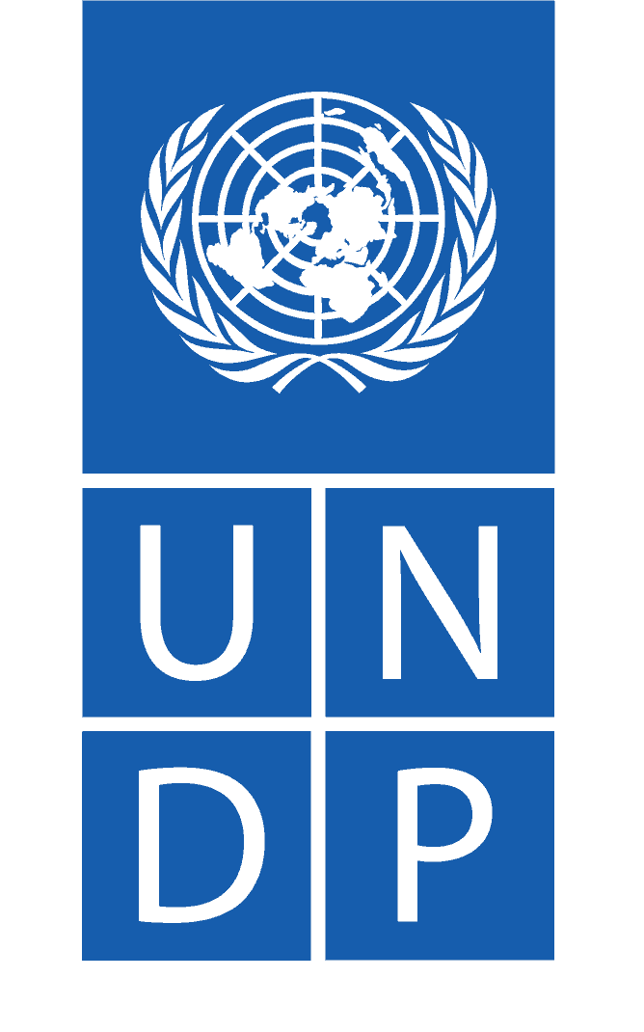

Call for Proposal

Project Title: “Recovery, Stability and Socio-economic Development in Libya (RSSD) - Baladiyati

Description of the assignment: Strengthening capacity of municipality staff to provide basic services adopting conflict sensitivity analysis and gender mainstreaming approaches

Country/place of implementation: Selected municipalities across Libya

Duration of assignment: 6 months

- BACKGROUND
The EU-funded Recovery, Stability and Socio-economic Development in Libya, Phase 1 “Baladiyati” project implemented by UNDP aims to support local authorities in Libya to respond to the many conflict- and human mobility-induced challenges by strengthening the local resilience and recovery mechanisms that negatively impact people’s access to essential services, sustainable livelihoods, social cohesion, and community security. The project is implemented in close cooperation with the Ministry of Local Governance, municipalities, Italian Agency for Development Cooperation (AICS) and the United Nations Children's Fund (UNICEF). The project is implemented in 20 municipalities: Kufra, Bayda, Maya, Mamoura, Ghat, Janzur, Zintan, Garabulli, Khoms, Emsaed, Brak Al Shati, Zawiya West, Zawiya South, Benghazi, Ajdabiya, Qatroun, Shweiref, Sabratha, Sebha and Murzuk.

As part of the project efforts to strengthen the capacity of municipalities to deliver services, rapid local governance surveys have been conducted by UNDP in the 20 targeted municipalities. Based on the findings, and extensive consultations with the Ministry of Local Government (MoLG)/General Secretary of Local Government/ the Supreme Council for Local Administration (SCLA), training needs have been identified for staff of the target municipalities as well as MoLG staff. This endeavour is being coordinated with other international partners (including GIZ and other EU-funded projects) to ensure harmonization of strategy and methodology in line with the National Training Plan managed by MoLG/SCLA

Against this background, UNDP Libya is launching this call for proposals to engage a qualified International or Local NGO through collaborative advantage modality to develop curricula, plan, organize and conduct the capacity development programme in selected municipalities, in close consultation with MoLG/ SCLA.

- MAIN GOALS AND OBJECTIVES
The objective of this project is to strengthen the capacity of selected municipality staff to provide basic services within the local governance framework, adopting conflict sensitivity analysis and gender mainstreaming approaches. Activities need to be closely coordinated with relevant municipalities, with the Ministry of Local Government (MoLG)/General Secretary of Local Government/ the Supreme Council for Local Administration (SCLA).

- SCOPE OF WORK AND EXPECTED OUTPUTS
Based on the results of the local governance survey and in line with the MoLG Training Master Plan, the capacity development programme will cover the following topics:
- Project Management
- Reporting
- Archiving
- M&E including data collection (segregated data as per the counterpart needs) in conflict setting
- Gender Mainstreaming (in planning and execution)

The municipalities covered by the programme are:

- Al-Kufrah
- Murzuk
- Bayda
- Maya
- Mamoura
- Ghat
- Janzour
- Zintan
- Ajdabiya
- Qatroun
- Garabulli
- Shweiref
- Sabratha
- Sebha
- Khoms
- Emsaed
- Brak alshati
- Zawiya West
- Zawiya South
- Benghazi

Detailed objectives, related outputs, deliverables, and key considerations are provided in the Terms of Reference – Annex I

- EXPERIENCE AND QUALIFICATION REQUIREMENTS
This call is open for both the International and/or Local Non- Governmental Organisations meeting the following minimum requirements:

    - Local experience operating in Libya for at least 2 years
    - Proven experience in developing training curricula for local government institutions
    - At least 5 years of professional experience in providing capacity building/training courses on related topics within the local governance framework
    - Proven experience in supporting local government institutions to develop Capacity Plans
    - Proven knowledge and experience in data collection and analysis ensuring gender mainstreaming, peacebuilding, and conflict prevention mechanisms at the local level
    - Ability to avail a team that is qualified and experienced in providing trainings on related topics and provide recommendations on capacity development plans (as defined in the TORs)
    - Ability to collect and analyse large quantities of data within strict and limited time frames and to produce high quality and timely reports
    - Language proficiency in written and oral English is required, Arabic (or ability to work with internal translation) is a plus

The parameters that will determine whether an NGO is eligible to be considered by UNDP will be based on the Capacity Assessment Checklist (CACHE) for international and/or Local NGO that should be duly completed and submitted alongside supporting documents request.
Capacity Assessment Checklist (CACHE) For NGO template – Annex III.

- TECHNICAL AND FINANCIAL PROPOSAL
Proposed methodology, approach, quality assurance plan and implementation plan: this section should demonstrate the NGOs/CSOs response to the Terms of Reference by identifying the specific components proposed, how the outputs/delivery shall be addressed, as specified; providing a detailed description of the essential performance characteristics proposed.

Moreover, the proposal should demonstrate how the proposed methodology meets or exceeds the TOR, while ensuring the appropriateness of the approach to the local conditions and the rest of the project operating environment. This methodology must be laid out in an implementation timetable and quality assurance.

Management Structure and Resource (Key Personnel): This section should include a comprehensive description of the management structure and information regarding required resources, including curriculum vitae (CVs), of key personnel that will be assigned to support the implementation of the proposed methodology. It should clearly define the roles and responsibilities vis-à-vis the proposed methodology. CVs should establish competence and demonstrate qualifications in areas relevant to the TOR.

- EVALUATION CRITERIA
Proposals will be evaluated based on the following criteria and methodology:

Summarized evaluation form of the  technical proposal |  | Share of  evaluation | Maximum score
1 | Experience of the organization that submits proposal | 30% | 300
2 | Proposed work plan, methodology, and approach | 45% | 450
3 | Staff and invited experts / consultants | 25% | 250
 | Total score | 100% | 1000
 | Remarks

Evaluation methodology:
The selection of the successful NGO candidate will be based on the ability of the bidder to demonstrate in the technical proposal the required area of expertise and experience as per the stated criteria in this TOR in addition to access to the beneficiaries. The total budget for this engagement is disclosed under the budget section. The bidders are expected to submit detailed financial proposal aligned with the estimated budget along with a deliverable-based work plan.

NGOs shall provide their technical proposal and financial breakdown (within the budget, and clearly stating proposed overheads, outside of direct costs associated with the cash transfer to beneficiaries, use of materials used in rehabilitation, and other direct costs) in a single envelope/email. UNDP will assess the best value for money focused on maximizing transfer of value to the beneficiary user. For these reasons, it is important to provide budget in the manner that the ratio between the operating overhead costs and implementation costs is assessed. The maximum overhead cost may vary depending on the type of assignment, size of the project component to be implemented, country or security situation among other factors.

Evaluation of all technical proposals shall be carried out in accordance with above outlined eligibility and technical evaluation criteria, and the entity that obtains the highest technical score shall be selected. NGOs exceeding the established stated budget in their financial proposals will be rejected.
- An International and/or Local NGO that is engaged to act as Responsible Party is subject to and must comply with the HACT policy (i.e., micro-assessment and assurance activities) that must be validated through performance measures and quality certified by an independent assessor engaged by UNDP. The selected NGO will be subject to a specific capacity assessment. UNDP is responsible for assessing the grant-making (or grant distribution) institution to ensure it has the programmatic, financial and management capacities and systems compatible with UNDP regulations and rules to effectively undertake its roles. The assessment for on-granting includes the following areas:
- Institutional capacity for grant award management, comprising a framework/system for undertaking grant proposal evaluation, due diligence and appropriate governance, and risk management (including composition and terms of reference of the grant award evaluation committee);
- Financial resources management and systems, including analysis of granting portfolio;
- Relevant history in managing resources through grant awards;
- Relevant history in working with small organizations—including past experience in technical assistance and developing other organizations' capacity for social service delivery, competing for grants, managing grants, etc.;
- Programmatic capacity, including monitoring and evaluation;
- Capacity to assess and manage risk, including safeguarding people and the environment from harm;
- Procurement and supply management procedures with clearly defined responsibilities and applicable templates for assessing the eligibility and capabilities of potential grant recipients;
- Transparency, including systems and processes to make information on grant recipients public.

- BUDGET SIZE AND DURATION
The estimated total funds allocated for “Strengthening capacity of municipality staff to provide basic services adopting conflict sensitivity analysis and gender mainstreaming approaches” amounts to 400,000 USD. The administrative costs, management cost and the overhead cost reflected in the financial offer should not exceed 25% of the total budget.

The anticipated implementation period is 6 months upon contract signature.

VIII. SUBMISSION PROCESS

Applicants shall bear all costs related to proposal preparation and submission.
Applicants must submit their Technical and Financial proposals in electronic format to
mahezabeen.khan@undp.org
Please note that bids received through any other address will not be considered.
PLEASE make all efforts to provide your electronic proposal not exceeding 10 MB size.

Applicants are solely responsible for ensuring that all files sent to UNDP are readable, that is, uncorrupted, in the indicated electronic format, and free from viruses and malware. Failure to provide readable files will result in the proposal being rejected.

The following documents must be submitted for the submission to be considered:
- Request for Information (RFI) (Annex II)
- Capacity Assessment Checklist for NGO/CSO (Annex III)
- Preliminary methodological approach to be used
- Information regarding required resources including curriculum vitae (CVs) of key personnel that will be assigned to support the implementation of the proposed methodology (clear definition of roles and responsibilities)
- Narrative and Financial proposal (Annex IV), including proven track record in the implementation of similar/related activities (as requested by the TOR) and a work plan with the proposed work schedule indicating the persons responsible for each area of activity

Only one submission per organization is allowed. Organizations may not participate in more than one proposal. Once the application is complete and submitted, revised versions of proposal documents will not be accepted. Partial applications will not be accepted.

Interested NGOs/CSOs may obtain further information or clarification by contacting UNDP Libya through the following email address: nora.ellafi@undp.org

Note: UNDP reserves the right not to fund any proposals arising from this Call for Proposals.

Submission Deadline:
Proposals, with supporting documents, should be submitted by 18 August 2022, at 24.00 midnight (Libya time).

Estimated Completion Timeline:
For reference purposes only, please consider the following indicative timeline:
31 July 2022: Call for Proposal opens, and relevant documents are posted online
18 August 2022: Deadline for organizations to submit proposals under this Call
02 September 2022: Assessment and selection processes will take place
05 September 2022: Selected applicant will be notified

IMPORTANT ADDITIONAL INFORMATION:

UNDP implements a policy of zero tolerance on proscribed practices, including fraud, corruption, collusion, unethical practices, and obstruction. UNDP is committed to preventing, identifying, and addressing all acts of fraud and corrupt practices against UNDP as well as third parties involved in UNDP activities. For a full description of the policies, please see:
- http://www.undp.org/content/dam/undp/library/corporate/Transparency/UNDP_Anti_Fraud_Policy_English_FINAL_june_2011.pdf
- http://www.undp.org/content/undp/en/home/operations/procurement/protestandsanctions/
In responding to this Call for Proposals, UNDP requires all Proposers to conduct themselves in a professional, objective, and impartial manner, and they must at all times hold UNDP’s interests paramount. Proposers must strictly avoid conflicts with other assignments or their own interests, and act without consideration for future work. All Proposers found to have a conflict of interest shall be disqualified. Without limitation on the generality of the above, Proposers and any of their affiliates shall be considered to have a conflict of interest with one or more parties in this solicitation process if they:
- Are or have been associated in the past, with a firm or any of its affiliates which have engaged with UNDP to provide services for the preparation of the design, Terms of Reference, cost analysis/estimation, and other documents to be used in this competitive selection process
- Were involved in the preparation and/or design of the programme/project related to the services requested under this Call for Proposals
- Are found to be in conflict for any other reason, as may be established by, or at the discretion of, UNDP
In the event of any uncertainty in the interpretation of what is potentially a conflict of interest, Proposers must disclose the condition to UNDP and seek UNDP’s confirmation on whether such conflict exists.

UNDP looks forward to receiving your proposals and thank you in advance for your interest in UNDP activities.

This project is part of the UNDP award number 104158 “Strengthening Local Capacities for Resilience and Recovery” (SLCRR).

