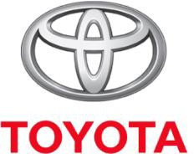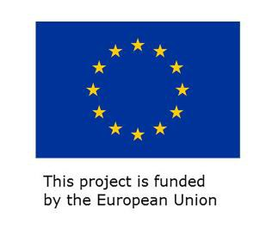 | 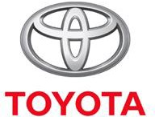

Training Announcement

Under the European Union (EU) funded project “Strengthening Local Capacities for Resilience and Recovery (SLCRR Top-up)’, the United Nations Development Programme (UNDP) and Toyota Libya F.Z.C. are expanding their partnership to provide additional car maintenance training course for group of 20 young Libyans for 12 weeks.

The programme includes car maintenance, computer skills, English language and Reporting.

The joint partnership aims to support the country to cope with the rising unemployment practicality among fresh graduates and promote their opportunities to attain a decent job that matches their technical and scientific qualifications.

With joint support from UNDP and Toyota Libya F.Z.C, a new batch of 20 trainees will be selected to participate in the training course program especially the Internally Displaced Persons (IDPs), to develop their skills and improve their chances in finding an appropriate job.

The course of 20 targeted participants are scheduled to start the training course by September 4th 2022.

We are inviting interested and competent candidates who fulfil the following criteria to apply for this opportunity, noting that only 20 participants will be selected for this training opportunity.

ELIGIBILITY CRITERIA:

To apply for the technical training programme the following conditions need to be met:

- Nationality: Libyan.
- Age: Not exceeding 25 years.
- Obtaining a Coivid-19 vaccination card.
- Education: New graduates from colleges and high technical institutes, including a
recommendation letter from institute if possible.
- Language: Fluent in Arabic language.
- Priority will be given to:
  - Internally Displace Persons (IDPs).
  - Applicants who are suffering economic hardship.
- Training is open to the qualified candidates from all Libyan regions and backgrounds, and those who believe that this training will create a positive change in their live

Applicants are required to submit copies of proof of all above-mentioned documents (confirming eligibility criteria) along with a motivation letter.

PROGRAMME:

Selected youth will receive the following support covered by the programme:

- Accommodation, lunch.
- Uniform, living expenses.
- Workers' accident insurance.
- Certificate of completion of the training course.

EVALUATION COMMITTEE:

A group of experts from Toyota Libya F.Z.C. will evaluate and screen all the applications, to select the 20 new participants for the technical training programme, which will start by September 4th 2022,
that is organized and sponsored by Toyota Libya F.Z.C, and UNDP Libya.

EVALUATION CRITERIA:

Applications will be evaluated based on:

Complete application, and submission of the required information
reference and recommendation letters

Toyota Libya F.Z.C online course contract details
Interested people are encouraged to send their applications to the email below, noting that the deadline to receiving applications is 31-08-2022.

mahmoud.ghmim@toyota.ly

For more information, please contact Mr. Mahmoud Ghmaim

Phone Number: 0917153853.

