# 

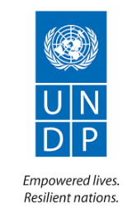  

Indigenous Peoples Plan

Enhancing conservation of globally significant biodiversity through protected area system strengthening in Gansu

China-Protected Areas System Reform

Program Child Project #2

August, 2022

Table of Contents

Executive Summary 3

1. Description of the Project 6

2. Description of Indigenous Peoples 10

2.1 Basic Concepts 10

2.2 Ethnic minorities in the project area 11

3. Substantive Rights and Legal Framework 18

International regulation protecting the rights of indigenous peoples 18

National regulation 19

Regulation at the local level 24

Legally recognized rights to lands 25

4. Environmental and Social impacts to ethnic minorities, and related mitigation measures 26

4.1. Project social risks to ethnic minorities 27

4.2. Project environmental risks to ethnic minorities 33

4.3. Mitigation Measures 34

4.3.1. Mitigation Measure 1: Prevent economic displacement and preserve land rights and traditional lifestyles of local herders 35

4.3.2. Mitigation Measure 2: Overcome gender-based barriers to participation in project activities 39

5. Participation, Consultation, and FPIC Processes 41

5.1. Definitions of the FPIC Process 41

5.2. Consultations and recording 44

5.3. Project Outcomes Requiring FPIC 47

6. Grievance Redress Mechanism 52

7. Institutional arrangements 53

8. Monitoring, Reporting, Evaluation 59

# Executive Summary

This project (C-PAR 2) is one of these six child projects of the China’s Protected Area System Reform (GEF-financed program) and it is centered on transforming West Qinling-Minshan Mountains’s national protected area system through systematic legal and institutional reform and innovation for conservation of globally significant biodiversity.

The UNDP SES policies concerning indigenous peoples (IP) recognize the distinct circumstances that expose IP to different types of risks and impacts from development projects. As social groups with identities that are often distinct from dominant groups in their national societies, IP are frequently among the most marginalized and vulnerable segments of the population. China does not recognize the term IP, but uses the term “Ethnic Minority”, which entail that all requirements of the UNDP Social and Environmental Standards (SES) 6 on indigenous people are applied. The terms Indigenous People and Ethnic Minorities are interchangeable in this document. As a result, their economic, social, and legal status often limits their capacity to defend their rights to lands, territories, and other productive resources, and restricts their ability to participate in and benefit from development. At the same time, C-PAR 2 recognizes that IP play a vital role in sustainable development and emphasize that conservation should benefit IP, thereby ensuring long-term sustainable management of critical ecosystems and national park.

A scoping study was carried out as part of the C-PAR 2 Project’s ESIA process. Some potential negative impacts and risks pertinent for Social and Environmental Standards (SES) 6 issues were identified during the initial scoping process include: (1) local communities (including ethnic minorities) living in core areas can be resettled gradually and voluntarily; (2) expansion of QMNP has the potential to affect the rights, culture, lands and livelihoods of local herders (including women and ethnic minorities); (3) some small-scale engineering construction activities may affect the native ecosystem and species conservation.

This Indigenous People Plan (hereafter IPP) provides a more in-depth assessment of the potential impacts on ethnic minorities the project may cause through the planned activities. Due to SES 6 being triggered in both SESP and ESIA, this IPP assesses potential social and environmental negative impacts and related mitigation measures of the programme against UNDP’s SES 6 and it reviews gaps to ensure full compliance. This IPP presents a suite of management and mitigation measures to address UNDP SES 6 related impacts with the C-PAR 2 project. These measures seek to provide an adequate response to the management of these risks in line with UNDP SES policy requirements. This IPP builds on the feasibility study, gender assessment and gender action plans prepared during the programme development phase and on the ESIA developed during early preparation/inception. It assesses potential social and environmental negative impacts and related mitigation measures of the programme against UNDP’s Social and Environmental Standards (SES) 6 and it reviews gaps to ensure full compliance. FPIC will apply to all activities affecting ethnic minorities, namely:

* Activity 2.1.2: Facilitate the development of proposals by Gansu Forestry Dept for the extension of the following PAs with due attention to management of social impacts.
* Activity 2.1.3: Facilitate the development of proposals by Gansu Forestry Dept for the establishment of ecological corridors with due attention to management of social impacts.
* Activity 2.1.5: Provide technical support to Yuhe NR regarding its incorporation within the proposed Giant Panda National Park.
* Activity 2.2.4: Support the development and operationalisation of management plans with full participation of stakeholders including local communities, local governments and business sectors.
* Activity 2.2.7: Provide input to the identification of training needs and determination of competence standards for professional development programmes and training modules, with proactive consideration of gender equality and ethnic minority engagement.
* Activity 2.2.10: Strengthen patrolling capacity to address specific threats identified in the targeted PAs through introduction and upgrading of smart patrolling systems, including equipment and human capacity, engagement of communities.
* Activity 2.3.1: Establish village level project committees to support implementation of co-management agreements and project activities such as sustainable livelihoods initiatives, proactively incorporating women as fully participating members in line with the Gender Action Plan.
* Activity 2.3.3: Engage local communities to assist in habitat restoration and management efforts through community co-management agreements and appropriate incentives, technical assistance and supervision.
* Activity 2.3.5: Facilitate community-based ecotourism development (e.g. for guided tours) at Yuhe NR/Giant Panda NP and Duoer NNR through capacity development and training support proactively targeting women and ethnic minorities, based on zoning plans and visitor carrying capacity assessments.
* Activity 2.4.2: Develop and test community-based participatory approaches towards the prevention and management of HWC damage to crops and livestock of local communities, as well as response systems involving damage assessment and compensation. Support demonstration activities with small grants administered through the project, with priority given to women and ethnic minority recipients.

In the process of the construction of NP, the government and NGOs will adopt a variety of methods to support community residents and develop alternative livelihoods, such as biodiversity friendly eco-tourism, ecological management and protection, and welder electrician and excavator operation. Developing these alternatives to traditional livelihoods can help local people adapt to any changes imposed by the project and can serve to mitigate potential impacts on their standard of life. The QMNP has actively recruited local residents as ecological officials, and consulted the park entrance attendants, so as to improve the livelihood of local residents. The QMNP also guided the community residents to develop the tertiary industry in the general control area or around the Qilian Mountain National Park and encourages and supports them to engage in franchise activities.

The Project has set up a participatory monitoring and evaluation mechanism to ensure that the communities affected by the project are informed regularly about progress and provided regular opportunities for community members to ask questions, raise concerns and review activities taking place on or near their land.

# Description of the Project

The West Qinling Mountains-Minshan Mountains landscape is recognized as a biodiversity hotspot, both within China and worldwide. It is located in the Bailongjiang basin in the upper reaches of the Yangtze River. The West Qinling Mountains form part of the Qinling Mountains, a geographical divide between the south and north of China. The biome in this region is characterized by a south-north transitional feature with extremely rich biodiversity. The Minshan Mountains are listed as one of the WWF Global 200 Ecoregions, a biodiversity hotspot of global significance, and included in the 25 biodiversity hotspot areas defined by Conservation International. Many Chinese endemic species are distributed in the Bailongjiang area. Surveys and incomplete statistics indicate that Over 100 species in the IUCN Red List (87 animal and 15 plant species) occur in the West Qinling Mountains-Minshan Mountains landscape.

The project implementation period is 60 months, from October 2018 to September 2023. The total GEF investment of US$2,652,294 for this project will leverage a minimum of US$18 million in co-financing from the Qinghai provincial government. The receipt of GEF resources channeled through a UN agency often facilitates the political commitment to take difficult decisions on issues such as reforming outdated legislation, making plans for extending the PA system network, strengthening inter-sectoral coordination, and adopting more environmentally friendly practices in related sectors. GEF funds will mainly support:

* Strengthening the conservation of globally significant biodiversity in Gansu Province through improving the legal and institutional framework;
* Reforming and mainstreaming the protected area system;
* Enhancing habitat connectivity and reducing key threats.

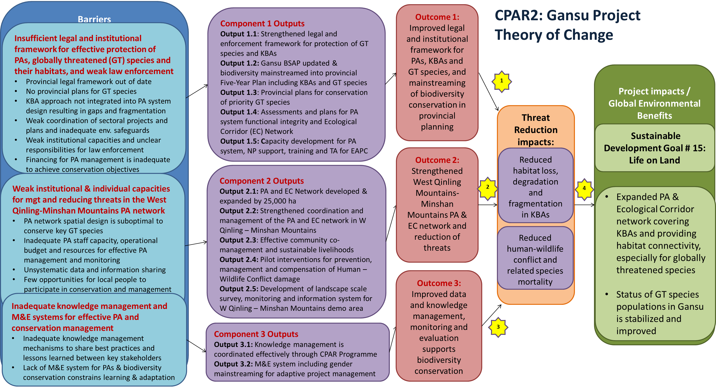

Figure 1. Summary of C-PAR 2 activities.

The Project Objective is to strengthen the conservation of globally significant biodiversity in Gansu Province through improving the legal and institutional framework, reforming and mainstreaming the protected area system, enhancing habitat connectivity and reducing key threats. To achieve this objective, the project will deploy three strategies (Project Components) with intervention pathways.

Component 1: Improved legal and institutional framework for protected areas (PAs), Key Biodiversity Areas (KBAs) and globally threatened species and mainstreaming of biodiversity conservation in provincial planning. This component will strengthen the legal and institutional framework for Gansu provincial government for reducing threats to globally threatened species and their habitats and mainstreaming biodiversity conservation into provincial planning processes. It will address key needs for updating and re-aligning provincial policies, legislation and plans for consistency with rapidly advancing national policy on biodiversity conservation, ecological security and environmental protection. This will include increased protection for globally threatened species and Key Biodiversity Areas, support for the Giant Panda and Qilian Mountains National Park pilots and introduction of compliance monitoring and evaluation. The provincial Biodiversity Strategy and Action Plan will be updated, and biodiversity conservation will be integrated as a mainstreamed task for key sectors in the ongoing 13th and upcoming 14th Provincial Five-Year Plan, and provincial level plans will be developed and implemented for the conservation, rehabilitation and reintroduction of priority globally threatened species. Assessments will be conducted and spatial plans developed to enhance the functional integrity of the provincial PA system, supported by an Ecological Corridor Network for the province that will increase ecosystem and species resilience against climate change and reduce the fragmentation of populations of globally threatened species. The capacity of key institutions for protected area system management and globally threatened species conservation will also be strengthened in coordination with developing national professional standards for PA system management.

Component 2: Strengthened West Qinling Mountains-Minshan Mountains protected area and ecological corridor network and reduction of threats. This Component will build on Component 1 by supporting the operationalization of plans for the conservation and recovery of globally threatened species, and expansion of the Protected Area and Ecological Corridor Network in the West Qinling – Minshan Mountains demonstration area to enhance species conservation and reduce threats. The Protected Area and Ecological Corridor Network will be expanded by more than 25,000 ha to increase coverage of KBAs and increase habitat connectivity, in line with the provincial species conservation and recovery plans. The coordination and management of the PA and Ecological Corridor Network will be strengthened through a range of activities, including establishing a hub for network capacity development and training at Yuhe NR / Giant Panda NP, in coordination with C-PAR National (child project 1) and Sustainability projects (child project 6). This network would integrate with the Tibetan Plateau-Qinghai Biodiversity Network. Capacity development, management plans, financing plans, provision of training, infrastructure and equipment, SMART patrolling and monitoring of threats and species status will all be supported at the targeted PAs (Axia, Chagangliang, Duoer and Yuhe NRs) to increase management effectiveness. This Component will also support more effective community co-management and engagement in PA management achieving livelihoods improvement and threat reduction. This will include facilitating the production and marketing (including online marketing) of PA-friendly sustainable products (e.g. non-forest timber products - NTFPs, honey) and eco-tourism development by selected local communities at the project demonstration sites. In addition, with an increase in the prevalence of human-wildlife conflict (HWC) in and around PAs impacting local farmers, the project will demonstrate mechanisms for the prevention, management and compensation of HWC damage adjacent to PAs and Ecological Corridors in coordination with the C-PAR National (child project 1) and Qinghai projects (child project 2). Finally, the project will develop a landscape scale biodiversity survey, monitoring and information system for the West Qinling Mountains-Minshan Mountains demonstration area to support PA management and species conservation.

Component 3: Knowledge management, monitoring and evaluation and gender mainstreaming. The third project component closely links with and underpins the other two, by supporting the sharing of knowledge, experiences and lessons learned through project implementation with project stakeholders, the wider public in Gansu Province, and nationally through the GEF C-PAR Program.

# Description of Indigenous Peoples

## 2.1 Basic Concepts

A **target nature reserve** means nature reserve where the project will target certain actions. A project municipality is the municipality where the project target nature reserve(s) are situated. Similarly, a project county/district/city is the county/district/city where the project target nature reserve(s) are situated. A pilot community is a community where the project plans to demonstrate some community development and biodiversity conservation activities.

The term **Ethnic Minorities** (EM) is used in the present IPP in lieu of thetermIndigenous Peoples since the latter has never been formally used in the People's Republic of China. It should be noted that the term EM is used in the People's Republic of China in a very similar way that the term IP is used in the UN-system. In total, 56 ethnic groups have been identified in China based on their similarities such as common ancestry, language, society, and culture in 1970s (Ping, J. (1994). Theory and Practice of China's Ethnic Problems. Central Party School Press, pp. 492-496).

In rural China, an **administrative village** is an autonomous management area which socially comprises a certain number of households. The households usually live in the same area, but not always. A small residential area is customarily called a natural village. That is, an administrative village informally consists of several natural villages. An administrative village is formally divided into several villager groups. Village Committee is the management agency of an administrative village. Each villager group has one to two group leaders. In this report, the term ‘village’ refers to administrative village.

**Community** in international discourse refers to a social group of any size whose members resides in a specific locality, and often has a common cultural and historical heritage. However, community is not a formal administrative term in the People’s Republic of China (the PRC). Community in this report refers to either an administrative village, a natural village, or an urban community.

## 2.2 Ethnic minorities in the project area

Multiple ethnic groups populate the People's Republic of China. The Han people are the largest ethnic group in mainland China. In 2010, 91.51% of the population were classified as Han (~1.2 billion), which characterize the Han group as an ethnic majority. On the other hand, there are 55 ethnic minority groups in present China, numbering approximately 105 million people (8% of the total population), mostly concentrated in the bordering northwest, north, northeast, south and southwest but with some in central interior areas.

The Qilian Mountain National Park covers a total area of 50,200 km2 and it is located at the junction area of Gansu province and Qinghai province. C-PAR 2 focuses on the area within the Gansu province, which had 26.1 million permanent residents in 2016, accounting for 1.9% of the total population in China. Of the total, 44.7% were urban, which was 12.7 percentage points lower than the national average in the same year. The ratio of women to men is similar to the national average. Among the total population, 2.56 million were ethnic minority, accounting for 9.85 of the total population in Gansu Province, and 2.2% of the total ethnic minority people in China in 2016. Qilian Mountain National Park is inhabited by more than 30 EM, including Tibetan, Hui, Mongolian, Tu, Yugu, Kazak, and Salar.

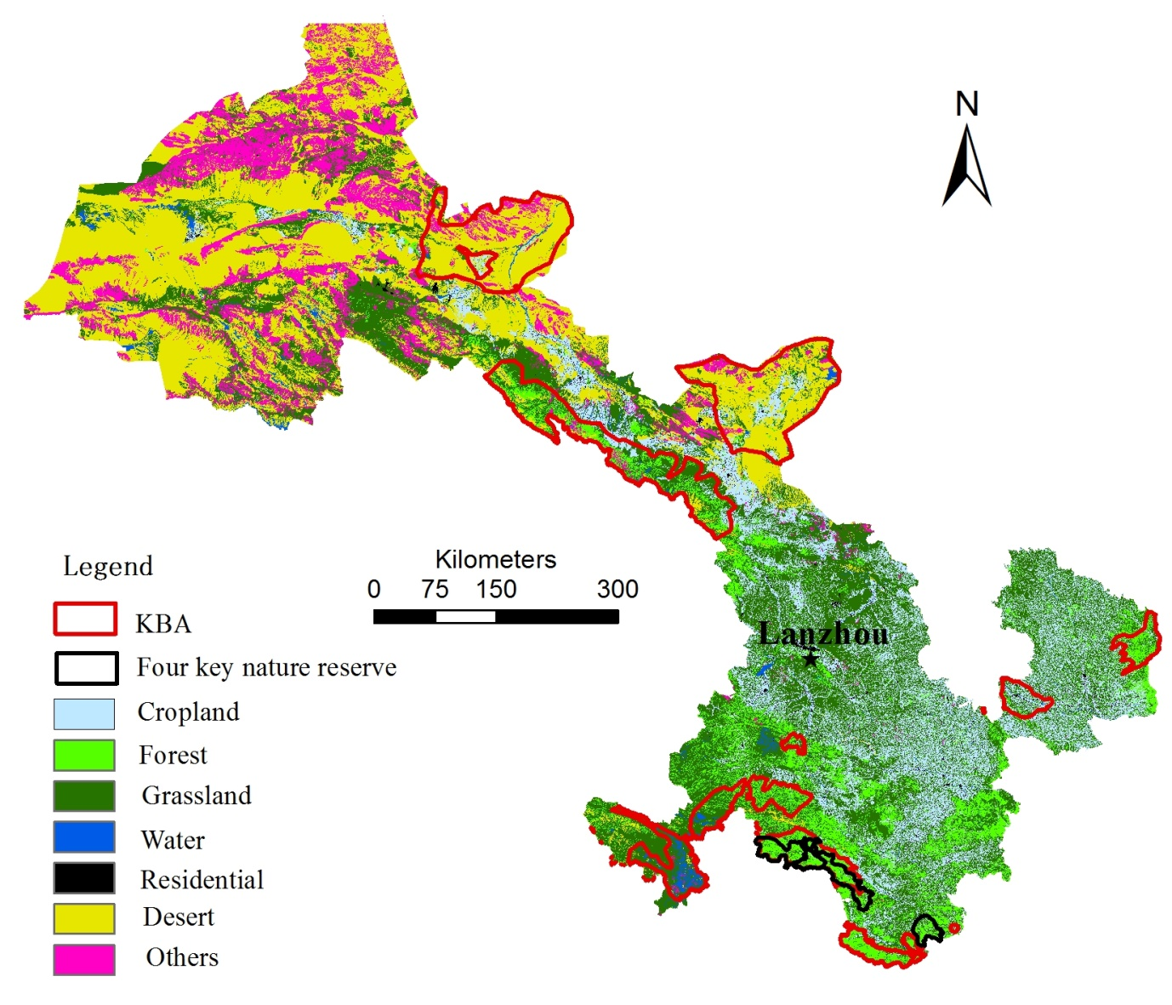

Figure 2. Four key nature reserves targeted by the project in Gansu Province.

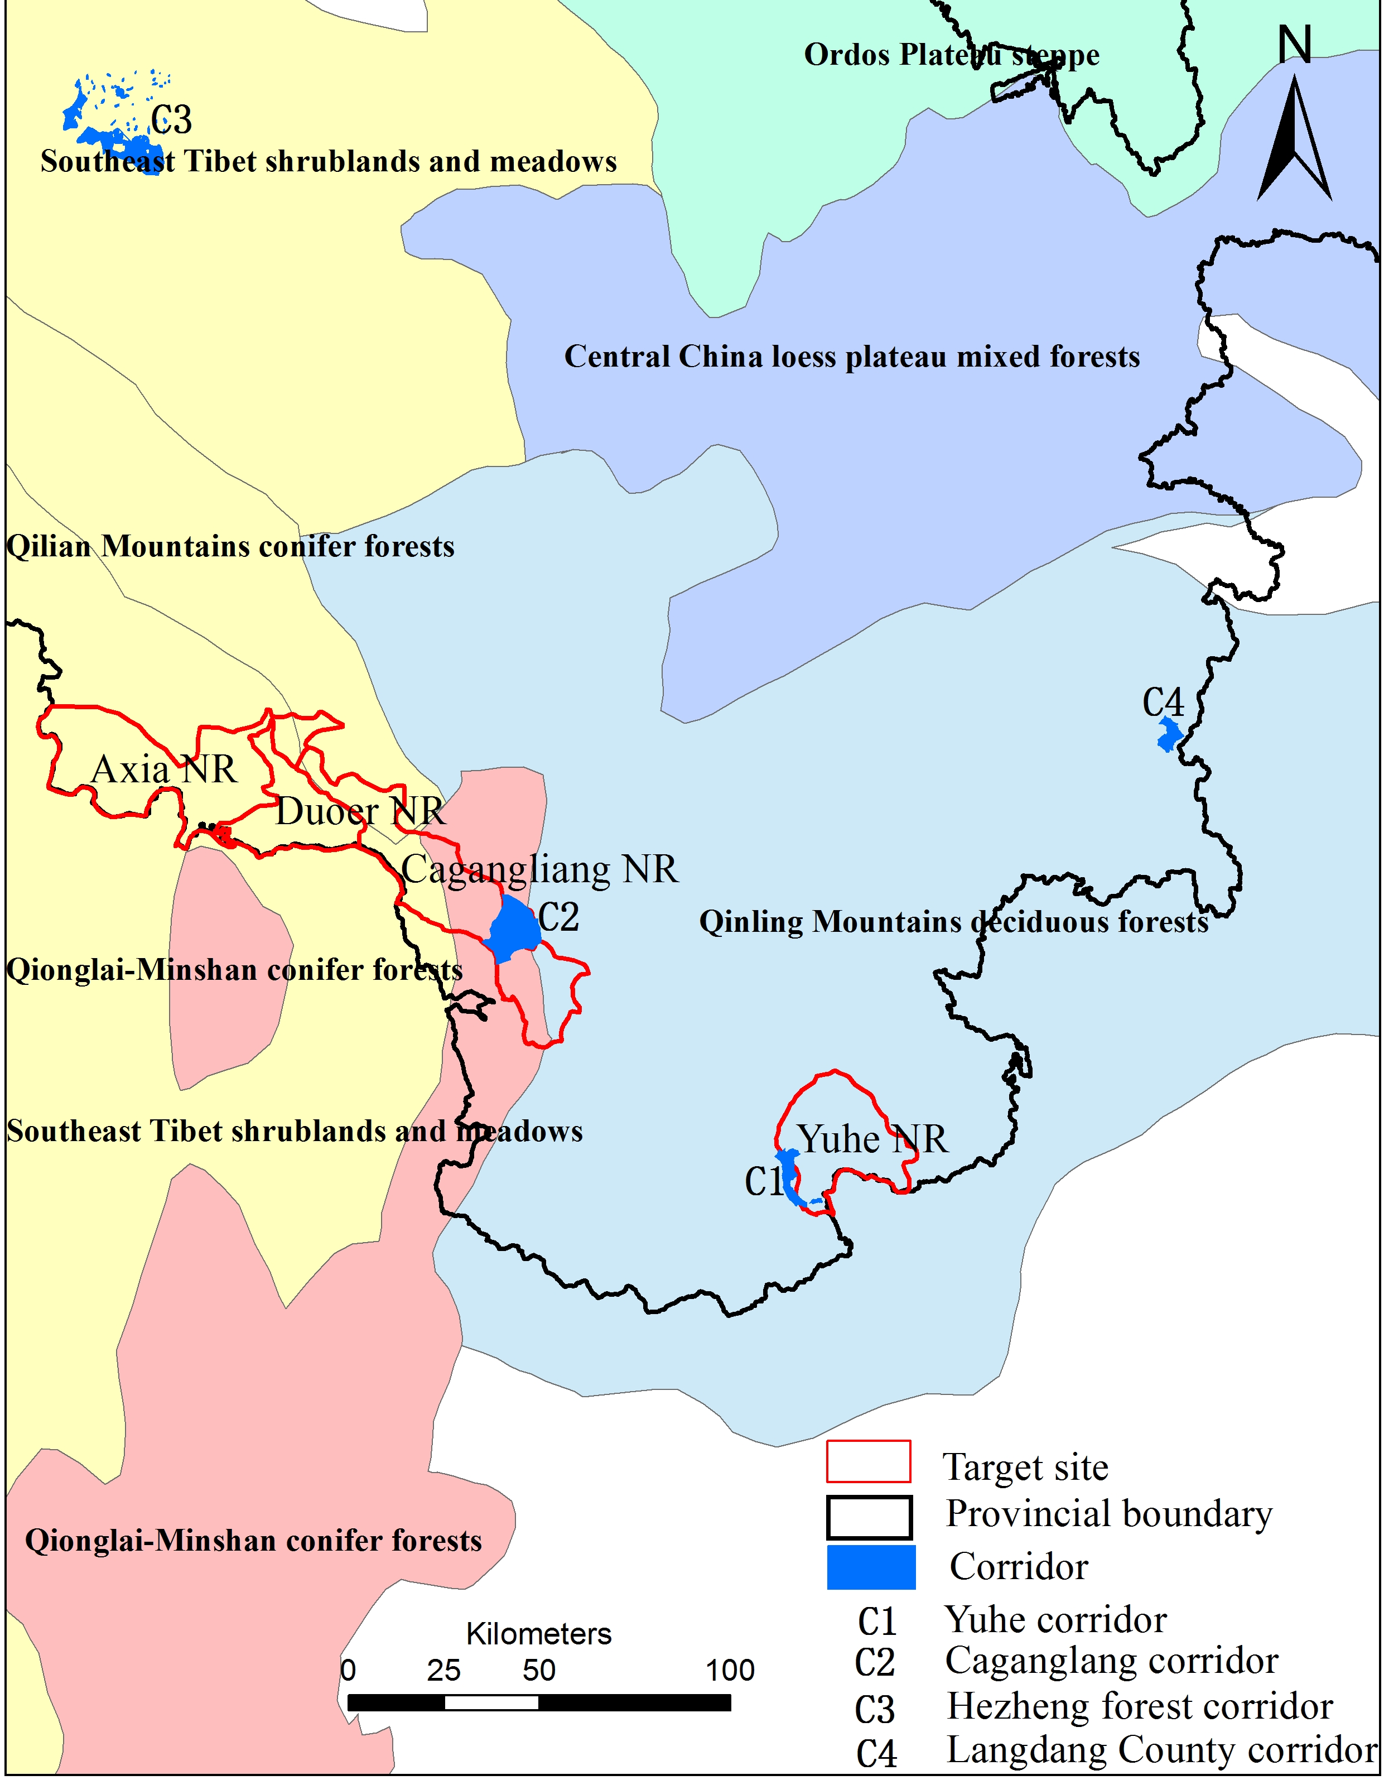

Figure 3. Location of project sites and corridor areas in relation to WWF terrestrial ecoregions.

Source: Xu Ming, Institute of Geographical Sciences and Natural Resources Research, Chinese Academy of Sciences.

There were 25,749 villagers living in the four nature reserves in 2016. Women accounts for 50 percent of the total. The majority of the rural villagers in Yuhe NR are Han majority while the majority of rural villagers in the other three project NRs are Tibetan people. Except for Yuhe NR, which is located in Longnan Municipality and has less than 3% of ethnic minority people, the other three nature reserves are all located in Gannan Tibetan Autonomous Prefecture.

Table 1. Population Composition of the Target Nature Reserves in 2016.

|  |  |  |  |  |  |  |
| --- | --- | --- | --- | --- | --- | --- |
| NR/eco-corridor  (county located) |  | Yuhe  (Wudu) | Chagangliang  (Zhouqu) | A'xia  (Diebu) | Duoer  (Diebu) | Sub-total |
| Township | # | 4 | 7 | 3 | 3 | 17 |
| Village | # | 30 | 17 | 11 | 11 | 69 |
| Household | # | 1,344 | 2,435 | 1,261 | 950 | 5,989 |
| Population | person | 5,374 | 9,739 | 5,554 | 5,082 | 25,749 |
| Male | % | 50.3 | 50.1 | 50.5 | 49.8 | 50.1 |
| Female | % | 49.7 | 49.9 | 49.5 | 50.2 | 49.9 |
| Han people | % | 97.4 | 0.5 | 0.1 | 0 |  |
| Tibetan | % | 0 | 95 | 99.9 | 100 |  |

Source: Gansu Provincial Forestry Department in November 2017.

There were 97,569 villagers living in the proposed ecological corridors in 2016. Women accounts for 50 percent of the total. Most rural villagers in the proposed ecological corridors next to Yuhe NNR and in Liangdang County are Han majority. Most people in the proposed corridor in Chagangliang are Tibetan people.

Table 2. Population Composition of the Proposed Eco-corridors in 2016.

|  |  |  |  |  |  |  |
| --- | --- | --- | --- | --- | --- | --- |
| NR/eco-corridor  (county located) | unit | Yuhe  (Wudu) | Chagangliang  (Zhouqu) | Hezheng  (Hezheng) | Liangdang  (Liangdang) | Sub-total |
| Township | # | 1 | 1 | 5 | 1 | 8 |
| Village | # | 5 | 4 | 51 | 4 | 64 |
| Household | # | 739 | 441 | 19,211 | 599 | 20,990 |
| Population | person | 2,957 | 1,831 | 90,387 | 2,394 | 97,569 |
| Male | % | 50.3 | 50.1 | 51 | 50 | 50.3 |
| Female | % | 49.7 | 49.9 | 49 | 50 | 49.7 |
| Han people | % | 97.4 | 0 | 40 | 98 |  |
| Tibetan | % |  | 100 |  |  |  |

Source: Gansu Provincial Forestry Department in November 2017.

**Tibetan ethnic minority**[1]**:** The Tibetans with a population of 4,593,100 mostly live in the Tibet Autonomous Region. There are also Tibetan communities in Qinghai, Gansu, Sichuan and Yunnan provinces. The Tibetan language belongs to the Tibetan sub-branch of the Tibetan-Myanmese language branch of the Chinese-Tibetan language family. According to geographical divisions, it has three major local dialects: Weizang, Kang and Amdo. The Tibetan script, an alphabetic system of writing, was created in the early 7th century. With four vowels and 30 consonants, it is used in all areas inhabited by Tibetans. The local Tibetans primarily use the Tibetan dialect, but the dialects of each project community are not exactly the same. During the assessments in Yangbu Village of Diebu County and Lamogaito Village of Zhouqu County, local Tibetan representatives were more inclined to communicate in Mandarin. When consulting everyone on the text used in future project training and promotional materials, the participants reported that the local Tibetans had received bilingual teaching in Tibetan and Mandarin since childhood, and they could understand both Tibetan and Mandarin. However, there may not be accurate corresponding translations in Tibetan for some natural protection and legal terms. For some elderly Tibetans who are illiterate or who cannot understand Mandarin, young people in the community, village officials, reserve management staff, and village support team members can assist with translation. All project documentation will be accessible, in a language and format that is culturally appropriate to project affected peoples, on an as-needed basis.

**Hui ethnic minority**[2]: With a sizable population of 8.61 million, the Hui ethnic group is one of China's largest ethnic minorities. People of Hui origin can be found in most of the counties and cities throughout the country, especially in the Ningxia Hui Autonomous Region and Gansu, Qinghai, Henan, Hebei, Shandong and Yunnan provinces and the Xinjiang Uygur Autonomous Region. The name Hui is an abbreviation for "Huihui," which first appeared in the literature of the Northern Song Dynasty (960-1127). It referred to the Huihe people (the Ouigurs) who lived in Anxi in the present-day Xinjiang and its vicinity since the Tang Dynasty (618-907). They were actually forerunners of the present-day Uygurs, who are totally different from today's Huis or Huihuis. During the early years of the 13th century when Mongolian troops were making their western expeditions, group after group of Islamic-oriented people from Middle Asia, as well as Persians and Arabs, either were forced to move or voluntarily migrated into China. As artisans, tradesmen, scholars, officials and religious leaders, they spread to many parts of the country and settled down mainly to livestock breeding. These people, who were also called Huis or Huihuis because their religious beliefs were identical with people in Anxi, were part of the ancestors to today's Huis. Earlier, about the middle of the 7th century, Islamic Arabs and Persians came to China to trade and later some became permanent residents of such cities as Guangzhou, Quanzhou, Hangzhou, Yangzhou and Chang'an (today's Xi'an). These people, referred to as "fanke" (guests from outlying regions), built mosques and public cemeteries for themselves. Some married and had children who came to be known as "tusheng fanke," meaning "native-born guests from outlying regions." During the Yuan Dynasty (1271-1368), these people became part of the Huihuis, who were coming in great numbers to China from Middle Asia. The Huihuis of today are therefore an ethnic group that finds its origins mainly with the above-mentioned two categories, which in the course of development took in people from a number of other ethnic groups including the Hans, Mongolians and Uygurs.

**Dongxiang ethnic minority[3]**: The Dongxiang people are Mongolic and, according to the 2010 census, their population numbers 621,500. Most of the Dongxiang live in the Linxia Hui Autonomous Prefecture and surrounding areas of Gansu Province in Northwestern China, half of them in Dongxiang Autonomous County, which is part of Linxia. The Dongxiang ethnic minority received its name from the place it lives -- Dongxiang. However, this ethnic group was not recognized as a minority prior to the founding of the People's Republic in 1949. The Dongxiangs were then called "Dongxiang Huis" or "Mongolian Huis." The Dongxiang language is basically similar to Mongolian, both belonging to the Mongolian branch of the Altaic language family. It contains quite a number of words borrowed from the Han Chinese language. Most of the Dongxiang people also speak Chinese, which is accepted as their common written language. Quite a few of them can use Arabic alphabet to spell out and write Dongxiang or Chinese words. The Dongxiangs are an agricultural people who grow potatoes, wheat, maize and broad beans as well as hemp, rapeseed and other industrial crops. Many changes took place in the Dongxiang area after the arrival of the People's Liberation Army in the autumn of 1949. Many Dongxiangs were trained to be government functionaries at various levels. Trees and grass were and are being planted on barren hills to check erosion which had plagued the Dongxiang area for ages. Large tracts of farmland on hill slopes have been transformed into terraced plots. All this, coupled with the construction of irrigation facilities, has greatly raised annual grain production. A power station and factories turning out farm implements, cement, flour, bricks and tiles have made their appearance in the area, one of the most under-developed localities in China a few decades ago. Transport and travelling have been made easier with the arrival of trucks and buses, and with the construction of a highway network that links together all the townships, and the Dongxiang area with the provincial capital of Lanzhou.

**Bonan ethnic minority[4]**: The Bonan people are a distinct ethno-linguistic group from all other Mongolic peoples, living in Gansu and Qinghai provinces in Northwestern China. They are one of the "titular nationalities" of Gansu's Jishishan Bonan, Dongxiang and Salar Autonomous County, which is located south of the Yellow River, near Gansu's border with Qinghai. Bonan are the 10th-smallest (ranked in 47th-position, out) of the 56 ethnic groups officially recognized by the People's Republic of China. Due to long years of contacts and exchanges with the neighboring Han and Hui people, the Bonan people have borrowed quite a number of words from the Han language. The Han language is accepted as the common written language among the Bonans. The economy of the Bonan consists of farming (mainly wheat and rye), raising livestock, selling local handicrafts, and working in the lumber industry. Bonan knives are renowned for their beauty and hardness and their manufacture and sale also form an important part of the local economy. The Bonan in Jishishan county follow a halal diet consisting mainly of beef and mutton, combined with carrots, potatoes and glass noodles. They also enjoy drinking tea.

**Salar ethnic minority[5]**: The Salar people numbered 130,607 people in the last census of 2010. They live mostly in the Qinghai-Gansu border region, on both sides of the Yellow River, namely in Xunhua Salar Autonomous County and Hualong Hui Autonomous County of Qinghai and the adjacent Jishishan Bonan, Dongxiang and Salar Autonomous County of Gansu and in some parts of Henan and Shanxi. There are also Salars in Northern Xinjiang (in the Ili Kazakh Autonomous Prefecture). They are a patriarchal agricultural society and are predominantly Muslim. Salars live in Gansu's Lintan County and Xining, Linxia County, and Qinghai's Hualong Hui autonomous county and Xunhua Salar autonomous county. The Salar had their own unique kinship clanships. Matchmakers and parents arrange marriages among the Salar. The Salar are an entrepreneurial people, going into multiple businesses and industries. They practice agriculture and horticulture. They cultivate chili and pepper in their gardens. Buckwheat, millet, wheat, and barley are among the crops they grow. Other important crops include melons, grapes, apples, apricots, and walnuts. A few Salar raise livestock and the local timber industry is also another source of income for some villages.

# Substantive Rights and Legal Framework

## International regulation protecting the rights of indigenous peoples

China is signatory to the United Nations Declaration on the Rights of Indigenous Peoples, a comprehensive statement addressing the human rights of indigenous peoples. The UN Declaration on the Rights of Indigenous Peoples (UNDRIP) was adopted by the General Assembly on 13 September 2007. The declaration specifically mandates the organs and specialized agencies of the United Nations system (including UNDP) to promote respect for and full application of the rights affirmed in UNDRIP. UNDP also follows the UN “Statement of Common Understanding” on Human Rights-Based Approaches to Development Cooperation providing that "human rights standards contained in, and principles derived from, the Universal Declaration of Human Rights and other international human rights instruments guide all development cooperation and programming in all sectors and in all phases of the programming process”.

The UN Convention on Biological Diversity (CBD) also known as the Biodiversity Convention, is an international treaty adopted in Rio de Janeiro in June 1992. The treaty aims to conserve the earth’s biological diversity, promote the use of resources, and promote equitable sharing of benefits from the use of resources. Parties of the CBD adopted decisions related to protected areas, ecosystem approach, education and public awareness, and indigenous and local communities. Article 8(j) of the CBD states that “Subject to its national legislation, respect, preserve and maintain knowledge, innovations and practices of indigenous and local communities embodying traditional lifestyles relevant for the conservation and sustainable use of biodiversity and promote their wider application with the approval and involvement of the holders of such knowledge, innovations and practices and encourage the equitable sharing of the benefits arising.”

## National regulation

**The Constitution** (1982, revised in 2018) addresses the issue of PA through confirming the state and collective ownership of land and natural resources and prescribing the State’s responsibility in environmental and resource protection. The Constitution emphasizes that all nationalities in the People’s Republic of China are equal. The State protects the lawful rights and interests of minority nationalities and upholds and develops a relationship of equality, unity and mutual assistance among all of China’s nationalities. The State assists areas inhabited by minority nationalities in accelerating their economic and cultural development according to the characteristics and needs of the various minority nationalities. Regional autonomy is practiced in areas where people of minority nationalities live in concentrated communities; in these areas organs of self-government are established to exercise the power of autonomy. And in exploiting natural resources and building enterprises in the national autonomous areas, the State shall give due consideration to the interests of those areas. And all these provisions are reiterated in the **Regional Ethnic Autonomy Law** (1984, revised in 2001)[6].

**The Rules of the State Council on the implementation of the Law of the People's Republic of China on Regional National Autonomy (2005)[7]** stipulates that the state strengthens the poverty alleviation and development of the ethnic autonomous areas, and emphasizes the infrastructure and the basic construction of the farmland in the poor rural areas of the autonomous areas, which focus on water, electricity, access, radio, television construction, and the transform of thatched house and dilapidated house, and ecological migration. And all these activities are based on the residents’ willingness.

Land in China is either owned by the state or by collectives, as outlined in Article 9 (Land Ownership) of the Constitution and Article 205, Part II of the Civil Law which further stipulates state ownership of forest and farmlands. In the project landscapes, the collectively held land is appropriated to local communities, regardless of their ethnic group.

**Land Rights:** China has a long history of establishing and implementing laws and regulations associated with displacement and resettlement. The National Construction Land Acquisition Measures, promulgated in 1953, was the first statute on land acquisition, demolition, removal and resettlement. These measures outlined the principles and procedures for land acquisition and set the standards for payment of compensation for acquired land, serving as the basis for the subsequent Land Administration Law. The Land Administration Law has been updated and amended several times, with regulations added to enhance the land law, including the Land Acquisition and Resettlement Regulation for Construction of Large and Medium-Sized Water Conservation Projects (1991 and 2006). The 2006 Regulations added subsidies for relocation and training for livelihoods, annual post-relocation fund support of RMB 600 per year per capita for 20 years, and community infrastructure rehabilitation and improvement based on the needs of resettled people. Additional guidelines promulgated in 2006 – Guidelines for Provision of Job Retraining and Social Insurance for Farmers that Lose Land – stipulated that the compensation and rehabilitation package also include a social security fund for rural farmers whose land is acquired and become urban citizens, and long-term compensation annually. The aim of both the 1991 and 2006 Regulations was to maintain or surpass pre-resettlement living standards which aligned China’s resettlement policy with the international standards of organizations such as the World Bank and Asian Development Bank.[8]

**Public participation:** The Opinions of the General Office of the State Council on Advancing Public Disclosure of Government Information in the Field of Approval and Implementation of Major Construction Projects, and the Opinions of the General Office of the State Council on Advancing Public Disclosure of Government Information in the Public Resource Allocation Field require that major decisions and surveys should cover all local stakeholders, and fully collect their opinions, and information should be disclosed to the public as much as possible so as to improve the transparency and efficiency of the approval and implementation of projects.

China’s policies do not require the development and implementation of a stakeholder engagement plan (SEP) that describes the times and methods of contact with stakeholders in the whole project lifecycle. During the preparation of the CPAR-3 project, a stand-alone Stakeholder engagement plan has been prepared and attached to the ProDoc to identify all stakeholders, including vulnerable groups, women and minority residents, provide timely, relevant, understandable and accessible information to stakeholders, and fully consult with them as well.

**Administration of Resettlement**: The administration and implementation of resettlement policy is essentially decentralized. Under the decentralized model of resettlement administration and management, provinces issue their own administrative standards within the guidelines of national regulations. Different provinces and even different counties apply different standards of compensation. The county government sets the multiplication figure within the range of the national standard. Major projects of national interest, such as highways and energy development (including large dams), tend to attract lower compensation standards than commercial projects. Paddy fields attract a higher multiplication factor than mountainous woodlands, and orchards have a higher multiplication factor than economic woodlands. The 2006 Regulations are also weighted towards compensation as a means of restoring rights rather than benefit sharing or development.

There is no specific law or regulation regarding compensation for landowners or households resettled from their lands due to biodiversity conservation purposes. The laws and regulations on resettlement discussed above have been applied for cases of ecological migration. Central government notices have been issued that reinforce the land rights of farmers and restricts involuntary requisition of collectively held farmland; for example:

* Notice issued by the State Council on 27 December 2010 on Strictly Regulating a Balance between Urban Development and Practical Treatment of Rural Land Issues. Point No. 8 indicates that it is forbidden to encroach on farmers’ interests. Local communities need to be informed of planned developments and if exchange of land cannot be realized without consent by the local communities and farmers.
* Notice issued by the Ministry of Land Resources on 26 June 2010 on Land Requisition Management. Point No. 11 states that after a proposal for land requisition is approved, public notice and compensation planning may start synchronously. If farmers have different opinions regarding the arrangements, the government must provide further information to the farmers until their consent is granted. Involuntary land requisition is forbidden.
* Urgent Notice issued by the Ministry of Land Resources on 14 June 2006 on Strict and Impartial Law Enforcement to Restrain Illegal Land Uses. Point No. 4 indicates that the legal rights and interests of farmers whose land will be requisitioned must be protected. Prior to requisitioning collectively held farmland, farmers must be informed and agree to the arrangements. If compensation and a new residence is not provided, the planned land requisition will be stopped.
* Urgent Notice issued by the State Council on 30 April 2004 on Conflict Resolutions Associated with the Current Rural Land Contract. Point No. 21 indicates that it is forbidden to force farmers to transfer their land rights against their will.

Table 3. Other applicable social laws and regulation that may affect ethnic minorities.

| No. | Name | Version | Applicability |
| --- | --- | --- | --- |
| I. General laws on social risk management | | | |
|  | Interim Regulations on Major Administrative Decision-Making Procedures | 2019 | Major administrative decisions shall be made under the principle of democratic decision-making, opinions shall be fully solicited from all parties, and it shall be guaranteed that the people participate in decision-making through various channels and forms.  If any major administrative policy may affect social stability and public security adversely, the undertaker or any other agency responsible for risk assessment shall assess the risk controllability of the draft decision. |
|  | Social Stability Risk Assessment for Major Fixed Asset Investment Projects | 2012 | The social stability risk assessment shall include: 1) if any major issue is meeting most people’s final needs, being financially affordable, and being understood and supported by most people; 2) if all major matters have been subject to consideration of various restrictions; 3) if any major security event will occur if local residents strongly object the project, and if there is any contingency plan; 4) potential major issues affecting social stability. |
| II. Laws on labor management | | | |
| 3. | Labor Law | Amended in 2018 | This Law applies to enterprises, individually-owned economic organizations (hereinafter referred to as the employer) and laborers who form a labor relationship with them within the boundary of the Peoples Republic of China. State departments, institutional organizations and social groups and laborers who form a labor relationship with them shall follow this Law.  Forced labor shall be prohibited. Any labor contract involved forced labor shall be illegal. Anyone who uses laborer by force, threat or illegal restriction of personal freedom shall be prosecuted criminally. |
| 4. | Labor Law  Labor Contract Law | Amended in 2018  Amended in 2012 | A labor contract should be entered into to define both parties’ rights and obligations.  When an employer hires an employee, it shall faithfully inform him of the work contents, conditions and location, occupational harm, work safety state, remuneration, and other information which the employee requires to be informed.  Where an employer formulates, amends or decides rules or important events which are directly related to the interests of the employees, such rules or important events shall be discussed at the meeting of employees' representatives or the general meeting of all employees, and the employer shall negotiate with the labor union or the employees' representatives on a equal basis. |
| 5. | Regulations on Labor Security Supervision | Amended in 2018  2004 | China has a sound labor dispute mediation system through a corporate committee under the formal trade union system. Workers may also appeal through the labor bureau directly.  the labor security supervision over enterprises and individual industrial and commercial households (hereinafter referred to as the employing entities) shall be governed by these Regulations. The labor security supervision over job intermediary institutions, occupational skills training institutions, and occupational skills assessment and authentication institutions shall be conducted in accordance with these Regulations.  The labor security supervision over an employing entity shall be under the jurisdiction of the labor security administration at the county level or at the level of a city divided into districts at the locality of employment by the employing entity.  Labor security supervision shall be conducted in such forms as routine inspection, written review, special inspection, and complaint investigation. |
| 6. | Trade Union Law | 2009 | All physical and mental workers of enterprises and public institutions shall have the right to join and organize trade unions, regardless of ethnic group, race, gender, occupation, religion and education. An enterprise or public institution shall establish a trade union according to law within one year after opening.  The trade union shall urge enterprises and public institutions to cover endowment, unemployment, medical, injury, maternity and other social insurance for workers according to law.  The trade union shall assist enterprises and public institutions in collective welfare, salary payment, social insurance, labor safety and health, etc. |
| 7. | Law of the PRC on the Protection of Rights and Interests of Women  Special Provisions on Labor Protection of Female Employees | Amended in 2018  2012  2017 | Special protection shall be offered to women and children, and they shall not be hired for dangerous jobs.  Women shall enjoy the same labor and social security rights as men, and receive equal pay for equal work.  The employer shall protect women’s safety and health at work, and not assign unsuitable jobs to women. Women enjoy special protection during menstruation, pregnancy, lying-in and breastfeeding periods.  The employer shall prevent sexual harassment on female workers, and protect their privacy when handling their appeals. |
| III. Policies on information disclosure | | | |
| 8. | Opinions of the General Office of the State Council on Advancing Public Disclosure of Government Information in the Public Resource Allocation Field | 2016 | The basic information, transaction process information, bidding information, contract execution and performance, etc. of a public resource project shall be disclosed by the administrative department or public institution managing or allocating public resources respectively; the administrative departments concerned should disclose law violation and discredit information along. |
| 9. | Regulations on Complaint Letters and Visits | 2005 | Transparent grievance redress channels have been established, and implementation measures for further appeals are in place. Citizens, legal persons or other organizations shall submit suggestions, opinions or appeal requests to governments at all levels by way of letter, e-mail, telephone or visit, etc., to be handled by competent administrative authorities according to law.  The department for letters and visits of the people's government at or above the county level shall, upon receiving a letter or visit, register the letter-or-visit matter presented and handle it on the merits of each case within 15 days. The matter presented by a letter-writer or visitor shall be handled within 60 days from the date it is accepted. If the matter is complicated, the time limit for handling it may be extended appropriately upon the approval by the responsible person of the administrative organ concerned, but the period extended shall not exceed 30 days, and the letter-writer or visitor shall be notified of the reasons for such extension. |

Table 4 - Other applicable social laws and regulation that may affect ethnic minorities

## Regulation at the local level

The regulations of the people's Republic of China on nature reserves were issued by the State Council of the people's Republic of China on October 9, 1994 and came into force on December 1, 1994. The regulation clearly stipulates that the construction and management of nature reserves should properly handle the relationship between the production and life of indigenous residents, delimit nature reserves, solicit the opinions of local communities and take into account the needs of production and life of indigenous residents. In 2019, China issued the guiding opinions on establishing a nature reserve system with national parks as the main body, which clearly proposed to protect the rights and interests of indigenous residents.

These laws and regulations fundamentally and systematically protect the rights and interests of local communities and indigenous residents in the process of national park construction. For some regions in China with 1 – 2 ethnic groups being the local majority population like Tibetan, Han, and Mongolia People, there are some local regulations for ensuring native ethnic groups’ rights and interests. Qinghai area of Qilian Mountain National Park mainly involves Menyuan County and Qilian County of Haibei Tibetan Autonomous Prefecture, Tianjun county and Delingha city of Haixi Mongolian Tibetan Autonomous Prefecture. The two Autonomous Prefectures have legislative competence to develop their own laws. On September 25, 2004, the 12th meeting of the Standing Committee of the Tenth People's Congress of Qinghai Province approved the regulations on the autonomy of Haibei Tibetan Autonomous Prefecture. On July 18, 1987, the 27th meeting of the Standing Committee of the Sixth People's Congress of Qinghai Province approved the regulations on the autonomy of Haixi Mongolian and Tibetan Autonomous Prefecture. These autonomy regulations are normative documents formulated by the people's congresses of China's national autonomous areas in accordance with the powers conferred by the Constitution and in accordance with the political, economic and cultural characteristics of the local nationalities. These regulations stipulate the basic organizational principles, institutional settings, functions and powers of autonomous organs, working system and other major issues related to the regional autonomy implemented in this region. They are the comprehensive activity guidelines for the implementation of regional national autonomy in national autonomous areas.

## Legally recognized rights to lands

The C-PAR 2 entails activities that are contingent on establishing legally recognized rights to lands, territories or resources that ethnic minorities have traditionally owned, occupied and used or acquired. The National Park may affect the livelihood of some original residents, mainly in terms of land ownership, production mode and risk of resettlment. There are several aspects to clarify what contingent activities on establishing legally recognized rights to lands are:

* It is important to note that the funds of GEF project and matching funds will not support any resettlement that may take place during the C-PAR2 implementation period. Any such resettlement would likely be under the auspices of the implementation plan for the NP system issued by the government in September 2017 which notes that any resettlement must be gradual and voluntary. In accordance with international best practice, the risks that have the potential to eventuate through activities supported solely by associated facilities (not directly related to C-PAR2) have been included in risk assessment undertaken during the completion of the ESIA. Therefore, it is important to note that while this risk has been assigned a significance level of ‘high’, this is not a direct reflection of the probability and consequence/impact of this risk eventuating as a direct result of C-PAR2 activities.
* Land use right: the collective land within the scope of Qilian Mountain National Park has often been subcontracted to households. Planning and construction on this part of land or grassland involves the separation of land ownership and use right, which will have a certain impact on the grazing mode and intensity of herdsmen, and farmers need to be compensated in the past.

# Environmental and Social impacts to ethnic minorities, and related mitigation measures

In accordance with UNDP SES, the Social and Environmental Screening Procedure (SESP) has been applied to C-PAR 2 during the project development phase. Based on the assessments, some social and environmental risks have been identified for this project. The Environmental and Social Impact Assessment (ESIA) process is considered a key component for the implementation of the project and provides a solid base for the assessment of issues relating to IP, which includes consideration of the potential impacts of project activities on local people and their livelihoods.

Between December 2019 and June 2022, the project's social integration experts with the support of Gansu Project Office staff, the project's Model Protected Area Administration and Forestry Bureau, and other project experts conducted a systematic assessment of the environmental and social impacts of the project to enhance the protected area system in Gansu Province and strengthen the conservation of biodiversity.

The ESIA identified 10 risks contingent on establishing legally recognized rights to lands, territories or resources that indigenous peoples have traditionally owned, occupied or otherwise used or acquired.

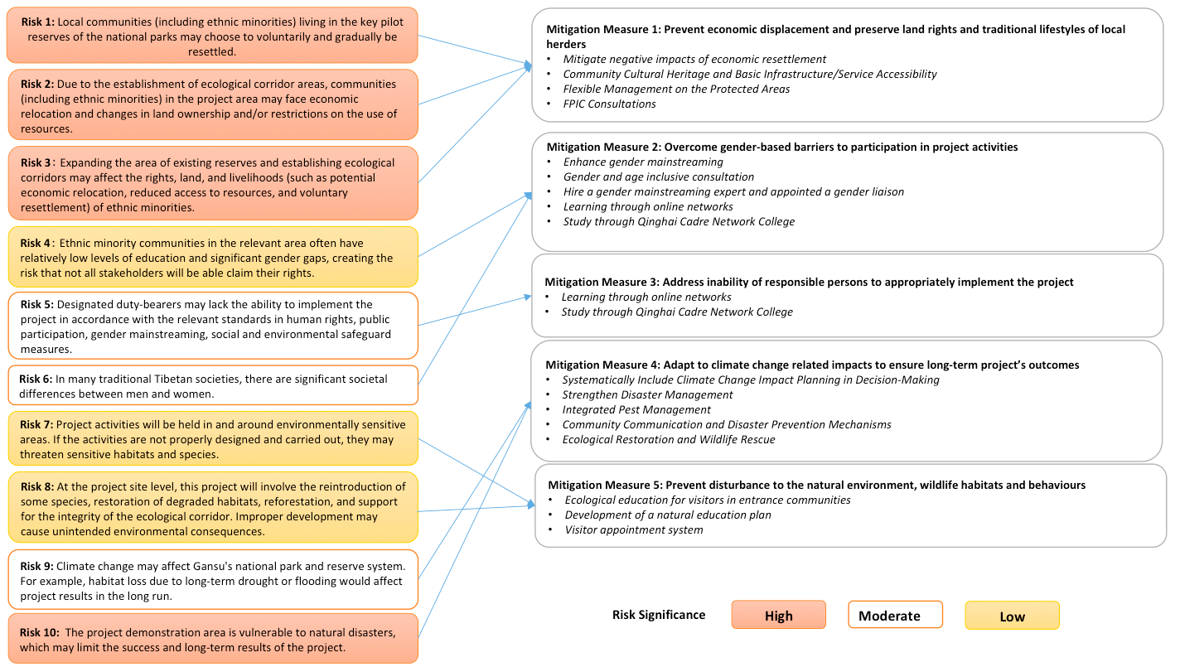

Figure 4. Project risks and related mitigation measures as outlined in the ESIA.

## Project social risks to ethnic minorities

**Risk 1: Local communities (including ethnic minorities) living in the key pilot reserves of the national parks may choose to voluntarily and gradually be resettled.**

This risk refers to physical displacement, which occurs when individuals or communities are fully or partially no longer able to occupy an area and must relocate to a new location. The implementation plan for the NP system issued by the government in September 2017 (which is not an element of the UNDP/C-PAR 2 project) notes that in key conservation zones, resettlement of local communities would support the full achievement of conservation objectives and that any such resettlement must be gradual and voluntary in nature. In accordance with international best practice, the risks that have the potential to eventuate through activities supported solely by associated facilities (not directly related to C-PAR 2) have been included in risk assessment undertaken during the completion of this ESIA. Again, it is important to note that while this risk has been assigned a significance level of ‘high’, this is not a direct reflection of the probability and consequence/impact of this risk eventuating as a direct result of C-PAR 2 activities. Voluntary resettlement is proposed in the national park pilot-zoning plan (which is not under the auspices of C-PAR 2 but is rather an ancillary/associated initiative under government funding and management).

When conducting community surveys, most villagers understood and supported moving out of the core area of ​​the reserve and ecological corridors. In recent years, with the promotion of ecological environmental protection and the spread of ecological protection-related legal information, awareness of environmental protection and associated laws has greatly improved. Most villagers could understand the importance of nature protection and basically knew the relevant laws and regulations. In addition to protection and legal awareness, community residents were (in respect of projects outside the auspices of C-PAR) willing to relocate because of economic interests. Most of the communities originally in the core area of ​​the reserve had inconvenient transportation, relatively high altitude, and poor natural conditions. The land was relatively uneven and could not easily be used for agricultural production. The lands were also often destroyed by wild animals such as wild boars. The residents living in the reserve were mainly engaged in agricultural production and animal husbandry with a low unit output value. Therefore, the income of the residents staying in the community was not high, and the economic development level of the community was relatively low.

|  |
| --- |
| **SES 6 requirement on analysing potential relocation and displacement risks and impacts**  The UN Committee on Economic, Social and Cultural Rights has deemed that forced relocations are “incompatible” with the rights affirmed in the Convention on Economic, Social and Cultural Rights. Forcible relocation of indigenous peoples severs their relationship to their ancestral lands and, as observed by the UN Sub-Commission on Economic, Social and Cultural Rights, “where population transfer is the primary cause for an indigenous people's land loss, it constitutes a principal factor in the process of ethnocide.” “For indigenous peoples, the loss of ancestral land is tantamount to the loss of cultural life, with all its implications.”[9]  Standard 6 (paras. 8, 9) reflects the emphasis in international law that only under narrow and exceptional circumstances should relocation of indigenous peoples be considered. Forcible removal is prohibited and in all cases, no relocation of indigenous peoples concerned will take place without their free, prior and informed consent.[10] Where there are potential risks of physical and economic displacement, the requirements of Standard 5 also need to be addressed (without prejudice to the requirements of Standard 6).  In the context of indigenous peoples, economic displacement might be implicated where project activities cause loss of critical assets. The assessment would need to identify the precise scope and extent of impacts on all potentially affected people. A survey of potentially affected indigenous peoples would need to be conducted together with socioeconomic analysis in order to determine eligibility for entitlements and baseline information for measuring restoration of incomes and living standards. |

**Risk 2:** **Due to the establishment of ecological corridor areas, communities (including ethnic minorities) in the project area may face economic relocation and changes in land ownership and/or restrictions on the use of resources.**

This risk refers to economic displacement, which occurs when individuals or communities are fully or partially restricted in their access to land or resources that are important to their livelihoods and economic well-being. These effects may affect women differently from men. As C-PAR 2 activities may result in impacts on traditional livelihoods, stakeholder consultations regarding the possibility of voluntary resettlement is required, which must include application for FPIC in accordance with the project's socio-environmental screening process and environmental and social management plans. The development of master plans for protected areas and ecological corridor networks must also focus on similar safeguards. It must be noted that any relocation or resettlement, as is the case with any resettlement that may have occurred prior to this project, will not be supported by GEF funds and is not within the purview of the C-PAR 2 project.

The impact of risk 2 in each protected area involved in the project is different. Some protected areas (such as the Fengxiang Conservation Station of Yuhe Nature Reserve) have small land area per capita, uneven land, and low output value. The main income of villagers is not agricultural production, and the economic dependence of local residents on the land is low. Other communities around the reserve use agricultural production as the main source of income, and economic relocation and land ownership changes may have a greater impact on these communities.

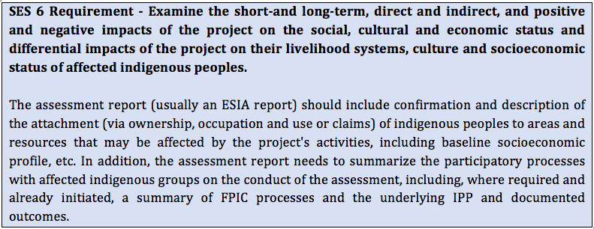

**Risk 3:** **Expanding the area of ​​existing reserves and establishing ecological corridors may affect the rights, land, and livelihoods (such as potential economic relocation, reduced access to resources, and voluntary resettlement) of ethnic minorities in and around the four exemplary reserves and Hezheng County.**

Adjusting the boundaries of reserves and establishing ecological corridors is likely to affect the minority population in and around the protected area. It must be noted that any such economic relocation is not under the auspices of C-PAR 2 but is rather an ancillary/associated initiative under government funding and management but has nonetheless been factored into this risk assessment due to difficulties differentiating the impacts caused by C-PAR and ancillary government initiatives being undertaken in an overlapping area.

The United Nations Declaration on the Rights of Indigenous Peoples clearly emphasizes that “indigenous peoples shall not be forced to move away from their lands or territories. If the freely given informed consent of the indigenous peoples has not been obtained in advance, fair compensation has been agreed upon, and the options of return are not provided, migration is not allowed.” Rights similar to those stated in the declaration are also acknowledged by the Chinese government and society. Since indigenous people’s beliefs, lifestyles, and cultural customs are largely based on interaction with the land, any voluntary resettlement or changes in land use restrictions will have a greater impact on ethnic minorities.

|  |
| --- |
| **SES 6 Requirement -** **The perspective of the indigenous peoples concerned**  This is a critical starting point for impact assessment, and the indigenous peoples concerned should have ample opportunities as early as possible to participate in the assessment and development of avoidance and mitigation measures. Indigenous peoples’ traditional knowledge is a valuable resource for identifying and addressing potential environmental and social risks, including hazards and disaster risks, and should be incorporated throughout the project cycle. |

**Risk 4:** **Ethnic minority communities in the relevant area often have relatively low levels of education and significant gender gaps, creating the risk that not all stakeholders will be able claim their rights.**

During the inception and project planning phases, meaningful consultation was conducted with representatives from local ethnic minority groups within the boundaries of C-PAR 2 sites (See Annex A). Local people (including EM) were presented with the ability to withhold consent and lodge complaints via the respective GRM channels.

The administration of most of the four exemplary reserves involve local Tibetans into their daily work. This is particularly the case for the Duoer Nature Reserve Management Bureau, most of whose staff are local Tibetans. In addition to nature protection and reserve management, the staff also participate in targeted poverty reduction work for communities in the reserve. The staff of the Reserve Management Bureau can assist in conveying this project’s content to community members and aid in encouraging them to participate in discussions and decision-making. The staff of this organisation will be particularly instrumental in promoting the participation of those who cannot communicate in Mandarin.

The local Tibetans primarily use the Tibetan dialect, but the dialects of each project community are not exactly the same. During the assessments in Yangbu Village of Diebu County and Lamogaito Village of Zhouqu County, local Tibetan representatives were more inclined to communicate in Mandarin. When consulting everyone on the text used in future project training and promotional materials, the participants reported that the local Tibetans had received bilingual teaching in Tibetan and Mandarin since childhood, and they could understand both Tibetan and Mandarin. However, there may not be accurate corresponding translations in Tibetan for some natural protection and legal terms. For some elderly Tibetans who are illiterate or who cannot understand Mandarin, young people in the community, village officials, reserve management staff, and village support team members can assist with translation. All project documentation will be accessible, in a language and format that is culturally appropriate to project affected peoples, on an as-needed basis.

**Risk 5: Designated duty-bearers may lack the ability to implement the project in accordance with the relevant standards of the United Nations Development Programme and the Global Environment Facility in human rights, public participation, gender mainstreaming, social and environmental safeguard measures.**

Within the project period, should the project-designated responsible entities lack the ability to implement the project in accordance with standards related to social and environmental protection measures, then the effective implementation of the environmental and social management plan is doubtful, potentially resulting in increased impact on the stakeholders of the project. For example, if the gender liaison officers in each project’s NP do not have the ability to collect and supervise the gender mainstreaming plan, then detection and screening of gender inequality issues in the project will not properly be implemented.

**Risk 6: In many traditional Tibetan societies, there are significant societal differences between men and women. Project activities may inadvertently reinforce this situation and limit women's participation in project implementation.**

In organizing community discussion activities, it is generally necessary to ask the project staff to “re-invite more community women representatives.” However, there are sometimes none or only one woman participating. When male representatives are present, female participants are less likely to actively participate in community discussions. It is usually necessary for meeting collaborators to question and designate a woman to answer, or after repeated questions, female participants are more likely to contribute. With the promulgation and implementation of the project of “Gender Mainstreaming,” the participation of women in Tibetan communities is increasing. Some young Tibetan women returned to the community after having undertaken further education, bringing back considerations of gender equality and women's participation in social affairs that stand in contrast to traditional patriarchal perspectives. These messages and ideas are also filtering through to the older women in the community. During the discussion in Lamogeto Village in the Chagangliang Reserve and Yangbu Village in the Duoer Reserve, young community women representatives participated actively in the discussion.

|  |
| --- |
| **SES 6 requirement on analysing gender dimensions and impacts on marginalized groups**  As part of the screening process (see the SESP screening checklist questions regarding human rights and gender equality), UNDP undertakes an initial mapping of the constituency that makes up the potentially affected indigenous peoples, including inter alia gender equality considerations, impacts on marginalized groups and individuals (including persons with disabilities, youth, poor, etc.) and risks of impacts on voluntarily isolated groups. Disaggregated data on the composition of potentially affected indigenous peoples should be collected as part of the scoping and assessment of potential adverse social impacts. Potential differentiated impacts on marginalized or vulnerable groups should be examined. In assessing potential gender and power relation impacts, opportunities for women's empowerment should be identified. It should be recognized that while often marginalized, women often play an indispensable role with respect to the management and use of indigenous lands and resources, protection of livelihoods, and the transmission of the communities’ culture. |

## Project environmental risks to ethnic minorities

**Risk 7: Project activities will be held in and around environmentally sensitive areas. If the activities are not properly designed and carried out, they may threaten sensitive habitats and species.**

The goal of this project is to strengthen the reserve system in Gansu Province. At all stages of project initiation, implementation and evaluation, it will focus on enhancing the effectiveness of the landscape, improving the utilization efficiency of the existing nature reserves and surrounding land, and improving the protection of reserve areas and endangered areas. Nonetheless, should some malpractice occur, the project may inadvertently cause environmental pollution/disruption through the release of wastes (such as community sewage and garbage), and vegetation destruction. Several of the intervention sites for C-PAR 2 project activities are in areas of critical habitat/high conservation value areas. Poorly designed or executed project activities, could unintentionally damage critical or sensitive habitats and ecosystems.

**Risk 8: At the project site level, this project will involve the reintroduction of some species, restoration of degraded habitats, reforestation, and support for the integrity of the ecological corridor. Improper development may cause unintended environmental consequences.**

The project will involve the management and restoration of habitats in and around the reserve area, as well as the reintroduction of threatened species to other areas. The restoration of forest habitats is needed when establishing ecological corridors and expanding the area of reserves. The project promotes the re-introduction of endangered species in compliance with international standards for species introduction. However, if habitat restoration and reforestation are improperly implemented, it may cause an invasion of alien species, reduction of biodiversity, and exacerbation of threats posed by forest pests and diseases. If the re-introduction of endangered species is improperly implemented, it may cause genetic contamination of existing populations, and may also play a role in the transmission of diseases to animals originally raised by the Endangered Animal Protection Center.

**Risk 9: Climate change may affect Gansu's national park and reserve system. For example, habitat loss due to long-term drought or flooding would affect project results in the long run.**

Given the complex and multifaceted nature of climate change, specifics of the effect of climate change on project activities are difficult to predict. The probability of negative impacts of climate change on national parks and reserves is, however, categorized as “moderate”. Climate change has caused frequent floods in southern Gansu and has brought increased precipitation to Zhengxian County, another project demonstration site in central Gansu. Therefore, from the point of view of several exemplary areas, the impact of this risk is minor, I = 2. Given the complex, and multifaceted nature of climate change, specifics of the effect of climate change on project activities are difficult to predict. The probability of negative impacts of climate change on national parks and reserves is still moderately likely, P = 3.

**Risk 10: The project demonstration area is vulnerable to natural disasters, which may limit the success and long-term results of the project.**

Natural disasters refer to abnormal phenomena that occur in nature, which can impose catastrophic impacts on surrounding organisms and human society. Natural disasters can cause serious damages such as vegetation destruction, habitat loss, and species reduction. The process of responding to natural disasters can also further affect the protected area and surrounding communities if improperly implemented.

## Mitigation Measures

A full detailed list of environmental and social mitigation and management measures is presented in the project’s ESMP. The ESMP summary table has been included in the ESIA in section 7.1. The following section provides further details on to implement potential mitigation and management measures that are relevant for ethnic minorities, and shall be implemented by the C-PAR 2 project.

Where potential risks and adverse impacts to ethnic minorities, their lands, territories, and resources are identified, the details for the planned measures to avoid, minimize, mitigate, or compensate for these adverse effects are described in this section. Mitigation measures also include, where relevant, measures to promote and protect the rights and interests of the indigenous peoples including compliance with the affected peoples’ internal norms and customs.

For the purpose of presenting cross-cutting and effective management measures, the mitigation actions for addressing the social and environmental risks relevant to ethnic minorities have been categorized into 2 categories. Mitigation measures not directly affecting ethnic minorities are addressed in the ESIA and ESMP.

* **Mitigation Measure 1: Prevent economic displacement and preserve land rights and traditional lifestyles of local herders**
* **Mitigation Measure 2: Overcome gender-based barriers to participation in project activities**

### Mitigation Measure 1: Prevent economic displacement and preserve land rights and traditional lifestyles of local herders

*Relevant risks: 1, 2, and 3*

**Action 1: Mitigate negative impacts of economic resettlement**

This action involves providing assistance in developing alternative livelihoods within protected areas. The livelihood development/engagement measures discussed below seek to mitigate and manage potential impacts caused by restrictions on traditional livelihoods. In assisting the development of alternative livelihoods, the intention is to reduce the need for relocation that otherwise may have been caused by impacts imposed on traditional livelihoods by project and associated activities. The reserve administration should encourage community residents to participate in species and habitat conservation protection work as an alternative to traditional livelihoods. For anyone that is actively contributing to the protection of the ecological environment in the community, incentives and awards could be given out as a form of motivation and encouragement.

For any traditional livelihood activities that could pose a threat to the species and habitat in the area, the reserve administration could guide residents to alternative practices that are less dependent on or detrimental to natural resources. One way to maintain and develop sustainable livelihoods in the community despite any restrictions that may be imposed on traditional livelihoods would be to invite all sectors of society to participate in exploring alternatives for future economic development. For instance, ecotourism has proven to be an effective alternative in many regions. This could be a great method to maintain and expand the economic sustainability in the protected areas. The reserve administration should actively recruit the farmers and agricultural workers as full-time reserve staff or as part time forest rangers and patrollers and continue to encourage local residents to take responsibility in monitoring scientific research and studies. To this end, Livelihood Action Plans (LAP) should be developed for each one of the areas in which C-PAR 2 will be implemented. A LAP details the procedures and actionsthat will be undertaken in order to ensure that the capacity, production levels, and standards of living of economically displaced people are improved or at least restored, and that displaced people are compensated adequately.

It must be noted that GEF funds will not be used for resettlement. Any resettlement must be voluntary in nature and conducted and financed by the government of China. Involuntary resettlement is not planned under the ongoing establishment of the NP system in China and will not be supported by this project. However, should any unplanned, voluntary resettlement take place, the FPIC process and letter of commitment must be adhered to.

**Action 2: Community Cultural Heritage and Basic Infrastructure/Service Accessibility**

The cultural traditions and religious beliefs of relevant communities should be fully respected in accordance with UNDP SES 4. At voluntary resettlement sites, the continuation of traditional customs and activities of the residents should be facilitated as much as possible. It must also be ensured that voluntarily relocated people and families have access to basic infrastructure and services such as transportation, medical care, education, and commodity markets in the new resettlement sites. Resettlement sites should be designed through meaningful participation and consultation with project affected peoples.

**Action 3: Flexible Management on the Protected Areas**

If species and habitat conservation require economic transformation or resource use restrictions, then the protected areas and the local government should not adopt a one-size-fits-all approach. The ecological impacts of each production activity in each area must be assessed in detail to minimize the scope of economic disruption and resource use restriction.

For example, in ecological corridor areas community residents can continue to engage in production activities such as nursery stock, and under the guidance of biodiversity experts that determine that adequate habitat for wildlife is guaranteed, they can plan thinning to seedlings that have economic value within the area. Furthermore, C-PAR 2 will support more effective community co-management and engagement in PA management achieving livelihoods improvement and threat reduction. This will include facilitating the production and marketing (including online marketing) of PA-friendly sustainable products (e.g. non-forest timber products and honey) and eco-tourism development by selected local communities at the project demonstration sites.

**Action 4: FPIC Consultations**

Culturally appropriate consultations will be carried out with the objective of informing local communities about any activities that may potentially impact them or their resources, following a process of Free Prior and Informed Consent (FPIC). The details of the FPIC process outlined in Chapter 5 will be communicated to relevant communities regarding any matters that may affect the rights and interests, lands, resources, territories, and traditional livelihoods of those people. Any such activities shall not be conducted/undertaken unless agreement has been achieved and maintained through the FPIC process. The withdrawal by relevant parties of consent provided under and in accordance with the FPIC process will be taken account of by the proponents of this project, with the cessation of any activities for which consent has been withdrawn. In addition, project affected peoples will also be able to lodge complaints/grievances via the project-level GRM.

For decisions regarding marginalized groups, the project will include the communities and promote their full participation in decision-making. Decision-making processes shall involve consultation with all stakeholders in the community, keeping in mind the gender-gaps that may be present in a traditional patriarchal Tibetan society.The local Tibetans primarily use the Tibetan dialect, but the dialects of each project community are not exactly the same. During the assessments in Yangbu Village of Diebu County and Lamogaito Village of Zhouqu County, local Tibetan representatives were more inclined to communicate in Mandarin. When consulting everyone on the text used in future project training and promotional materials, the participants reported that the local Tibetans had received bilingual teaching in Tibetan and Mandarin since childhood, and they could understand both Tibetan and Mandarin. However, there may not be accurate corresponding translations in Tibetan for some natural protection and legal terms. For some elderly Tibetans who are illiterate or who cannot understand Mandarin, young people in the community, village officials, reserve management staff, and village support team members can assist with translation to ensure that the FPIC process is fully understood.

| Risk # | Mitigation /  Management Action | Monitoring (indicators and reporting) | Responsible Party |
| --- | --- | --- | --- |
| **1, 2, 3** | **Action 1**:  Mitigate negative impacts of economic resettlement | Providing assistance in developing alternative livelihoods within protected areas. In assisting the development of alternative livelihoods, the intention is to reduce the need for relocation that otherwise may have been caused by impacts imposed on traditional livelihoods by project and associated activities. | Gansu Project Office |
| **Action 2**:  Community Cultural Heritage and Basic Infrastructure/Service Accessibility | At voluntary resettlement sites, the continuation of traditional customs and activities of the residents should be facilitated as much as possible. | PMO |
| **Action 3**:  Flexible Management of the Protected Areas | The ecological impacts of each production activity in each area must be assessed in detail to minimize the scope of economic disruption and resource use restriction. | Gansu project Office Staff |
| **Action 4:** FPIC Consultations | Annual project reports must include information regarding how the FPIC process has been conducted. It must be made clear: (i) what information was provided to local communities in consultations; (ii) the language and method of information sharing that was used; (iii) the number of participants present at community consultations (including gender and ethnic minority disaggregated statistics); (iv) the manner in which consent is recorded; (v) any instances of consent being withdrawn; and (vi) any other grievances raised and subsequent action taken by project management and other relevant stakeholders (including whether this action properly complies with the Grievance Redress Mechanism). | Gansu Project Office |

### Mitigation Measure 2: Overcome gender-based barriers to participation in project activities

*Relevant risks: 4 and 6*

**Action 5: Enhance gender mainstreaming**

Improving gender mainstreaming needs to follow the following principles:

* Ask men and women equally about the needs and requirements of project intervention;
* Gender-sensitive complaint and grievance mechanisms are put in place and proactively managed;
* Advocate equal participation of men and women in project activities;
* When formulating strategies and plans, every effort should be made to consult the same proportion of men and women;
* Organize gender equality training;
* Ensure equal pay for men and women;
* Half of the direct beneficiaries of the project should be women.

**Action 6: Gender and age inclusive consultation**

To facilitate women’s participation in the villages, planned activities need to be mindful of women’s daily routines and where their activities take place. A critical issue is childcare. The project will budget for childcare to be provided at all meetings/consultations to ensure the involvement of women in project activities. It may be necessary at times to undertake differentiated approaches to engaging with certain groups and communities to ensure inclusion of marginalized and disadvantaged groups as well as to protect their safety and security. For example, private meetings that ensure a degree of anonymity may be needed. Gender and age inclusive consultations must include: female/elderly/youth-only interviews; gender or age specific focus groups and group consultations; separate meetings with women’s cooperatives or youth associations; reserved seating in steering committees, decision-making and monitoring bodies for females, youth & elderly; choosing consultation times and places that will increase gender and age inclusiveness; providing childcare during consultations; and tailored capacity building sessions.

**Action 7: Hire a gender mainstreaming expert and appointed a gender liaison**

C-PAR 2 project office should hire a gender mainstreaming expert and appoint gender liaisons to collect and report detailed gender information, including people affected by the project, project beneficiaries, participants in each project activity, etc. Gender management activities should be integrated into the project biennial/annual work plan through the monitoring and implementation of the gender mainstreaming action plan.

| Risk # | Mitigation /  Management Action | Monitoring (indicators and reporting) | Responsible Party |
| --- | --- | --- | --- |
| **4, 6** | **Action 5:** Enhance gender mainstreaming | # of gender mainstreaming activities conducted  Annual reports by Gender liaison officer  Online gender sensitive training developed  # of attendees for online training  # of attendees for in-person leadership training | PMO |
| **Action 6:** Gender and age inclusive consultation | Reports on measures taken to ensure participation at all consultations. Such reports must include details of the measures taken, the resulting proportion of female participants, and the extent to which they actively participated. | PMO, Gender mainstreaming expert |
| **Action 7:** Hire a gender mainstreaming expert and appointed a gender liaison | Annual report from gender liaison officer. | PMO |

# Participation, Consultation, and FPIC Processes

## Definitions of the FPIC Process

Ethnic minority communities’ decision-making processes must be respected and allowed to operate in an open and transparent manner. The right of these communities to choose how they want to live will be respect. If consent compliant with all the above principles and definitions is not given, this shall be respected without exception.

Both the GEF and the UNDP recognize the importance of incorporating indigenous (and ethnic minority) peoples into the formulation and implementation of projects in a manner that is consistent with their rights and cultural values. This recognition serves to ensure that project activities do not have adverse impacts on these communities and that they are considered as stakeholders during the formulation and implementation of the Project. This is to be achieved by recognizing traditional management practices, as well as identifying those communities whose identity and culture are linked to the land, territories and natural resources on which they depend.

No activities that may adversely affect ethnic minority communities, their lands, resources, or cultural heritage will be permitted without explicit agreement of the potentially affected communities. Such agreement must adhere to the following definition of Free, Prior, and Informed Consent (FPIC) in order to be sufficient to permit the relevant activities to take place. FPIC is the acronym of Free, Prior and Informed Consent and for the purposes of this project it is defined as follows:

**Free** means the process will be self-directed by the relevant ethnic minority communities from whom consent is sought. Such consent must be unencumbered by coercion, expectations, or timelines that are externally imposed. The process of seeking and obtaining consent will, throughout the entirety of the process:

* Will be free from coercion, bias, conditions, bribery, or rewards;
* Will ensure that the decision-making structure is determined by stakeholders;
* Will give information transparently and objectively;
* Meetings and decisions will take place at locations and times, and in languages and formats determined by the stakeholders;
* All community members will be free to participate regardless of age, gender, or standing.

**Prior** means that no project activity implementation will take place before a decision by the relevant ethnic minority community has been made. The process will ensure that enough time is provided to customary landowners to understand, access, and analyse information on the proposed activities.

**Informed:** Information will be provided in a manner that is accessible, clear, consistent, accurate, and transparent. Such information will be:

* Delivered in appropriate language and format (including video, graphics, radios, documentaries, photos, etc.);
* Objective, covering both the positive and negative potential of activities and consequences of giving or withholding consent;
* Complete, covering the entire spectrum of potential social, financial, political, cultural, and environmental impacts, including scientific information with access to original sources in appropriate language;
* Delivered in a manner that strengthens and does not erode ethnic minority cultures.

**Consent**:

* Made by ethnic minority communities through their customary decision-making process;
* A freely given decision that may be a ‘Yes’ or a ‘No’, including the option to reconsider if conditions agreed upon are not met, there are changes in the proposed activities, or if new information relevant to the proposed activities emerges;
* A collective decision determined by affected people in accordance with their customary forms of decision-making (e.g. consensus, majority, etc.);
* Based on full understanding of opportunities and risks associated with the proposed activity;
* Given or withheld in phases, over specific periods of time for distinct stages or phases of the project.

**SES 6 requirements for FPIC**

At the earliest stage of project conceptualization and design, and iteratively throughout implementation and closure, mechanisms are identified and implemented to guarantee the meaningful, effective and informed participation of indigenous peoples on all matters. Culturally appropriate consultation are carried out with the objective of achieving agreement and FPIC is ensured on any matters that may affect—positively or negatively—the indigenous peoples’ rights and interests, lands, territories (whether titled or untitled to the people in question), resources, traditional livelihoods, and/or tangible and intangible Cultural Heritage. This includes any potential relocation and activities proposing the development, utilization or exploitation of mineral, forest, water or other resources on lands and territories traditionally owned, occupied or otherwise used or acquired by indigenous peoples, including lands and territories for which they do not yet possess title. Project activities that may adversely affect the existence, value, use or enjoyment of indigenous lands, resources or territories are not conducted unless agreement has been achieved through the FPIC process.

## Consultations and recording

#### Outcome of consultation during PPG and early implementation

In Gansu Province, all target villages selected in C-PAR 2 have presence of ethnic minorities, namely: Tibetan, Hui, Dongxiang, Bonan, and Salar. During the scoping and inception phase of undertaking this ESIA, local consultants undertook robust consultation with affected communities throughout the four NPs and the four ecological corridors for C-PAR 2. During the inception and project planning phases, meaningful consultation was conducted (see Annex A) with representatives from local ethnic minority groups within the boundaries of C-PAR 2 sites. Local peoples (including ethnic minorities) were presented with the ability to withhold consent and lodge complaints via the respective GRM channels. These consultations were aligned with the FPIC process, specifically in the consultation and informative stages, with awareness raising amongst local communities about their rights to raise grievances and to withhold consent if directly impacted by an element of the project.

The local contingency of the research team asked ethnic minorities about their views on ecological migration through focus interviews and questionnaires. Respondents generally considered ecological migration to be a double-edged sword. On the positive side, ecological migration in groups may be beneficial in terms of ecological restoration and the formation of community cohesion, as well as the prospect of improvement in access to public services. On the negative side, respondents indicated that ecological migration and voluntary resettlement of pastoralists has, to some extent, led to fractures and gaps in cultural heritage. For example, in pastoral areas, pastoralists will worship the community's mountain gods together, and similar rituals are only meaningful in a fixed geographical area, thus ecological migration cuts off the carriers of religious rituals and their meaning.

All activities of the project will put the participation of local ethnic minority residents at the core to ensure that they are aware of and participate in the whole decision-making process. The informed consent of local minority residents must be taken into account in any activity of the project that has the potential to impact them. Effective information should be obtained through sufficient opinion collection and public opinion surveys in advance, and the opinions offered should be taken into account in the activity. In addition, China's law clearly stipulates that ethnic minorities have the freedom to use and develop their own languages, as well as the freedom to maintain or reform their own customs and habits. The project must use minority languages to ensure smooth information communication and respect minority customs.

The collective right to give or withhold consent applies to project activities (i.e. 2.1.2, 2.1.3, 2.1.5, 2.2.4, 2.2.7, 2.2.10, 2.3.1, 2.3.3, 2.3.5) that may directly impact the lands, territories, resources, and livelihoods of ethnic minority communities. Consent must be sought and granted or withheld in accordance with the unique decision-making processes of each community.

FPIC consultations will be comprehensively documented. Ideas, questions, and concerns raised by different stakeholders, including related government institutions, NGO, CSOs, and women’s groups, private institutions, ethnic minority communities and/or resource-owners, shall be captured, well documented, and made available to relevant stakeholders.

Documentation of consultations shall include the following information:

* What information was provided to local communities in consultations;
* The language and method of information-sharing that was used;
* Measures taken to ensure the participation/representation of women and other marginalized sub-groups; and,
* The number of participants present at community consultations (including gender and ethnic minority disaggregated statistics).

Other information that must be recorded, updated, and made available includes:

* The manner in which consent (or the withholding of consent) is recorded;
* Any instances of previously given consent being withdrawn; and
* Any other grievances raised and subsequent action taken by project management and other relevant stakeholders.

#### FPIC Stages

PMOs will carry out a consultation and FPIC process in three stages: a pilot/information stage; a stage of dialogue and construction; and a stage of feedback, consensus and validation.

**Informative stage:**In this stage they will approach and establish a dialogue with various entities and organizations in the indigenous territories, including Councils of Elders, Women's Groups, Youth Groups, among others. This dialogue will be structured to, among others, introduce the Project and identify decision-making processes and representative organizations. The dialogues will also outline the next steps.

This stage seeks to achieve a better understanding about the various activities, establish channels of dialogue between the actors of the C-PAR 2 such as the the National Forestry and Grassland Administration, the National Parks Administration, and the various entities in the area of ​​intervention, and to collect information on the governance structures and organizations that the ethnic minority itself considers representative.

This informative stage will also include workshops and discussion spaces with the groups convened about the risks and mitigation measures that have been identified in the Plan. In particular, these issues include women's rights, culturally appropriate accountability mechanisms, grievance mechanisms and considerations of potential changes to livelihoods.

**Consensus stage and construction of the protected area management Plan**: In this stage, the Project and the NPA will convene and establish a dialogue with the representative organizations and other groups of the ethnic minority, in order to give continuity to the FPIC on their participation. At this stage adjustments may be made to the Management Plan that incorporates the preferences of ethnic minorities into project activities.

**Village collective feedback and validation stage**: In this stage, the Project will report to the representative organizations of ethnic minorities and to the other entities that have participated in the FPIC process about the implementation of the Natural Park Management Plan. This stage will also collect perspectives from the participants about what lessons can be learned from strengthening the collaborative management measures of the protected area, in addition to reviewing, prioritizing and determining the activities that are finally operationalized for each area according to its context. This stage will also include the presentation of the results of the consultation and application of the Plan to the Government authorities. For ethnic minorities, this will entails an open disclosure of the proposal to all sectors.

## Project Outcomes Requiring FPIC

Meaningful consultations and free, prior, and informed consent (FPIC) for indigenous peoples will be conducted for any project-activities that have the potential to impact ethnic minority peoples throughout this project.

While systemic changes to PA legislation and planning are dealt with in Component 1 and the C-PAR national project, through this output the project will demonstrate mechanisms for community engagement at the target nature reserves, including the establishment of village level project committees to support implementation of co-management agreements and project activities such as sustainable livelihoods initiatives, incorporating women as fully participating members. Local communities will be engaged to assist in patrolling, habitat restoration and management efforts through community co-management agreements and appropriate incentives, technical assistance and supervision. Sustainable livelihoods will be supported with assistance for online marketing, and for branding of PA-friendly products.

In accordance with Guidance Note on Standard 6, Output 2.3 - under which village level project committees will be established to support implementation of co-management agreements and project activities such as sustainable livelihoods initiatives, community-based ecotourism development, and habitat management and restoration - shall not be conducted unless agreement has been achieved through the FPIC process.

In view of the connection between local livelihoods and certain types of threats impacting the condition of habitats, such as grazing pressure, firewood collection and unsustainable collection of medicinal herbs, interventions will focus on communities in areas experiencing such issues and will include awareness raising campaigns as well as sustainable livelihood and conservation activities. Monitoring of both local threats and awareness levels will indicate whether this approach is effective. The project will demonstrate mechanisms for community engagement at the target nature reserves, including the establishment of village level project committees to support implementation of co-management agreements which must be developed in compliance with the FPIC principles.

This section lists project outcomes to which the FPIC principles, definitions, and processes outlined above must be applied and implemented. Any project activity that contributes to the achieving the outcomes listed below must obtain FPIC from ethnic minority communities that have the potential to be affected. Table 5 shows project outputs requiring FPIC, specific action to comply with FPIC principles, and related correspondence with FPIC requirement.

Table 5. C-PAR 2's outcomes requiring FPIC

|  |  |  |  |
| --- | --- | --- | --- |
| Output | Related Activity | Specific action to comply with FPIC principle | Correspondence with FPIC principle |
| *2.3* Effective community co-management and engagement in PA management achieving livelihoods improvement and threat reduction. | *2.3.2* Establish community co-management agreements at each targeted PA to provide a basis for collaboration, sustainable natural resource management and incentives for conservation actions. | **Informative stage** | |
| - Inform in an accessible way the relevant interested parties (i.e. ethnic minorities) of the process to be carried out through culturally relevant material and through accessible channels.  - A first diagnosis of its current organizational structures is made and models of participation of ethnic minorities within the project are defined (forms of dialogue, who downloads the information, who invites who).  - A note of admissibility to participate in the process will be drawn up with the ethnic minorities that demonstrates their interest in continuing to participate in the process.  -In the absence of organizational structures that act as representative, spaces for dialogue are generated to define a structure responsible for the continuation of the process. For example: work committee with representation of ethnic minorities, as long as the due exchange of information has been carried out and this election h as been established collectively. | The project seeks to develop management measures in the project area that strengthen work with sectors involved in the management and use of these areas.  Along these lines, article 6.2 of the ILO Convention number 169 establishes that: *"The consultations carried out in application of this Agreement must be carried out in good faith and in a manner appropriate to the circumstances, with the purpose of reaching an agreement or obtaining consent on the proposed measures."*  This implies the duty to carry out a prior and informed consultation process that is respectful of plurality, where the ethnic minority participates in a free, prior and informed manner without the use of coercive measures to obtain it. |
| *2.3.5:* Facilitate community-based ecotourism development (eg for guided tours) at Yuhe NR/Giant Panda NP and Duoer NNR through capacity development and training support proactively targeting women and ethnic minorities, based on zoning plans and visitor carrying capacity assessments. | **Consensus stage and construction of the protected area management Plan** | |
| - Local consultation events are organized in order to ensure local knowledge related to the areas of interest of the project is well understood, this has the aim of idenifying risks, mitigation activities and traditional ways of life to be included in the management plan for ethnic minorities. | Ethnic minorities have traditional activities related to livelihoods, culture, and ancestral knowledge located in the project implementation area. To strengthen sustainable livelihoods that do not interfere with local knowledge and practices, a management plan is required that responds to safeguarding local knowledge in line with the protection of protected areas.  **Under the principle of self-determination,** ethnic minorities have the right to freely determine their political status, to freely achieve their economic, social, and cultural development, and to form part of the decision-making processes that affect them. This right implies, in turn, guaranteeing ethnic minorities that they are duly consulted on matters that affect or may affect their cultural and social life, in accordance with their values, uses, customs and forms of organization with a view to achieving harmony of projects with the distinctive vision and development priorities identified by these populations. |
| *2.3.3*: Engage local communities to assist in habitat restoration and management efforts through community co-management agreements and appropriate incentives, technical assistance and supervision. | Involvement with ethnic minorities is defined by the forms of internal dialogue for the conclusion of the management plan with the vision of promoting the rights of ethnic minorities, especially with regard to their lands, territories, resources, traditional livelihoods. These territorial events will define who, how, when, through whom the required FPIC is obtained by the ethnic minorities.  -Participation mechanisms are defined at the local, regional and community levels, and include:  **a. intercultural dialogue.** Respect and locate the particularities of two or more cultural reference frameworks.  **b. Respect for representative organizations of Indigenous Peoples.** Respect for the forms of organization established in the legal system and its own recognized structures, if any.  **c. Inclusion of traditional authorities**: Inclusion of recognized community structures promoting the process of consultation and intercultural dialogue.  **d. Intergenerational participation**  The effective participation of different age groups must be guaranteed, recognizing them as indispensable populations for informed participation.  **e. Gender equality:** Within all stages of the consultation process, the effective and equal participation of women from ethnic minorities must be guaranteed, as an indispensable population for the purposes of inclusion.  A communication framework is established, and should include:   * principles of intercultural communication. These principles must be applied by all actors in the process, * Respect for beliefs, traditions and knowledge * Recreate forms of internal dialogue to be consistent with local forms of communication. · Open communication and information channels. | Culturally appropriate procedures (allowing the free and adequate expression of cultural, social and political organization systems, as well as their forms of communication and their language, within the framework of their worldview).  It is thus understood that all stages of the consultation process must be appropriate and adjusted to cultural, socioeconomic, geographic and demographic particularities. This in order to adapt the consultation procedure to the reality of ethnic minorities. |

# Grievance Redress Mechanism

The project management office will establish and implement, as described in the Project Document, a transparent, fair and free-to-access project-level Grievance Redress Mechanism (GRM), approved by stakeholders, which has been put in place at the start of implementation. Interested stakeholders may raise a grievance at any time to the Project Management Office, the Executing Agency, Implementing Agency (UNDP), or the GEF. The grievance mechanisms take into account indigenous peoples’ customary laws and dispute resolution processes, as well as the effective capacity of indigenous peoples under national laws to denounce violations and secure remedies for the same in domestic courts and administrative processes.

Due diligence efforts will be made by the local project representatives to first resolve grievances locally, in a manner sensitive to local social and cultural norms. If the local process does not result in resolution of a grievance, the case will be upgraded to the PMO, with the process managed by the Project Manager and National Project Director providing guidance and signing off on written responses to grievances.

Table 6. GRM procedures for C-PAR 2

|  |  |  |  |
| --- | --- | --- | --- |
| Mechanism for filing complaints by communities in and around protected areas | Goal | Main responsible organizations | Time |
| Step 1: provide contact information of the protected areas and a description of how to file a complaint to communities that are affected by the project. | Enable affected communities to access project information and resolve any complaints as soon as possible. | Project implementation unit | Immediately effective after the meeting |
| Step 2: The affected stakeholder submits a complaint to the PA administration. Complaints can be made by phone and recorded by the telephone operator. Complaints can be made in minority language and a community liaison officer will translate the content into Mandarin. | Give every stakeholder, regardless of gender, ethnicity, literacy (or lack thereof), a fair chance to appeal. | Project implementation unit | Any time during project implementation |
| Step 3: the PA administration responds to the complainant and forwards the response to the project office. | Guarantee the complainant's right for consideration. | Project implementation unit | Complaints received within 15 business days |
| Step 4: if the complainant is not satisfied with the response from the PA administration, they can submit a second appeal to the project office. |  | Project office | Response received within 7 business days |
| Step 5: project office responds to the complainant and forwards the response to the PA administration and UNDP. | Guarantee the complainant's right for reconsideration. | Project office | Complaints received within 15 business days |
| Step 6: if the complainant is not satisfied with the response from the project office, then they can submit a third appeal to UNDP for another reconsideration. |  | UNDP | Response received within 7 business days |
| Step 7: UNDP gives a final response to the complainant and forwards the response to the project office and the reserve administration. |  | UNDP | Received reconsideration within 7 business days |

# Institutional arrangements

The project will be implemented following UNDP’s national implementation modality, according to the Standard Basic Assistance Agreement between UNDP and the Government of the People’s Republic of China, and the United Nations Development Assistance Framework for the People’s Republic of China.

The Implementing Partner for this project is the Gansu Forestry Department, which is responsible and accountable for managing this project, including the monitoring and evaluation of project interventions, achieving project outcomes, and for the effective use of UNDP resources.

Figure 5 - Project Organizational Structure

**Project Management Office**

Project Manager

Project Assistant

Project Officer*

CTA / Landscape Coordinator

**Project Board/Steering Committee**

**Chair:** Gansu Forestry Department **Members:** UNDP,Gansu Dept of Finance, Development and Reform Commission, Dept of Agriculture and Animal Husbandry, Dept of Water Resources, Dept of Environmental Protection, Tourism Bureau, Axia, Chagangliang, Duoer and Yuhe NRs, Gansu Endangered Animals Protection Centre, local government including Wudu District, Zhouqu County, Diebu County, Liangdang County, Hezheng County and Wuwei City.

**Project Assurance**

UNDP CO Programme Officer; Regional Technical Advisor; UNDP-HQ

**Project Support**

See list of part-time GEF-funded consultants

**Project Organisation Structure**

**Yuhe PNR**

Project Site Coordinator*

**Duoer NNR**

Project Site Coordinator*

**Chagangliang PNR**

Project Site Coordinator*

**Axia PNR**

Project Site Coordinator*

**Liangdang County**

Project Site Coordinator*

**Hezheng County**

Project Site Coordinator*

**Local Stakeholder Committees**

**Technical Advisory Group**

Provincial agencies, experts, NGOs

**Project Director**

Vice Director General, GFD

**C-PAR Program Support**

C-PAR Program Coordinator (M&E, Safeguards, Gender, Procurement, communications)

**Coordination Support**

 International Division of Gansu Provincial Financial Department

**Gansu Endangered Animals Protection Centre**

Project Site Coordinator*

Project Steering Committee: The Project Steering Committee (also called Project Board) is responsible for making by consensus, management decisions when guidance is required by the Project Manager, including recommendations for UNDP/Implementing Partner approval of project plans and revisions, and addressing any project level grievances. In order to ensure UNDP’s ultimate accountability, Project Steering Committee decisions should be made in accordance with standards that shall ensure management for development results, best value money, fairness, integrity, transparency and effective international competition. In case a consensus cannot be reached within the Board, final decision shall rest with the UNDP Programme Manager. Specific responsibilities of the Project Steering Committee include:

* Provide overall guidance and direction to the project, ensuring it remains within any specified constraints;
* Address project issues as raised by the project manager;
* Provide guidance on new project risks, and agree on possible countermeasures and management actions to address specific risks;
* Monitor the implementation of the safeguards requirements of the project, and review and act upon any risks, issues and/or grievances brought to their attention;
* Agree on project manager’s tolerances as required;
* Review the project progress, and provide direction and recommendations to ensure that the agreed deliverables are produced satisfactorily according to plans;
* Appraise the annual project implementation report, including the quality assessment rating report; make recommendations for the workplan;
* Provide ad hoc direction and advice for exceptional situations when the project manager’s tolerances are exceeded; and
* Assess and decide to proceed on project changes through appropriate revisions.

The PSC will include the following roles:

Executive: The Executive is an individual who represents ownership of the project who will chair the PSP. This role can be held by a representative from the Government Cooperating Agency or UNDP. The Executive is: Forestry Department of Gansu Province. The Executive is ultimately responsible for the project, supported by the Senior Beneficiary and Senior Supplier. The Executive’s role is to ensure that the project is focused throughout its life cycle on achieving its objectives and delivering outputs that will contribute to higher level outcomes. The executive has to ensure that the project gives value for money, ensuring cost-conscious approach to the project, balancing the demands of beneficiary and suppler.

Senior Supplier: The Senior Supplier is an individual or group representing the interests of the parties concerned which provide funding and/or technical expertise to the project (designing, developing, facilitating, procuring, implementing). The Senior Supplier’s primary function within the PSC is to provide guidance regarding the technical feasibility of the project. The Senior Supplier role must have the authority to commit or acquire supplier resources required. If necessary, more than one person may be required for this role. Typically, the implementing partner, UNDP and/or donor(s) would be represented under this role. The Senior Suppler is: UNDP.

Senior Beneficiary: The Senior Beneficiary is an individual or group of individuals representing the interests of those who will ultimately benefit from the project. The Senior Beneficiary’s primary function within the Board is to ensure the realization of project results from the perspective of project beneficiaries. The Senior Beneficiary role is held by a representative of the government or civil society. The Senior Beneficiary is: Financial Department of Gansu Province. The Senior Beneficiary is responsible for validating the needs and for monitoring that the solution will meet those needs within the constraints of the project. The Senior Beneficiary role monitors progress against targets and quality criteria. This role may require more than one person to cover all the beneficiary interests. For the sake of effectiveness, the role should not be split between too many people.

Project Manager: The Project Manager has the authority to run the project on a day-to-day basis on behalf of the Project Steering Committee within the constraints laid down by the PSC. The Project Manager is responsible for day-to-day management and decision-making for the project. The Project Manager’s prime responsibility is to ensure that the project produces the results specified in the project document, to the required standard of quality and within the specified constraints of time and cost. Specific responsibilities include:

* Provide direction and guidance to project team(s)/ responsible party(ies);
* Liaise with the PSC to assure the overall direction and integrity of the project;
* Identify and obtain any support and advice required for the management, planning and control of the project;
* Responsible for project administration;
* Plan the activities of the project and monitor progress against the project results framework and the approved annual workplan;
* Mobilize personnel, goods and services, training and micro-capital grants to initiative activities, including drafting terms of reference and work specifications, and overseeing all contractors’ work;
* Monitor events as determined in the project monitoring schedule plan/timetable, and update the plan as required;
* Manage requests for the provision of financial resources by UNDP, through advance of funds, direct payments or reimbursement using the fund authorization and certificate of expenditures;
* Monitor financial resources and accounting to ensure the accuracy and reliability of financial reports;
* Be responsible for preparing and submitting financial reports to UNDP on a quarterly basis;
* Manage and monitor the project risks initially identified and submit new risks to the PSC for consideration and decision on possible actions if required; update the status of these risks by maintaining the project risks log;
* Manage and monitor the implementation and reporting of safeguards requirements under the project’s SESP and EMSF and subsequent ESMP with assistance from the Project Officer and Landscape Coordinator.
* Capture lessons learned during project implementation;
* Prepare the annual workplan for the following year; and update the Atlas Project Management module if external access is made available.
* Prepare the GEF PIR and submit the final report to the PSC;
* Based on the GEF PIR and the PSC review, prepare the AWP for the following year.
* Ensure the mid-term review process is undertaken as per the UNDP guidance, and submit the final MTR report to the PSC.
* Identify follow-on actions and submit them for consideration to the PSC;
* Ensure the terminal evaluation process is undertaken as per the UNDP guidance, and submit the final TE report to the PSC.

Project Management Office (PMO): The PMO will be located at the Forestry Department of Gansu Province in Lanzhou. It will be led by the Project Manager, to coordinate the overall project; a part-time Chief Technical Advisor (CTA) to guide implementation of Component 1; a Landscape Coordinator to lead coordination of Component 2, guiding and facilitating work at the 4 Nature Reserves, 2 Ecological Corridors and the EAPC demonstration sites and cross-landscape activities that engage multiple sites and wider areas; a Project Officer - a technical position supported by Gansu FD to support the PM and Landscape Coordinator, which will lead on ESIA and ESMP implementation; and a Project Assistant to cover administration, finance, communications and Information Technology. Project Site Coordinators located at the demonstration sites will be the focal points for local project activities (NR, local FB or Gansu EAPC staff) who will work with the Landscape Coordinator. The Gender Focal Points for the project will be the Project Site Coordinators, and the Project Officer for central activities.

Project Assurance: UNDP provides a three – tier supervision, oversight and quality assurance role – funded by the GEF agency fee – involving UNDP staff in Country Offices and at regional and headquarters levels. Project Assurance must be totally independent of the Project Management function. The quality assurance role supports the Project Steering Committee and Project Management Office by carrying out objective and independent project oversight and monitoring functions. This role ensures appropriate project management milestones are managed and completed. The PSC cannot delegate any of its quality assurance responsibilities to the Project Manager.  This project oversight and quality assurance role is covered by the GEF Agency.

Governance role for project target groups:

The International Division of the Department of Finance of Gansu Province will provide coordination support for project implementation, working closely with the PMO and Gansu Forestry Department, and facilitating engagement with provincial government agencies in particular.

The Technical Advisory Group will provide a mechanism for stakeholder review of project plans and implementation, and consultation with government agencies, NGOs and experts on technical issues. The Group will also include other donors and projects, in particular other GEF projects in the field of biodiversity and natural resources management for Gansu Forestry Department to better ensure aid coordination and coherence to capacity development needs. The PM will coordinate and solicit necessary inputs from the group members. Members of the TAG may be assigned specific tasks for implementation, with the agreement of the PSC.

Annual stakeholder meetings will be convened to share project results, discuss plans for the coming year and review topical technical themes or issues.

Local Stakeholder Committees will support project activities at the demonstration sites, including co-management, sustainable livelihoods development and marketing, participation in monitoring activities, etc., as well as providing a mechanism for consultation and engagement of local stakeholders including communities.

Village Committees will be established at selected communities at the project demonstration sites, in order to provide a platform for developing and implementing community co-management agreements, sustainable livelihood demonstrations, HWC mitigation and compensation demonstrations, etc.

# Monitoring, Reporting, Evaluation

The implementation of the IPP has been integrated into the ESIA, and will be monitored and evaluated throughout the 60-month project timeframe. Details will be captured in project reports, meeting memorandums and through various knowledge products. Adaptive management measures will be put in place, as needed, to adjust the plan to current circumstances and according to the findings of monitoring and evaluation efforts.

The monitoring plan will also ensure that:

* Long-term monitoring plan to assess impacts on living standards of resettled persons and whether objectives of action plans achieved is established.
* Projects involving resettlement are not considered complete until adverse impacts are addressed and plans fully implemented.
* Independent experts are utilized, and undertake completion analysis whether livelihoods and living standards were improved or at least restored and where necessary propose corrective actions.
* Ensure meaningful collaboration of Ethnic Minorities in verifying that project designed and implemented per IP Standard.
* Transparent participatory monitoring will be placed whereby Ethnic Minorities jointly monitor project implementation.

Monitoring and evaluation of the implementation of the IPP are part of the project M&E plan as outlined in the ESIA. The IPP monitoring and evaluation plan is outlined below.

Table 7. M&E System for C-PAR 2

| **M&E Activity** | **Description** | **Timeframe** | **Responsibility** |
| --- | --- | --- | --- |
| Track progress of IPP implementation | Ensure implementation of the IPP is coordinated and completed in a timely manner, with results reported to the Project Board and shared among the project landscapes. | Continuous | National Project Coordinator, Gender-Safeguards Consultant |
| Learning | Knowledge, good practices, and lessons will be reviewed and used to inform decisions on improving project performance and inclusiveness. | At least annually | National Project Coordinator, Gender-Safeguards Consultant |
| Annual project implementation review (PIR) reports | Include description of progress of IPPF and IPP, as warranted, in the annual PIR reports, including a summary of avoidance and mitigation of potential impacts, sharing lessons and good practices across the landscapes | Annually | National Project Coordinator, Gender-Safeguards Consultant |

C-PAR 2 will ensure that the communities affected by the project are informed regularly about progress and provided regular opportunities for community members to ask questions, raise concerns and review activities taking place on or near their land.

**Annex A**

***Consultation process with local communities***

The consultation processes that lead to the determined benefit sharing arrangements took place between 2019 and 2021. The contents of community consultation meetings and surveys include: the main conflicts between the protected area and the community; the publicity, education, information disclosure and communication of the protected area; the livelihood development and poverty alleviation of the protected area in the surrounding communities; restrictions on the economic development, road construction, natural resource utilization, etc. of the surrounding communities; the possible impact of future zoning adjustment of the protected area on the community; the resettlement relocation plan of the surrounding communities; the economic, social, personnel and cultural structure of the surrounding communities; the development plan of surrounding communities; the distribution of wild animals and plants in surrounding communities; the compensation for wildlife damage in surrounding communities; the awareness of protected area staff about policies and regulations related to environmental and social management; assessment and prioritization of potential social risks in protected areas; and communication mechanism among protected area stakeholders, etc. During the community survey process, C-PAR2 trained the relevant staff of the protected area administration and invited them to participate in community consultation meetings and community surveys. This kind of participatory ESIA not only greatly stimulated the participation of the protected area management bureau as the most important stakeholder of the plan, but also ensured the rationality and operability of the plan. C-PAR2 fully took into account gender equality and the particularities of ethnic minorities in terms of culture, belief, and living customs, and incorporated the special needs and suggestions of women and ethnic minorities into ESIA through interviews and communication with representatives of women and ethnic minorities. It consists of the following list of community meetings, stakeholder meetings, and households surveys.

In October and December 2019, 4 stakeholder meetings were organized in Hezhen, Liangdang, Yuhe, and Chagangliang. A total of 8 community representatives from potentially impacted villages participated in the meetings with the intention of better understanding the C-PAR 2 project, sharing their concerns, and expressing their support. The other stakeholders who took part into the meetings include officers from Gansu Forest and Grassland Bureau, Gansu PMO, C-PAR 2 specialists, township governments, county forestry bureaus, and natural reserve administrations.

From May 19 to June 6, C-PAR 2 organized 4 community meetings in all proposed expansion and corridor areas. In Liangdang county, 4 community members living in the proposed corridor joined the meeting. In Yuhe Natural Reserve, 8 villagers (including 3 women) attended the meeting. In Chagangliang Natural Reserve, a total of 6 Tibetan villagers joined the meeting. In Hezhen county, 27 villagers (including 11 women) attended the community meeting. In order to protect the right to know of GEF project stakeholders, project specialists presented background information related to C-PAR 2 to community representatives, including project funding sources, management, and implementing agencies. Next, the participants discussed the possible environmental and social impacts of C-PAR 2 on the local communities. Villagers raised concerns about wildlife damage and restrictions on rural tourism development. Experts facilitated workshops during which local residents drew maps listing roads, rivers, forests, and biodiversity hotspots around the villages. Villagers also discussed the optimal location of ecological corridors and protected areas. After thorough discussions, the villagers expressed their support for C-PAR 2. Participants also specifically discussed the impacts of the project on women in the local communities. With the construction of ecological corridors and nature reserves, space for food plantations will be reduced with a consequent decrease in the total amount of labor rendered by women from the local communities. Women could find new employment opportunities in the expanding sectors of entertainment (e.g. eco-tourism) and handicraft (e.g. embroidery). After the community meeting, the project specialists also conducted household interviews to further understand the lifestyle of the villagers and the impacts that C-PAR 2 may have on them.

In May and June 2021, project specialists took field trips to all nature reserves and ecological corridors again. Through household surveys and community meetings, specialists helped 2 villages develop small projects for alternative livelihood and sustainable development. One village planned to improve the variety of Chinese prickly ash and at the same time promote the use of organic fertilizers, along with training on prickly ash planting and prickly ash drying to improve the quality and yield of this crop. In addition, through the promotion of e-commerce, the sales of Zanthoxylum will be expanded. Furthermore, given that the planting, management, and sales of Chinese prickly ash are tasks mainly performed by the women living in the local communities, they will be the main beneficiaries of the expansion in production and sale. Another village planned to optimize the management of tea gardens, increase tea production, demonstrate and promote organic fertilizers and ecological pest control under the leadership of community women. These two projects were funded through C-PAR 2.

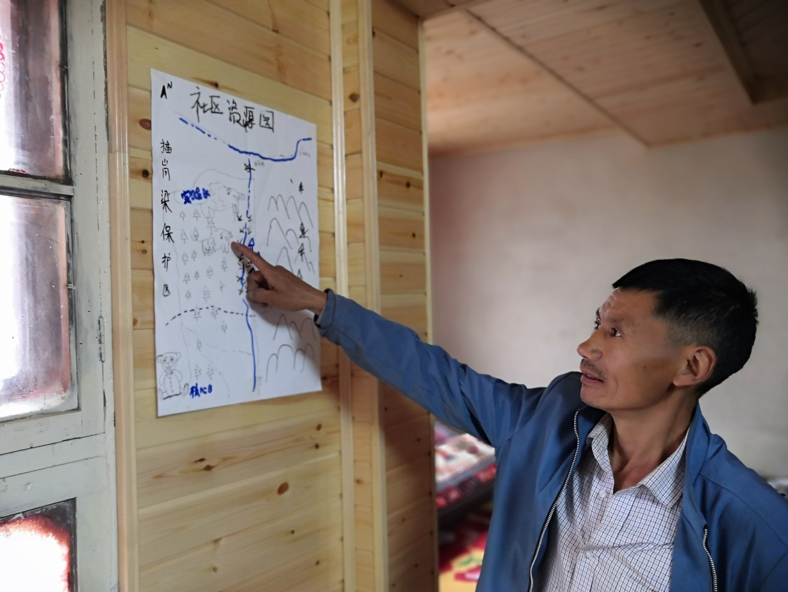

Figure 6. One of the workshops during which local residents drew maps listing roads, rivers, forests, and biodiversity hotspots around the villages.

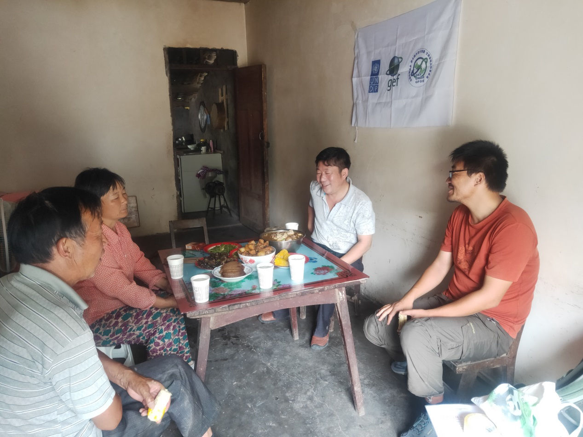

Figure 7. One of the household surveys conducted by C-PAR 2 experts.

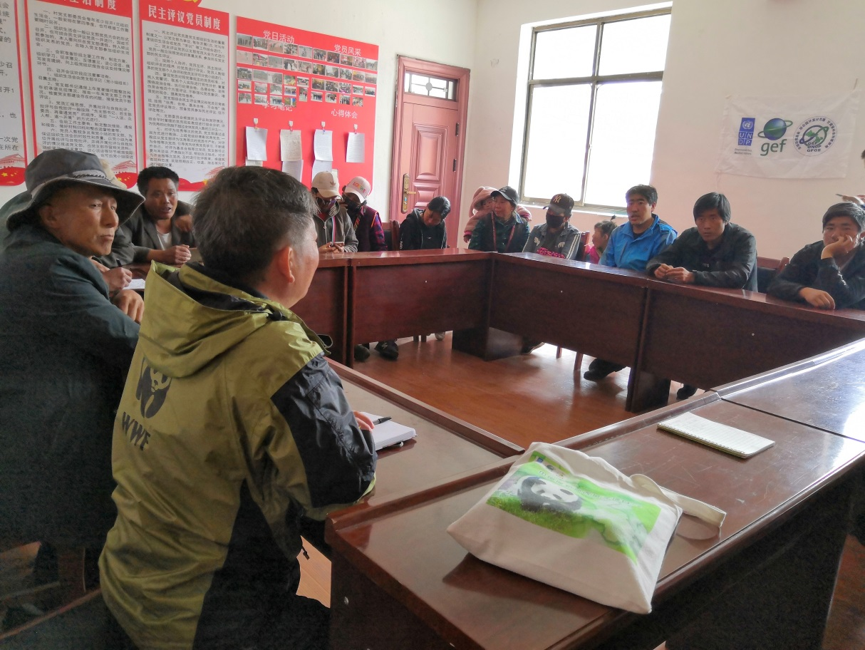

Figure 8. One of the community meetings discussing the socio-economic impacts of C-PAR 2.

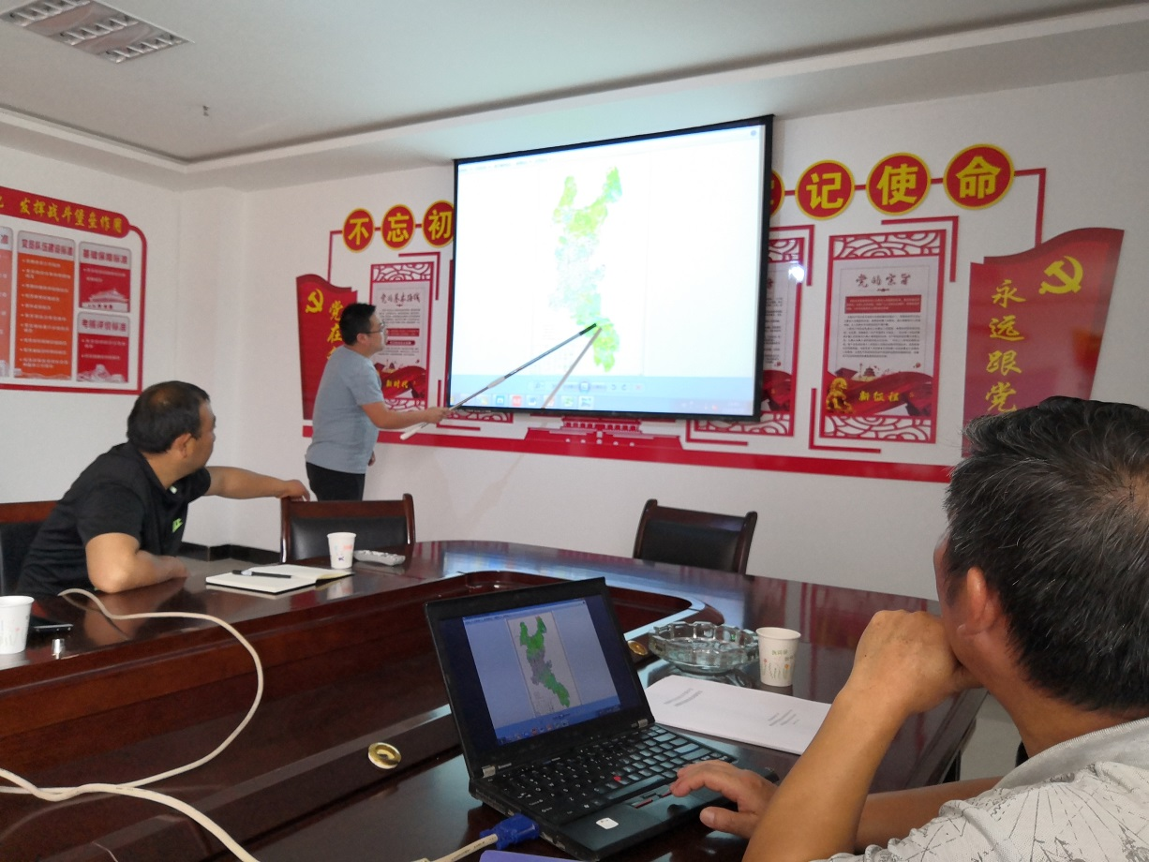

Figure 9. One of the meetings discussing the location of newly-established ecological corridors and nature reserves.

1. s://www.fmprc.gov.cn/mfa_eng/ljzg_665465/3584_665493/t17918.shtml
2. https://www.fmprc.gov.cn/mfa_eng/ljzg_665465/3584_665493/t17889.shtml
3. https://www.mfa.gov.cn/ce/ceee//eng/zggk/mz/t109327.htm
4. http://www.china.org.cn/english/travel/40751.htm
5. http://en.chinaculture.org/library/2008-02/05/content_24059.htm
6. State Ethnic Affairs Commission of the People’s Republic of China. *Regional Ethnic Autonomy Law (second amendment),* 28 February 2001*).*  http://www.seac.gov.cn/art/2011/6/29/art_4901_128701.html
7. General Office of the State Council. *Rules of the State Council on the implementation of the Law of the People's Republic of China on Regional National Autonomy*. Issued on 11 May 2005. http://www.gov.cn/xxgk/pub/govpublic/mrlm/200803/t20080328_31650.html
8. https://www.ecologic.eu/sites/default/files/publication/2021/B1_Restoriation-measures.pdf
9. The human rights dimensions of population transfer, including the implantation of settlers. Preliminary report prepared by Mr. A.S. Al-Khasawneh and Mr. R. Hatano. UN Doc. E/CN.4/Sub.2/1993/17*, at para. 101 and para. 336.
10. Among others, ILO 107, art. 12, ILO 169, art. 16(2), UNDRIP, art. 10, and Committee on the Elimination of Racial Discrimination, General Recommendation XXIII.