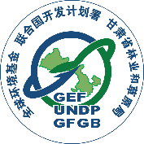
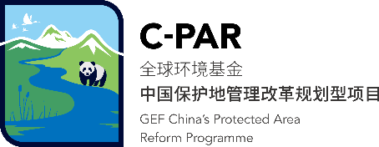

C-PAR 2 Environmental and Social Impact Assessment Report

Zhao Zhong
Social Inclusion Specialist (National), C-PAR 2
Version 6
May 19th, 2022

Executive Summary 2
1. Introduction and Structure of the ESIA 3
2. Legal and Institutional Framework 5
2.1 Environmental and Social Management Laws in China 5
2.1.1 Domestic Legal System 5
2.2.2 International Agreements 15
2.2 UNDP SES: Social and Environmental Assessment and Management 16
2.3 Global Environment Facility Environmental and Social Management Policies 17
2.3.1 Environmental and Social Safeguard Policy 18
2.3.2 Gender Equality Policy 18
2.3.3 Public Involvement Policy 19
2.3.4 Principles and Guidelines for Engagement with Indigenous People 19
2.3.5 Conflict in Regulatory Stringency 19
3. Project Description 20
4. Baseline Data 26
4.1 Geographical and Biological Baseline 26
4.2 Social Baseline 39
5. Social and Environmental Risks and Impacts 42
5.1 Introduction 42
5.2 Impact Assessment Methodology 43
5.3 Assessment of Risks and Impacts 47
5.4 Assessment of Social Risks 48
5.5 Assessment of Environmental Risks 62
6. Analysis of Alternatives 66
7. Mitigation and Management Measures 68
Risk 6: In many traditional Tibetan societies, there are significant societal differences between men and women. 75
7.1 ESMP table 82
7.2 Monitoring 86
8. Stakeholders 92
8.1 Stakeholders Engagement 92
8.2 Grievance Redress Mechanism 102
9. Conclusions and recommendations 105
Appendix 1: PMU Consent 107
Appendix 2: Assessment Participants 108
Appendix 3: Participation, Consultation, and Overview of the FPIC 109
Appendix 4: Voluntary resettlement/Land Commitment Letter Template 114
Appendix 5: Livelihood Action Plan – Template 115

Executive Summary
This project will seek to remove barriers to the achievement of the following outcomes: (i) Improved legal and institutional framework for PAs, Key Biodiversity Areas (KBAs) and globally threatened species, and mainstreaming of biodiversity conservation in provincial planning; (ii) Strengthened West Qinling Mountains-Minshan Mountains PA and Ecological Corridor Network and reduction of threats to endangered wildlife; and, (iii) Improved data and knowledge management, monitoring and evaluation supports for biodiversity conservation.
In accordance with UNDP requirements, the Social and Environmental Screening Procedure (SESP) was undertaken for this project resulting in an overall ‘high’ risk categorization. According to the 2015 SESP guidelines, a project is considered to have ‘high’ risk when it includes activities “with potential significant and/or irreversible adverse social and environmental risks and impacts, or which raise significant concerns among potentially affected communities and individuals as expressed during the stakeholder engagement process.”
As a consequence of this risk rating, it was decided that an ESIA should be undertaken to further assess the environmental and social risks that were initially identified in the SESP. The purpose of this ESIA is to: (i) Identify the potential positive and adverse environmental and socio-economic impacts that may arise as a consequence of project activities; (ii) Identify the measures for the management, mitigation, and monitoring of those impacts; and (iii) Assess the residual impact following mitigation. Impacts are to be assessed against the environmental and social baseline conditions presented in this report, with compliance being assessed against UNDP SES (2015) requirements.
Ten risks identified through SESP during the project preparation period were reassessed through environmental and social impact assessment carried out in the first year of formal implementation after the project was launched. In the ESIA the overall impact and probability of individual risks were reassessed beyond those identified in the SESP assessment, resulting in a conclusion that there are four ‘high’, three ‘moderate’, and three ‘low’ significance risks.

High significance risks involve voluntary resettlement of the project site community (risk 2) and economic relocation (risk 1). Both risks will involve ethnic minorities (risk 3). The added high risk is the environmental and social impact of natural disasters (risk 10). A summary of SES risks and mitigation measures is available in Figure 1. The UNDP SES policies concerning indigenous peoples recognize the distinct circumstances that expose them to different types of risks and impacts from development projects, hence an Indigenous Peoples Plan for C-PAR 2 was developed.
Figure 1 - SES Risks and Mitigation measures for CPAR - 2

1. Introduction and Structure of the ESIA
The enhancing conservation of globally significant biodiversity through protected area system strengthening in Gansu (China-Protected Areas System Reform (C-PAR) Program Child Project #2) (hereinafter referred to as C-PAR 2) is implemented by the Forestry Department of Gansu Province covering the period from 2018 to 2023. This ESIA report has been produced to assess potential adverse environmental and social impacts that could eventuate either directly or indirectly from the implementation of C-PAR 2 project activities.
As an important aspect of C-PAR 2, the ESIA was conducted between December 2020 and May 2022 by the project's social integration experts, with the support of Gansu Project Office staff, the project's Model Protected Area Administration and Forestry Bureau, and other project experts.
The ten risks identified during the Social and Environmental Screening Procedure (SESP) undertaken during project preparation have been reassessed. Eight of them have not changed, but one risk has been raised from medium to high risk (Risk 10), and another has been lowered from moderate to low (Risk 4). A monitoring and evaluation plan for project implementation, a capacity development plan for duty-bearers, and a plan for stakeholder participation were designed to correspond to the ten proposed mitigation and management actions.
The ESIA report is organised as follows:
- Chapter 1: Introduction and Structure of the ESIA: This chapter provides background information about the structure and scope of this ESIA.
- Chapter 2: Legal and Institutional Framework: This chapter provides a description of the applicable regulatory framework for the proposed project.
- Chapter 3: Project Description: This chapter provides a description of the Project, including location, project components and activities, details of Project inputs and outputs.
- Chapter 4: Baseline Data: This chapter describes the available baseline data on the environment and social resources and receptors within the project study area.
- Chapter 5: Social and Environmental Risks and Impacts: In this chapter, potential and associated environmental and social impacts of project activities are identified, assessed and evaluated.
- Chapter 6: Analysis of Alternatives: This chapter analyses alternatives to identify other options and compare impacts with the original proposal.
- Chapter 7: Mitigation and Management measures: This chapter presents potential mitigation and management measures as they pertain to the impacts identified in chapter 5.
- Chapter 8: Stakeholders: This chapter outlines the process and results of the stakeholder engagement activities undertaken so far.
- Chapter 9: Conclusions and recommendations: This chapter summarizes the ESIA and formulates key recommendations.
- Appendices: This section provides ancillary documents referenced in the body of the ESIA.

2. Legal and Institutional Framework

2.1 Environmental and Social Management Laws in China

2.1.1 Domestic Legal System
Under the standards set out by the Constitution of the People’s Republic of China, environmental and social regulations have developed rapidly in the past thirty years. As a result, a relatively comprehensive environmental and social management legal system has been formed.
The Environmental Protection Act, revised in 2017, is the predominant law used by various governmental departments for environmental protection and management. Many other environmental statutes can be categorised and applied to their respective areas of interest. For example, the laws and regulations for the protection of natural resources include: Law on Nature Reserves, Grassland Law, Forest Law, Wild Animal Conservation Law, and the Water and Soil Conservation Law. There are several statutes and regulations for environmental management, such as Law on Environmental Impact Assessment, Regulation on Environmental Impact Assessment of Planning, Regulation on the Administration of Construction Project Environmental Protection and so on. There is also a series of regulations and departmental rules which concern public involvement, including: Measures for the Disclosure of Environmental Information, Measures for Public Participation in Environmental Protection, Interim Procedure on the Public Take Part In Environmental Impact Assessment and many more.
Compared to its environmental regulations, China’s social management laws are even more abundant and diverse. Land Law, Law on Rural Land Contracting, and Measures for Announcement of Land Expropriation are just a small portion of the legislation which concerns proprietary and land expropriation. Some laws deal with ethnic minority groups and their development in particular, an example of such would be Regional Autonomy for Ethnic Minorities in China. Another prime example of China’s social management law would be the Law on the Protection of Rights and Interest of Women.
Furthermore, there are various environmental and social management standards and guidelines, as well as local laws and measures based on state legislations and normative documents which are in turn implemented by local governments.
Grassland Law of the People’s Republic of China, which is formulated in accordance with the provisions of the Constitution of the People's Republic of China regarding: (i) the protection, management and development of grasslands; (ii) protecting and improving the ecological environment; (iii) modernizing animal husbandry; and (iv) enhancing the prosperity of the local economies of the national autonomous areas.
Wild Animal Conservation Law of the People’s Republic of China is formulated for the purpose of protecting and saving wildlife species which are rare or near extinction, and protecting, developing and rationally utilizing wildlife resources.
Urban and Rural Planning Law of the People’s Republic of China: this law is formulated for the purpose of strengthening urban and rural planning administration, harmonizing urban and rural spatial layouts, improving people’s living environment and promoting the integrated, harmonious and sustainable development of urban and rural society.
Water and Soil Conservation Law of the People’s Republic of China: this law is formulated for the purpose of preventing and controlling erosion, protection and promoting rational utilization of water and soil resources, the mitigation of natural disasters and the development of production.

Law of the People’s Republic of China on Environmental Impact Assessment: this law is formulated to: (i) promote sustainable development strategies; (ii) prevent adverse impacts on the environment due to execution of plans and construction projects; and (iii) facilitate the coordinated development of the economy, society and the environment.

Law of the People’s Republic of China on the Protection of Women’s Rights and Interest is formulated to protect women’s lawful rights and interests, promote the equality between men and women.

Land Administration Law of the People’s Republic of China: this law is formulated with a view to strengthening the administration of land, safeguarding socialist public ownership of land, protecting and developing land resources, ensuring a rational use of cultivated land and promoting sustainable development of the socialist economy through appropriate land use.

The aim of Law of the People's Republic of China on the Prevention and Control of Atmospheric Pollution（revised in 2018）is to protect and improve the environment, prevent and control air pollution, safeguard public health, promote ecological civilization and promote sustainable economic and social development. The law stipulates that the competent ecological and environmental departments of the people's governments at or above the county level shall exercise unified supervision and administration over the prevention and control of air pollution. Other relevant departments of the people's governments at or above the county level shall, within the scope of their respective functions and duties, exercise supervision and administration over the prevention and control of air pollution.

The goal of the Law of the People's Republic of China on the Prevention and Control of Noise Pollution（2022）is to prevent and control environmental noise pollution, protect and improve the living environment, and ensure human health. It stipulates that local people's governments at various levels shall be responsible for the quality of acoustic environment within their respective administrative areas and take effective measures to improve the quality of acoustic environment. The emission of noise and the generation of vibration shall conform to the noise emission standards, the relevant environmental vibration control standards and the requirements of relevant laws, regulations and rules.

The purpose of Law of the People's Republic of China on the Prevention and Control of Water Pollution（revised in 2017）is to protect and improve the environment, prevent and control water pollution, protect water ecology, ensure drinking water safety, safeguard public health, promote ecological civilization construction, and promote sustainable economic and social development. The law stipulates that the discharge of water pollutants shall not exceed the national or local standards for the discharge of water pollutants and the total discharge control targets of key water pollutants. In particular, people's governments at or above the county level may delimit protection zones for water bodies in scenic spots, important fishery water bodies and other water bodies of special economic and cultural value, and take measures to ensure that the water quality in the protection zones meets the water environmental quality standards for specified purposes.

The regulations of the people's Republic of China on nature reserves were issued by the State Council of the people's Republic of China on October 9, 1994 and came into force on December 1, 1994. The regulation clearly stipulates that the construction and management of nature reserves should properly handle the relationship between production and the interests of indigenous residents. These regulations also delineate the boundaries of nature reserves and require consultations that take into account the needs of production of indigenous residents to be conducted during nature reserve-related decision-making processes. In 2019, China issued the guiding opinions on establishing a nature reserve system with national parks as the main body, which clearly proposed to protect the rights and interests of indigenous residents.
These laws and regulations fundamentally and systematically protect the rights and interests of local communities and indigenous residents in the process of national park construction. In China with 1 – 2 ethnic groups being the local majority population like Tibetan, Han, and Mongolia People, there are some local regulations for ensuring native ethnic groups’ rights and interests. Qinghai area of Qilian Mountain National Park mainly involves Menyuan County and Qilian County of Haibei Tibetan Autonomous Prefecture, Tianjun county and Delingha city of Haixi Mongolian Tibetan Autonomous Prefecture. The two Autonomous Prefectures have legislative competence to develop their own laws. On September 25, 2004, the 12th meeting of the Standing Committee of the Tenth People's Congress of Qinghai Province approved the regulations on the autonomy of Haibei Tibetan Autonomous Prefecture. On July 18, 1987, the 27th meeting of the Standing Committee of the Sixth People's Congress of Qinghai Province approved the regulations on the autonomy of Haixi Mongolian and Tibetan Autonomous Prefecture. These autonomy regulations are normative documents formulated by the people's congresses of China's national autonomous areas in accordance with the powers conferred by the Constitution and in accordance with the political, economic and cultural characteristics of the local nationalities. These regulations stipulate the basic organizational principles, institutional settings, functions and powers of autonomous organs, working system and other major issues related to the regional autonomy implemented in this region. They are the comprehensive activity guidelines for the implementation of regional national autonomy in national autonomous areas.

In the C-PAR 2 UNDP-GEF project, there are no large-scale infrastructure construction projects planned that may cause large-scale air, water and noise pollution. There are no significant potential negative impacts to the health and safety of communities during the project construction and operational phases as a result of noise, air and disease during construction and operation.

The table below lists the major national laws relevant to environmental and social management in China.

Table 1 - major national laws relevant to environmental and social management in China
Category | Name | Institution or Department
Laws | Environmental Protection Law of the People’s Republic of China (1989, revised in 2014) | Standing Committee of the National People's Congress
 | Forest Law of the People’s Republic of China (1984, revised in 2020) | Standing Committee of the National People's Congress
 | Grassland Law of the People’s Republic of China (1985, revised in 2013) | Standing Committee of the National People's Congress
 | Wild Animal Conservation Law of the People’s Republic of China (1989, revised in 2018) | Standing Committee of the National People's Congress
 | Urban and Rural Planning Law of the People’s Republic of China (2007, revised in 2015) | Standing Committee of the National People's Congress
 | Water and Soil Conservation Law of the People’s Republic of China (1991, revised in 2010) | Standing Committee of the National People's Congress
 | Law of the People’s Republic of China on Environmental Impact Assessment (2002, revised in 2016) | Standing Committee of the National People's Congress
 | Law of the People’s Republic of China on the Protection of Women’s Rights and Interest (1992, revised in 2018) | Standing Committee of the National People's Congress
 | Law of the People’s Republic of China on Regional National Autonomy (1984, revised in 2001) | Standing Committee of the National People's Congress
 | Land Administration Law of the People’s Republic of China (1986, revised in 2020) | Standing Committee of the National People's Congress
 | Law of the People’s Republic of China on the Contracting of Rural Land (2002, revised in 2018) | Standing Committee of the National People's Congress
 | Law of the People’s Republic of China on the Mediation and Arbitration of Rural Land Contract Disputes (2010) | Standing Committee of the National People's Congress
Administrative Regulations, Decisions and Orders | Regulations of the People’s Republic of China on Nature Reserves (2017) | State Council
 | Measures on Administration of the Natural Reserves of Forest and Wild Animals (1985) | State Council
 | Implementation of way to strengthen environmental protection through a scientific outlook (2005) | State Council
 | Open Government Regulation (2007) | State Council
 | Regulations on Environmental Impact Assessment of Planning (2009) | State Council
 | Regulations on the Administration of Construction Project Environmental Protection (2017) | State Council
 | Interim Regulation on Major Administrative Decision-Making Procedures (Proposal) (2017) | State Council
 | Proposal for the development of Ethnic Affairs (2014) | State Council
 | 13.5 Development Plan for Ethnic Minority Groups and Regions with Small Populations (2017) | State Council
Departmental regulations | Interim Administrative Measures for Examination and Approval of Constructing Facilities in National Natural Reserves (2018) | The National Forestry and Grassland Administration (formerly known as the State Forestry Administration)
 | Measures in regards to Permits for Forestry Administrative Hearings (2008) | The National Forestry and Grassland Administration
 | Measures in regard to the Supervision of Implementation of Forestry Administrative Laws (1996) | The National Forestry and Grassland Administration
 | Interim Measures for Hearing the Administrative License in Respect of Environmental Protection (2004) | The Ministry of Ecology and Environment (formerly known as the State Environmental Protection Administration)
 | Interim Measures for Public Participation in Environmental Impact Assessment (2006) | The Ministry of Ecology and Environment
 | Measures for the Disclosure of Environmental Information (Trial) (2007) | The Ministry of Ecology and Environment
 | Ministry of Environmental Protection’s Comments on Implementing the Opinions of the State Council on Strengthening the Construction of a Government ruled by Law (2011) | The Ministry of Ecology and Environment
 | Guidelines for Government Information Disclosure on Environmental Impact Assessment of Construction Projects (Trial) (2013) | The Ministry of Ecology and Environment
 | Opinions of the Ministry of Environmental Protection in regard to the Guidelines on Promoting Public Participation in Environmental Protection (2014) | The Ministry of Ecology and Environment
 | Measures for Public Participation in Environmental Protection (2015) | The Ministry of Ecology and Environment
 | Measures for Announcement of Land Expropriation (2001) | The Ministry of Natural Resources (Formerly known as the Ministry of Land and Resources)
Local regulations | Regulations of Gansu Province on environmental protection | Gansu Provincial Government
 | Administrative measures for administrative license of Gansu Forestry and grassland administration | Gansu Forestry and grassland administration

According to the new Environmental Protection Law, the definition of environment refers to any natural and artificially modified natural factors which affect the development and survival of the human species. This includes the atmosphere, water resources, ocean, land, mineral resources, forests, grasslands, wetlands, wildlife, natural relics, cultural heritages, natural reserves, scenic spots, cities, towns etc. The Environmental Protection Act stipulates that environmental protection is a basic national policy, and therefore all governmental units and individuals have an obligation to protect the environment.
The newly revised Regulations on Nature Reserves provide the legal basis for environmental and social management within the scope of natural reserves. For example, Article 7 states that: “all units and individuals have the obligation to protect the environment and natural resources within the scope of natural reserves. In addition to the right to report and file charges against those that damage or encroach the natural reserve.”
With regard to social management, the regulations also take into account the relationship between the reserves, the residents living within them, and their economic development. Article 5 points out that: “Properly handling the relationship between the local economic development as well as the production of local residents is key to constructing and managing a natural reserve.”
Disclosure of information plays a fundamental role in environmental and social management as it allows people to be informed of the actions and decisions that may affect them, and in turn allows them to participate in those decisions. China’s information disclosure system has improved substantially in the past decade. The Open Government Information Regulation (2007) states that when administrative departments produce or obtain information that complies with certain conditions, they should be disclosed to the public in a timely and accurate manner. Depending on the nature of the production, citizens, legal personnel, and other organisations may apply to the Government for the disclosure of certain information. Additionally, Government departments must take the initiative to release material that is of immediate concern to the interest of its citizens, legal personnel, or other organisations.
The Land Administrative Law, Law on the Contracting of Rural Land and other relevant legal documents define the ownership of rural land, providing a legal basis for the handling and settlement of various social and economic issues that arise in the process of land development, utilisation, protection and management. The Land Law stipulates that the ownership and the right to use registered land shall be protected by law and shall not be infringed upon. Additionally, owners of registered land shall have the right to occupy, utilise, profit from, and dispose of the land.
According to the Law on the Protection of Rights and Interest of Women, women’s rights include political, cultural, educational, labour, social security, property, marital and family rights, as well as rights to bodily integrity and autonomy. This statute, revised in 2005 and 2018, has solidified the place of gender equality in national law. This branch of law has been polished and improved comprehensively as new measures have been implemented and monitored in the relevant legislative, judicial, administrative, and social bodies.
The Law on Regional autonomy for Ethnic Minorities regulates the political system of regional ethnic autonomy and the handling of ethnic relations. Based on this law, the State Council and Government at all levels have introduced a series of ethnic development policies, which not only safeguard and promote the legitimate rights and interest of ethnic minority groups.
Regulations of Gansu Province on environmental protection. In order to protect and improve the local environment, prevent and control pollution and other public hazards, protect public health, promote the construction of ecological civilization and promote the sustainable development of economy and society.
Administrative measures for administrative license of Gansu Forestry and grassland administration. In order to further promote administration according to law, standardize administrative licensing, and facilitate the work of enterprises and the masses.

2.2.2 International Agreements
As a member of the United Nations, China has actively participated in much of the UN’s work and has promoted international cooperation and the construction of an international legal system. Under the framework of the UN, China has signed a series of international conventions. The international conventions (relating to environmental and social management) to which China is a party are listed below.
Environmental Management:
- Convention Concerning the Protection of the World Cultural and Natural Heritage (1972)
- Convention on Wetlands of International Importance Especially as Waterfowl Habitat (1992)
- Basel Convention on the Control of Transboundary Movements of Hazardous Wastes and Their Disposal (1992)
- Convention on Biological Diversity (1993)
- The United Nations Framework Convention on Climate Change (1994)
- Cartagena Protocol on Biosafety (2000)
- Stockholm Convention on Persistent Organic Pollutants (2001)

Social Management:
- The Convention on the Elimination of all Forms of Discrimination Against Women (1980)
- The International Convention on the Elimination of All Forms of Racial Discrimination (1982)
- The United Nations Convention on the Rights of the Child (1990)
- Beijing Declaration (1995)
- The International Covenant on Economic, Social and Cultural Rights (1997)
- Declaration on the Rights of Indigenous Peoples (2007)

Additionally, China has actively supported many important international environmental and resource protection conventions and has incorporated the essence of these international legal documents into its own laws and policies. These documents include the Declaration of the United Nations Conference on the Human Environment (1972), the Outline of the World’s natural Resources Protection (1980), the Nairobi Declaration (1982), and the Rio Declaration on Environment and Development.

2.2 UNDP SES: Social and Environmental Assessment and Management
The UNDP social and environmental standards, which came into effect on January 1, 2015, contribute to the UNDP's commitment to integrate social and environmental sustainability into its programs and projects in support of sustainable development, and are a component of the UNDP's quality assurance and risk management programming. Through social and environmental screening, UNDP meets the requirements of the GEF Policy on Environmental and Social Safeguards.
The objectives of social and environmental screening are to:
- Reinforce the social and environmental outcomes of the overall program and individual projects;
- Avoid negative impacts on populations and the environment;
- Minimize, mitigate and manage negative impacts when they cannot be avoided;
- Enhance the capacity of UNDP and partners to manage social and environmental risks; and
- Ensure full and effective stakeholder participation, including through a mechanism for feedback on complaints from project-affected populations.
The SESP was finalised during project preparation, as required by UNDP’s Social and Environmental Standards. The SESP identified ten risks for this project that could have potential negative impacts in the absence of safeguards, two of these risks were rated as low, five moderate and three high. Therefore, the overall SESP risk categorization for the project is High. The three risks with high rating relate to potential physical displacement of local populations from NP pilot core zones and ecological corridors, the potential economic displacement of local populations due to restricted/changed access to land and resources, and the potential that both voluntary resettlement and displacement will affect ethnic minorities. The following safeguards are triggered:
- Human Rights;
- Gender Equality and Women’s Empowerment;
- Climate Change Mitigation and Adaptation;
- Community Health, Safety and Working Conditions;
- Displacement and Resettlement; and
- Indigenous Peoples.

2.3 Global Environment Facility Environmental and Social Management Policies
The Global Environment Facility (GEF) is an international organisation that is in collaboration with 184 countries and 18 Agencies. Their mission is to work with international institutions, civil society organisations and private sector entities to solve environmental issues around the globe. The GEF was established in 1991 to provide financial and technical support to developing countries and help them comply with international environmental conventions. The GEF serves as a funding mechanism for five international conventions: The Convention on Biological Diversity, The United Nations Framework Convention on Climate Change, The Stockholm Convention on Persistent Organic Pollutants, The United Nations Convention to Combat Desertification, and the Minamata Convention on Mercury. These funds are used by both developed and developing countries to support the implementation of environmental protection projects related to biodiversity, climate change, international waters, land degradation, chemicals, and waste.
The policies of the GEF are a reflection of the principles and values adopted by the Council of the GEF, who controls the activities undertaken by the group in order to achieve their objectives. To prevent and reduce the negative environmental and social impacts of the GEF grant projects, the GEF has developed a series of policies and guidelines (listed below).
As an accredited Implementing Partner of the GEF, UNDP’s standards have been assessed as complying with the GEF requirements, and thus the UNDP SES will be used as the applicable safeguard’s framework for this project.

2.3.1 Environmental and Social Safeguard Policy
This policy was adopted on the 20th of December 2018, at the 55th Council Meeting of the GEF and has been effective as of 1st of July 2019. It sets out the mandatory requirements and standards for identifying and addressing environmental and social impacts in all GEF-financed projects and programs. It applies universally to the Secretariat and all GEF Partner Agencies. The document outlines GEF’s approach to anticipating, avoiding, preventing, minimizing, mitigating, managing, offsetting or compensating any adverse impacts that GEF-financed projects and programs may have on people or the environment, thereby enhancing the environmental and social outcomes of such projects and programs (GEF 2019).

2.3.2 Gender Equality Policy
This policy was adopted in 2017, at the 53rd Council Meeting, and it supersedes the Gender Mainstreaming Policy which was introduced in 2011. The document sets out the guidelines and requirements for mainstreaming gender across the GEF’s governance and operations with an enhanced objective to promote gender equality and the empowerment of women and girls in support of the GEF’s mandate to achieve global environmental benefits (GEF 2017). These standards apply to the Council, Secretariat and all GEF Partner Agencies.

2.3.3 Public Involvement Policy
This policy was adopted in April 1996, at the 7th Council Meeting. The following principles have been approved by the GEF Council as the basis for public involvement in the design, implementation, and evaluation of GEF-funded projects (GEF 2014):
- Effective public involvement should enhance the social, environmental, and financial sustainability of projects and programs.
- Responsibility for assuring public involvement rests within the country, normally with the government and project executing agency or agencies, with the support of the GEF Partner Agencies.
- Public involvement activities should be designed and implemented in a flexible manner, adapting and responding to recipient countries’ national and local conditions and to project requirements.
- To be effective, public involvement activities should be broad-based and sustainable. GEF Partner Agencies will include in project budgets, as needed, the necessary financial and technical assistance to recipient governments and project executing agencies to ensure effective public involvement.
- Public involvement activities will be carried out in a transparent and open manner. All GEF-financed projects and programs should have full documentation of public involvement.
The Council stresses the importance of context when applying these principles, specifically regarding the state and local conditions.

2.3.4 Principles and Guidelines for Engagement with Indigenous People
This policy has been effective since 2012. The objective of these guidelines is to recognise and acknowledge indigenous people as valuable contributors, potential stakeholders, and partners of the GEF. In addition, these guidelines aim to align the GEF’s policies with the United Nations Declaration on the Rights of Indigenous People.

2.3.5 Conflict in Regulatory Stringency
This project will adhere to the host country, international, and UNDP requirements listed above. Should any conflict arise relating to the respective stringency of particular requirements, the most stringent of the conflicting requirements will apply, in accordance with UNDP best practice.

3. Project Description
The West Qinling Minshan Mountain landscape area in Gansu Province is an important water conservation area and an integral part of the ‘biodiversity hotspot’ in central and southern China. It is of great significance to local and global threatened species such as giant pandas and golden monkeys. The long-term solution to strengthening the conservation of threatened species in Gansu Province through strengthening the protected area system is constrained by the following barriers: (i) insufficient legal and institutional framework for effective protection of PAs, globally threatened species and their habitats, and weak law enforcement; (ii) weak institutional and individual capacities for protected area (PA) management in the West Qinling-Minshan Mountains PA network; and, (iii) inadequate knowledge management, monitoring, and evaluation systems for effective PA and conservation management.
There are four project demonstration protected areas within the region that this project will take place in: Axia, Chagangliang, Duoer and Yuhe Nature Reserves. Yuhe NR is in the process of being absorbed by the transboundary Giant Panda National Park on the Sichuan-Shaanxi-Gansu border. In addition, the project will support the development of ecological corridors contiguous with Yuhe NR, connecting the two parts of Chagangliang NR, as well as in Liangdang County (contiguous with Lingguanxia PNR) and Hezheng County (adjoining Taizishan NNR).
The integrity and connectivity of Gansu’s forested landscapes is threatened by both infrastructure development and unsustainable land management. There is a lack of sufficient PA management capacity and systemic weaknesses in the PA system relating to the legal and regulatory framework and inadequate safeguards for sectoral development planning. There is currently a lack of awareness and knowledge of the Key Biodiversity Area (KBA) approach to spatial conservation efforts and inadequate attention to representation of KBAs in the provincial PA system. Although Gansu is home to a range of endangered and endemic species, there are no provincial level conservation and restoration plans to guide effective species conservation efforts.
Gansu’s globally significant ecosystems and species are being progressively impacted by economic development. Historically, land use changes did not take biodiversity values into account and unsustainable land use management was driven by increasing population pressure, demand for natural resources, and rural poverty. This issue has by now been addressed and currently land use change practices require a very strict approval process. However, a number of direct and indirect threats to Gansu’s ecosystems still persist to date:
- Unsustainable land and natural resource use;
- Habitat fragmentation due to infrastructure development;
- Human–wildlife conflicts;
- Illegal and unsustainable hunting and wildlife trade;
- Climate change.
Unsustainable land and natural resource use: The project demonstration area in the Bailongjiang Basin is an important forest area in China, not only for the biodiversity that it houses but also as critical watershed. From the 1950s to the 1990s, large-scale state-owned forest farm and local forest farms conducted high-range logging in this area. Logging intensity was even greater along the easily accessible banks of the Bailongjiang River. The extent and quality of wild habitats decreased dramatically as a result. In 1998, the Chinese government issued a logging ban policy in this area to stop logging in natural forest. Since 2004, 4 nature reserves were officially established along with Bailong river watershed, which are now GEF project pilot nature reserves. Consequently, deforestation is no longer a major threat, and with the implementation of national policy for conversion of sloping farmland to forest and grassland (the so-called "Grain for Green Project"), reclamation has been reduced significantly. The Nature Reserves are mostly located in remote mountainous areas where the economy is less developed and rural poverty may be prevalent. Farmers living within or around NRs depend on farming and livestock with limited livelihood options. However, grazing, fuel wood collection, small-scale forestland reclamation in limited localities, and some forestry side-lines such as gathering medicinal herbs, harvesting bamboo shoots, and mushrooms, etc., continue to some extent. Depending on their location and intensity, these activities may result in incremental habitat degradation and fragmentation and disturbance to wildlife – for example, fuel wood collection and removal of kiwifruit has degraded habitats formerly suitable for the golden snub-nosed monkey.
Habitat fragmentation due to infrastructure development: The project demonstration area in the Bailongjiang Basin is an important residence and passageway for animals such as the giant panda, golden snub-nosed monkey, takin and forest musk deer. Habitat fragmentation has become a serious problem for their dispersion and genetic exchange. Industry and construction of linear infrastructure such as roads, railways, powerlines and dams have fragmented habitats of threatened species to various degrees to the point where some sub-populations have become isolated with little or no gene exchange with other sub-populations and restricting movement both within and between PAs. For example, Yuhe PA is home to thirteen musk deer populations, among which four are completely isolated from the others due to habitat fragmentation. Increasing habitat fragmentation and separation of threatened species into small populations increases the risk of their further decline. For example, studies have indicated that isolation of giant panda populations may increase the risk of their extinction in the future, with an extinction probability of 41% among populations consisting of 10 or fewer individuals. Examples of such construction impacts include tunnels of the Lan-Yu (Lanzhou-Chongqing) railway and the Wuguan highway, communication towers and electric transmission lines set up within or around Yuhe NR. In addition, rural roads have been constructed within and around all the NRs in the Bailongjiang River basin. There are 15 small hydropower stations within the experimental zone of Chagangliang NR, although they are required to set aside enough water volume for ecological maintenance along the watercourse. There was mining within Qilianshan Mountains NR in the past, although this was halted after the rectification in 2014.
Human–wildlife conflicts: The shrinkage of wildlife habitats, expansion of agricultural land, and increase in the local populations of some wild animals (such as black bear and wild boar) have resulted in increased incidence of localized damage to farmers’ crops from wild boar and of black bear attacks on livestock and humans. Human-wildlife conflicts cause harm and reduce the goodwill of local people towards wildlife conservation and increase the risk of retaliation against wild animals. Agriculture and husbandry are encroaching on the habitats within the PAs and migration corridors of wild animals, while regeneration of protected forest and afforestation have led to an increase in the local populations of some wild animals, such as wild boar. Forest residents are likely to cause deliberate damage to wild animals in retaliation unless such damage can be prevented, mitigated and an effective and fair compensation mechanism for wild animal damage established.
Illegal and unsustainable hunting and wildlife trade: While Chinese law for wildlife protection was strengthened in 2017, and it is reportedly not a significant issue within the demonstration landscape at present, the illegal poaching and trafficking of wild animals remains a risk, especially for species present in Gansu that have a high value internationally for traded parts such as bears and serow (for gall bladders), snow leopard (skins, bones, claws), pheasants (live trade), musk deer (musk glands), Chinese giant salamander (for traditional Chinese medicine), and Saiga antelope (horns). Given the great demand for such products and their high value, it will require great vigilance by patrolling PA staff and other enforcement agencies to respond quickly to potential future changes in levels of poaching and illegal wildlife trade in Gansu.
Climate change: The recent climatic variation in Gansu tends to manifest itself in increasing temperature, decreasing precipitation, warmer winters and drier summers. The temperature in Gansu shows an increasing trend from 1951 to 2010 with a rate of increase of 0.175ºC/10 years. The temperature increase in winter is more pronounced, with a growth rate of 0.371ºC/10 years. The year 1986 was a significant turning point of climatic variation towards warming. After that point, the annual mean temperature in Gansu has increased by 1.1ºC, with an increase of 0.9ºC in the east and 1.4ºC in the west comparing the periods of 1987-2010 and 1960-1986. Climate change has caused an expansion of the arid area, greater incidence of drought, giving rise to deep changes in cropping system and pattern, water distribution and wildlife habitat. The ecological impacts of climate change relate to increased risks of forest fires under drought conditions, floods due to more variable and extreme rainfall, and distributional shifts of species related to the increasing temperature trend. For example, evidence of the activities of three giant pandas has been found on the northern side of the Bailongjiang river, which implies that the panda population is extending northwards, and its activities reach higher altitudes. Before the 1960s, the giant panda lived only to the south of the Baishuijiang River. These trends exacerbate the impacts of existing human pressures and imply that both protected area and species conservation planning need to include climate resilience through habitat connectivity.
The project will seek to remove the aforementioned barriers and achieve the following outcomes: (i) Improved legal and institutional framework for PAs, Key Biodiversity Areas (KBAs) and globally threatened species, and mainstreaming of biodiversity conservation in provincial planning; (ii) Strengthened West Qinling Mountains-Minshan Mountains PA and Ecological Corridor Network and reduction of threats to endangered wildlife; and, (iii) Improved data and knowledge management, monitoring and evaluation supports for biodiversity conservation.
Component 1: Improved legal and institutional framework for protected areas (PAs), Key Biodiversity Areas (KBAs) and globally threatened species and mainstreaming of biodiversity conservation in provincial planning.
This component will strengthen the legal and institutional framework for Gansu provincial government for reducing threats to globally threatened species and their habitats and mainstreaming biodiversity conservation into provincial planning processes. It will address key needs for updating and re-aligning provincial policies, legislation and plans for consistency with rapidly advancing national policy on biodiversity conservation, ecological security and environmental protection. This will include increased protection for globally threatened species and Key Biodiversity Areas, support for the Giant Panda and Qilian Mountains National Park pilots and introduction of compliance monitoring and evaluation. The provincial Biodiversity Strategy and Action Plan will be updated, and biodiversity conservation will be integrated as a mainstreamed task for key sectors in the ongoing 13th and upcoming 14th Provincial Five-Year Plan, and provincial level plans will be developed and implemented for the conservation, rehabilitation and reintroduction of priority globally threatened species. Assessments will be conducted and spatial plans developed to enhance the functional integrity of the provincial PA system, supported by an Ecological Corridor Network for the province that will increase ecosystem and species resilience against climate change and reduce the fragmentation of populations of globally threatened species. The capacity of key institutions for protected area system management and globally threatened species conservation will also be strengthened in coordination with developing national professional standards for PA system management.
Component 2: Strengthened West Qinling Mountains-Minshan Mountains protected area and ecological corridor network and reduction of threats.
This Component will build on Component 1 by supporting the operationalization of plans for the conservation and recovery of globally threatened species, and expansion of the Protected Area and Ecological Corridor Network in the West Qinling – Minshan Mountains demonstration area to enhance species conservation and reduce threats. The Protected Area and Ecological Corridor Network will be expanded by more than 25,000 ha to increase coverage of KBAs and increase habitat connectivity, in line with the provincial species conservation and recovery plans. The coordination and management of the PA and Ecological Corridor Network will be strengthened through a range of activities, including establishing a hub for network capacity development and training at Yuhe NR / Giant Panda NP, in coordination with C-PAR National (child project 1) and Sustainability projects (child project 6). This network would integrate with the Tibetan Plateau-Qinghai Biodiversity Network. Capacity development, management plans, financing plans, provision of training, infrastructure and equipment, SMART patrolling and monitoring of threats and species status will all be supported at the targeted PAs (Axia, Chagangliang, Duoer and Yuhe NRs) to increase management effectiveness. This Component will also support more effective community co-management and engagement in PA management achieving livelihood improvement and threat reduction. This will include facilitating the production and marketing (including online marketing) of PA-friendly sustainable products (e.g. non-forest timber products - NTFPs, honey) and eco-tourism development by selected local communities at the project demonstration sites. In addition, with an increase in the prevalence of human-wildlife conflict (HWC) in and around PAs impacting local farmers, the project will demonstrate mechanisms for the prevention, management and compensation of HWC damage adjacent to PAs and Ecological Corridors in coordination with the C-PAR National (child project 1) and Qinghai projects (child project 2). Finally, the project will develop a landscape scale biodiversity survey, monitoring and information system for the West Qinling Mountains-Minshan Mountains demonstration area to support PA management and species conservation.
Component 3: Knowledge management, monitoring and evaluation and gender mainstreaming.
The third project component closely links with and underpins the other two, by supporting the sharing of knowledge, experiences and lessons learned through project implementation with project stakeholders, the wider public in Gansu Province, and nationally through the GEF C-PAR Program. Gender mainstreaming has been integrated throughout the project design based on a gender analysis and gender mainstreaming plan.

4. Baseline Data

4.1 Geographical and Biological Baseline
The West Qinling Mountains-Minshan Mountains landscape is recognized as a biodiversity hotspot, both within China and worldwide. It is located in the Bailongjiang basin in the upper reaches of the Yangtze River. The West Qinling Mountains form part of the Qinling Mountains, a geographical divide between the south and north of China. The biome in this region is characterized by a south-north transitional feature with extremely rich biodiversity. The Minshan Mountains are listed as one of the WWF Global 200 Ecoregions, a biodiversity hotspot of global significance, and included in the 25 biodiversity hotspot areas defined by Conservation International. Many Chinese endemic species are distributed in the Bailongjiang area. Surveys and incomplete statistics indicate that Over 100 species in the IUCN Red List (87 animal and 15 plant species) occur in the West Qinling Mountains-Minshan Mountains landscape (including giant panda Ailuropoda melanoleuca (Vulnerable), golden snub-nosed monkey Rhinopithecus roxellana (Endangered), takin Budorcas taxicolor (Vulnerable), Chinese giant salamander Andrias davidianus (Critically Endangered), Forest musk deer Moschus berezovskii (Endangered) and Tibetan Black Bear Ursus thibetanus (Vulnerable). Other threatened species occur in different landscapes in Gansu Province, including the snow leopard Panthera uncia (Vulnerable) in the Qilian Mountains, Bactrian Camel Camelus bactrianus (Critically Endangered) and Przewalski’s horse Equus ferus przewalskii (Endangered) in the Tengger Desert. The last two species as well as Saiga antelope Saiga tatarica (Critically Endangered) are being reintroduced to Gansu.
Gansu Province is located in North-Western China with a total land area of 425,800 km². About 70% of its territory is hilly or mountainous and 75% historically suffers from drought. It is geographically and climatically diverse, containing an eastern monsoon region, the Qinghai-Tibetan Plateau, and the northwest arid zone. It is in the upper reaches of the Yangtze and Yellow River basins with inland rivers in the west, and experiences both subtropical and temperate climates with annual rainfall ranging from 40mm to more than 1,000mm. The elevation lies between 1,500m and 3,000m in the main. These unique geographical conditions have fostered a highly diversified population of flora and fauna. Gansu Province has more than 4,000 species of plants. There are 68 nationally rare, endangered, and key protected plant species, of which 34 species are under national protection. Gansu Province is also home to 957 species and sub-species of wild animals, of which 33 are under first grade and 81 under second grade national protection.
Gansu Province is notable for its topographical, climatic, and biological diversity. The West Qinling - Minshan Mountains feature large tracts of forest that are critical watersheds and part of the south-central China ‘biodiversity hotspot’. Gansu Province has more than 60 nature reserves (NRs) that are important for endemic and globally threatened species such as the giant panda, and the golden snub-nosed monkey. However, the connectivity of forested landscapes and viability of key species populations are threatened by infrastructure development and unsustainable land management.
Thirteen sites have been internationally recognized as Key Biodiversity Areas (KBAs) in Gansu Province. Four KBAs have been identified in the west Qinling Mountains-Minshan Mountains: the Minshan Mountains, Longshengou Nature Reserve (NR), Baishuijiang NR, Babso NR and Baihe NR (the last two being located in Sichuan Province). The four selected C-PAR 2 Gansu Project sites - Yuhe, Chagangliang, Axia and Duoer Nature Reserves overlap or are contiguous with these KBAs.
In the proposed ecological corridor area, human-wildlife conflict has resulted in significant harm to crops and livestock in communities surrounding the reserve. Although the Gansu Provincial Forestry and Grassland Bureau collected relevant information and developed a provincial-level compensation mechanism, this initiative was unsuccessful due to complex administrative processes, resulting in limited applications, unclear verification procedures, low compensation rates, and delayed payments. The result has been an increasingly negative attitude towards wildlife and protected areas among affected communities.
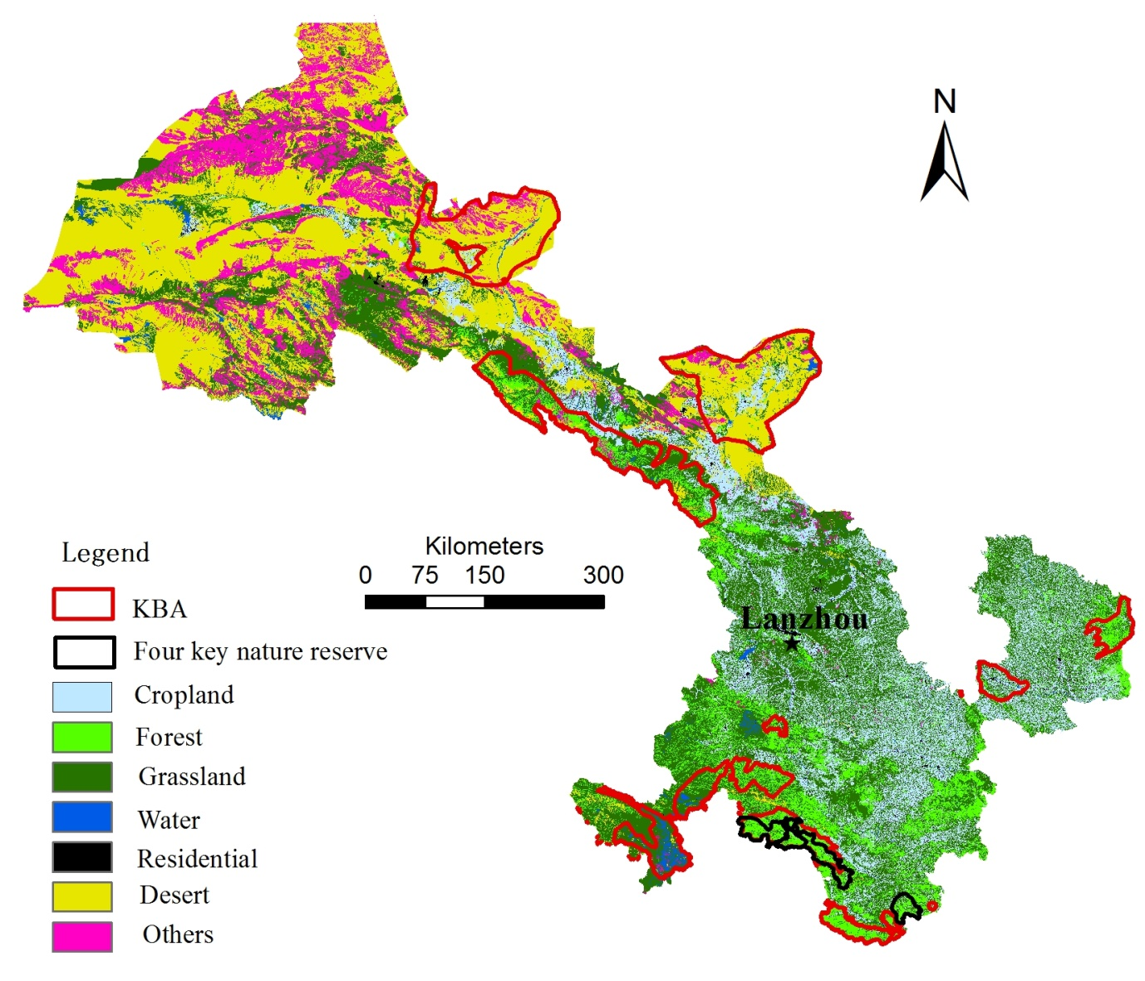
Figure 2. Four key nature reserves targeted by the project in Gansu Province.
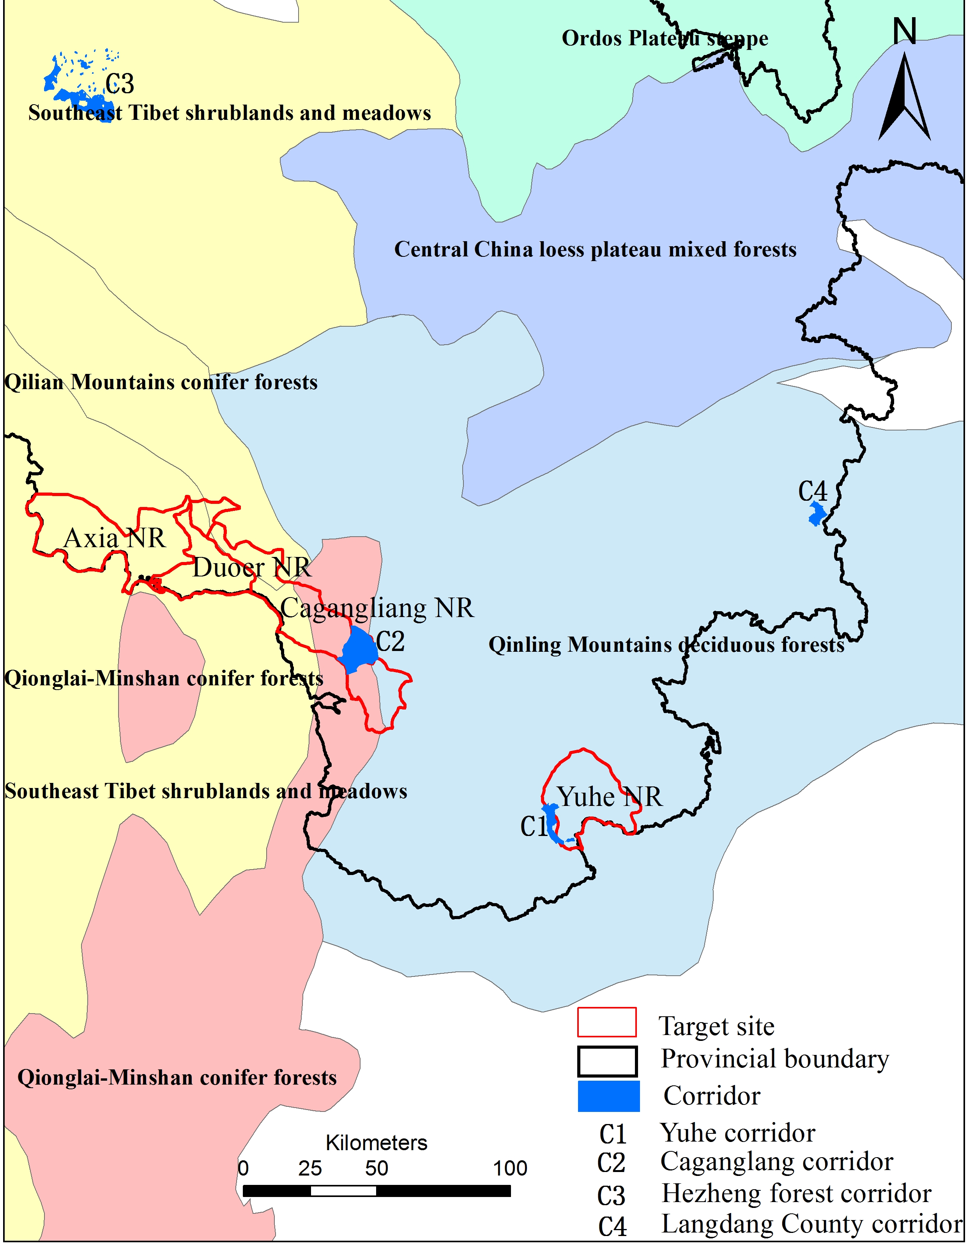
Figure 2. Location of project sites and corridor areas in relation to WWF terrestrial ecoregions.
Source: Xu Ming, Institute of Geographical Sciences and Natural Resources Research, Chinese Academy of Sciences.

Axia Landscape and PA Profile
Axia NR, established in 2004, lies between the northern part of the Minshan range and the southern margin of the Dieshan Mountains in the Bailongjiang river basin. It is built on Diebu Forestry Bureau under the Bailongjiang Forestry Administration, a state-owned enterprise, formerly engaged in logging. Its financing comes from the provincial government budget with no other revenue. It has a staff of 30 and is based in Diebu County. There is no wildlife corridor planned for Axia Sanctuary. Furthermore, GEF carries out project activities such as sweet cherry planting and e-commerce marketing in Tso xi village of Wangzang Town, Diebu County, a demonstration village of Axia nature reserve.
Figure 3 - Axia PNR map.
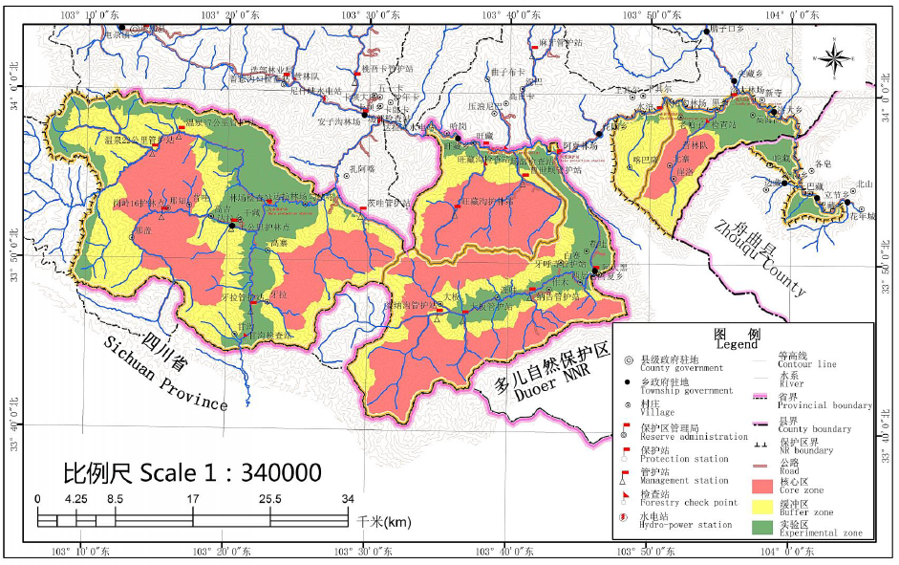
Table 2. Summary of major strengths and weaknesses of Axia PA and associated opportunities and threats.
 | Opportunities | Threats
Strengths
Located in KBA with flagship species | 1) Seek for National NR status.  2) Apply for more budget, enlist more staff and enhance technical capacity; | 1) Strengthen communication with provincial government to gain special funds support.
Raised awareness in environmental conservation | 1) Promote co-management | 1) Improve the institutional framework to push for eco-tourism, concession and so on to increase NR's revenue.
Weaknesses
Shared staff with Diebu Forestry Bureau | 1) Communicate with governments at provincial and prefecture levels to improve the law and policy framework to ensure more sustainable livelihood for farmers. | 1) Provide farmers with training for labour mobility, new technology for daily life
Limited technical capacity | 1) Reinforce international and national publicity to seek more aids from international organizations | 1) Increase training for staff.

Chagangliang Landscape and PA Profile
Chagangliang NR, established in 2005, is located in the transitional zone between the western wing of the Qinling Mountains and Minshan Mountains in the Bailongjiang river basin. It is supported by Zhouqu Forestry Bureau under the Bailongjiang Forestry Administration, a state-owned enterprise, formerly engaged in logging. Its finance comes from the provincial government budget with no other revenue. It has a shared staff with Zhouqu Forestry Bureau and is based in Zhouqu County. GEF carries out project activities such as pepper planting and e-commerce marketing in Lamoguetto Village, Qujina Town, Zhouqu County, a demonstration village of Chagangliang Nature Reserve. The Chagangliang corridor is 6,920 ha, of which 5,510 ha is state owned forest, and 1,410 ha is collective forest. The Chagangliang corridor is outside the protected area, and there is no relocation and resettlement plan for local indigenous people in the future. A community-based approach is adopted in corridor areas to strengthen ecosystem management.

Figure 4 - Chagangliang PNR map.
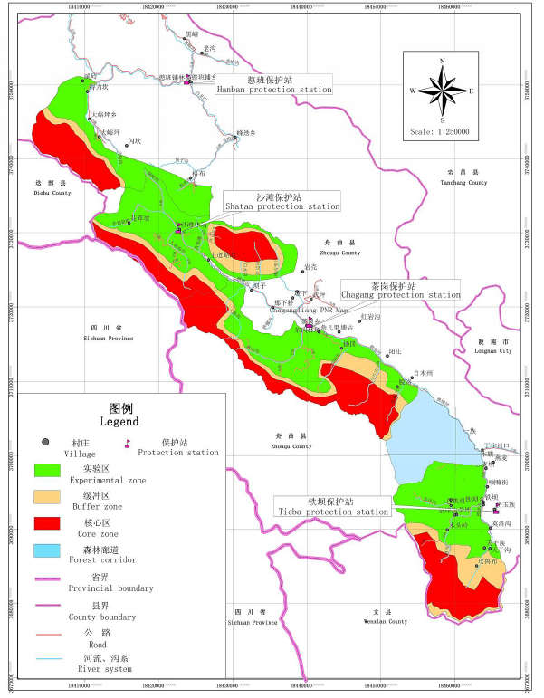

Table 3. Summary of major strengths and weaknesses of Chagangliang PA and associated opportunities and threats.
 | Opportunities | Threats
Strengths
Located in KBA with flagship species | 1) Apply for National NR status | 1)Strengthen communication with NR authorities and government to gain an increased and secure budget.  - Look for sustainable livelihood options for farmers.
Raised conservation awareness of farmers | 2) Promote the co-management | 2) Improve the institutional framework to push for eco-tourism, concession and so on
Weaknesses
No special staff | 1) Make use of reform to set up a special governing body and separate responsibilities | 1) Push for improvement of the law and policy framework to pay equal attention to conservation and resources use
Limited technical capacity | 2) Reinforce international and national publicity to seek more aids from international organizations

Duoer Landscape and PA Profile
Duoer NR, established in 2004, is located on the eastern margin of the Qinghai-Tibetan Plateau and in the northern Minshan mountains. It belongs to the Duoer water system, a tributary of the Bailongjiang River. It has a staff of 33 and the NR office is based in Diebu County town. Its current financing mainly comes from Diebu County government budget. The main threats faced include habitat fragmentation, natural disasters such forest fire, heavy snow, etc., and bamboo die-off after blossoming. GEF carries out project activities such as eco-tourism and e-commerce marketing in Dayi Village, Diebu County, a demonstration village of Dore Nature Reserve. There is no wildlife corridor planned in Dore Nature Reserve.

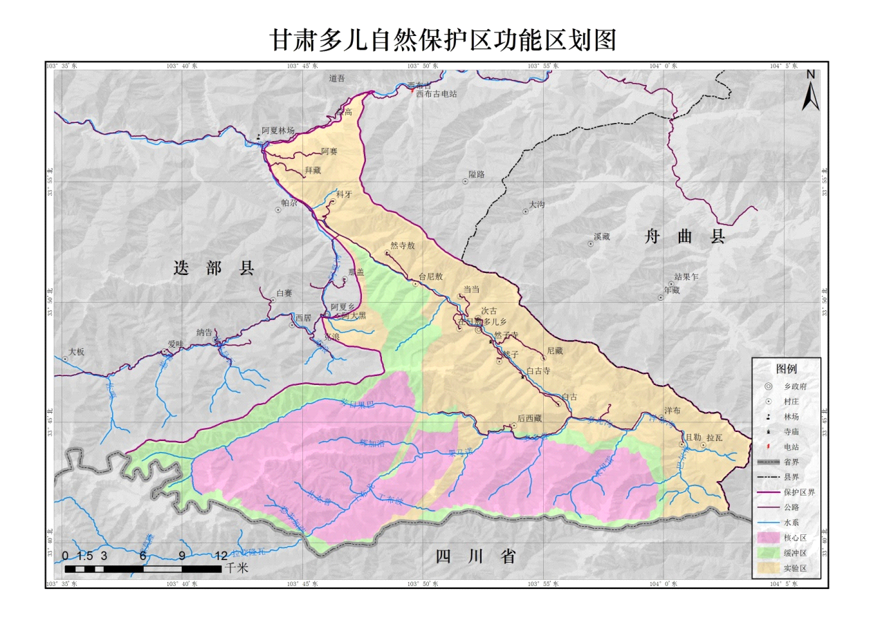
Figure 5 - Duoer PNR map
Table 4 - Summary of major strengths and weaknesses of Duoer PA and associated opportunities and threats.
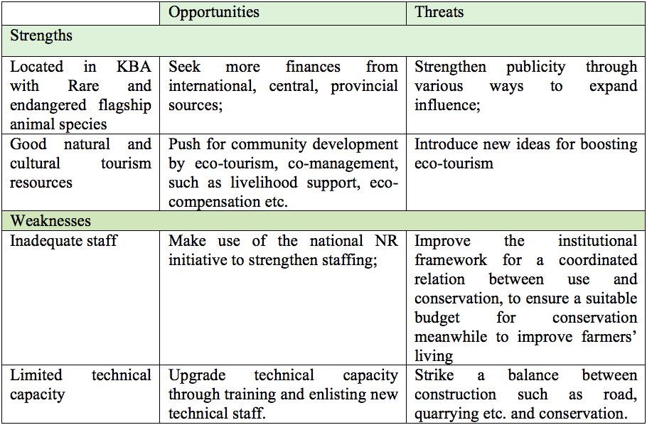

Yuhe Landscape and PA Profile
The Yuhe corridor (located between Yuhe NR and Baishuijiang NR) is about 4,376 ha, including 2,957 people and 5 administrative villages. GEF carries out project activities such as tea planting and e-commerce marketing in the Yuhe Tea Farmers Cooperative, a demonstration village of Yuhe Nature Reserve. The tree species include Abies faxoniana, Abies hensiensis, spruce, Picea wilsonii, Betul albo-sinensis, Quercus, Tetracentron sinense, linden, Pterocarya macroptera, Rhododendron lapponicum etc. It is mainly state public welfare forest. The vegetation comprises alpine meadow, mixed conifer, secondary deciduous broadleaved forest. Only the corridor of Yuhe Nature Reserve is included in the Giant Panda National Park and only a part of the residents of the area (Fengxiang Township) are not in the core conservation zone. According to the Giant Panda National Park planning and management requirements, residents of the general control zone do not need to be relocated outside the national park.

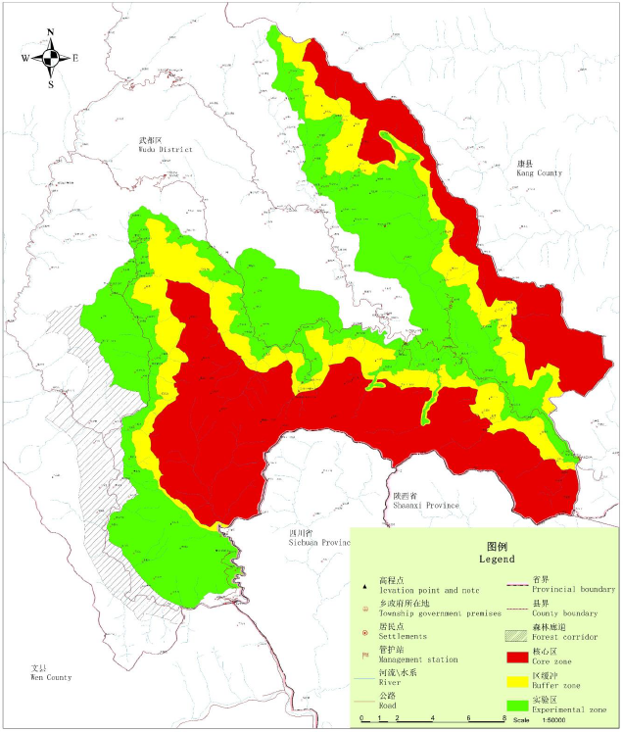
Figure 6. Yuhe PNR map.

Table 5 - Summary of major strengths and weaknesses of Yuhe PA and associated opportunities and threats.
 | Opportunities | Threats
Strengths
1) Located in KBA with more rare and endangered animal species | 1) Push for panda national park initiatives to upgrade conservation.  2) Develop cooperatives to support community livelihood opportunities, and boost co-management. | 1) Develop sustainable livelihood options for farmers for instance, eco-compensation, sale of products on internet, training for labor mobility etc.
1) Raised awareness in conservation | 1) Push for legislation for national park management. | 1) Introduce new ideas for boosting community development and eco-tourism.
Weaknesses
Inadequate staff  poor infrastructure | 1) Take the advantage of the panda national park initiative to strengthen institutional capacity building;  2) Look for more aid from international organizations and national channels | 1) Improve the law and policy framework for a coordinated relation between use and conservation to make a more reasonable budget and institutional arrangement for conservation.
Limited technical capacity | 1) Enhance training for staff | 2) Strike a balance between construction such as road, quarrying etc. and conservation.

Hezheng County Landscape and PA Profile
Hezheng corridor is located in the southern part of Linxia Hui Autonomous Prefecture, Gansu Province, a transitional zone between the Qinghai Tibet Plateau and the Loess Plateau. It belongs to the Yellow river basin. It is designated as public welfare forest and based on the Daheigou state-owned tree farm. It is managed by Hezheng County Forestry Bureau with a total staff of 61. There are four rivers flowing from east to west across the region, all of them are tributaries of the Yellow River. So far activities carried out include: reafforestation, forest tending, fire prevention, and forest protection and wildlife conservation. The ecological corridor in Hezheng County is outside the protected area and there is no resettlement plan for the local indigenous people. A community-based approach is adopted in corridor areas to strengthen ecosystem management.

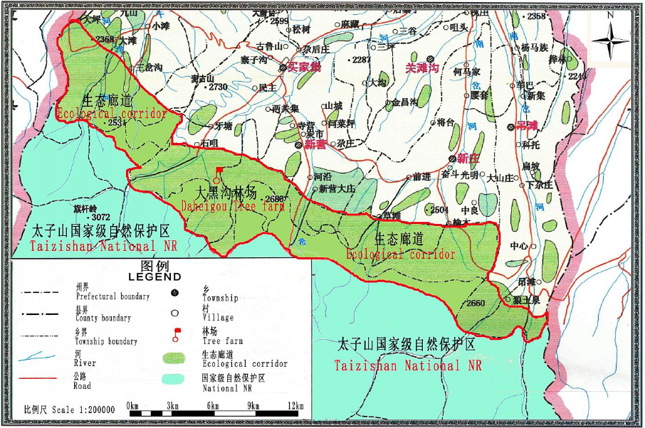
Figure 7. Hezheng ecological corridor map.

Liangdang County Landscape and PA Profile
The proposed ecological corridor in Liangdang County builds on the Lingguanxia NR, which has no fixed institution, staff and special project, and is located in the Qinling trough, on the south slope of the northern Qinling Mountains. The Lingguan River, a main tributary of the Jialing River, flows through the whole area from west to east. Its main tributary is Chenjiagou River. The major rivers in the Lingguanxia NR region include the Majiagou River and the Hejiagou River to its north, and the Yagouli River and Hujiagou River to its south. All rivers in the Lingguanxia NR run into the Hongya River, which is the largest tributary of the Jialing River. Activities conducted so far include natural forest and public welfare forest conservation in the corridor. The ecological corridor in Liangdang County is outside the protected area, and there is no relocation and resettlement plan for the local indigenous people in the future. . A community-based approach is adopted in corridor areas to strengthen ecosystem management.

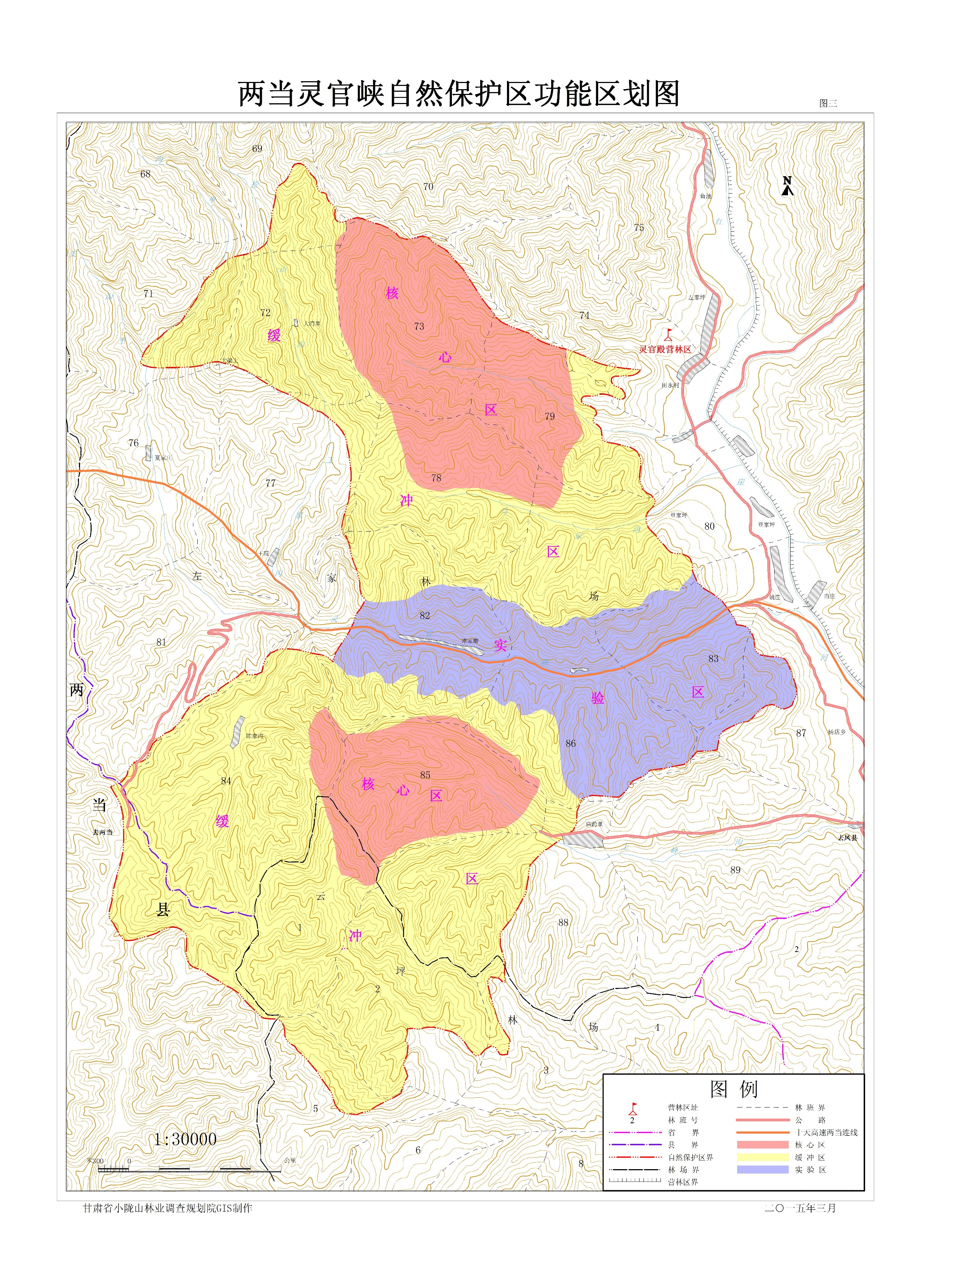
Figure 8. Liangdang ecological corridor distribution and functional zoning map.

4.2 Social Baseline
Gansu had 26.1 million permanent residents in 2016, accounting for 1.9% of the total population in China. Of the total, 44.7% were urban, which was 12.7 percentage points lower than the national average in the same year. The ratio of women to men is similar to the national average. Among the total population, 2.56 million were ethnic minority, accounting for 9.85 of the total population in Gansu Province, and 2.2% of the total ethnic minority people in China in 2016.

Table 6. Population Composition in Gansu Province in 2016.
 | Unit | Data | % of China
Permanent residents | million | 26.1 | 1.9%
Urban | % | 44.7
Rural | % | 55.3
Male | % | 51.0
Female | % | 49.0
Han ethnicity* | % | 90.2
Ethnic minorities* | % | 9.8 | 2.2%
Source: Gansu Statistical Yearbook-2017; 1% National Population Sample Survey in 2015.

There were totally 25,749 villagers living in the four nature reserves in 2016. Women accounts for 50 percent of the total. The majority of the rural villagers in Yuhe NR are Han majority while the majority of rural villagers in the other three project NRs are Tibetan people. Except for Yuhe NNR, which is located in Longnan Municipality and has less than 3% of ethnic minority people, the other three nature reserves are all located in Gannan Tibetan Autonomous Prefecture.
Table 7. Population Composition of the Target Nature Reserves in 2016.
NR/eco-corridor  (county located) |  | Yuhe  (Wudu) | Chagangliang  (Zhouqu) | A'xia  (Diebu) | Duoer  (Diebu) | Sub-total
Township | # | 4 | 7 | 3 | 3 | 17
Village | # | 30 | 17 | 11 | 11 | 69
Household | # | 1,344 | 2,435 | 1,261 | 950 | 5,989
Population | person | 5,374 | 9,739 | 5,554 | 5,082 | 25,749
Male | % | 50.3 | 50.1 | 50.5 | 49.8 | 50.1
Female | % | 49.7 | 49.9 | 49.5 | 50.2 | 49.9
Han people | % | 97.4 | 5 | 0.1
Ethnic minority | % | 2.6 | 95 | 99.9 | 100
Tibetan | % |  | 95 | 99.9 | 100
Source: Gansu Provincial Forestry Department in November 2017.

There were totally 97,569 villagers living in the proposed ecological corridors in 2016. Women accounts for 50 percent of the total. Most rural villagers in the proposed ecological corridors next to Yuhe NNR and in Liangdang County are Han majority. Most people in the proposed corridor in Chagangliang are Tibetan people. Within the proposed ecological corridor in Hezheng County, 60% of the villagers are ethnic minority people, including 33% of Hui Group, 24% of Dongxiang Group, and 3% of other ethnic minority peoples.
Table 8. Population Composition of the Proposed Eco-corridors in 2016.
NR/eco-corridor  (county located) | unit | Yuhe  (Wudu) | Chagangliang  (Zhouqu) | Hezheng  (Hezheng) | Liangdang  (Liangdang) | Sub-total
Township | # | 1 | 1 | 5 | 1 | 8
Village | # | 5 | 4 | 51 | 4 | 64
Household | # | 739 | 441 | 19,211 | 599 | 20,990
Population | person | 2,957 | 1,831 | 90,387 | 2,394 | 97,569
Male | % | 50.3 | 50.1 | 51 | 50 | 50.3
Female | % | 49.7 | 49.9 | 49 | 50 | 49.7
Han people | % | 97.4 | 0 | 40 | 98
Ethnic minority | % | 2.6 | 100 | 60 | 2
Tibetan | % |  | 100
Hui ethnicity | % |  |  | 33
Dongxiang Ethnicity | % |  |  | 24
Source: Gansu Provincial Forestry Department in November 2017.

Literacy situation: In the Tibetan area, most laborers received primary school education. People older than 50 years have limited school education. Women’s education level is less than that of men. Villagers younger than 45 years, both women and men, can speak in Tibetan and Mandarin, but they may lack enough capacity to read and write. It is a little bit difficult for the villagers, women and men, older than 45 years to speak in Mandarin.

Electricity and Internet Connection: Almost every village has access to electricity. Internet cables have been placed to some villages in 2017. Individual households pay for connecting the cable to their houses, CNY680 per set, and pay for user fee, CNY 107 per month. Currently some households are connected. Not all villages have primary schools. For example, Zhangjiayuan Village, in Yuhe NNR, does not have a school. The children study in Luotang Town of Wudu District, or in Wen County, or in Yaodu, Sichuan.

Livelihoods: Most male laborers younger than 45 years migrated outside of the villages for waged work. For example, in Zhangjiayuan Village of Yuhe NR, two thirds of villagers actually lived outside the village for waged work, or for kids’ education. In Qiazi Village of Yuhe, 90% of the households have at least a laborer working outside the villages. Few people were working as rangers for the nature reserves. For example, there were 17 villager rangers working for Yuhe NNR, with a salary of CNY 7,000 per year in 2016. These rangers were mainly from poverty households. Many farmers stayed in the villages tried various livelihood activities, such as planting Chinese medicines, bee-keeping, yaks, cattle etc. Keeping bees has started in the past few years. In Dashuigou Village, where few households kept bees, about 30 kg of honey was produced per household in 2016. More households have engaged in bee-keeping since 2017. Some households produced over 500 kg honey in 2017. Besides bee-keeping, the farmers tried various options, such as raising chickens, planting konjak, and gastrodia elata, but income was not as much as expected due to lack of demand.

Table 9. Employment Situation of the Interviewed Villages in 2016.
Village interviewed  (NR located) |  | Zhangjiayuan  (Yuhe) | Dashuigou (Yuhe) | Qiazi  (Chagangliang) | Gongba (Chagangliang) | Citang (A’Xia)
Households | # | 85 | 123 | 93 | 150 | 60
Total population | person | 316 | 522 | 400 | 700 | 323
Ethnic minority | % | 0 | 0 | 100% Tibetan | Tibetan | Tibetan
laborer | person | 175 |  | 240 | 400 | 170
Migrated laborer | % | 80% | 50% | 50% | 60% | 50%
cropland | mu | Few | 1,060 |  | 1,900
Ecological forestland | mu | 900 | many | many | many | many
Chinese medicine | mu |  | Some | 500
Tea | mu | 850
Walnut | mu |  | Over 100
Huajia | mu |  |  |  | Over 40
Bee-keeping | hh |  | 70 | Over 20 | 30
Cattle/yak | Head |  | 30 | 300 | 1,000 | 1,300
sheep | head |  | 600 | 0 | Few | few
Note: 15 mu=1 ha.

5. Social and Environmental Risks and Impacts

5.1 Introduction
UNDP uses a social and environmental screening process to identify potential social and environmental risks for proposed projects. The type, location, scope, sensitivity, and scale of potential social and environmental impacts of each project are carefully reviewed. All project activities have been screened, including planning support, policy recommendations, capacity building, and physical interventions at specific project sites.
In accordance with UNDP SES, the Social and Environmental Screening Procedure (SESP) has been applied to C-PAR 2 during the project development phase. An environmental and social management framework (ESMF) has also been developed during the project preparation phase. Based on initial assessments, some social and environmental risks have been identified for this project. The Environmental and Social Impact Assessment (ESIA) process is considered a key component for the implementation of the project. The ESIA process consists of two main phases: scoping and impact assessment. The scoping report is not intended to provide detailed information regarding the project. Instead, it is a preliminary overview of the project intended to form the basis for early engagement with relevant stakeholders and to help identify potential project impacts.
The environmental and social impact assessment (ESIA) was carried out during project inception to further evaluate potential impacts associated with the project activities. As a part of this process, mitigation measures have been built into the environmental and social management plan (ESMP) to guide the implementation process. These measures seek to provide an adequate management response to the identified risks in line with UNDP best practice. The assessment of social impacts within the boundaries (and sphere of influence of C-PAR 2) has followed the methodology as prescribed by the Social Assessment for Protected Areas (SAPA). The SAPA approach is a multi-stakeholder assessment for use by PA/CA managers, communities living within and around a PA/CA or other stakeholders and rights holders at local and national levels. The goal of SAPA is to help more equitably to share the positive social impacts and reduce the adverse social impacts of conservation initiatives.

5.2 Impact Assessment Methodology
Methodological Background
This environmental and social impact assessment adopts a comprehensive, participatory assessment method, classifying the work process into three time periods: communicating with project office staff and chief experts to understand the background of the assessment, designing an assessment plan, and conducting on-site assessments. In the on-site assessment process, methods such as household and focus group interviews, group work, data collection, and field observation methods were comprehensively conducted.
The assessment content includes: a) the 10 social and environmental risks identified through the screening procedures during the project preparation period; b) the risk response plan developed by the Reserve Authority (Forestry Bureau) since project preparation; c) the Reserve Authority Community communication mechanism; d) suggestions of the community and local government regarding the work on the reserves; e) the roles and functions of various stakeholder groups in the project; and, f) the challenges generally faced in environmental and social management of similar projects.
The personnel participating in the assessment process inspected the office space, staff composition, management structure, and publicity and community work of the reserve management bureau. Other areas of inspection included the community environment, community industrial production and living conditions, and community and local government development plans.
Assessment of Significance
An impact is essentially any change to a resource or receptor brought about by the presence of a Project component or by the execution of a project-related activity. For this ESIA report, the assessment of impacts will proceed through an iterative process considering three key elements:
- Prediction of potential impacts and their magnitude (i.e., the consequences of the development on the natural and social environment);
- Evaluation of the significance of potential impacts taking the sensitivity of the environmental resources or human receptors into account;
- Development of mitigation measures to avoid, reduce or manage the potential impacts or enhancement measures to increase positive impacts.

In adhering to international best practice, this ESIA will establish a ‘significance’ level for each identified risk/impact. Criteria for assessing the significance of impacts will stem from the following key elements:
- Status of compliance with relevant host country legislation, UNDP SES standards/requirements, as well as international best practice standards and guidelines.
- The magnitude (including nature, scale and duration) of the change to the natural or socio- economic environment, expressed, wherever practicable, in quantitative terms. The magnitude of all impacts is viewed from the perspective of those affected by them considering the likely perceived importance as understood through stakeholder engagement.
- The nature and sensitivity of the impact receptor (physical, biological, or human). Where the receptor is physical, the assessment considers the quality, sensitivity to change and importance of the receptor. For a human receptor, the sensitivity of the household, community or wider societal group is considered along with their ability to adapt to and manage the effects of the impact; and
- The likelihood (probability) that the identified impact will occur. This is estimated based upon experience or evidence that such an outcome has previously occurred.

It is generally accepted that significance is a function of the magnitude of the impact and the likelihood (probability) of the impact occurring. For this assessment, significance will be defined according to the following levels (as prescribed by UNDP’s SES). When probability and consequence of impacts are combined, as shown in Figure 1, it is possible to determine a significance value (low, moderate, or high) for each type of risk.

Table 10 - Rating of Probability/likelihood of Risk
Score | Rating
5 | Expected
4 | Highly Likely
3 | Moderately likely
2 | Not Likely
1 | Slight

Table 11 - Rating the Consequence/ ‘Impact’ of Risk
Score | Rating | Definition
5 | Critical | Significant adverse impacts on human populations and/or environment. Adverse impacts high in magnitude and/or spatial extent (e.g. large geographic area, large number of people, transboundary impacts, cumulative impacts) and duration (e.g. long-term, permanent and/or irreversible); areas impacted include areas of high value and sensitivity (e.g. valuable ecosystems, critical habitats); adverse impacts to rights, lands, resources and territories of indigenous peoples; involve significant displacement or resettlement; generates significant quantities of greenhouse gas emissions; impacts may give rise to significant social conflict
4 | Severe | Adverse impacts on people and/or environment of medium to large magnitude, spatial extent and duration more limited than critical (e.g. predictable, mostly temporary, reversible). The potential risk impacts of projects that may affect the human rights, lands, natural resources, territories, and traditional livelihoods of indigenous peoples are to be considered at a minimum potentially severe.
3 | Moderate | Impacts of low magnitude, limited in scale (site-specific) and duration (temporary), can be avoided, managed and/or mitigated with relatively uncomplicated accepted measures.
2 | Minor | Very limited impacts in terms of magnitude (e.g. small affected area, very low number of people affected) and duration (short), may be easily avoided, managed, mitigated.
1 | Negligible | Negligible or no adverse impacts on communities, individuals, and/or environment.

Figure 1: Determining the ‘Significance’ of Risk Matrix
Consequence of Impact | 5
 | 4
 | 3
 | 2
 | 1
 |  | 1 | 2 | 3 | 4 | 5
 | Probability
Green = Low, Yellow = Moderate, Red = High

5.3 Assessment of Risks and Impacts
Between December 2019 and June 2022, the project's social integration experts with the support of Gansu Project Office staff, the project's Model Protected Area Administration and Forestry Bureau, and other project experts conducted a systematic assessment of the environmental and social impacts of the project to enhance the protected area system in Gansu Province and strengthen the conservation of biodiversity.
Assessment Objectives:
- Comprehensive and in-depth understanding of the negative impacts of GEF projects on the environment and affected populations.
- Updating the social and environmental screening process risks since the project preparation period.
- Collecting data and conducting surveys to mitigate social and environmental risks, or to reduce, curtail or compensate for negative social and environmental impacts.
- To understand the impact that women, minorities, and other vulnerable groups may face as a result of the project.
- Conducting baseline surveys and needs assessments for upgrading protected areas (conservancies) to strengthen management systems and carry out environmental and social risk capacity building.
A full list of assessment participants is provided in Appendix 2.

5.4 Assessment of Social Risks
The assessment of social issues will be one key issue of the ESIA Report, which includes consideration of the potential impacts of project activities on local people and their livelihoods.
Risk 1: Local communities (including ethnic minorities) living in the key pilot reserves of the national parks may choose to voluntarily and gradually be resettled. This risk refers to physical displacement, which occurs when individuals or communities are fully or partially no longer able to occupy an area and must relocate to a new location.
- Evaluation conclusion during project design - impact and probability: I = 4, P = 4; significance: high.
- Latest assessment conclusions-impact and probability: I = 4, P = 4; significance: high; unchanged.
- Risk stage: both in project implementation and operation phases.
The implementation plan for the NP system issued by the government in September 2017 (which is not an element of the UNDP/C-PAR 2 project) notes that in core conservation zones, resettlement of local communities would support the full achievement of conservation objectives and that any such resettlement must be gradual and voluntary in nature. In accordance with international best practice, the risks that have the potential to eventuate through activities supported solely by associated facilities (not directly related to C-PAR 2) have been included in risk assessment undertaken during the completion of this ESIA. Therefore, it is important to note that while this risk has been assigned a significance level of ‘high’, this is not a direct reflection of the probability and consequence/impact of this risk eventuating as a direct result of C-PAR 2 activities. Voluntary resettlement is proposed in the national park pilot zoning plan (which is not under the auspices of C-PAR 2 but is rather an ancillary/associated initiative under government funding and management).
The consultation and consent processes that lead to the determined benefit sharing arrangements took place between 2019 and 2021. The contents of community consultation meetings and surveys include: the main conflicts between the protected area and the community; the publicity, education, information disclosure and communication of the protected area; the livelihood development and poverty alleviation of the protected area in the surrounding communities; restrictions on the economic development, road construction, natural resource utilization, etc. of the surrounding communities; the possible impact of future zoning adjustment of the protected area on the community; the resettlement relocation plan of the surrounding communities; the economic, social, personnel and cultural structure of the surrounding communities; the development plan of surrounding communities; the distribution of wild animals and plants in surrounding communities; the compensation for wildlife damage in surrounding communities; the awareness of protected area staff about policies and regulations related to environmental and social management; assessment and prioritization of potential social risks in protected areas; and communication mechanism among protected area stakeholders, etc. During the community survey process, C-PAR2 trained the relevant staff of the protected area administration and invited them to participate in community consultation meetings and community surveys. This kind of participatory ESIA not only greatly stimulated the participation of the protected area management bureau as the most important stakeholder of the plan, but also ensured the rationality and operability of the plan. C-PAR2 fully took into account gender equality and the particularities of ethnic minorities in terms of culture, belief, and living customs, and incorporated the special needs and suggestions of women and ethnic minorities into ESIA through interviews and communication with representatives of women and ethnic minorities. It consists of the following list of community meetings, stakeholder meetings, and households surveys.
In October and December 2019, 4 stakeholder meetings were organized in Hezhen, Liangdang, Yuhe, and Chagangliang. A total of 8 community representatives from potentially impacted villages participated in the meetings with the intention of better understanding the C-PAR 2 project, sharing their concerns, and expressing their support. The other stakeholders who took part into the meetings include officers from Gansu Forest and Grassland Bureau, Gansu PMO, C-PAR 2 specialists, township governments, county forestry bureaus, and natural reserve administrations.
From May 19 to June 6, C-PAR 2 organized 4 community meetings in all proposed expansion and corridor areas. In Liangdang county, 4 community members living in the proposed corridor joined the meeting. In Yuhe Natural Reserve, 8 villagers (including 3 women) attended the meeting. In Chagangliang Natural Reserve, a total of 6 Tibetan villagers joined the meeting. In Hezhen county, 27 villagers (including 11 women) attended the community meeting. In order to protect the right to know of GEF project stakeholders, project specialists presented background information related to C-PAR 2 to community representatives, including project funding sources, management, and implementing agencies. Next, the participants discussed the possible environmental and social impacts of C-PAR 2 on the local communities. Villagers raised concerns about wildlife damage and restrictions on rural tourism development. Experts facilitated workshops during which local residents drew maps listing roads, rivers, forests, and biodiversity hotspots around the villages. Villagers also discussed the optimal location of ecological corridors and protected areas. After thorough discussions, the villagers expressed their support for C-PAR 2. Participants also specifically discussed the impacts of the project on women in the local communities. With the construction of ecological corridors and nature reserves, space for food plantations will be reduced with a consequent decrease in the total amount of labor rendered by women from the local communities. Women could find new employment opportunities in the expanding sectors of entertainment (e.g. eco-tourism) and handicraft (e.g. embroidery). After the community meeting, the project specialists also conducted household interviews to further understand the lifestyle of the villagers and the impacts that C-PAR 2 may have on them.
In May and June 2021, project specialists took field trips to all nature reserves and ecological corridors again. Through household surveys and community meetings, specialists helped 2 villages develop small projects for alternative livelihood and sustainable development. One village planned to improve the variety of Chinese prickly ash and at the same time promote the use of organic fertilizers, along with training on prickly ash planting and prickly ash drying to improve the quality and yield of this crop. In addition, through the promotion of e-commerce, the sales of Zanthoxylum will be expanded. Furthermore, given that the planting, management, and sales of Chinese prickly ash are tasks mainly performed by the women living in the local communities, they will be the main beneficiaries of the expansion in production and sale. Another village planned to optimize the management of tea gardens, increase tea production, demonstrate and promote organic fertilizers and ecological pest control under the leadership of community women. These two projects were funded through C-PAR 2.

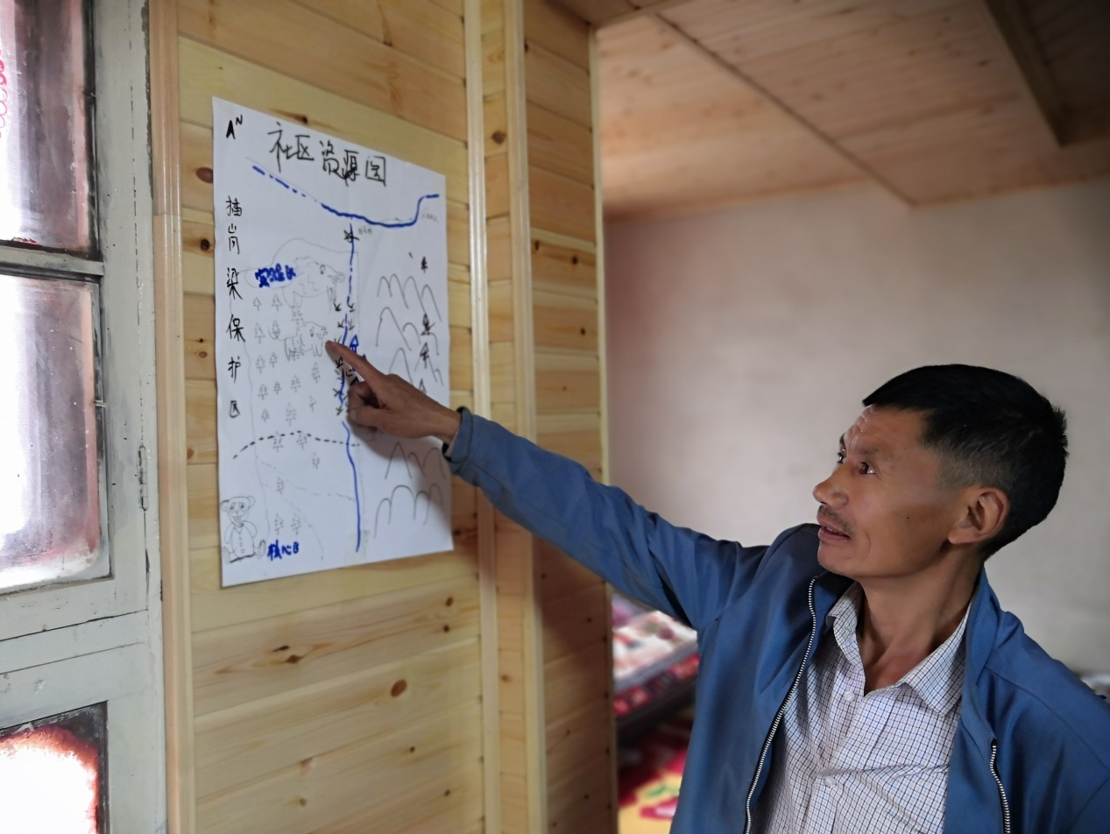
Figure 9. One of the workshops during which local residents drew maps listing roads, rivers, forests, and biodiversity hotspots around the villages.

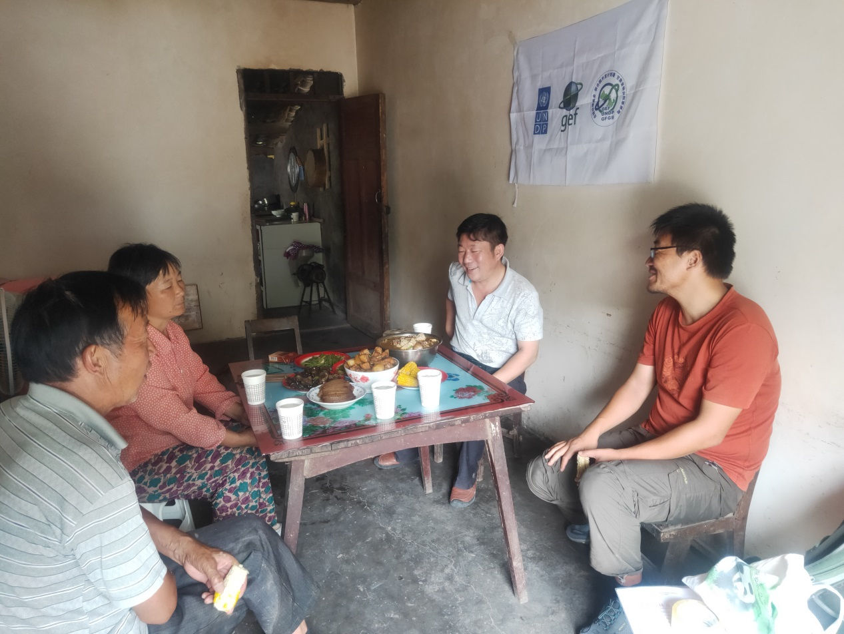
Figure 10. One of the household surveys conducted by C-PAR 2 experts.
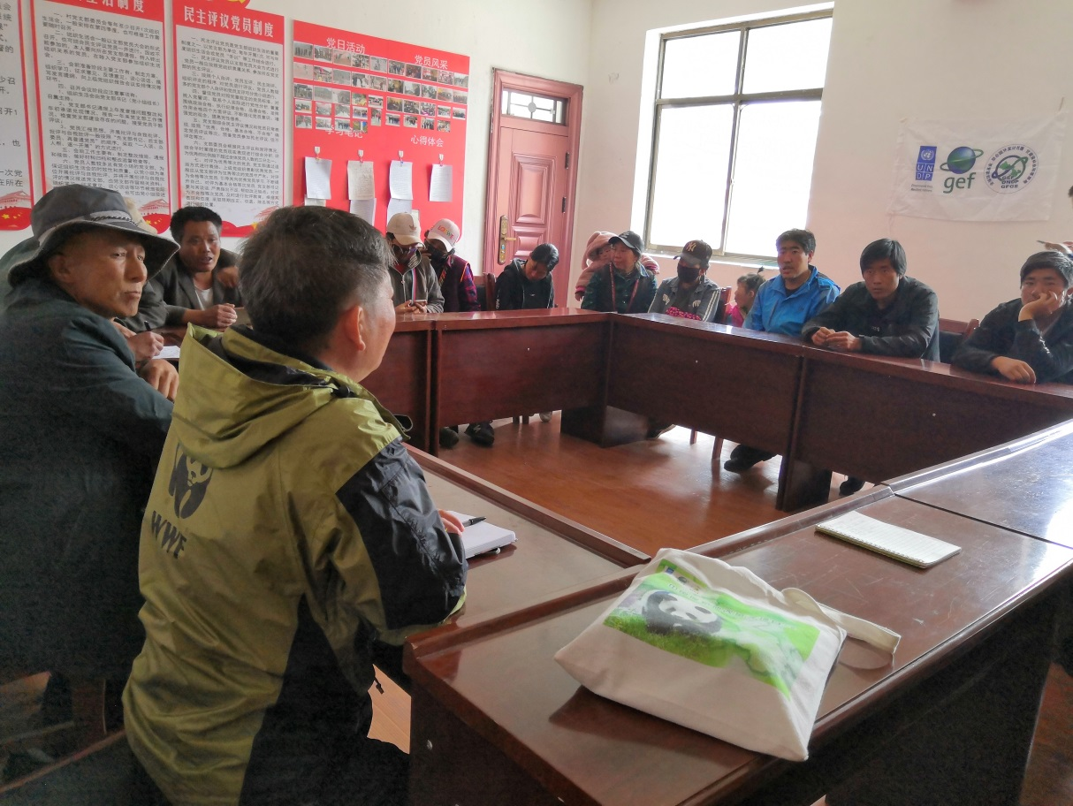
Figure 11. One of the community meetings discussing the socio-economic impacts of C-PAR 2.

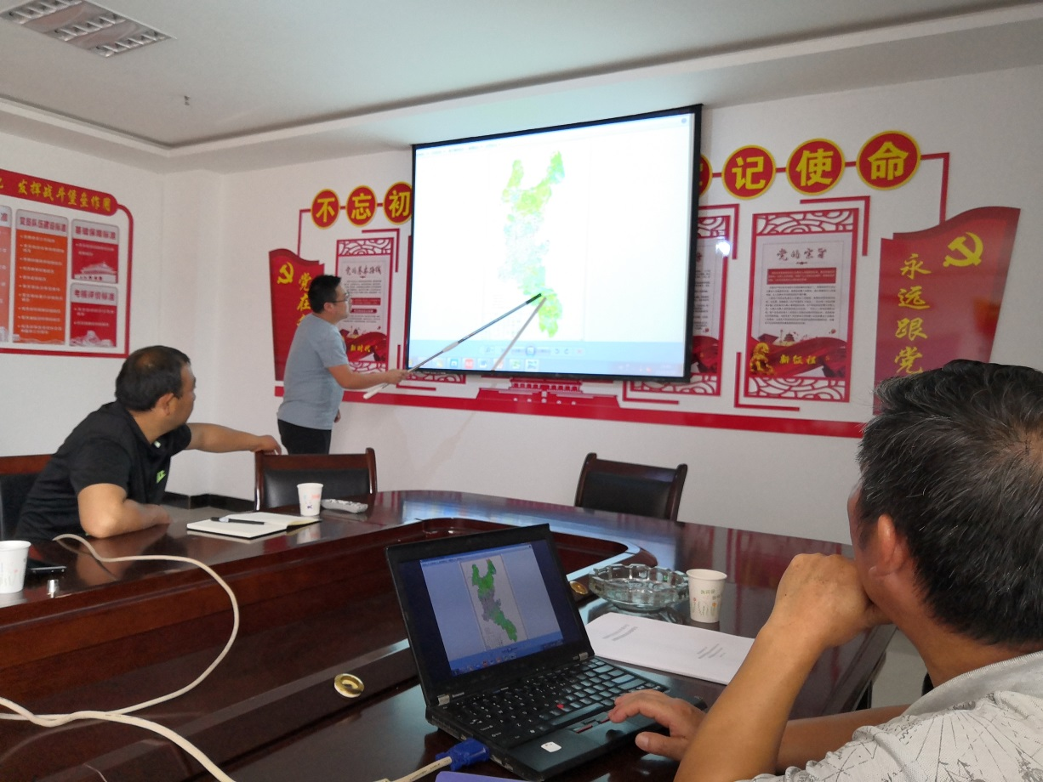
Figure 12. One of the meetings discussing the location of newly-established ecological corridors and nature reserves.

Yuhe Nature Reserve: The government has implemented relocation and resettlement in the core area (which is not under the auspices of C-PAR 2 but is rather an ancillary/associated initiative under government funding and management). There are no community residents in the core area, but the land acquisition has not been completed.
Hezheng County Ecological Corridor: The ecological corridor has not yet been established. The country's targeted poverty reduction policy that is independent of the C-PAR 2 project involves resettlement. The preliminary preparations have been completed. Some community residents have moved out. The local resettlement plan has preferential policies for women.
Chagangliang and Axia Nature Reserves: According to the latest reserve demarcation standard, there are still community residents living in the core area. They will be offered assistance to voluntarily relocate, if they so wish. Any resettlement from Chagangliang and Axia NR will be based on the principles of ‘willing buyer-willing seller’ and shall follow UNDP and GEF minimum requirements.
As the demarcation of the reserves has not been completed, it is likely that boundary of the project’s core zones will be adjusted by 2025. According to the data of the Third Survey of Land Use, the People’s Republic of China should strive to maintain at least 1.8 billion mu of cultivated land in the country as a priority. Hence, there is still a great possibility of functional zoning and boundary adjustment of protected areas. Farmers living in the reserves or surrounding areas traditionally live off the land. However, during the next few years’ implementation period, the residents living in the core are highly likely to face issues relating to resettlement. Therefore, the probability of this risk is still ‘highly likely’, P = 4. Voluntary resettlement would have a great impact on their livelihood, cultural traditions, religious beliefs, and social relations. Therefore, the impact of this risk is ‘severe’, I = 4. In summary, the significance of resettlement risks for residents in this local community is still high.
When conducting community surveys, most villagers understood and supported moving out of the core area of ​​the reserve and ecological corridors. In recent years, with the promotion of environmental protection related public awareness and laws have greatly improved. Most villagers could understand the importance of nature protection and basically knew the relevant laws and regulations.
In addition to protection and legal awareness, community residents were (in respect of projects outside the auspices of C-PAR) willing to relocate because of economic interests. Most of the communities originally in the core area of ​​the reserve had inconvenient transportation, relatively high altitude, and poor natural conditions. The land was relatively uneven and could not easily be used for agricultural production. The lands were also often destroyed by wild animals such as wild boars. The residents living in the reserve were mainly engaged in agricultural production and animal husbandry with a low unit output value. Therefore, the income of the residents staying in the community was not high, and the economic development level of the community was relatively low.
In case of Donggou Village, Fengxiang Township, Wudu District in Yuhe Reserve as an example, after the "5.12" earthquake in 2008, some of the old houses closer to the core area of ​​the reserve collapsed or became dangerous. During the reconstruction after the earthquake, the government rebuilt the village at a low altitude, close to the road, and far from the core area of ​​the reserve.
In recent years, many local peoples have decided to voluntarily relocate out of the core conservation zones (i.e., for economic/livelihood opportunities, access to services, etc.). Nevertheless, it cannot be denied that some people are still unwilling to relocate. For this part of the population, it is necessary to pay attention to their various needs of family and social interaction, health, and psychology. For community residents who are unwilling to relocate, their choices must be respected at all times.
Any project activities (including those that merely play a supporting role in relation to government initiatives not under the auspices of C-PAR 2) that have the potential to make this risk eventuate must be undertaken only after complying with the FPIC principles, definitions, and processes outlined in Appendix 3 and in the Indigenous People Plan. Should any voluntary resettlement occur following Appendix 3 compliant implementation, the letter provided in Appendix 4 must be completed, recorded, and made available to relevant stakeholders to ensure transparency of the consultation and consent processes.

Risk 2: Due to the establishment of ecological corridor areas, communities (including ethnic minorities) in the project area may face economic relocation and changes in land ownership and/or restrictions on the use of resources. This risk refers to economic displacement, which occurs when individuals or communities are fully or partially restricted in their access to land or resources that are important to their livelihoods and economic well-being. These effects may affect women differently from men.
- Evaluation conclusion during project design - impact and probability: I = 4, P = 4. Significance: High.
- Latest assessment conclusions - impact and probability: I = 4, P = 4; significance: high; unchanged.
- Risk stage: both in project implementation and operation phases
As C-PAR 2 activities may result in impacts on traditional livelihoods, stakeholder consultations regarding the possibility of voluntary resettlement are required, which must include application for FPIC in accordance with the project's socio-environmental screening process and environmental and social management plans. The development of master plans for protected areas and ecological corridor networks must also focus on similar safeguards. It must be noted that any relocation or resettlement, as is the case with any resettlement that may have occurred prior to this project, will not be supported by GEF funds and is not within the purview of the C-PAR 2 project.
Again, it must be mentioned that any such economic relocation is not under the auspices of C-PAR 2 but is rather an ancillary/associated initiative under government funding and management but has nonetheless been factored into this risk assessment due to difficulties differentiating the impacts caused by C-PAR and ancillary government initiatives being undertaken in an overlapping area.
As one of the important achievements of the GEF C-PAR 2 project, the ecological corridor establishment plan is still in the process of research and formulation and will be officially released soon. Robust stakeholder consultation has been undertaken on the establishment of the ecological corridor establishment plan. Once the plan is finalized, the communities in the ecological corridor area may be at risk of encountering newly imposed restrictions that may in turn impact their traditional livelihoods.
The impact of risk 2 in each protected area involved in the project is different. Some protected areas (such as the Fengxiang Conservation Station of Yuhe Nature Reserve) have small land area per capita, uneven land, and low output value. The main income of villagers is not agricultural production, and the economic dependence of local residents on the land is low. Other communities around the reserve use agricultural production as the main source of income, and economic relocation and land ownership changes may have a greater impact on these communities.
The impact of management measures such as restricting the use of resources in the reserve may be larger than those imposed previously by different projects. For example, during the investigation of Lingguanxia Reserve in Liangdang County, some interviewees stated that the restriction on the construction and expansion of roads in the reserve will not only affect the convenience of local residents, but also affect the development of local tourism by the government and enterprises’ investments on natural and cultural tourist attractions.
There are also gendered aspects to this risk. In traditional rural societies within the spatial bounds of C-PAR 2, men and women share agricultural production work. Although most households in the communities covered by the project are male-dominated, most women still participate in the control and use of economic income. After any potential economic relocation, women may receive lower wages and fewer job opportunities when compared to their male counterparts. Many women are also occasionally unable to go out in search of jobs due to responsibilities of looking after the elderly and raising children. Should women encounter these difficulties, they may face a net loss in income that is not experienced by their male counterparts.
Any project activities (including those that merely play a supporting role in relation to government initiatives not under the auspices of C-PAR 2) that have the potential to make this risk eventuate must be undertaken only after complying with the FPIC principles, definitions, and processes outlined in Appendix 3 and in the IPP. Should any voluntary resettlement occur following Appendix 3 compliant implementation, the letter provided in Appendix 4 must be completed, recorded, and made available to relevant stakeholders to ensure transparency of the consultation and consent processes.
C-PAR 2 shall organize and hold at least two meetings each year with the participation of representatives from provinces, counties, townships, villages, and herdsmen to solicit everyone's opinions on the project activity plan in advance. At the end of the project, the project will consult with all stakeholders to reflect their suggestions in the relevant plans.

Risk 3: Expanding the area of ​​existing reserves and establishing ecological corridors may affect the rights, land, and livelihoods (such as potential economic relocation, reduced access to resources, and voluntary resettlement) of ethnic minorities in and around the four exemplary reserves and Hezheng County.
Again, it must be mentioned that any such economic relocation is not under the auspices of C-PAR 2 but is rather an ancillary/associated initiative under government funding and management but has nonetheless been factored into this risk assessment due to difficulties differentiating the impacts caused by C-PAR and ancillary government initiatives being undertaken in an overlapping area.
- Evaluation conclusion during project design - impact and probability: I = 4, P = 4. Significance: High
- Latest assessment conclusions - impact and probability: I = 4, P = 4; significance: high; unchanged.
- Risk stage: both in project implementation and operation phases.
Adjusting the boundaries of reserves and establishing ecological corridors is likely to affect the minority population in and around the protected area. Therefore, the probability of this risk is highly likely, P = 4. The United Nations Declaration on the Rights of Indigenous Peoples clearly emphasizes that “indigenous peoples shall not be forced to move away from their lands or territories. If the freely given informed consent of the indigenous peoples has not been obtained in advance, fair compensation has been agreed upon, and the options of return are not provided, migration is not allowed.” Rights similar to those stated in the declaration are also acknowledged by the Chinese government and society. Since indigenous people’s beliefs, lifestyles, and cultural customs are largely based on interaction with the land, any voluntary resettlement or changes in land use restrictions will have a greater impact on ethnic minorities. In summary, the significance of risk 3, aiming at minority rights, land, and livelihoods, remains high.
Any project activities (including those that merely play a supporting role in relation to government initiatives not under the auspices of C-PAR 2) that have the potential to make this risk eventuate must be undertaken only after complying with the FPIC principles, definitions, and processes outlined in Appendix 3. Should any voluntary resettlement occur following Appendix 3 compliant implementation, the letter provided in Appendix 4 must be completed, recorded, and made available to relevant stakeholders to ensure transparency of the consultation and consent processes.
Risk 4: Ethnic minority communities in the relevant area often have relatively low levels of education and significant gender gaps, creating the risk that not all stakeholders will be able claim their rights.
- Evaluation conclusion during project design - impact and probability: I = 3, P = 2. Significance: Moderate.
- The latest assessment conclusion-impact and probability: I = 3, P = 1; significance: Low.
- Risk stage: both in project implementation and operation phases.
During the inception and project planning phases, meaningful consultation was conducted with representatives from local ethnic minority groups within the boundaries of C-PAR 2 sites. Local peoples (including ethnic minorities) were presented with the ability to withhold consent and lodge complaints via the respective GRM channels. Local ethnic minorities will be updated on project progress throughout the implementation of C-PAR 2, and will be able to access the GRM to withdraw their consent (i.e. following UNDP principles on FPIC) at any juncture. Ethnic minority communities will be informed of the principles of FPIC and their associated rights in accordance with the requirements outlined in Appendix 3 of this ESIA and in the IPP. Especially for decisions regarding marginalized groups, the project will include the communities and promote their full participation in decision-making. Decision-making processes shall involve consultation with all stakeholders in the community, having regard for and taking account of the gender-gaps that may be present in a traditional patriarchal Tibetan society.
C-PAR 2 conducted project research activities and community symposia in ethnic minority areas from 2019 to 2021, fully taking into account the particularities of ethnic minorities in terms of culture, belief, and living customs. On the basis of respecting the culture of ethnic minorities and with the participation of ethnic minority members of the project team, we incorporated the special needs and suggestions of ethnic minorities into the activities and future environmental and social management plans. For example, in the meetings and training with the Tibetan communities the presentations were conducted both in Chinese and in Tibetan. C-PAR 2 prioritizes training and learning opportunities for ethnic minority employees of the administrations of nature reserves. The project also guides the implementation units to respect the religious beliefs and cultural traditions of ethnic minorities in their work. For example, the forest rangers should supervise the burning spots rather than extinguish the fires when the Tibetan people are simmering mulberries for religious purposes.
The administration of most of the four exemplary reserves incorporate community outreach and communication work with local Tibetans into their daily work. This is particularly the case for the Duoer Nature Reserve Management Bureau, most of whose staff are local Tibetans. In addition to nature protection and reserve management, the staff also participate in targeted poverty reduction work for communities in the reserve. The staff of the Reserve Management Bureau can assist in conveying this project’s content to community members and aid in encouraging them to participate in discussions and decision-making. The staff of this organisation will be particularly instrumental in promoting the participation of those who cannot communicate in Mandarin.
The local Tibetans primarily use the Tibetan dialect, but the dialects of each project community are not exactly the same. During the assessments in Yangbu Village of Diebu County and Lamogaito Village of Zhouqu County, local Tibetan representatives were more inclined to communicate in Mandarin. When consulting everyone on the text used in future project training and promotional materials, the participants reported that the local Tibetans had received bilingual teaching in Tibetan and Mandarin since childhood, and they could understand both Tibetan and Mandarin. However, there may not be accurate corresponding translations in Tibetan for some natural protection and legal terms. For some elderly Tibetans who are illiterate or who cannot understand Mandarin, young people in the community, village officials, reserve management staff, and village support team members can assist with translation. All project documentation will be accessible, in a language and format that is culturally appropriate to project affected peoples, on an as-needed basis.
Some project communities have traditionally had pronounced gender gaps. Broadly speaking these gaps present themselves in women having lower social status, less participation in community public affairs, and weaker influence in community decision-making. However, it must be stated that these gaps are narrowing in recent years. During the evaluation process, Tibetan women in communities with higher education can actively participate in discussions and share their views and attitudes. This portion of the younger Tibetan women will also lead to increased engagement by older women in the community.
In summary, the probability of the risk of minority rights’ infringement caused by low education, gender differences, and language barriers eventuating is slight, P = 1; the impact of the risk is moderate, I = 3; therefore, the significance of this risk is low. Compared with the assessment during the project preparation period, the probability and significance of this risk are reduced.
Nonetheless, further community consultations will be carried out to ensure that ethnic minority communities are fully consulted and involved in development of all project interventions and plans at the target sites (with application of FPIC throughout). Project activities that may adversely affect the existence, value, use or enjoyment of indigenous lands, resources or territories shall not be conducted unless agreement has been achieved through the FPIC process that sufficiently accounts for barriers to participation that may be faced by marginalized people within the consulted communities. Ethnic minority communities will be informed of the principles of FPIC and their associated rights in accordance with the requirements outlined in Appendix 3 of this ESIA and in the IPP. The inclusion of gender and ethnic minority disaggregated data is of particular importance in relation to this risk.

Risk 5: Designated duty-bearers may lack the ability to implement the project in accordance with the relevant standards of the United Nations Development Programme and the Global Environment Facility in human rights, public participation, gender mainstreaming, social and environmental safeguard measures.
- Evaluation conclusion during project design - impact and probability: I = 4, P = 2: Significance: Moderate.
- Latest assessment sample - impact and likelihood: I = 4, P = 2; significance: moderate; unchanged.
- Risk stage: in project implementation phase.
Within the project period, should the project-designated responsible entities lack the ability to implement the project in accordance with standards related to social and environmental protection measures, then the effective implementation of the environmental and social management plan is doubtful, potentially resulting in increased impact on the stakeholders of the project. For example, if the gender liaison officers in each project’s exemplary reserve do not have the ability to collect and supervise the gender mainstreaming plan, then detection and screening of gender inequality issues in the project will not properly be implemented. In such a situation, it will not become apparent that increased mitigation measures to ensure that women are not marginalized with respect to project activities and decision-making are needed. Therefore, the impact of this risk is severe, I=4.
The project organizes training regularly. Training topics include gender mainstreaming and integration of communities around the reserve. The project promotes communications and sharing among the exemplary reserves, including organizing other exemplary reserve staff to visit Duoer Nature Reserve in May 2020. Exemplary area staff, project planning experts and social integration experts went to various exemplary areas to provide training for the staff of the Reserve Administration (Forestry Bureau) from May to July 2020. Through the efforts of the project team, the risk is of ill-equipped project staff is controlled to a minimum. However, due to the major personnel adjustments during the establishment of the Giant Panda National Park and the internal changes of the Reserve Management Bureau, the liaison personnel and trainees of the participating units have changed from time to time. Newer personnel still need a certain amount of time and training to achieve the ability to ensure that environmental and social safeguards are upheld. Therefore, while it is still possible for these risks to occur, the probability that this will happen is not likely, P = 2.
Based on the above assessment of risk impact and probability, the significance of risk 5 is moderate, and the assessment result during project design remains unchanged.

Risk 6: In many traditional Tibetan societies, there are significant societal differences between men and women. Project activities may inadvertently replicate this situation and limit women's participation in project implementation.
- Evaluation conclusion during project design - impact and probability: I=3, P=2. Significance: Moderate.
- Latest assessment sample-impact and likelihood: I = 3, P = 2; Significance: Moderate; unchanged.
- Risk stage: both in project implementation and operation phases.
In organizing community discussion activities during the evaluation, it is generally necessary to ask the project staff to “re-invite more community women representatives.” However, there are sometimes none or only one woman participating. When male representatives are present, female participants are less likely to actively participate in community discussions. It is usually necessary for meeting collaborators to question and designate a woman to answer, or after repeated questions, female participants are more likely to contribute. With the promulgation and implementation of the project of “Gender Mainstreaming,” the participation of women in Tibetan communities is increasing. Some young Tibetan women returned to the community after having undertaken further education, bringing back considerations of gender equality and women's participation in social affairs that stand in contrast to traditional patriarchal perspectives. These messages and ideas are also filtering through to the older women in the community. During the discussion in Lamogeto Village in the Chagangliang Reserve and Yangbu Village in the Duoer Reserve, young community women representatives participated actively in the discussion. Therefore, the probability of these risks occurring is not likely, P = 2.
However, if the potential risks do eventuate, Tibetan women may not have the opportunity in practice to actively participate in project activities and decision-making. The impact of these risks is therefore moderate, I=3.
According to the assessment of risk impact and probability, the significance of risk 6 is moderate, which is consistent with the previous assessment results.
The inclusion of gender and ethnic minority disaggregated data in FPIC/consultation reporting (as outlined in Appendix 3) is of particular importance in relation to this risk.

5.5 Assessment of Environmental Risks
The assessment of environmental risks will be another key issue of the ESIA Report and will consider the potential impacts of project activities on the physical environment.

Risk 7: Project activities will be held in and around environmentally sensitive areas. If the activities are not properly designed and carried out, they may threaten sensitive habitats and species.
- Evaluation conclusion during project design - impact and probability: I = 2, P = 1. Significance: Low.
- Latest assessment conclusions-impact and probability: I = 3, P = 1; significance: low; unchanged.
- Risk stage: both in project implementation and operation phases.
The goal of this project is to strengthen the reserve system in Gansu Province. At all stages of project initiation, implementation and evaluation, it will focus on enhancing the effectiveness of the landscape, improving the utilization efficiency of the existing nature reserves and surrounding land, and improving the protection of reserve areas and endangered areas.
Nonetheless, should some malpractice occur, the project may inadvertently cause environmental pollution/disruption through the release of wastes (such as community sewage and garbage), and vegetation destruction. Any such impact would be a clear contravention of the regulations and requirements of the NRs/NPs. Other perceptible impacts include change the natural flow of water bodies, occupation of the water source of wild animals, and causing human noise threats that affect the wild animal habitats. Considering these potential instances, the degree of magnitude should this impact eventuate is moderate, I = 3
In conclusion, the significance of this environmental impact risk is low, which is consistent with the initial overall risk assessment results.

Risk 8: At the project site level, this project will involve the reintroduction of some species, restoration of degraded habitats, reforestation, and support for the integrity of the ecological corridor. Improper development may cause unintended environmental consequences.
- Evaluation conclusion during project design - impact and probability: I = 2, P = 1. Significance: Low.
- Latest assessment conclusions - impact and probability: I = 2, P = 1; significance: low; unchanged.
- Risk stage: In project operation phase.
The project will involve the management and restoration of habitats in and around the reserve area, as well as the reintroduction of threatened species to other areas. The restoration of forest habitats is needed when establishing ecological corridors and expanding the area of reserves. The project promotes the re-introduction of endangered species in compliance with international standards for species introduction. However, if habitat restoration and reforestation are improperly implemented, it may cause an invasion of alien species, reduction of biodiversity, and exacerbation of threats posed by forest pests and diseases. If the re-introduction of endangered species is improperly implemented, it may cause genetic contamination of existing populations, and may also play a role in the transmission of diseases to animals originally raised by the Endangered Animal Protection Center. The impact of these risks is minor, with I = 2.
In general, this environmental risk has not changed significantly since the preparation period, and the significance of the risk is still low.

Risk 9: Climate change may affect Gansu's national park and reserve system. For example, habitat loss due to long-term drought or flooding would affect project results in the long run.
- Evaluation conclusion during project design-impact and probability: I = 2, P = 3. Significance: Moderate.
- Latest assessment conclusions - impact and probability: I = 2, P = 3; significance: moderate; unchanged.
- Risk stage: In project operation phase.
In 2020, the catastrophic flood disaster in Longnan City, Gansu Province, where some exemplary areas are located, caused casualties and huge economic loss. However, the reserves are mainly located in mountainous areas with higher altitudes, where the impact of this flood was limited. Climate change has caused frequent floods in southern Gansu and has brought increased precipitation to Zhengxian County, another project demonstration site in central Gansu. Therefore, from the point of view of several exemplary areas, the impact of this risk is minor, I = 2.
Given the complex, and multifaceted nature of climate change, specifics of the effect of climate change on project activities are difficult to predict. The probability of negative impacts of climate change on national parks and reserves is still moderately likely, P = 3.
The significance of this risk is moderate, and there is no change from the evaluation result during the preparation period.

Risk 10: The project demonstration area is vulnerable to natural disasters, which may limit the success and long-term results of the project.
- Evaluation conclusion during project design - impact and probability: I = 3, P = 2. Significance: Moderate.
- The latest assessment conclusions - impact and probability: I = 4, P = 4; significance: high; increased risk.
- Risk stage: In project operation phase.
Natural disasters refer to abnormal phenomena that occur in nature, which can impose catastrophic impacts on surrounding organisms and human society. Natural disasters can be divided into the following categories:
- geological disasters (volcanoes, earthquakes, mudslides, etc.),
- climatic disasters (droughts, global warming), and
- biological disasters (insects and diseases, infectious diseases etc.).
During initial project risk screening, the main considerations (i.e. concerning natural disasters) related to geological and climate disasters. The ecological disasters, most notably forest diseases and insect pests were not considered in detail.
In this assessment, five of the six target institutions, including Yuhe Reserve, Axia Reserve, Chagangliang Reserve, Liangdang Forestry Bureau, and Hezheng Forestry Bureau, identified pest hazards as high impact and high probability key risks. Several interviewed institutions stated that forest fire prevention and pest control are some of the main focus areas of their work. The predecessors of these reserves were the branches of the Bailongjiang Forestry Bureau. Before the “Natural Protection Project” in 1998, their work focused mostly on deforestation. Following that project, forest fire prevention and pest control became the main focuses.
Considering previous instances and the additional consideration of risks associated with pests and diseases, the probability of natural disasters impacting the project demonstration area is highly likely, P = 4.
Natural disasters can cause serious damages such as vegetation destruction, habitat loss, and species reduction. The process of responding to natural disasters can also further affect the protected area and surrounding communities if improperly implemented. The impact of natural disasters is therefore severe, I=4.
According to the results of this assessment, the risk of natural disasters in risk 10 has increased from the initial screening. Its significance is now rated as high.
Any project activities that have the potential to make this risk eventuate in a manner that may involve ancillary impacts to ethnic minority communities must be undertaken only after complying with the FPIC principles, definitions, and processes outlined in Appendix 3.

6. Analysis of Alternatives
The purpose of the analysis of alternatives is to identify other options, including the ‘no project’ option, that could be used to achieve the project objectives and comparing their impacts against the original proposal.

The ‘no project’ alternative option would result in the integrity of local biodiversity not being effectively protected. If the C-PAR 2 project is not implemented, the West Qinling-Minshan Mountains PA network will continue to be fragmented by linear infrastructure (such as roads, railways, power lines, and dams) with the resulting threat to species. Habitat fragmentation and separation of threatened species into small populations increases the risk of their further decline because of the impossibility of gene exchange with other sub-populations. Furthermore, without the updated and strengthened provincial environmental legislation resulting from the implementation of C-PAR 2, the illegal poaching and trafficking of wild animals remains a risk, especially for species present in Gansu that have a high value internationally for traded parts. Lastly, if knowledge awareness of biodiversity conservation is not raised among key stakeholders, there is a substantial risk that unsustainable land and natural resource use practices continue and result in incremental habitat degradation and fragmentation and disturbance to wildlife (which is the main cause of human-wildlife conflicts).

The ‘no project’ alternative option would further exacerbate the barriers identified in the Project Document. For instance, many provisions of local legislation are outdated and not consistent with the revised national legislation and do not reflect the latest development of biodiversity conservation and sustainable development. Total financing investment for the PA system in Gansu is insufficient, and some provincial and county nature reserves are experiencing a serious shortage. Furthermore, weak coordination of planning and implementation of sectoral plans at the provincial level and inadequate safeguards for biodiversity exacerbates the fragmentation of important habitats, impacting globally threatened species and ecosystem functions. There is currently a lack of awareness and knowledge of the KBA approach and how this can be applied to increase the effectiveness of conservation investments and consequently poor integration of KBAs and PAs into provincial planning. Besides, in Gansu Province the problem is that the competent departments do not completely fulfil their responsibilities regarding environmental protection has been prominent in recent years.

Other barriers that would continue to exist in an alternative ‘no project’ scenario include weak institutional and individual capacities for PA management in reducing threats in the West Qinling Mountains-Minshan Mountains PA network. Indeed, there is limited capacity for acquiring and applying biodiversity information and knowledge to guide PA planning and management. Biodiversity data at the provincial level are very outdated and while some monitoring has been conducted within specific PAs within this landscape. A systematic monitoring and information system is lacking at a suitable landscape scale for collecting urgently needed information on the distribution and status of wild animal populations needed to inform planning and management. Lastly, knowledge management mechanisms to share best practices and lessons learned between key stakeholders involved in natural resource management, biodiversity conservation and PA management are currently inadequate. There is no current coordinated systematic monitoring and evaluation system for the management performance of PAs against stated conservation objectives, and no systematic monitoring of key biodiversity areas, globally threatened species or their habitats against provincial level plans for biodiversity conservation, rehabilitation and re-introduction.

7. Mitigation and Management Measures
The SESP assessment (and in turn this ESIA) identified 10 project associated environmental and social risks. For the purpose of presenting cross-cutting mitigation and management measures, these risks have been categorized into the following 5 categories:
- Economic displacement, land rights and traditional lifestyles.
- Gender-based barriers to participation in related project activities.
- Inability of responsible persons to appropriately implement the project.
- Climate change related impacts on long-term outcomes.
- Disturbance to the natural environment, wildlife habitats and behaviors.
The proposed management measures link to the risks identified in section 5. Correlation between risk and mitigation measures is summarised in the figure below.

Figure 13 - Risks and Mitigation measures of the CPAR 2 project.

- Mitigation measures on economic displacement, land rights, and traditional lifestyles of local herders
Relevant Risks: 1, 2, and 3

Action 1: Mitigate negative impacts of economic resettlement
This action involves providing assistance in developing alternative livelihoods within protected areas. The livelihood development/engagement measures discussed below seek to mitigate and manage potential impacts caused by restrictions on traditional livelihoods. In assisting the development of alternative livelihoods, the intention is to reduce the need for relocation that otherwise may have been caused by impacts imposed on traditional livelihoods by project and associated activities.
The reserve administration shall encourage community residents to participate in species and habitat conservation protection work as an alternative to traditional livelihoods. For anyone that is actively contributing to the protection of the ecological environment in the community, incentives and awards could be given out as a form of motivation and encouragement.
For any traditional livelihood activities that could pose a threat to the species and habitat in the area, the reserve administration shall guide residents to alternative practices that are less dependent on or detrimental to natural resources. One way to maintain and develop sustainable livelihoods in the community despite any restrictions that may be imposed on traditional livelihoods would be to invite all sectors of society to participate in exploring alternatives for future economic development. For instance, ecotourism has proven to be an effective alternative in many regions. This could be a great method to maintain and expand the economic sustainability in the protected areas.
Involuntary resettlement is not planned under the ongoing establishment of the NP system in China and will not be supported by this project. However, should any unplanned, voluntary resettlement take place, the FPIC process and letter of commitment contained in Appendices 3 and 4 respectively must be adhered to.

Action 2: Community Cultural Heritage and Basic Infrastructure/Service Accessibility
The cultural traditions and religious beliefs of relevant communities should be fully respected in accordance with UNDP SES 4. At voluntary resettlement sites, the continuation of traditional customs and activities of the residents should be facilitated as much as possible. It must also be ensured that voluntarily relocated people and families have access to basic infrastructure and services such as transportation, medical care, education, and commodity markets in the new resettlement sites. In some resettlement cases that have occurred in China, local government offers houses and compensation for migrants and help to develop alternative livelihoods, thus improving their ability to adapt to the new environment. Such an approach has been suggested for any voluntary associated facility resettlement that would occur within the boundaries of C-PAR 2. Resettlement sites should be designed through meaningful participation and consultation with project affected peoples. Such consultation must comply with the principles and processes outlined in Appendix 3 of this ESIA.
Action 3: Flexible Management on the Protected Areas
If species and habitat conservation require economic transformation or resource use restrictions, then the protected areas and the local government should not adopt a “one-size-fits-all” approach. The ecological impacts of each production activity in each area must be assessed in detail to minimize the scope of economic disruption and resource use restriction.
For example, in ecological corridor areas, community residents can continue to engage in production activities such as nursery stock, and under the guidance of biodiversity experts that determine that adequate habitat for wildlife is guaranteed, they can plan thinning to seedlings that have economic value within the area. Furthermore, C-PAR 2 will support more effective community co-management and engagement in PA management achieving livelihoods improvement and threat reduction. This will include facilitating the production and marketing (including online marketing) of PA-friendly sustainable products (e.g. non-forest timber products - NTFPs, honey) and eco-tourism development by selected local communities at the project demonstration sites.
Action 4: FPIC Consultations
Culturally appropriate consultations will be carried out with the objective of informing local communities about any activities that may potentially impact them or their resources, following a process of Free Prior and Informed Consent (FPIC). The details of the FPIC process outlined in Appendix 3 will be communicated to relevant communities regarding any matters that may affect the rights and interests, lands, resources, territories, and traditional livelihoods of those people. Any such activities shall not be conducted/undertaken unless agreement has been achieved and maintained through the FPIC process outlined in Appendix 3. The withdrawal by relevant parties of consent provided under and in accordance with the FPIC process outlined in Appendix 3 and in the IPP, which will be taken account of by the proponents of this project, with the cessation of any activities for which consent has been withdrawn. In addition, project affected peoples will also be able to lodge complaints/grievances via the project-level GRM.
For decisions regarding marginalized groups, the project will include the communities and promote their full participation in decision-making. Decision-making processes shall involve consultation with all stakeholders in the community as outlined in the IPP that serves as the main management plan for SES 6 issues, keeping in mind the gender-gaps that may be present in a traditional patriarchal Tibetan society (see Annex A of the IPP).
The local Tibetans primarily use the Tibetan dialect, but the dialects of each project community are not exactly the same. During the assessments in Yangbu Village of Diebu County and Lamogaito Village of Zhouqu County, local Tibetan representatives were more inclined to communicate in Mandarin. When consulting everyone on the text used in future project training and promotional materials, the participants reported that the local Tibetans had received bilingual teaching in Tibetan and Mandarin since childhood, and they could understand both Tibetan and Mandarin. However, there may not be accurate corresponding translations in Tibetan for some natural protection and legal terms. For some elderly Tibetans who are illiterate or who cannot understand Mandarin, young people in the community, village officials, reserve management staff, and village support team members can assist with translation to ensure that the FPIC process (see Appendix 3) is fully understood.
GEF funds will not be used for resettlement. Any resettlement must be voluntary in nature and conducted and financed by the government of China. Involuntary resettlement is not planned under the ongoing establishment of the NP system in China and will not be supported by this project.
In determining specified approaches for flexible management in different areas, the FPIC consultation principles and processes outlined in Appendix 3 must be complied with.
Risk(s) | Mitigation/Control Activity | Monitoring (indicators and reporting) | Responsible Party
Risk 1: Local communities (including ethnic minorities) living in the key pilot reserves of the national parks may choose to voluntarily and gradually be resettled. | - Mitigate negative impacts of economic resettlement | - Providing assistance in developing alternative livelihoods within protected areas.  - At voluntary resettlement sites, the continuation of traditional customs and activities of the residents should be facilitated as much as possible.  - The ecological impacts of each production activity in each area must be assessed in detail to minimize the scope of economic disruption and resource use restriction.  - Annual project reports must include information regarding how the FPIC process has been conducted. | Gansu Project Office  PMO
 | Community Cultural Heritage and Basic Infrastructure/Service Accessibility
Risk 2: Due to the establishment of ecological corridor areas, communities (including ethnic minorities) in the project area may face economic relocation and changes in land ownership and/or restrictions on the use of resources.
 | Flexible Management on the Protected Areas
 | FPIC Consultations
Risk 3: Expanding the area of ​​existing reserves and establishing ecological corridors may affect the rights, land, and livelihoods (such as potential economic relocation, reduced access to resources, and voluntary resettlement) of ethnic minorities.

- Mitigation measures for gender-based barriers to participation in project activities
Relevant Risks: 4 and 6
Action 5: Enhance gender mainstreaming
Improving gender mainstreaming needs to follow the following principles:
- Ask men and women equally about the needs and requirements of project intervention;
- Gender-sensitive complaint and grievance mechanisms are put in place and proactively managed;
- Advocate equal participation of men and women in project activities;
- When formulating strategies and plans, every effort should be made to consult the same proportion of men and women;
- Organize gender equality training;
- Ensure equal pay for men and women;
- Half of the direct beneficiaries of the project should be women.
Action 6: Gender and age inclusive consultation
To facilitate women’s participation in the villages, planned activities need to be mindful of women’s daily routines and where their activities take place. A critical issue is childcare. The project will budget for childcare to be provided at all meetings/consultations to ensure the involvement of women in project activities. It may be necessary at times to undertake differentiated approaches to engaging with certain groups and communities to ensure inclusion of marginalized and disadvantaged groups as well as to protect their safety and security. For example, private meetings that ensure a degree of anonymity may be needed. Gender and age inclusive consultations must include: female/elderly/youth-only interviews; gender or age specific focus groups and group consultations; separate meetings with women’s cooperatives or youth associations; reserved seating in steering committees, decision-making & monitoring bodies for females, youth & elderly; choosing consultation times & places that will increase gender and age inclusiveness; providing childcare during consultations; and tailored capacity building sessions.

Action 7: Hire a gender mainstreaming expert and appointed a gender liaison
C-PAR 2 project office should hire a gender mainstreaming expert and appoint gender liaisons to collect and report detailed gender information, including people affected by the project, project beneficiaries, participants in each project activity, etc. Gender management activities should be integrated into the project biennial/annual work plan through the monitoring and implementation of the gender mainstreaming action plan.

Risk(s) | Mitigation/Control Activity | Monitoring (indicators and reporting) | Responsible Party
Risk 4: Ethnic minority communities in the relevant area often have relatively low levels of education and significant gender gaps, creating the risk that not all stakeholders will be able claim their rights. | - Enhance gender mainstreaming. | - # of gender mainstreaming activities conducted  - Annual reports by Gender liaison officer  - Online gender sensitive training developed  - # of attendees for online training  - # of attendees for in-person leadership training | Gender Mainstreaming expert  PMO
 | Gender and age inclusive consultation.
 | Learning through online networks.

Risk 6: In many traditional Tibetan societies, there are significant societal differences between men and women.

- Improve the ability of the responsible persons to appropriately implement the project
Relevant Risks: 5
Action 8: Learning through online networks
Although the QMNP area is remote, the villages have access to electricity and fibre optic networks. C-PAR 2 office personnel can conduct online training remotely to improve their project management ability regarding human rights, public participation, gender mainstreaming, etc. Project personnel can also learn various policies through some mobile apps such as Learning Power and Faxuan Online so as to continuously improve their knowledge of UNDP SES requirements.
Action 9: Study through Qinghai Cadre Network College
Qinghai Cadre Network College is a cadre network training platform established by Qinghai provincial party committee and Qinghai provincial government to implement the relevant requirements of the Central Committee. The college is committed to building an online training platform integrating intellectual development which gathers a large number of cutting-edge, high-end and high-quality learning resources, and can carry out convenient, fast, diverse, flexible and effective online training for project managers at all levels. Relevant personnel can access a variety of knowledge from this network platform including topics related to ecological compensation, financial and file management, and sustainable development.

Risk(s) | Mitigation/Control Activity | Monitoring (indicators and reporting) | Responsible Party
Risk 5: Address inability of responsible persons to appropriately implement the project. | - Learning through online networks. | - # of attendees for online training.  - # of attendees for training. | PMO
 | Study through Qinghai Cadre Network College.

- Mitigation measures for climate change related impacts on long-term outcomes.
Relevant Risks: 9 and 10
Action 10: Systematically Include Climate Change Impact Planning in Decision-Making
The government should attach great importance to addressing climate change impacts within the scope of C-PAR 2 activities. It should actively participate in the formulation of countermeasures and policies related to responding and adapting to global climate change. In addition, NP management should: (i) further strengthen the construction of a climate change monitoring system, and (ii) improve forecasting and early warning capabilities.
Action 11: Strengthen Disaster Management
The reserve should improve its disaster prevention and mitigation capabilities, raise awareness regarding disaster prevention and mitigation, identify potential natural disasters and develop corresponding disaster response plans. The reserve management authority should reach out to national/regional authorities that are already responsible for disaster risk reduction/preparedness planning in order to further develop relevant response mechanisms that align with the objectives of the project. Stakeholder consultations should be organized outside of the traditional disaster season to avoid loss of life and disruption during consultations/workshops.
The natural hazards that present the highest risk in the C-PAR 2 project area include river flood, landslide, earthquake, extreme heat, wildfire, water scarcity. Strenghtening disaster management measures will include the following actions:
- implementation early warning systems;
- restoration of natural wetlands;
- removal of impermeable surfaces;
- implementation of flood defence;
- provision of sufficient on-site back-up and seismic protection of critical utilities;
- minimization of inappropriate excavation, slope loading, vegetation removal, and interference with natural waterways to limit landslides;
- adoption of heat management measures such as technological adaptation, building design, and changing working practices.
Action 12: Integrated Pest Management
For pest and disease control, many technicians in the reserve recommend moderate forest thinning in order to decrease the probability of pest and disease occurrence. Any forest thinning shall not involve any threatened species of flora. It must be noted that the current management system of the reserve does not allow thinning in the protected area. Therefore, implementation of this mitigation measure requires professional and technical personnel to advise policy makers to promote a more appropriate, and SES compliant, pest management response. Furthermore, there is the potential for invasive alien species to be inadvertently introduced to the NP areas by visitors from outside areas. Policies and measures to reduce the interference and damage to the environment by limiting the number of tourists, carrying out natural education activities, and formulating/displaying notice of visiting behaviour norms should be implemented. Any pest management actions that have the potential to impose additional risks to local ethnic minority communities must only be undertaken in accordance with the FPIC principles and process outlined in Appendix 3.
Action 13: Community Communication and Disaster Prevention Mechanisms
Activities relating to natural disaster prevention/response in the protected areas should be communicated with the local communities in advance of their implementation to explain to the villagers activity procedures and the potential resulting impacts.
After receiving consent from community members, disaster prevention activities such as pest control treatments can be carried out. Pest control programs will be chosen to have as little impact as possible on the health of community residents and agricultural production. Any use of pesticides/herbicides and other pest control techniques will follow Good Industry International Practice (GIIP). They must not contravene UNDP’s excluded activities list.
The reserve administration should establish a long-term disaster prevention mechanism with the community including information sharing, disaster response programs, disaster prevention drills, and a database disaster backup system.

Action 14: Ecological Restoration and Wildlife Rescue
If damage is caused by natural disaster, remedial measures such as the rescue of injured wildlife, repair and replanting of damaged vegetation, and repair of equipment that is used in monitoring the protected areas should be implemented in a timely and considered manner.
Risk(s) | Mitigation/Control Activity | Monitoring (indicators and reporting) | Responsible Party
Risk 9: Address inability of responsible persons to appropriately implement the project. | - Systematically Include Climate Change Impact Planning in Decision-Making. | - Any changes in disaster management policy must be included in annual project reports.  - Any changes in integrated pest management Policy must be included in annual project reports.  - Specifics of information-sharing sessions with local residents regarding disaster prevention mechanisms must be included in annual project reports.  - Observed damage caused must be included in the annual project reports along with detailed reporting on the remedial measures that have been taken. | - PMO  - Gansu project office staff  - C-PAR 2 Model Protected Area Administration
 | - Strengthen Disaster Management.
Risk 10: Adapt to climate change related impacts to ensure long-term project’s outcomes
 | - Integrated Pest Management
 | - Community Communication and Disaster Prevention Mechanisms
 | - Ecological Restoration and Wildlife Rescue

- Mitigation measures on disturbance to the natural environment, wildlife habitats and behaviors
Relevant Risks: 7 and 8
Action 15: Ecological education for visitors in entrance communities
In the entrance communities, visitors are provided ecological protection and management knowledge in the form of models, display boards, video broadcasting, and interactive experiences. These knowledge-sharing methods promote an understanding of and respect for the ecological and social sensitivity of the areas among visitors.

Action 16: Development of a natural education plan
Considering the rare animals and plant life in C-PAR 2 areas, a natural education plan is to be compiled, displaying the characteristics of various animals, plants, and ecosystems in the area. Regular training of nature education instructors is needed to ensure that they understand the latest methods and means of nature education. The aim of this educational initiative is to equip educators to promote the perception of these areas as a fragile and significant conservation environment that each visitor must seek to safeguard.

Action 17: Visitor appointment system
Visitors will be required to make an appointment through the official website and official WeChat account. This allows management to control the number of visitors accessing the PAs. Visitors entering the PAs must experience activities within the specified scope and will be informed of the required visitation etiquette regarding production of excessive noise and disposal of waste.

Risk(s) | Mitigation/Control Activity | Monitoring (indicators and reporting) | Responsible Party
Risk 7: Project activities will be held in and around environmentally sensitive areas. If the activities are not properly designed and carried out, they may threaten sensitive habitats and species. | - Ecological education for visitors in entrance communities. | - # of trainings/community education activities ran.  - Community education materials produced and distributed.  - Visitor appointment system created, numbers of visitors constantly tracked/monitored | - PMO  - Gansu project office staff
 | - Development of a natural education plan.
Risk 8: At the project site level, this project will involve the reintroduction of some species, restoration of degraded habitats, reforestation, and support for the integrity of the ecological corridor. Improper development may cause unintended environmental consequences.
 | - Visitor appointment system

7.1 ESMP table
Risk # | Mitigation /  Management Action | Monitoring (indicators and reporting) | Responsible Party | Timeline
1, 2, 3 | Action 1:  Mitigate negative impacts of economic resettlement | Providing assistance in developing alternative livelihoods within protected areas. In assisting the development of alternative livelihoods, the intention is to reduce the need for relocation that otherwise may have been caused by impacts imposed on traditional livelihoods by project and associated activities. | Gansu Project Office | September 2022 - January 2023
 | Action 2:  Community Cultural Heritage and Basic Infrastructure/Service Accessibility | At voluntary resettlement sites, the continuation of traditional customs and activities of the residents should be facilitated as much as possible. | PMO | March 2023 - September 2023
 | Action 3:  Flexible Management of the Protected Areas | The ecological impacts of each production activity in each area must be assessed in detail to minimize the scope of economic disruption and resource use restriction. | Gansu project Office Staff | September 2022 - December 2022
 | Action 4: FPIC Consultations | Annual project reports must include information regarding how the FPIC process has been conducted. It must be made clear: (i) what information was provided to local communities in consultations; (ii) the language and method of information sharing that was used; (iii) the number of participants present at community consultations (including gender and ethnic minority disaggregated statistics); (iv) the manner in which consent is recorded; (v) any instances of consent being withdrawn; and (vi) any other grievances raised and subsequent action taken by project management and other relevant stakeholders (including whether this action properly complies with the Grievance Redress Mechanism in section 7.2 of this report).  An assessment of this information should also be included in the project’s independent mid-term review (MTR). | Gansu Project Office | December 2022
4, 6 | Action 5: Enhance gender mainstreaming | # of gender mainstreaming activities conducted  Annual reports by Gender liaison officer  Online gender sensitive training developed  # of attendees for online training  # of attendees for in-person leadership training | PMO | September 2022 - September 2023
 | Action 6: Gender and age inclusive consultation | Reports on measures taken to ensure participation at all consultations. Such reports must include details of the measures taken, the resulting proportion of female participants, and the extent to which they actively participated. | PMO, Gender mainstreaming expert | January 2023
 | Action 7: Hire a gender mainstreaming expert and appointed a gender liaison | Annual report from gender liaison officer. | PMO | September 2023
5 | Action 8: Learning through online networks | # of attendees for online training | PMO | April 2023 - September 2023
 | Action 9: Study through Qinghai Cadre Network College | # of attendees for training | PMO | April 2023 - September 2023
9, 10 | Action 10: Systematically Include Climate Change Impact Planning in Decision-Making | Any changes in disaster management policy must be included in annual project reports. | Forestry Bureau | September 2022 - September 2023
 | Action 11: Strengthen Disaster Management | Any changes in disaster management policy must be included in annual project reports.  Any such changes should be assessed in the project’s independent mid-term review (MTR) with consideration of any potential changes in the significance of risks identified in this ESIA resulting from policy change. | Forestry Bureau | December 2022 - September 2023
 | Action 12: Integrated Pest Management | Any changes in integrated pest management Policy must be included in annual project reports.  Any such changes should be assessed in the project’s independent mid-term review (MTR) with consideration of any potential changes in the significance of risks identified in this ESIA resulting from policy change. | C-PAR 2 Model Protected Area Administration and Forestry Bureau | February 2023
 | Action 13: Community Communication and Disaster Prevention Mechanisms | Specifics of information-sharing sessions with local residents regarding disaster prevention mechanisms must be included in annual project reports. | C-PAR 2 Model Protected Area Administration and Forestry Bureau | November 2022 - July 2023
 | Action 14: Ecological Restoration and Wildlife Rescue | Observed damage caused must be included in the annual project reports along with detailed reporting on the remedial measures that have been taken.  Any such changes should be assessed in the project’s independent mid-term review (MTR) with consideration of any potential changes in the significance of risks identified in this ESIA resulting from remedial measures. | Gansu project office staff  C-PAR 2 Model Protected Area Administration and Forestry Bureau | January 2023 - September 2023
7  8 | Action 15: Ecological education for visitors in entrance communities | Number of trainings/community education activities ran | PMO  Gansu project office staff | January 2023
 | Action 16: Development of a natural education plan | Community education materials produced and distributed | PMO  Gansu project office staff | October 2022
 | Action 17: Visitor appointment system | Visitor appointment system created, numbers of visitors constantly tracked/monitored | PMO  Gansu project office staff | June 2023

7.2 Monitoring
Implementation of the environmental and social management plan will be evaluated every year in an annual report. The project office and social inclusion specialists will be responsible for tracking the progress of the environmental and social plans and reporting on a quarterly basis.

Monitoring activities and related projects | Description | Time period | Expected action | Position and responsibility | Budget (every project, not including labor and time)
Track the progress of the environmental and social management plan | Coordinate the implementation of the environmental and social mitigation measures (as prescribed in the ESMP) in each of the respective C-PAR 2 demonstration sites | Every quarter | Promptly complete all the required procedures of the environmental and social management plan | Project management office and social inclusion specialist | 20,000 yuan;  travel fee round trip to and from the pilot protected area
Implement mitigation measures and monitor the potential impacts that were identified in the goal evaluation and the subsequent environmental and social plan | Permanent and participatory implementation and monitoring of impacts and mitigation measures in accordance with the environmental and social management plan | Long-term | Implement the environmental and social management plans; participate in monitoring the target assessment results (i.e., identification of indicators, monitoring of potential impacts and risks); monitoring the environmental and social risks | Project management office and social inclusion specialist, project model demonstration area | Permanent and participatory implementation and monitoring of impacts and mitigation measures
Learning | Regularly collect knowledge, good practices and lessons learned from social and environmental risk management and actively absorb any experiences from other projects and partnerships and incorporate them into projects. | At least once a year | Relevant lessons learned from those experiences will be collected by the project team and will be used to inform management decisions | Social inclusion specialist will be responsible to collect relevant data | N/A
Annual management plan evaluation report | A copy of the annual management plan evaluation report to the project steering committee and key stakeholders. The report will include analysis, updates and recommendations for risk management | Every year and midterm of project | In the report, there will be a summary that will explain ways to avoid and reduce the potential social and environmental impact and share the best real life applications, experiences and lessons learned during the implementation year. | Social inclusion specialist | N/A
Project review | The project steering committee will review the most updated risk analysis and the recommendation on risk mitigation measures | Every year and midterm of project | Any risks and/or impacts not adequately addressed by governmental institutions or project teams will be discussed in the project steering committee. Recommendations will be presented, discussed and agreed upon. | Project management office and project steering committee | N/A
Livelihood Action Plans | LAP details the procedures and actions that will be undertaken in order to ensure that the capacity, production levels, and standards of living of economically displaced people are improved or at least restored, and that displaced people are compensated adequately. | Once during the implementation phase. | Promptly develop a LAP following the template in Appendix 5 for each PA. | Project management office and social inclusion specialist. | 25,000 yuan for each PA.
FPIC Consultations | Culturally appropriate consultations will be carried out with the objective of informing local communities about any activities that may potentially impact them or their resources. | During the implementation phase | Prior to any activity, agreement with local communities should be achieved and maintained through the FPIC process. | Project management office and social inclusion specialist.

8. Stakeholders

8.1 Stakeholders Engagement
The following table summarizes the main stakeholder workshops and consultations conducted during the project development process.
Stakeholders | Consultation mode | Date | No. Persons consulted | Content of consultations
Totally 25 stakeholders: including 13 from provincial departments such as Provincial Financial Dep. Development, Legislation committee of Gansu People's Congress, Provincial Reform and Development Commission, Financial Department, Land Resource Department, Science-Technology Department, Environmental Protection Department; 1 NGO, 4 NRs, 2 forestry bureaus and 1 wild animal protection canter etc. | PPG start-up workshop | May 4, 2017 | 33(29M, 4F) | 1.Launch C-PAR Gansu child project PPG  2.Introduce PPG arrangement  3. Collect requirements and suggestions from 12 provincial level institutions such as Provincial People’s Congress, Provincial Governmental Legislative Office, Environmental Department, Forestry Bureau; Gansu Wildlife Conservation Bureau, NGO, and 4NRs and 2 forestry bureaus.
Liangdang County Forestry Bureaus and Longnan City Forestry Bureau | Meeting | May 5 | - staff (16M, 2F) | 1. Introduces basic situation on biodiversity conservation, human-animal conflict, requirements and suggestions on the project.
Yuhe NR and Longnan City Forestry Bureau | Meeting and field visit | May 6. | 26 (23M, 3f) | 1. A brief introduction to local biodiversity conservation; 2. Discussion with local staff on status quo of local biodiversity conservation, compensation to wild animal damages to crops, local requirements etc.
Chagangliang NR and Zhouqu Forestry Bureau | Meeting | May 7. | 13 (12M, 1F) | 1. A brief introduction to biodiversity conservation in Chagangliang NR; 2. Discussion with local staff on status quo of local biodiversity conservation, farmers' livelihood development within and near NR, enterprise involvement and requirements etc.
Duoer NR, Axia NR, and Taohe Forestry Bureau | Meeting and field visit | May 8. | 36(27M, 9F) | 1. A brief introduction to biodiversity conservation in Duoer NR;  2. Discussion with local staff on status quo of local biodiversity conservation, farmers' livelihood development within and near NR, "One NR one law" progress, enterprise involvement and requirements etc.
Hezheng County Forestry Bureau, Linxia Prefecture Forestry Bureau | Meeting | May 9. | 6(5M,1F) | 1. A brief introduction to biodiversity conservation in Duoer NR; 2. Discussion with local staff on status quo of local biodiversity conservation, farmers' livelihood development within and near NR, "One NR one law" progress, enterprise involvement and requirements etc.
Gansu Endangered Animal Protection Center | Meeting | May 10. | 3 (M) | Gansu Endangered Animal Protection Center introduces basic situation, plan on biodiversity conservation research including wild animal rescue, ex-situ conservation and requirements.
20 stakeholders: including 13 from provincial departments such as Provincial Financial Dep. Development, Legislation Commission of Gansu People's Congress, provincial Reform and Development Committee, Financial Department, Land Resource Department, Science-Technology Department, Environmental Protection Department; NGO, Gansu Wild Animal Protection Center etc. | Feedback Meeting | May 11. | 24(20M, 4F) | 1. Feedback to provincial stakeholders 2. PPG Work for next phase.
Yuhe NR, Liujiaping village, Dashuigou village | Interview and field visit | June 21/23 | 4 (M) in NR office/14(12M, 2F) in village visit | Financial sources, obstacles to biodiversity conservation, NGO participation, farmers livelihood, farmers income, human-animal conflict compensation and scoring METT.
Chagangliang NR, Qiazi village, and Gongba village. | Interview and field visit | June 23/25 | 4(M) in office/5(M)in village visit | Financial sources, obstacles to biodiversity conservation, NGO participation, farmers livelihood, farmers income, human-animal conflict compensation and scoring METT.
Axia NR and Gaoji village | Interview and field visit | June 25/27 | 5(4M, 1F)/5(2M, 3F) in village visit | Financial sources, obstacles to biodiversity conservation, NGO participation, farmers livelihood, farmers income, human-animal conflict compensation and scoring METT.
Duoer NR | Interview | June 27/29 | 4(3M, 1F) | Financial sources, obstacles to biodiversity conservation, NGO participation, folk ecological society, farmers livelihood, farmers income, human-animal conflict compensation and scoring METT.
Yuhe NR, Chagangliang NR, Axia NR, Duoer NR and Wuwei Wild Animal Conservation Center, Bailongjiang Forestry Administration, Conservation Division, Regulation Division, Planning and Financial Division of Gansu Forestry Dep. Gansu Wildlife Conservation Bureau. | Meeting | July 16/18 | 18(14M,4F) | Scoring the financial sustainability card relating to sources, inputs, income, etc. Wuwei Wildlife Protection Center’s capacity and requirements.
UNDP consultant(International Team Leader), Conservation Division, Policy and Regulation Division, National Park Office, International Cooperation Division of Gansu Forestry Department, Gansu Forestry Foreign-Aided Project Management Office. | Meeting | Nov. 13 | 8 | A brief introduction to:  1. Theory of Change  2.Baseline activities and co-financing  3.Project Results Framework  4.Expected Results and Partnerships  5.Project management arrangements  6.List of approvals required during project implementation  Solicit suggestions from the 5 stakeholders on the theory of change, baseline activities, project results framework, expected results and so on. The stakeholders gave their advices.
UNDP consultant(International Team Leader), Gansu Financial Department, Gansu Environmental Conservation Department, Gansu Agro-Animal Husbandry Department, Gansu Land National Land Resources Department, Gansu People’s Congress, Legislation Office of Gansu Provincial Government, Gansu Tourism Committee, Conservation Division; Policy and Regulation Division, National Park Office, and International Cooperation Division of Gansu Forestry Department; Gansu Forestry Foreign-Aided Project Management Office; 3 municipal forestry bureaus, 7 project sites, 2 NGO and so on. | Workshop | Nov. 14 | 34 | 1. To review progress during the Project Preparation Phase and outstanding information needs  2. To review and advise on draft content for key sections of the project document:  a. Theory of Change  b. Baseline activities and co-financing  c. Project Results Framework  d. Expected Results and Partnerships  e. Project management arrangements  f. List of approvals required during project implementation  3. To discuss and elaborate project output strategies and indicative activities  4. To agree the next steps within the PPG timeline  5. To find cooperation partners
UNDP consultant (International Team Leader), International Cooperation Division of Gansu Forestry Department, WWF and Gansu Forestry Foreign-Aided Project Management Office. | Meeting | Nov. 15 | 8 | WWF introduces cooperation plan with GFD on snow leopard conservation action strategy and GFD expresses the intent of inviting WWF to join the C-PAR 2 as a stakeholder.

The implementation of the ESIA for C-PAR 2 required extensive stakeholder participation at various levels. The following table lists the methods of stakeholder engagement at different levels during project implementation including information that requires disclosure and report.
Stakeholder | Method of Participation | Information that Needs to be Disclosed or Reported
Gansu project office | All methods | Full participation in all project activities
Pilot protected area administration | All methods | Full participation in all project activities
Residents in the affected communities | - Promotional brochures and community posters  - Email/WeChat/Website  - Telephone hotline  - Suggestion boxes at community centers  - Regular visits to affected villages by a designated community liaison officer  - Community forums | - Project background, project content, project progress  - Contact information of the protected area  - Introduction to the appeal method
Women in the affected communities | - Promotional brochures and community posters  - Email/WeChat/Website  - Telephone hotline  - Suggestion boxes at community centers  - Regular visits to affected villages by a designated community liaison officer (woman)  - Community forums | - Project background, project content, project progress  - Contact information of the protected area  - Introduction to the appeal method  - Gender mainstreaming plan
Minority residents in the affected communities | - Promotional brochures and community posters  - Email/WeChat/Website  - Telephone hotline  - Suggestion boxes at community centers  - Regular visits to affected villages by a designated community liaison officer (minority)  - Community forums | - Project background, project content, project progress  - Contact information of the protected area  - Introduction to the appeal method  - Contact information of the minority language liaison officer

Illiterate people in the affected communities | - Telephone hotline  - Regular visits to affected villages by a designated community liaison officer  - Community forums | - Project background, project content, project progress  - Contact information of the protected area  - Introduction to the appeal method  - Contact information of the community liaison officer
Local government | - Promotional brochures and community posters  - Email/WeChat/Website  - Telephone hotline  - Community forums | - Project background, project content, project progress  - Contact information of the protected area  - Contact information of the project office
Local social organizations | - Email/WeChat/Website  - Telephone hotline  - Community forums | - Project background, project content, project progress  - Contact information of the protected area  - Contact information of the project office  - Project subcontract
Universities and research organizations | - Email/WeChat/Website  - Telephone hotline  - Community forums | - Project background, project content, project progress  - Contact information of the protected area  - Contact information of the project office  - Project subcontract
Local business | - Email/WeChat/Website  - Telephone hotline  - Suggestion boxes at community centers  - Regular visits to affected villages by a designated community liaison officer  - Community forums | - Project background, project content, project progress  - Contact information of the protected area  - Community livelihood development program
Media department and schools | - Email/WeChat/Website  - Telephone hotline  - Community forums | - Project background, project content, project progress  - Contact information of the protected area  - Contact information of the project office  - Project promotional materials and environmental education program

8.2 Grievance Redress Mechanism
The grievance redress mechanism (GRM) is based on the principles of transparency, fairness, and freedom of use, so that stakeholders can file a complaint at any time to the project office, the executing agency (UNDP) or the GEF.
The GRM should be easy to use and allow for confidential filing of complaints, including anonymous complaints. The project implementing agency should publicize the GRM so that stakeholders are aware of its existence and know how to use it. The appeal process and results should be transparent, and case summaries should be posted in the community and should respond to the complainant on the result of the case.
Mechanism for filing complaints by communities in and around protected areas | Goal | Main responsible organizations | Time
Step 1: provide contact information of the protected areas and a description of how to file a complaint to communities that are affected by the project | Enable affected communities to access project information and resolve any complaints as soon as possible | Project implementation unit | Immediately effective after the meeting
Step 2: The affected stakeholder submits a complaint to the PA administration. Complaints can be made by phone and recorded by the telephone operator. Complaints can be made in minority language and a community liaison officer will translate the content into Mandarin. | Give every stakeholder, regardless of gender, ethnicity, literacy (or lack thereof), a fair chance to appeal | Project implementation unit | Any time during project implementation
Step 3: the PA administration responds to the complainant and forwards the response to the project office | Guarantee the complainant's right for consideration | Project implementation unit | Complaints received within 15 business days
Step 4: if the complainant is not satisfied with the response from the PA administration, they can submit a second appeal to the project office |  | Project office | Response received within 7 business days
Step 5: project office responds to the complainant and forwards the response to the PA administration and UNDP | Guarantee the complainant's right for reconsideration | Project office | Complaints received within 15 business days
Step 6: if the complainant is not satisfied with the response from the project office, then they can submit a third appeal to UNDP for another reconsideration |  | UNDP | Response received within 7 business days
Step 7: UNDP gives a final response to the complainant and forwards the response to the project office and the reserve administration |  | UNDP | Received reconsideration within 7 business days

9. Conclusions and recommendations
The C-PAR 2 project aims to remove barriers to the achievement of the following outcomes: (i) Improved legal and institutional framework for PAs, Key Biodiversity Areas (KBAs) and globally threatened species, and mainstreaming of biodiversity conservation in provincial planning; (ii) Strengthened West Qinling Mountains-Minshan Mountains PA and Ecological Corridor Network and reduction of threats to endangered wildlife; and, (iii) Improved data and knowledge management, monitoring and evaluation supports for biodiversity conservation. For C-PAR 2, the screenings conducted during project development indicate that three of the nine social and environmental principles and standards have been triggered due to ‘high’ risks. In accordance with UNDP’s SES policy, High Risk projects require comprehensive forms of assessment represented by the present ESIA.

The C-PAR 2 ESIA report first outlines national legislation, policies and regulations, international agreements and treaties and UNDP’s social and environmental standards that are relevant to the project. Baseline data has been collected relating to the ecological environment, species, and habitat quality from Local Government Environmental Protection Bureau and the National Park Service and conducted community surveys and stakeholder engagement interviews on the potential social impacts. Social risks are assessed from the aspects of affected groups/communities, ethnic minorities, land tenure system, economic displacement and access restriction, livelihoods, cultural heritage, gender discrimination, community health and safety and supply chains. Environmental risks are assessed from the aspects of threats to conservation of biodiversity/natural habitats and climate change. In general, high risks arise from the potential for economic displacement and access restriction in certain core conservation areas of the relevant four NP sites. Moderate risks arise from the shift from traditional livelihoods (animal husbandry and subsistence farming), the loss of traditional cultural heritage and practices, unintentional of damage critical or sensitive habitats and ecosystems and climate change.

In order to mitigate the potential negative environmental and social impacts, the following actions are proposed: mitigate negative impacts of economic resettlement; community cultural heritage and basic infrastructure/service accessibility; flexible management on the protected areas; FPIC consultations; enhance gender mainstreaming; gender and age inclusive consultation; hire a gender mainstreaming expert and appointed a gender liaison; learning through online networks; study through Qinghai Cadre Network College; systematically include climate change impact planning in decision-making; strengthen disaster management; integrated pest management; community communication and disaster prevention mechanisms; ecological restoration and wildlife rescue. Finally, this report makes detailed Stakeholder Engagement and Monitoring/Reporting Plans, the regulations and standards requirements for the relevant stakeholders’ active participation, and a Grievance Redress Mechanism.

Appendix 1: PMU Consent
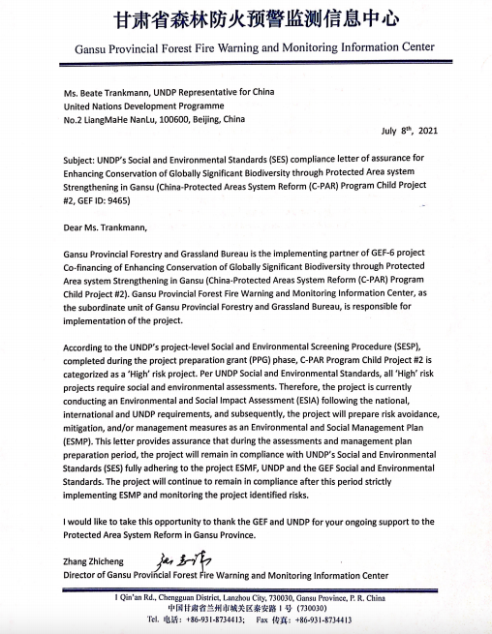

Appendix 2: Assessment Participants
- GEF Gansu Project Office Staff: Ma Yan, Hong Guangkuan, Wang Huahua, etc.
- GEF Gansu Project Experts:
  - Social Integration Expert (Local): Zhao Zhong
  - Planning expert: Ouyang Feng
  - Advocacy Specialist: Qianqian Wang
- Gender and Safeguards Specialist: Xue-Mei Zhang
- Social integration experts (local): Jiaobadongchi
- Project demonstration reserve: Forestry Bureau of Liangdang County Yang Wenjuan, Ma Wenhui, etc. Hezheng County Forestry and Grass Center Yang Wanlin, Yang Tong, etc.
- Yuhe Protected Area Administration: Bai Yongxing, Hu Minghu, Li Hui, Ma Xiaoqiang, etc.
- Chagangliang Preserve Administration: Wang Jianhua, Li Huihua, etc.
- Doyle Reserve Administration: Yang Xiaofeng, Gabo Tsering, etc.
- Axia Reserve Administration: Yan Wanjin, Zeng Wei, Sang Kaijun, etc.
- Protected areas around the project site: Baishuijiang Area Administration of Giant Panda National Park Huang Chenxiang, Shu Yuping and others
- Boyu River Reserve Administration: An Jing, Zhang Xiaoping and others
- Jianshan Reserve: Wang Shoucheng and others
- Community representatives around the project reserve: Longnan City, Liangdang County, Yangdian Town, Lingguan Village Government and community representatives
- Longnan City Wudu District Fengxiang Township Donggou village government and community representatives
- Longnan city Wen County Zhongmiao town tea garden village government and community representatives
- Gannan Prefecture Diebu county Duoer township Yangbu village government and community representatives
- Gannan Prefecture Zhouqu County Gaona Town Lamogaituo Village Government and community representatives
- Linxia Prefecture, Hezheng County, Luojiaji Market Town, Sanchagou Village Government and community representatives

Appendix 3: Participation, Consultation, and Overview of the FPIC
Introduction
Both the GEF and the UNDP recognize the importance of incorporating indigenous (and ethnic minority) peoples into the formulation and implementation of projects in a manner that is consistent with their rights and cultural values. This recognition serves to ensure that project activities do not have adverse impacts on these communities and that they are considered as stakeholders during the formulation and implementation of the Project. This is to be achieved by recognizing traditional management practices, as well as identifying those communities whose identity and culture are linked to the land, territories and natural resources on which they depend.
No activities that may adversely affect ethnic minority communities, their lands, resources, or cultural heritage will be permitted without explicit agreement of the potentially affected communities. Such agreement must adhere to the following definition of Free, Prior, and Informed Consent (FPIC) in order to be sufficient to permit the relevant activities to take place. The project outcomes for which FPIC must be obtained are listed in subsection 4 below.
Definitions
FPIC, for the purposes of this project, is defined as follows:
Free means the process will be self-directed by the relevant ethnic minority communities from whom consent is sought. Such consent must be unencumbered by coercion, expectations, or timelines that are externally imposed. The process of seeking and obtaining consent will, throughout the entirety of the process:
Will be free from coercion, bias, conditions, bribery, or rewards;
Will ensure that the decision-making structure is determined by stakeholders;
Will give information transparently and objectively;
Meetings and decisions will take place at locations and times, and in languages and formats determined by the stakeholders; and
All community members will be free to participate regardless of age, gender, or standing.
Prior means that no project activity implementation will take place before a decision by the relevant ethnic minority community has been made. The process will ensure that enough time is provided to customary landowners to understand, access, and analyse information on the proposed activities.
Informed: Information will be provided in a manner that is accessible, clear, consistent, accurate, and transparent. Such information will be:
Delivered in appropriate language and format (including video, graphics, radios, documentaries, photos, etc.);
Objective, covering both the positive and negative potential of activities and consequences of giving or withholding consent;
Complete, covering the entire spectrum of potential social, financial, political, cultural, and environmental impacts, including scientific information with access to original sources in appropriate language; and
Delivered in a manner that strengthens and does not erode ethnic minority cultures;
Consent is:
Made by ethnic minority communities through their customary decision-making process.
A freely given decision that may be a “Yes” or a “No”, including the option to reconsider if conditions agreed upon are not met, there are changes in the proposed activities, or if new information relevant to the proposed activities emerges;
A collective decision determined by affected people in accordance with their customary forms of decision making (e.g. consensus, majority, etc.);
Based on full understanding of opportunities and risks associated with the proposed activity;
Given or withheld in phases, over specific periods of time for distinct stages or phases of the project;
Ethnic minority communities’ decision-making processes must be respected and allowed to operate in an open and transparent manner. The right of these communities to choose how they want to live will be respect. If consent compliant with all the above principles and definitions is not given, this shall be respected without exception.
Consultations and Recording
The collective right to give or withhold consent applies to all project activities that may directly impact the lands, territories, resources, and livelihoods of ethnic minority communities. Consent must be sought and granted or withheld in accordance with the unique decision-making processes of each community.
FPIC consultations will be comprehensively documented. Ideas, questions, and concerns raised by different stakeholders, including related government institutions, NGO, CSOs, and women’s groups, private institutions, ethnic minority communities and/or resource-owners, shall be captured, well documented and made available to relevant stakeholders.
Documentation of consultations shall include the following information:
What information was provided to local communities in consultations;
The language and method of information-sharing that was used; and
The number of participants present at community consultations (including gender and ethnic minority disaggregated statistics).
Other information that must be recorded, updated, and made available includes:
The manner in which consent (or the withholding of consent) is recorded;
Any instances of previously given consent being withdrawn; and
Any other grievances raised and subsequent action taken by project management and other relevant stakeholders (including an assessment of whether this action properly complies with the Grievance Redress Mechanism in section 7.2 of this report).
FPIC Consultations shall be carried out in a culturally appropriate manner, delivered by culturally appropriate personnel, and in culturally appropriate locations. Consultations shall be delivered with sufficient time to be understood and verified, and measures must be taken to ensure that consultations reach and account for the particular challenges faced by, the most marginalized and vulnerable within potentially affected communities. Consultations and the associated reporting must be undertaken on an on-going and continuous basis throughout the lifecycle of the project.
Project Outcomes Requiring FPIC
This section lists project outcomes and activities to which the FPIC principles, definitions, and processes outlined above must be applied. However, it must be noted that this list is not necessarily exhaustive. Any project activity that could reasonably be assumed to have the potential to impact ethnic minority communities must adhere to the principles, definitions, and processes relating to FPIC outlined above.
Outcomes and Actions Under Project Component 1 Requiring FPIC:
Strengthened safeguards and enforcement frameworks (including legislation, policies and enforcement system) in place for protection of endangered species and Key Biodiversity Areas (KBAs);
Mainstreaming of PA management plans and species protection and restoration plans into Provincial planning processes;
Increased area of habitats for flagship species (including Sichuan golden monkey, musk deer, serow, giant panda, black bear, Przewalski's horse and gazelle and two hump camel) by 10% increased corridor area.
Outcomes and Actions Under Project Component 2 Requiring FPIC:
Establishment of forest corridors and expansion of PA System by 25,000 ha, increasing coverage of KBAs and with emphasis on habitat connectivity;
Increasing the management effectiveness of the four PAs (Axia, Chagangliang, Duoer, Wuwei and Yuhe NRs) in the target landscape and strengthen site operations to address existing threats to the protection of PA conservation values including endangered species, through: (i) development and operationalisation of management plans with full participation of stakeholders including local communities, local governments and business sectors, (ii) augmenting of management units with dedicated trained staff and community involvement, (iii) staff training programmes developed and institutionalized, (iv) minimum management infrastructure and equipment;
Restoration of critical species habitat (Sichuan golden monkey, musk deer, serow, giant panda, and black bear) with community participation in existing and new PAs and corridors to restore critical species habitats;
Providing community livelihoods support and conservation incentives. Sustainable Non-Timber Forest Product (NTFP) collection and eco-tourism will be explored as a means to strengthen and diversify incomes for vulnerable people;
Introduction and promotion of measures to reduce human-wildlife conflict and retaliatory killings, including application of an effective eco-compensation scheme for wild animal damage.
Mitigation and Management Measures Requiring FPIC (see chapter 6):
Action 2: Adjustments to the Boundaries of the Protected Areas and the Functional Zone
Action 4: Community Cultural Heritage and Basic Infrastructure/Service Accessibility
Action 5: Flexible Management on the Protected Areas
Action 8: Integrated Pest Management

ß

Appendix 4: Voluntary resettlement/Land Commitment Letter Template
Dear Sir/Madam,
Re: LAND AVAILABILITY/VOLUNTARY RESETTLEMENT FOR THE PROJECT
This letter serves to confirm that I, ______________________ am the owner/holder of proprietary interest in the land identified as/located at _________________________.
I hereby grant my grant my consent that ___________________ may use this land in the implementation of project activities, and that I shall be voluntarily leaving my property.
I affirm that this consent is given of my own free will and that I fully understand that this may irrevocably affect my proprietary interests in the land.

______________________________ ______________________________
Resource owner/Interest Holder (Name) Witness (Name)

______________________________ ______________________________
Signature Signature

____________________ ____________________
Date Date

Appendix 5: Livelihood Action Plan – Template

The Livelihood Action Plan (LAP) covers the following elements:
1. Introduction
- Briefly describe the project and associated facilities (if any)
- Describe project components requiring economic displacement; land acquisition and resettlement; give overall estimates of land and/or resources to which access has been restricted
- Provide explanation of how economic displacement is necessary to achieve the project objectives, how the project is in the ‘public interest’ and how displacement is proportional to project outcomes
2. Minimizing Displacement
- Describe the justification for the displacement. Please also discuss alternative project designs, including the “no project” scenario and if they may have avoided or reduced the resettlement.
- Describe efforts and measures to minimize displacement, and expected outcomes of these efforts and measures
- Describe how requirements of Indigenous Peoples Standard have been addressed if Indigenous Peoples are displaced.
3. Census and Socioeconomic Surveys/Social Baseline
- Provide results of the census, assets inventories, natural resource assessments, and socioeconomic surveys and briefly describe how these were performed, i.e., techniques used, individuals interviewed, etc.
- Identify all people and communities potentially affected by displacement activities and potential impacts to each. Be precise about the land titles or the lack thereof in the social baseline. Conduct a vulnerability assessment and outline what determines vulnerability (i.e. which criteria need to be met to consider someone vulnerable)
4. Legal Framework
- Describe all relevant international, national, local, and community laws and customs that apply to displacement activities, with particular attention to laws and customs relating to tenure rights and highlight any potential conflicts e.g. between UNDP’s SES and national or regional law
- Describe how free, prior, informed consent was obtained for displacement of indigenous peoples and tribal communities, if applicable
- Describe project-specific mechanisms to address conflicts
- Describe entitlement/compensation policies for each type of impact
- Describe method of valuation used for affected structures, land, trees, and other assets
- Prepare entitlement matrix, which includes budget and timeframe for payment of entitlements
5. Displacement-related Property
- Describe how affected people have been involved in a participatory process to identify replacement property when they have lost access to property to which they have legitimate rights. Describe the advantages and disadvantages of the properties, including the property chosen.
- Describe how affected people whose livelihoods are urban-based have been involved in a participatory process to identify livelihood replacement and support opportunities. Provide evidence of past consultation events, such as participation lists, photos and reports.
- Describe how affected people whose livelihoods are land-based have been involved in a participatory process to identify lands they can access, including lands with productive potential, locational advantages, and other factors at least equivalent to that being lost.
- Describe how affected people whose livelihoods are natural resource-based have been involved in a participatory process to identify resources they can access with equivalent livelihood-earning potential and accessibility.
- Describe how affected people whose access to legally designated parks and protected areas has been restricted have been involved in identifying and choosing measures to mitigate impacts.
- Describe the feasibility studies conducted to determine the suitability of chosen lands and/or natural resources described above, including natural resource assessments (soils and land use capability, vegetation and livestock carrying capacity, water resource surveys) and environmental and social impact assessments of the sites.
- Give calculations relating to land and resource availability
- Describe, as relevant, mechanisms for: 1) procuring, 2) developing and 3) allotting displacement property, including the awarding of title or use rights to allotted lands and/or resources. Indicate to whom titles and use rights will be allocated, including by gender.
- Provide detailed description of the arrangements for site development for agriculture, including funding of development costs
- If circumstances made it difficult to provide land or resources as described above, provide evidence of mutual agreement with affected people/communities on alternative measures.
6. Income Restoration
- Are compensation entitlements sufficient to improve livelihoods and income streams for each category of impact? Attach independent review of opportunities to enhance incomes/livelihoods. What additional economic rehabilitation measures are necessary?
- Briefly spell out the restoration strategies for each category of impact and describe their institutional, financial, and technical aspects
- Describe the process of consultation with affected populations and their participation in finalizing strategies for income restoration
- How do these strategies vary with the area of impact?
- Provide a transparent methodology/formula that is understandable to project-affected people and can be verified for each case.
- Does income restoration require change in livelihoods, development of alternative farmlands or some other activities that require a substantial amount of training, time for preparation, and implementation?
- How are the risks of impoverishment to be addressed?
- What are the main institutional and other risks for the smooth implementation of the resettlement programs?
- Describe the process for monitoring the effectiveness of the income enhancement/restoration measures
- Describe any social or community development programs currently operating in or around the project area. If programs exist, do they meet the development priorities of their target communities? Are there opportunities to support new programs or expand existing programs to meet the development priorities of communities in the project area?
7. Institutional Arrangements
- Describe the institution(s) responsible for delivery of each item/activity in the entitlement policy; implementation of income restoration programs; and coordination of the activities associated with and described in the livelihood action plan
- State how coordination issues will be addressed where displacement is spread over a number of jurisdictions or where displacement will be implemented in stages over a long period of time
- Identify the agency that will coordinate all implementing agencies. Does it have the necessary mandate and resources?
- Describe the external (nonproject) institutions involved in the process of income restoration (land development, land allocation, credit, training) and the mechanisms to ensure adequate performance of these institutions
- Discuss institutional capacity for and commitment to displacement
- Describe mechanisms for ensuring independent monitoring, evaluation, and financial audit of the LAP and for ensuring that corrective measures are carried out in a timely fashion
8. Implementation Schedule
- List the chronological steps in implementation of the LAP, including identification of agencies responsible for each activity and with a brief explanation of each activity
- Prepare a month-by-month implementation schedule of activities to be undertaken as part of resettlement implementation
- Describe the linkage between resettlement implementation and initiation of civil works for each of the project components
9. Participation and Consultation
- Describe the various stakeholders
- Describe the process of promoting consultation/participation of affected populations and stakeholders in resettlement preparation and planning. Be specific about which kinds of documentation will have to be collected (photos, reports, attendance lists, etc.)
- Describe the process of involving affected populations and other stakeholders in implementation and monitoring
- Describe the plan for disseminating LAP information to affected populations and stakeholders, including information about compensation for lost assets, eligibility for compensation, displacement assistance, and grievance redress
10. Grievance Redress
- Describe the step-by-step process for registering and addressing grievances and provide specific details regarding a cost-free process for registering complaints, response time, and communication modes
- Describe how the mechanism ensured unrestricted access, transparency, accountability, how it documents cases and keeps the complainants informed and the institutional setup.
- Describe the mechanism for appeal
- Describe the provisions for approaching civil courts if other options fail
11. Monitoring and Evaluation
- Describe the internal/performance monitoring process. Ensure monitoring program seeks to measure whether displaced enjoy at least a standard of living and access to livelihoods equal to what they enjoyed before displacement
- Define key monitoring indicators derived from baseline survey. Provide a list of monitoring indicators that will be used for internal monitoring, including number and location of displaced persons
- Describe institutional (including financial) arrangements
- Describe frequency of reporting and content for internal monitoring
- Describe process for integrating feedback from internal monitoring into implementation
- Define methodology for external monitoring
- Define key indicators for external monitoring
- Describe frequency of reporting and content for external monitoring. Ensure monitoring program is regular and ongoing following project completion until durable solutions are reached
- Describe process for integrating feedback from external monitoring into implementation
- Describe arrangements for final external evaluation
- Describe need for updates to census, assets inventories, resource assessments, and socioeconomic surveys, if necessary, as part of LAP monitoring and evaluation
12. Costs and Budgets
- Provide a clear statement of financial responsibility and authority
- List the sources of funds for displacement and describe the flow of funds
- Ensure that the budget for displacement is sufficient and included in the overall project budget. Include provisions for non-anticipated adverse impacts.
- Identify displacement costs, if any, to be funded by the government and the mechanisms that will be established to ensure coordination of disbursements with the LAP and the project schedule. Prepare estimated budget, by cost and by item, for all displacement costs including planning and implementation, management and administration, monitoring and evaluation, and contingencies
- Describe the specific mechanisms to adjust cost estimates and compensation payments for inflation and currency fluctuations
- Describe the provisions to account for physical and price contingencies
- Describe the financial arrangements for external monitoring and evaluation including the process for awarding and maintenance of contracts for the entire duration of displacement
Appendixes
- Copies of census and survey instruments, interview formats, and any other research tools
- Information on all public consultation including announcements and schedules of public meetings, meeting minutes, and lists of attendees
- Examples of formats to be used in monitoring and reporting on LAP implementation
- Entitlement matrix
- Evidence of prior informed consent for indigenous peoples and tribal communities

https://pubs.iied.org/sites/default/files/pdfs/migrate/14659IIED.pdf?
It must be noted that GEF funds will not be used for resettlement. Any resettlement must be voluntary in nature and conducted and financed by the government of China.

