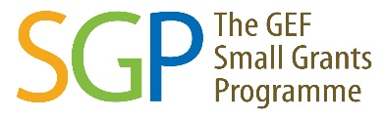
Call for Proposals for Innovative Projects for 2022
GEF-Small Grants Programme, UNDP
(Date of Announcement: 12th July 2022)
Background
The Global Environment Facility’s Small Grants Programme (GEF-SGP), implemented by UNDP in partnership with the Royal Government of Bhutan provides financial and technical support to Civil Society Organizations (CSOs) including Community-based Organizations (CBOs) to conserve and restore the environment while enhancing people's well-being and livelihoods. SGP demonstrates that community action can maintain the fine balance between human needs and environmental imperatives.

Since its inception in October 1998, SGP-UNDP has implemented a total of 188 projects in partnership with the Royal Government of Bhutan, CSOs, CBOs and academia. SGP-UNDP is now in its 7th Operational Phase (OP7) (2020-2023). The Strategic Goal of OP-7 is “to promote and support innovative, inclusive and scalable initiatives, and foster multi stakeholder partnerships at the local level to tackle global environmental issues in the priority landscape”.

Call for innovative proposals for 2022
The SGP-UNDP announces the 2022 "Call for Proposals" inviting CSOs (including Community-Based Organizations and grassroot institutions/communities) to submit inclusive and innovative project proposals for small grants.
Preference will be given to proposals that are inclusive and innovative. Duly completed project proposals (digital copy) should be submitted to the National Coordinator, SGP, UNDP Country Office, Bhutan via email. Proponents are encouraged to explore co-financing and integrate in-kind contribution for the proposed projects.
Project proposals must be aligned with the SGP’s Country Programme Strategy and are encouraged to reflect on the SGP’s COVID-19 green recovery as well as relevant policies and strategies of UNDP, government and others. Please refer the SGP Proposal Template (download here: https://www.undp.org/bhutan/gef-sgp-call-proposal ) and Covid-91 Offer Guidance (download here: https://www.undp.org/bhutan/gef-sgp-call-proposal) for the development of project proposals which can be obtained from here: https://www.undp.org/bhutan/gef-sgp-call-proposal. Refer the Country Programme Strategy (CPS) https://www.bt.undp.org/content/bhutan/en/home/library/environment_energy/sgp-country-programme-strategy-for-operational-phase-7.html for Operational Phase 7 (OP7).
Sensitization webinar
For interested grantees, SGP will conduct sensitization webinar on 26th July 2022 on the general guidance. Kindly REGISTER yourself in the given link; https://forms.gle/xju7T99PxTDUkwY39

Introduction to potential grantees
To know more about GEF-Small Grants Programme and its grant making modality, eligibility and grant ceiling, potential proponents are requested to watch these videos:
1. Dzongkha Version with sign language https://www.youtube.com/watch?v=1Iu0TD5iISw) and
2. English version (https://www.youtube.com/watch?v=kh3r_YuOO48&t=132s)

Potential proponents can also watch past SGP supported project on UNDP Bhutan YouTube Channel https://www.youtube.com/user/undpbhutan2012/videos
Project proposal submission deadline

The “Call for Proposals” for innovative project is being made on 12th July 2022.
Project proposals will be accepted via email only between 1st – 15th September 2022. The deadline for the submission of proposals is 03.00 PM, 15th September (Thursday) 2022. Proponents are encouraged to submit the proposals in advance to permit enough time for review. Please see the Project Proposal Review Process below.
For further information contact, National Coordinator OR Programme Assistant, GEF-Small Grants Programme, UNDP, Thimphu at 02-322424 [Ext-330/331] or e-mail to tshering.phuntsho@undp.org OR tenzin.wangchuk@undp.org
SGP Secretariat reserves the right to reject proposals which are; submitted after the deadline, not submitted in SGP proposal template, incomplete and those which are submitted by ineligible proponents.
Project Proposal Review Process
The GEF-Small Grants Programme is implemented by UNDP in partnership with the Royal Government. The “project proposal review process” will follow the four steps in the selection of the most innovative proposals.

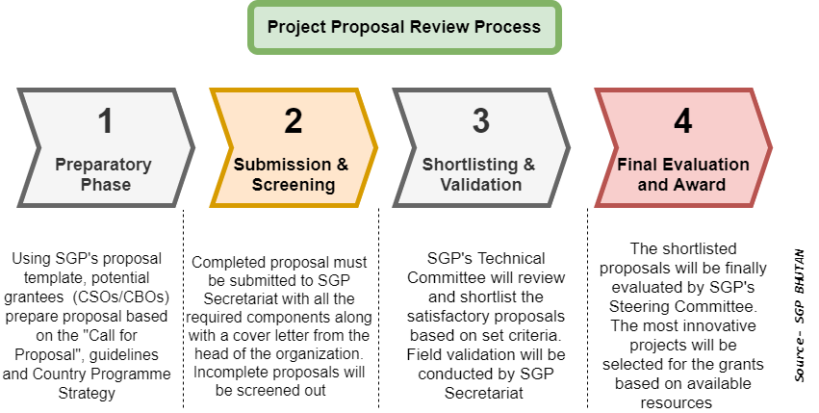

Preparatory Phase
- The call is open to all eligible civil society organizations (CSOs) and community-based organizations (CBOs) in the country who are interested in contributing to global environmental benefits by implementing micro projects.
- All interested CSOs/CBOs must prepare proposals using SGP’s standard Proposal Template (click HERE). The proposals can be also submitted in Dzongkha and in video format especially for CBOs who have limitations.
- Proposals must be prepared based on the guidelines (click HERE) and SGP Country Programme Strategy (click HERE).
- All consultations (local or national) must be conducted during the proposal development phase and relevant agencies and authorities must be informed and their approval sought in advance.
- SGP Secretariat can be contacted for clarifications.

Submission and screening
- Qualified CSOs/CBOs must submit the full proposal documents within specified time.
- Qualified CSOs/CBOs must submit the full proposal documents within specified time. While CSOs can submit the proposals directly to SGP Secretariat, CBOs in Dzongkhags can route it through Local Government (Dzongkhag and Thromdes).
- Ensure that all components of the proposal are properly written.
- Supporting letters from agencies and institutions must be submitted as additional documents.
- SGP Secretariat will initiate the screening process.
- CSOs/CBOs that do not meet the eligibility criteria or submits incomplete proposals will be screened out.
- Satisfactory proposals will be reviewed by SGP’s Technical Committee members

Shortlisting and validation
- SGP’s Technical Committee will review and shortlist the project proposals based on the set criteria, sub-criteria, and point system.
- Shortlisted proposals will be recommended for field validation.
- The proposals will be then presented to the Steering Committee for final evaluation

Final Evaluation and Award
- The shortlisted proposals will be evaluated by SGP’s Steering Committee.
- Based on the final scoring and field validation report, the Steering Committee will take decision to select the most innovative proposals.
- The selected CSOs/CBOs will be contacted to accept the grant and signing of Memorandum of Agreement.
- The project will be subjected to strict monitoring and evaluation.

