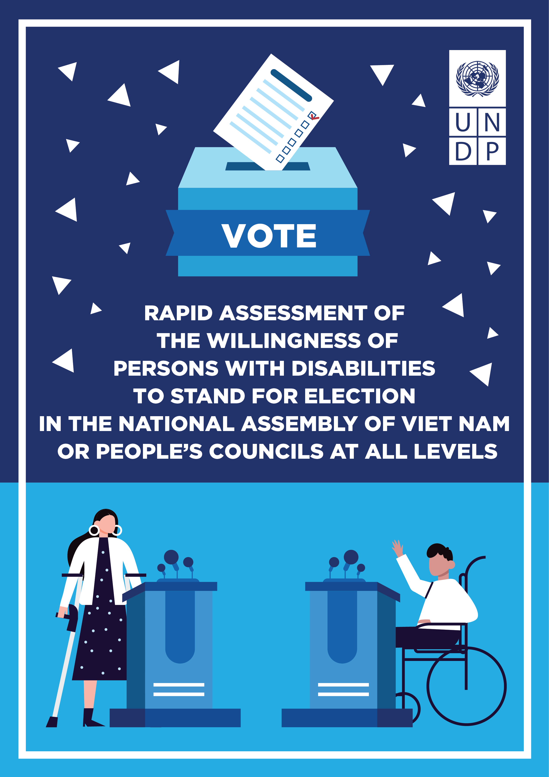

REPORT ON THE KEY FINDINGS OF THE RAPID ASSESSMENT OF THE WILLINGNESS OF PERSONS WITH DISABILITIES TO STAND FOR ELECTION TO THE NATIONAL ASSEMBLY OF VIET NAM OR PEOPLE’S COUNCILS AT ALL LEVELS

UNDP, May 2020

TABLE OF CONTENTS
ACKNOWLEDGEMENT 3
I. INTRODUCTION 4
II. CONTEXT 7
III. METHODOLOGY 11
IV. KEY FINDINGS 13
1. Information about the Survey respondents 13
2. Respondents’ opinions towards PWDs’ participation in the National Assembly and People’s Councils and their willingness to stand for election 15
2.1. PWDs ready to stand for election 18
2.2. Reasons why PWDs are not ready to stand for election 20
2.3. Challenges faced by PWDs in the self-nomination process 22
3. Respondents’ recommendations to support PWDs in self-nomination 24
V. RECOMMENDATIONS 26
Recommendation 1 26
Recommendation 2 27
Recommendation 3 27
Recommendation 4 27
APPENDIX: SURVEY QUESTIONS 29

ACKNOWLEDGEMENT
This assessment was performed within the framework of the Project: "Strengthening the capacity to monitor the implementation of the Convention on the Rights of Persons with Disabilities in Viet Nam", which is being implemented by United Nations Development Program (UNDP) Viet Nam with support from the Embassy of Norway in Hanoi.
The Rapid Assessment was initiated and coordinated by Ms. Nguyen Minh Chau, Disability-Inclusive COVID-19 Recovery Officer of UNDP, together with colleagues in UNDP Viet Nam who are strongly committed to protecting the rights of persons with disabilities in Viet Nam. UNDP Viet Nam gratefully acknowledges the participation of Organizations of Persons with Disabilities and all persons with disabilities (PWDs) who took the time to respond to interviews and provide comments on this Rapid Assessment. We also would like to express our sincerest gratitude to Mr. Nguyen Hong Ngoc, Deputy Director of the Department of Social Affairs of the Office of the National Assembly; Professor Nguyen Anh Tri, Member of the 14th and 15th National Assembly, and Ms. Ngo Thi Thu Ha, Director of the Center for Education Promotion and Empowerment of Women (CEPEW) for contributing their precious ideas to our research process on the political rights of PWDs.
Hero of Labor, Member of the 14th and 15th National Assembly, Professor Nguyen Anh Tri has noted that “This is a very scientific, standardized and honest written report, supported by research and discussion.”

INTRODUCTION
The active participation of all citizens in political processes is a cornerstone of democracy. The right to equal participation in politics is enshrined in the Universal Declaration of Human Rights and the International Covenant on Civil and Political Rights (ICCPR), declaring the right of every person to equal participation in public affairs, including the right to vote and to be elected, and the right to access to public service. Article 29 of the United Nations (UN) Convention on the Rights of Persons with Disabilities (CRPD) clearly states the right of PWDs to participate in political and public life without discrimination and on an equal basis with others, and it calls upon state parties to guarantee those rights. Viet Nam has ratified both the ICCPR and the CRPD and has enshrined the right to stand for election in both its Constitution and legislation.
This right is vital in combatting inequality and discrimination to ensure that no one is left behind. Achieving equality requires obtaining equitable and fair development outcomes throughout the lifetime of an individual — spanning from quality education and life-long learning opportunities to equal access to quality employment, natural resources, social protection, and inclusive decision-making. Such development outcomes are hard to achieve when PWDs are underrepresented in legislative bodies, regardless of how hard the Government, communities, and organizations of and for PWDs may work to promote the rights of PWDs.
Like everywhere else, PWDs in Viet Nam are capable of bringing their unique experiences and perspectives into the decision-making process. No one else can understand and raise disability issues better than PWDs themselves. Therefore, to make our disability policies fully protect the rights of PWDs as stipulated in the CRPD and the Law on Persons with Disabilities, representatives with disabilities must be present in the National Assembly and People’s Councils at all levels.
In March and April 2021, UNDP conducted a ‘Rapid Assessment on the Willingness of Persons with Disabilities to Stand for Election to the National Assembly of Viet Nam or People’s Councils at All Levels’, with the aim of understanding the wishes and aspirations of PWDs to become Representatives in Vietnamese legislatures, as well as their ability and potential to participate in politics in the near future. The assessment successfully involved 111 respondents from different regions, ethnicities, and ages, with different types of disabilities. On 15 April 2021, the Center for Education Promotion and Empowerment of Women (CEPEW) and UNDP Viet Nam organized a workshop on “Opportunities, Challenges and Solutions to Promote Political Rights of Persons with Disabilities in Viet Nam” to launch the key findings of the Assessment. 70 people participated, including representatives from the Norwegian Embassy in Hanoi, the Department of Social Affairs of the National Assembly, the National Assembly, Ha Noi Bar Association, Ha Noi Lawyers Association, Universities, and organizations of and for PWDs, as well as respondents of the Rapid Assessment.

II. CONTEXT
In the 10 years from 2006 to 2016, since the adoption of the CRPD, there have been 14 countries with politicians who are PWDs representing governmental elective bodies. These countries are Argentina, Australia, Canada, Ecuador, Estonia, Fiji, Hungary, Poland, New Zealand, San Marino, Scotland, Sri Lanka, Thailand and the USA. According to the statistics released by Rutgers University, in the USA alone, 10.3% of Congressmen at all levels, equal to around 3,800 people, are PWDs. This rate, however, is still considered to be small, at 5% lower than the overall rate of PWDs in the country.
Viet Nam ratified the CRPD in 2014, recognizing all the rights of persons with disabilities, including the right to participate in politics as provided in Article 29 of the CRPD, without any reservations.
In Viet Nam, Article 27 of the Constitution 2013 and Article 2 of the Law on election of deputies to the national assembly and people’s councils 2015 clearly prescribe, “every 18-year-old or older citizen of the Socialist Republic of Vietnam is entitled to vote in the election and every 21-year-old or older citizen is entitled to stand for election to the National Assembly and the People’s Councils.” The self-nominees to the National Assembly or the People’s Councils shall meet the following criteria set out in Article 22 of the Law on Organization of the National Assembly 2014 and Article 7 of the Law on Organization of Local Administration 2015:
1) To be loyal to the Fatherland, the People and the Constitution, to strive to carry out the renewal cause for the goal of a prosperous people and a strong, democratic, equitable and civilized country.
2) To possess moral qualities, to be diligent, thrifty, incorruptible, altruistic, exemplary in the observance of law; to have the spirit and be determined to control corruption, waste and all manifestations of bureaucracy, imperiousness and authoritarianism and other illegal acts.
3) To possess educational and professional qualifications, to have full capacity, health, work experience and prestige to perform the tasks of a National Assembly deputy.
4) To keep close ties with the People, to listen to opinions of the People, to gain confidence of the People.
5) To have the conditions to participate in the activities of the National Assembly.
Article 37 of the Law on Organization of the National Assembly clearly defines cases who are not eligible to stand for election. As such, evidently, if Vietnamese PWDs meet requirements prescribed in Article 22 and do not fall into the categories mentioned in Article 37, they may legitimately stand for election to the National Assembly.
On 23 May 2021, Vietnamese citizens voted to elect the next deputies of the 15th National Assembly of Viet Nam and of People’s Councils at all levels for the 2021 – 2026 term. On this occasion, which occurs every five years, voters nationwide make decisions and vote for the most qualified delegates to represent the voice of the people in governmental agencies from local to central levels. Accounting for 7% of Viet Nam’s population, equivalent to approximately 6.2 million people, Viet Nam citizens who are PWDs are of no exception. However, to date, the research team has identified hardly any reports or sources of information on the number of delegates who are PWDs in any of the terms of the National Assembly or the People's Council.
In 2021, the Viet Nam Federation on Disability (VFD) announced the theme of Viet Nam’s day of Persons with disabilities 2021, which is Safety – Equality: Safety during the Covid-19 pandemic and equality in the election of National Assembly and People's Councils at all levels. Therefore, this is the right time for us to promote the political rights of PWDs.
In the process of conducting this Rapid Assessment, we were introduced by the Office of the National Assembly to a member of the 12th and 13th National Assembly who is a person with a disability. Born in 1970, belonging to the Khmer ethnic group, Ms. Thach Thi Dan has a mild disability in her left leg. Ms. Dan is currently working as the vice principal of Tra Vinh University. Recommended by Tra Vinh Provincial Party Committee, Ms. Dan stood for election and became a member of the National Assembly for the 12th and 13th term. During her tenure as a delegate, Ms. Dan undertook several activities to engage with voters and collect their comments and feedbacks. At the same time, she directly participated in and made a significant contribution to the Amendment of the Law on Persons with Disabilities and the Labor Law. The reason why there has not been any report or information about Ms. Thach Thi Dan as a person with a disability who is a member of the National Assembly is because the registration process for applicants for the National Assembly has no sections for disability-related information.
With the aims to promote the full implementation of policies on the rights of PWDs as stipulated in the CRPD and ensure that the voice of PWDs is represented in the National Assembly and People’s Council, along with the realization that no one can understand and raise issues about PWDs better than PWDs themselves, UNDP conducted this Rapid Assessment to collect and provide information on the measures and supports needed to promote the political rights of PWDs.

III. METHODOLOGY
The objective of the Rapid Assessment is to understand the willingness of PWDs to stand for election to become members of the National Assembly and People's Councils at all levels, as well as to make recommendations to government agencies on actions to promote the political rights of PWDs. The Rapid Assessment was conducted through interviews with individuals with disabilities. A questionnaire was developed based on close consultation with and feedback from organizations of and for PWDs. This questionnaire consisted of 14 questions on basic personal information about respondents; their perspectives towards the importance of including PWDs as representatives in the National Assembly and People’s Councils at all levels; their willingness to self-nominate or stand for election if nominated; the challenges in the self-nominating process, and recommendations proposed to promote confidence of PWDs to participate in the National Assembly and People’s Council at all levels. Please refer to the full questionnaire in the appendix at the end of this report.
The questionnaire was uploaded online on the Google Form platform to ensure accessibility for all types of disabilities in a period of 2 weeks from March 24 to April 7, 2021. At the same time, the research team also conducted face-to-face interviews or by phone with PWDs living in remote areas, to support those who are unable to fill out the questionnaires themselves for any reason, including not being able to access the Internet.
The Rapid Assessment, however, bears certain limitations. Due to the time restriction of 2 weeks, the assessment only covers a sample of 111 people, which does not sufficiently represent all communities of PWDs across the country. Therefore, the key findings concluded from this assessment are mainly for reference. However, as mentioned previously, throughout this assessment, the team attempted to collect information from different groups of PWDs in different geographical areas. This was done to reflect opinions and perspectives of PWDs to the extent possible regarding the issue of disability inclusion in the National Assembly and People’s Councils at all levels, as well as to provide a brief glimpse into their willingness to stand for election within the allowed time frame. If widely implemented on different platforms, these findings might vary; however, this assessment provides the baseline for future efforts in ensuring political rights of PWDs, along with their other fundamental rights, such as access to information or access to employment.

IV. KEY FINDINGS

1. Information about the Survey respondents
A total of 111 people answered this questionnaire, of which, 47.7% identify themselves as male, 51.4% identify as female, and 0.9% describe themselves as having another gender. The respondents belong to 8 different ethnic groups (Tay, Cham Hroi, Muong, Thai, Hmong, Nung, Jrai and Kinh); of which, 87.4% are Kinh people. 87.4% of respondents are aged between 24 and 60, 9.9% are aged 18 – 23, and 2.7% are over 60 years of age.

Figure 1. Information regarding 111 respondents

The following table presents information in Figure 1 above:
TABLE 1: Information regarding 111 respondents
Information regarding 111 respondents | Percentage
Kinh | 87.4%
Nung | 2.7%
Tay | 4.5%
Muong | 1.8%
Others: Thai, Cham Hroi, Jrai | 3.6%
The survey respondents include representatives with different types of disabilities, specifically: Mobility (64.9%), Visual impairment (21.6%), Hearing and Speech (6.3%), Cognitive Impairment (0.9%) and others (6.3%).
Approximately 60% of respondents hold college and university degrees or higher; above 22% finished high school education; more than 10% completed secondary schools; 6.1% with primary school education level, and 2% have not finished primary school. 86.5% currently have a job; 47.9% of whom are working full-time, and 53.1% are working in private sector.

Respondents’ opinions towards PWDs’ participation in the National Assembly and People’s Councils and their willingness to stand for election
The survey results show that 98.2% of respondents are of the opinion that there should be members of the National Assembly or People’s Council who are PWDs. The reasons given for this position varied. 52.3% said their representatives will speak on their behalf to protect the rights of PWDs; 26.6% hoped their representatives will stand for equality and equity for PWDs; 10.1% considered this representation as proof of PWDs’ capacity, and 2.8% wanted to ensure the representation of diverse groups in the community in the National Assembly and the People’s Councils. 1.8% of respondents do not favor the inclusion of PWDs as members of the National Assembly or People’s Councils, as they believe PWDs have to deal with their challenges due to their health needs and other areas, such as restricted mobility and other accessibility needs, inadequate knowledge and education, limited social skills, etc. The result also reveals that 71.2% of respondents want to become delegates in the National Assembly and People’s Council, and 62.0% of them are ready for self-nomination.

Figure 2A. Percentage of respondents who think PWDs should become members of the National Assembly and People’s Councils
Respondents who think that PwDs should not become members of National Assembly/People's Councils
Respondents who think that PwDs should become members of National Assembly/People's Councils

Figure 2B. Reasons for respondents’ opinion
Reasons PWDs should
not become members
of National Assembly/
People's Councils
Reasons PWDs should become members of National Assembly/People's Councils
  - The following table presents information in Figures 2A and 2B above:
Table 2: Opinions on whether PWDs should become members of the National Assembly or People’s Councils, and reasons for these views
- Opinion | Percentage | Corresponding reasons | Percentage
Respondents who think that PWDs should become members of National Assembly/People's Councils | 98.2%
 |  | Equality and equity for PWDs | 26.6%
 |  | Protect and represent PWDs | 52.3%
 |  | Demonstrate PWDs’ capacity | 10.1%
 |  | Ensure representation of diverse groups | 2.8%
 |  | Others | 8.2%
Respondents who think that PWDs should not become members of National Assembly/People's Councils | 1.8%
 |  | Complicated | 50%
 |  | Not meeting health requirement | 50%

2.1. PWDs ready to stand for election
The rapid assessment records the results of 49/111 PWDs ready to self-nominate, of which 53.1% identified as male, 44.9% as female, and 2.0% as another gender. They come from 6 ethnic groups, though 87.8% are Kinh people. 93.9% are aged between 24-60. 77.6% have mobility disabilities, 10.2% with hearing and speech impairments and 8.2% with visual impairment. 59.2% hold a university degree or higher, and 81.6% having a job (62.5% of whom are working in the private sector).
Figure 3. Information regarding 49 respondents who are ready to self-nominate

  - The following table presents information in Figure 3 above:

TABLE 3: Information regarding 49 respondents who are ready to self-nominate
Information regarding of 49 respondents who are ready to self-nominate | Percentage
Kinh | 87.8%
Tay | 4.0%
Others: Muong, Nung, Cham Hroi, Jrai | 8.2%

2.2. Reasons why PWDs are not ready to stand for election
The 38.0% respondents who are not ready to self-nominate for the National Assembly or People's Council provided various reasons for not being ready to stand for election.
It is important to firstly emphasize that lack of time and appropriate conditions for political participation accounts for a significant proportion of the reasons why PWDs are not ready to stand for election: 33.3%. Lack of confidence is also a major reason at 33.3%. Other reasons are: not knowing how to self-nominate and call for votes (16.7%), not believing the communities will support PWDs in election (10.0%) and not being interested in politics (6.7%).

Figure 4. Reasons why PWDs are not ready to self-nominate

  - The following table presents information in Figure 4 above:

Table 4: Reasons why PWDs are not ready to self-nominate
- Reasons why PWDs are not ready to self-nominate | Percentage
Not interested in politics | 6.7%
Not believe that the community will vote for PWDs | 10.0%
Not clear about the self-nominating and voting process | 16.7%
Lack of self-confidence | 33.3%
Others: Lack of time, personal reasons, etc. | 33.3%

  - Insights from PWDs
“The reason I am not confident to self-nominate is because I think PWDs will face many challenges at every stage: From preparing documents for the application to running campaigns to call for votes. Also, PWDs have hardly any chance of being recommended by socio-political organizations.”

2.3. Challenges faced by PWDs in the self-nomination process
Among the 111 survey respondents, 42.3% have difficulty in proving their health and capacity, and 16.2% are not clear about the process of self-nomination.
Figure 5. Challenges in Self-nomination – Opinions from 111 PWDs

  - The following table presents information in Figure 5 above:
Table 5: Challenges in Self-nomination – Opinions from 111 PWDs
- Challenges in Self-nomination – Opinions from  - 111 PWDs | Percentage
Proof of good health and capacity | 42.3%
Not clear about the nomination process | 16.2%
Barriers in connecting with voters | 13.5%
Running election campaigns | 12.6%
Meeting all eligibilities | 9.0%
Preparing application documents | 2.8%
Others | 3.6%

Insights from PWDs
“Knowing that there are several challenges in standing for election, still we want to give it a try. The first barrier is built from the prejudice against PWDs. Thus, it is important that PWDs believe in themselves. The second barrier comes from the fact that most PWDs do freelance work, which does not engender as much credibility as other stable jobs. That also explains why the number of PWDs who can meet the requirements to become a member of the National Assembly and People’s Council remains low. However, it does not mean that there is no opportunity for PWDs in political participation.”
“Many people associate disabilities with poor health conditions and assume that PWDs cannot meet the health requirements to stand for election, and that their performance as delegates in the National Assembly and People’s Council cannot be ensured either. In fact, much research reveals that disability and health conditions belong to two entirely separate categories. Having a disability does not mean being unhealthy. A disability is a combination of medical deficiency, physically or mentally, and social barriers. Provided that appropriate and accessible conditions are ensured, there is no reason why PWDs cannot fully meet the requirements to become members of the National Assembly or the People's Council.”

3. Respondents’ recommendations to support PWDs in self-nomination
According to the result of the Rapid Assessment, of the 49 respondents who are ready for self-nomination, 18.4% express their desire for more knowledge on the self-nomination process and legal systems; 16.3% wish to enhance their skills in calling for votes and support from the communities and groups/associations related to the election process; 22.4% propose improving accessibility to facilitate the process of self-nomination, voting and working as delegates of the National Assembly or People’s Councils at all levels.

Figure 6. Recommendations to support PWDs in self-nomination – Opinions from 49 respondents who are ready to self-nominate

  - The following table presents information in Figure 6 above:
Table 6: Recommendations to support PWDs in self-nomination – Opinions from 49 respondents who are ready to self-nominate
- Recommendations to support PWDs in self-nomination – Opinions from 49 respondents who are ready to self-nominate | Percentage
Accessibility (information, facilities, etc.) | 22.4%
Information on groups/associations relating to the electing process | 16.3%
Information on election campaigns | 16.3%
Information on legal system | 18.4%
Information on self-nominating process | 18.4%
Others | 8.2%

V. RECOMMENDATIONS
The recommendations from members of National Assembly, Ha Noi Bar Association, Universities, leaders of Organizations of and for PWDs and respondents of the Rapid Assessment are as follows:

Recommendation 1
Education and campaigns to raise awareness on the role of PWDs in the National Assembly and People’s Council are essential to ensure the full representation of the community of PWDs in these legislative bodies at all levels, as no one can understand and raise issues about disabilities better than PWDs themselves. If public perception is shifted, families of PWDs and the community will respect and support them in political participation. As a result, the role of PWDs in leadership and management will be promoted.

Recommendation 2
Legal documents on the election of members of the National Assembly and People’s Council that are currently available include no Guidelines or regulations on the proportion of delegates who are PWDs. Therefore, it is suggested that international organizations, legislative bodies, organizations of and for PWDs work on promoting the amendment and supplement of legal provisions in the Election Law on 1% minimum rate for PWDs in the official list of candidates for the National Assembly and People’s Councils at all levels.

Recommendation 3
Capacity building for PWDs qualified to become members of the National Assembly and People’s Councils must be a priority activity. To become members of the National Assembly and People’s Councils and to fully perform the role of delegates, it is important that PWDs are well equipped with knowledge on the legal system and policies, with political experience, with social knowledge, and with essential skills in running campaigns to call for support from the community. PWDs should begin with self-nomination for the People’s Councils at district level, the lowest one, in order to gradually foster their political and professional skills, and to gain practical experience.

Recommendation 4
It is recommended that organizations of persons with disabilities strengthen their commitment to promoting opportunities for political participation of PWDs by developing training and capacity building plans for PWDs who are qualified to become members of the National Assembly or People’s Councils.

Hero of Labor, Prof. Nguyen Anh Tri – Member of the 14th and 15th National Assembly:
“The aspirations of PWDs to become members of People's Councils at all levels and the National Assembly are legitimate and should be respected, encouraged and supported. In Viet Nam, the fact is that there are no regulations prohibiting PWDs from political participation.
In my opinion, PWDs should be confident, constantly foster their capacities, assert themselves with active contributions to society, especially to the common efforts of the community of PWDs. A candidate for the National Assembly and People’s Councils should, firstly, be a person of great prestige recognized in the community of PWDs. This is the foremost factor! Voters have the ultimate right to decide who will become members of the National Assembly – this is a fact I have come to realize after twice being elected.
Viet Nam Federation on Disability, therefore, should make strategic plans to foster, support, propose and recommend the most outstanding individuals to participate in politics at the People's Councils at all levels first before nominating them to participate in the National Assembly.”

APPENDIX: SURVEY QUESTIONS

RAPID ASSESSMENT ON THE WILLINGNESS OF PERSONS WITH DISABILITIES TO STAND FOR ELECTION TO THE NATIONAL ASSEMBLY OF VIET NAM OR PEOPLE’S COUNCILS AT ALL LEVELS

This survey was conducted by the United Nations Development Programme (UNDP) Viet Nam to measure the willingness of persons with disabilities to stand for election to the National Assembly and People’s Councils at all levels.
The deadline for responses to this survey is by the end of 7th April 2021.
All responses will remain anonymous and confidential.
Thank you very much for your contribution to the work for persons with disabilities.
1. In your opinion, should persons with disabilities become members of the National Assembly/ People’s Council? *
a. Yes
b. No
(If yes, skip Question 1.1. If no, skip to Question 1.2)
1.1. If yes, why? *
1.2. If no, why *
2. Do you want to become a member of the National Assembly/ People’s Council? *
a. Yes
b. No
2.1. If yes, are you ready to self-nominate? *
a. Ready
b. Not ready

2.1.1. If you are ready for self-nomination, please kindly let us know if you have clearly understood the process of self-nomination. *
a. Yes, I have understood the process clearly
b. No, I haven’t understood the process
2.1.2. If you are not ready to self-nominate, why? *
a. Lack of self-confidence
b. Not interested in politics
c. Do not believe the community will support and vote for persons with disabilities
d. Not clear about the self-nomination process and how to call for votes
e. Other (please clarify: …)
3. What are the greatest challenges faced by persons with disabilities during the self-nomination process? *
4. What kind of support do you need to confidently self-nominate to the National Assembly or People’s Councils? *
a. Knowledge on the self-nomination process
b. Knowledge on the legal system
c. Information on the election process and campaigns
d. Information on groups/associations related to the election process
e. Improvement in accessibility (information, facilities, policies)
f. Others. (Please specify)
5. Your gender *
a. Male
b. Female
c. Other
6. Which of the following age groups do you belong to? *
a. 18 - 23
b. 24 - 60
c. Above 60
7. What is your ethnicity? *
8. What is your highest level of education? *
a. Not finished primary education
b. Primary Education
c. Secondary Education
d. Highschool
e. College, university
f. Postgraduate
9. Where do you live? *
a. Central city (Ha Noi, Da Nang, Ho Chi Minh City, Hai Phong, Can Tho)
b. Provincial city
c. Small town
d. Countryside
e. Mountainous area
10. What is your type of disability? *
a. Mobility
b. Hearing and Speech
c. Visual impairment
d. Cognitive Impairment
e. Mental disorder
f. Others
11. What is your professional status? *
a. Full-time employment
b. Part-time employment
c. Freelance
d. Self-employed
e. Unemployed
f. Retired
11.1. What sector are you working in? *
a. Public sector
b. Private sector
c. Non-profit sector
12. Your full name:
13. Your Email address:
14. Your phone number:

For further information, please follow us at: @undpvietnam

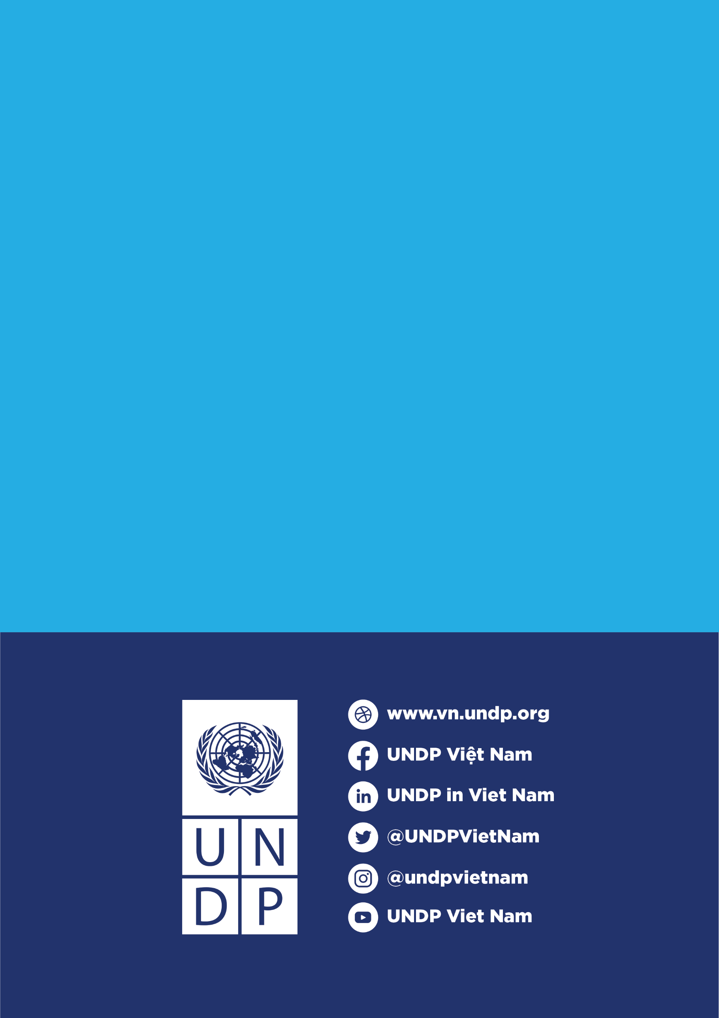

United Nations General Assembly, International Covenant on Civil and Political Rights, Article 25, 16 December 1966. Accessed: 11 April 2021. https://www.ohchr.org/en/professionalinterest/pages/ccpr.aspx.
Constitution of the Socialist Republic of Viet Nam (2013), Article 27.
The Law on Election of Deputies to the National Assembly and People’s Councils (2015), Article 2; the Law on Organization of the National Assembly (2014), Article 22; and the Law on Organization of Local Administration (2015), Article 7.
https://smlr.rutgers.edu/news/report-1-10-politicians-has-disability-gap-in-representation
From the National Survey of People with Disabilities conducted in 2016

