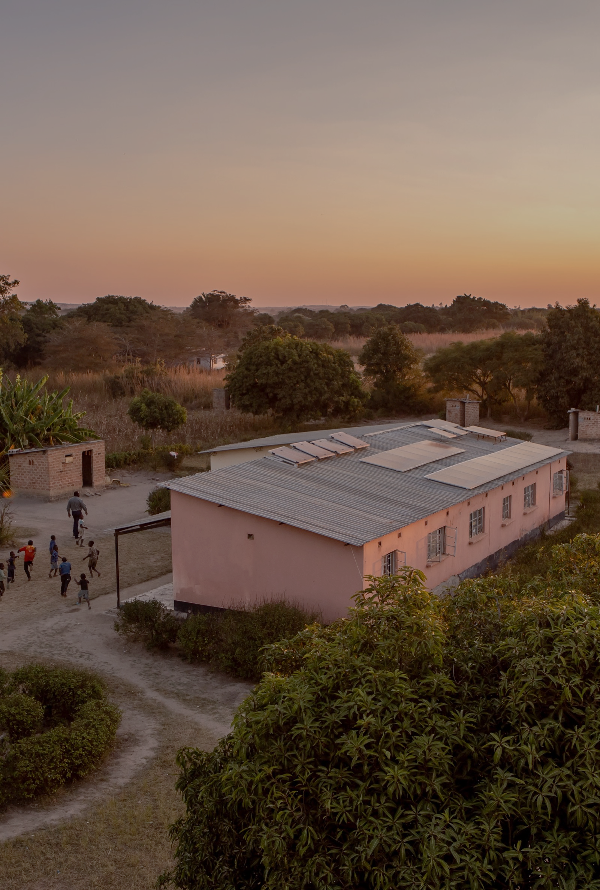
Climate
Aggregation
Platform
Financial Innovation
Challenge
Application Form
Photo credit: Zambia-health centre with solar panels ©UNDP - Karin Schermbrucker for Slingshot

www.undp.org/climate-aggregation-platform

Instructions
- Applications should be submitted using the provided Application Form and templates. Applications submitted in a different format will not be considered.
- Before completing the Application Form, please read the Call for Proposals & Guidelines attentively and make sure to register here.
- Please complete all sections of the Application Form in English using font size 11.
- Follow the guidelines provided in grey with each question. Note: These can be erased before submitting the Application Form. The cover page and instructions can also be erased.
- Applications that exceed the maximum number of pages (10 pages excluding attachments) will not be considered.
- All required documents and annexes must be submitted together with a signed Application Form before the deadline. Documents submitted after the deadline or incomplete applications will not be considered; All questions are mandatory.
- Once completed, submit your signed Application Form via email to cap.fic@undp.org, together with all the Annexes (1&2) and supporting documents (See list below). Please include “CAP FIC” and the name of the Applicant in the Subject line.
- Attachments are to be submitted in an electronic format (PDF, Word, Excel). Hard copies may be requested at a later stage.
- Please ensure that the total size of the email and attachments does not exceed 10 MB. UNDP will not be responsible for any application emails that fail to be sent/received.
- The deadline for submissions of Applications is August 31st, 2022, at 12:00 PM EAT.
- Submissions received after the deadline will not be considered – Note that all submissions will be time-stamped – You will receive an email confirmation of the receipt of your application.
- Each Entity may submit one Application. Re-submission of a modified or improved Application after the deadline is not allowed.
- Please contact us by email at cap.fic@undp.org for any problems or questions, we will do our best to get back to you in a timely manner. Please include “CAP FIC” and the name of the Applicant in the subject line. UNDP will consider incoming questions until August 18th, 2022, at 12:00 PM EAT.
- Check the CAP Financial Innovation Challenge webpage for updates and announcements:
https://www.undp.org/climate-aggregation-platform/cap-financial-innovation-challenge

- The Frequently Asked Questions (FAQ) section will be updated in the coming weeks.

- UNDP will host an online information session on the CAP FIC on Tuesday, 9th Aug 2022, 15:00-16:00 EAT (click to register).

Attachments to include with the application
- Application Form with signed “ACCEPTANCE OF TERMS AND CONDITIONS”
- Extract from Public Registry or relevant Registration documents for your organisation issued by the appropriate authority (e.g., Incorporation Certificate) – This may differ depending on the type of entity applying. UNDP may request additional documentation.
- ANNEX 1 – Signed Declaration to confirm the Applicant is not included in the UNDP Vendor Sanctions List. This will be required for all members of a consortium or joint venture, if applicable.
- ANNEX 2 - Budget Template (Excel Sheet)
- CVs of team members (PDF or Word)
- UNDP may request Applicants to submit additional documents

Climate Aggregation Platform
Financial Innovation Challenge
(CAP FIC)
APPLICATION FORM

Applicant INFORMATION
NAME of the Lead Applicant  (The legal Entity) | Type here
Address | (Street, city, state/province, postal code) |  |  |  | Telephone |  |  | Type here
 |  |  |  |  | Website |  |  | Type here
Type of Entity  & Legal Form  (e.g. private sector company, research institute, university) | Type here |  |  |  | Legal registration number |  |  | Type here
country OF Registration  Innovations must be implemented in and benefit stakeholders in developing countries but may be submitted by applicants in either developing or developed countries. | Type here |  |  |  | year of registration
Name & TITLE of Contact Person  Individual submitting proposal on behalf of the organization | Type here |  |  |  | Telephone |  |  | Type here
 |  |  |  |  | E-mail |  |  | Type here
is this a Consortium or Joint Venture application? | ☐ YES  ☐ No |  |  | LIST all members of consortium or joint venture (if applicable) | - Type here  - Type here  - Type here  - Type here
as the lead applicant, which best applies to your organization?
“Buy-side” actors |  | “Sell-side” actors |  |  |  |  | Other relevant entities
☐ Commercial Bank |  | ☐ energy company |  |  |  |  | ☐ government agency
☐ Impact investor |  | ☐ project originator |  |  |  |  | ☐ digital platform
☐ financial intermediary |  | ☐ developer |  |  |  |  | ☐ consulting firm
☐ OTHER “BUY-SiDE”, Specify below |  | ☐ OTHER “SELL-SIDE”, Specify below |  |  |  |  | ☐ Non-governmental entity
 |  |  |  |  |  |  | ☐ Industry association
 |  |  |  |  |  |  | ☐ OTHER, Specify below
Provide details here (max. 20 words)
Is the lead applicant a Private, Public Sector entity or NGO/Cso? |  |  | ☐ Private Sector |  |  | ☐ Public Sector |  |  | ☐ NGO/CSO
Provide a brief description of your business/organization
Type here (max. 80 words)

[Guidelines: Lead applicant & cosortium or joint venture members.]

Project overview
PROJECT TITLE |  | Type here
time frame for Implementation  [MAX 4 MONTHS] |  | Month/Year  (Earliest 01/11/2022) |  |  | Month/Year  (Latest 31/01/2023)
Country(ies) of Implementation (Must be in Eastern Africa)
☐ Uganda |  | ☐ Rwanda
☐ Other, Please Specify: |  | Type here
Type of technology(ies) / sector(s) that will be targeted by the innovative financial aggregation structure or model
The CAP FIC will focus on distributed, small-scale low carbon energy assets in developing countries.
☐ | Off-grid solar PV including PAYGO solar |  | ☐ | Energy efficient solutions for buildings, lighting, industrial, agricultural, and transport  (e.g., e-mobility) applications
☐ | On-grid solar PV (residential, C&I)
☐ | Mini-grids |  | ☐ | Other, Please Specify:
☐ | Clean cooking solutions |  |  | Type here
☐ | Productive use appliances
SUMMARY OF THE Proposed solution
Type here (max. 300-500 words)

[GUIDELINES:
Please state the problem/challenge your Application aims to address. Describe the proposed solution and the expected outcome in the targeted country(ies).
The proposed solution should include an Innovative Financial Aggregation Structure or Model (mechanisms, instruments, processes, tools, business, and financing models) that can help increase access to and lower the cost of financing for small-scale, low-carbon energy assets in developing countries.
Present the key features of the novel structure or model including an explanation of the mechanisms, structures (proposed vehicle, legal structures to be put in place, etc.) and stakeholders involved.
Explain the benefits and advantages of the proposed solution – How it can help address market barriers, unlock new sources of capital, de-risk, increase access to, or lower the cost of financing for small-scale, low-carbon energy assets in developing countries.
We encourage you to include a diagram depicting the proposed Innovative Financial Aggregation Structure or Model.]

project BUDGET Summary
Please provide detailed Budget Breakdown in a separate Excel Sheet in Annex 2.
AWARD requested (USD)  [Up to US$ 40,000.00] | US$ __,___.__ | (__%)
Co-Funding provided by the proponent (USD)  [Applicant’s in-kind or cash contribution to the total project costs. While co-funding is not mandatory, Applications that include co-funding will receive additional points during the evaluation process.] | US$ __,___.__ | (__%)
Total BUDGET (USD) | US$ __,___.__ | (100%)

Additionality
Type here (max. 100 words)

[GUIDELINES: Please explain (i) how the activities funded by the CAP FIC will be additional to your existing activities; and (ii) how the proposed Innovative Financial Aggregation Structure or Model can help address market barriers and close the energy access financing gap with a high degree of additionality compared to existing solutions.]

degree of innovation
Type here (max. 250 words)

[GUIDELINES: Describe how the proposal is innovative: Does the proposed solution have the potential to disrupt the market? Can it help address key market barriers? Increase access to and lower the cost of finance? Unlock new sources of capital for the sector?
Is it a first-of-a-kind solution that has not yet been attempted anywhere before, or an existing proven solution applied to a new market/sector, geography, or context?
Does it involve buy-side actors that have not traditionally been active (or had limited participation) in the energy access space?
Solutions with a strong focus on digitalization and the use of smart data will be preferred.
Remember, to be eligible, the proposed solution must involve an Innovative Financial Aggregation Structure or Model (mechanisms, instruments, processes, tools, business, and financing models) that can help increase access to and lower the cost of financing for small-scale, low-carbon energy assets in developing countries.]

Scale up & Replication
Type here (max. 150 words)

[GUIDELINES: What is the potential for scale-up and replication of your solution?
Potential for scale-up (i.e., building on existing approach, adaptable at minimum cost, addressing bigger need in market)
Potential replicability (i.e., easy to duplicate, adaptable to different regions and countries, applicable in other sectors)
Potential of the proposed solution to leverage additional funds for financial aggregation transactions in the small-scale, low-carbon energy sector in developing countries (i.e., value of financially closed financial aggregation transaction or future transactions enabled or facilitated).]

Development Impact (Social, Economic, Environmental)
Type here (max. 300 words)

[GUIDELINES: Describe how the proposed solution can help overcome development challenges in developing countries and contribute to the to the achievement of the Sustainable Development Goals (SDGs) and Targets, and more specifically SDG 7 on clean and affordable energy and SDG 13 on climate action.
What is the proposed solution’s potential/likelihood to:
- Lead to economic savings due to lower financing costs;
- Lead to GHG emission reductions and support climate adaptation/resilience;
- Lead to increased energy access via the deployment of small-scale, low-carbon energy products (e.g., households and/or businesses connected, etc.);
- Contribute to poverty reduction, gender equity, livelihoods creation and Covid-19 pandemic response and recovery.]

Gender
Type here (max. 100 words)

[GUIDELINES: Briefly describe how your innovation will support gender mainstreaming, including benefits to women and girls, either directly or indirectly]

sustainability
Type here (max. 200 words)

[GUIDELINES: Briefly describe how the innovation will be sustained at the end of the initial CAP FIC support. How will you ensure the long-term financial sustainability of the proposed solution? How does your solution incorporate social and environment sustainability, which fits the local context and is valid for the long-term?]

project management
Type here (max. 150 words)

[GUIDELINES: Briefly describe how the innovation will be managed. Explain, why your team is uniquely qualified to develop the proposed solution – Provide evidence of your organization’s relevant expertise (At a minimum, Applicants will need to have at least 2 years of experience in the relevant sector), track record and organizational capacity.]

roles and responsibilities
[GUIDELINES: Balance between women and men in the Project team(s) responsible for implementing and publicly presenting the Project.]
Team Member’s NAME | Role & Responsibilities | GEnder
Please attach CVs of all relevant team members.
Project Plan
[GUIDELINES: Please describe the planned activities (5) required to develop a Feasibility Study (over a period of 4 months) for the proposed Innovative Financial Aggregation Structure or Model and the proposed timeline.
The required outputs/deliverables under the Innovation Challenge Agreement will be (i) the submission and approval of a mid-term progress report (50%) and (ii) the final Feasibility Study (50%).]
Activity | Description of Activities & Outputs | Sept  2022 | Oct  2022 | Nov  2022 | Dec  2022 | Jan  2023
Activity 1 | Type here
Activity 2 | Type here
Activity 3 | Type here
Deliverable: Mid-term progress report
Activity 4 | Type here
Activity 5 | Type here
Deliverable: Feasibility study

RISK ASSESMENT
[GUIDELINES: Identify high-level external risks and strategies to mitigate them.]
RISK | Mitigation Strategy

Acceptance of terms and conditions
By signing this form, the Applicant accepts the following terms and conditions:
The Applicant declares that he/she is bounded by the process and rules of the competition that were specified in the Guidelines of the Climate Aggregation Platform – Financial Innovation Challenge (CAP FIC) and shall accept the outcome of the process without any deviation or reservation.
The Applicant shall bear all costs related to the preparation and submission of the proposal regardless of whether his/her proposal is selected or not. He/she accepts that the UNDP will in no case be held responsible or liable for those costs regardless of the outcome of the process.
The Applicant accepts that the UNDP determines the level of responsiveness to the Call for Proposals of the Climate Aggregation Platform – Financial Innovation Challenge (CAP FIC) exclusively on the contents of the written, submitted, and signed Application Forms and Annexes.
The Applicant accepts that information relating to the examination and evaluation of the Applications, and selection of Awardees and signature of Award Agreement shall not be disclosed to any person not officially concerned with such processes.

Signature: …………………………………………………
Name: …………………………………………………
Date: …………………………………………………

Annex 1

DECLARATION

Date:

United Nations Development Programme
Bureau for Programme and Policy Support
304 E. 45th St. 9th floor
NY, NY 10017 USA

Assignment: Climate Aggregation Platform – Financial Innovation Challenge

Reference: CAP FIC 2022-2023

Dear Madam/Sir,

I declare that …………………………………………………………………. is not in the UN Security Council 1267/1989 List, UN Procurement Division List or Other UN Ineligibility List. Yours Sincerely,

Signature: …………………………………………………
Name: …………………………………………………
Date: …………………………………………………

The terms ‘financial aggregation’ and “small-scale, low-carbon, energy assets’ refer to the definitions in the Guidelines. Innovations that are not linked to ‘financial aggregation’ and “small-scale, low-carbon, energy assets’ will not be considered. The CAP FIC will focus on debt aggregation transactions. The CAP will exclude equity aggregation transactions (e.g., yieldcos).
Please refer to section 1.6 Target Innovations of the Guidelines for more details. The terms ‘financial aggregation’ and “small-scale, low-carbon, energy assets’ refer to the definitions in the Guidelines. Innovations that are not linked to ‘financial aggregation’ and “small-scale, low-carbon, energy assets’ will not be considered. The CAP FIC will focus on debt aggregation transactions. The CAP will exclude equity aggregation transactions (e.g., yieldcos).

