RFQ Reference: Purchasing of Yurts for the summer festival | Date: 28 June 2022

SECTION 1: REQUEST FOR QUOTATION (RFQ)

UNDP kindly requests your quotation for the provision of goods, works and/or services as detailed in Annex 1 of this RFQ.
This Request for Quotation comprises the following documents:
Section 1: This request letter
Section 2: RFQ Instructions and Data
Annex 1: Schedule of Requirements
Annex 2: Quotation Submission Form
Annex 3: Technical and Financial Offer
When preparing your quotation, please be guided by the RFQ Instructions and Data. Please note that quotations must be submitted using Annex 2: Quotation Submission Form and Annex 3 Technical and Financial Offer, by the method and by the date and time indicated in Section 2. It is your responsibility to ensure that your quotation is submitted on or before the deadline. Quotations received after the submission deadline, for whatever reason, will not be considered for evaluation.
Thank you and we look forward to receiving your quotations.
Issued by:

Signature:
Name: Subhan Ahmadov
Title: OM UNDP
Date: 28 June 2022

SECTION 2: RFQ INSTRUCTIONS AND DATA
Introduction | Bidders shall adhere to all the requirements of this RFQ, including any amendments made in writing by UNDP. This RFQ is conducted in accordance with the UNDP Programme and Operations Policies and Procedures (POPP) on Contracts and Procurement  Any Bid submitted will be regarded as an offer by the Bidder and does not constitute or imply the acceptance of the Bid by UNDP. UNDP is under no obligation to award a contract to any Bidder as a result of this RFQ.  UNDP reserves the right to cancel the procurement process at any stage without any liability of any kind for UNDP, upon notice to the bidders or publication of cancellation notice on the UNDP website.
Deadline for the Submission of Quotation | 12 July 2022, 18:00 Baku Time  If any doubt exists as to the time zone in which the quotation should be submitted, refer to http://www.timeanddate.com/worldclock/.  For eTendering submission - as indicated in the eTendering system. Note that the system time zone is in EST/EDT (New York) time zone.
Method of Submission | Quotations must be submitted as follows:  ☐ E-tendering  ☒ Dedicated Email Address  ☐ Courier / Hand delivery  ☐ Other Click or tap here to enter text.  Bid submission address: procurement.aze@undp.org  - File Format: pdf, jpeg, rar, zip  - File names must be maximum 60 characters long and must not contain any letter or special character other than from Latin alphabet/keyboard.  - All files must be free of viruses and not corrupted.  - Max. File Size per transmission: 35 MB  - Mandatory subject of email: Purchasing of Yurts for the summer festival  - Multiple emails must be clearly identified by indicating in the subject line “email no. X of Y”, and the final “email no. Y of Y.  - It is recommended that the entire Quotation be consolidated into as few attachments as possible.  - The bidder should receive an email acknowledging email receipt.  [For eTendering method, click the link https://etendering.partneragencies.org and insert Event ID information]  - Insert BU Code and Event ID number  Detailed instructions on how to submit, modify or cancel a bid in the eTendering system are provided in the eTendering system Bidder User Guide, and Instructional videos available on this link: http://www.undp.org/content/undp/en/home/operations/procurement/business/procurement-notices/resources/
Cost of preparation of quotation | UNDP shall not be responsible for any costs associated with a Supplier’s preparation and submission of a quotation, regardless of the outcome or the manner of conducting the selection process.
Supplier Code of Conduct, Fraud, Corruption, | All prospective suppliers must read the United Nations Supplier Code of Conduct and acknowledge that it provides the minimum standards expected of suppliers to the UN. The Code of Conduct, which includes principles on labour, human rights, environment and ethical conduct may be found at: https://www.un.org/Depts/ptd/about-us/un-supplier-code-conduct  Moreover, UNDP strictly enforces a policy of zero tolerance on proscribed practices, including fraud, corruption, collusion, unethical or unprofessional practices, and obstruction of UNDP vendors and requires all bidders/vendors to observe the highest standard of ethics during the procurement process and contract implementation. UNDP’s Anti-Fraud Policy can be found at http://www.undp.org/content/undp/en/home/operations/accountability/audit/office_of_audit_andinvestigation.html#anti
Gifts and Hospitality | Bidders/vendors shall not offer gifts or hospitality of any kind to UNDP staff members including recreational trips to sporting or cultural events, theme parks or offers of holidays, transportation, or invitations to extravagant lunches, dinners or similar. In pursuance of this policy, UNDP: (a) Shall reject a bid if it determines that the selected bidder has engaged in any corrupt or fraudulent practices in competing for the contract in question; (b) Shall declare a vendor ineligible, either indefinitely or for a stated period, to be awarded a contract if at any time it determines that the vendor has engaged in any corrupt or fraudulent practices in competing for, or in executing a UNDP contract.
Conflict of Interest | UNDP requires every prospective Supplier to avoid and prevent conflicts of interest, by disclosing to UNDP if you, or any of your affiliates or personnel, were involved in the preparation of the requirements, design, specifications, cost estimates, and other information used in this RFQ. Bidders shall strictly avoid conflicts with other assignments or their own interests, and act without consideration for future work. Bidders found to have a conflict of interest shall be disqualified.  Bidders must disclose in their Bid their knowledge of the following: a) If the owners, part-owners, officers, directors, controlling shareholders, of the bidding entity or key personnel who are family members of UNDP staff involved in the procurement functions and/or the Government of the country or any Implementing Partner receiving goods and/or services under this RFQ.  The eligibility of Bidders that are wholly or partly owned by the Government shall be subject to UNDP’s further evaluation and review of various factors such as being registered, operated and managed as an independent business entity, the extent of Government ownership/share, receipt of subsidies, mandate and access to information in relation to this RFQ, among others. Conditions that may lead to undue advantage against other Bidders may result in the eventual rejection of the Bid.
General Conditions of Contract | Any Purchase Order or contract that will be issued as a result of this RFQ shall be subject to the General Conditions of the Contract  Select the applicable GTC:  ☑ General Terms and Conditions / Special Conditions for Contract.  ☐ General Terms and Conditions for de minimis contracts (services only, less than $50,000)  ☐ General Terms and Conditions for Works  Applicable Terms and Conditions and other provisions are available at UNDP/How-we-buy
Special Conditions of Contract | ☑ Cancellation of PO/Contract if the delivery/completion is delayed by 30 days  ☐ Others [pls. specify]
Eligibility | A vendor who will be engaged by UNDP may not be suspended, debarred, or otherwise identified as ineligible by any UN Organization or the World Bank Group or any other international Organization. Vendors are therefore required to disclose to UNDP whether they are subject to any sanction or temporary suspension imposed by these organizations. Failure to do so may result in termination of any contract or PO subsequently issued to the vendor by UNDP.  It is the Bidder’s responsibility to ensure that its employees, joint venture members, sub-contractors, service providers, suppliers and/or their employees meet the eligibility requirements as established by UNDP.  Bidders must have the legal capacity to enter a binding contract with UNDP and to deliver in the country, or through an authorized representative.
Currency of Quotation | Quotations shall be quoted in USD
Joint Venture, Consortium or Association | If the Bidder is a group of legal entities that will form or have formed a Joint Venture (JV), Consortium or Association for the Bid, they shall confirm in their Bid that : (i) they have designated one party to act as a lead entity, duly vested with the authority to legally bind the members of the JV, Consortium or Association jointly and severally, which shall be evidenced by a duly notarized Agreement among the legal entities, and submitted with the Bid; and (ii) if they are awarded the contract, the contract shall be entered into, by and between UNDP and the designated lead entity, who shall be acting for and on behalf of all the member entities comprising the joint venture, Consortium or Association.  Refer to Clauses 19 – 24 under Solicitation policy for details on the applicable provisions on Joint Ventures, Consortium, or Association.
Only one Bid | The Bidder (including the Lead Entity on behalf of the individual members of any Joint Venture, Consortium or Association) shall submit only one Bid, either in its own name or, if a joint venture, Consortium or Association, as the lead entity of such Joint Venture, Consortium or Association.  Bids submitted by two (2) or more Bidders shall all be rejected if they are found to have any of the following:  a) they have at least one controlling partner, director or shareholder in common; or b) any one of them receive or have received any direct or indirect subsidy from the other/s; or  b) they have the same legal representative for purposes of this RFQ; or  c) they have a relationship with each other, directly or through common third parties, that puts them in a position to have access to information about, or influence on the Bid of, another Bidder regarding this RFQ process;  d) they are subcontractors to each other’s Bid, or a subcontractor to one Bid also submits another Bid under its name as lead Bidder; or  e) some key personnel proposed to be in the team of one Bidder participates in more than one Bid received for this RFQ process. This condition relating to the personnel, does not apply to subcontractors being included in more than one Bid.
Duties and taxes | Article II, Section 7, of the Convention on the Privileges and Immunities provides, inter alia, that the United Nations, including UNDP as a subsidiary organ of the General Assembly of the United Nations, is exempt from all direct taxes, except charges for public utility services, and is exempt from customs restrictions, duties, and charges of a similar nature in respect of articles imported or exported for its official use. All quotations shall be submitted net of any direct taxes and any other taxes and duties, unless otherwise specified below:  All prices must:  ☐ be inclusive of VAT and other applicable indirect taxes  ☒ be exclusive of VAT and other applicable indirect taxes
Language of quotation | English or Azerbaijani  Annexes shall be given in English. Supporting documents and standard registration documents can be submitted in English, Azerbaijani, Russian or Turkish.
Documents to be submitted | Bidders shall include the following documents in their quotation:  ☒ Annex 2: Quotation Submission Form duly completed and signed  ☒ Annex 3: Technical and Financial Offer duly completed and signed and in accordance with the Schedule of Requirements in Annex 1  ☒ Company Profile.  ☒ Registration certificate;  ☐ List of projects performed for the last 1 year plus client’s contact details who may be contacted for further information on those contracts;  ☐ List and value of ongoing Projects with UNDP and other national/multi-national organizations with contact details of clients and the current completion ratio of each ongoing project;  ☒ Statement of Satisfactory Performance (Certificates) from the top 2 clients in terms of the Contract value in a similar field;  ☐ Completed and signed CVs for the proposed key Personnel;  ☒ Models, brand names, and technical specifications of the offered products , photos of Yurts
Quotation validity period | Quotations shall remain valid for 90 days from the deadline for the Submission of the Quotation.
Price variation | No price variation due to escalation, inflation, fluctuation in exchange rates, or any other market factors shall be accepted at any time during the validity of the quotation after the quotation has been received.
Partial Quotes | ☒ Not permitted  ☐ Permitted Insert conditions for partial quotes and ensure that the requirements are properly listed in lots to allow partial quotes
Alternative Quotes | ☒ Not permitted  ☐ Permitted  If permitted, an alternative quote may be submitted only if a conforming quote to the RFQ requirements is submitted. Where the conditions for its acceptance are met, or justifications are clearly established, UNDP reserves the right to award a contract based on an alternative quote. If multiple/alternative quotes are being submitted, they must be clearly marked as “Main Quote” and “Alternative Quote”
Payment Terms | ☒ 100% within 30 days after receipt of goods, works and/or services and submission of payment documentation.  ☐Other Click or tap here to enter text.
Conditions for Release of  Payment | ☒ Passing Inspection [specify method, if possible] Complete Installation  ☐ Passing all Testing [specify standard, if possible]  ☐ Completion of Training on Operation and Maintenance [specify no. of trainees, and location of training, if possible  ☒ Written Acceptance of Goods, Services and Works, based on full compliance with RFQ requirements  ☐ Others [pls. specify]
Contact Person for correspondence, notifications and clarifications | E-mail address: procurement.aze@undp.org  Any delay in UNDP’s response shall be not used as a reason for extending the deadline for submission, unless UNDP determines that such an extension is necessary and communicates a new deadline to the Proposers.
Clarifications | Requests for clarification from bidders will not be accepted any later than 3 days before the submission deadline. Responses to request for clarification will be communicated through https://www.az.undp.org/content/azerbaijan/en/home/procurement.html or by the email
Evaluation method | ☒The Contract or Purchase Order will be awarded to the lowest price substantially compliant offer  ☐ Other Click or tap here to enter text.
Evaluation criteria | ☒Full compliance with all requirements as specified in Annex 1  ☒Full acceptance of the General Conditions of Contract  ☒Comprehensiveness of after-sales services  ☒Earliest Delivery /shortest lead time  ☐Others Click or tap here to enter text.
Right not to accept any quotation | UNDP is not bound to accept any quotation, nor award a contract or Purchase Order
Right to vary requirement at time of award | At the time of award of Contract or Purchase Order, UNDP reserves the right to vary (increase or decrease) the quantity of services and/or goods, by up to a maximum twenty-five per cent (25% ) of the total offer, without any change in the unit price or other terms and conditions.
Type of Contract to be awarded | ☐ Purchase Order  ☒ Contract Face Sheet (Goods and-or Services)  ☐ Contract for Works  ☐ Other Type/s of Contract [pls. specify]
Expected date for contract award. | 18 July 2022
Publication of Contract Award | UNDP will publish the contract awards valued at USD 100,000 and more on the websites of the CO and the corporate UNDP Web site.
Policies and procedures | This RFQ is conducted in accordance with UNDP Programme and Operations Policies and Procedures
UNGM registration | Any Contract resulting from this RFQ exercise will be subject to the supplier being registered at the appropriate level on the United Nations Global Marketplace (UNGM) website at www.ungm.org.  The Bidder may still submit a quotation even if not registered with the UNGM, however, if the Bidder is selected for Contract award, the Bidder must register on the UNGM prior to contract signature.

ANNEX 1: SCHEDULE OF REQUIREMENTS
Purchasing of Yurts for the summer festival. All purchased Yurts should be delivered and installed at Goygol district till 28 July 2022. Please note that pictures are indicative.
Item No | Minimum technical requirements | Unit | Quantity | Photo sample
Yurt 1 | Size: Ø6m(diameters)  Specificatios: wooden frame, outer felt cover, decorative and functional details  Details: Lattice walls, coating around the lattice walls,poles, domed top, double door | PCS | 2 | 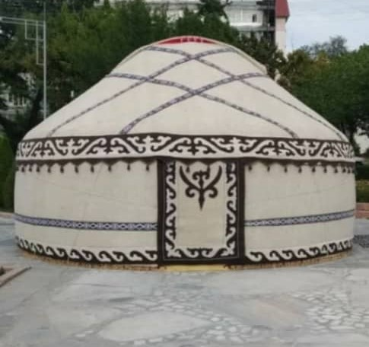
Yurt 2 | Size: Ø7m(diameters)  Specificatios: wooden frame, outer felt cover, decorative and functional details  Details: Lattice walls, coating around the lattice walls,poles, domed top, double door | PCS | 2 | 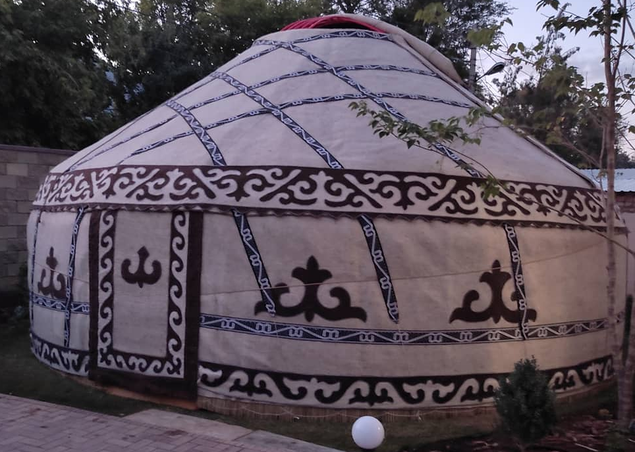
Yurt 3 | Size: Ø8m(diameters)  Specificatios: wooden frame, outer felt cover, decorative and functional details  Details: Lattice walls, coating around the lattice walls,poles, domed top, double door | PCS | 2 | 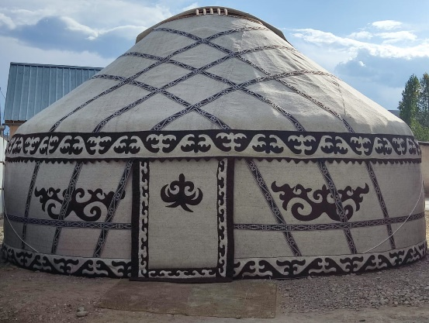
Yurt 4 | Size: Ø9m(diameters)  Specificatios: wooden frame, outer felt cover, decorative and functional details  Details: Lattice walls, coating around the lattice walls,poles, domed top, double door | PCS | 1 | 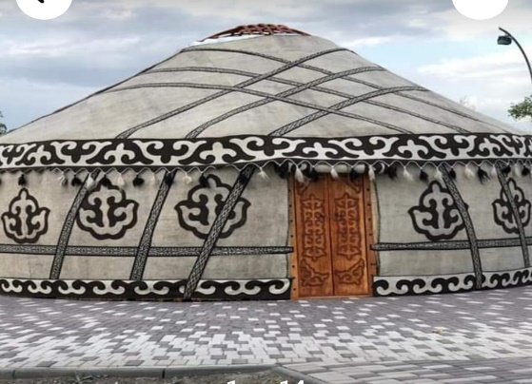

Delivery Requirements
Delivery Requirements
Delivery date and time | Bidder shall deliver the goods in up to 30 days after Contract signature. Bidder should identify the items available for immediate delivery and provide delivery schedule of remaining items.
Delivery Terms (INCOTERMS 2020) | UNDP Project office
Customs clearance  (must be linked to INCOTERM) | ☐ Not applicable  Shall be done by:  ☐ Name of organisation (where applicable)  ☒ Supplier/bidder with the help of UNDP  ☐ Freight Forwarder  The Supplier is responsible for submission of entire package of documents required for customs clearance: Certificate of Origin, Packing list, AWB/CMR (bill of lading), Commercial invoice.
Exact Address(es) of Delivery Location(s) | All purchased Yurts should be installed at Goygol district till 28 July 2022
Warranty Period | As per requirements in Annex 1
After-sales service and local service support requirements | Required. The after-sale service shall be available in Azerbaijan.
Preferred Mode of Transport | No specific transportation mode. The Supplier may use any or multimodal transportation if required.

ANNEX 2: QUOTATION SUBMISSION FORM
Bidders are requested to complete this form, including the Company Profile and Bidder’s Declaration, sign it and return it as part of their quotation along with Annex 3: Technical and Financial Offer. The Bidder shall fill in this form in accordance with the instructions indicated. No alterations to its format shall be permitted and no substitutions shall be accepted.
Name of Bidder: | Click or tap here to enter text.
RFQ reference: | Click or tap here to enter text. | Date: Click or tap to enter a date.

Company Profile
Item Description |  | Detail
Legal name of bidder or Lead entity for JVs |  | Click or tap here to enter text.
Legal Address, City, Country |  | Click or tap here to enter text.
Website |  | Click or tap here to enter text.
Year of Registration |  | Click or tap here to enter text.
Legal structure |  | Choose an item.
Are you a UNGM registered vendor? |  | ☐ Yes ☐ No If yes, insert UNGM Vendor Number
Quality Assurance Certification (e.g. ISO 9000 or Equivalent) (If yes, provide a Copy of the valid Certificate): |  | ☒ Yes ☐ No
Does your Company hold any accreditation such as ISO 14001 or ISO 14064 or equivalent related to the environment? (If yes, provide a Copy of the valid Certificate): |  | ☒ Yes ☐ No
Does your Company have a written Statement of its Environmental Policy? (If yes, provide a Copy) |  | ☒ Yes ☐ No
Does your organization demonstrate significant commitment to sustainability through some other means, for example internal company policy documents on women empowerment, renewable energies or membership of trade institutions promoting such issues (If yes, provide a Copy) |  | ☒ Yes ☐ No
Is your company a member of the UN Global Compact |  | ☒ Yes ☐ No
Bank Information |  | Bank Name: Click or tap here to enter text.  Bank Address: Click or tap here to enter text.  IBAN: Click or tap here to enter text.  SWIFT/BIC: Click or tap here to enter text.  Account Currency: Click or tap here to enter text.  Bank Account Number: Click or tap here to enter text.
Previous relevant experience: 3 contracts
Name of previous contracts | Client & Reference Contact Details including e-mail |  | Contract Value | Period of activity | Types of activities undertaken

Bidder’s Declaration
Yes | No
☐ | ☐ | Requirements and Terms and Conditions: I/We have read and fully understand the RFQ, including the RFQ Information and Data, Schedule of Requirements, the General Conditions of Contract, and any Special Conditions of Contract. I/we confirm that the Bidder agrees to be bound by them.
☐ | ☐ | I/We confirm that the Bidder has the necessary capacity, capability, and necessary licenses to fully meet or exceed the Requirements and will be available to deliver throughout the relevant Contract period.
☐ | ☐ | Ethics: In submitting this Quote I/we warrant that the bidder: has not entered into any improper, illegal, collusive or anti-competitive arrangements with any Competitor; has not directly or indirectly approached any representative of the Buyer (other than the Point of Contact) to lobby or solicit information in relation to the RFQ ;has not attempted to influence, or provide any form of personal inducement, reward or benefit to any representative of the Buyer.
☐ | ☐ | I/We confirm to undertake not to engage in proscribed practices, , or any other unethical practice, with the UN or any other party, and to conduct business in a manner that averts any financial, operational, reputational or other undue risk to the UN and we have read the United Nations Supplier Code of Conduct :https://www.un.org/Depts/ptd/about-us/un-supplier-code-conduct and acknowledge that it provides the minimum standards expected of suppliers to the UN.
☐ | ☐ | Conflict of interest: I/We warrant that the bidder has no actual, potential, or perceived Conflict of Interest in submitting this Quote or entering a Contract to deliver the Requirements. Where a Conflict of Interest arises during the RFQ process the bidder will report it immediately to the Procuring Organisation’s Point of Contact.
☐ | ☐ | Prohibitions, Sanctions: l/We hereby declare that our firm, its affiliates or subsidiaries or employees, including any JV/Consortium members or subcontractors or suppliers for any part of the contract is not under procurement prohibition by the United Nations, including but not limited to prohibitions derived from the Compendium of United Nations Security Council Sanctions Lists and have not been suspended, debarred, sanctioned or otherwise identified as ineligible by any UN Organization or the World Bank Group or any other international Organization.
☐ | ☐ | Bankruptcy: l/We have not declared bankruptcy, are not involved in bankruptcy or receivership proceedings, and there is no judgment or pending legal action against them that could impair their operations in the foreseeable future.
☐ | ☐ | Offer Validity Period: I/We confirm that this Quote, including the price, remains open for acceptance for the Offer Validity.
☐ | ☐ | I/We understand and recognize that you are not bound to accept any Quotation you receive, and we certify that the goods offered in our Quotation are new and unused.
☐ | ☐ | By signing this declaration, the signatory below represents, warrants and agrees that he/she has been authorised by the Organization/s to make this declaration on its/their behalf.

Signature:
Name: Click or tap here to enter text.
Title: Click or tap here to enter text.
Date: Click or tap to enter a date.

ANNEX 3: TECHNICAL AND FINANCIAL OFFER - GOODS
Bidders are requested to complete this form, sign it and return it as part of their bid along with Annex 2: Quotation Submission Form. The Bidder shall fill in this form in accordance with the instructions indicated. No alterations to its format shall be permitted and no substitutions shall be accepted.
Name of Bidder: | Click or tap here to enter text.
RFQ reference: | Click or tap here to enter text. | Date: Click or tap to enter a date.

Currency of the Quotation: US Dollars
(offer should be all inclusive – including transportation to end beneficiaries, installation, testing, warranty etc.)
Item No | Description | UOM | Qty | Unit price | Total price
1 | Yurt 6m diameter | PCS | 2
2 | Yurt 7m diameter | PCS | 2
3 | Yurt 8m diameter | PCS | 2
4 | Yurt 9m diameter | PCS | 1
Total Final and All-inclusive Price
(including transportations to the regions, installation etc )
Compliance with Requirements
 | You Responses
 | Yes, we will comply | No, we cannot comply | If you cannot comply, pls. indicate counter - offer
Minimum Technical Specifications | ☐ | ☐ | Click or tap here to enter text.
Delivery Term (INCOTERMS) | ☐ | ☐ | Click or tap here to enter text.
Delivery Lead Time | ☐ | ☐ | Click or tap here to enter text.
Warranty and After-Sales Requirements | ☐ | ☐ | Click or tap here to enter text.
Validity of Quotation | ☐ | ☐ | Click or tap here to enter text.
Payment terms | ☐ | ☐ | Click or tap here to enter text.
Other requirements [pls. specify] | ☐ | ☐ | Click or tap here to enter text.

I, the undersigned, certify that I am duly authorized to sign this quotation and bind the company below in event that the quotation is accepted.
Exact name and address of company  Company NameClick or tap here to enter text.  Address: Click or tap here to enter text.  Click or tap here to enter text.  Phone No.: Click or tap here to enter text.  Email Address: Click or tap here to enter text. | Authorized Signature:  Date: Click or tap here to enter text.  Name: Click or tap here to enter text.  Functional Title of Authorised  Signatory: Click or tap here to enter text.  Email Address: Click or tap here to enter text.

