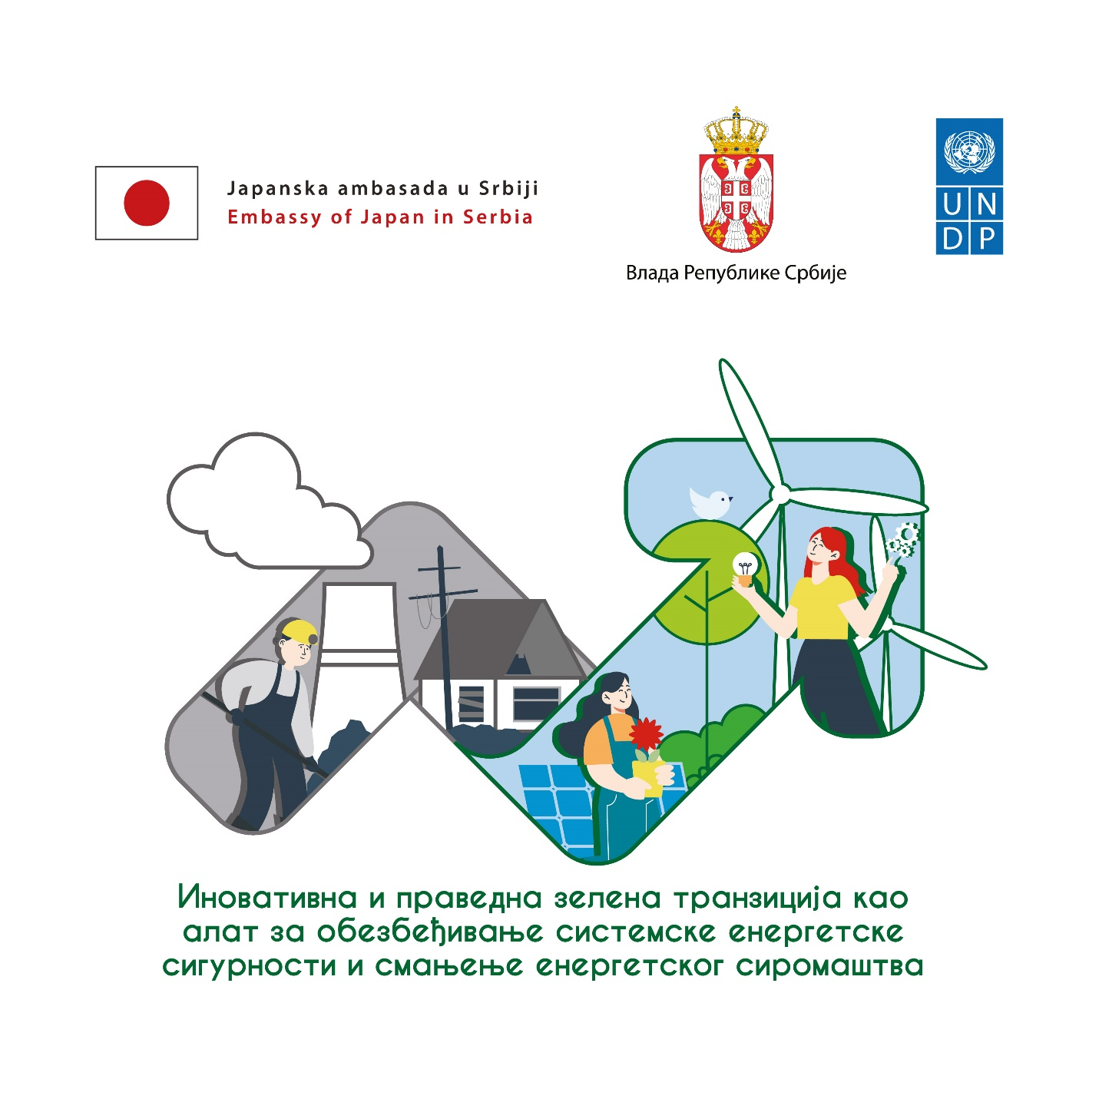
Innovative and Just Green Transition as Tool for Securing Systemic Energy Security and Reducing Energy Poverty

A Public Challenge Call for Innovative business models that diversify electricity generation mix, reduce energy intensity of the economy or enable access to clean and affordable energy for vulnerable population
May 2023
WE HEREBY INVITE PUBLIC COMPANIES AND REPRESENTATIVES OF THE PRIVATE SECTOR TO PROPOSE NEW BUSINESS MODELS AND INNOVATIVE TECHNOLOGICAL SOLUTIONS WHOSE APPLICATION WILL REDUCE GREENHOUSE GAS EMISSIONS.
THE SUGGESTED SOLUTIONS SHOULD ENABLE DIVERSIFICATION OF ELECTRICITY GENERATION MIX, REDUCE ENERGY INTENSITY OF THE ECONOMY OR ENABLE ACCESS TO CLEAN AND AFFORDABLE ENERGY FOR VULNERABLE POPULATION. AT THE SAM TIME, SOLUTIONS ARE EXPECTED TO CONTRIBUTE TO REDUCING THE COUNTRY'S ENERGY IMPORT DEPENDENCY
THESE SOLUTIONS WILL ALSO CONTRIBUTE TO:
- ECONOMY DECARBONIZATION,
- DEPOLLUTION OF THE ENVIRONMENT,
- ENCOURAGEMENT OF WOMEN’S ENTREPRENEURSHIP AND NEW INDUSTRY BRANCHES AS AN ALTERNATIVE TO THE COAL INDUSTRY.
IN ADDITION, THE SOLUTIONS SHOULD SUPPORT THE RETRAINING OF WORKERS FROM THE FOSSIL FUEL-INTENSIVE SECTORS FOR THE PURPOSE OF DEVELOPING NEW SKILLS REQUIRED IN THE MODERN LABOUR MARKET.

Why challenge call?
Changes, such as the green energy transition, bring extensive benefits as well as certain challenges. Green transition and green economy should become strategic goals of the business sector because they generate sustainable income in the long run and foster economic competitiveness. In addition, green transition plays an important role in the fight against climate change. That is why the public and private sectors must sustainably use energy and natural resources and thus reduce the negative environmental impact, and, on the other hand, contribute to the development of new business initiatives that can accelerate green transformation.
Serbia has increased its climate-ambitious commitment, set in the revised Nationally Determined Contributions to the Reduction of Greenhouse Gas Emissions adopted in 2022, which implies committing itself to reduce GHG emissions by 33.3% by 2030 compared to the levels set in 1990. Positive influence to reaching this goal was enabled by adopting the Law on Climate Change, the Law on the Use of Renewable Energy Sources, the Law on Energy Efficiency and Rational Use of Energy, and by-laws on green energy, which enable further improvement of energy efficiency and use of renewable energy sources.
The Republic of Serbia has limited funds to support the necessary energy diversification and efficiency. While most donor funds are intended for large-scale investments in the energy sector (e.g. reconstruction of large plants, etc.), funds are missing on the market for small investments in the public and private sectors, which is willing to for invest in renewable energy sources and energy efficiency. On the other hand, such green transformation solutions can have added value to energy diversification and energy security of the country, transformation of the green economy, and contribution to prevention of energy poverty.
The green transition contributes to the improvement of the quality of the environment, as well as the health of the people, the economy, and society as a whole. It also affects the sustainable transformation of industry, mining and the energy sector. This is why it must be just and strategically planned. Energy transition has been long discussed. It includes increased energy production from renewable sources and abandoning energy production from coal, which particularly affects the industrial sector. This transition requires enormous changes, both in public policies and in the awareness of all the participants in the energy production and consumption chain. This transition must be just, especially for regions, sectors, local communities, and individuals who are economically dependent on the intensive use of fossil fuels. This means that new industry branches must be developed as an alternative to the coal industry, development of new technologies, enable the workers to retrain and acquire new skills that they need in the modern labor market. That is why it is important to understand that just green transition is an integral part of decarbonization of the economy and not its consequence.

The objective of the challenge call
The objective of the challenge call is to recognize and support innovative project proposals that will contribute to the reduction of greenhouse gas emissions and reduction of industrial emissions, thus contributing to the decarbonization of the economy and depollution of the environment.
It aims at selecting and supporting the implementation of innovative project ideas and business models, technologies, and applicable solutions that will contribute to green transformation and decarbonization of the economy, industry and society in Serbia while simultaneously reducing greenhouse gas emissions and other harmful emissions.
This Challenge Call will help to support the implementation of projects which present innovative business models of the carbon-intensive industries which:
- Diversify electricity generation mix;
- Decrease in the energy intensity of the economy;
- Enable affordable supply of clean energy, especially for vulnerable consumers;
- Reduce import dependency;
- Encourage just green transition in the coal region and development of new industry branches as an alternative to the coal industry.
This challenge call is a good opportunity for promotion of strategic partnerships between public and private sectors with the aim of adopting new approaches to green transformation and decarbonization. One of the expected results of this call is the further promotion of the grants program for commercial loans and other loans for green investments and the development of a multiplication of green investment projects.
Through this challenge call and within the project “Innovative and Just Green Transition as Tool for Securing Systemic Energy Security and Reducing Energy Poverty”, the United Nations Development Program (UNDP) in cooperation with the Ministry of Environmental Protection and the Ministry of Mining and Energy, and with financial support from the Government of Japan, invites companies from both public and private sectors to propose innovative solutions for the green transition of the Serbian economy.

Expected types of projects
Expected types of projects | Additional aspects that must be taken into account during the project preparation
- Projects applying new technologies or promoting new applications of the existing technological solutions (the first-of-its-kind in Serbia) for reducing GHG emission;  - New business models for products/services that promote decarbonization;  - New/improved business models or organization/production processes;  - Projects that create conditions for workers’ retraining and development of new skills necessary for the modern labor market;  - Projects in the field of women’s entrepreneurship which encourage reduction in GHG emissions;  - Models, technologies, or methods of reducing GHG emissions, improving resource and energy efficiency;  - Green and more sustainable traffic network, which makes traffic operations more efficient and reduces GHG emissions;  - Urban solutions, including the construction, reconstruction and rehabilitation of buildings in order to increase energy efficiency and the use of RES. | - Concrete impact on the reduction of GHG emission;  - Solving social challenges (gender equality, marginalized groups, unemployment, etc.);  - Developing solutions that can be further scaled up or used as a model for replication;  - Identifying potential partnerships with Japanese companies that operate in Serbia in order to encourage the use of Japanese green technologies and products, application of knowledge and experience in the process of green transformation of the economy;  - Identifying other partnerships that bring added value to the project by contributing to the systemic green transformation of cities/communities;  - Implementation of new public policies, planning the systemic decarbonization;  - The relevance of the proposed project for reducing harmful emissions into environment (air, water, and soil) improving the quality of the environment;  - The possibility of job transformation and reskilling to ensure minimal job losses, map potentials for economic diversification, support employability, and provide livelihoods for the workers' families;  - Positive impact on reduction of energy poverty of vulnerable consumers.

Who can apply?
The following can apply to this call:
- Public and utility companies;
- Business companies (companies, entrepreneurs).
All applicants must be registered in Serbia according to the national legislation in force.
Applicants can apply independently or in consortia. If applying as a consortium, the Lead Applicant, which shall represent the consortium and serve as the main point of contact throughout the application process, must be clearly indicated. The Lead Applicant will also be the main recipient of the financing funds.
Applicants can submit up to two applications as the Lead Applicant and can participate in an unlimited number of applications as consortium members.
Note: Research institutions and organizations, local self-governments, public and utility companies and/or companies can apply as consortium members.
Important note: The applications submitted by the following companies shall not be accepted:
- Companies manufacturing, selling, or distributing tobacco or tobacco products,
- Companies engaged in selling or distributing firearms,
- Companies in the alcoholic beverage industry.

Application process
During the challenge call, applicants are invited to submit their innovative project proposals.
The Challenge Call Evaluation Committee, comprised of external evaluators and Project Steering Committee members, will review, and evaluate submitted Innovative Project Proposals, based on pre-defined criteria (see Section X), and select proposals that will receive technical support (the so-called “Acceleration”).
Acceleration of successful innovative project proposals implies technical support to the applicants in further elaboration of their projects and preparation of project documents. This will further qualify them to compete for co-financing support. The co-financing will be provided in the form of Performance-Based Payment Agreements (PBPA). The acceleration process may include the following technical assistance: provision of technical and expert support to de-risk project/business proposals and enable access to finance, improve technical aspects of the projects/businesses, and eventually support the development of fully implementable projects/businesses that will have a direct positive impact and contribute to the green transition of Serbia. During this phase, the applicants will receive individual mentorship, as well as additional training on GHG emissions calculation, business plan development, marketing planning, fundraising, public presentation, gender mainstreaming, and other relevant topics. General training will be organized for all the projects that contribute to the green transition, while specialized/thematic training will be provided in line with the five pillars of the Green Agenda.
At the end of the acceleration phase, each project document will be re-evaluated by the Challenge Call Evaluation Committee to identify the most mature projects, ready for implementation, sustainable, and with the highest environmental, social and economic benefits. Those projects will receive co-financing in line with developed Project Documents, and as per the available budget, through Performance-based Payment Agreements (PBPA). This type of agreement enables the co-financing of projects with up to 50% of the estimated project total investment value (detailed information about co-financing may be found in Section VII).

Challenge call timeline and important dates
CALL FOR INNOVATIVE PROJECT PROPOSALS
25 May 2023 | CALL OPENING
15 June 2023  16 June 2023  20 June 2023  21 June 2023 | INFOR DAYS FOR POTENTIAL APPLICANTS  (hybrid or online consultation)
7 July 2023 | DEADLINE FOR APPLICATION SUBMISSION
EVALUATION OF PROJECT PROPOSALS
Until 31 July 2023 | Selection of project proposals that will receive technical support and participate in the Accelerator
ACCELERATION PHASE
August 2023 – October 2023 | Mentoring, training, coaching, training and webinars
October 2023 | Selection of the most successful projects that are ready for implementation and signing of Performance-Based Co-financing Agreements (PBPAs)
IMPLEMENTATION PHASE
October 2023 – February 2024 | IMPLEMENTATION of the most successful projects that are sustainable and have positive impacts

Benefits for the applicants
The applicants whose project ideas have been selected for the acceleration process will receive the following:
⇒ Development support and mentorship
This type of support will be organized through a program lasting 3 months for the selected applicants who will work on the improvement of their projects/businesses and will receive valuable skills in GHG emissions calculation, business planning, fundraising, public presentations, gender mainstreaming, etc. This program will also include management assistance, education on specific environmental issues relevant to each specific area, various training, support, assessment of compliance with legal requirements (permits, licenses, etc.), networking and experience sharing among peers throughout Serbia.
Projects selected for implementation will also receive:
⇒ Co-financing
Based on the financial plan and total project budget, potential co-financing is up to 50% of the total investment and not more than 150,000.00 € per applicant. In exceptional cases, for project proposals with high evaluation score and budget justification, it might be possible to increase the rate of donor co-financing.

Value-based categories of the projects and co-financing
Based on the financial plan and total project budget value, proposals will be divided into 3 categories:
  - Small projects (up to 100 000.00 USD),
  - Medium projects (up to 1 million USD),
  - Large projects (investment values exceed 1 million USD).
Important Note on co-financing: All projects that are expected to be co-financed, either through bank loans or other sources of financing (bilateral, multilateral, private, etc.), must present a contract with the bank and/or other documents confirming the co-financing commitments by the end of the Acceleration Phase. In addition, it is important to note that there is a requirement in the Project Proposal form to indicate the financing sources and the amount of co-financing. Where relevant, the applicants can confirm this by letters of intent, memorandums of understanding, guarantee schemes, bank guarantees, etc.
The value of the co-financing of each project will be defined based on the cost-benefit analysis and the determined impact of the project. Individual grants per project will also depend on the project investment value and are limited to the established proportional share of the total investment, or an established maximum sum, as indicated below:

Investment value | Co-financing through the donor (Government of Japan)
Small projects with a total value of up to 100 000 USD | Up to 50% of the total investment, but not more than 50 000 USD
Medium projects with a total value from 100 000 to 1 000 000 USD | Up to 30% of the total investment, but not more than 100 000 USD
Large projects with a total investment value of over 1 000 000 USD | Up to 20% of the total investment value, but not more than 150 000 USD

The co-financing will be delivered in tranches upon fulfillment of the indicators that are to be specified for each selected project.
Disclaimer: In exceptional cases, for project proposals with evaluation score of minimum 85 points, and a provided budget justification, it might be possible to increase the rate of donor co-financing.

Evaluation process and selection of the projects for the acceleration phase
The process of evaluating and selecting projects for the acceleration phase will last from July 7 to July 31, 2023, at the latest.
Based on the evaluation criteria, the Committee will evaluate the project proposals, and up to 20 best project proposals will be selected for the acceleration phase. Only proposals that successfully complete the acceleration process will be considered ready for co-financing.
The applications that meet the requirements of the Call will be evaluated and selected for the acceleration phase based on the following criteria:

Criteria for evaluation and scoring of projects eligible for the acceleration phase
Criterion | Maximum score | Description
Effectiveness and Impact | 45 | Key criteria (max. 30 points)  What is the impact of the project on the decarbonization of the economy - how much does it contribute to the direct reduction of greenhouse gas emissions (t/CO2 eq)? The cost efficiency of carbon emission mitigation (EUR/tСО2).  What is the assessment of the impact of project implementation on the green transition realization? Is there a clearly presented relevance of the proposed project for the reduction of harmful emissions into the air, water, and soil, that will improve the quality of the environment?  Additional criteria (max. 15 points):  Are sustainable partner solutions that bring added value to the project contributing to systemic green transformation foreseen? Is it planned to establish partnerships with Japanese companies operating in Serbia in order to encourage the use of Japanese green technologies and products and the application of knowledge and experience in the process of green transformation of the economy?  Does the solution generate an inclusive impact, specifically targeting a vulnerable population (for example youth, women and/or marginalized groups)?  What is the project’s short- and long-term impact on local development and employment?  Does the project have elements of support for women’s entrepreneurship in the process of green transformation of the economy?  Does the project encourage the retraining of workers and the development of new skills necessary for the modern labor market?  Is the project’s impact on managing the social and economic effects of a fair green transition in the coal regions and/or energy poverty demonstrated?
Sustainability and possibility of replication | 20 | Do the proposed methodology and planned activities guarantee the realization of the proposed technology, product, or service development? Does the project have the potential to be scaled up and/or replicated over time and implemented by other stakeholders in Serbia?
Innovation | 10 | Can the project be considered innovative compared to the existing solutions in Serbia? Will the project result in innovative improvement of existing products and technological solutions? Is the project subject to intellectual property rights?
Project quality, consistency and feasibility | 10 | Are the targeted area(s) of intervention relevant and in the scope of the call? Are the overall project objectives and expected outcomes clear, precisely defined, relevant, and realistic? Based on the presented experience, do the applicants have sufficient access to resources (materials, supplies, analytical services, information, equipment, facilities, etc.) needed to accomplish their goal?
Project budget and financial viability | 10 | Are the project costs realistic, are the planned activities cost-efficient? Does the proposed approach have the potential to lead to a competitive and marketable technology, product or process that could generate revenue? Already provided co-financing for testing the solution will be additionally scored What is the project cash co-financing amount of the project implementing agent, that is, what is the share of it in the total investment?
Operational and management capacity | 5 | Do the applicants demonstrate the relevant skills, expertise, experience and other resources to implement the project successfully within the timeframe? To what extent do they combine the necessary expertise?
Total | 100

Acceleration phase
The acceleration phase will last from August to October 2023.
The decarbonization accelerator will act as a co-working space and a help desk for the selected project applicants. With the support of the project’s technical staff, consultants, and experts-mentors, applicants will be provided with an opportunity to further elaborate their project concepts, test pilot models, and further develop the proposed technical solutions. The selected teams will receive free training on various topics, including business planning, product promotion, and market research, as well as specific thematic training. The acceleration support will also include specific analyses, assistance in the development of project documentation, workshops, and participation in the events, including possible site visits.
The Acceleration phase will last at least 3 (three) months.
The applicants are expected to devote themselves to the development of their project ideas during acceleration, and to successfully meet the following indicators:
- Participate in training programs, workshops, mentoring sessions, and other events organized by UNDP and/or project partners;
- Develop a clear business ‘roadmap’ in order to transform their business from linear to circular, with a complete work plan and activities that will be carried out;
- Prepare the necessary technical documentation, pre-feasibility studies, and other relevant studies to enable the proposed solution for implementation.
At the end of the acceleration phase, each team should have the key elements of the project document prepared in accordance with the form provided by UNDP, and decisions on the project co-financing will be made based on the previously mentioned and defined criteria.

Co-financing mechanism
Upon completion of the Acceleration Phase, the Steering Committee will select the best-evaluated projects that are deemed ready for actual implementation. Appropriate co-financing will be provided in the form of Low-value Performance-Based Payment Agreements (PBPAs) and/or grant programs for commercial loans and other loans for green investments. PBPAs as a contracting modality are regarded to bring more value compared to regular grants as they represent a kind of partnership agreement with the beneficiary.
However, it is important to mention that co-financing provided within this Challenge call is considered initial capital and a de-risking mechanism, which should enable the applicant to secure the remaining funds for the entire investment. The applicant is responsible for identifying and obtaining other sources of financing for the particular project. The number of projects selected for support in the implementation of obtained co-financing, and the corresponding value of such financing, could be increased, depending on the availability of additional funding resources.

Criteria for evaluation and selection of the projects for co-financing
Criterion | Maximum score
Impact on pollution reducton | 20
Impact on CO2 reduction | 20
Concept promotion and replicability | 20
Impact on new jobs / women’s entrepreneurship / mitigation of energy poverty | 20
Innovativeness, quality and foundation of the idea | 20
Sustainability, secured co-financing | 40
Maturity of the project for implementation | 40
Operational and management capacity | 10
Local environmental impacts and vulnerable groups | 10
Total | 200

The projects selected for co-financing by the Steering Committee will have to finalize the implementation of the proposed activities by February 2024.
After signing the Co-financing Agreements, in the implementation phase - the selected teams will implement their ideas and projects, and their progress will be constantly monitored. In this phase, the focus is primarily on successful implementation and evidence of results.
Site visits will be organized, including the participation of the project team and project partners. One visit at least must be organized to coincide with the last report of the applicant who was rewarded with the co-financing agreement.

Application form for innovative project proposals
The application for innovative project proposal submission must be completed in Serbian, and the summary of the proposed project idea has to be provided in both Serbian and English. It is important that all issues are addressed and answered precisely and clearly. When completing the application form, please note the limited space for responding to certain questions.
The application is submitted through an online form, which is available at the UNDP website (https://www.undp.org/sr/serbia) until 5 p.m. on July 7, 2023.
The following documents are attached to the application form:
- Evidence of previous experience in relevant sectors (list of completed projects, if applicable), and individual CVs, both for the project leader and for the team members (other participants-applicants) with clearly indicated roles in the project development and implementation (including authorship/co-authorship);
- Draft partnership agreement (if applicable);
- Statement of acceptance of the co-financing commitment.
When filling in the application form, please keep in mind the relevant evaluation criteria.
Application details
Project name | Enter the full name of the project
Main area/sector in accordance with the objectives of the Challenge call (mark the areas to which the project applies) | - Projects applying new technologies or promoting new applications of the existing technological solutions (the first-of-its-kind in Serbia) for reducing GHG emission;  - New business models for products/services that promote decarbonization;  - New/improved business models or organization/production processes;  - Projects that create conditions for workers’ retraining and development of new skills necessary for the modern labor market;  - Projects in the field of women’s entrepreneurship which encourage reduction in GHG emissions;  - Models, technologies, or methods of reducing GHG emissions, improving resource and energy efficiency;  - Green and more sustainable traffic network, which makes traffic operations more efficient and reduces GHG emissions;  - Urban solutions, including the construction, reconstruction and rehabilitation of buildings in order to increase energy efficiency and the use of RES.
Project duration | (expressed in months)
Lean applicant
Name of the lead applicant | Enter the full registered name of the lead applicant
Contact details of the lead applicant | Enter the full name, address, postal code, e-mail address, and telephone number of the contact person
Оther applicants (if applicable)
Name of applicant | Enter the full name, type of organization/institution
Contact details | Enter the full name, address, postal code, e-mail address, and telephone number of the contact person
Summary of the proposed project idea
Please provide a summary of the project idea, including the scope and objective/s of the project  The summary should be no more than 2000 characters (both in Serbian and English) | The summary should present the main description of the project proposal, with sufficient information to provide a clear understanding of the challenge call and its overall goal. It should also clearly present how the project will achieve its objective/s.
Project description
Detailed project description  The limit is 4000 characters | Describe how you will apply the principles of decarbonization in your proposal. Describe the approach (technical, technological, business model, etc.) and methodology that your project aims to apply to respond to the main challenge. State how much it contributes to the direct reduction of greenhouse gas emissions (t/CO2 eq) and how the cost efficiency of carbon emission mitigation (EUR/tСО2) will be achieved.  Describe how you plan to adopt partnership solutions that bring added value to the project as well as the ways, if any, in which you plan to establish a partnership with Japanese companies operating in Serbia in order to apply Japanese green technologies and products, or the knowledge and experience, in the process of green transformation of the economy.  Describe whether the solution creates an inclusive impact, specifically targeting a vulnerable population (for example youth, women and/or marginalized groups). What is the short-term and long-term impact of the project on local development and employment?  Indicate whether the project has elements of support for women’s entrepreneurship in the process of green transformation of the economy.  Explain whether the project encourages the retraining of workers and the development of new skills that are needed for the modern labor market.  Explain the impact of the project on managing the social and economic effects of fair green transition of coal regions and/or energy poverty.
What makes your  project innovative?  The limit is 1000 characters. | Applicant(s) need to consider some of the following questions: What are the innovative elements of the proposed project? Does it represent the implementation of an existing idea into a new operational setting, etc? Why will your innovation be successful in addressing the problem compared to some other more standard approaches?
What are the risks to project success and what is the project’s risk management strategy? The limit is 1000 characters | Please identify the key risks and uncertainties of the project and how the project would mitigate these risks.
Intellectual property rights  The limit is 1000 characters | Please identify the intellectual property rights precisely or describe the model in which they will be resolved, and confirm the absence of any legal disputes arising from intellectual property rights.
Do the project applicants have the skills and experience to implement the proposed project?  The limit is 2000 characters | Describe the previous experience and roles of your team members. Please describe the previously implemented projects/activities relevant to the objective of this Challenge Call.
Project activities (including timetable - dynamics)  The limit is 3000 characters | Please list the activities required for the implementation of the proposed project, and explain how the proposed project fits in with your existing activities and operations.  Please explain how the local community will be engaged.
Expected impact and outcomes  The limit is up to 2000 characters | Describe the most important impacts and outcomes of the project.  Describe the impacts arising from applying the measures for decarbonization and depollution.  Describe the impacts on depollution and submit the information on the reduction of emissions, if any.  In what way will the applicant/applicants ensure the sustainability of the project results and the impacts created?
Gender approach  The limit is up to 1000 characters | Please explain the approach to gender mainstreaming,  while acknowledging the complementary roles of both women and men, in order to obtain gender equality.
Expected project budget  The limit is up to 4000 characters | Please indicate the expected project costs in USD (in compliance with planned activities and outcomes). The total budget and cost structure must be realistic and in line with the project activities.  Present clearly the contribution from project partners. How will the funds necessary for the project implementation be secured (include the sources, structure, and any supporting documentation as evidence)?

Intellectual property right disclosure
The applicant must confirm to UNDP that no intellectual property disputes have arisen from the submitted innovative idea. In case the applications were submitted in consortia, the consortium agreement should appropriately confirm and resolve intellectual property rights between consortium members. In case of other intellectual property issues, the applicant(s) are required to disclose them to UNDP before the evaluation process.

Contact details
The interested parties can send questions regarding the application process to the challenge call to the UNDP by e-mail at the following address: smiljka.zivanovic@undp.org or contact us via telephone: 060 0802 981 and 064 2244 027.

