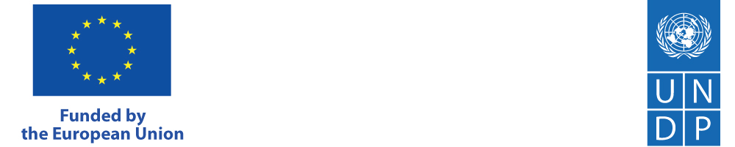

Regional Programme on Local Democracy in the Western Balkans 3 (ReLOaD3), funded by the European Union and implemented by UNDP announces:

PUBLIC CALL
for
Civil Society Organizations (CSOs), academic institutions, and individuals
for membership in
Advisory Group for the ReLOaD3 Project in Kosovo

The Regional Programme on Local Democracy in the Western Balkans 3 (ReLOaD3) continues the EU-UNDP partnership and builds upon the previous initiatives, ReLOaD1 and ReLOaD2, implemented between 2017 and 2024.
The programme focuses on strengthening local self-governance and civil society engagement. ReLOaD3 will be implemented across Western Balkans. By fostering regional collaboration, the project aims to enhance the capacities of local governments and civil society organisations (CSOs) to establish effective partnerships, improve service delivery, and align with local development strategies and priorities.
Working across the region, ReLOaD3 will continue to strengthen further dialogue between local governments and CSOs, stimulate their cooperation by spreading and anchoring positive CSO funding practices across all levels of governments in the Western Balkans and invest in further developing the CSOs’ to ensure their sustainability.
It aims to enhance the role of civil society organizations (CSOs) as key agents of accountability, promoting civic participation and effectively monitoring policy design and implementation, focusing on those that are most vulnerable and simultaneously stimulating governments to create a supportive policy, legal and financial environment for civil society.
The Action will focus on enabling a crucial number of local governments to adopt and maintain high standards of transparency and accountability in their operations. This approach will also strengthen result-oriented dialogues between CSOs, citizens and local authorities, contributing to more inclusive local governance, improving municipal service delivery and overall sustainable development.
By fostering government-civil society interactions and empowering civil society, the Action will continue to support the EU enlargement process, where civil society is recognized as a crucial element of participatory democracy. It will also promote transparency and sound public financial management, which are priorities of the EU Growth Plan by preparing a reform agenda related to the fundamentals of the enlargement process, including the rule of law, democracy, and respect for human rights and fundamental freedoms. The Action will directly contribute to enhanced civic engagement in monitoring the performance of governments in implementing socio-economic measures under the EU Growth Plan for the Western Balkans and the Reform and Growth Facility, whenever relevant.
Target groups in Kosovo and transfer of experiences to new municipalities: 5 partner municipalities / 4 new municipalities and 1 municipality from the previous phase, CSOs, youth and citizens in 5 partner municipalities.
Same as in the previous two phase, the project structure foresees the creation of the Advisory Board, with the aim of providing support to the Kosovo Board of Partners (BoPs) on ensuring regular feedback vis-à-vis the project implementation and its effects on civil society, youth initiatives and local governments. The Advisory Group will share information about ReLOaD3 project activities and results to all other relevant stakeholders to support the achievements of project results. The Advisory Group will consist of a maximum of 15 members, and one representative will be nominated on the rotational basis to participate in the Board of Partners (BoPs) regular meetings.

- Criteria for participation in the Advisory Group
The project has envisaged the composition of the Advisory Group from representatives of civil society organization, academic institutions, and individuals, whose previous experience and deep expertise shall contribute to the successful and development-oriented work of the group.

In addition to academia and qualified experts, we also kindly encourage smaller local organizations (grassroots organizations) to apply for membership of the Advisory Group, to contribute to the overall policymaking and development of participatory democracies at the local level. Fair territorial and sectoral CSO participation will be considered through selection process.

Participation and contributions of the members of the Advisory Group is strictly on a voluntary, non-remunerated basis.

- Eligible CSOs and academic institutions to apply for membership

CSOs and academic institutions may nominate a candidate for membership of the Advisory Group, if:
- possess the certification of the registration prior to the publication of the public call;
- the founding act and/or the Statute of the organization presents activities and objectives in areas related to the objectives of the ReLOaD3 project;
- successfully implemented, in the previous year, at least one project or activity related to the objectives of the ReLOaD3 project;
- CSOs that propose their representatives in the Advisory Group shall be active in the community and be recognized by the citizens/users of their services in the community;
- more than half of the members of the management body of CSOs are not members of political parties, public officials, senior civil servants or government officials/employees;

- Eligible individuals to apply for membership

- a candidate who shall apply for membership to the Advisory Group shall be Kosovo citizen and residing in Kosovo;
- a candidate shall possess extensive experience in working in one of the following areas: civil society, democratic processes, human rights; and is willing to voluntarily contribute to a successful implementation of project objectives and to the work of the Advisory Group;

All CSOs and academic institutions may propose more than one candidate for membership to Advisory Group; however, only one representative can be elected from the respective CSO and academic institution.

- Required documents

- CSOs should submit the following documents:

- copy of the certification of registration;
- copies of the founding act and the statute;
- review of the implemented projects and activities in the previous year,
- statement by the person authorized to represent the CSOs that half of the members or/and management are not members of any political party, public officials, senior civil servants or government officials/employees;
- letter of support from CSOs for the nominated candidate, with a short biography that provides sufficient information on the experience and expertise of the candidate;
- contact information (phone and/or email address) of the organization that nominates the representative;

- Academic institutions should submit the following documents:

- letter of support from academic institutions for the nominated member, with a short biography that provides sufficient information on the experience and expertise of the candidate;
- contact information (phone and/or email address) of the institutions that proposes the representative;

- Individuals should submit the following documents:

- photocopy of the ID card or other identification document;
- CV that emphasizes details of previous experience in relation to the objectives of the ReLOaD3 project;
- Statement from the candidate that is not a member of a political party, public official, senior civil servant or government official/employee;

- Submission of application
Applications for membership to the Advisory Group with all the required documents shall be submitted no later than 12 March 2025 to the following e-mail address registry.ks@undp.org

UNDP Kosovo shall, notify the selected candidates on the results of the selection within 5 days from the proposals of candidates. Any questions regarding the procedure for nomination and application for membership to the Advisory Group can be submitted electronically to the following address: registry.ks@undp.org.

