Annex 2: Methodological note on performance factor analysis

Background

Over the past years, UNDP has accumulated rich performance data from a range of systems such as the enterprise resource planning system (Atlas), integrated results and resources framework (IRRF) indicators, qualitative results from the Results Oriented Analysis Report (ROAR), evaluation, audit and surveys.

As part of the evidence-based lessons learning for the Midterm Review of the Strategic Plan for 2018-2020, UNDP conducted a performance factor analysis (PFA), an advanced statistical analysis to identify key factors and approaches that contribute to the achievement of higher-level development results.

This paper outlines the model and methodology of the PFA and its findings, which served as critical evidence to underpin the Midterm Review of the Strategic Plan.

Performance Factor Analysis - Model and Methodology

As shown in the figure below, the PFA has tested - factors (X – Independent Variables) that are associated with the achievement of development results in 2018-2019 (Y – Dependent Variables).

Figure: PFA Model for the Midterm Review of the Strategic Plan
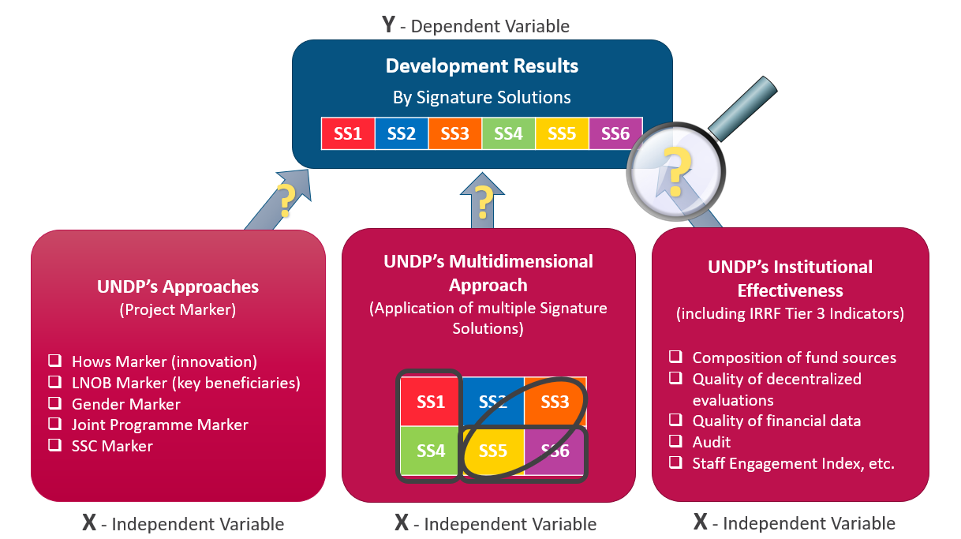
Y - Dependent Variables (development results)

- Overall IRRF achievement rate per country

The aggregated achievement of overall IRRF indicators at country level was used as dependent variables. Different countries have selected a different set of IRRF indicators according to their development context and national development priorities reflected in their country programme document (CPD). The aggregated overall average across indicators, a percentage number, is used for the analysis. Each country has one value for each year – 2018 and 2019.

X - Independent Variables (factors contributed to the achievement of development results)

Consistent with dependent variables, independent variables are defined and calculated at country level and are grouped into three domains:

- UNDP’s approaches to achieve results (Project Markers)

At country level, a percentage is calculated for each independent variable (Project Marker) by dividing the number of project outputs that are tagged through a respective Project Marker by the total number of project outputs.

- Hows Marker (Innovative approaches) - Number of project outputs that used innovative approaches, as a proportion out of all project outputs;
- Leaving No One Behind (LNOB) Marker - Number of project outputs that included people living in rural areas, women and youth as a proportion out of all project outputs, separated into three independent variables (rural, women and youth);
- Joint Programme Marker - expenditure on project outputs that are joint programming, as a proportion out of all programme expenditure); and
- South-South Cooperation (SSC) Marker - Number of project outputs that used SSC, as a proportion out of all project outputs.

- UNDP’s multidimensional approach

At country level, single or multiple signature solutions can be applied to each CPD output: a one-to-one primary link to a Strategic Plan output and additional link(s) (one-to-many) by selecting relevant Strategic Plan IRRF indicator(s).

This variable measures the extent to which each country office applies a multidimensional approach as the number of CPD outputs where more than one signature solution was applied through multiple linkages against the total number of country programme outputs. The percentage is further categorized into three groups:

- Low: 0% – 30%; for a typical CPD with 12 – 15 outputs, up to 4 outputs apply multiple solutions;
- Medium: 30% – 60%; for a typical CPD with 12 – 15 outputs, between 4 and 8 outputs; and
- High: 60% – 100%; for a typical CPD with 12 – 15 outputs, between 8 and 15 outputs.

- UNDP’s institutional effectiveness

At country level, various institutional-level data, including Tier 3 IRRF indicators, were used as factors for the analysis, these include:
- Audit (qualitative score on audit result);
- Transparency data quality (quantitative score on transparency data quality);
- Decentralized evaluation quality (qualitative score from decentralized evaluation);
- Funding type (proportion of funding from regular resources);
- Management efficiency ratio (proportion of utilization on management);
- Utilization on projects marked as “gender mainstreaming”;
- Office programme delivery category (small[<10$m], medium[10-50$m], large[>50$m]); and
- Financial data quality.

Statistical Analysis

Country-level observations were combined over 2018 and 2019. A linear regression was conducted with the overall country-level achievement rate against independent variables. Initial exploration suggested that some independent variables were not associated with the dependent variable and including them reduced model goodness-of-fit, so they were excluded in the final model. The Generalized Linear Latent and Mixed Model (gllamm) approach is applied to take into consideration random correlations among repeated measures within each country (over two years) and within each region (over five regions) to make the estimates more accurate and reliable.

All analyses are performed using STATA software version 15.1.

Performance Factor Analysis - Findings

A number of independent variables were found to be statistically significantly associated with the dependent variable of country performance over two years.

- Multidimensional approach (application of multiple signature solutions to achieve results)

Evidence shows that when a moderate level of multiple signature solutions was applied (30 – 60 per cent of CPD Outputs), the office achieved higher performance (IRRF results) compared to those offices where multidimensional linkage is outside that range (higher than 60 per cent or lower than 30 per cent). The magnitude of change is 8 percentage points.

For example, a typical office has about 12 CPD outputs. Applying multiple solutions to 4 to 8 of them would help elevate performance by 8 percentage points.

- Proportion of regular resources

Evidence shows that offices with higher proportion of regular resources achieved higher performance. The magnitude of change is linear – for every 10 percentage point increase in regular resources, there is a 2.5 ppt increase in performance.

- Innovative approaches

Evidence shows that offices with more projects that use innovative methodologies and tools achieved higher development results. The magnitude of change is linear – for every 10 percentage point increase in the proportion of innovative projects, there is a 3 percentage point increase in performance.

Conclusion

UNDP found the PFA a valuable tool to help the organisation identify key factors that contribute to the attainment of higher-level development results. The findings of the PFA confirmed the validity of UNDP’s multidimensional approach and use of innovative tools and methodologies. The value of regular resources was also reaffirmed by the PFA. The findings of the PFA were incorporated in the Midterm Review of the Strategic Plan as critical data-based evidence to inform UNDP’s work in the second half of the Strategic Plan and the design of the new Strategic Plan for 2022-2025.

Development results are measured by an achievement rate of aggregated IRRF output indicators as explained in the following section.
“Statistical significance” suggests that the changes in performance are indeed associated with changes in these factors, not due to randomness. The magnitude of such associations, however, is very contextual. Given that the average office performance is about 90%, a three percentage point increase or decrease is a meaningful (although relatively small) change.

