DP/OPS/2015/CRP.1
7 January 2015

English only
First regular session 2015
26-30 January 2015, New York
Item 8 on the provisional agenda
United Nations Office for Project Services

Strengthening of the UNOPS Audit Advisory Committee
Conference room paper submitted by UNOPS

A. Introduction

1. UNOPS was established in 1995 pursuant to General Assembly decision 48/501. Since the Executive Board has through a number of key decisions ensured the establishment of solid mandate and governance arrangements for the organization. This process culminated with General Assembly resolution 65/176, reconfirming decisions of the Executive Board.

2. Today UNOPS has a confirmed status as a partner in the UN system and beyond. In addition to promoting national ownership and capacity; accountability for results and transparency; partnerships and coordination; excellence are core values to the organization; UNOPS is committed to United Nations harmonization and simplification of business processes, including those supporting the Executive Board, and subsidiary committees advising the Executive Director. To this end the UNOPS Executive Director proposes to further align the UNOPS governance and accountability arrangements with those of sister agencies governed by the Executive Board. Specifically, it is proposed to replace the UNOPS Strategy and Audit Advisory Committee with a strengthened UNOPS Audit Advisory Committee with roles and responsibilities aligned with sister agencies.

B. Evolution of the UNOPS Audit Advisory Committee

3. The core roles and responsibilities of the present UNOPS Strategy and Audit Advisory Committee were approved by Executive Board decision 2008/7, which simultaneously approved the accountability framework and oversight policies for UNDP and UNOPS, as well as UNFPA oversight policy, subject to additional provisions set out in the decision.

4. Subsequently, detailed terms of reference for the UNOPS Strategy and Audit Advisory Committee were developed. Following consultation with the Bureau of the Executive Board, the terms of references were promulgated by the Executive Director in September 2008.

5. Through its decision 2009/4, approving the UNOPS financial regulations and rules, the Executive Board requested that the Executive Director establish a process to consult the Strategy and Audit Advisory Committee on any proposed amendments or suspension of the UNOPS financial rules. This role of the Strategy and Audit Advisory Committee was reconfirmed by the Executive Board when revised financial regulations and rules were approved through decision 2012/5.

6. In 2009, after consultation with the Bureau of the Executive Board, the terms of references for the Strategy and Audit Advisory Committee were revised. By the end of 2014, the UNOPS Strategy and Audit Advisory Committee had convened for 22 meetings and submitted five annual reports to the Executive Board, including its report for 2014.

7. In 2010, through resolution 65/176 the General Assembly, inter alia, decided that the functions of the Executive Board as set forth in resolution 48/162 shall apply mutatis mutandis to the United Nations Office for Project Services. Furthermore, the Assembly decided that the name of the Executive Board should be changed to “Executive Board of the United Nations Development Programme/United Nations Populations Fund/United Nations Office for Project Services.”

8. In its report for the biennium ending 31 December 2009, the UNBOA recommended that UNOPS consider gaps identified and take further steps in its process of strengthening the governance and oversight arrangements.

9. In 2012, having carefully considered the possibilities to further strengthen the UNOPS governance and oversight arrangements based on the provisions of GA resolution 48/162 and Executive Board decision 2008/37, the UNOPS Executive Director, in consultation with the Chair and members of the Strategy and Audit Advisory Committee, decided to establish an Audit Advisory Subcommittee under the auspices of the terms of references for the Strategy and Audit Advisory Committee. Since the Audit Advisory Subcommittee has convened for five meetings and reported to the Executive Board through the annual report of the Strategy and Audit Advisory Committee.

C. Measures to strengthen the UNOPS Audit Advisory Committee

10. After careful consideration and consultation with the Chair and members of the Strategy and Audit Advisory Committee, the Chair and members of the UNOPS Audit Advisory Subcommittee, the UNOPS General Counsel and the Director of the UNOPS Internal Audit and Investigations Group, it is proposed that the Strategy and Audit Advisory Committee and its subcommittee are replaced with a UNOPS Audit Advisory Committee.

11. In developing the terms of reference for the UNOPS Audit Advisory Committee, UNOPS has harmonized with those of the UNDP Audit Advisory Committee. Consequently it is proposed that this committee, with due regard to the purpose laid out in its terms of reference, assumes the roles and functions the Executive Board previously designated to the Strategy and Audit Advisory Committee through its decisions 2008/37, 2009/4 and 2012/5. To ensure that the committee does not infringe on the functions of the Executive Board as laid out in GA resolution 48/162, due regard has been paid to ensure that the advisory nature of the committee is preserved.

12. Over the years the Strategy and Audit Advisory Committee has provided a rich source of advice and sparring on strategy and other business related matters to the Executive Director. In order not to lose this valuable source for inspiration and advice on industry best practices and standards the Executive Director proposes to establish a more limited Strategic Advisory Group of Experts to assume these functions of the present UNOPS Strategy and Audit Advisory Committee.

D. Elements of an Executive Board decision

13. The Executive Board may wish to:
- Take note of the Executive Director’s initiative to further align the UNOPS governance and accountability arrangements with those of sister agencies governed by the Executive Board
- Approve the establishment of an Audit Advisory Committee to assume the roles and functions designated to the Strategy and Audit Advisory Committee through its decision 2008/37, 2009/4 and 2012/5.
- Take note of the purpose and terms of reference for the UNOPS Audit Advisory Committee, noting that the advisory nature of the committee is in line with the functions of the Executive Board as laid out in GA resolution 48/162.
- Acknowledge the UNOPS commitment to continue to seek external and independent advice on strategy and industry best practices and standards through the establishment of a Strategic Advisory Group of Experts.

Annexes
Annex 1. Audit Advisory Committee - Terms of Reference 4
Annex 2. Strategic Advisory Group of Experts - Terms of Reference 8
Annex 3. General Assembly resolutions 48/162 and 65/176, and decision 48/501 11
GA resolution 48/162 (A/RES/48/162) – Executive Board functions 11
GA resolution 65/176 (A/RES/65/176) – UNOPS mandate and governance 12
GA decision 48/501 – establishment of UNOPS 13
Annex 4. Executive Board decisions 2008/35, 2008/37, 2009/4, 2012/5 and 2013/23 14
EB decision 2008/35 – Policy advisory committee and delegation of HR authority 14
EB decision 2008/37 – Accountability framework and oversight policies 15
EB decision 2009/4 – Financial regulations and rules 17
EB decision 2012/5 – Financial regulations and rules 18
EB decision 2013/23 – Strategic plan 19
Annex 5. Changes of UNOPS Organizational Directives No. 2, 3 and 25 20
OD 2 Accountability Framework and Oversight Policies 20
OD 3 Financial Regulations and Rules 23
OD 25 Charter of the Internal Audit and Investigations Group 24

Annex 1. Audit Advisory Committee - Terms of Reference

Audit Advisory Committee
Terms of Reference

Purpose and context
1. The purpose of the Audit Advisory Committee (“Committee”) is to assist the Executive Director in fulfilling his/her responsibilities regarding oversight, financial management and reporting, internal audit and investigation, external audit, risk management, and systems of internal control and accountability. The primary role of the Committee is to advise the Executive Director, taking into consideration the Financial and Staff Regulations and Rules as well as the policies and procedures applicable to UNOPS and its operating environment.
2. The Committee has an independent advisory role and is not a governance body; no language or clauses in these Terms of Reference (“TOR”) shall imply otherwise.
3. The Committee shall seek to promote proper governance and high ethical standards, as well as the adoption and use by management of best practices in risk and financial management.
4. Members of the Committee shall act in an independent, non-executive capacity. Members shall not be held personally liable for decisions taken by the Committee acting as a whole.
5. The United Nations Board of Auditors (“BOA”) performs the external audit of the UNOPS operations and the Internal Audit and Investigations Group (“IAIG”) provides internal audit and investigations services.

Mandate
6. The Committee shall:
a) Review and advise the Executive Director on policies significantly affecting financial management and reporting, the internal audit and investigations functions, and the effectiveness of the UNOPS systems of internal control and accountability; including its governance, risk management and control procedures;
b) Review and advise on the fraud and corruption prevention policy, ethics function including the code of ethics and whistle blower policy;
c) Consult on any proposed changes to the Financial Regulations and Rules;
d) Review and advise on the UNOPS financial statements and reports, including any significant changes in accounting policies, presentation and disclosures;
e) Promote the understanding and effectiveness of the audit and investigations functions, provide a forum to discuss internal control and matters raised by the BOA and IAIG as well as strive to maintain open communications with them;
f) In relation to IAIG review and advise on:
i) The Charter;
ii) The appointment, performance evaluation, extension and dismissal of the Director;
iii) The strategy, annual work plans, budget and periodic reports;
iv) The quality and assurance improvement programme, including internal and external assessments;
v) Relevant reports and management letters;
vi) The status of implementation by management of audit recommendations;
vii) Policy for disclosure of internal audit reports and implementation thereof.
g) In relation to the BOA review and advise the Executive Director on:
i) Audit scope and related matters;
ii) BOA reports and relevant management letters;
iii) The status of implementation by management of audit recommendations.
h) Consider the risk and control implications of audit reports and management letters and highlight, as appropriate, issues that may need further examinations with due consideration as to confidentiality and due process;
i) Review and advise on the governance, development and management information technology systems impacting financial management and reporting;
j) Review and advise on any issues arising from activities covered by these TOR.

Authority
7. The Committee has the authority and the responsibility to review all activities that it deems appropriate and relevant to these TOR. In exercising this responsibility, the Committee may;
a) Obtain all information and/or documents it considers necessary to perform its mandate including all internal and external audit reports;
b) Seek any information from any UNOPS personnel or request information generated from the UNOPS systems and require all UNOPS personnel to cooperate with any request made by the Committee in performing its mandate; and
c) Obtain legal or other independent professional advice, as it deems appropriate.
8. The Committee shall meet with the Director of IAIG at least annually in a private session.
9. The Committee shall meet with the representatives of the BOA at least annually in a private session.

Membership
10. The Executive Director shall appoint three to five members of the Committee. All members will be independent and external to UNOPS.
11. In appointing members, the Executive Director shall ensure that the Committee as a whole is made up of people with working knowledge and familiarity of finance, accounting, governance, internal audit and investigation, external audit, internal control and risk management practices and principles.
12. The Executive Director shall designate a Chairperson from amongst the members of the Committee. The terms of office for members shall be three years, renewable once.

Remuneration
13. Members will not be remunerated for activities undertaken in their capacity as members of the Committee.
14. UNOPS will reimburse all committee members for any travel and subsistence costs that are necessarily incurred in relation to participation in Committee meetings.

Secretariat
15. The Executive Director and Deputy Executive Director will provide the Secretariat to the Committee. The Secretariat will convene meetings at the request of the Chairperson.

Number and organization of meetings
16. The Committee shall establish an annual programme of work.
17. The Committee shall normally meet at least four times a year at Headquarters. The Committee may meet in a regional setting, as it determines appropriate. The Chairperson, any member, the Executive Director, the Deputy Executive Director, the Director IAIG, and the BOA may request additional meetings. Meetings will normally be face to face, but where circumstances demand, meetings may be conducted virtually such as by video or teleconference.
18. The time and duration of a meeting will be scheduled to reflect the quantum of work and as decided by the Chairperson in consultation with members and the Executive Director/Deputy Executive Director. Time will be allowed for any pre-briefing of the Committee by UNOPS personnel and the BOA, as the Committee shall deem appropriate.
19. The Chairperson, in consultation with the members, will prepare a provisional agenda, which will be circulated by the Secretariat together with all supporting documents, (including any proposed presentations by personnel invited to brief the Committee one week prior to the relevant meeting.
20. The BOA may also submit documents.
21. Members of the Committee shall normally be given at least 21 days’ notice of meetings.

Attendance
22. All meetings of the Committee at Headquarters will be attended by the Deputy Executive Director or his/her representative and by the Director of IAIG or his/her representative, and Chief Finance Officer or his/her representative. Other UNOPS personnel may attend at the invitation of the Chairperson.
23. If the Chairperson designated by the Executive Director is not present at a meeting, the members will elect an acting Chairperson from amongst the members present.

Quorum
24. Any three members present, in person or virtually, shall constitute a quorum. An alternate cannot represent a member.
25. It is expected that members will be present for meetings in person. Exceptionally, members may attend meetings by video or teleconference.

Disclosure of interest
26. All members of the Committee shall sign a statement of disclosure of interest. In order to avoid any appearance of doubt, members shall consult the Ethics Officer, prior to any meeting at which they expect to raise any potential conflict of interest and to inform the Chairperson and Executive Director of the outcome of such consultation. A register of interests will be maintained by the Secretariat to record members’ interests in general or on specific matters. Where an actual or potential conflict of interest arises, the interest will be declared and will cause the members(s) to be excused from the discussion and abstain from voting on the matter. In such an event, a quorum will be required from the remaining members.

Voting
27. The Committee’s decisions will be made by the members present (including by video or teleconference) by voting and based on a simple majority. Should the votes be equally divided, the Chairperson shall have the casting vote. However, as the desired option, the Committee should strive to achieve decisions on a consensus basis of all members attending the meeting.

Minutes
28. The Secretariat will prepare and keep minutes of all meetings. The Committee shall approve the minutes by correspondence within a month of each meeting.

Self-assessment and reporting
29. The Chairperson will interact regularly with the Executive Director/Deputy Executive Director on the results of the Committee deliberations as well as on forthcoming issues relevant to its business.
30. The Committee shall perform from time to time a self-assessment relative to the Committee’s purpose, duties, and responsibilities outlined herein and also review its TOR to ensure it is operating at maximum effectiveness and recommend any changes it considers necessary to the Executive Director for approval.
31. The Committee shall prepare a report on its work for the previous calendar year for presentation to the Executive Director by 31 March of every year. The report will be made available to the Executive Board at its annual session. Upon request, the Chairperson shall present this report.

Confidentiality
32. All members of the Committee shall sign a statement of confidentiality on first appointment.
33. The deliberations of the Committee and the minutes of the meetings are confidential unless otherwise decided. The documents and informational material circulated for the consideration of the Committee shall be used solely for that purpose and treated as confidential.

Indemnity of members
34. Committee members will be indemnified from actions taken against them as a result of activities performed in the course of exercising their responsibilities as members of the Committee, as long as such activities are performed in good faith and with due diligence.

Approved: _____________________ Date: ____________
Grete Faremo
Under-Secretary-General and Executive Director

Annex 2. Strategic Advisory Group of Experts - Terms of Reference

Strategic Advisory Group of Experts
Terms of Reference

Purpose
1. The Strategic Advisory Group of Experts (SAGE) provides external, independent, expert, non-binding advice and guidance on the application of relevant best practices and industry standards to assist the Executive Director in fulfilling her/his responsibilities for developing and implementing the organization’s strategy.

Principal duties
2. The work of the SAGE will complement that of the Policy Advisory Committee (PAC) and the Audit Advisory Committee (AAC), and integrate their advice into operational strategy discussions for UNOPS.
3. In fulfilling its advisory role on strategy, the SAGE may, at its discretion or at the invitation of the Executive Director, assess, discuss, and advise the Executive Director on issues, as they arise. Per initiatives launched by the Executive Director, these strategic issues may include such topics as those in the examples which follow:
a) UNOPS focus areas, with a view to how UNOPS may respond to evolving global priorities and development landscape;
b) UNOPS marketplace trends, growth opportunities, political ramifications, new partnerships and funding modalities;
c) Corporate performance against contribution and management goals, including balanced scorecard objectives and key performance indicators;
d) General composition of the leadership team or organizational structure;
e) Succession planning for essential management positions;
f) Branding and corporate identity strategy;
g) Public Relations and communications planning, including management of reputational risks;
h) Staff retention and staff development initiatives, including leadership development and talent management;
i) Major business initiatives within UNOPS such as innovation in technology and approaches, organizational restructuring, leverage of ICT for large scale business process improvements, and enhancement of management information and organizational performance.

Membership
4. The membership, including the chairperson, may comprise independent participants, with expert knowledge and experience which by the Executive Director is deemed significant and relevant for furthering the strategic realization and development of the organization and its business portfolio. The Executive Director may consider members who have substantive or operational expertise from the UN that is relevant to the specific focus areas and operations.
5. Members of the SAGE may be recommended by internal or external individuals, as well as by any member of UNOPS’ senior management team The Executive Director shall appoint SAGE members from the pool of nominees. Members of the SAGE, prior to their appointment, should be reviewed for any possible conflict of interest.
6. The Executive Director and Deputy Executive Director will appoint the SAGE Chairperson.
7. The Executive Director or the Deputy Executive Director shall appoint the Secretary to the SAGE.
8. Members of the SAGE, including the SAGE Chairperson, shall be appointed for a one year term, renewable at the discretion of the Executive Director and Deputy Executive Director.
9. The SAGE membership will consist of three to five members. All members are encouraged to attend SAGE meetings on a regular basis.
10. The SAGE members shall not be remunerated for their services, but shall be reimbursed for expenses according to UNOPS standard travel policies, including airfare and DSA.
11. Each SAGE member shall promptly inform the Executive Director in writing of any personal or professional conflict of interest, or appearance thereof, related to the activities of the SAGE or the knowledge gained through his/her serving on the SAGE.

Attendance at meetings
12. The SAGE may have, at its disposal and per invitation, members of the UNOPS management team, including: Executive Director and Deputy Executive Director, or any other manager.
13. The Secretary to the SAGE, or other nominee from the Executive Director or Deputy Executive Director, shall serve as the secretary of the SAGE and will record the Minutes of the SAGE Meetings.
14. SAGE members are encouraged to attend all SAGE meetings. A quorum is not necessary for a meeting to take place, however, the spirit of the SAGE’s purpose is to encourage group discussion and therefore the SAGE shall endeavour to ensure maximum attendance at its meetings.

Frequency of meetings
15. Meetings shall be held, ideally, 3 times annually, but not less than two times each calendar year.
16. The Chairperson of the SAGE or any two members of the SAGE may request any additional meetings if they consider them to be necessary.

Access to resources
17. At the direction and sole discretion of the Executive Director, the SAGE may be allocated resources to assist with the performance of advisory tasks that could require specific outside counsel.

Other
18. The SAGE may, at the discretion of, or in conjunction with, the Executive Director:
a) Review any other relevant matters referred to it by UNOPS management or the members of the SAGE;
b) Delegate the review or research tasks to one or more of its members, if the Chairperson of the SAGE deems this appropriate.

Approved: _____________________ Date: ____________
Grete Faremo
Under-Secretary-General and Executive Director

Annex 3. General Assembly resolutions 48/162 and 65/176, and decision 48/501

GA resolution 48/162 (A/RES/48/162) – Executive Board functions
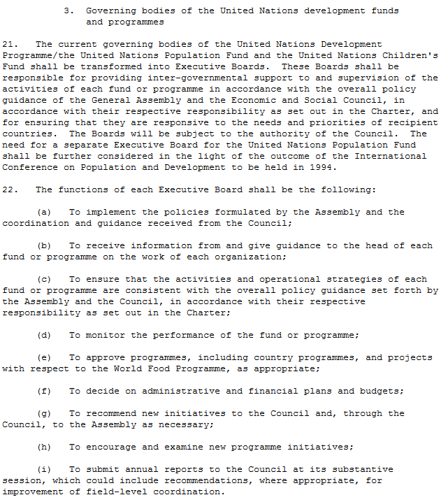
20 December 1993

GA resolution 65/176 (A/RES/65/176) – UNOPS mandate and governance
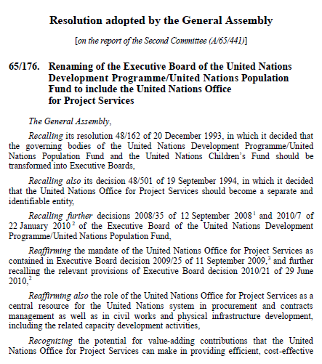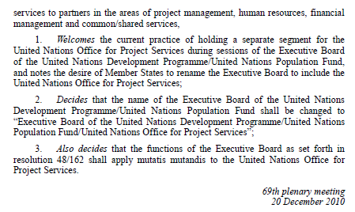

GA decision 48/501 – establishment of UNOPS
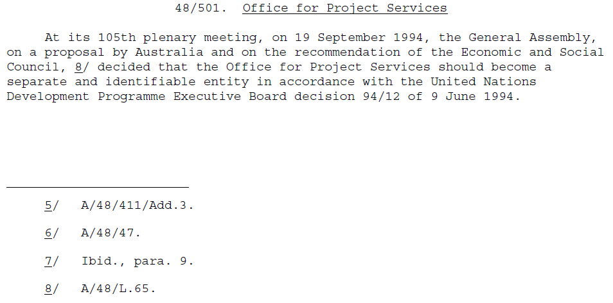

Annex 4. Executive Board decisions 2008/35, 2008/37, 2009/4, 2012/5 and 2013/23

EB decision 2008/35 – Policy advisory committee and delegation of HR authority
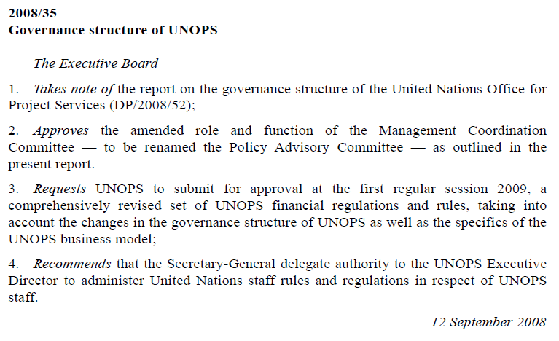

EB decision 2008/37 – Accountability framework and oversight policies
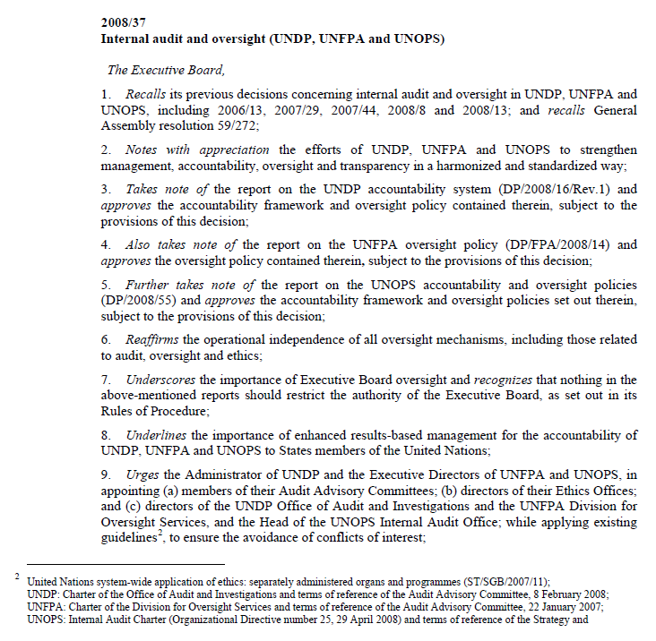
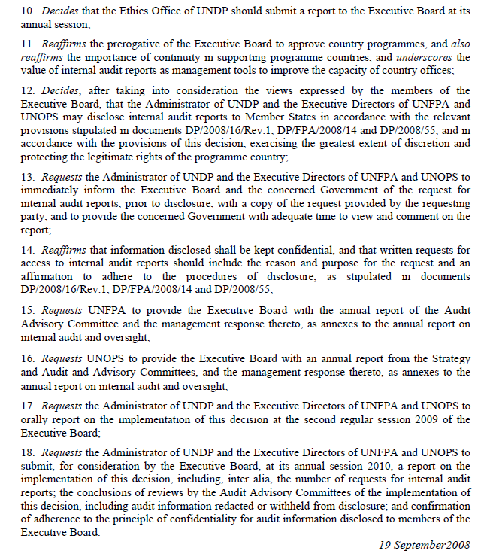

EB decision 2009/4 – Financial regulations and rules
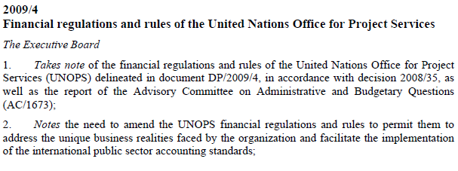
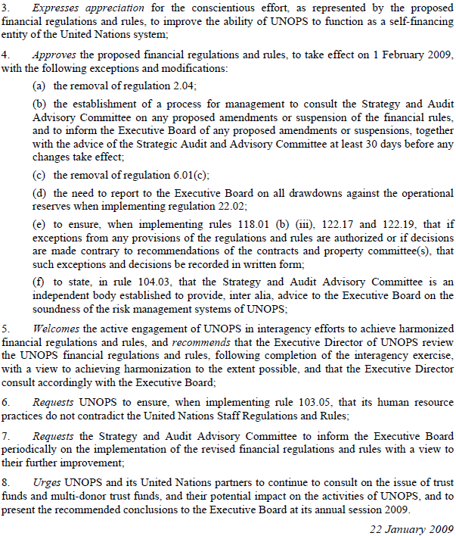

EB decision 2012/5 – Financial regulations and rules
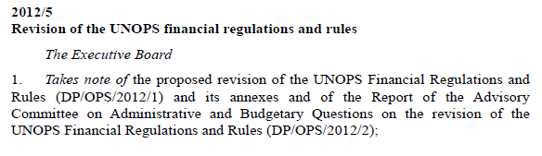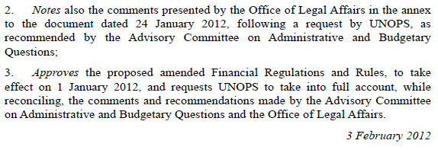

EB decision 2013/23 – Strategic plan
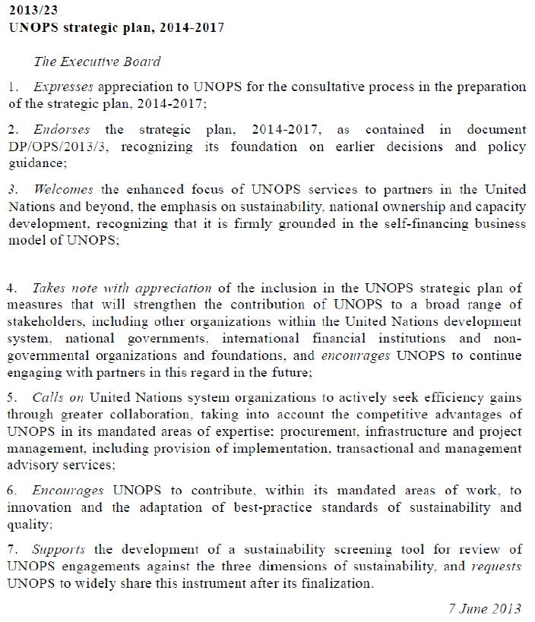

Annex 5. Changes of UNOPS Organizational Directives No. 2, 3 and 25

OD 2 Accountability Framework and Oversight Policies
…
I. Accountability Framework and Oversight Policies in UNOPS

1. Below an outline of main UNOPS Policy documents framing the accountability framework and oversights policies is included:
i. UNOPS Financial Regulations and Rules (OD 3);
ii. UNOPS Global Structure (OD 15 (rev. 1 – Add. 1));
iii. Internal Control and Risk Management Framework (OD 27);
iv. UNOPS Strategic Risk Management Planning Framework (OD 33);
v. UNOPS Policy to Address Fraud (OD 10 (rev.2));
vi. Framework for Delegations of Authority (OD 34);
vii. UNOPS Internal Control for UNOPS Offices (OD 9);
viii. Strategy and Audit Advisory Committee and Strategic Advisory Group of Experts Terms of Reference (OD 5 (rev. 3 4));
ix. Charter of the Internal Audit and Investigations Group (OD 25 (rev. 1));
x. UNOPS Legal Framework for Addressing Non-Compliance with United
Nations Standards of Conduct (OD 36);
xi. Protection against retaliation for reporting misconduct or cooperating with duly authorized fact-finding activities (OD 35);
xii. UNOPS - Policy on Prohibition of Discrimination, Harassment, including
Sexual Harassment, and Abuse of Authority (OD 08 (rev. 1));
xiii. UNOPS Policy on Financial Declaration Statements (OD 23 (rev. 2));
xiv. UNOPS Client Pricing Policy (OD 22 (rev. 1));
xv. UNOPS Procurement Framework (OD 16 (rev. 1));
xvi. UNOPS Quality Management Policy (OD 31);UNOPS Recruitment Policy
(OD 18 (rev. 2));
xvii. UNOPS Staff Rotation Policy (OD 24);
xviii. UNOPS Succession Management Policy (OD 26);
xix. UNOPS Recognition, Rewards and Sanctions Policy (OD 37);
xx. UNOPS Personnel Performance Management Policy (OD 38 (rev. 1));
xxi. UNOPS Individual Contractor Agreement (ICA) Policy (OD 21 (rev. 2));
xxii. UNOPS Information Disclosure Policy (OD 30);
xxiii. UNOPS Travel Policy (OD 11 (rev. 2));
xxiv. UNOPS Records Retention Policy (OD 12);
xxv. UNOPS Electronic Communications Policy (OD 13).
….
IV. Roles and responsibilities
6. The oversight roles and responsibilities include those related to assurance and accountability. Effective oversight results from coordinating the respective roles and
responsibilities of: management; the Internal Audit and Investigations Group; the Strategy and Audit Advisory Committee; the Strategic Advisory Group of Experts; the Ethics Office; the Executive Board; the United Nations Board of Auditors; the United Nations Joint Inspection Unit; the Advisory Committee on Administrative and Budgetary Questions; and the Fifth Committee. Furthermore, the following UNOPS internal committees provide assurance and accountability in specific areas: the Appointment and Selections Panel; the Appointment and Selections Board; the Headquarters Contracts and Property Committee; and the Local Contracts and Property Committee.

7. A process of assurance examines and evaluates the adequacy and effectiveness of the bodies responsible for oversight. That process includes the following activities:
a. Internal audits to examine and measure the adequacy and effectiveness of UNOPS processes, structure and controls, providing reasonable assurance that these are functioning as intended; as well as investigations to look into alleged misconduct and violations of UNOPS regulations, rules, organizational directives and administrative instructions;
b. The Strategy and Audit Advisory Committee and the Strategic Advisory Group of Experts assists the Executive Director in fulfilling his/her oversight responsibilities in accordance with relevant leading practices and industry standards. The Executive Director will appoint future members to the Committee and the Group, bearing in mind the need to avoid potential conflict of interest, and after consultation with the Executive Board;
c. The United Nations Board of Auditors undertakes independent audits of UNOPS and assists the Executive Director and Director of Finance in working towards certification of UNOPS financial statements.

Management
8. Management is responsible for putting in place the system of governance and risk management; the internal control framework; the measurement of performance; and the evaluation of results and impact. It is also responsible for communicating results in a timely, accurate, open and transparent manner.

9. In addition, management is responsible for implementing the UNOPS internal control framework and other applicable policies related to oversight activities. Management is accountable for exercising its oversight role in the particular areas of its responsibility. As part of its evaluation responsibilities, UNOPS management plans, organizes and directs the performance of actions to provide reliable information on the achievement of goals, outcomes, outputs and results, and their impact on intended beneficiaries. Management endeavours to employ, whenever feasible, the leading practices, norms and standards prevailing in the outside world, such as the International Public Sector Accounting Standards as of January 2012. All relevant work is harmonized with UNDP, UNFPA and other United Nations partners.

Internal oversight
Internal Audit and Investigations Group
10. The oversight roles and responsibilities of the Internal Audit and Investigations Group, including the use of relevant professional standards, are set forth in the Internal Audit and Investigations Group charter approved by the UNOPS Executive Director. In addition to internal auditing, the oversight services provided by the Internal Audit and Investigations Group include fraud prevention and detection, investigation, thematic reviews, and advisory services. The Internal Audit and Investigations Group frequently reports to the Executive Director on its activities and reports annually to the Executive Board. The Head of the Internal Audit and Investigations Group shall be selected bearing in mind the need to avoid potential conflict of interest.

11. Internal auditing includes examination and evaluation of the adequacy and effectiveness of UNOPS governance processes, risk management processes, internal controls structure and performance in carrying out assigned responsibilities. These activities are performed so as to provide reasonable assurance to the Executive Director, the Strategy and Audit Advisory Committee and the Executive Board, that the processes are functioning as intended to enable UNOPS to achieve its stated goals and objectives.

12. The scope of fraud prevention and detection includes examination and evaluation of the effectiveness of UNOPS internal controls to prevent and detect fraud. The Internal Audit and Investigations Group conducts investigations into reports of violations of applicable regulations, rules and administrative or policy directives (unless otherwise directed by the Executive Director and the Strategy and Audit Advisory Committee in cases of conflict of interest).

Strategy and Audit Advisory Committee and the Strategic Advisory Group of Experts

13. The Strategy and Audit Advisory Committee was established to provide assist the Executive Director with external, senior level advice regarding the strategic, business and audit objectives of the organizations in fulfilling his/her responsibilities regarding oversight, financial management and reporting, internal audit and investigation, external audit, risk management, and systems of internal control and accountability. The Committee has an advisory role and is not a governance body. All Committee members are external to the United Nations system and serve on a pro-bono basis. The Executive Director will provide the Executive Board with an annual report from the Strategy and Audit Advisory Committee, and the management response thereto, as annexes to the annual report on internal audit and oversight. The Strategic Advisory Group of Experts (SAGE) was established to provide external, independent, expert, non-binding advice and guidance on the application of relevant best practices and industry standards to assist the Executive Director in fulfilling her/his responsibilities for developing and implementing the organization’s strategy.
….
17. To facilitate Executive Board oversight, UNOPS submits the following documents, for review and approval by the Board, at the intervals and at the sessions prescribed by the Board:
a. Audited financial statements;
b. Planning and budget framework;
c. Annual report, including financial results for prior year, and, a report on contributions to results;
d. Annual report of the Internal Audit and Investigations Group, of the Strategy and Audit Advisory Committee, and management response;
e. Annual ethics report from the Ethics Office;
f. Implementation of the prior audits‟ recommendations of the United Nations Board of Auditors; and
g. Annual statistical report on procurement in the United Nations system.
…
Transparency
27. The transparency and independence of the UNOPS Internal Audit and Investigations
Group and the Strategy and Audit Advisory Committee are enhanced by their ability to communicate directly with the Executive Director of UNOPS. The Executive Director may request that the Head of the UNOPS Internal Audit and Investigations Group has occasional access to the Executive Board, and any other entity having any oversight or governing function with respect to UNOPS. The Head of the Internal Audit and Investigations Group may request private and confidential access to the Strategy and Audit Advisory Committee, and liaises and fully cooperates with the United Nations Board of Auditors and the Joint Inspection Unit.

28. The Head of the Internal Audit and Investigations Group presents an annual report on internal audit and investigation activities, transmitted through the Executive Director, to the Executive Board. Management is responsible for ensuring that responses are prepared for each specific internal and external audit recommendation. Management follows the status of implementation on a regular basis. In addition, management reviews and addresses systemic issues that arise from audit findings using a risk-based approach.

29. Management provides a management response to the annual activity reports of the
Internal Audit and Investigation Group and of the Strategy and Audit Advisory Committee presented to the Executive Board. The management response includes an update on the implementation of internal audit recommendations. The Executive Director may report on the progress made toward the objectives in the balanced scorecard, in conjunction with the UNOPS strategic plan, and may address any important issues in this context.

30. Notwithstanding the above dispositions, the Head of the Internal Audit and Investigations Group may, in exceptional circumstances, bring reports to the attention of the Executive Board, taking into account the standards and code of ethics contained in the professional practices framework of the Institute of Internal Auditors.
….

OD 3 Financial Regulations and Rules

Article 3. Accountability and responsibility

Regulation 3.01
The Executive Director of UNOPS is fully responsible and directly accountable to the Executive Board for all aspects of UNOPS activities.

Regulation 3.02
(a) The Executive Director shall issue detailed Financial Rules and procedures to ensure effective financial administration and economical use of resources.
(b) The Executive Director may, when he or she deems it necessary, amend the
Financial Rules;
(c) The Executive Director may, when he or she deems it necessary, suspend the application of any of these Financial Rules;
(d) The Executive Director shall establish a process to consult the strategy and audit advisory committee on any proposed amendments or suspension of these financial rules, and shall inform the Executive Board of any proposed amendments or suspensions, together with the advice of the strategy and audit advisory committee, at least 30 days before any changes take effect.
…
Article 4. Risk management

Regulation 4.01
The Executive Director shall maintain a risk-management system to manage and control financial and other types of risks, including the identification, evaluation, and measurement of possible impact on UNOPS, and the selection and maintenance of various solutions to mitigate risk.

Rule 104.01
The heads of UNOPS business units shall on an annual basis define their major risks and business opportunities as integral elements of setting management work plans.

Rule 104.02
Risk appetite and risk tolerance shall be defined periodically based on the changing business environment. Heads of UNOPS business units shall re-evaluate at least annually such risks and strategies to mitigate them.

Rule 104.03
An independent strategy and audit advisory committee and a strategic advisory group of experts shall be established with a view, inter alia, to advise the Executive Director on any significant risk management issues. The audit advisory committee shall provide advice to the Executive Board on the soundness of the risk management systems of UNOPS.

Rule 104.04
A policy advisory committee shall be established to provide policy guidance to the Executive Director on UNOPS activities.
….

OD 25 Charter of the Internal Audit and Investigations Group

17. To ensure appropriate organizational independence and objectivity of IAIG, and to enable
IAIG to fulfil its responsibilities free from interference in determining its scope of work, performing its work and communicating results:
a) The Director of IAIG shall report independently and exclusively to the
Executive Director for both administrative and operational matters, with exceptions noted in the “UNOPS legal framework for addressing noncompliance with UN standards of conduct” (Organizational Directive No. 36);
b) The Director of IAIG shall have free and unrestricted access to the Strategy and Audit Advisory Committee (SAAC) and the Executive Board. He/she may request private and confidential access to the SAAC through a request made to its Chairperson.
….
INTERNAL AUDIT PLAN
30. The Director of IAIG will submit to the Executive Director at least annually an internal audit plan for review and approval.

31. The internal audit plan will be developed based on a prioritization of the audit universe using a risk-based methodology, with input of senior management, the SAAC and the Board. The approval requirement does not prevent the Director of IAIG from auditing any other area within the purview of its mandate, as deemed necessary.

32. The Director of IAIG is responsible for implementing the approved work plan and keeping the SAAC informed about IAIG’s activities and performance, as required. The information provided will include details of progress made in the implementation of the annual plan, scope limitations if any, and action taken by management on the implementation of audit recommendations. The Director of IAIG will communicate the impact of resource limitations and significant interim changes to the SAAC, senior management and the Executive Board.
….
RESOURCES
38. IAIG shall be provided with the necessary resources, including budgetary resources and appropriately trained and experienced professionals, in order to fulfil its responsibilities under this Charter. The budget of IAIG shall be presented to the Executive Director for approval, on the basis of the request submitted by the Director of IAIG in accordance with the annual work plan, after review and advice from the SAAC.
….
PERIODIC ASSESSMENT
41. The Director of IAIG will communicate to the Executive Director and the SAAC on the internal audit activity’s quality assurance and improvement activities, including results of ongoing internal assessments, and the external assessments that are conducted at least once every five years.

AMENDMENT OF THE CHARTER
42. The Director of IAIG is responsible for applying this Charter and for keeping it current.
Amendment of this Charter is subject to the approval of the Executive Director after consultation with the SAAC.
….

Key decisions include 2008/35, 2008/37, 2009/4, 2012/5 and 2013/23.
The UNOPS Strategic Plan 2014-2017, DP/OPS/2013/3, para 21

