Appendix I.

UNDP overview
- Statement of financial performance for the year ended 31 December 2021
(In thousands of United States dollars)
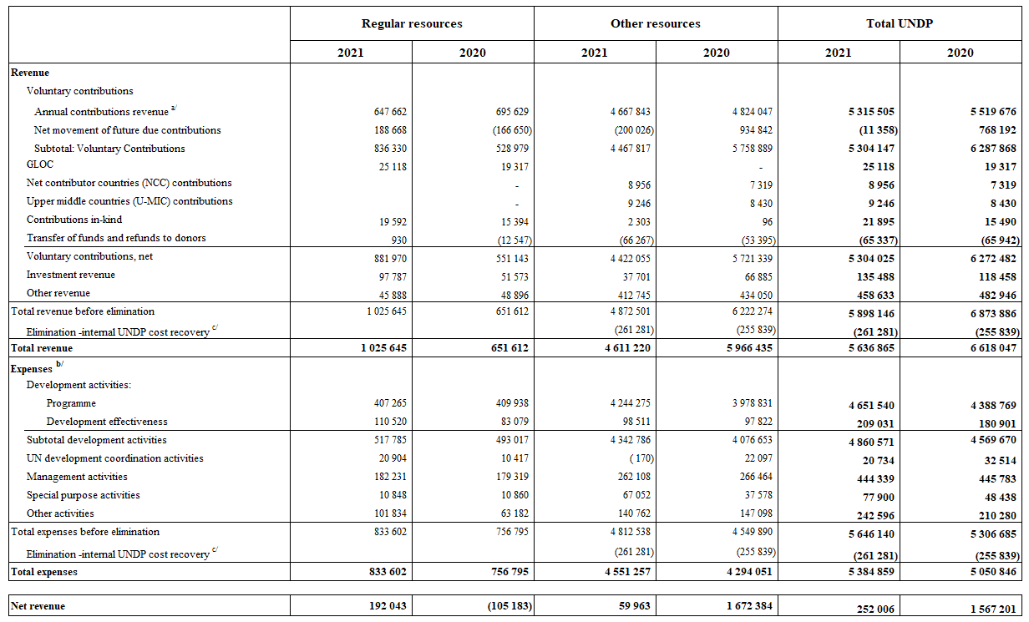
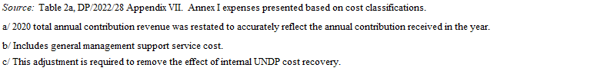
- Statement of financial position as at 31 December 2021
(In thousands of United States dollars)
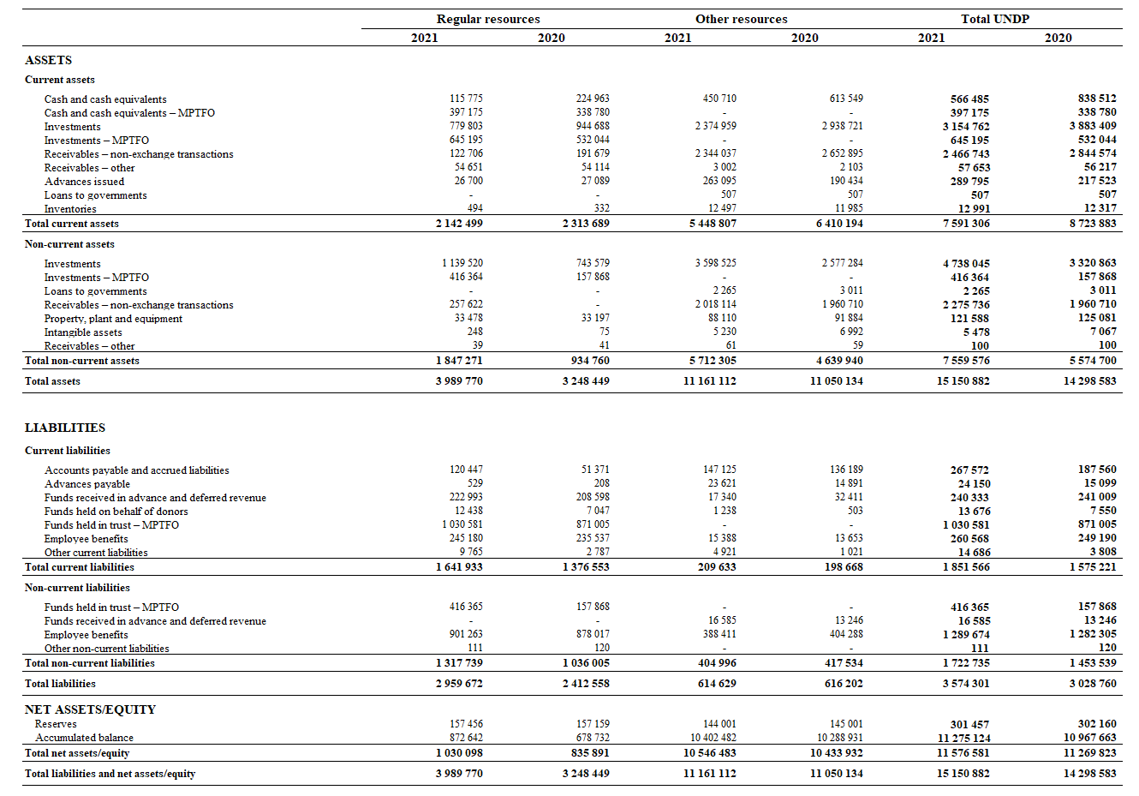

Appendix II.

Regular resources
- Comparison of budget to actual, 2021
(In thousands of United States dollars)

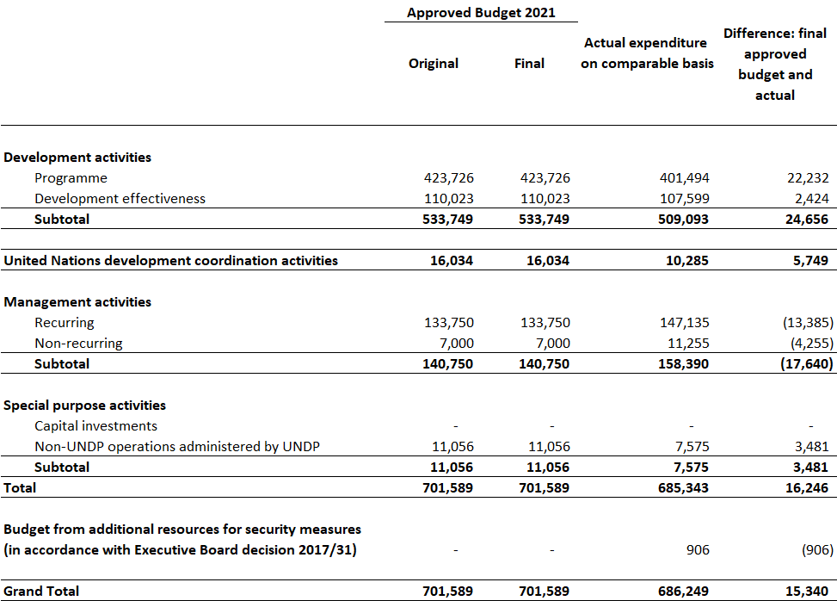

- Comparison of budget to actual, 2018-2021
(In thousands of United States dollars)

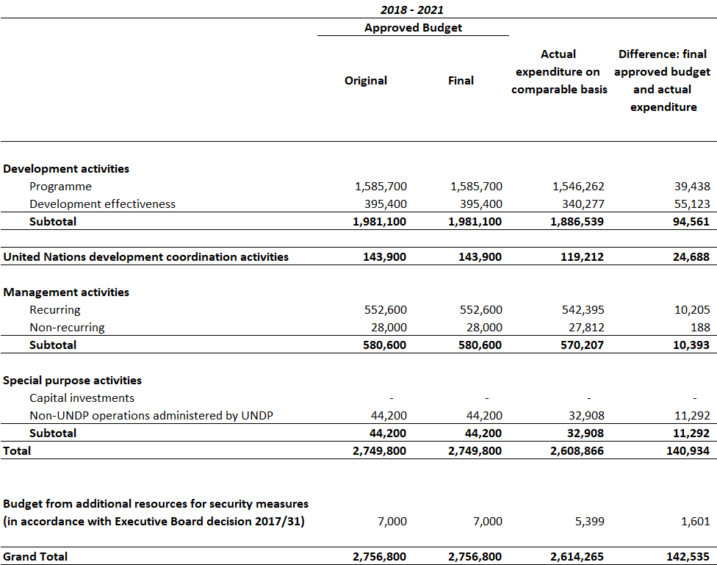

Appendix III.

Integrated Resources
- Integrated resources plan, 2018-2021 estimates compared to 2018-2021 actuals
(In millions of United States dollars)
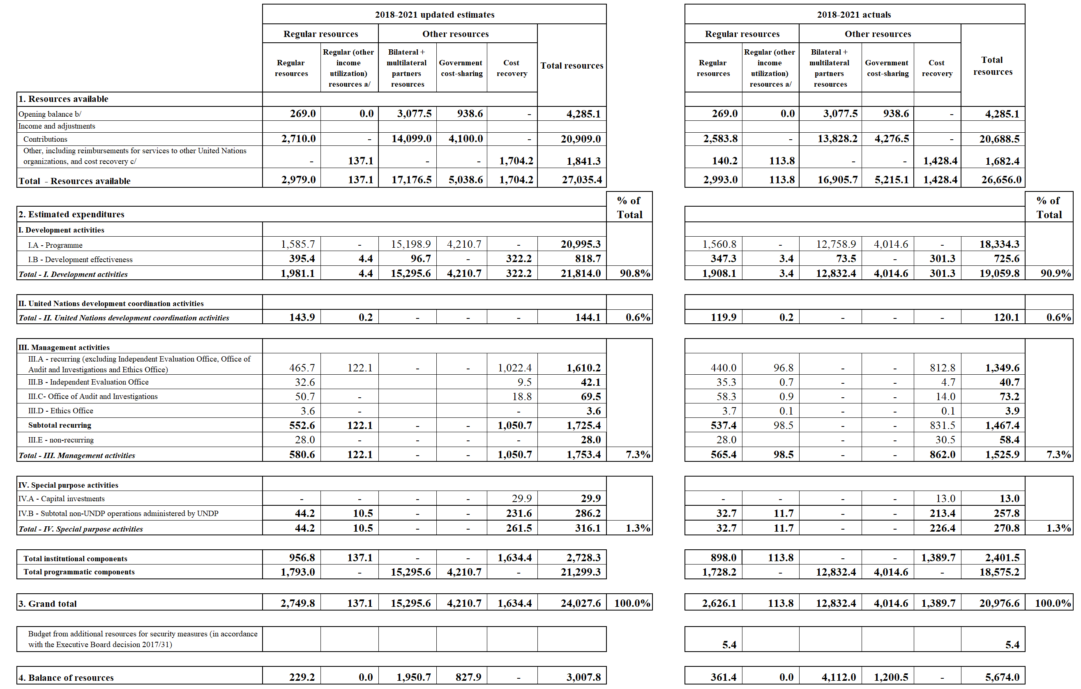

- Summary of institutional component of the integrated budget by category of expenditures:
2018-2021 annualized estimates vs 2018-2021 actual expenditures
(In millions of United States dollars)

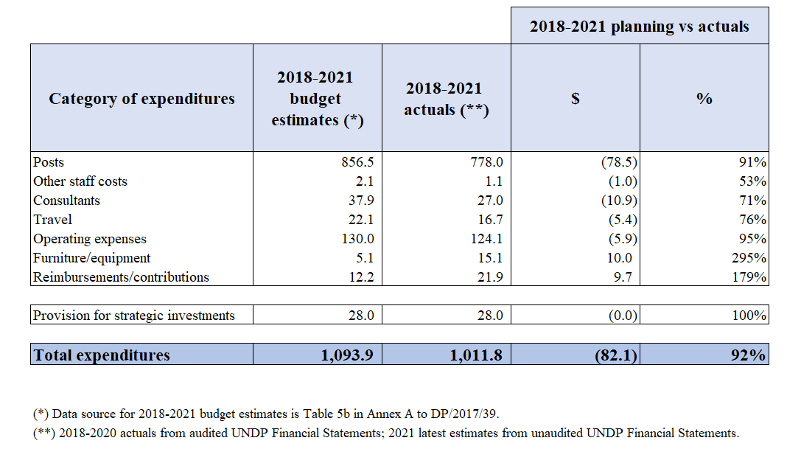

- Resources allocated to posts by location, 2021
(In United States dollars)
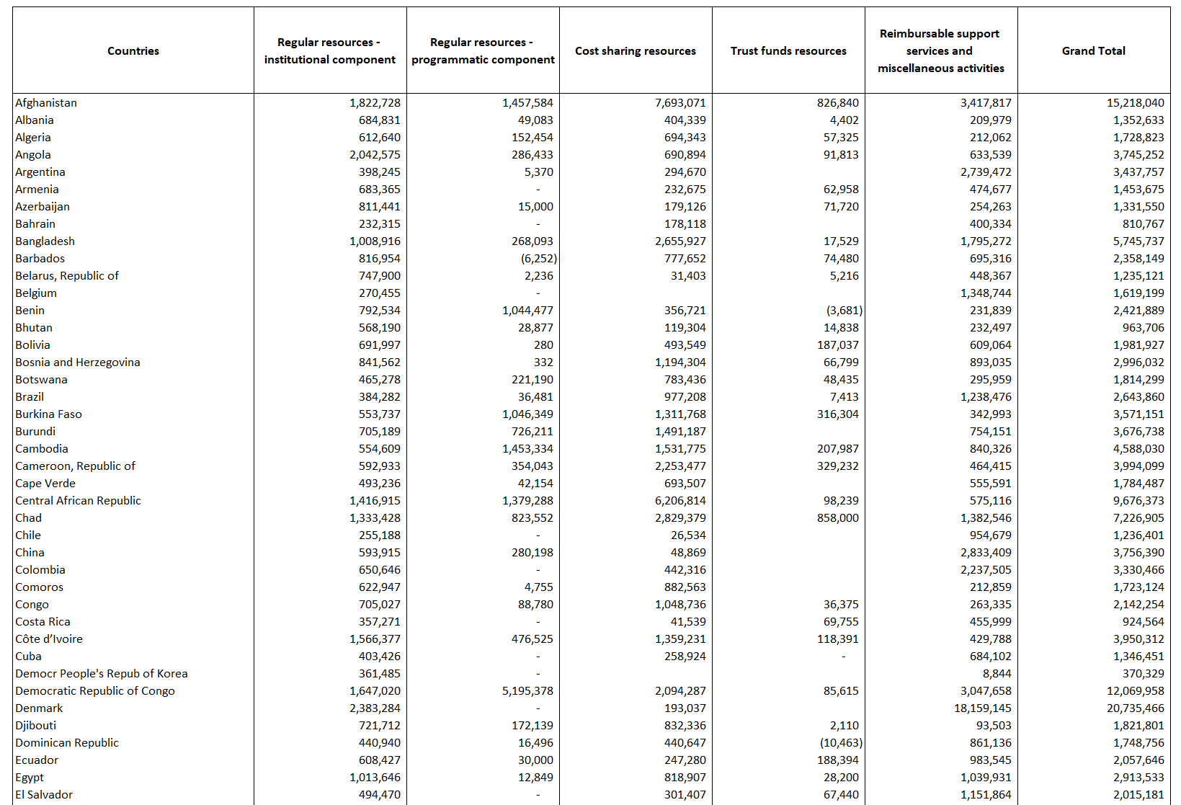

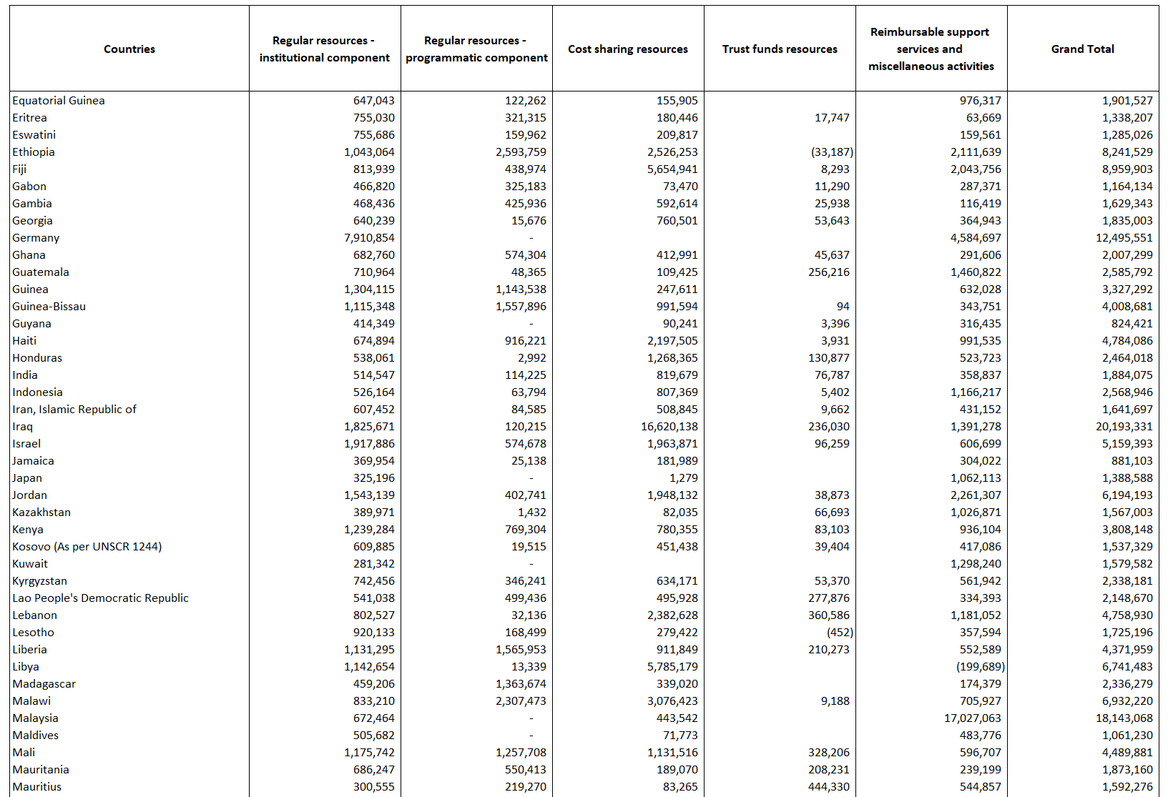
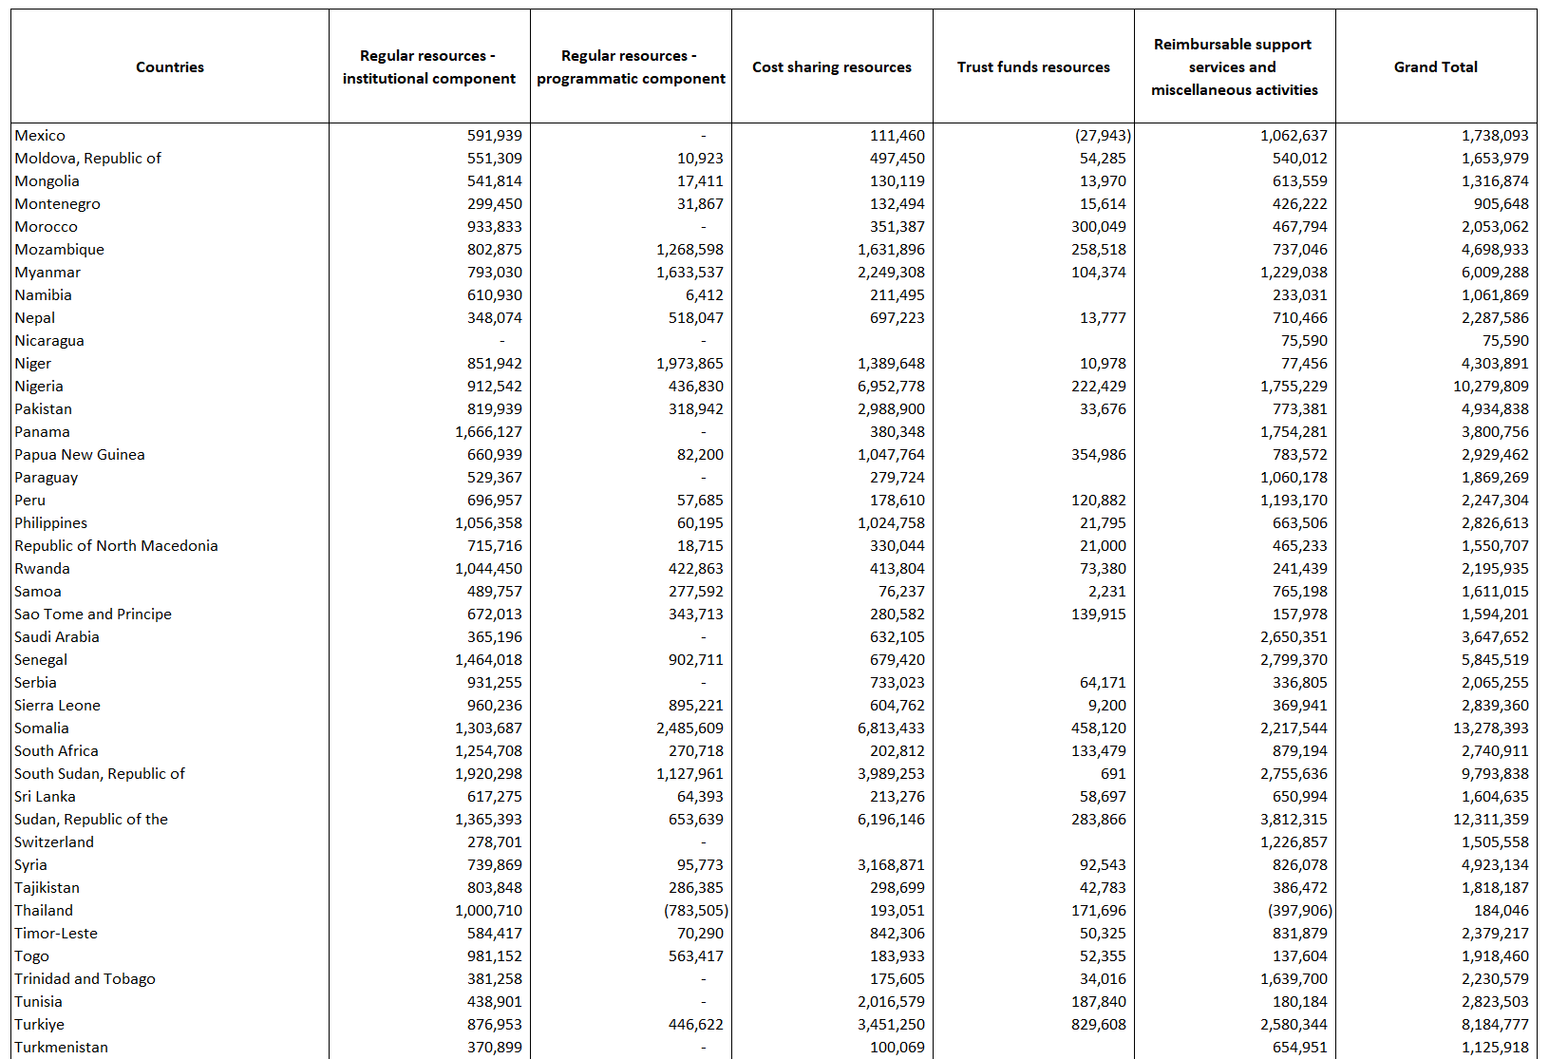
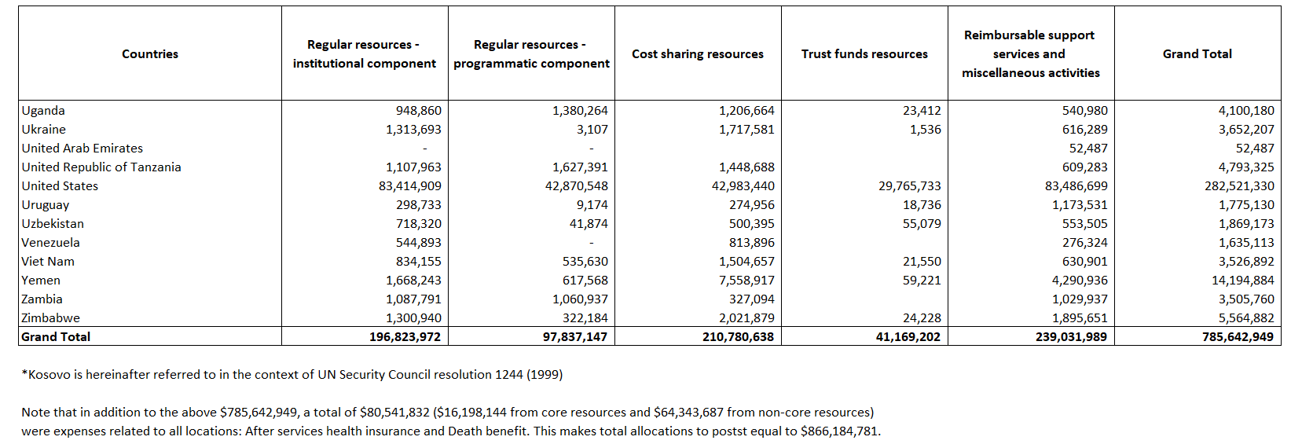

Appendix IV.

Regular resources – annual contributions from top 10 donors, 2020-2021
(In millions of United States dollars)

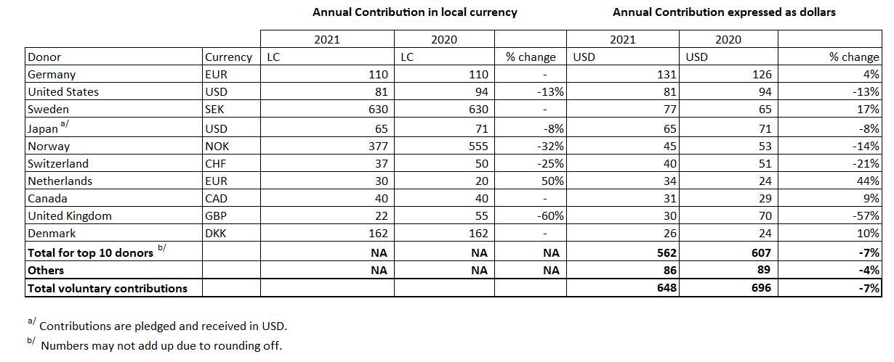

Appendix V.

Update on general management services cost-recovery waivers
- The Executive Board in its decision 2013/9 endorsed “a general, harmonized cost recovery rate of 8 per cent for non-core contributions,” and further endorsed the following differentiated cost recovery rate structure: “(a) a harmonized 1 per cent reduction for the thematic contributions at the global, regional and country level in UNDP, UNFPA and UNICEF (8 per cent - 1 per cent = 7 per cent), with the United Nations Entity for Gender Equality and the Empowerment of Women (UN-Women) maintaining the 8 per cent as a temporary arrangement; and (b) maintaining the existing preferential rates for government cost-sharing, South- South contributions and private-sector contributions.”
- In the same decision, the Executive Board also decided that on an exceptional basis, and when the urgency of the circumstances requires, “the Administrator of UNDP and the Executive Director of UNFPA may consider granting a waiver of the cost-recovery rates on a case-by-case basis, taking into account specific priorities, modalities that incur lower management costs, and harmonization goals, and that the Executive Board will be informed of these waivers in the annual financial reports;”
- Consistent with decision 2013/9, UNDP has annually reported to the Executive board on the cost recovery waivers through the successive annual reviews of the financial situation as well as the cumulative review of the UNDP integrated budgets.
- In its decision 2018/21 from the second regular session of 2018, the Executive Board requested “UNICEF, together with UNDP, UNFPA and UN-Women, to reduce the granting of waivers lowering the agreed cost-recovery rates and to provide an update on the steps taken in this regard, including on the application of waivers across their organizations, to the Executive Board at its annual session in 2019”.
- In addition to the standard reporting, UNDP together with UNICEF, UNFPA and UN-Women provided detailed information on the effective cost-recovery rates and financial impact of the differentiated rates covering the period 2014 to 2019 in the joint comprehensive proposal on the cost-recovery policy (DP/FPA-ICEF-UNW/2020/1). The joint comprehensive cost-recovery policy was approved in September 2020 through decision 2020/12 and includes cost-classification categories, methodology and rates effective 1 January 2022.
- In its decision 2020/12, the Executive Board requested “UNDP and UNFPA, in collaboration with UNICEF and UN-Women, to provide harmonized annual reporting on the progress of implementation of the cost recovery policy as an annex to their respective existing reporting, including the presentation of the financial impact of the harmonized differentiated rates and waivers granted, and to continue including, in line with the policy, inter alia an itemization of each waiver/discount listing the donor name, total contribution, programme name, cost-recovery rate and United States dollar value of the waiver/discount, as well as the resulting effective cost-recovery rates and cost-recovery amounts realized”.
- Cost recovery waivers
- UNDP makes every effort to apply the Executive Board decisions regulating the General Management Services (GMS) cost recovery rate applied to non-core programme expenses, to recover the costs incurred by UNDP in managing programmes funded from non-core resources. Whilst infrequent, GMS waivers continue to be demanded by funding partners. UNDP considers carefully all demands by funding partners for waivers and has agreed to such demands only in exceptional cases where the project funding would otherwise be at risk, negatively impacting UNDP’s ability to help programme countries to achieve development results.
- Accordingly, information on GMS waivers is presented here in two segments:
    - GMS waiver issued in 2021; and
    - GMS waivers issued prior to 2021 for activities on-going in 2021
- Separate from the above referred GMS waivers, this note also sets out framework agreements with multilateral funding partners where GMS rates were agreed below the current 8% GMS rate.

i. GMS waivers issued in 2021
- During 2021, there was no new waiver on the general management support fee granted for new projects. Note that a waiver has been negotiated in 2021 for an agreement that was signed in 2022. UNDP will report on this waiver in next year’s reporting – (i.e. in the calendar year 2023 UNDP reports on any new waivers granted that would come into effect in the year 2022).

ii. GMS waivers issued prior to 2021 for activities on-going in 2021
- Four projects with reduced GMS rates were ongoing in 2021 where the donors have insisted on retaining the previously agreed GMS rates due to project size and scale:
- A reduced (4 per cent) fee was applied for a contribution from Global Fund for "Commitment Towards Fast Tracking 90-90-90 Targets and Ending AIDS by 2030" in Zimbabwe, as previously reported in the annexes to the Annual review of the situation, 2017 (DP/2018/19); and
- A reduced (4 per cent) fee was applied for contributions to "Law & Order Trust Fund for Afghanistan – MOIA (Ministry of Interior Affairs) Afghanistan Development Outcome – Capacities for reform and accountable and efficient MOIA management and oversight are improved with integrated civilian and uniformed leadership and management and Support to payroll management”, as previously reported in the annexes to the Annual review of the financial situation, 2015 (DP/2015/26);
- A reduced (3 per cent) fee for contributions to the "Yemen Crisis Response III”, as reported in the annex to the Midterm review of the UNDP integrated resources plan and integrated budget, 2018-2021 (DP/2020/09);
- A reduced (5 per cent) fee for a contribution to the "UN Democratic Republic of the Congo Humanitarian Fund”, as reported in the annex to the Midterm review of the UNDP integrated resources plan and integrated budget, 2018-2021 (DP/2020/09).
The financial impact of the above four projects in 2018-2021 is summarized below:
Projects | GMS rate | Funding Partner | 2018 | 2019 | 2020 | 2021
"Commitment Towards Fast Tracking 90-90-90 Targets and Ending AIDS by 2030" in Zimbabwe | 4% | GFATM | $3,518,566 | $5,260,059 | $4,869,058 | $6,458,073
"Law & Order Trust Fund for Afghanistan" | 4% | Multiple donors, see details below: | Total | Total | Total | Total
 |  |  | $14,635,078 | $12,723,652 | $13,422,224 | $6,543,076
 |  | Thru Multi Donor Partnership Fund |  |  | $5,646,840 | $3,038,589
 |  | Government of Japan | $4,673,636 | $3,115,152 | $2,633,123 | $838,395
 |  | European Commission ^{a/} | $1,643,704 | $2,470,943 | $1,345,359 | ($4,794)
 |  | Government of Germany | $2,969,172 | $4,091,599 | $2,057,266 | $1,441,185
 |  | Government of Italy | $2,373,257 | $2,494,138 | $1,319,722 | $1,306,344
 |  | Government of the United Kingdom | $1,775,929
 |  | Government of Australia | $546,695
 |  | Government of Norway | $222,696 | $421,021 | $301,782 | $65,774
 |  | Government of Republic of Korea | $151,977 |  | $5,498 | $1,667
 |  | Government of New Zealand | $87,692
 |  | Government of United States of America ^{b/} | $41,248 | $54,274 | $112,468 | ($144,084)
 |  | Government of Croatia | $38,462 | $19,231
 |  | Government of Switzerland | $34,487
 |  | Government of Netherlands | $29,372 | $35,482 | $166
 |  | Government of Estonia, Republic | $19,135 | $11,752
 |  | Government of Afghanistan | $14,282
 |  | Government of Poland | $11,108 | $10,060
 |  | Government of Romania | $2,226
Yemen Crisis Response III | 3% | World Bank |  |  | $2,990,345 | $2,221,520
UN DRC Humanitarian Fund in the Democratic Republic of the Congo | 5% | UNOCHA |  |  | $916,778 | $127,442
 |  | Total Impact: | $18,153,644 | $17,983,711 | $22,198,406 | $15,350,111
a/ Asset impairment of vehicle in 2021 causing a corresponding reversal of GMS expense
b/ Additional GMS charges in 2021 to adjust the under-charged GMS in prior years. Financial impact reported in prior years were decreased in 2021.
Cumulative financial impact is $63,906 during 2018-2021.

- A summary of the GMS waivers approved in 2017-2021 with the associated financial impact is set out in the below table. It indicates that over the 2017-2021 period, the number of waivers granted has notably declined from 6 to 0. The table also indicates that there has been a significant decrease in the annual financial impact of GMS waivers granted from $29.2 million in 2017 to $15.4 million in 2021.

 | 2017 | 2018 | 2019 | 2020 | 2021
Number of GMS waivers granted: | 6 | 5 | 3 | 1 | 0
Financial impact of GMS waivers:
Impact of GMS waivers which were granted in the year: | $12,075,664 | $1,226,516 | $5,496,935 | $33,582 | $0
Impact of GMS waivers which were granted in previous years: | $17,127,497 | $18,153,643 | $17,983,711 | $22,198,406 | $15,350,111
Total financial impact | $29,203,161 | $19,380,159 | $23,480,646 | $22,231,988 | $15,350,111

Framework agreement with multilateral funding partners
- In addition to the GMS waivers as explained above, there are a number of framework agreements with multilateral funding where GMS rates have been agreed below the 8% rate. In 2021, contributions from the European Commission, UNOCHA/CERF, the UN Trust Fund for Human Security (UNTFHS), Global Fund to Fight AIDS, Tuberculosis and Malaria (GF), Global Environmental Fund’s small grant programme, Montreal Protocol, and other UN entities were received at GMS rate below the 8% rate. As per the policy on fee structures for accredited entities of the Green Climate Fund (GCF), all projects/programmes except micro-size projects will be subject to the cost recovery rate below 8%. The financial impact of the framework agreements with reduced cost recovery rates is summarized below:
Funding Partners | GMS Rate applied | 2018 | 2019 | 2020 | 2021
European Commission | 7% | $2,174,735 | $1,914,951 | $2,463,953 | $2,446,282
Global Fund to Fight AIDS, Tuberculosis and Malaria (GF) | 7% | $1,977,110 | $1,657,720 | $1,580,788 | $1,892,812
Montreal Protocol | 7% | $431,015 | $258,078 | $293,146 | $238,711
UNOCHA/CERF | 7% | $66,847 | $37,871 | $65,997 | $70,274
UN Trust Fund for Human Security (UNTFHS) | 7% | $23,099 | $25,733 | $27,979 | $22,044
Green Climate fund (Small, Medium or Large size projects) | 4%-7% |  | $1,712 | $94,676 | $214,612
Global Environmental Programme - Small Grant Programme | 4% | $1,816,037 | $1,859,195 | $1,433,679 | $1,725,728
Funds received from other UN Agencies with lower than 8% GMS:
UN | 7% or below | $6,901 | $908,220 | $924,015 | $202,260
UNICEF | 7% or below | $7,949 | $838
UNFPA | 7% or below | $2,228
UNHABITAT | 7% or below |  |  | $15,253 | $25,295
UNOPS | 7% or below |  | $17,944
UNODC | 7% or below |  |  | $4,266 | $10,915
UNWOMEN | 7% or below |  | $5,106 | $1,523 | $8,055
WHO | 7% or below |  |  | $16,523 | $13
WFP | 7% or below |  | $1,135 | $7,741 | $6,585
Total financial impact |  | $6,505,921 | $6,688,503 | $6,929,540 | $6,863,583

- Cost recovery effective rate
- In 2021, UNDP remained compliant with the relevant Executive Board decisions on cost recovery. The table below summarizes actual financial performance for 2019–2021 and covers the current Strategic Plan. The effective rate represents the actual cost-recovery rate realized after taking into account the effect of differentiated rates and waivers granted each year.
Effective average indirect cost-recovery rate, 2018–2021
Effective average indirect cost-recovery rates | 2018 | 2019 | 2020 | 2021 | 2018-2021  (weighted average)
UNDP | 6.16% | 6.38% | 6.17% | 6.01% | 6.18%
- Financial impact of the differentiated cost-recovery rates
- The following table indicates the financial impact of differentiated rates compared to the 8 per cent rate, broken down by financial impact in the following categories, where applicable: (a) thematic funding; (b) framework/umbrella agreements; and (c) programme Government preferential rates. In addition, the financial impact of the waivers is presented.
Financial impact of the differentiated cost-recovery rates, 2018–2021
(In millions of United States dollars)

Financial impact by agency and category | 2018 | 2019 | 2020 | 2021 | 2018–2021 (average)
Thematic funding | 0.4 | 0.3 | 0.8 | 1.3 | 0.7
Umbrella agreements | 6.5 | 6.7 | 6.9 | 6.9 | 6.7
Preferential rates (programme Government and South-South contributions) | 40.2 | 32.7 | 38.7 | 51.1 | 40.7
Waivers | 19.4 | 23.5 | 22.2 | 15.4 | 20.1
Total impact | 66.5 | 63.2 | 68.6 | 74.7 | 68.2

Appendix VI.

Explanations of terms used in Annex I to DP/2022/28
- Accumulated surplus: Formerly referred to as ‘unexpended resources or unspent balance’. It represents accumulated funds at the end of the reporting period, noting that not all of the amount is available for spending.
- Bilateral governments: Governments of the Member States that contribute to UNDP regular resources and other resources, comprising the Development Assistance Committee of the Organisation for Economic Co-operation and Development (OECD/DAC) members, and non-members of OECD/DAC including programme countries.
- Certified Emission Reductions (CER)s: Under the Kyoto Protocol industrialized countries are offered the opportunity to offset greenhouse gas (GHG) emissions by procuring credits from Clean Development Mechanism (CDM) projects located in developing countries. A CER basically allows an entity to pay for the reduction of GHG emissions elsewhere and is often more cost-effective than reducing the GHG emissions from their own operations or is used where GHG emissions cannot be avoided. UNDP is committed to buying only very credible, UNFCCC-issued credits (“Gold Standard”) which also deliver tangible sustainable development benefits. For details please refer to the EG-approved HQ Emission Reduction Strategy (https://undp.unteamworks.org/node/369936).
- Cost classification: Set of criteria and the process of determining programme implementation vs. administration costs.
- Development activities: Activities associated with ‘programmes’ and ‘development effectiveness,’ activities essential for achieving development results.
- Programmes: Activities traced to specific programme components or projects, which contribute to delivering development results contained in country/regional/global programme documents or other programming arrangements.
- Development effectiveness activities: Activities of a policy-advisory, technical and implementation nature needed to achieve the objectives of programmes and projects in UNDP’s areas of focus. While essential to the delivery of development results, they are not included in specific programme components or projects in country, regional, or global programme documents.
- Elimination: Represents an IPSAS-compliant accounting adjustment to remove the effect of internal UNDP cost-recovery revenue and general management support expense from total UNDP amounts.
- Expenditure: Utilization of available financial resources, across harmonized cost classification categories. Excludes accruals for goods received and services rendered.
- Expenses: Expenses include disbursements and accruals for goods received and services rendered, and the use or impairment of assets, dependent on the implementation arrangement.
- Government contributions towards local office costs (GLOC): Contributions in the form of cash, or by provision in-kind of specific goods, services, and facilities that a host Government makes towards meeting the expenses of maintaining a UNDP country office.
- Institutional budget: The institutional component of the integrated budget covering activities over a period based on a set of defined results from the strategic plan.
- IPSAS: International Public Sector Accounting Standards: Independently developed accounting standards which have been considered the best accounting practice by public sector organisations.
- Joint programmes: Collective efforts through which United Nations organisations and national partners work together to prepare, implement, monitor and evaluate the activities aimed at effectively and efficiently achieving the Millennium Development Goals and other international commitments arising from United Nations conferences, summits, conventions and human rights instruments.
- Low-income countries (LICs), Middle-income countries (MICs): On the basis of their GNI per capita, countries are grouped into the following categories: low-income countries (LICs), middle income countries (MICs), transitional net-contributing countries and net-contributing countries (NCCs).
(a) LICs are defined as countries with 2012-2015 an average GNI per capita of less than $1,280.
(b) MICs are defined as countries with 2012-2015 an average GNI per capita of between $1,281 and $12,475. There are two groups of MICs:
  - MICs with levels of GNI per capita of between $1,281 and $6,660.
  - MICs with high levels of GNI per capita of between $6,660 and $12,475 per capita;
(c) Transitional NCCs are defined as countries with 2012-2015 average GNI per capita greater than $12,475 for the first time in 2018-2019 (as compared to the previous biennial budget period 2016-2017).
(d) NCCs are defined as countries with 2012-2015 average GNI per capita greater than $12,475 for the second consecutive Integrated Budget period (i.e., in 2018-2019 as well as 2016-17).
The Executive Board decided in decision 2012/28 that there would be a system of biennial updates. In this regard, a four-year approach for GNI per capita averaging are applied, with the average GNI per capita of the years 2012-2015 applied to the first two years of the Integrated Budget, 2018-2019, and the average GNI per capita of the years 2014-2017 will be applied to the last two years of the Integrated Budget, 2020-2021.
- Management activities: Activities whose primary function is the promotion of the identity, direction and well-being of an organisation. These include executive direction, representation, external relations and partnerships, corporate communications, legal, oversight, audit, corporate evaluation, information technology, finance, administration, security and human resources.
- Management service agreements (MSAs): Management service agreement (MSA) signed with a donor to prepare for receiving contributions to deliver management and other support services to recipient governments under a specific programme or project.
- Multilateral sources: Multilateral partners, such as regional development banks, international financial institutions, United Nations organisations, foundations and the private sector, which contribute to other resources.
- Other expenses: Expenses on activities other than those covered under the four broad cost classifications (i.e., development, management, United Nations development coordination and special purpose).
- Other resources: Resources of a voluntarily funded organisation that are received for a specific theme, programme purpose and for the provision of specific services to third parties. Resources that fall under this category are: cost-sharing, trust funds established by the Administrator, reimbursable support services and miscellaneous activities.
- Overall UNDP contributions: Contributions to UNDP regular resources and other resources.
- Operational reserve: A reserve established in 1979 by the Governing Council (now the Executive Board) of UNDP to ensure adequate liquidity of UNDP by funding such reserve through a defined formula that is calculated yearly.
- Regular resources: Resources of UNDP which are commingled and untied. They include voluntary contributions, contributions from governmental, intergovernmental or non-governmental sources, and related interest earnings and miscellaneous income.
- Reimbursable support services and miscellaneous activities: Resources of UNDP other resources (other than cost-sharing and trust funds). Such funds are received for the provision of management and other support services to third parties. It comprises the following activities: management services agreements; the Junior Professional Officer programme, reimbursable support services; the United Nations Volunteers programme, programme support to Resident Coordinators, and special purpose activities.
- Revenue: Consists of: (a) voluntary contributions; (b) investment revenue; and (c) other revenue (see below).
- Voluntary contributions: Effective in 2019, UNDP refined its accounting policy for recognizing revenue from voluntary contributions (non-exchange transactions); and as a result of the change, the full value of the contributions agreements signed (including multi-year agreements) is recognized as revenue in the year an agreement is signed. The amounts shown include returns to donors, and transfers to other funds of unused contributions. Contributions may also include in-kind contributions and GLOC cash contributions provided by programme country governments.
  - Annual contributions: Annual contributions are calculated to provide additional information in order to align with previous revenue recognition policies for contributions (i.e., cash received in a reporting year, plus receivables due in a reporting year).
  - Net movement of future due contributions: Net movement of future due contributions are calculated to show the net impact of (i) cash to be received after the reporting year based on the multi-year agreement signed in a reporting year and (ii) cash received in a reporting year based on agreements signed prior years. This also includes accounting adjustments for the policy change as referred to above which were made in 2019 for agreements signed prior to 2019 for all contributions not received by the end of 2018, based on the change in revenue recognition policy in 2019.
- Voluntary Contributions, net: Net Contributions after returns of unused contributions to donors, and transfers of funds have been deducted.
- Investment revenue: Interest inflows from UNDP investments
- Other revenue: Revenue from sources other than contributions and investments, for example, revenue from sale of goods and provision of services, such as procurement, training, and other services to governments, UN agencies and other parties, foreign exchange gains, common services and miscellaneous revenue, and cost recovery revenue.
- Special purpose activities: Activities and associated costs of (a) capital investments; and (b) non-UNDP operations administered by UNDP.
- United Nations development coordination activities: Activities and associated costs supporting the coordination of development activities of the United Nations system.

